Narra Gopi chand
Reg No : 192371093
QUESTION 1: DEAD CODE REMOVAL

Aim: To demonstrate dead code removal in a C program.
C Program:
#include <stdio.h>
int main()
{
int a = 10;
int b = 20;
int unused = 100; // Dead code
int sum = a + b;
printf("Sum = %d\\n", sum);
if (0)
{
printf("This statement is unreachable.\\n"); // Dead code
}
return 0;
}
Optimized Program After Dead Code Removal:
#include <stdio.h>
int main()
{
int a = 10;
int b = 20;
int sum = a + b;
printf("Sum = %d\\n", sum);
return 0;
}
Output Screenshot:
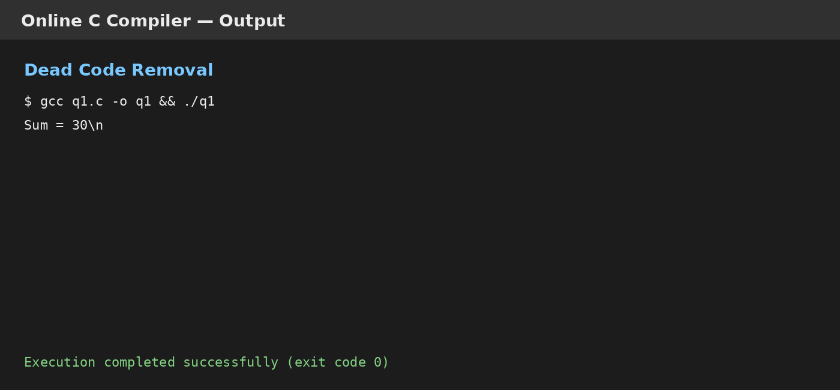
Result: Dead statements were removed and the optimized program produced the correct output.

