**GOPIKA S**

**CONTACT DETAILS:**

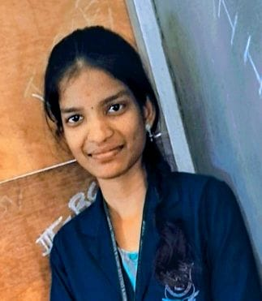**EMAIL : gopikabcai@gmail.com**

**PHONE NO :** 8056694071

**ADDRESS :** 42/4-1, Om sakthi nagar, south

bharathidasan nagar,

Thanthonimalai,

Karur.

**EDUCATIONAL QUALIFICATION:**

|  |  |  |  |
| --- | --- | --- | --- |
| **STANDARD** | **INSTITUTE NAME** | **YEAR** | **PERCENTAGE** |
| BCA | Annai women’s college, (Arts & science), Punnamchatram , Karur. | 2024 | 86.2% |
| 12th | St. Theresa girls higher secondary school, Gandhigramam, Karur. | 2021 | 88.33% |
| 10th | Government girls higher secondary school, Velliyanai ,Karur | 2019 | 90% |

**PERSONAL DATA:**

**Name :** Gopika.S

**Date of birth :** 25.08.2003

**Age :** 20

**Gender :** Female

**Marital status :** Unmarried

**Father’s name :** Sakthivel.R

**Nationality :** Indian

**Religion :** Hindu.

**Languages known :** Tamil ,English**.**

**PERSONAL SKILLS:**

* Quick learner
* Team work
* Multitasking
* Leadership qualities

**PROFILE:**

Bachelor of computer application graduate looking to work in a growth-oriented organisation we offers me challenging opportunities to enhance my profession and technical knowledge.

**OTHER ACTIVITIES:**

* Won first prize in speech competition.
* I present a presentation about Chat GPT in conference in my college.
* Won second prize in district level football competition.
* Got active participant certificate in eco wall project.

**TECHNICAL SKILLS:**

* Languages: basic level C, C++, JAVA.
* Database: MySQL.
* Basic Photoshop and flash
* Basic Tally prime
* Ms Word, Ms excel, Ms PowerPoint.