db.createCollection('Student')

db.Student.insertMany(

[

{

id:101,

name:'Sidharth',

age:35,

address:'Ernakulam',

semester:'s1'

},

{

id:102,

name:'Malavika',

age:40,

address:'Trissur',

semester:'s3'

},

{

id:103,

name:'Niharika',

age:45,

address:'Ernakulam',

semester:'s2'

},

{

id:104,

name:'Mithun',

age:41,

address:'Kannur',

semester:'s8'

}

]

db.createCollection('Faculty')

db.Faculty.insertMany(

[

{

id:01,

name:'Minhaj',

age:30,

dept_name:'CS',

salary:30000,

job_role:'Assistant Professor'

},

{

id:02,

name:'Kavya',

age:24,

dept_name:'Civil',

salary:15000,

job_role:'Clerk'

},

{

id:03,

name:'Manoj',

age:28,

dept_name:'MCA',

salary:50000,

job_role:'HOD'

},

{

id:04,

name:'Abhinav',

age:45,

dept_name:'EC',

salary:40000,

job_role:'Assistant Professor'

}

]

)

db.createCollection('Department')

db.Department.insertMany(

[

{

id:1001,

dept_name:'MCA',

location:'MCA Block'

},

{

id:1002,

dept_name:'Civil',

location:'Civil Block'

},

{

id:1003,

dept_name:'CS',

location:'MCA Block'

},

{

id:1004,

dept_name:'EC',

location:'Academic Block Block'

}

]

)

db.createCollection('Course')

db.Course.insertMany(

[

{

id:1,

dept_name:'MCA',

subject_offered:'Artificial Intelligence',

},

{

id:2,

dept_name:'Civil',

subject_offered:'TOC',

},

{

id:3,

dept_name:'CS',

subject_offered:'Computer Science',

},

{

id:4,

dept_name:'EC',

subject_offered:'Electrical',

}

]

)

use institute

db.createCollection('Student')

db.Student.insertMany(

[

{

id:101,

name:'Sidharth',

age:35,

address:'Ernakulam',

semester:'s1'

},

{

id:102,

name:'Malavika',

age:40,

address:'Trissur',

semester:'s3'

},

{

id:103,

name:'Niharika',

age:45,

address:'Ernakulam',

semester:'s2'

},

{

id:104,

name:'Mithun',

age:41,

address:'Kannur',

semester:'s8'

}

]

)

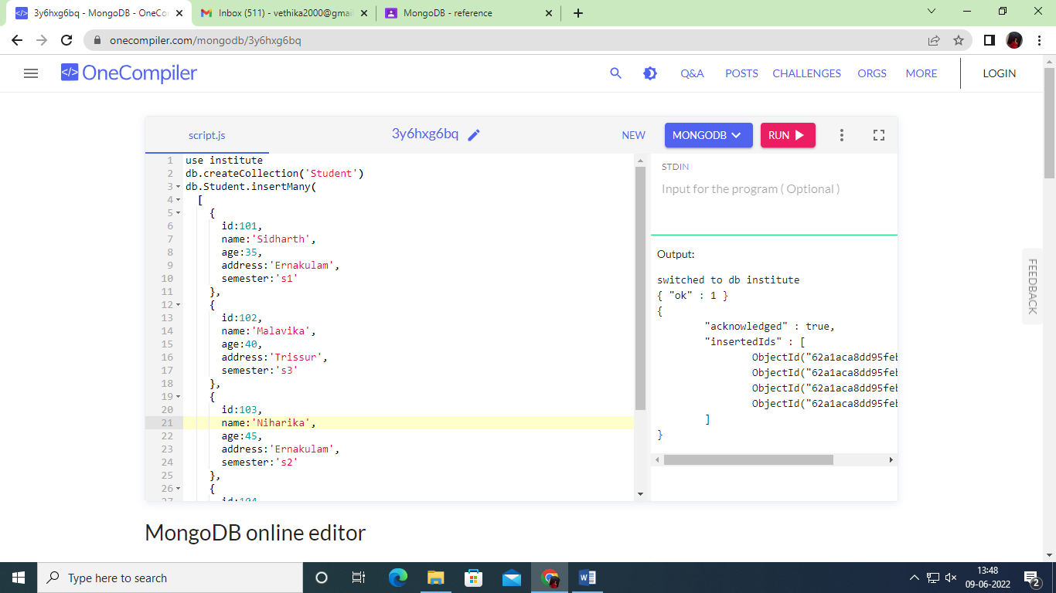

use institute

db.createCollection('Faculty')

db.Faculty.insertMany(

[

{

id:01,

name:'Minhaj',

age:30,

dept_name:'CS',

salary:30000,

job_role:'Assistant Professor'

},

{

id:02,

name:'Kavya',

age:24,

dept_name:'Civil',

salary:15000,

job_role:'Clerk'

},

{

id:03,

name:'Manoj',

age:28,

dept_name:'MCA',

salary:50000,

job_role:'HOD'

},

{

id:04,

name:'Abhinav',

age:45,

dept_name:'EC',

salary:40000,

job_role:'Assistant Professor'

}

]

)

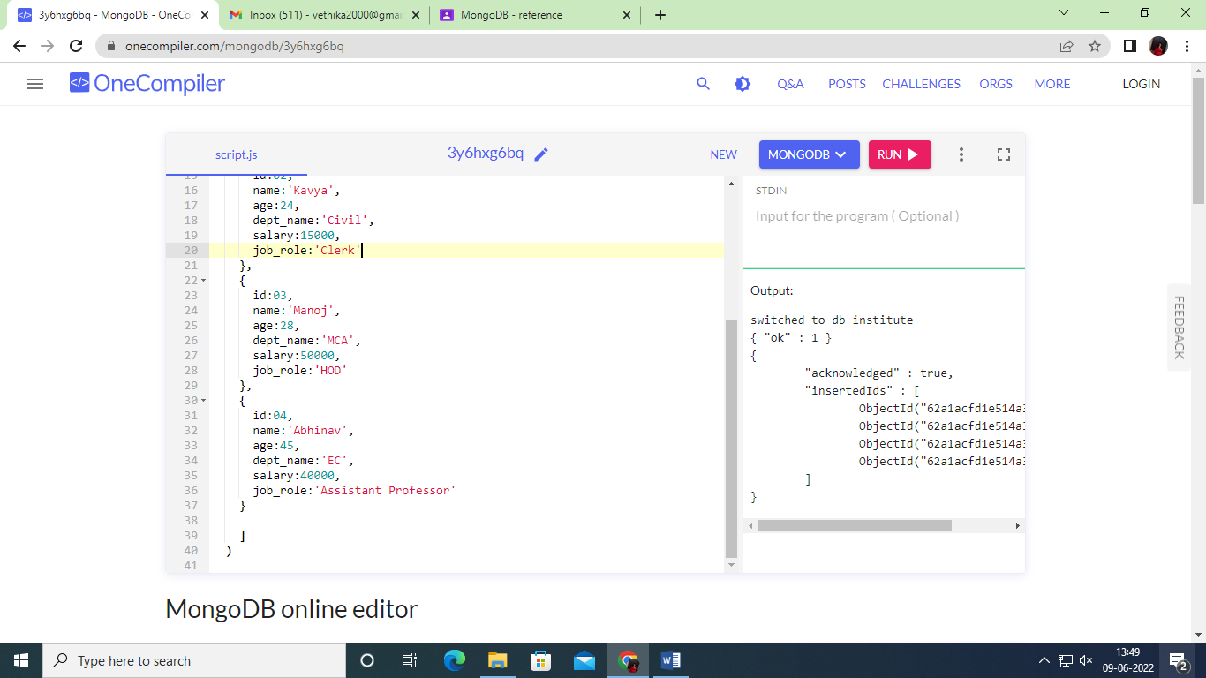

use institute

db.createCollection('Department')

db.Department.insertMany(

[

{

id:1001,

dept_name:'MCA',

location:'MCA Block'

},

{

id:1002,

dept_name:'Civil',

location:'Civil Block'

},

{

id:1003,

dept_name:'CS',

location:'MCA Block'

},

{

id:1004,

dept_name:'EC',

location:'Academic Block Block'

}

]

)

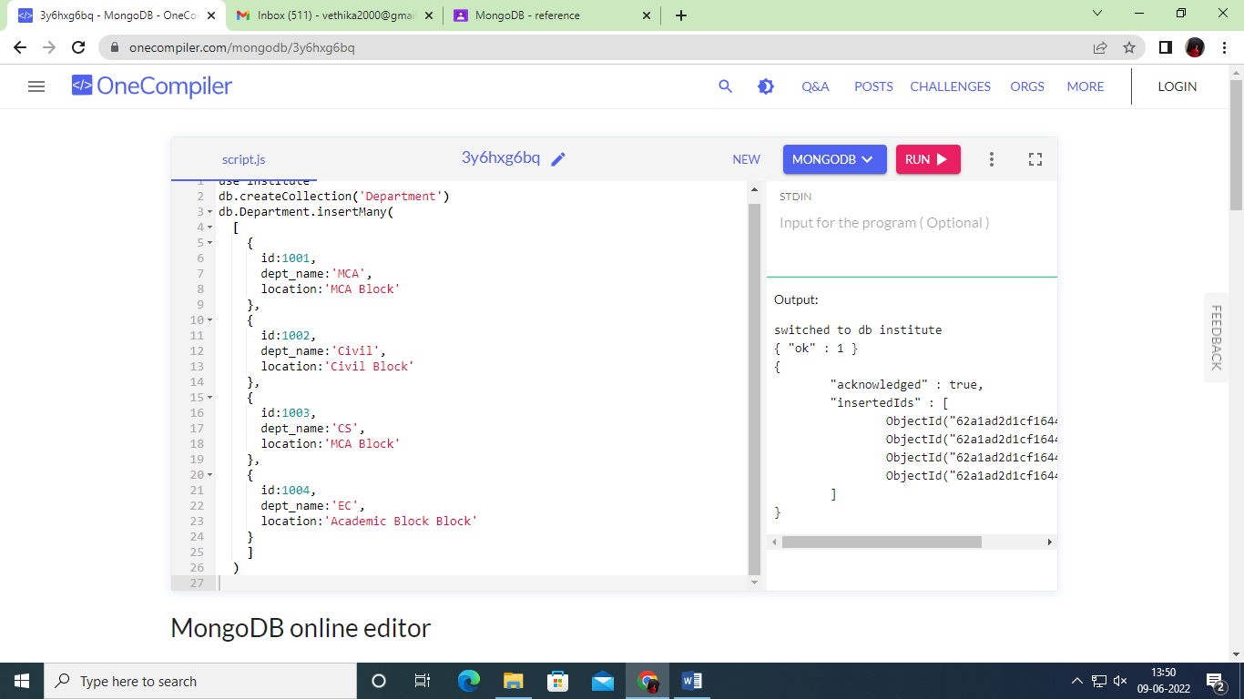

use institute

db.createCollection('Course')

db.Course.insertMany(

[

{

id:1,

dept_name:'MCA',

subject_offered:'Artificial Intelligence',

},

{

id:2,

dept_name:'Civil',

subject_offered:'TOC',

},

{

id:3,

dept_name:'CS',

subject_offered:'Computer Science',

},

{

id:4,

dept_name:'EC',

subject_offered:'Electrical',

}

]

)

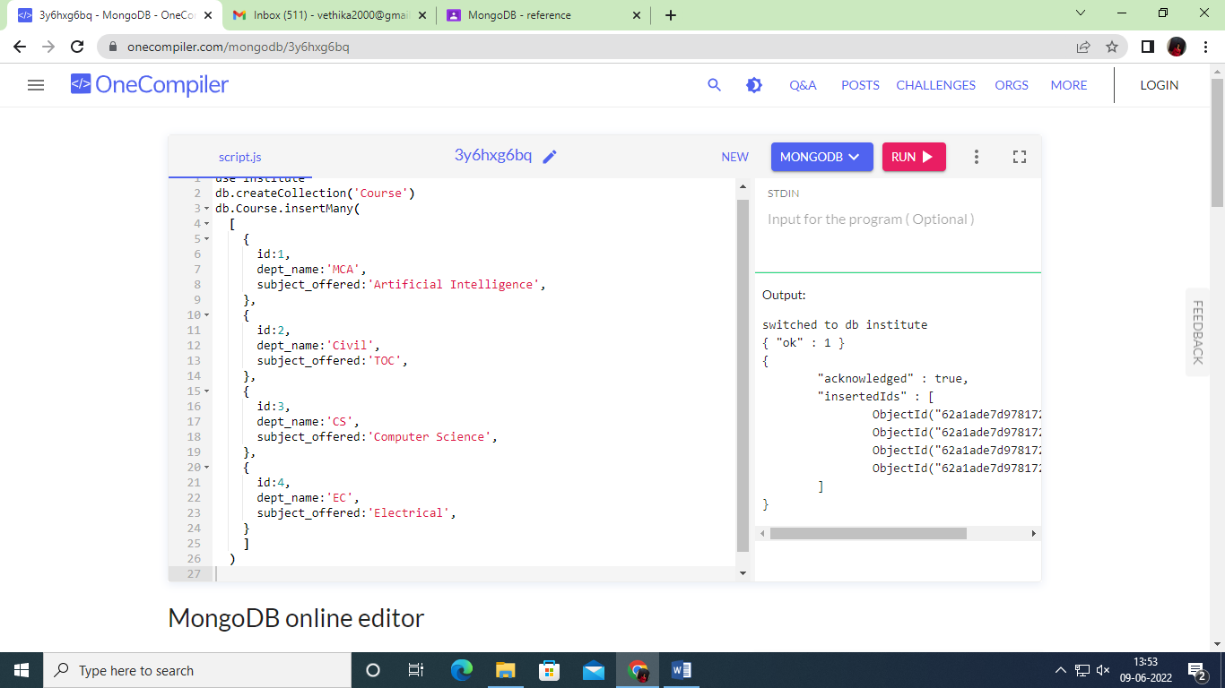

db.Student.find().pretty()

1 db.Student.find({id:101}).pretty()

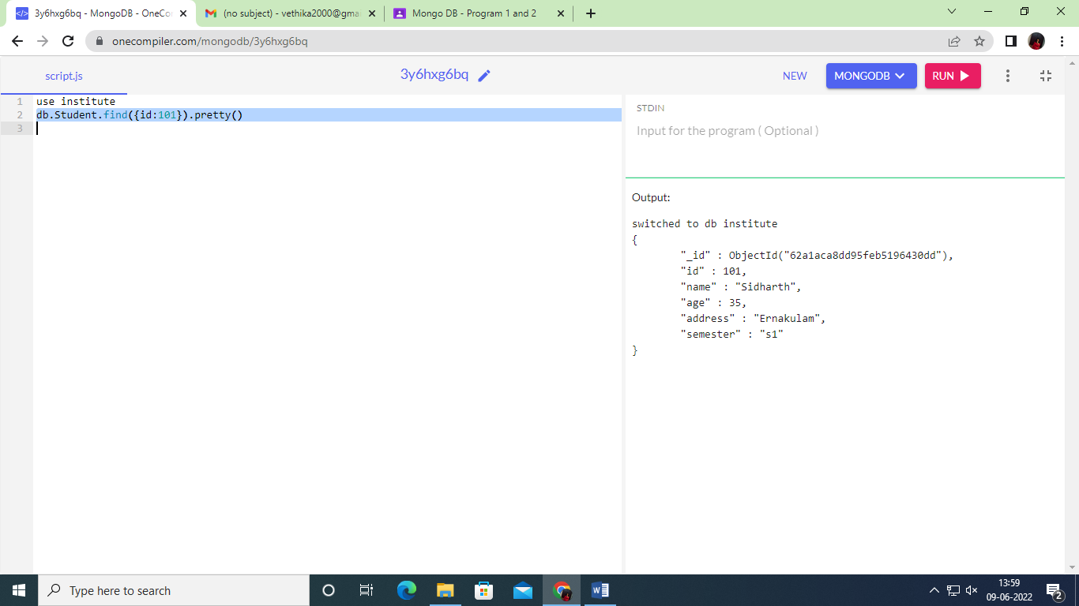

2 db.Faculty.find({salary:{$gt:25000}}).pretty()

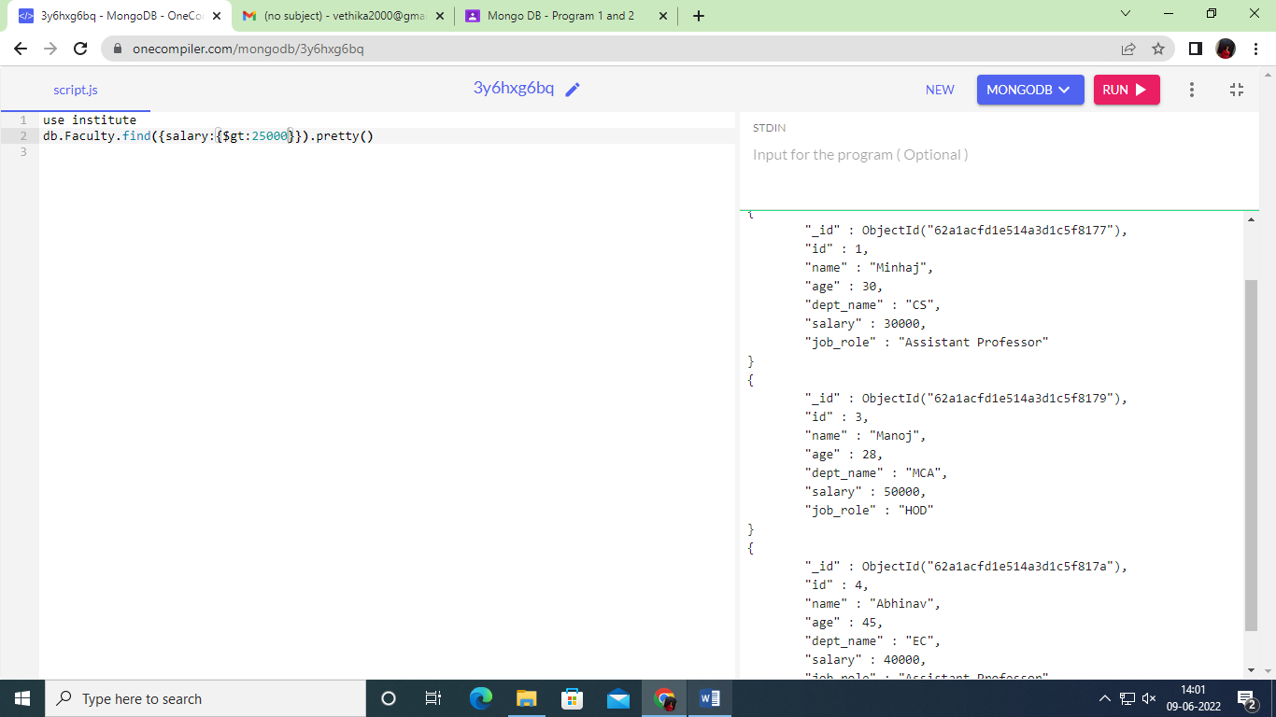

3 db.Faculty.find({salary:{$lt:25000}}).pretty()

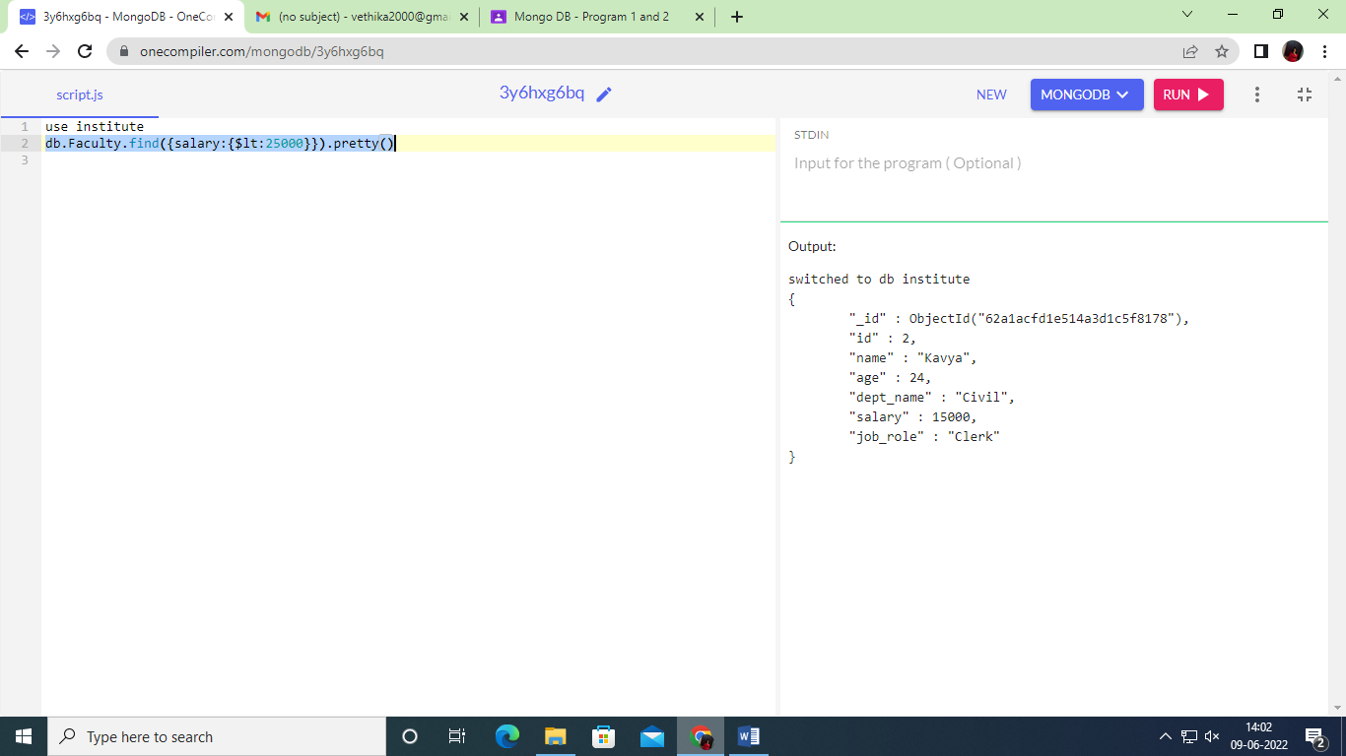

4 db.Faculty.find({salary:{$gte:25000}}).pretty()

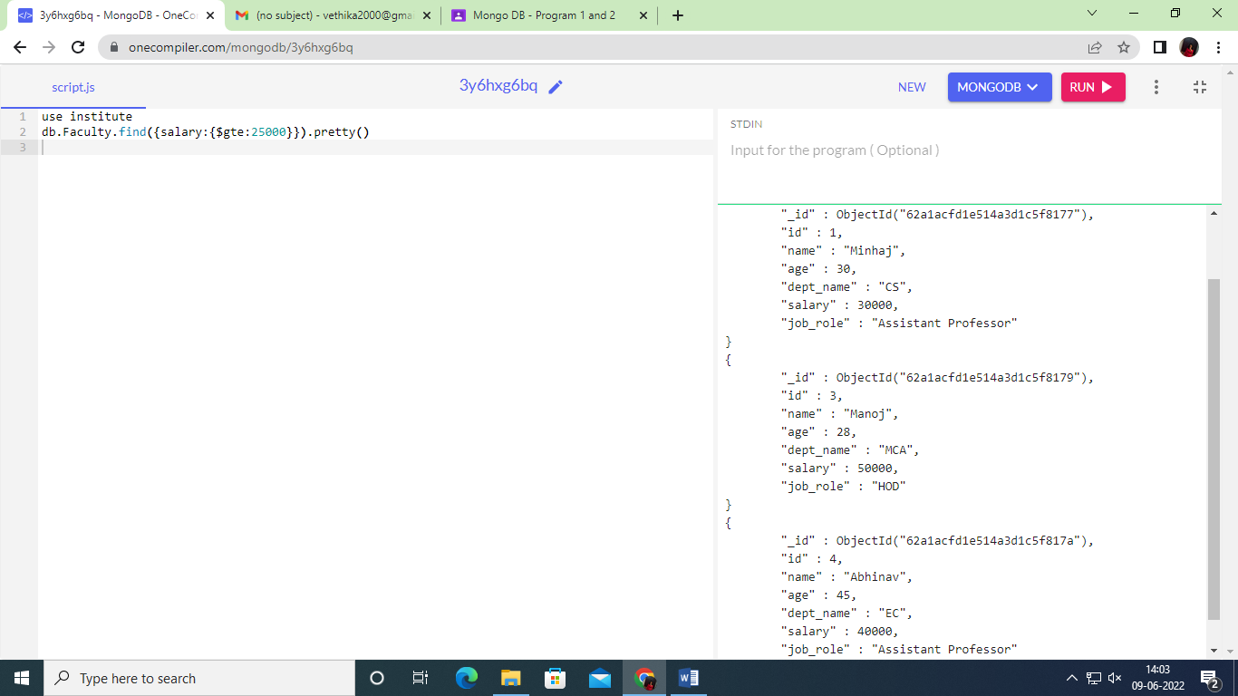

5 db.Faculty.find({salary:{$lte:15000}}).pretty()

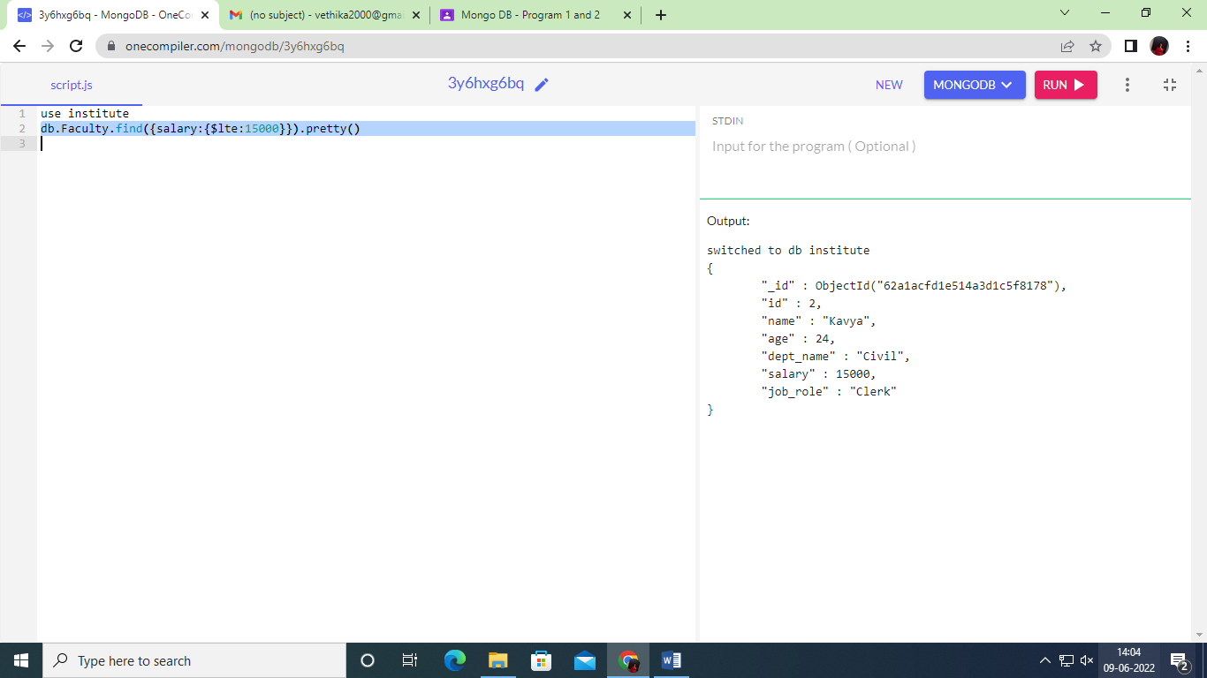

6 db.Faculty.find({

$or:[

{dept_name:"MCA"},{dept_name:"CS"}

]

})

Output:

switched to db institute

{ "_id" : ObjectId("62a1acfd1e514a3d1c5f8177"), "id" : 1, "name" : "Minhaj", "age" : 30, "dept_name" : "CS", "salary" : 30000, "job_role" : "Assistant Professor" }

{ "_id" : ObjectId("62a1acfd1e514a3d1c5f8179"), "id" : 3, "name" : "Manoj", "age" : 28, "dept_name" : "MCA", "salary" : 50000, "job_role" : "HOD" }

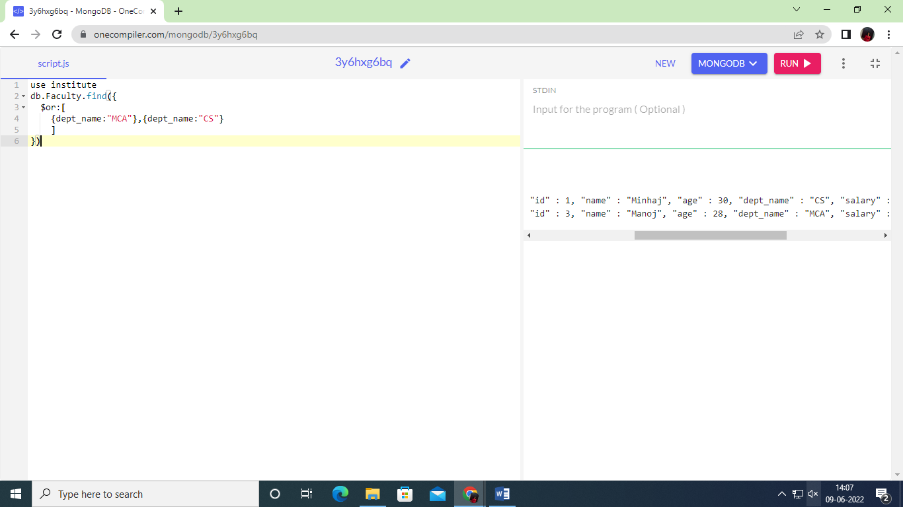

7