**Exception Handling**

**Program : 1**

Aim : Exception handling using try

**Source Code**

f=input("Enter the filename : ")

try:

f1=open(f,"r")

except IOError:

print("No file named",f)

**Output**

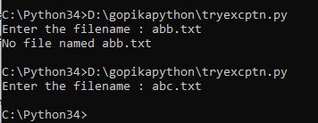

**Program : 2**

Aim exception handling using raise

**Source code**

x=int(input("Enter a number : "))

if x < 0:

raise ValueError("Sorry, no numbers below zero")

**Output**

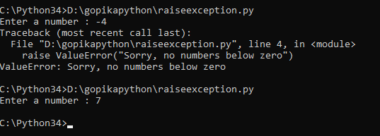

**Program : 3**

Aim : Try finally exception handling

**Source Code**

try:

print(x)

except:

print("Something went wrong")

finally:

print("The 'try except' is finished")

**Output**

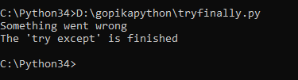

**Program : 4**

Aim : Try else exception handling

**Source Code**

def divide(x, y):

try:

result = x // y

except ZeroDivisionError:

print("Sorry ! You are dividing by zero ")

else:

print("Yeah ! Your answer is :", result)

x=int(input("Enter first number : "))

y=int(input("Enter second number : "))

divide(x,y)

**Output**

