str=input("Enter the string : ")

c=input("Enter the character : ")

count=0

for i in range(len(str)):

if(str[i]==c):

count=count+1

print("The occurance of the letter",c,"in the string is ",count)

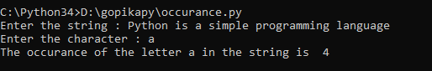

str=input("Enter the string : ")

s=str[0]

for i in range(len(str)):

str=str.replace(str[0],'$')

str1=s+str[1:]

print(str1)



def exchange(str):

return str[-1:]+str[1:-1]+str[:1]

str=input("Enter the string : ")

print("String after exchange : ")

print(exchange(str))

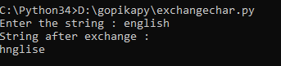

s1=input("Enter first string : ")

s2=input("Enter second string : ")

a=s1.replace(s1[0:1],s2[0:1])

b=s2.replace(s2[0:1],s1[0:1])

c=a+' '+b

print("After swapping : ",c)

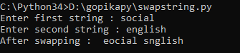

n=input("Enter the string : ")

if n[-3:]=='ing':

n=n+'ly'

else:

n=n+'ing'

print(n)

