**Program : 1**

**Aim :**

Write a shell script to display the following

1.User details

2.Current password

3.Present working directory

4.Current date

5.Exit

**Source Code:**

echo -e "1-User details\n2-Current user\n3-Present working directory\n4-Current date\n5-Exit"

while true;do

echo "Enter your choice "

read ch

case $ch in

1)

echo "User details : $HOSTNAME"

cat /etc/passwd ;;

2)

echo "Current user : $USER";;

3)

echo "Present working directory : $PWD";;

4)

now=`date`

echo "Current date : $now";;

5)

exit 1;;

*)

echo "Invalid choice"

exit 1;;

esac

done

**Output**

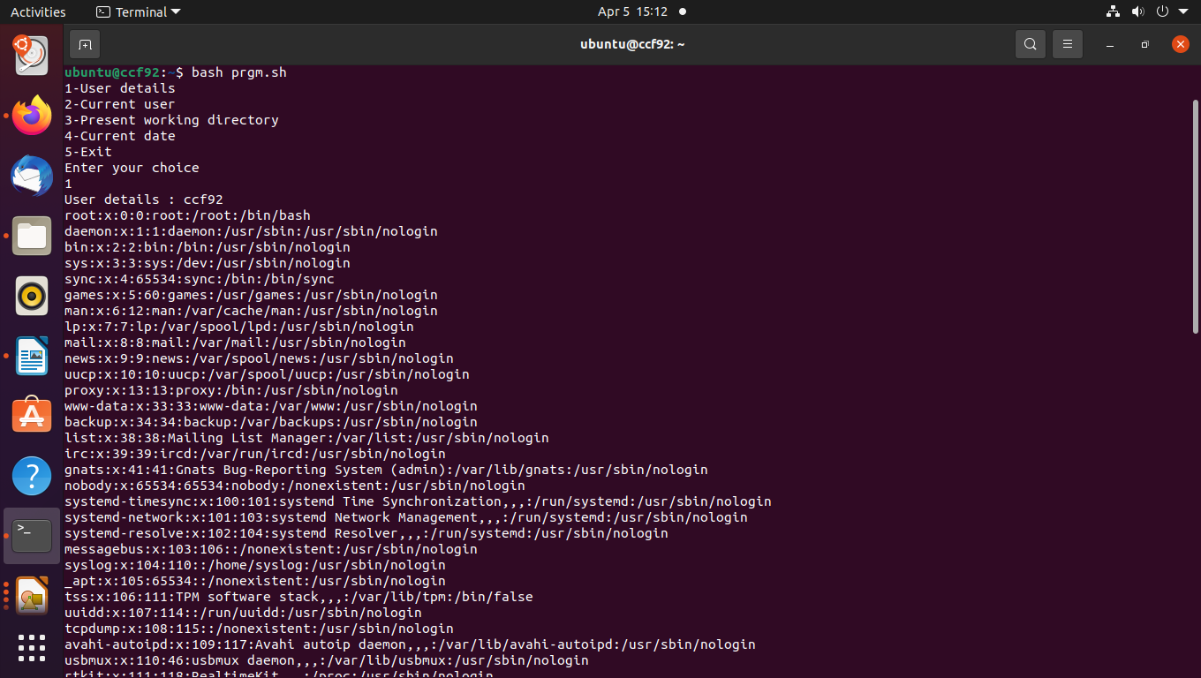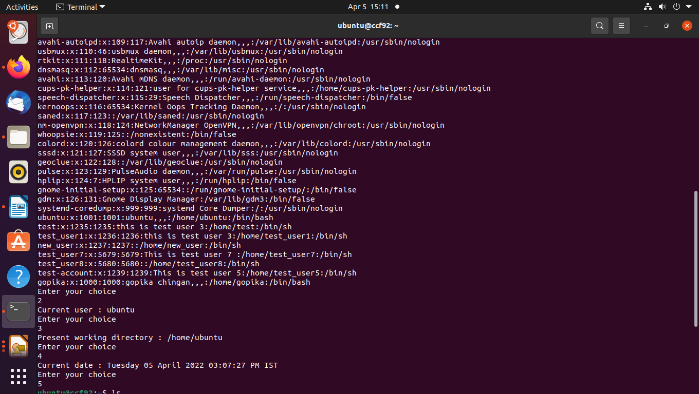

**Program : 2**

**Aim:**

Read the folder and file name from the user as argumnets.If folder not present then create it.If file present,remove it.If file not present in the given directory create it and add the content “Networking And System Adminisrative Lab.

**Source Code**

echo "Enter folder name"

read dir

echo "Enter file name "

read file

if [ ! -d $dir ]

then

mkdir $dir

echo "Directory created with name $dir"

else

echo "$dir Directory exists"

fi

if [ -f "$file" ]

then

rm "$file"

echo "$file File removed"

else

echo "$file File doesnot exist so create it and add the contents"

cat > $file

fi

**Output**

