Program 8

echo -e "1-List of directory contents\n2-Name of current directory\n3-Who is loogged on\n4-Long list of directory contents according to choice of user\n5-Exit"

while true;

do

echo "Enter your choice "

read ch

case $ch in

1) echo "List of directories"

ls;;

2) echo "Name of current directory "

pwd;;

3)echo "Logged one is "

who ;;

4) echo "Enter the Directory"

read d

echo "Long listing of directory in $d"

cd "$d"

ls -l ;;

5)exit 1;;

\*)echo "Invalid choice..Try Again..........";;

esac

done

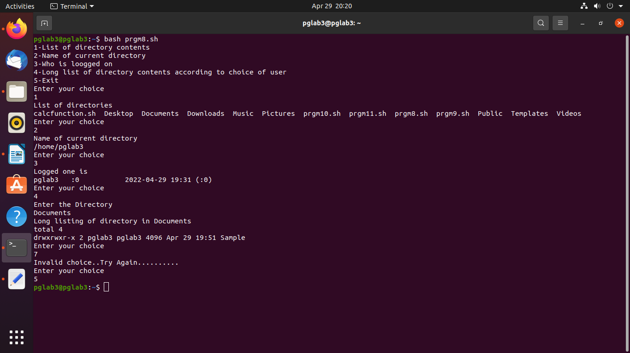

program 9

echo "Name of student : $1"

echo "Roll Number of student : $2"

echo "Mark of student : $3"

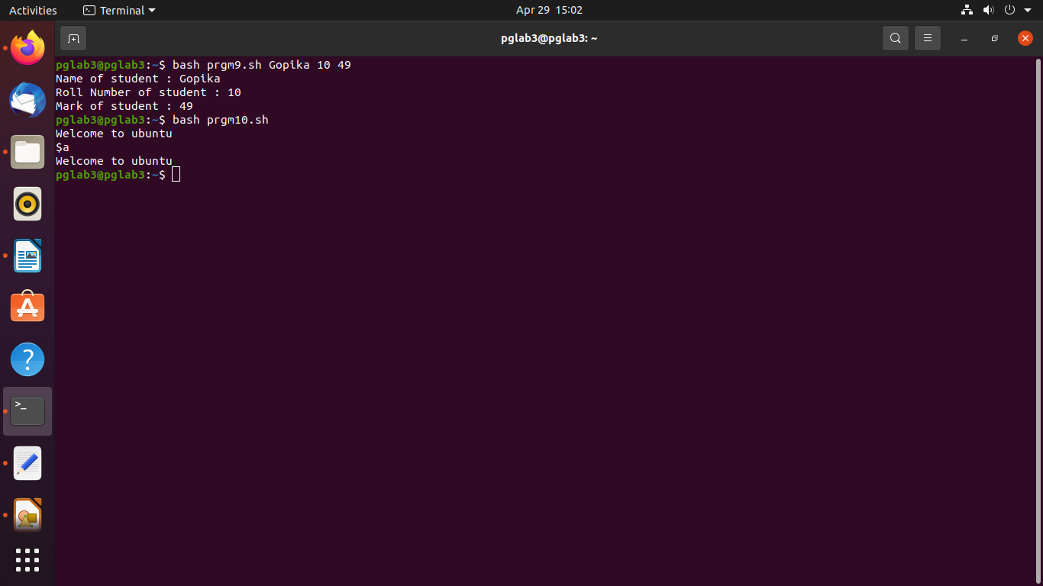

prgm 10

a="Welcome to ubuntu"

echo $a

echo '$a'

echo "$a"

prgm 11

if [[-e/var/log/sylog]]

then

cat/var/log/syslog|grep "^May"

else

echo "File not found"

fi

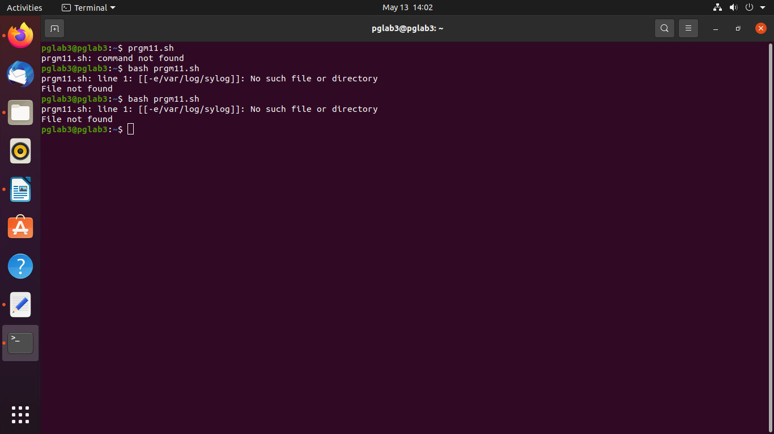

prgm 12

function add()

{

sum=$(($1 + $2))

echo "Sum = $sum"

}

function sub()

{

d=$(($1 - $2))

echo "Difference = $d"

}

function mul()

{

m=$(($1 \* $2))

echo "Product = $m"

}

function div()

{

q=$(($1 / $2))

echo "Quotient = $q"

}

function modulo()

{

m=$(($1 % $2))

echo "Reminder = $m"

}

echo -e "1-Addition\n2-Subtraction\n3-Multiplication\n4-Division\n5-Modulus\n6-Exit"

while true;

do

echo "Enter your choice "

read ch

case $ch in

1)add $1 $2

;;

2)sub $1 $2

;;

3)mul $1 $2

;;

4)div $1 $2

;;

5)modulo $1 $2

;;

6)exit 1;;

\*)echo "Invalid choice..Try Again..........";;

esac

done

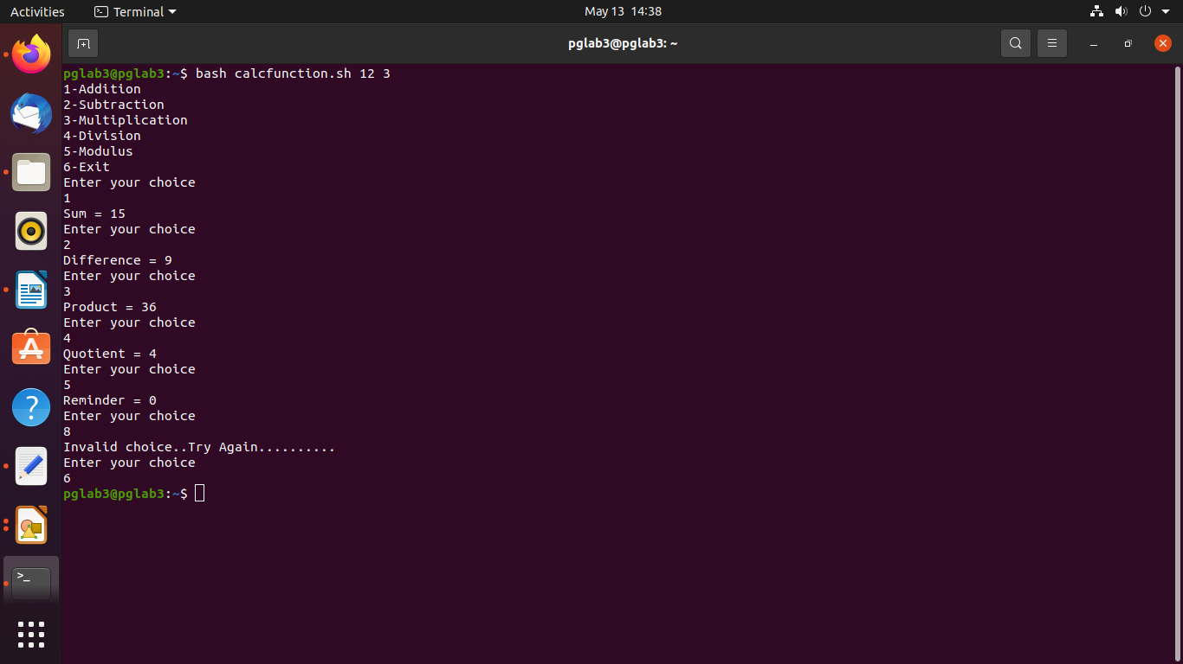

prgm 13

echo "Enter the limit "

read n

i=1

sum=0

echo "1-Sum of natural numbers using for loop\n2-Sum of natural numbers using while loop\n3-Exit"

while true;

do

echo "Enter your choice "

read ch

case $ch in

1)echo "Using for loop"

for ((i=1;i<=n;i++))

do

sum=` expr $sum + $i `

done

echo "Sum of natural numbers : $sum"

;;

2)echo "Using while loop "

while [ $i -le $n ]

do

sum=`expr $sum + $i`

i=` expr $i + 1 `

done

echo "Sum of natural numbers : $sum";;

3)exit 1;;

\*)echo "Invalid choice..Try Again..........";;

esac

done

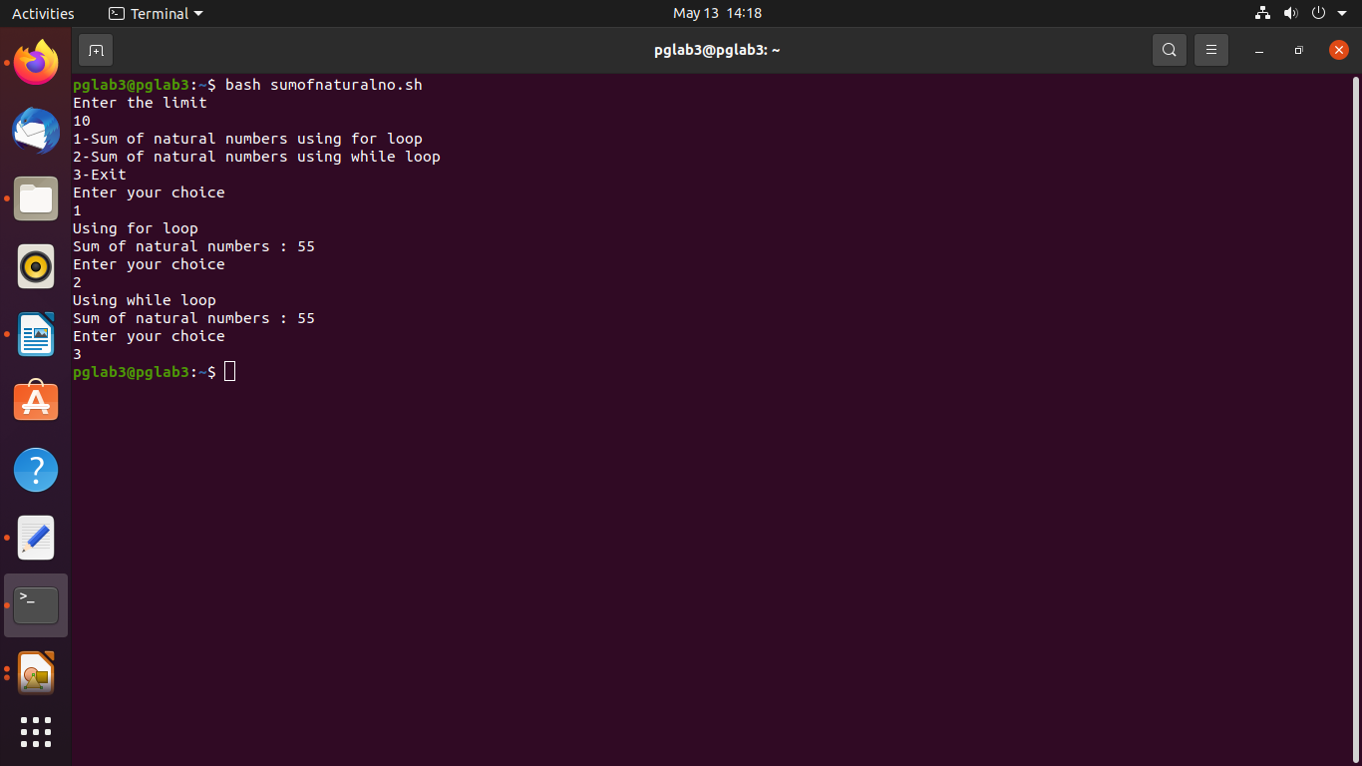

Experiment 2

