**Program 3:Forms**

<doctype html>

<html>

<head><title>CV</title></head>

<body bgcolor="cyan">

<H1>Details</h1>

<form>

<label for="fname">First Name:</label>

<input type="text" id="t1" name="t1">

<label for="mname">Middle Name:</label>

<input type="text" id="t2" name="t2">

<label for="lname">Last Name:</label>

<input type="text" id="t3" name="t3"><br>

Gender :<input type="radio" id="r1" name="r1">Male

<input type="radio" id="r2" name="r1">Female

<input type="radio" id="r3" name="r1">Other<br>

Age:<input type="text" id="t4" name="t4"><br>

DOB:<input type="date" ><br>

Address:<textarea name="ta" rows="10" cols="30"></textarea><br>

Languages Known : <input type="checkbox" id="c1" name="c1" value="English">English

<input type="checkbox" id="c2" name="c2" value="Hindi">Hindi

<input type="checkbox" id="c3" name="c3" value="Malayalam">Malayalam<br>

Education qualification:<br>

<table border=1 style="width:25%" bgcolor="pink">

<tr>

<th>Qualification</th>

<th>Year of passing </th>

<th>Institution</th>

</tr>

<tr>

<td><input type="text" id="t1" name="t1"></td>

<td><input type="text" id="t2" name="t2"></td>

<td><input type="text" id="t3" name="t3"></td>

</tr>

<tr>

<td><input type="text" id="t4" name="t4"></td>

<td><input type="text" id="t5" name="t5"></td>

<td><input type="text" id="t6" name="t6"></td>

</tr>

<tr>

<td><input type="text" id="t7" name="t7"></td>

<td><input type="text" id="t8" name="t8"></td>

<td><input type="text" id="t9" name="t9"></td>

</tr>

<tr>

<td><input type="text" id="tt" name="tt"></td>

<td><input type="text" id="ti" name="ti"></td>

<td><input type="text" id="tu" name="tu"></td>

</tr>

</table><br>

Hobbies:<select name="hobbies" id="hobbies">

<option value="Reading">Reading</option>

<option value="Drawing">Drawing</option>

<option value="Singing">singing</option>

</select>

</form>

</body>

<html>

**Output**

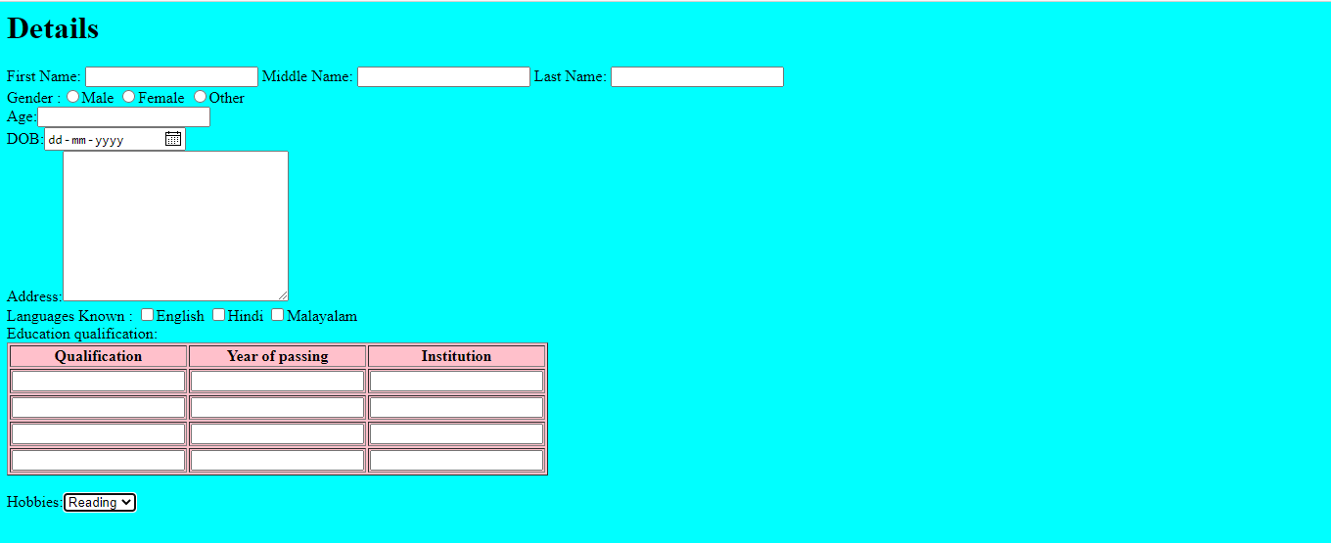

**<!doctype html>**

**<html>**

**<head><title>Tables</title></head>**

**<style>**

**table, th, td {**

**border: 1px solid black;**

**border-collapse: collapse;**

**}**

**th, td {**

**background-color: #96D4D4;**

**}**

**</style>**

**<body>**

**<center>**

**<table style="width:25%">**

**<tr style= "background-color:redwhite;color:white;">**

**<caption>Personal Details</caption>**

**<th>Name</th>**

**<th>Age</th>**

**</tr>**

**<tr >**

**<td>Arun</td>**

**<td>23</td>**

**</tr>**

**<tr>**

**<td>Malavika</td>**

**<td>21</td>**

**</tr>**

**<tr>**

**<td>Arun</td>**

**<td>25</td>**

**</tr.**

**</table>**

**</center>**

**</body>**

**</html>**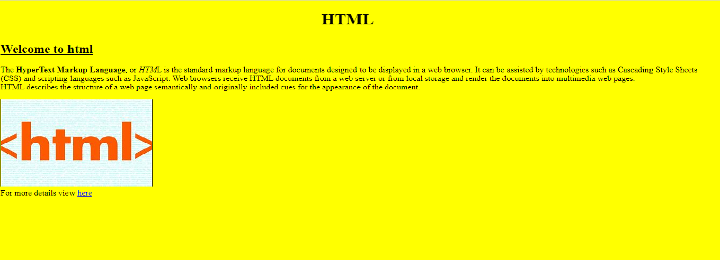

**<!Doctype html>**

**<html>**

**<head><title>Basic tags</title></head>**

**<body bgcolor="yellow" alink="blue" vlink="violet">**

**<h1><marquee>HTML</marquee></h1>**

**<h2><u>Welcome to html</u></h2>**

**<p>The <b>HyperText Markup Language</b>, or <i>HTM</i>L is the standard markup language for documents designed to be displayed in a web browser. It can be assisted by technologies such as Cascading Style Sheets (CSS) and scripting languages such as JavaScript.**

**Web browsers receive HTML documents from a web server or from local storage and render the documents into multimedia web pages.<br> HTML describes the structure of a web page semantically and originally included cues for the appearance of the document.**

**</p>**

**<img src="C:\Users\student\Pictures\Saved Pictures\h.jfif" border="1" alt="cannot process"><br>**

**For more details view <a href="url">here</a>**

**</body>**

**</html>**