TASK-19
class Solution {
public int[] nextGreaterElement(int[] nums1, int[] nums2) {
int[] ans = new int[nums1.length];

for (int i = 0; i < nums1.length; i++) {
ans[i] = -1;

// Find nums1[i] in nums2
for (int j = 0; j < nums2.length; j++) {
if (nums1[i] == nums2[j]) {

// Find next greater element
for (int k = j + 1; k < nums2.length; k++) {
if (nums2[k] > nums2[j]) {
ans[i] = nums2[k];
break;
}
}

break;
}
}
}

return ans;
}
}

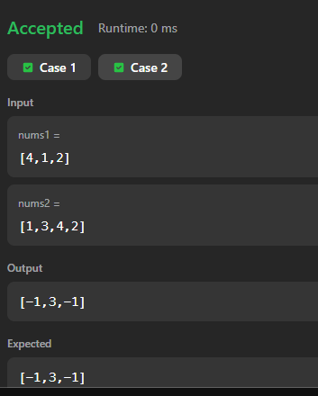

TASK-20
import java.util.Stack;
class Solution {
public int[] dailyTemperatures(int[] temperatures) {
int n = temperatures.length;
int[] answer = new int[n];
Stack<Integer> stack = new Stack<>();
for (int i = 0; i < n; i++) {
while (!stack.isEmpty() &&
temperatures[i] > temperatures[stack.peek()]) {
int prev = stack.pop();
answer[prev] = i - prev;
}
stack.push(i);
}
return answer;
}
}
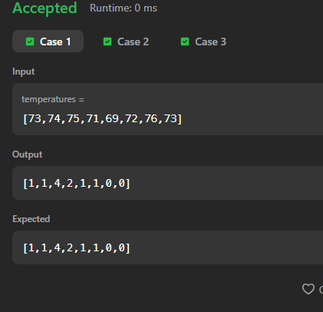

TASK-21
import java.util.Stack;

class StockSpanner {

Stack<int[]> stack = new Stack<>();

public StockSpanner() {
}

public int next(int price) {

int span = 1;

while (!stack.isEmpty() && stack.peek()[0] <= price) {
span += stack.pop()[1];
}

stack.push(new int[]{price, span});

return span;
}
}
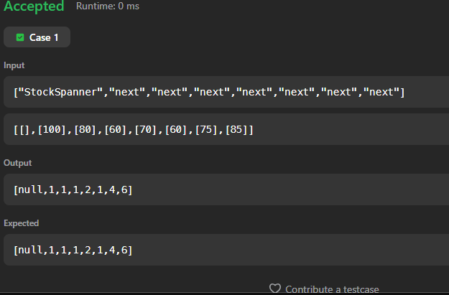

TASK-22
class Solution {
public int[] finalPrices(int[] prices) {
for (int i = 0; i < prices.length; i++) {
for (int j = i + 1; j < prices.length; j++) {
if (prices[j] <= prices[i]) {
prices[i] = prices[i] - prices[j];
break;
}
}
}
return prices;
}
}
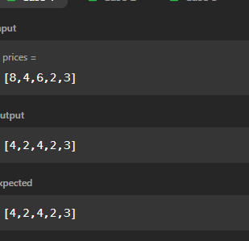

TASK-23
import java.util.Stack;

class Solution {
public boolean isValid(String s) {
Stack<Character> stack = new Stack<>();
for (char c : s.toCharArray()) {
if (c == '(' || c == '[' || c == '{') {
stack.push(c);
}
else {
if (stack.isEmpty()) {
return false;
}
char top = stack.pop();
if (c == ')' && top != '(') {
return false;
}
if (c == ']' && top != '[') {
return false;
}
if (c == '}' && top != '{') {
return false;
}
}
}

return stack.isEmpty();
}
}

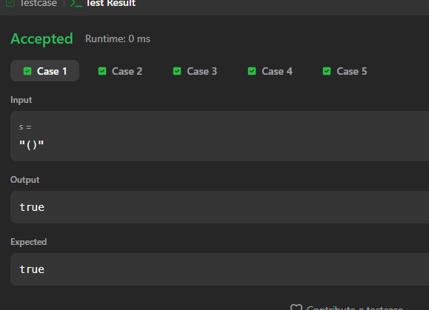

TASK-24
class Solution {
public String minRemoveToMakeValid(String s) {
StringBuilder result = new StringBuilder();
Stack<Integer> stack = new Stack<>();
for (int i = 0; i < s.length(); i++) {
char c = s.charAt(i);
if (c == '(') {
stack.push(result.length());
result.append(c);
}
else if (c == ')') {
if (!stack.isEmpty()) {
stack.pop();
result.append(c);
}
}
else {
result.append(c);
}
}
// Remove unmatched '('
while (!stack.isEmpty()) {
int index = stack.pop();
result.deleteCharAt(index);
}

return result.toString();
}
}

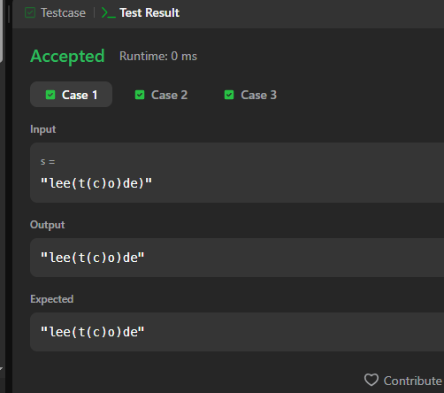

TASK-25
import java.util.Stack;
class MinStack {
Stack<Integer> stack = new Stack<>();
Stack<Integer> minStack = new Stack<>();
public MinStack() {
}
public void push(int val) {
stack.push(val);
if (minStack.isEmpty() || val <= minStack.peek()) {
minStack.push(val);
}
}
public void pop() {
if (stack.peek().equals(minStack.peek())) {
minStack.pop();
}
stack.pop();
}
public int top() {
return stack.peek();
}

public int getMin() {
return minStack.peek();
}
}

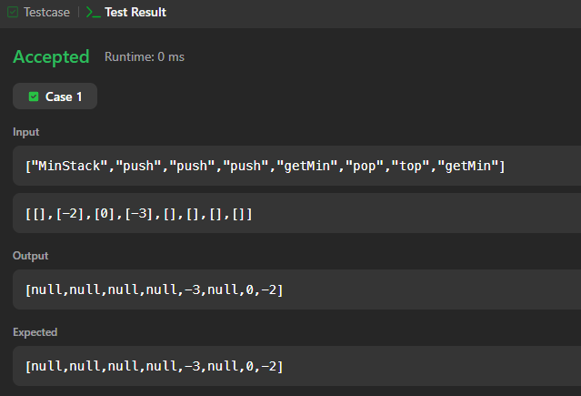

TASK-26
class Solution {
public int[] asteroidCollision(int[] asteroids) {
Stack<Integer> stack = new Stack<>();
for (int asteroid : asteroids) {
boolean destroyed = false;
while (!stack.isEmpty() &&
stack.peek() > 0 &&
asteroid < 0) {
if (stack.peek() < -asteroid) {
stack.pop();
}
else if (stack.peek() == -asteroid) {
stack.pop();
destroyed = true;
break;
}
else {
destroyed = true;
break;
}
}
if (!destroyed) {
stack.push(asteroid);
}
}
int[] result = new int[stack.size()];
for (int i = 0; i < result.length; i++) {
result[i] = stack.get(i);
}
return result;
}
}
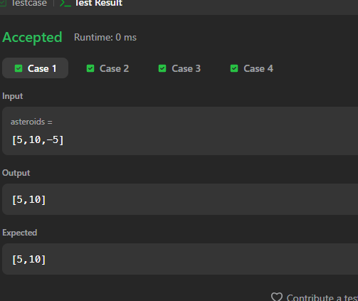

TASK-27
import java.util.Stack;
class Solution {
public boolean validateStackSequences(int[] pushed, int[] popped) {
Stack<Integer> stack = new Stack<>();
int j = 0;
for (int num : pushed) {
stack.push(num);
while (!stack.isEmpty() && stack.peek() == popped[j]) {
stack.pop();
j++;
}
}
return stack.isEmpty();
}
}
