class Solution {
public int[] sortedSquares(int[] nums) {
int n = nums.length;
int[] result = new int[n];

int left = 0;
int right = n - 1;

for (int i = n - 1; i >= 0; i--) {
if (Math.abs(nums[left]) > Math.abs(nums[right])) {
result[i] = nums[left] * nums[left];
left++;
} else {
result[i] = nums[right] * nums[right];
right--;
}
}

return result;
}
}

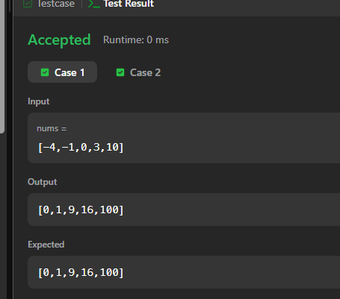

TASK-2
class Solution {
public boolean containsNearbyDuplicate(int[] nums, int k) {
HashMap<Integer, Integer> map = new HashMap<>();
for (int i = 0; i < nums.length; i++) {
if (map.containsKey(nums[i])) {
int previousIndex = map.get(nums[i]);
if (i - previousIndex <= k) {
return true;
}
}
// Store the latest index
map.put(nums[i], i);
}
return false;
}

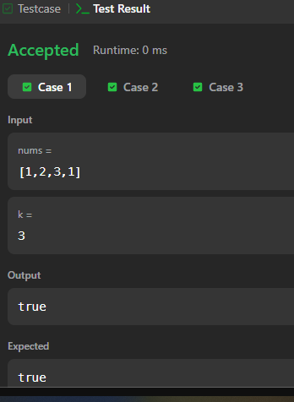}

TASK-3
class Solution {
public int[] runningSum(int[] nums) {
for (int i = 1; i < nums.length; i++) {
nums[i] = nums[i] + nums[i - 1];
}

return nums;
}
}

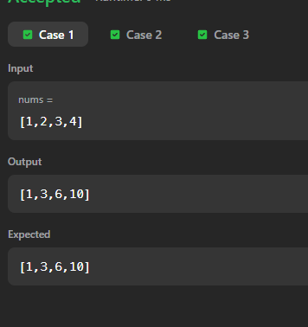

TASK-4
class Solution {
public int[] getSumAbsoluteDifferences(int[] nums) {
int n = nums.length;
int[] result = new int[n];
for (int i = 0; i < n; i++) {
for (int j = 0; j < n; j++) {
result[i] += Math.abs(nums[i] - nums[j]);
}
}
return result;
}
}

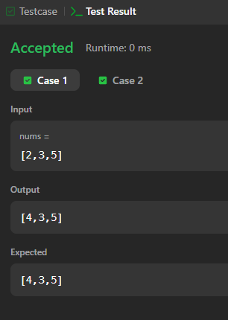

TASK-5
class Solution {
public int search(int[] nums, int target) {
int left = 0;
int right = nums.length - 1;
while (left <= right) {
int mid = left + (right - left) / 2;
if (nums[mid] == target) {
return mid;
}
else if (nums[mid] < target) {
left = mid + 1;
}
else {
right = mid - 1;
}
}
return -1;
}
}
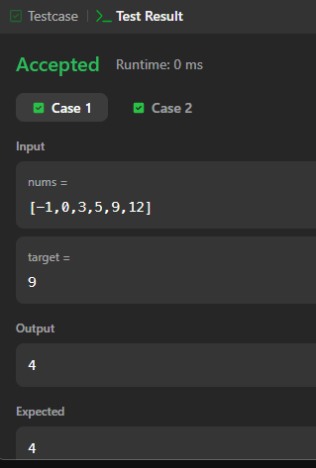

TASK-6
class Solution {
public void sortColors(int[] nums) {
int count0 = 0;
int count1 = 0;
int count2 = 0;

for (int num : nums) {
if (num == 0) {
count0++;
} else if (num == 1) {
count1++;
} else {
count2++;
}
}

int i = 0;

while (count0-- > 0) {
nums[i++] = 0;
}

while (count1-- > 0) {
nums[i++] = 1;
}

while (count2-- > 0) {
nums[i++] = 2;
}
}
}

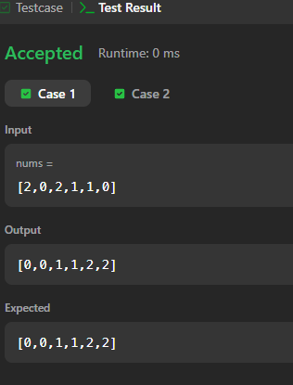

TASK-7
class Solution {
public int maxProfit(int[] prices) {
int minPrice = prices[0];
int maxProfit = 0;
for (int i = 1; i < prices.length; i++) {
if (prices[i] < minPrice) {
minPrice = prices[i];
}
int profit = prices[i] - minPrice;
if (profit > maxProfit) {
maxProfit = profit;
}
}
return maxProfit;
}
}
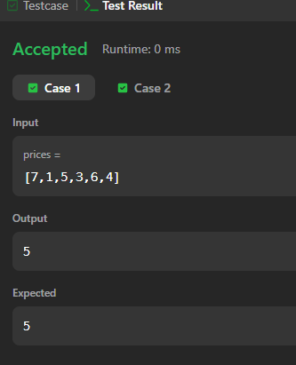
TASK-8
class Solution {
public int strStr(String haystack, String needle) {
for (int i = 0; i <= haystack.length() - needle.length(); i++) {

if (haystack.substring(i, i + needle.length()).equals(needle)) {
return i;
}
}

return -1;
}
}
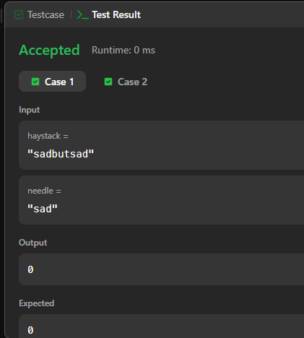

TASK-9
class Solution {
public void moveZeroes(int[] nums) {
int index = 0;
// Move all non-zero elements to the front
for (int i = 0; i < nums.length; i++) {
if (nums[i] != 0) {
nums[index] = nums[i];
index++;
}
}
// Fill the remaining positions with 0
while (index < nums.length) {
nums[index] = 0;
index++;
}
}
}
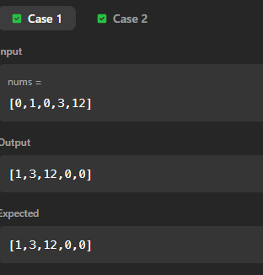

TASK-10
class Solution {
public void reverseString(char[] s) {
int left = 0;
int right = s.length - 1;
while (left < right) {
char temp = s[left];
s[left] = s[right];
s[right] = temp;
left++;
right--;
}
}
}
