

**TOPIC: CALCULATING FAMILY EXPENSes USING SERVICENOW**

**PROJECT REPORT**

***Submitted by***

|  |  |
| --- | --- |
| **NAME** | **REGISTER NUMBER** |
| **B. GOPIKA** | **222308147** |
| **G. PRINCY** | **222308153** |
| **M.YABEZH** | **222308144** |
| **B. VISHNU** | **222308143** |

**In partial fulfilment for the award of the degree**

**of**

**BACHELOR OF SCIENCE**

**IN**

**COMPUTER SCIENCE**

**SHREE CHANDRAPRABHU JAIN COLLEGE**

**MINJUR**

**SEP 2025**

***Calculating Family Expenses using***

***Service now***

***Introduction:***

***Managing family expenses effectively is essential for maintaining financial stability and achieving future goals. Traditionally, households track expenses using notebooks, spreadsheets, or mobile apps. While these methods work, they often lack automation, accuracy, and insights into long-term financial patterns.***

***ServiceNow, a cloud-based platform widely used for workflow automation and data management in enterprises, can also be adapted for personal and family expense tracking. By leveraging its robust database, reporting tools, and automation features, ServiceNow can help families systematically record, calculate, and analyze expenses. This ensures better visibility of income versus expenditure, promotes budgeting, and supports smarter financial decision-making.***

***Problem Statement:***

***Families often struggle to manage expenses due to the lack of a centralized, automated, and analytical system. Manual tracking methods may lead to:***

***Errors in expense calculation.***

***Difficulty in categorizing and analyzing spending.***

***Lack of timely reminders for recurring expenses.***

***Limited insights into saving opportunities.***

***Without proper tracking, families may overspend, fail to save adequately, or miss payments. Therefore, there is a need for an automated expense management solution that is easy to use, secure, and capable of providing clear financial insights.***

***Objectives:***

***The main objectives of this project are:***

***1. Expense Tracking – Create a system to record and categorize daily, weekly, and monthly family expenses (e.g., groceries, bills, healthcare, education, entertainment).***

***2. Automation – Utilize ServiceNow workflows to automate repetitive tasks such as recurring expenses and notifications.***

***3. Reporting & Analytics – Generate expense summaries, visual dashboards, and trend reports for better financial insights.***

***4. Budget Management – Compare expenses with predefined budgets and highlight overspending areas.***

***5. User-Friendly Interface – Provide an intuitive interface that allows family members to easily log and review expenses.***

***6. Financial Planning Support – Help families identify saving opportunities and plan for long-term goals.***

***Scope of the Project:***

***The scope of this project is to design and implement an automated family expense management system using ServiceNow. The system focuses on simplifying the process of recording, calculating, and analyzing household expenses. By leveraging ServiceNow’s workflow automation, database, and reporting capabilities, the project aims to provide a reliable platform for families to manage their financial activities efficiently.***

***In Scope:***

***Recording and storing family expenses in a centralized system.***

***Categorizing expenses (e.g., groceries, utilities, healthcare, education, entertainment).***

***Setting monthly budgets and comparing them with actual spending.***

***Automating recurring expense entries (e.g., rent, electricity bill).***

***Generating visual reports and dashboards for expense analysis.***

***Sending alerts/notifications for overspending or approaching budget limits.***

***Providing user-friendly access for family members to enter and view expenses.***

***Out of Scope (Not Covered in this Project):***

***Integration with external payment gateways or bank accounts.***

***Advanced financial forecasting and investment management.***

***Multi-currency support for international use.***

***Data encryption or advanced security beyond ServiceNow’s built-in features***

***Existing System vs Proposed System***

***Existing System:***

***1. Families usually track expenses using manual methods like notebooks or Excel sheets.***

***2. Expense entries need to be added manually without automation.***

***3. No automatic categorization of expenses (e.g., food, bills, education).***

***4. Difficult to analyze trends over time because of scattered data.***

***5. Error-prone calculations while summing up totals or preparing monthly reports.***

***6. No notifications or alerts when expenses exceed the budget.***

***7. Data security and sharing is limited, especially when multiple family members want to contribute.***

***Proposed System (Using ServiceNow)***

***1. A centralized automated system built on ServiceNow platform.***

***2. Expense records stored in a custom table (u_family_expenses) with fields like date, amount, comments, and details.***

***3. Automation using Business Rules and Workflows – automatically updates total when a new expense is added.***

***4. Categorization of expenses (groceries, bills, entertainment, healthcare, etc.).***

***5. Visual reports and dashboards generated to analyze daily, monthly, and yearly spending.***

***6. Budget management with alerts/notifications when nearing or exceeding limits.***

***7. Multiple users (family members) can log their expenses in one shared system securely.***

***8. Ensures accuracy, time-saving, and better financial decision-making.***

***Proposed System Architecture:***

***The proposed system is designed on the ServiceNow platform, which provides workflow automation, data storage, and reporting features. The architecture is divided into different layers/modules for efficient functioning:***

***1. User Layer***

***Family members (users) interact with the system through the ServiceNow interface.***

***Users can log in to enter daily expenses, view reports, and set budgets.***

***2. Application Layer (ServiceNow Modules)***

***Expense Entry Module: Captures expense details (date, amount, category, comments).***

***Business Rule Automation: Updates total expenses automatically when a new record is added.***

***Budget Management Module: Compares actual spending with predefined limits.***

***Notification Module: Sends alerts when expenses cross thresholds.***

***3. Database Layer***

***A custom table (u_family_expenses) stores all expense records.***

***Fields include:***

***u_date → Expense date***

***u_expense → Amount spent***

***u_comments → Expense description***

***u_amount → Running total***

***u_expense_details → Complete log of daily spending***

***4. Reporting & Dashboard Layer.***

***Generates charts, graphs, and summaries for daily, monthly, and yearly analysis.***

***Provides insights into spending patterns and supports better financial planning.***

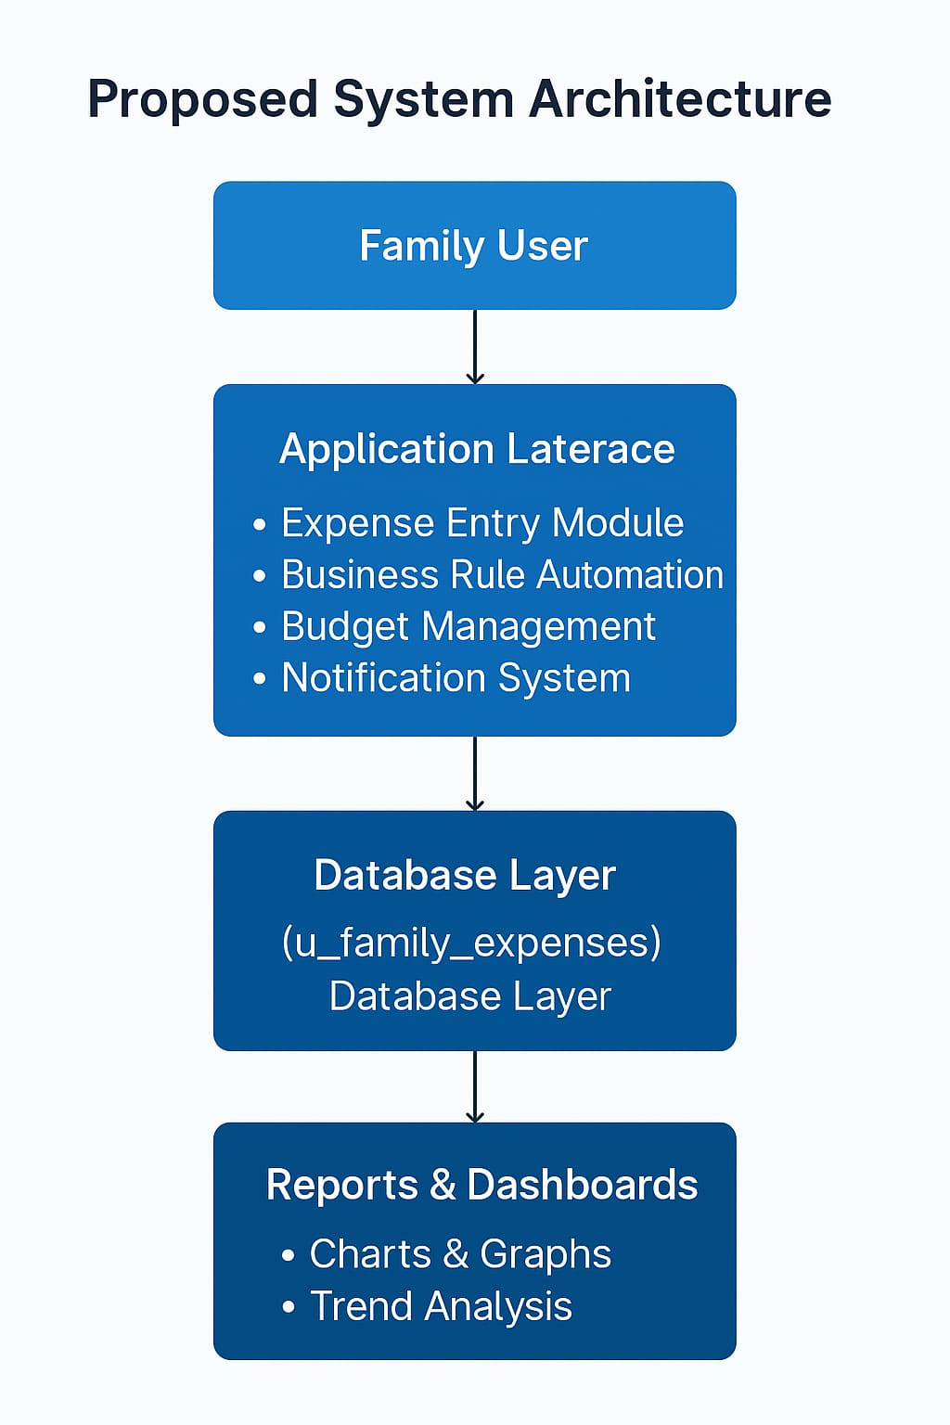

***Use Case Diagram:***

***Actors:***

***Family Member (User) – Enters and reviews expenses.***

***ServiceNow System – Manages database, workflows, and reports.***

***Use Cases:***

***1. Add Expense – User records daily expense.***

***2. Categorize Expense – Assigns category (food, transport, healthcare, etc.).***

***3. View Expense Report – System generates summary or charts.***

***4. Set Monthly Budget – User defines budget for categories.***

***5. Receive Alerts/Notifications – System alerts when nearing/exceeding budget.***

***6. Analyze Trends – System provides insights (monthly/annual trends).***

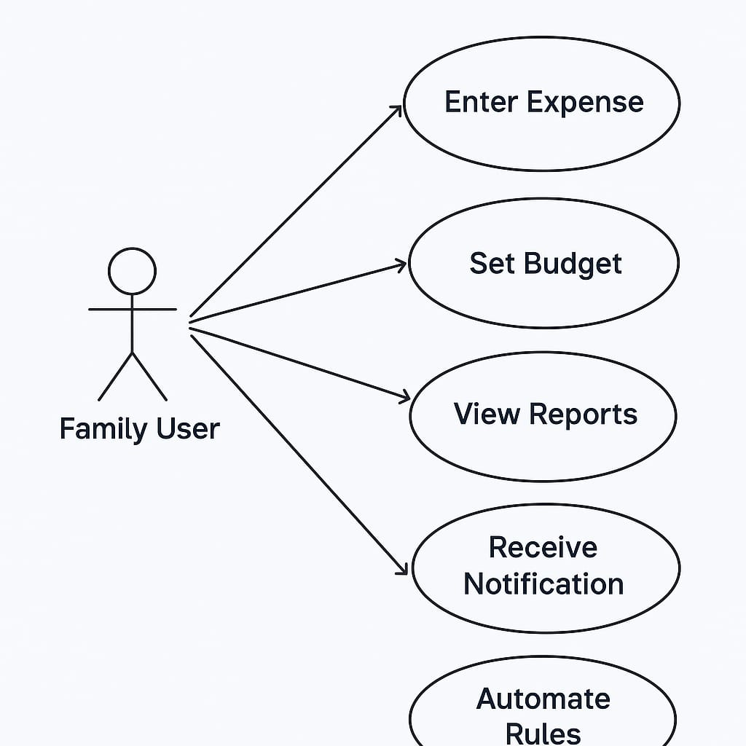

***Workflow (Step by Step):***

***1. User logs in to ServiceNow.***

***2. Add Expense:***

***User enters details → amount, date, category (groceries, bills, etc.).***

***System stores in the expense database.***

***3. Categorization:***

***Expenses automatically tagged under categories.***

***System applies workflows (e.g., recurring bills auto-added monthly).***

***4. Budget Check:***

***Compare expense totals with the predefined monthly budget.***

***If budget exceeds 80% → notification is sent.***

***5. Report & Dashboard :***

***User views reports (bar chart, pie chart, line graph).***

***Monthly/annual summaries generated automatically.***

***6. Trend Analysis:***

***System highlights highest spending areas.***

***Suggests possible savings (example: “Reduce entertainment expenses by 10% to meet savings goal”).***

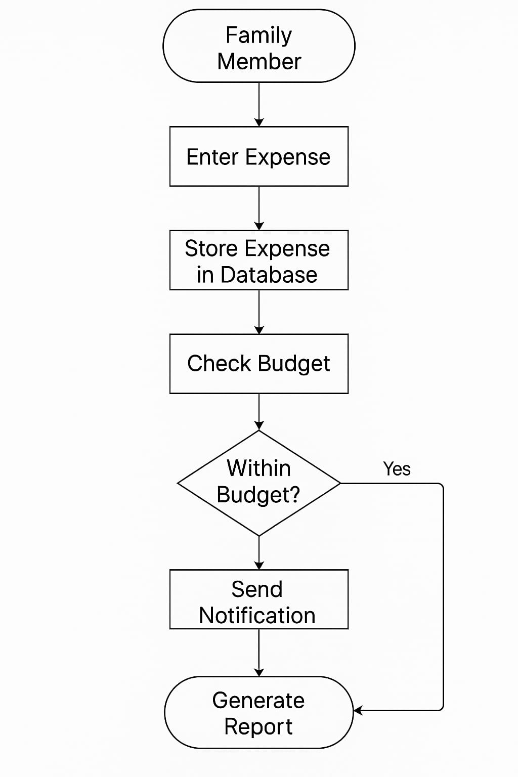

Modules of the system:

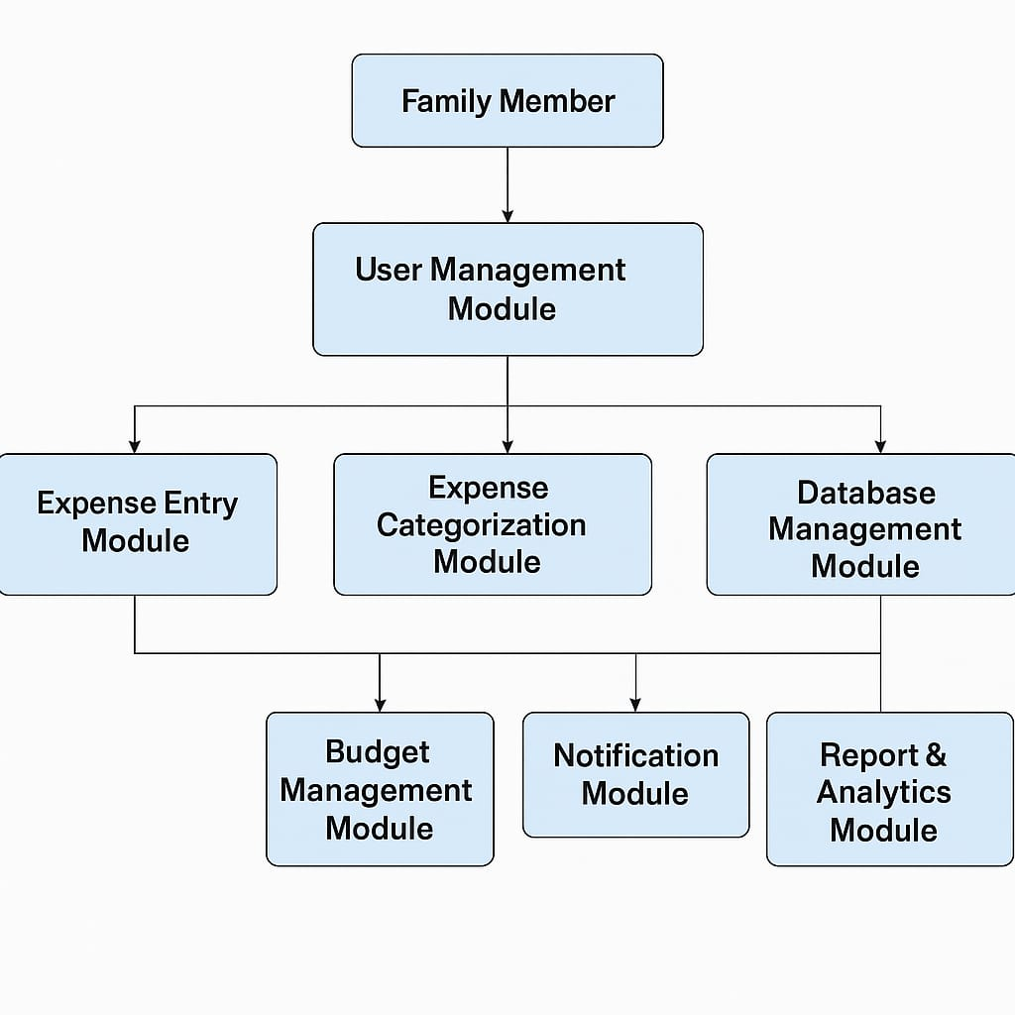

***1. User Management Module***

***Manages login and authentication.***

***Allows multiple family members to add/view their expenses.***

***2. Expense Entry Module***

***Add daily/weekly/monthly expenses.***

***Attach comments (e.g., groceries, bills, medical).***

***3. Expense Categorization Module***

***Automatically classifies expenses into categories.***

***Helps in analyzing where money is spent.***

***4. Budget Management Module***

***Allows users to set monthly/annual budgets.***

***Sends alerts/notifications if expenses exceed the budget.***

***5. Report & Analytics Module***

***Generates monthly/annual reports.***

***Provides charts and dashboards for clear visualization.***

***6. Database Management Module***

***Stores expenses securely in the ServiceNow table (u_family_expenses).***

***Ensures centralized and consistent data storage.***

***7. Notification Module***

***Sends reminders or alerts (e.g., budget exceeded).***

***Helps in controlling overspending.***

***Implementation Steps in ServiceNow:***

***Step 1: Create Custom Table***

***Navigate to System Definition → Tables.***

***Create a new table named Family Expenses (u_family_expenses).***

***Add the following fields:***

***u_date (Date)***

***u_expense (Currency/Number)***

***u_comments (String/Text)***

***u_amount (Currency/Number – for totals)***

***u_expense_details (String/Text – for log details)***

***Step 2: Design the Form***

***Customize the Form Layout for the u_family_expenses table.***

***Include fields: Date, Expense, Comments, Amount, and Expense Details.***

***Ensure it is user-friendly for daily entries.***

***Step 3: Create Business Rule (Automation)***

***Navigate to System Definition → Business Rules.***

***Create a new Business Rule for table u_family_expenses.***

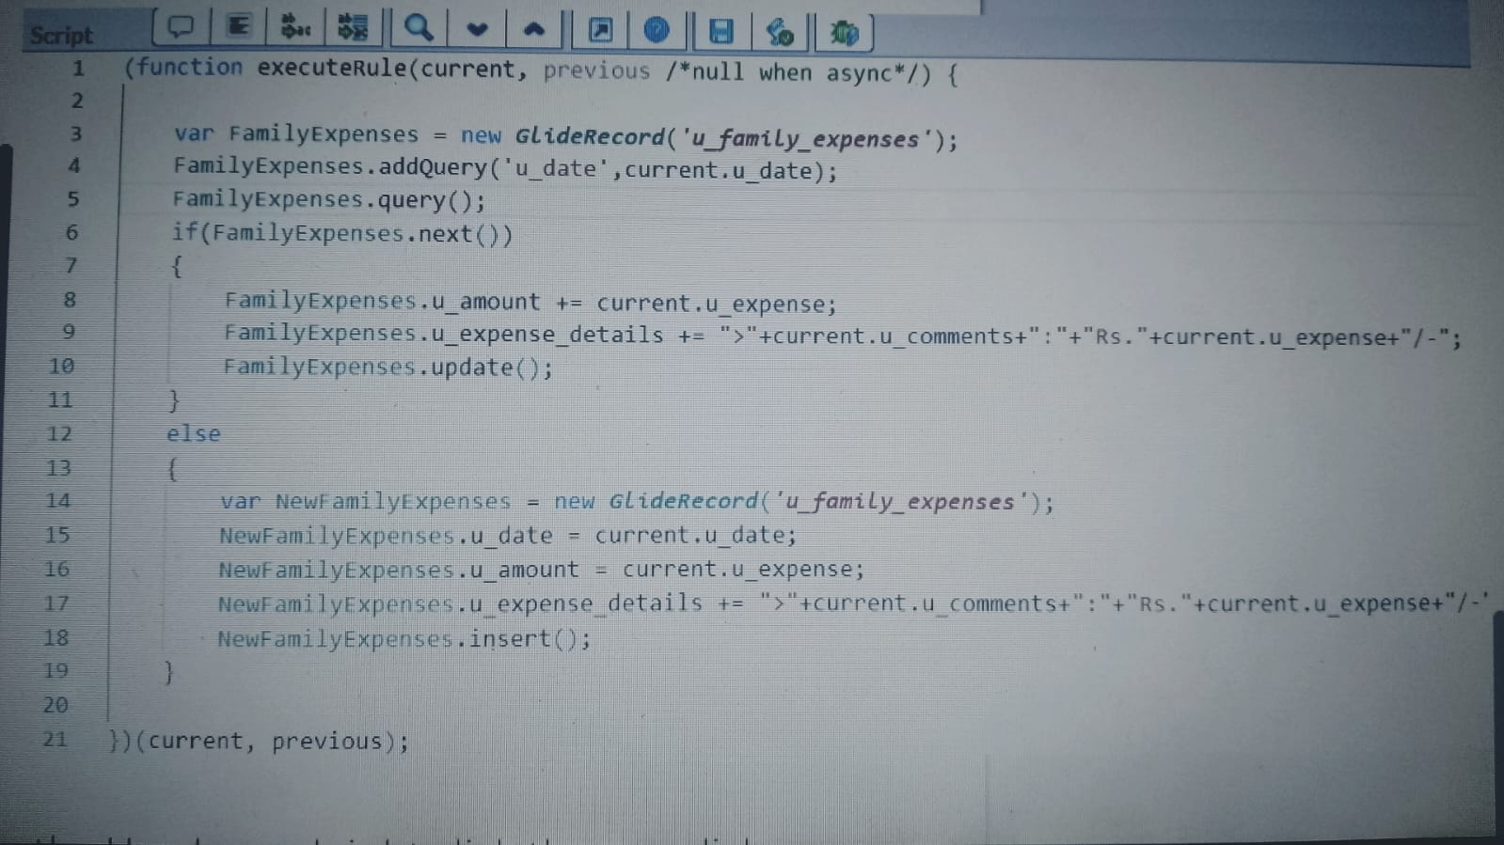

***Check if the date already exists.***

***If yes → Update total amount and append comments.***

***If no → Insert a new record.***

***Step 4: Implement Notifications (Optional)***

***Navigate to System Notification → Email → Notifications.***

***Create rules to alert users if expenses exceed a certain budget.***

***Step 5: Create Reports & Dashboards***

***Go to Reports → Create New.***

***Build Pie charts, Bar charts, or Line charts for:***

***Daily expenses***

***Monthly totals***

***Category-wise breakdown (if categorization added)***

***Add them to a Dashboard for easy visualization.***

***Step 6: Test the System***

***Enter test records (e.g., Groceries = ₹500, Travel = ₹200).***

***Verify if:***

***Totals update correctly.***

***Old dates append expenses.***

***Reports display accurate values.***

***QUERY SCRIPT:***

***Implementation → Configure Relationship between Tables***

***1. Step 1: Open Family Expenses Table***

***Navigate to Related Lists → Configure → Relationship.***

***2. Step 2: Link Daily Expenses Table***

***Select Queries from table = Daily Expenses.***

***3. Step 3: query script***

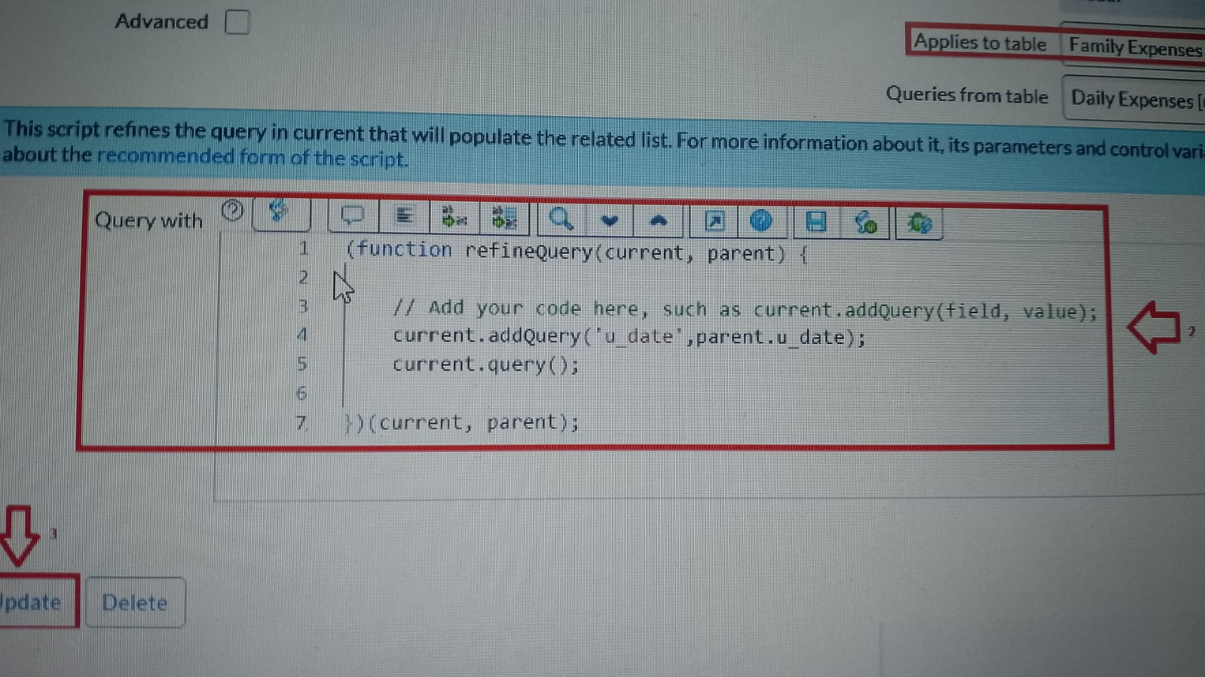

***Future Enhancements:***

***1. Mobile App Integration***

***Build a simple Android/iOS app to add/view expenses on the go***

***2. Bank/UPI Auto Integration***

***Automatically fetch transactions from SMS, Google Pay, Paytm, or bank APIs.***

***3. AI-based Expense Prediction***

***Use machine learning to predict upcoming monthly expenses (e.g., bills, groceries).***

***4. Multi-Currency Support***

***Allow expenses to be logged in different currencies with automatic conversion.***

***5. Advanced Reports & Analytics***

***Integrate with tools like Power BI / Tableau for deeper insights and interactive dashboards.***

***6. Voice Assistant Support***

***Add expenses using voice commands (e.g., “Add 500 rupees groceries”).***

***7. Cloud Backup & Sync***

***Enable Google Drive/Dropbox backup for expense history.***

***8. Family Budget Gamification***

***Add achievements/alerts (e.g., “This month you saved 10% more than last month”).***

***Conclusion:***

***The Family Expenses Calculation System using ServiceNow simplifies and automates the process of recording, categorizing, and analyzing household expenses. By integrating different modules such as User Management, Expense Entry, Categorization, Budgeting, Reporting, and Notifications, the system ensures that families can track their financial activities in a structured and transparent way.***

***The project demonstrates how ServiceNow’s powerful tables, GlideRecord scripting, and workflows can be customized beyond IT Service Management, extending into real-life applications like personal finance.***

***Although the current system has some limitations (manual entry, basic reports, and limited automation), it provides a solid foundation. With future enhancements like mobile app integration, AI-based predictions, and advanced analytics, the system can evolve into a complete personal finance management tool.***

*THANK YOU!*