Date:31/3/22

Course code:20MCA241

DATA SCIENCE LAB

Gopika Das

Reg no: AJC20MCA-2039

1.Given 3 matrices A,B,C.Write a program to perform the following operation:

A.B+4B2-C/4

Program code:

import numpy  
A = numpy.array([1,1])  
B = numpy.array([1,0])  
C = numpy.array([6,7])  
print(A,B,C)  
print(numpy.dot)  
print(numpy.sqrt)  
print(numpy.multiply)  
print(numpy.divide)  
print(numpy.array(A.B+4*B*B-C/4))

Output:

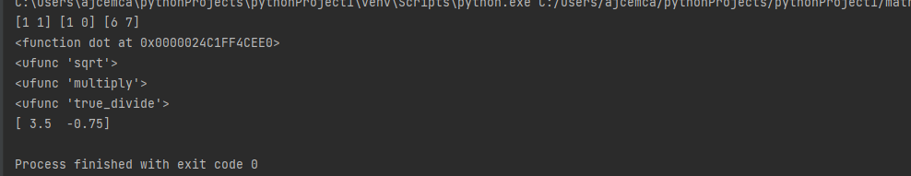

2.Program to implement multiple regression using Boston data set available in public domain and evaluate its performance and display the coefficient values.

Program code:

import numpy  
from sklearn.linear_model import LinearRegression  
from sklearn.metrics import accuracy_score  
x=([2,1],[7,9])  
y=([3,4],[6,9])  
  
model=LinearRegression()  
model.fit(x,y)  
r_sq=model.score(x,y)  
print("score",r_sq)  
print("Intercept",model.intercept_)  
print("slope",model.coef_)  
y_pred = ("model_predict",x)  
print ("prediction",y_pred)

Output:

