

**IS4151/IS5451 - AIoT**

**Project Final Report**

**Group 07**

|  |  |
| --- | --- |
| **Name** | **Student ID** |
| Gopika Sarasvathi Kothandaraman | A0274980R |
| Li Wei Ting | A0274987A |
| Sylviya Alexander | A0276584M |
| Yusril Izza | A0264323L |

**Table of Contents**

1. Description of Idea and its Value Proposition 3
2. Main Content for Managerial Idea 3
   1. Overview of Business Operation 3
   2. Business problem 4
   3. Business processes prior to the incorporation of AIoT 4
   4. Business processes after the incorporation of AIoT 4
   5. Potential economic business value that is generated 5
3. Prototype Description and Sample Screenshots 5
   1. Bin Level Monitoring 6
   2. Android App Implementation 8
      1. User Interface (UI) 8
      2. Displaying Information System 10
   3. Fall Detection System Using Micro:bit and Decision Tree Classifier 11
      1. Data Collection and Labelling 11
      2. Data Preparation 12
      3. Model Training 12
      4. Model Deployment and Real-time Prediction 13
      5. Application Integration 13
   4. Waste Type Classification Using CNN 14
      1. Data Used 14
      2. Data Preparation 14
      3. Model Training 14
      4. Model Deployment and Real-time Prediction 14
      5. System Integration 15
4. References 16

# Description of Idea and its Value Proposition

The Smart Waste Management System is designed to revolutionize traditional waste collec- tion processes. The system employs real-time monitoring of waste bins, including metrics such as bin fullness level and bin rolled-over status. The trucker can view this information on the fly using the mobile application. The mobile application is designed to present information without overwhelming users with excessive numbers and data; this is achieved by displaying the key metrics using easy-to-understand icons. To facilitate data collection, the bins are equipped with multiple sensors and microprocessors. The bins can also detect the type of waste locally using the built-in camera and microcomputer and dispose of the waste in the appropriate container. The project aims to reduce carbon emissions, improve waste disposal practices, and provide waste management professionals with a streamlined and technologically advanced solution.

# Main Content for Managerial Idea

## Overview of Business Operation

The business operation of garbage collection in Singapore is overseen by the National Environment Agency (NEA). Garbage collection is a daily service, with garbage collectors emptying trash cans regularly. The current conventional practices rely largely on manual labour and fixed schedules, workers are required to sort the recyclables themselves manually.

Singaporean authorities have streamlined the recycling process by providing just two types of household garbage cans: recyclable and non-recyclable. While this approach simplifies recycling in theory, the actual implementation has faced challenges. Singapore’s domestic recycling rate stands at only 19%, indicating room for improvement. People’s behaviour and attitude towards recycling is still inconsistent. The National Environment Agency (NEA) notes that 40% of the contents in recycling bins are non-recyclable. Contamination from food and liquids is a common issue, as is the disposal of non-recyclable materials like styrofoam into recycling bins.

## Business problem

In the current waste management system in Singapore, there is a potential problem due to the lack of public awareness of recyclable materials and the uncertainties in waste segregation. Many individuals are uncertain about what items are recyclable or non-recyclable, leading to contamination of recyclable streams and contributing to environmental degradation. In addition, the absence of real-time monitoring exacerbates the problem, resulting in inefficient waste collection routes, unnecessary trips, and increased carbon emissions.

In addition, the issue of fallen waste bins is a concern where quick detection and responses are essential. Falling bins can disrupt business by creating an unsanitary mess, increasing cleaning costs, and posing safety risks. Implementing fall detection systems can help businesses efficiently manage these incidents.

## Business processes prior to the incorporation of AIoT

Before the incorporation of AIoT technologies, the business processes of waste disposal companies were predominantly manual and relying heavily on scheduled operations. Garbage collection was routinely executed without real-time data on bin fullness, which often leads to overflows or inefficient collection of half-empty bins. Traditional waste bins required the public to separate recyclables from organic waste, a task that frequently resulted in improper sorting due to a lack of knowledge and inadequate public education on recycling protocols. This ineffective separation led to contaminated recyclables, complicating the recycling facility sorting process, and reducing the overall effectiveness of recycling programs.

## Business processes after the incorporation of AIoT

With the integration of AIoT technologies, the business operations of waste disposal compa- nies have been significantly transformed. Modern waste bins are now equipped with sensors and cameras, enabling them to report real-time data on the bin fullness and the type of waste deposited. These bins utilize image recognition algorithms that operate locally, without the need for internet connectivity, ensuring the availability of service regardless of the status of the net-

work. This local processing capability allows for immediate identification and categorization of waste as recyclable or organic; this reduces the latency of recognition for a more seamless waste disposal experience. For individuals who prefer to recycle manually, these bins are designed to offer manual recycling options along with automated sorting, catering to user preferences, and encouraging public participation in recycling efforts. The integration of these smart technologies improves the accuracy and efficiency of recycling processes, optimizes collection routes, and significantly reduces the environmental impact of waste management operations.

## Potential economic business value that is generated

The system can be installed in facilities such as universities, malls, and parks. By provid- ing real-time monitoring of waste bins and their operational status, the system can improve operational efficiency. Furthermore, with the data collected from bin usage patterns and waste generation patterns, data analysis can be performed to further improve efficiency and provide opportunities for data monetization. The offering of a technologically advanced waste manage- ment solution can help differentiate a company from its competitors, thus contributing to its value of service differentiation.

# Prototype Description and Sample Screenshots

The prototype is designed to precisely understand its key functions by simulating the basic flow of the smart waste management system, as depicted in Figure 2. Our primary objective in building the prototype is to demonstrate its potential and emulate real-world scenarios. While the proposed actual model will be capable of gathering data and operating as required at all installed locations, the current prototype serves as a working model to showcase all proposed cases at a single location.

The process begins with the user placing their waste on top of the bin. Users are presented with two options: they can manually choose to discard the waste, or they can opt for the system to automatically detect the type and discard it into the respective bin. The live status and well-being of the bin can be conveniently monitored in the mobile application. The

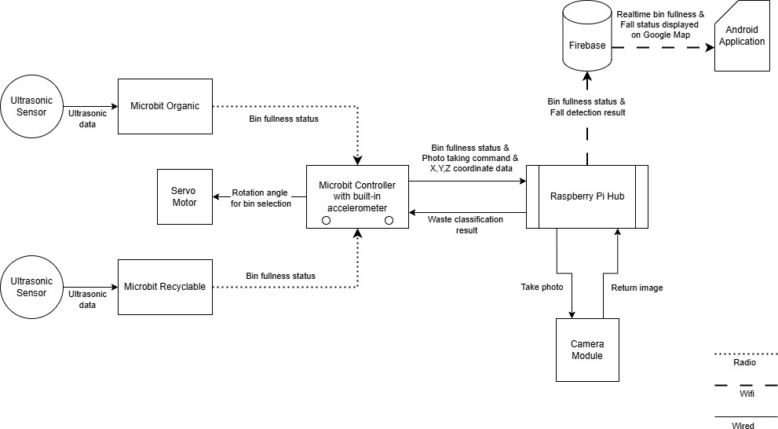

Figure 1: Basic Block Diagram

prototype uses combinations of connected devices such as mobile phones, sensors, single-board microcontrollers, and single-board computer. The development is primarily done in Python, while making use of Firebase for the database and Flutter for application development. Each module of the system is detailed in depth in the following sections.

## Bin Level Monitoring

To detect the level of waste accumulated in the bin, we use two micro:bits with each attached to two ultrasonic sensors. One ultrasonic sensor is positioned at half the height of the bin, while the second sensor is placed at the maximum allowed threshold capacity of the bin. This setup is replicated for both organic and recyclable bin as shown in the figure 3. The sensors are set diagonally to ensure maximum possible coverage.

The micro:bits are attached to their respective sides, each responsible for sending data from its sensor via radio communication to a common third micro:bit, which is designed to be the receiver. As shown in Figure 5, the sensors are connected to the micro:bit for the organic bin. When the lower sensor detects objects in its sight for 5 seconds, it will send the number 2 to the receiver. This, as per Table 1, indicates that the organic bin is partially full.

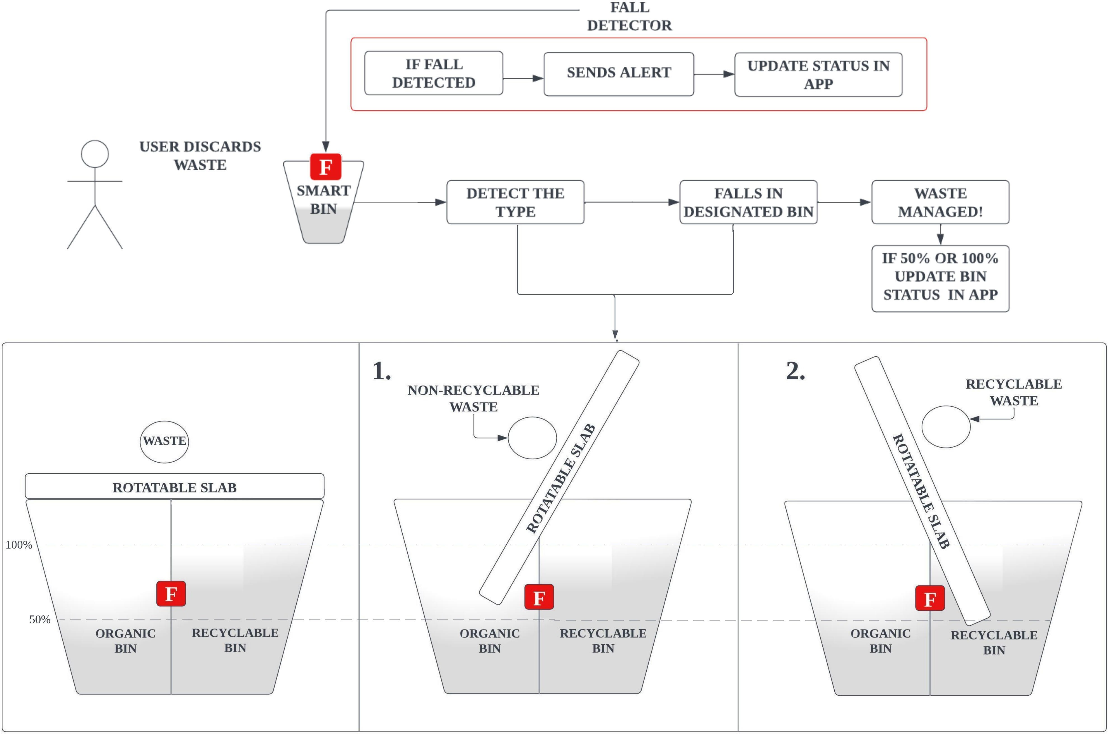

Figure 2: Prototype Overview

|  |  |  |  |
| --- | --- | --- | --- |
| Bin Type | Empty | Partially-full | Completely-full |
| Organic | 1 | 2 | 3 |
| Recyclable | 4 | 5 | 6 |

Table 1: Back-end value to process status level

Five seconds are allocated for detection to avoid accidental sensor reads, such as when an object is thrown into the bin. The sensor should only detect objects that are statically present inside the bin.

The code also carefully ensures that it doesn’t mistakenly send a partial signal when the bin is full. Therefore, when the bin is full, it only sends the signal for completely-full.

After the detection, the receiver, which receives data from both micro:bits, will send the data to the Raspberry Pi through serial communication. The data will be processed as 1, 2, or 3 for both bins to maintain uniformity and ease of understanding in the database. We are using a Firebase database to store the data. In the actual implementation, additionally, the receiver ID

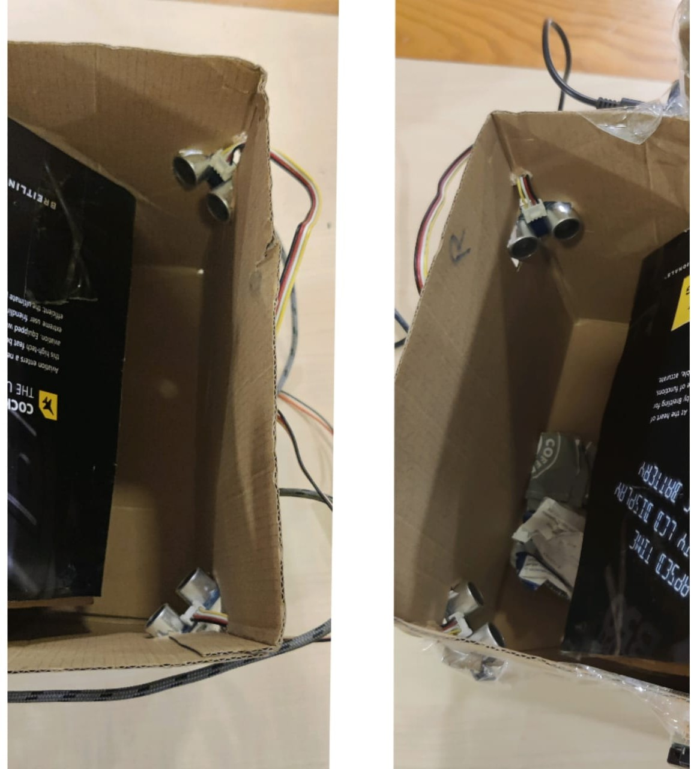

Figure 3: Installation of ultrasonic sensor in both bins

should also be sent as an identifier for the location.

Now that the real-time database has the live data of the bin readily accessible, the mobile application can fetch this information to display the necessary details.

## Android App Implementation

### User Interface (UI)

This project utilizes the Android platform to automatically display the level of garbage, which requires the user to install the application on their mobile phone. The app is developed with Flutter and is also connected with Firebase, serving as the cloud database for accessing online garbage data. Figure 6 shows that the user interface is performed conveniently by the users while accessing the garbage level. They can use many features to help them display the data, and moreover, the application is integrated with the Google Map through the Application Programming Interface (API) to track the garbage locations. Regarding the navigation menus, In the main menu, users initially access this default page when operating the app for the first time, and they enable to view the garbage level both organic and recycle bins as well as all garbage locations on the map. By clicking the search in the menu bar, users can view all the waste management systems listed. This functionality simplifies the process for users to locate

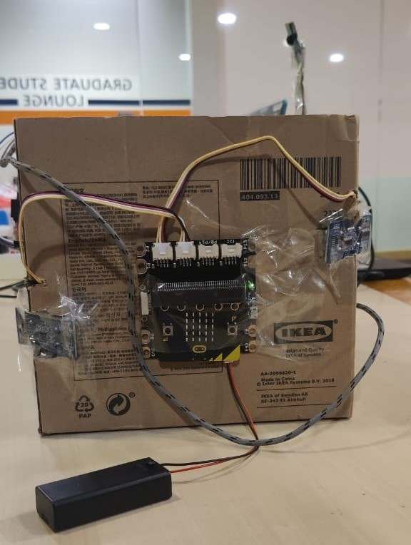

Figure 4: Micro:bit and ultrasonic setup

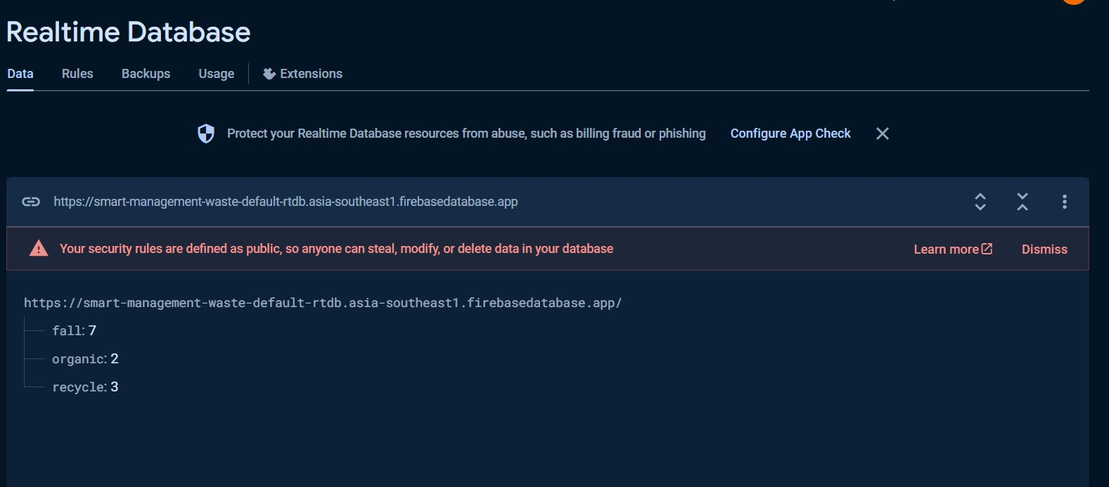

Figure 5: Sample data stored in Firebase Database

nearby available garbage, and special measures can be taken for waste that has reached full capacity, such as collection.

Finally, a map menu can be utilized to guide the user to garbage locations, with the Google Map feature providing accurate tracking. For example, Figure 7 shows that the waste manage- ment system located in COM3, School of Computing, NUS efficiently directs the user to the location using the tracking feature in the Android application.

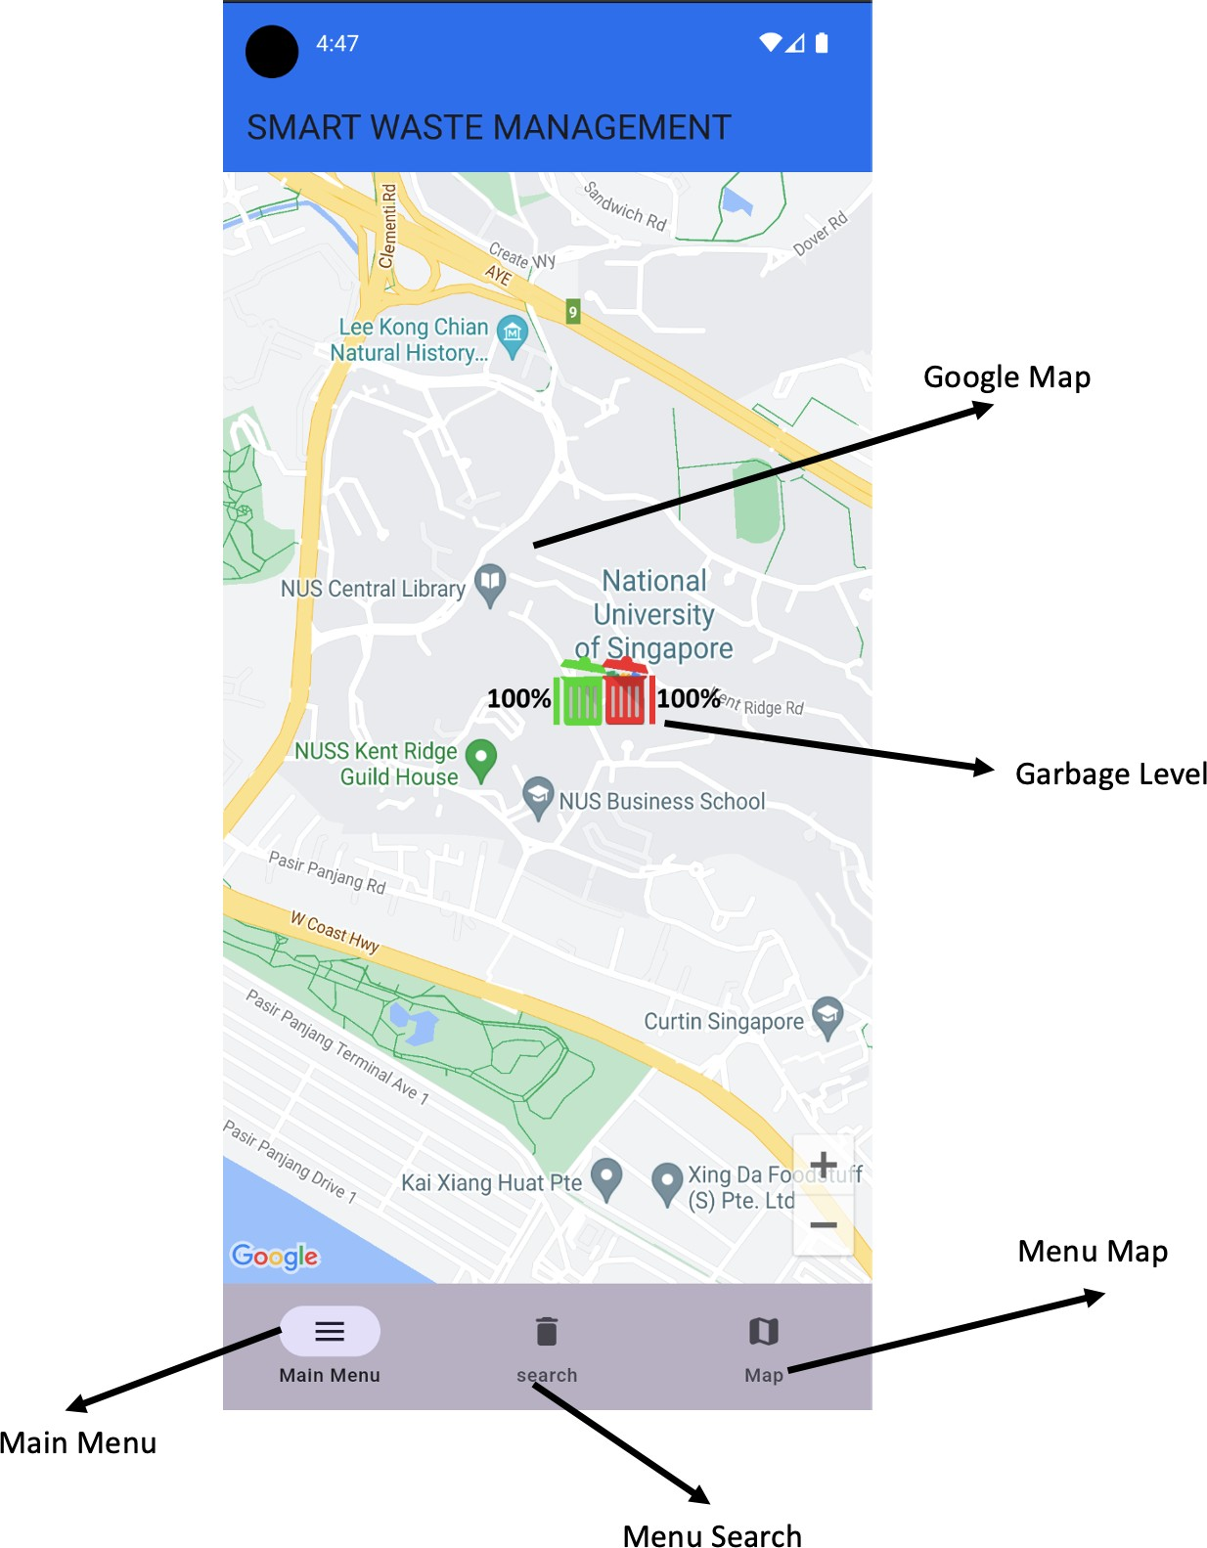

Figure 6: Android User Interface Smart Waste Management

### Displaying Information System

Our team developed a system to track the amount of waste in the organic and recycling containers, utilizing three level indicators (blank, half, and full) on the Android platform. As depicted in figure 5, the concentrations of waste are determined by dynamic data variables in the real-time database on the Firebase platform, including recycling, organic, and fall. Data values ranging from 1 to 3 for both organic and recycle signify the respective capacities of the bins.

Furthermore, the system issues alerts for fall detection, where a value of 7 signals a fall event and 8 denotes a normal state. The fall condition will be identified with how the garbage icon on the map changes automatically. Figure 8 shows the icon on the Android platform changed when the system is in fall condition. Consequently, users will fully know whether the condition of the waste bin is fall or normal just from their mobile phone.

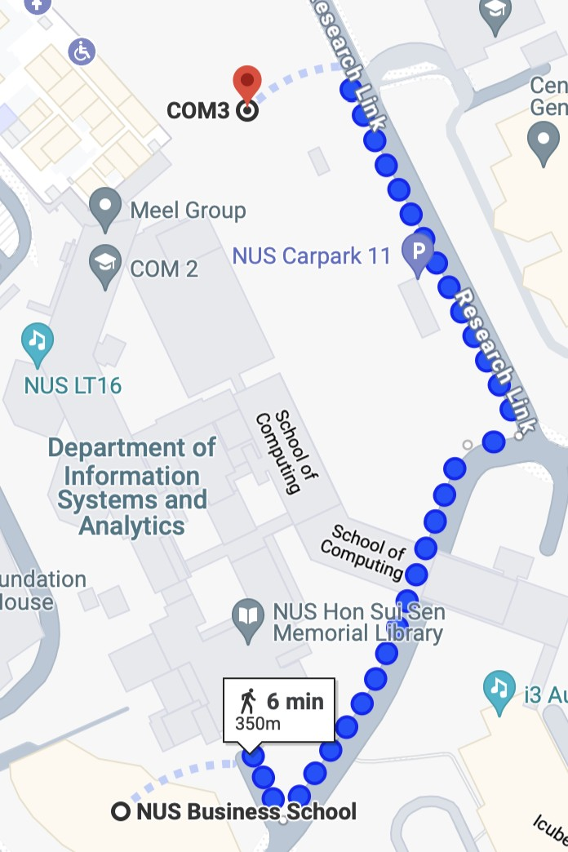

Figure 7: Garbage Location Tracking

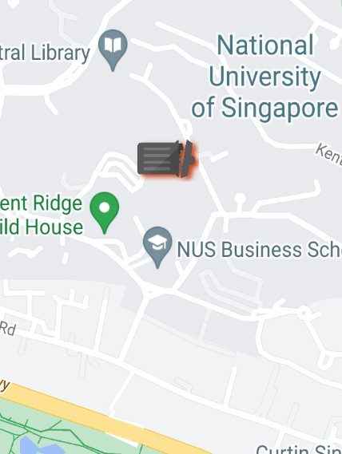

Figure 8: Fall condition

## Fall Detection System Using Micro:bit and Decision Tree Classifier

### Data Collection and Labelling

Using the micro:bit, we first captured x, y, z axis coordinates values when at rest and with slight movements. This data was sent to firebase database. The collected data was labelled by introducing a new column to it and then exported the data as JSON file. Further, we collected the values when the bin is tripped in multiple positions, taking in all possible considerations and again repeating the process by storing in database, adding new column and exporting as JSON.

Using python and pandas, all the files were merged as one table. As the result, the final table contains x, y, z coordinates with the following label.

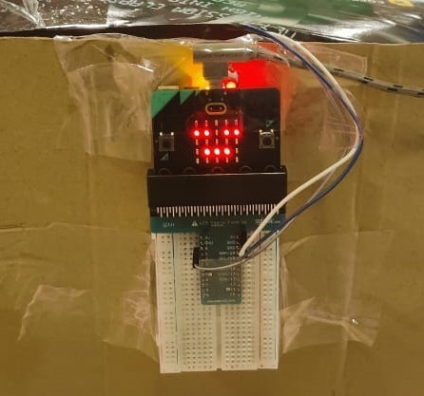

Figure 9: Fall detector

0: Indicates that the bin has not fallen. 1: Indicates the bin has fallen.

### Data Preparation

When merging, it was ensured that there was no bias and the data was collected was uniform. That is, the amount of data collected for Bin at rest was equivalent to the amount of data collected when Bin was in fall position.

The dataset was then prepared for machine learning:

The data set is divided into features (X) and target variables (Y). It is split into training and testing sets.

### Model Training

A decision tree classifier is used to train the model on the training data. Decision trees are effective for this type of binary classification task because they can easily handle binary split based on angle data.

### Model Deployment and Real-time Prediction

Once trained, the model is used to predict the fall status in real time as new data is inserted into Firebase. Predictions are made as follows:

* + - 1. Not fallen (0): Label 8 is assigned.
      2. Fallen (1): Label 7 is assigned.

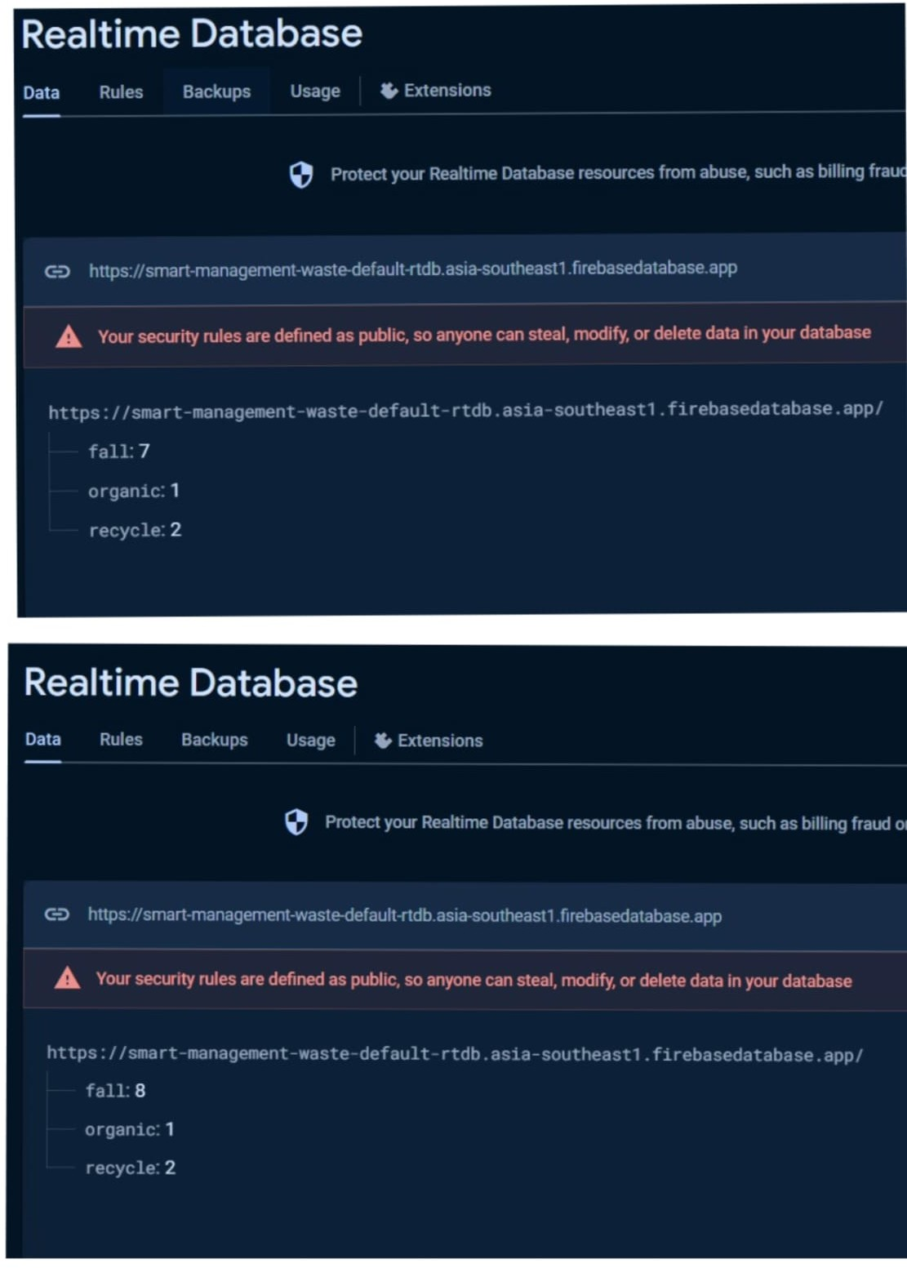

Figure 10: Real-time Database when bin has fallen and is OK state respectively

These labels are predicted using the Raspberry Pi Hub and updated in the Firebase database in real time, based on the predictions from the trained model.

### Application Integration

The updated data in Firebase, labelled with predictions. The app accesses these data to display real-time updates about the bin’s status, whether it has fallen or not. This integration enables users to monitor the bin’s condition effectively through the mobile application.

## Waste Type Classification Using CNN

### Data Used

The data used for the training came from Kaggle waste classification data. This data set contains 22,500 images of organic and recyclable objects. This is a binary classification problem to classify whether the item is organic or recyclable.

### Data Preparation

The dataset from Kaggle has already been pre-split into Train and Test Set. The images are loaded using CV2. Before training, the images are resized to 224 by 224 and the color mode is rgb.

### Model Training

A simple CNN is used to train the model on the training data. The model is trained with 10 epochs with a batch size of 128. After training, we are able to achieve the following accuracy and loss:

Figure 11: Model Loss and Accuracy

Using predict_func() we are able to test the inference using our own images as shown below:

### Model Deployment and Real-time Prediction

Once trained, the model is converted to a TFLite model. TensorFlow Lite is optimized for low power devices which suits mobile and edge devices such as the Raspberry Pi, on which we will deploy our model. It is also highly efficient in inference, which is important in providing fast local prediction for users of our Smart Waste Bins so users will be able to make predictions even when the network is down and the whole experience will be seamless enough to not hinder the waste disposal experience.

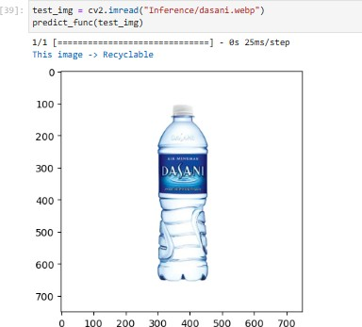

Figure 12: Inference on Dasani Water Bottle

### System Integration

Users have the option to access organic or recyclable materials manually or automatically through the Microbit Controller. To access them manually, users can press the A or B button to access recyclable and organic, respectively. If the user is unsure whether the waste is recyclable or not, they can press the A and B buttons together.

Pressing the A and B buttons together will send "takephoto" to the Raspberry Pi Hub via serial USB. The Raspberry Pi Hub will read the serial data and check if the string is equal to "takephoto". If that is the case, the Raspberry Pi Hub will start by taking a photo of the waste. This photo will then be loaded using CV2 with the data preparation steps stated earlier. The precessed photo will then be used to make the prediction with the Tensorflow Lite model. The result will then be sent back to the Microbit Controller using serial USB. Depending on whether the result is organic or recyclable, the Microbit Controller will turn the servo motor left or right, disposing the waste in the respective bins.

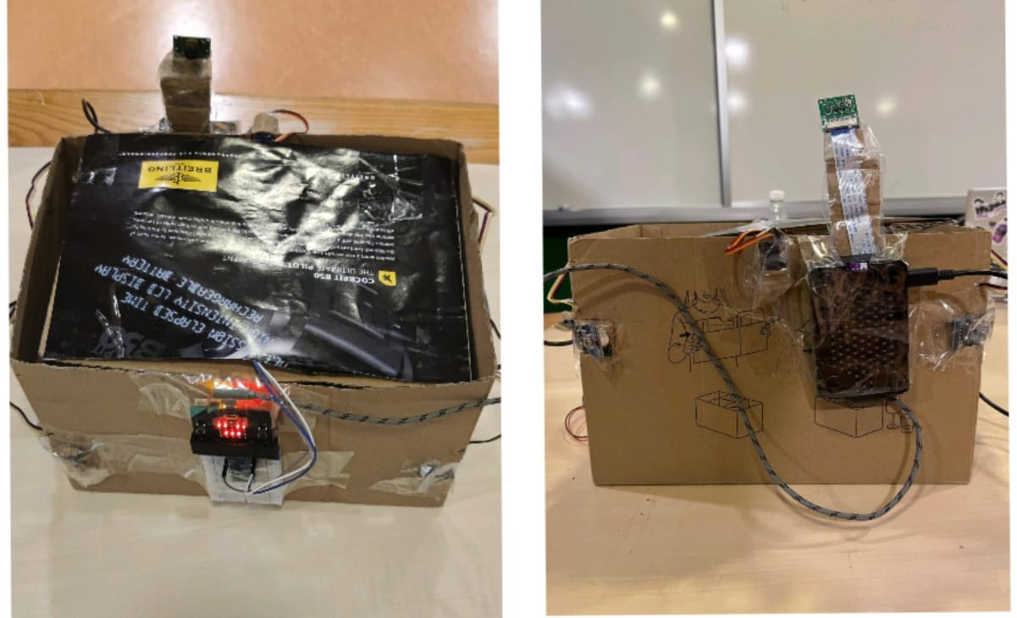

Figure 13: Placement of Raspberry Pi on the prototype

# References

* “Google Api Service.,” (n.d.). Google cloud apis, Google

(available at https://cloud.google.com/apis/docs/o ;;retrieved April 28, 2024).

* “Flutterfire overview: Flutterfire.,” (n.d.). FlutterFire Blog RSS (available at https://firebase. flutter.dev/docs/overview;retrieved April 28, 2024).
* “Google-maps-flutter: Flutter Package.,” 2024. Dart packages, April 17 (available at https://pub.dev/packages/google-maps-flutter; retrieved April 28, 2024).
* “Build apps for any screen.,” (n.d.). Flutter (available at https://flutter.dev/?gad-source=1gclid

=CjwKCAjw57exBhAsEiwAaIxaZoezmgVnixIvCqvjFdWpeG5dzvFiMEGLCl7W-tjZZdiR7 HYevcD0-hoC9msQAvD-BwEgclsrc=aw.ds; retrieved April 28, 2024).

* Sekar, S. 2019a. “Waste classification data,” Kaggle, June 16

(available at [https://www.kaggle.com/dataset](http://www.kaggle.com/dataset) classification-data; retrieved April 28, 2024

* Singapore’s Waste Management System (2024) Expatica Singapore (available at:

[https://www](http://www.expatica.co/).e[xpatica.co](http://www.expatica.co/) waste-management-2172780/; retrieved: April 28, 2024)