STUDENT PERFORMANCE MANAGER
ASSIGNMENT 3 - CODING DOCUMENTATION

Name: Gopikaa T
Register No.: 242BCA05
Subject: Software Engineering Concepts
Submitted to: Mr. Selwyn Paul J
Semester: 4
Date: 08-03-2026
GitHub Link:
Website Link:

Overview:
The Student Performance Manager is a web-based system developed using HTML, CSS, JavaScript, and Firebase. The application allows teachers to manage student records, mark attendance, and enter internal assessment marks. Students can log in to view their attendance and academic performance. Firebase Authentication is used for secure login, and Firestore is used for storing academic data.

System:

User (Teacher / Student)
↓
Frontend (HTML, CSS, JS)
↓
Firebase Authentication
↓
Firestore Database
↓
Student / Attendance / Results Data

The system follows a client–server architecture where the frontend interacts with Firebase services for authentication and data storage.

Login Page
The login page allows teachers and students to access the system using their registered email and password. Firebase Authentication verifies the user credentials and redirects them to the appropriate dashboard.

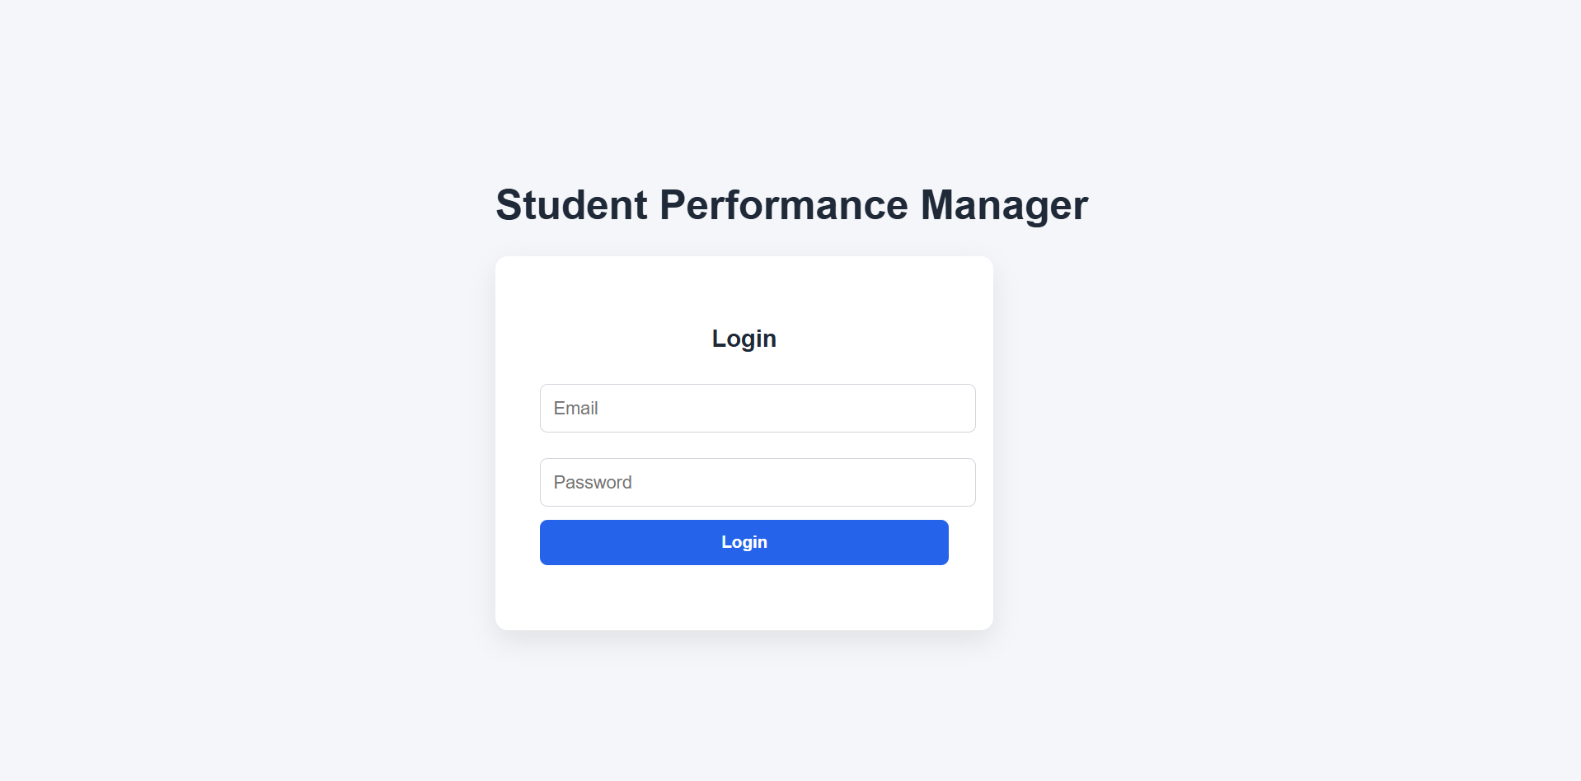
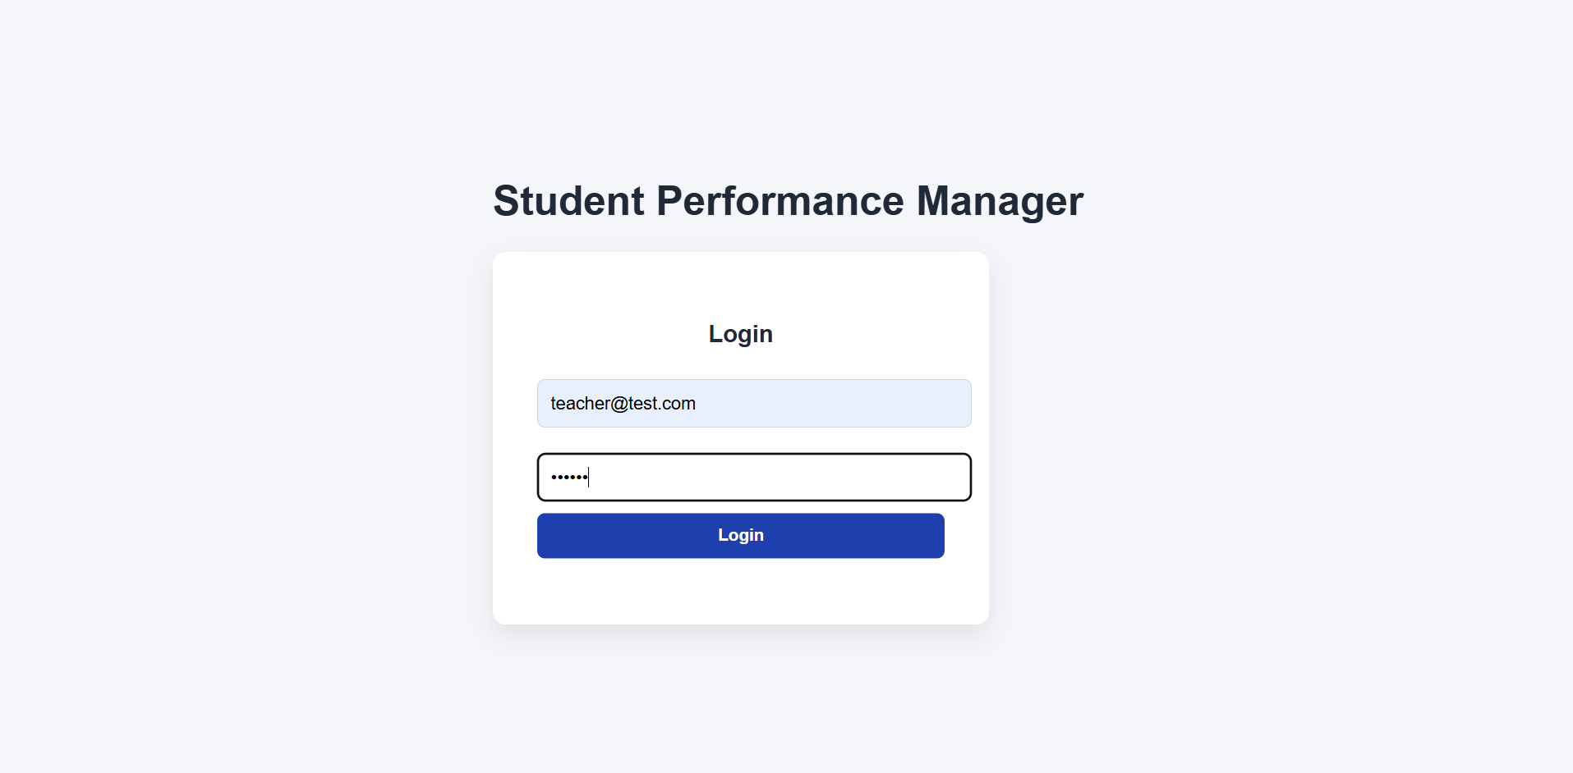
Teacher Dashboard
The teacher dashboard displays an overview of the academic data, including total students, class average, low attendance alerts, and low performance alerts.
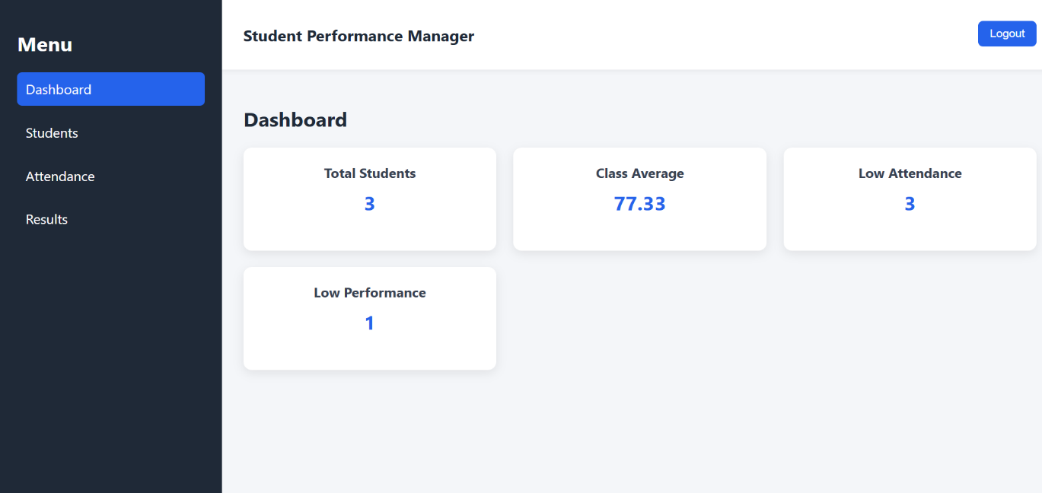

Student Management Page
The student management module allows teachers to add, update, and delete student records. These records are stored in the Firestore database.

Adding a new student test 3 to the student list
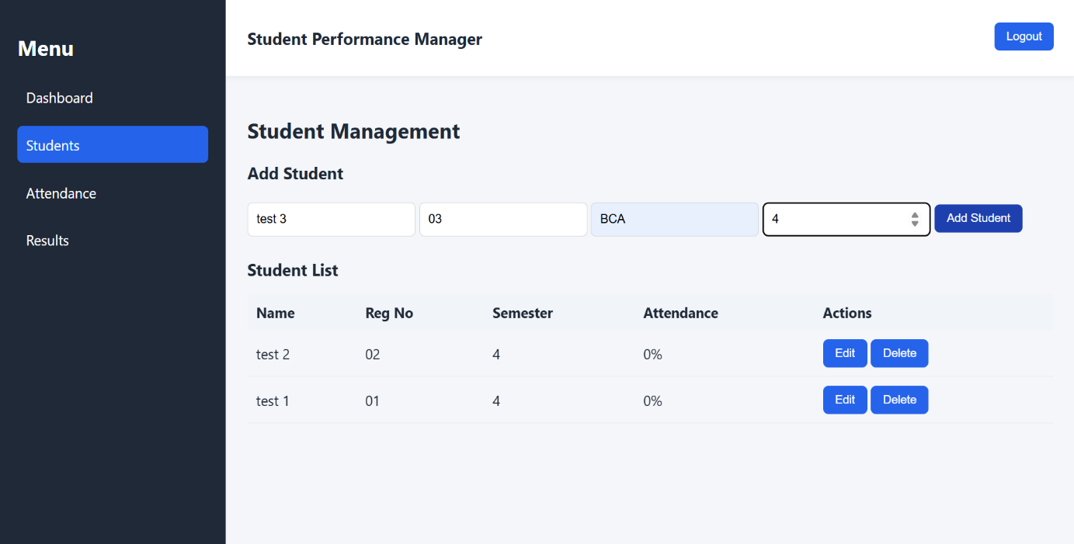
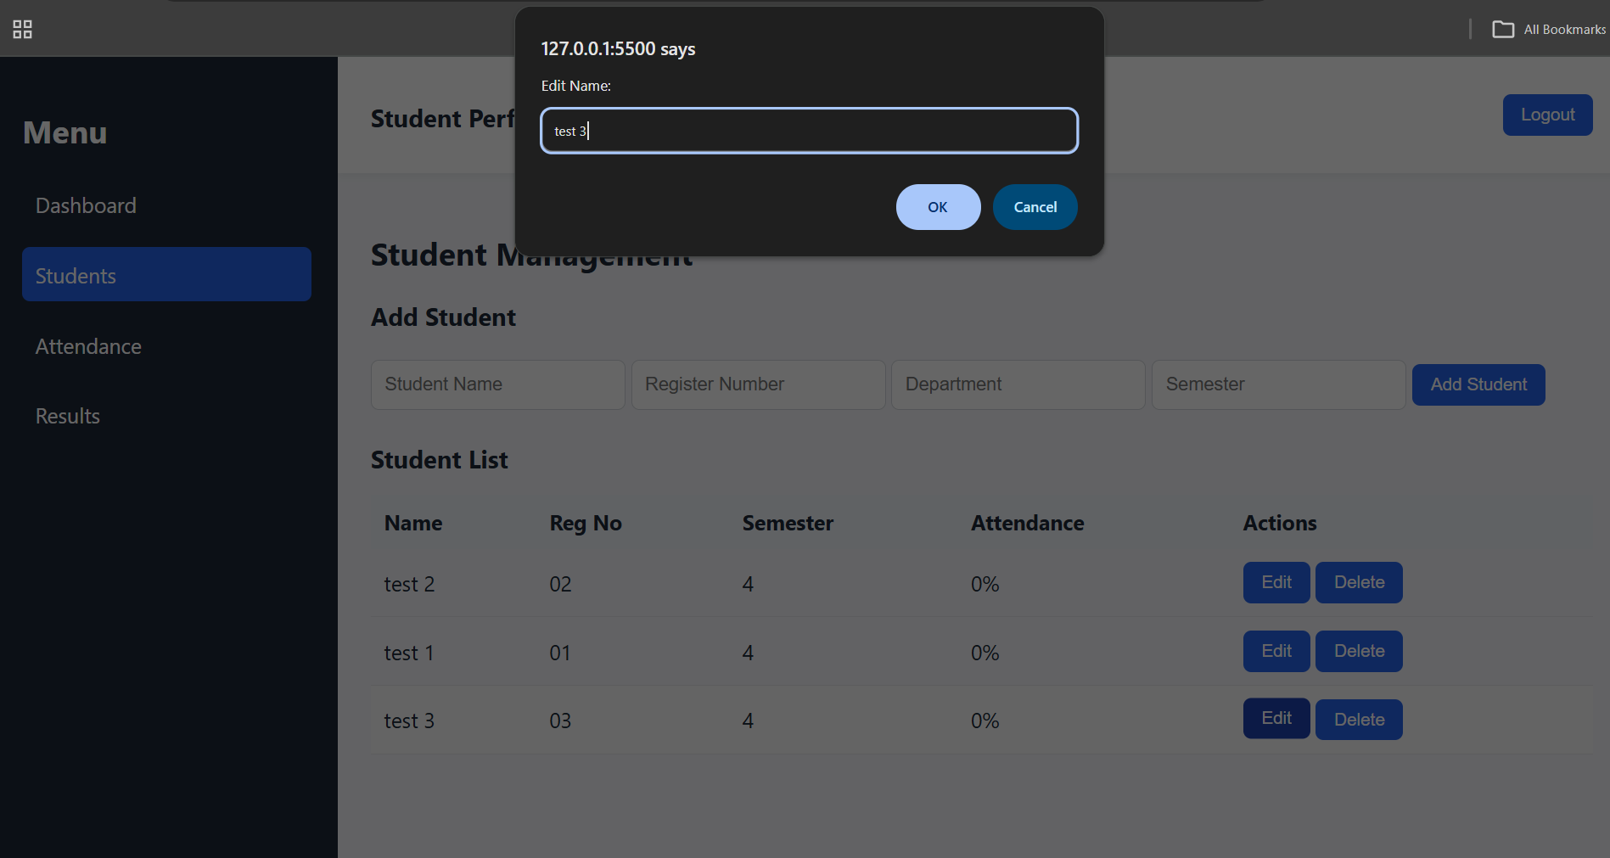
Editing the newly added student test 3

Deleting newly added student test 3
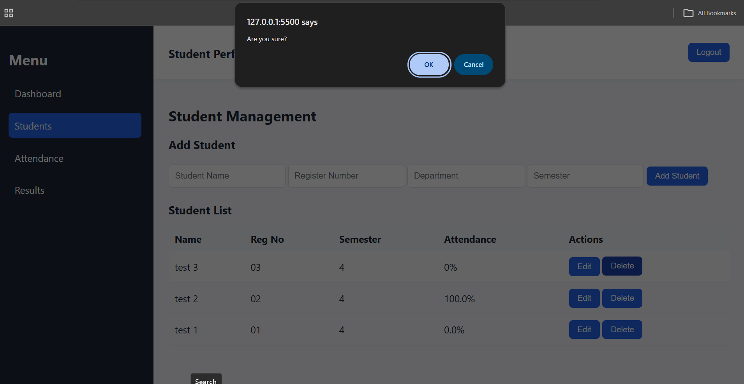
Student list after the CRUD operations
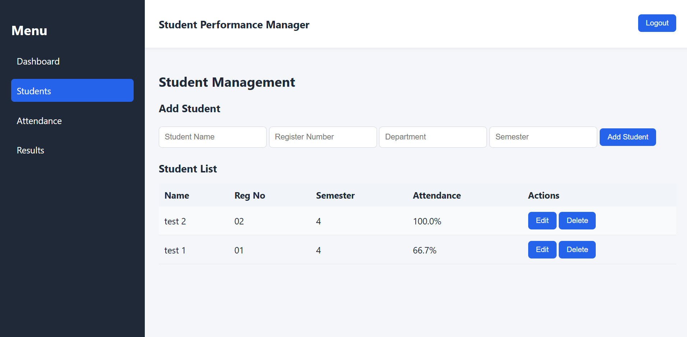

Attendance Page
The attendance module allows teachers to mark student attendance using checkboxes. Each attendance record is stored with the student ID and date.
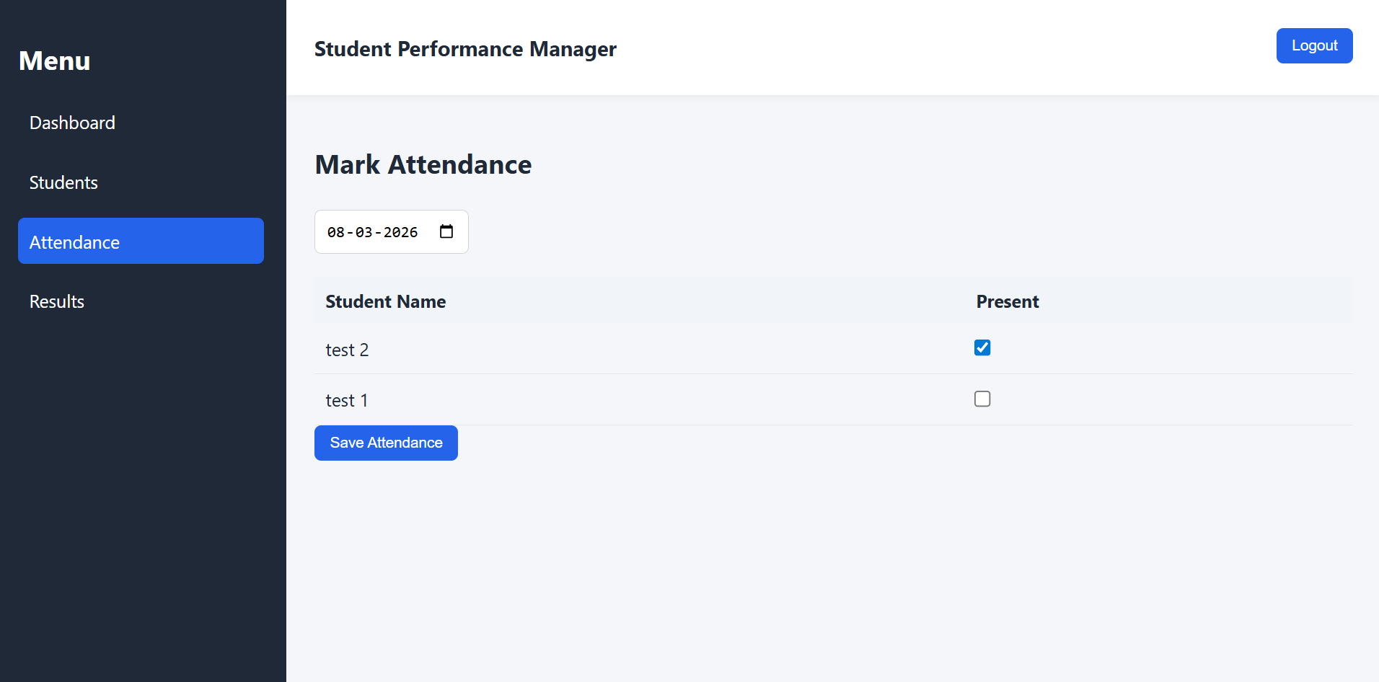
Attendance saved to database
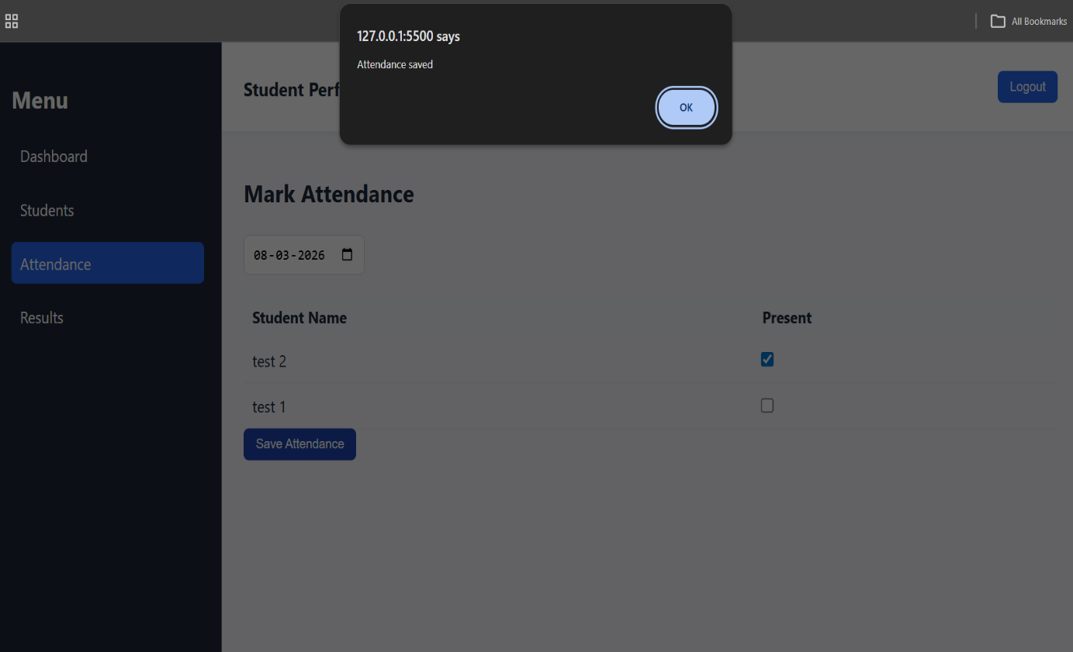

Results Page
The results module allows teachers to enter internal assessment marks and exam marks. The system automatically calculates the final score.
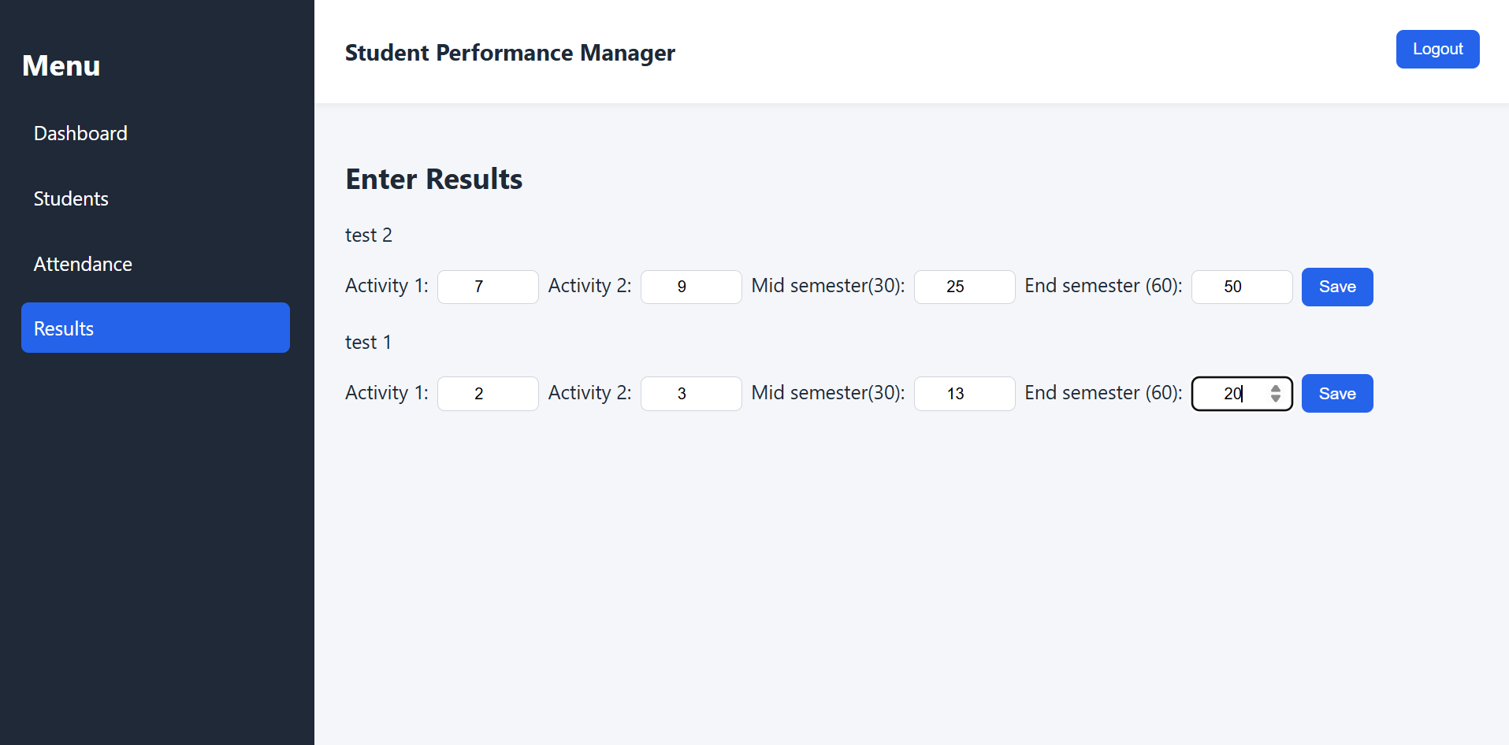
Results saved to database
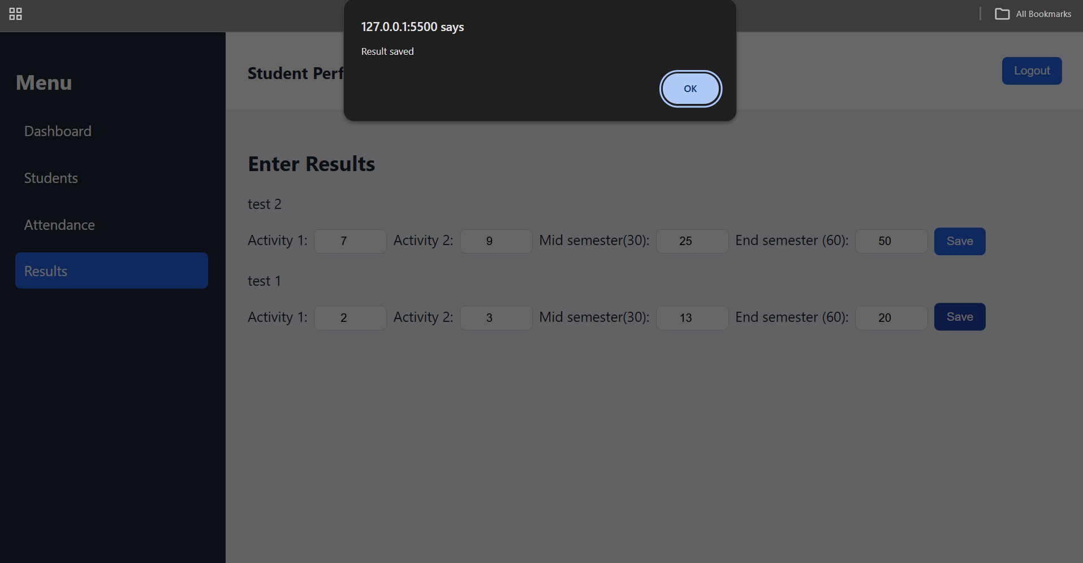

Final teacher dashboard after the above operation. Logout button will lead back to login page
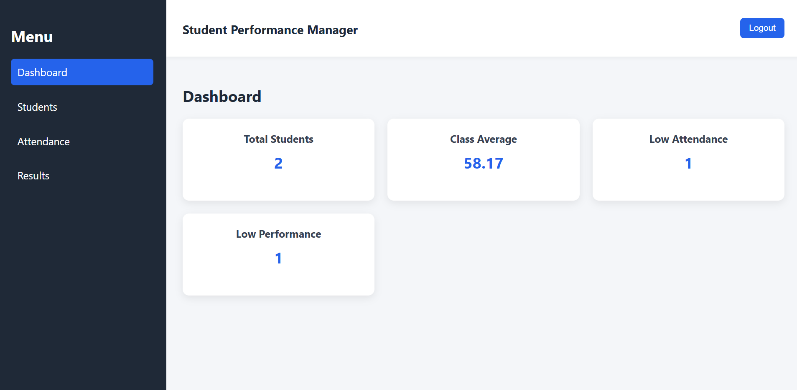

Student-side View:
- Student 1 with attendance lower than 75% and results below 40 will get a warning message.
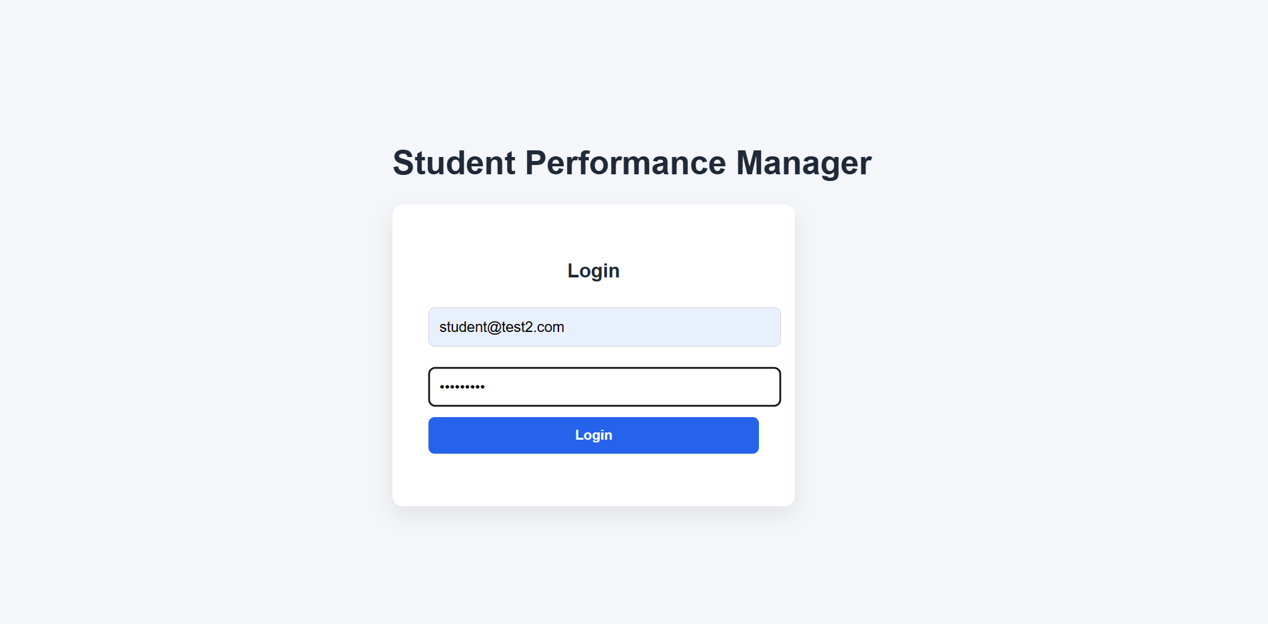

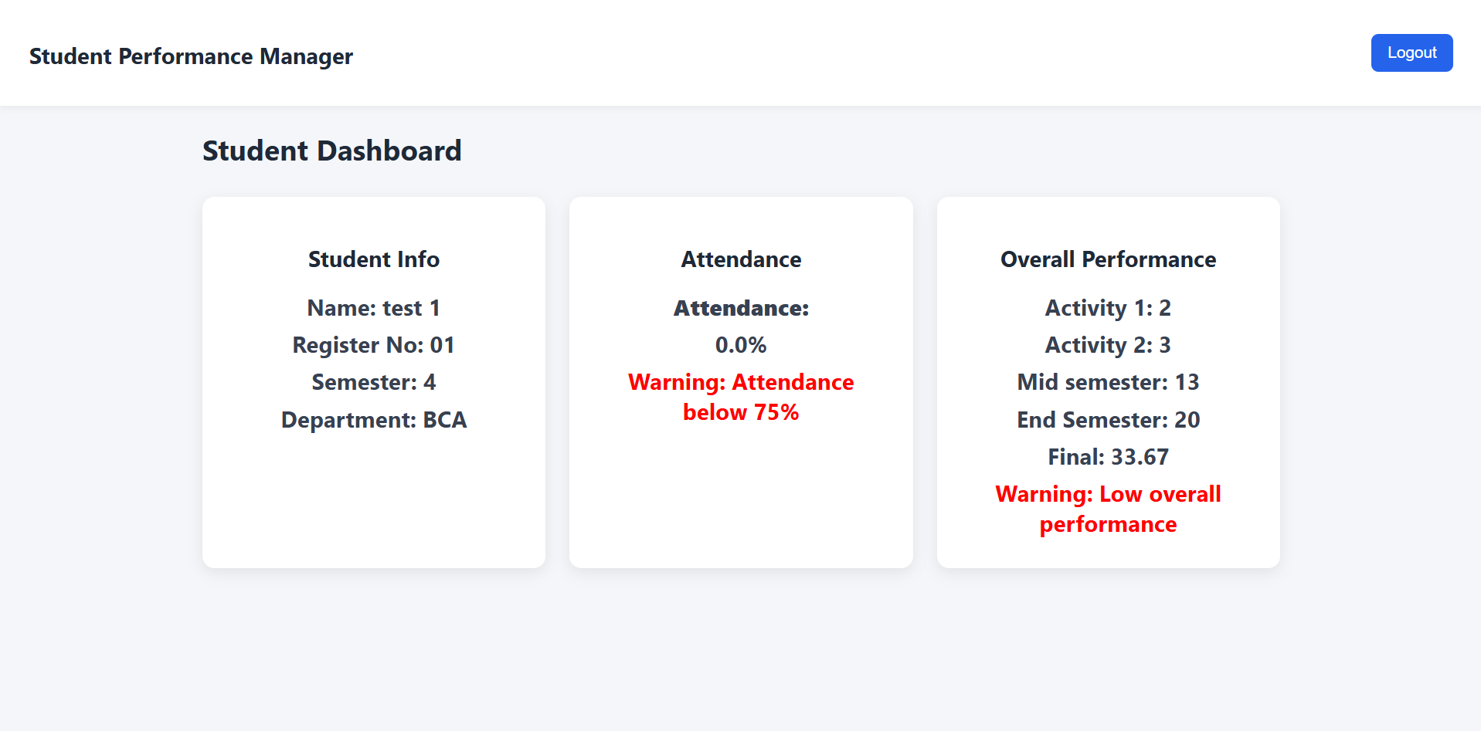
- Student 2 dashboard with no warnings
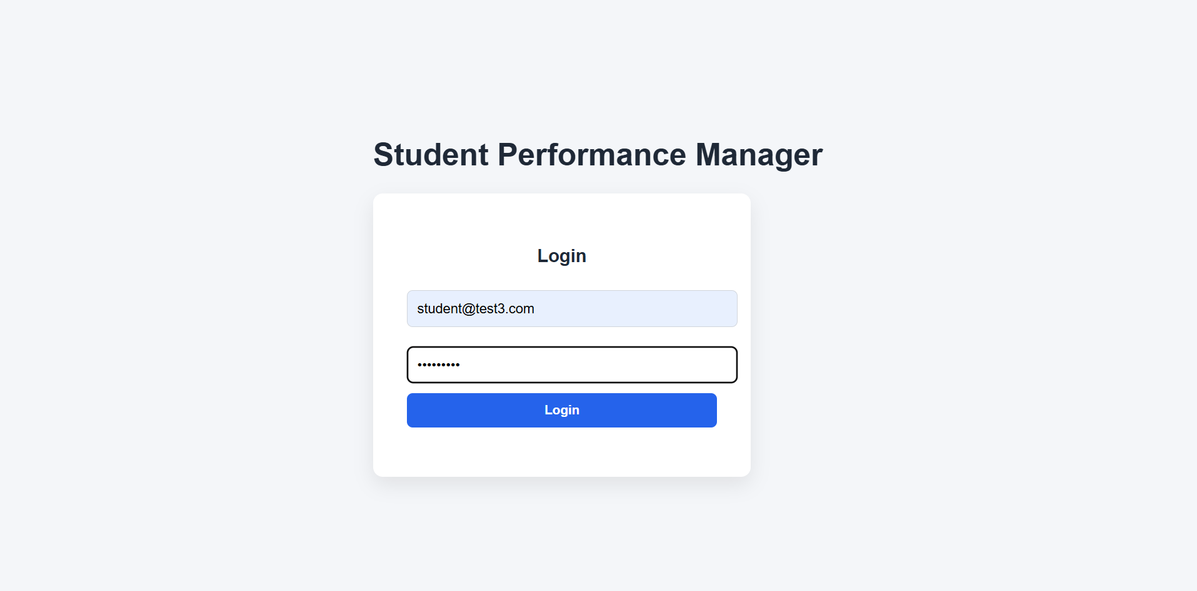

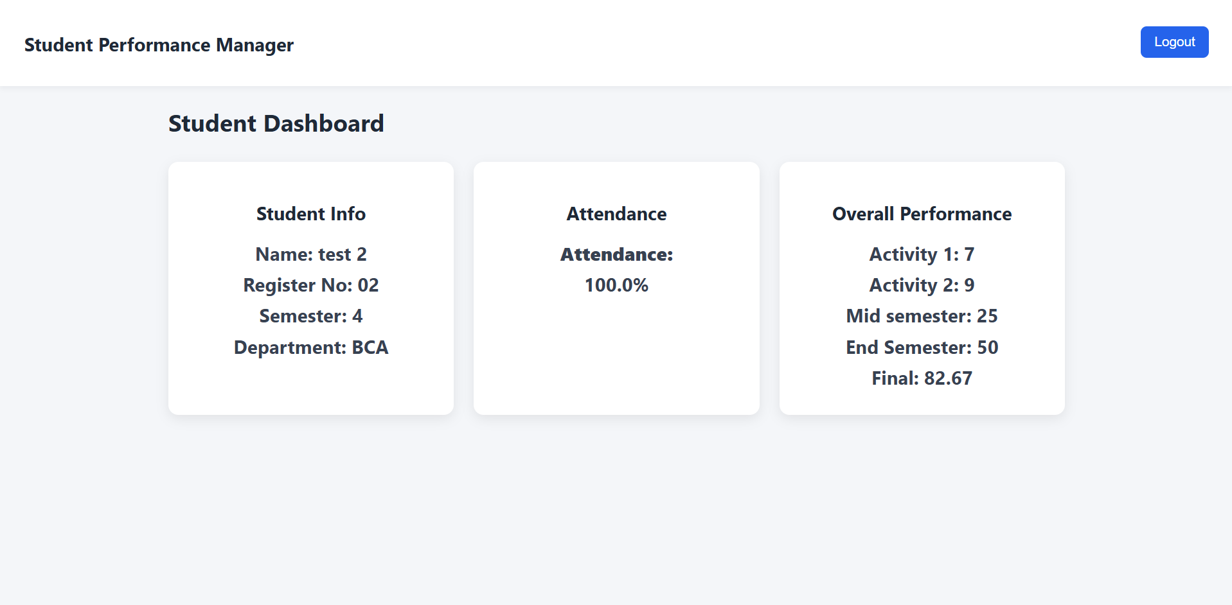


Logout button leading back to login page

Firebase Database:
Users like teachers and Students created in the firebase database with email.id and password for login
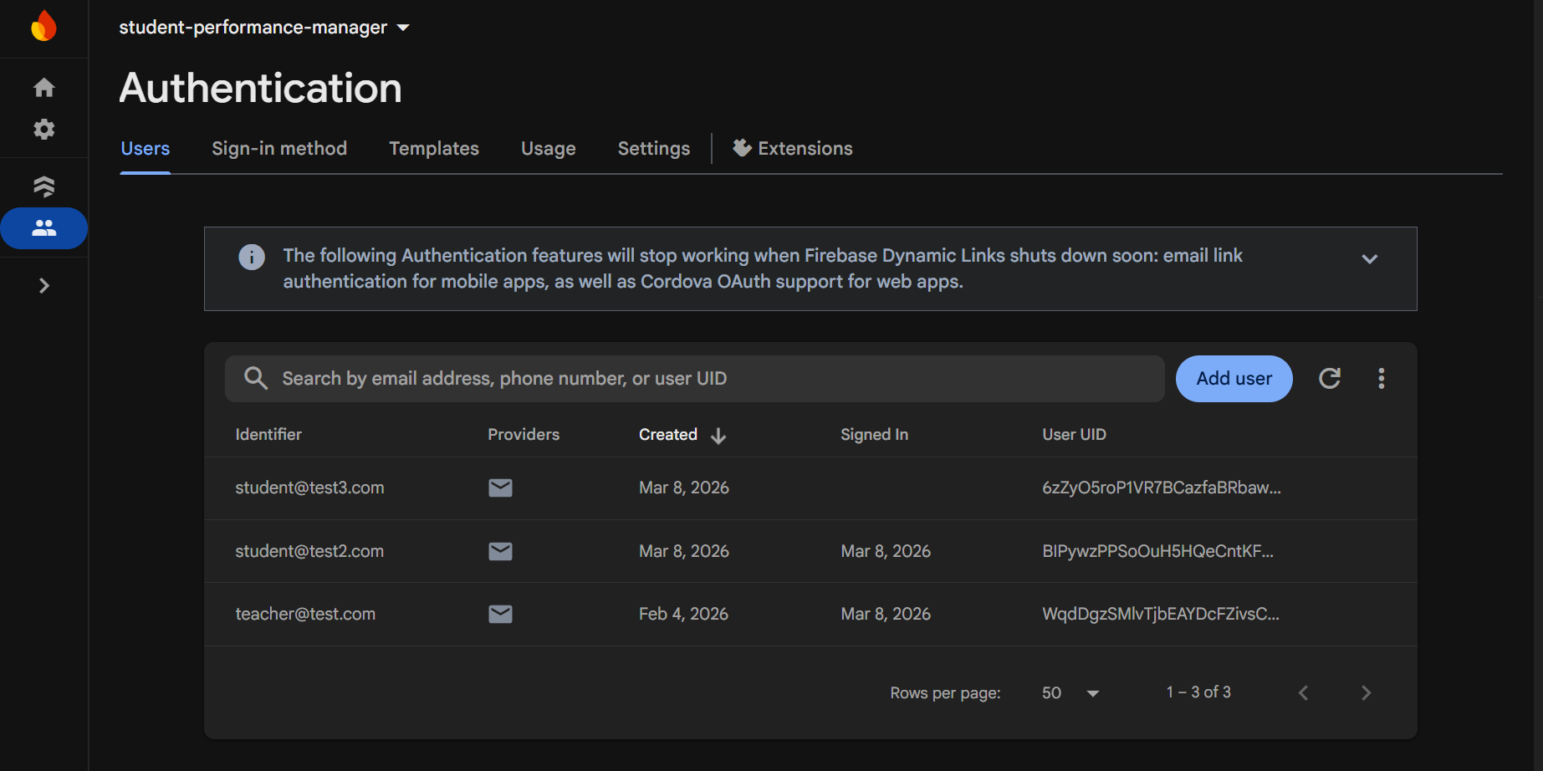

Firebase collections:
- students collection for students page and CRUD operations.
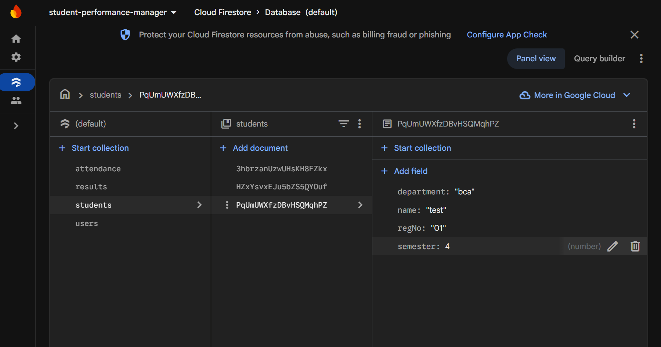
Any student added in the website will be simultaneously saved in the database in students collections with unique IDs.

- Results collections
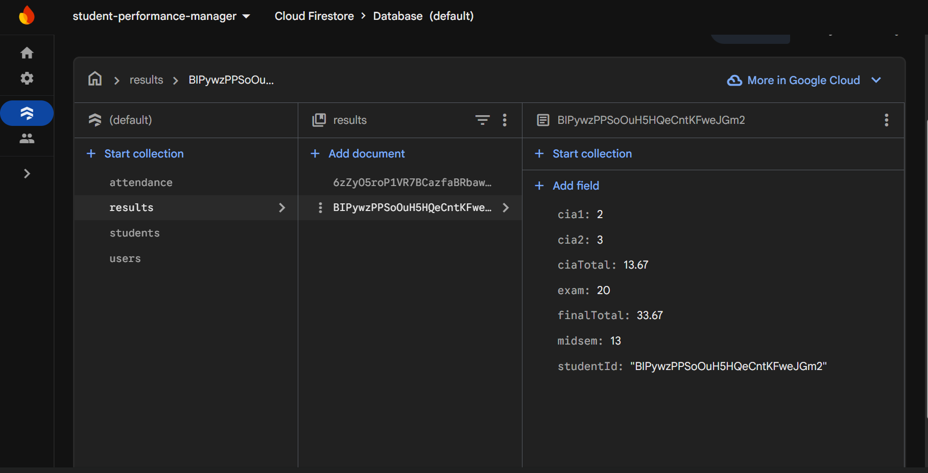
The activity and exam marks entered for each student in the website will be saved here in the Firestore.
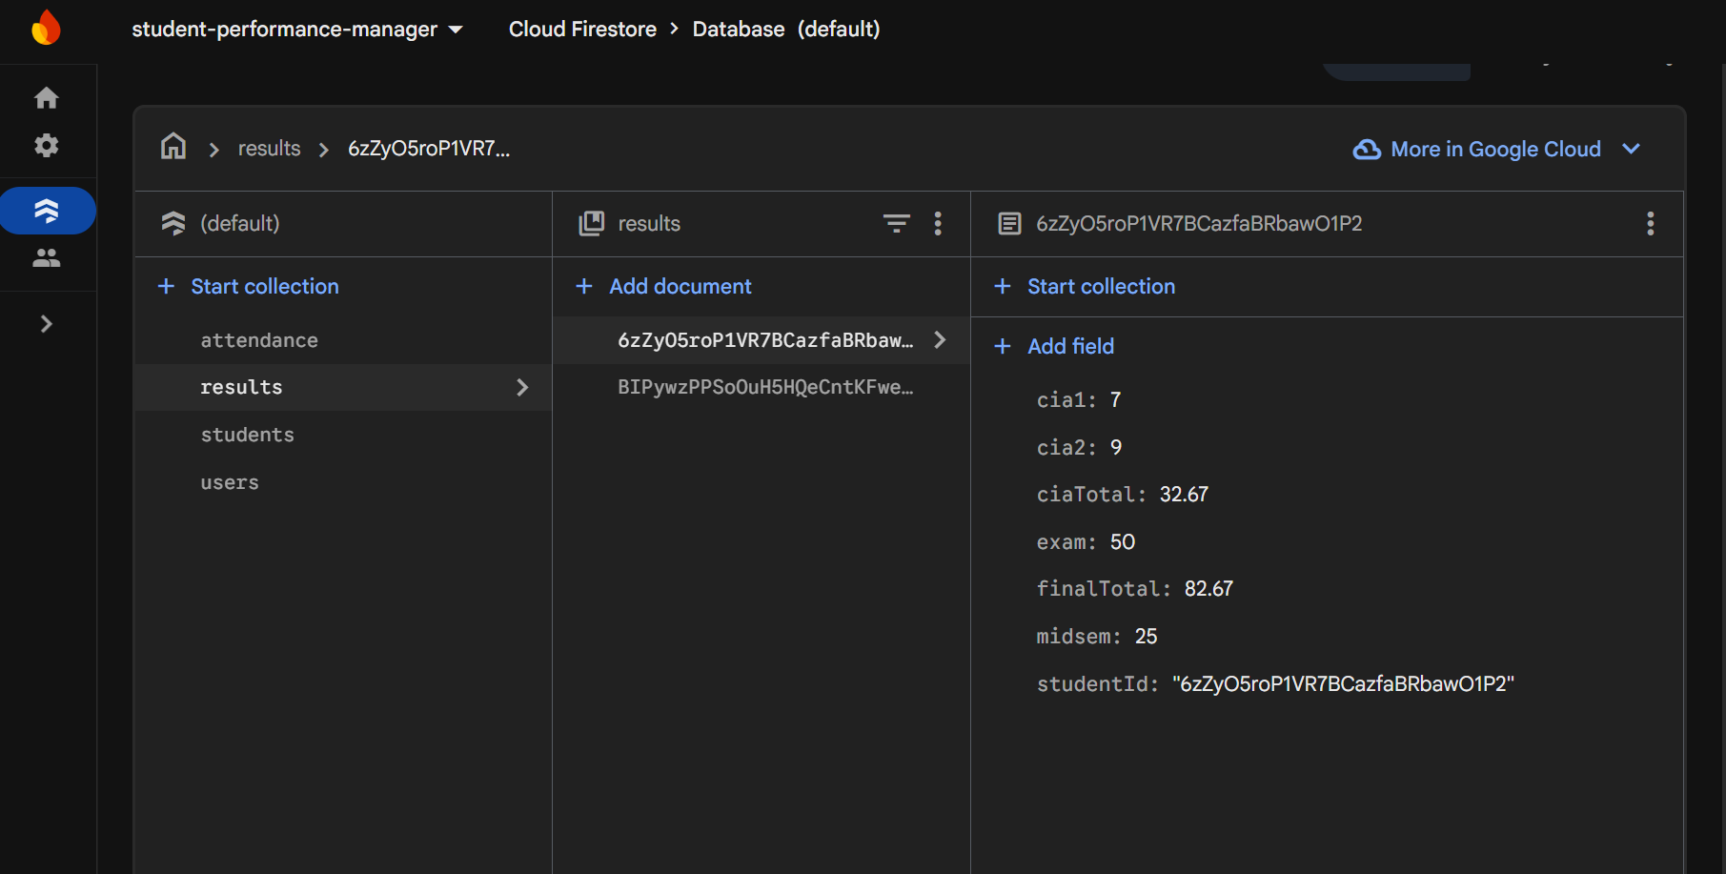

- Attendance collections:
The database will automatically update the students’ attendance in the database after each entry and save in the website. Each document in the database has an auto ID to save per day attendance for per student.

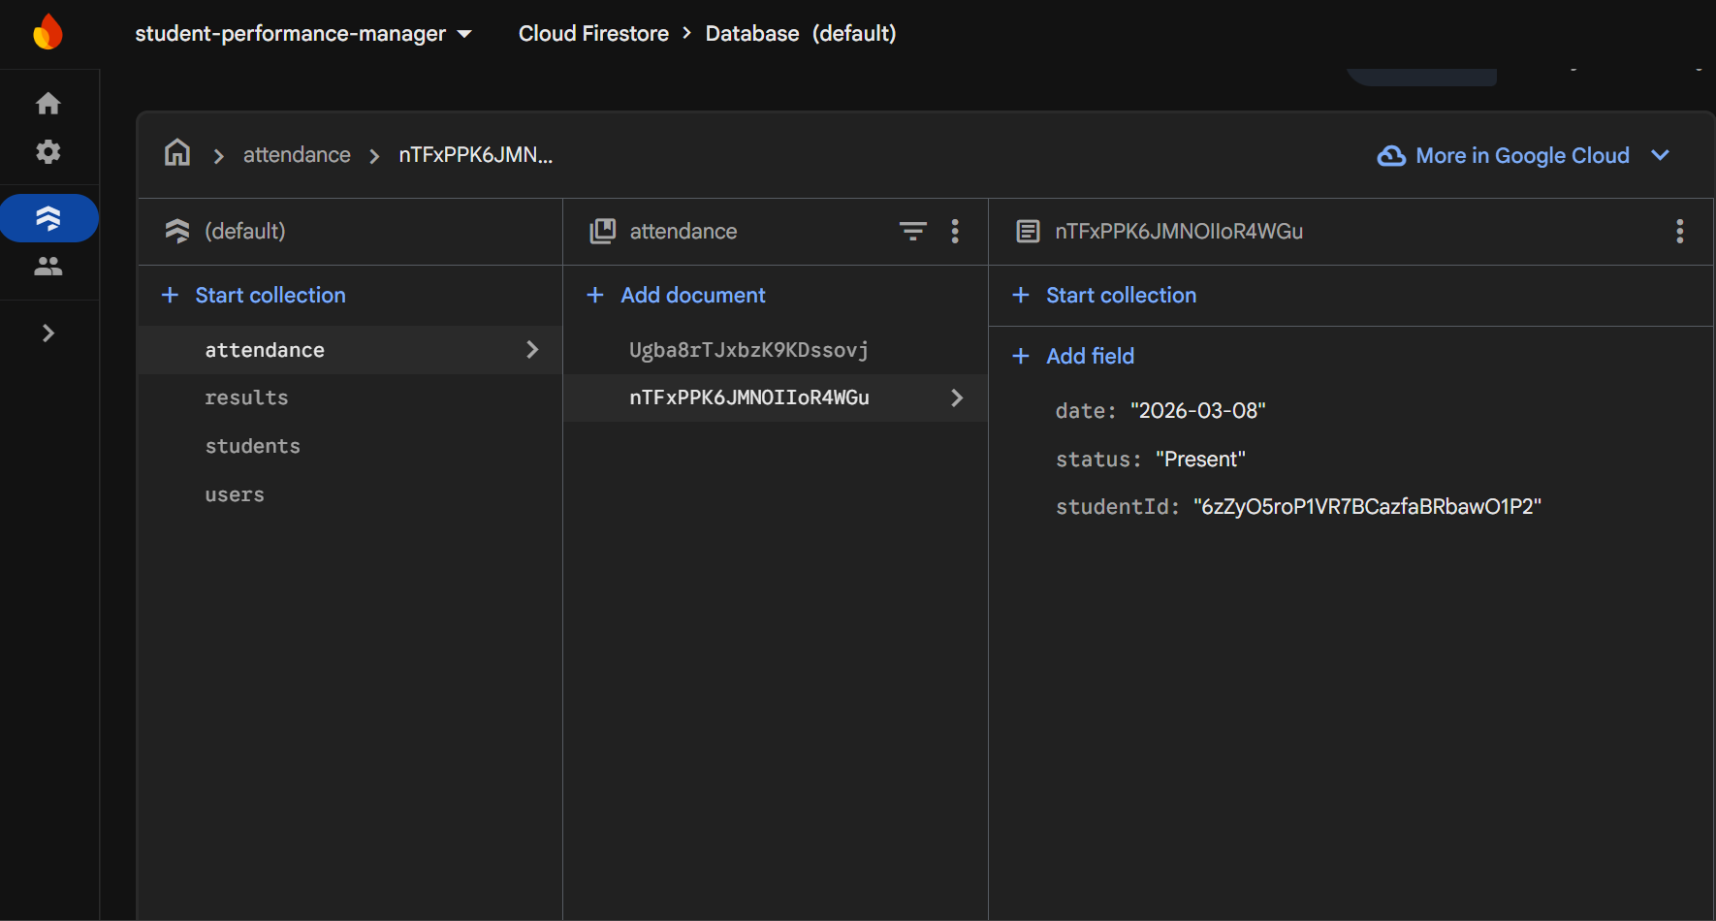
Test 2 student marked present saved in the database

Test 1 student marked absent saved in the databse
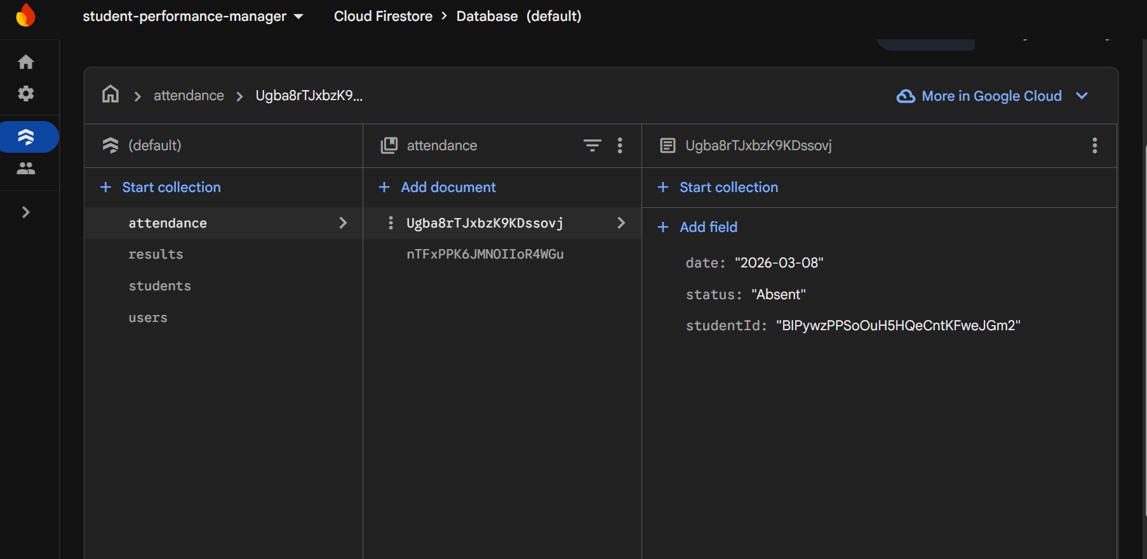

- Users Collection:
Each user created is added to users collection with their unique ID to help login with authorized access.
