Smart public restroom

Ganesh College of Engineering , Salem 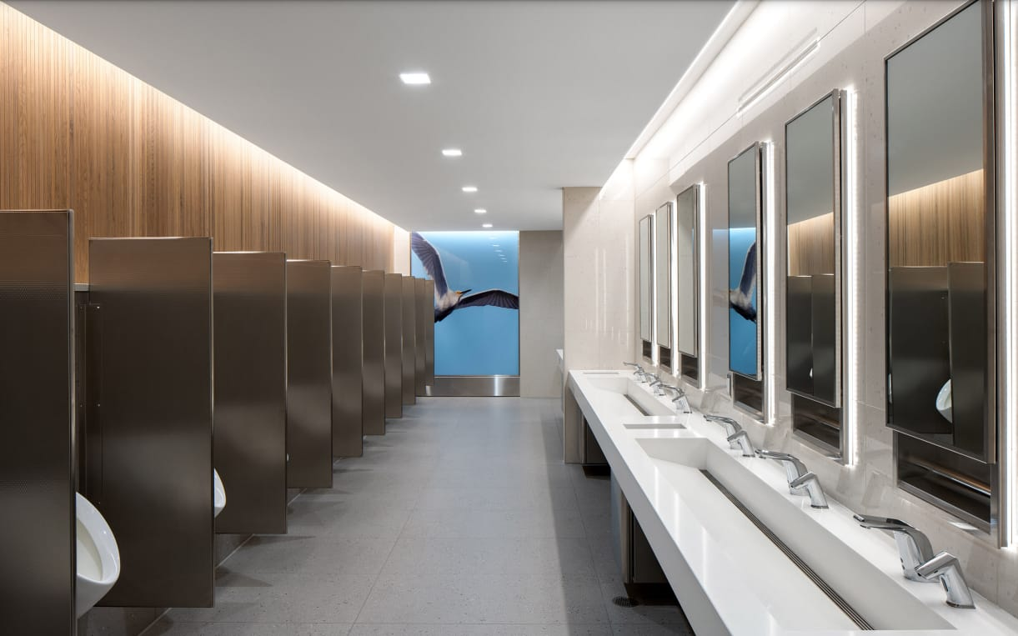

Submitted by,

Y.Esther

K.Anusha

T.Gopika

G.Subasri

ABRACTS

Smart washrooms are among recent IOT solutions that are very soon to be implemented her and there.Such new generation restrooms expect to siginificantly improve customer experience and employee well-being while also lower costs allocated to maintain equipment . we provide you a range of electronic urinal flushes that are suitable for hotels ,hospitals ,airport and public toilets .Quick view of DSGW-210 multi-protocol smart IOT hub gateway. The goal of the system is to monitor and evaluates toilet condition in real-time to improve the toilet .

URINAL SENSOR

* Keep your bathroom &restrooms hygienic & safe ,you need to use a good automatic urinal sensor and sensor flusher.
* They also tend to save water and uses the water only when required . also, you can purchase automatic urinals pot sensor at a very cost effective price .

**Advantages of getting automatic urinal sensor installed.**

* Proper cleanliness: If a person forgets to flush the urinal manually, then auto flush sensor feature very well helps to take care of it .

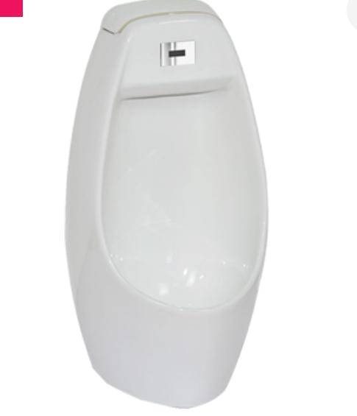

* Reduction in wastage of water: One of the major advantage of urinal sensor flusher is that they reduce the wastage of water as compared to manual urinals .also ,there would be delay between one automatic flush to another which ensures not flushing not again and again.
* Easy to use : Easy to use and thus is perfect for elders and youngs .

**GOAL**

To Achieve this goal , we have to monitor

1. Number of Male \female using toilets
2. Water usage and level monitoring
3. The smell in the toilet
4. Light \darkness in the toilets
5. User feedback from the toilet

**USER COUNTER**

* When a person passes beneath the PIR sensors which will be mounted on the head of the Toilet, it detects the motion of the persons . this gives a high pulse at the outputs.
* It can detect motion within 18 feet.
* We can use a single triggering mode with some timing hacks.

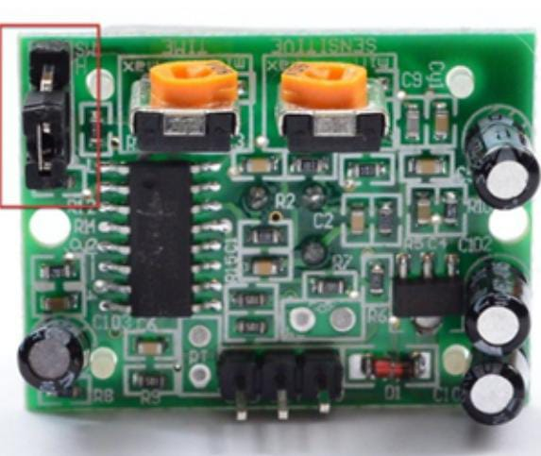

There are two ‘timeout’ associated with the PIR sensor.

One is the “Tx” timeout: how long the LED is after it detects movement –this is easy to adjust because there’s potentiometer.

Tx= 24576.R10.C6

The second is the “Ti timeout :how long the output line is guaranteed to be LOW when there is NO movement .

Ti =24 . R9 .C7

**SMELL SENSOR**

A smell sensor node is a Wi-Fi-based sensor that will detect the level of gases that causes the bad smell in the toilets .

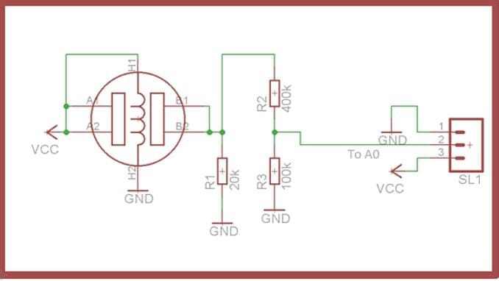

We found two sensors are TGS2602 and MQ135

**WATER LEVEL SENSOR**

The water level sensor node is a Wi-Fi-based device that is used to detect four levels i.e 25%,50%,75% and 100% in the tank. There are many water level sensors .But we need to use cost effective water levels sensors ,so we have selected conductivity based water level sensor ....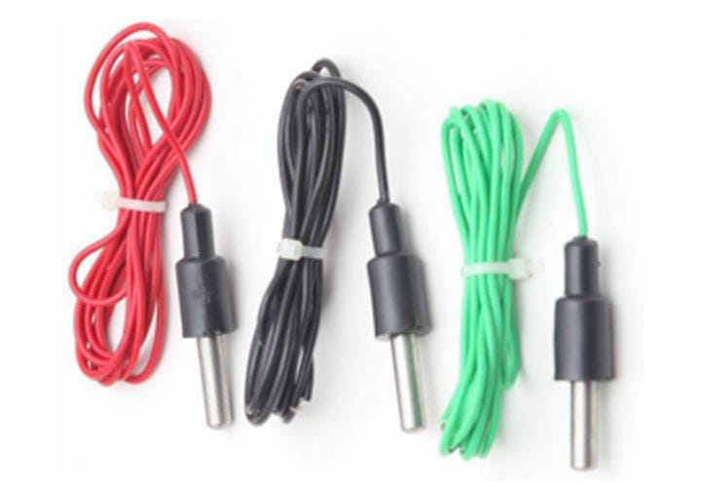

Normal conduct

**DUSUN SMART IoT GATEWAY**

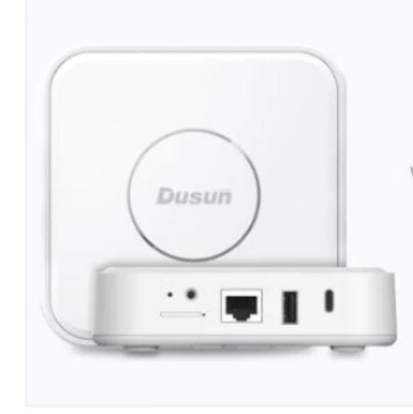

Smart sensors: Install smart sensors in public toilets ,such as temperature sensors, humidity sensors , gas sensors.

**AI – powered Systems** :



Artifical intelligence (AI) is expected to play a significant role in the revolution of smart restrooms .AI algorithms can analyze complex data patterns ,predict usage trends and optimize resource allocation .

AI-powered systems can also enhance user experience by personalizing settings based on individual preferences .

**JAVA SCRIPT for smart public restroom**\\simulating a motion sensor's inputs

let motion detected = false ;

\\function to turn on the restroom light

function turn On light() {

console.log("Restroom light is turned on");

\\Add code to control the actual light her

}

\\Function to turn off the restroom light

function check Motion (){

    if (motion Detected){

        turn On Light();

    } else {

        Turn Off Light();

    }

}

\\Simulating motion detection every seconds

Set Interval(()=>{

    Motion Detected = !motion Detected;

    Check Motion();

},5000);

* We have a variable “motion Detected” to simulate the status of a motion sensor.
* Two function, “turn on light” and “ turnoff light” are used to control the restroom light .
* The “check motion” function checks the “motion detected” variable and turns the light on or off accordingly.

We simulate motion detection every five seconds using “set interval” for demonstration purposes. [Running] node "c:\Users\home\Documents\tempCodeRunnerFile.js"

'node' is not recognized as an internal or external command,

operable program or batch file.

[Done] exited with code=1 in 0.272 seconds

[Running] node "c:\Users\home\Documents\tempCodeRunnerFile.js"

'node' is not recognized as an internal or external command,

operable program or batch file.

[Done] exited with code=1 in 0.228 seconds

[Running] node "c:\Users\home\Documents\tempCodeRunnerFile.js"

'node' is not recognized as an internal or external command,

operable program or batch file.

[Done] exited with code=1 in 0.262 seconds

[Running] node "c:\Users\home\Documents\tempCodeRunnerFile.js"

'node' is not recognized as an internal or external command,

operable program or batch file.

[Done] exited with code=1 in 0.399 seconds

[Running] node "c:\Users\home\Documents\tempCodeRunnerFile.js"

'node' is not recognized as an internal or external command,

operable program or batch file.

[Done] exited with code=1 in 0.246 seconds

[Running] node "c:\Users\home\Documents\tempCodeRunnerFile.js"

'node' is not recognized as an internal or external command,

operable program or batch file.

[Done] exited with code=1 in 0.206 seconds

[Running] node "c:\Users\home\Documents\tempCodeRunnerFile.js"

'node' is not recognized as an internal or external command,

operable program or batch file.

[Done] exited with code=1 in 0.214 seconds

* Remember ,a complete smart public restroom system would involve more complex logic,sensors for occupancy, temperature and various other features, as mentioned in the previous response.
* The hardware and integration details would depend on your specific project requirements.