**Co5 programmes**

**3.Write a Python program to read each row from a given csv file and print a list of strings.**

***Input:***

import csv

# csv file name

filename = "username.csv"

# initializing the titles and rows list

fields = []

rows = []

# reading csv file

cf=open(filename, 'r')

# creating a csv reader object

csvreader = csv.reader(cf)

# extracting field names through first row

fields = next(cf)

print(fields)

print(".............................")

# extracting each data row one by one

for r in csvreader:

rows.append(r)

#print the list containing the rows of csv file

print(rows)

print("...............")

print('\nFirst 3 rows are:\n')

for r in rows[:3]:

print(*r)

print("...............")

print("The file content :\n")

for sl in rows:

for l in sl:

print(l)

print()

cf.close()

***Output:***

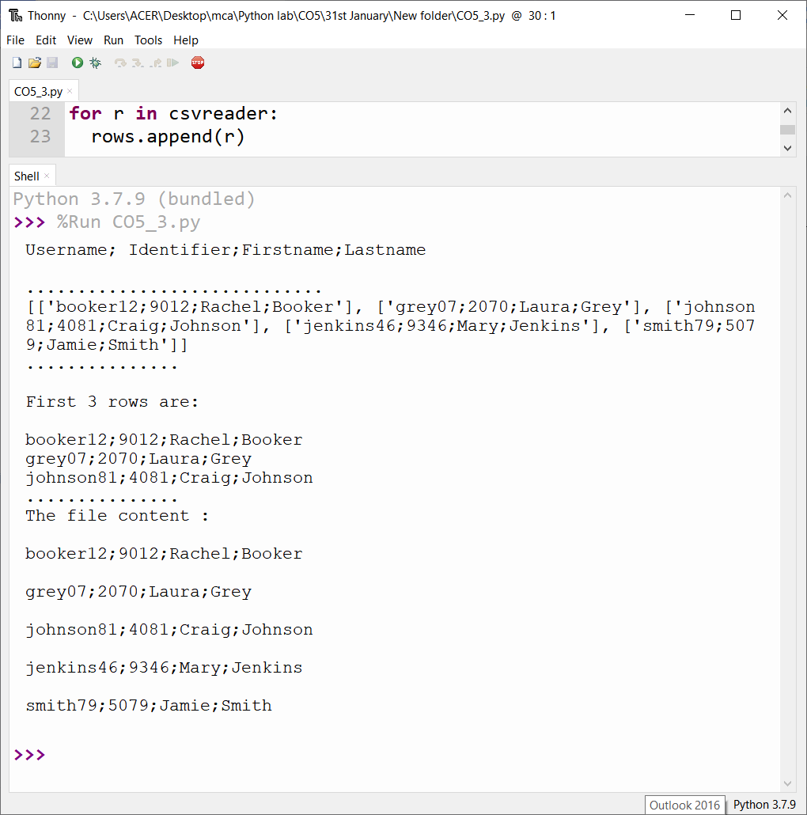

**4. Write a Python program to read specific columns of a given CSV file and print the content**

**of the columns.**

***Input:***

import csv

filename = "Names.csv"

cf=open(filename, 'r')

#csvreader = csv.reader(cf)

data = csv.DictReader(cf)

print("No Company")

for r in data:

print(r['No'], r['Company'])

***Output:***

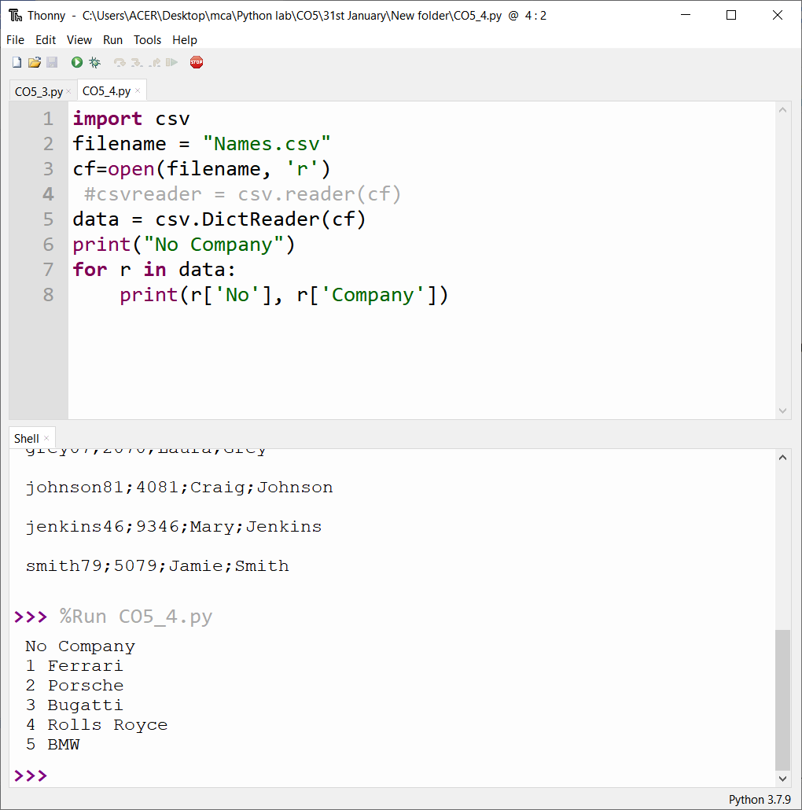

**5. Write a Python program to write a Python dictionary to a csv file. After writing the CSV file**

**read the CSV file and display the content.**

***Input:***

import csv

field_names = ['No', 'Company', 'Car Model']

cars = [

{'No': 1, 'Company': 'Ferrari', 'Car Model': '488 GTB'},

{'No': 2, 'Company': 'Porsche', 'Car Model': '918 Spyder'},

{'No': 3, 'Company': 'Bugatti', 'Car Model': 'La Voiture Noire'},

{'No': 4, 'Company': 'Rolls Royce', 'Car Model': 'Phantom'},

{'No': 5, 'Company': 'BMW', 'Car Model': 'BMW X7'},

]

with open('Names1.csv', 'w') as csvfile:

writer = csv.DictWriter(csvfile, fieldnames = field_names)

writer.writeheader()

writer.writerows(cars)#print(".................")

filename = "Names1.csv"

cf=open(filename, 'r')

rows=[]

csvreader = csv.reader(cf)

for r in csvreader:

rows.append(r)

for r in rows[:3]:

print(*r)

***Output:***

