**File upload in Spring Boot**

Step1: - Add folder name images, where we want to save the files. Go to “application.properties”

project.image = images/

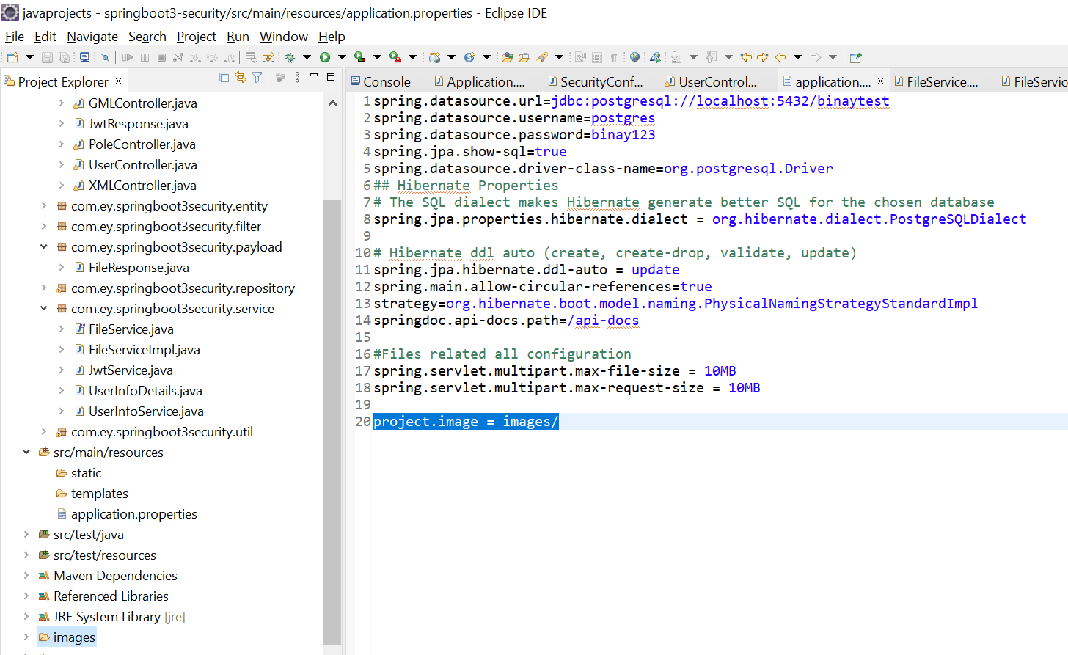

**Step2: -** Then create “service” package. Inside service package create class ‘FileService’ and ‘FileServiceImpl’

**FileService.java: -**

**package** com.ey.springboot3security.service;

**import** java.io.IOException;

**import** org.springframework.stereotype.Service;

**import** org.springframework.web.multipart.MultipartFile;

@Service

**public** **interface** FileService {

String uploadImage(String path, MultipartFile file) **throws** IOException;

}

**FileServiceImpl.java: -**

**package** com.ey.springboot3security.service;

**import** java.io.File;

**import** java.io.IOException;

**import** java.nio.file.Files;

**import** java.nio.file.Paths;

**import** java.util.UUID;

**import** org.springframework.stereotype.Service;

**import** org.springframework.web.multipart.MultipartFile;

@Service

**public** **class** FileServiceImpl **implements** FileService{

@Override

**public** String uploadImage(String path, MultipartFile file) **throws** IOException {

//File name

String name = file.getOriginalFilename();

//Random name generate

String randomID = UUID.*randomUUID*().toString();

String fileName1 = randomID.concat(name.substring(name.lastIndexOf(".")));

//Full path

String filePath = path+ File.***separator*** +fileName1;

//Create folder if not created

File f = **new** File(path);

**if**(!f.exists()) {

f.mkdir();

}

//File copy

Files.*copy*(file.getInputStream(), Paths.*get*(filePath));

**return** fileName1;

}

}

**Step3: -** Then create “controller” package. Inside controller package create class ‘FileController’

**FileController.java: -**

**package** com.ey.springboot3security.controller;

**import** java.io.IOException;

**import** org.springframework.beans.factory.annotation.Autowired;

**import** org.springframework.beans.factory.annotation.Value;

**import** org.springframework.http.HttpStatus;

**import** org.springframework.http.ResponseEntity;

**import** org.springframework.web.bind.annotation.PostMapping;

**import** org.springframework.web.bind.annotation.RequestMapping;

**import** org.springframework.web.bind.annotation.RequestParam;

**import** org.springframework.web.bind.annotation.RestController;

**import** org.springframework.web.multipart.MultipartFile;

**import** com.ey.springboot3security.payload.FileResponse;

**import** com.ey.springboot3security.service.FileService;

@RestController

@RequestMapping("/file")

**public** **class** FileController {

@Autowired

**private** FileService fileService;

@Value("${project.image}")

**private** String path;

@PostMapping("/upload")

**public** ResponseEntity<FileResponse> fileUpload(@RequestParam("image")MultipartFile image)

{

String fileName;

**try** {

fileName = **this**.fileService.uploadImage(path, image);

//repository can call

//file name you can save in table

} **catch** (IOException e) {

// **TODO** Auto-generated catch block

e.printStackTrace();

**return** **new** ResponseEntity<>(**new** FileResponse(**null**, "Image is not uploaded"), HttpStatus.***INTERNAL_SERVER_ERROR***);

}

**return** **new** ResponseEntity<>(**new** FileResponse(fileName, "Image successfully uploaded"), HttpStatus.***OK***);

}

}

**Step4: -** Then create “payload” package. Inside payload package create class ‘FileResponse’

**FileResponse.java: -**

**package** com.ey.springboot3security.payload;

**public** **class** FileResponse {

String fileName;

String message;

**public** FileResponse(String fileName, String message) {

**super**();

**this**.fileName = fileName;

**this**.message = message;

}

**public** String getFileName() {

**return** fileName;

}

**public** **void** setFileName(String fileName) {

**this**.fileName = fileName;

}

**public** String getMessage() {

**return** message;

}

**public** **void** setMessage(String message) {

**this**.message = message;

}

}

**Step 5: - Project structure for file upload below**

