Propwise Property Operations Dashboard
Full Project Report and Implementation Review
Prepared: September 2025 | Project: property-dashboard | Status: Seven sprints completed

1. Executive Summary
Propwise is a responsive property-operations dashboard prototype for property managers. The completed implementation provides a working frontend shell with role-aware login, protected routes, property creation, service-request operations, dashboard analytics, search, notifications, preferences, exports, responsive navigation, and accessibility-oriented interaction behavior.
The project was delivered across seven implementation sprints. The result is intentionally frontend-only: session, properties, dashboard layout, notification state, and preferences are stored in browser localStorage. This makes the application easy to demo and validate locally while clearly identifying the backend and production hardening work still required.

2. Product Goals and Intended Users
Area | Implementation outcome
Primary user | Property manager overseeing properties, occupancy, revenue, service requests, and reminders.
Operational goal | Provide a single workspace for monitoring portfolio health and acting on maintenance work.
Key workflow | Create a property, review requests, inspect request details, filter work, and export results.
Experience goal | Offer clear desktop and mobile navigation with keyboard-friendly overlays and feedback.
Prototype boundary | No server API, database, real authorization service, or production tenancy isolation yet.

3. Technology Stack and Architecture
Layer | Technology / approach
UI | React 19 with TypeScript
Build and dev server | Vite 8
Routing | React Router DOM 7
Styling | CSS in App.css and index.css with responsive media queries
Validation | Client-side form validation and browser-side state checks
Persistence | localStorage keys for session, properties, widgets, notifications, and preferences
Quality tooling | TypeScript build plus Oxlint
Deployment model | Static dist/ bundle suitable for Azure Static Web Apps, Azure Storage static hosting, or CDN hosting

The current architecture is intentionally compact and keeps most application behavior in App.tsx. This reduced refactoring risk while completing the sprint scope, but a production evolution should split the dashboard, property, request, notification, and settings features into feature folders with API and state boundaries.

4. Sprint-by-Sprint Delivery Summary
Sprint | Scope | Delivered capabilities
1 | Application shell and property flow | Route-aware sidebar, dashboard routes, Add Property modal, validation, persistence, property table.
2 | Authentication and user management | Login validation, submitting state, role permissions, editable profile, session persistence.
3 | Dashboard core widgets | Operational KPIs, occupancy visualization, typed service requests, filters, search, badges, pagination, empty states.
4 | Advanced dashboard features | Refresh state, widget visibility/order, request drill-down timeline, CSV and JSON export.
5 | Notifications, search, settings | Global search, unread notification state, mark-all-read, email preference, compact dashboard setting.
6 | Responsive and accessibility polish | Mobile drawer, backdrop, Escape handling, focus-visible styles, reduced motion, compact layouts.
7 | Testing and deployment readiness | Lint cleanup, successful build, production preview smoke test, project README and deployment guidance.

5. Main Workflows

5.1 Add Property
The Add property action is available from the manager dashboard. The modal collects property name, location, and unit count, validates required values and numeric constraints, supports cancel and backdrop close behavior, and writes the new property into localStorage. The dashboard property list updates immediately after save.
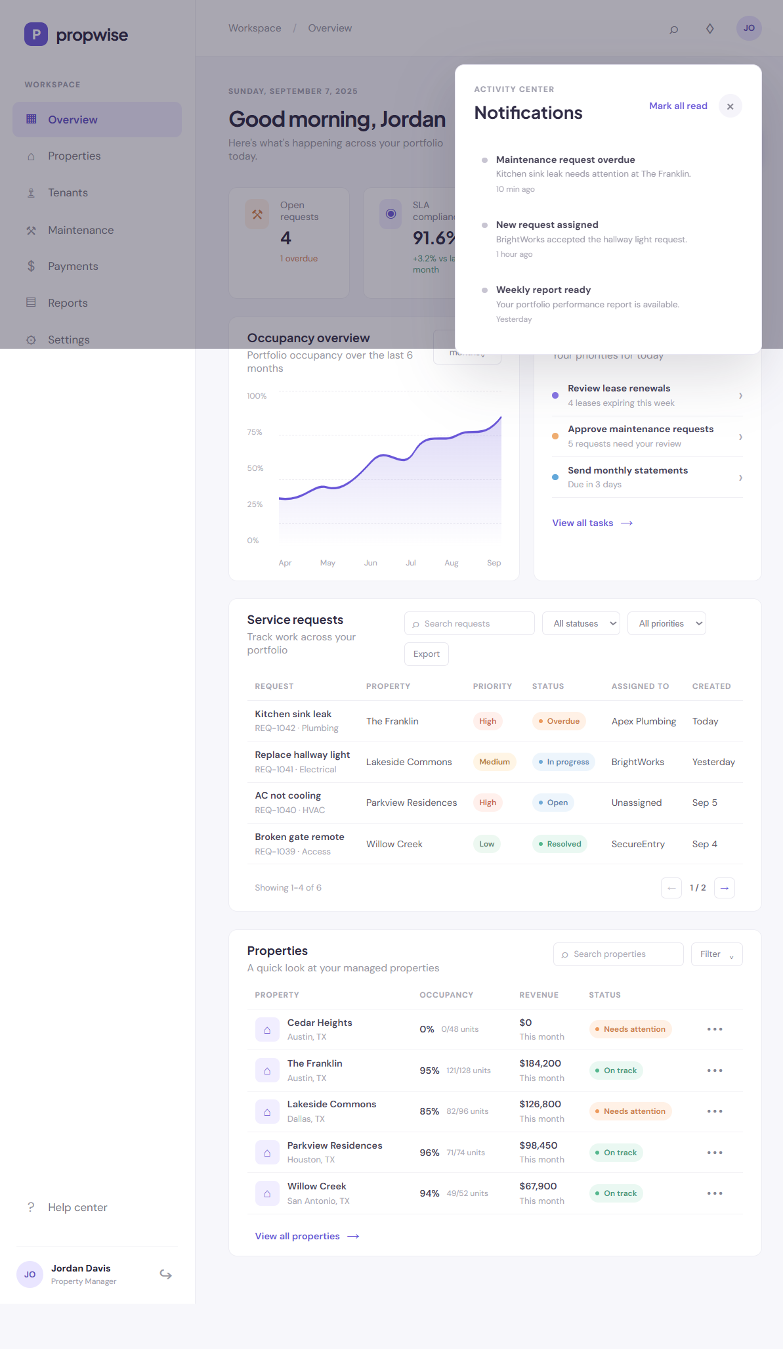
Figure 1. Add Property modal opened from the dashboard.

5.2 Service Request Operations
The service-request table provides status and priority filters, text search, pagination, badges, and an export menu. A request can be opened in a detail overlay that presents the request metadata and operational timeline, supporting a quick drill-down without leaving the dashboard.
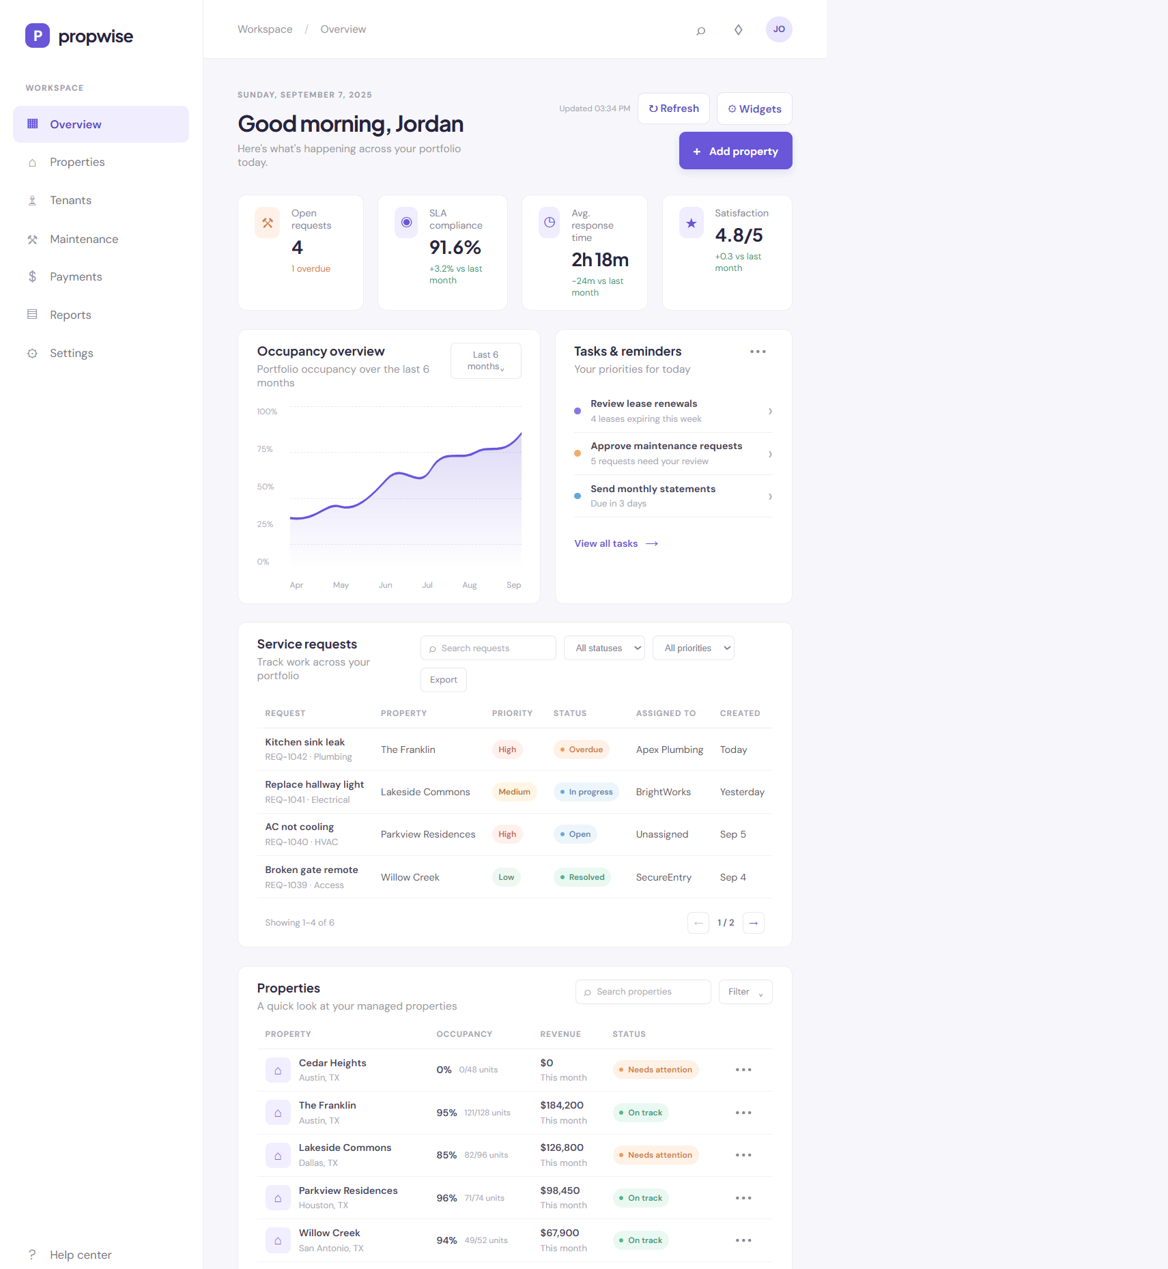
Figure 2. Dashboard request operations view captured during validation.

5.3 Notifications and Search
The header exposes global search and the activity center. Search matches property and service-request content. Notifications show unread state, individual read behavior, and mark-all-read support, with state persisted locally.
Figure 3. Activity Center notifications panel.

5.4 Profile and Settings
Profile editing supports name, email, phone, and email-update preference. Settings separately controls email notifications and compact dashboard mode. Both surfaces provide save/cancel behavior and persist the selected values.
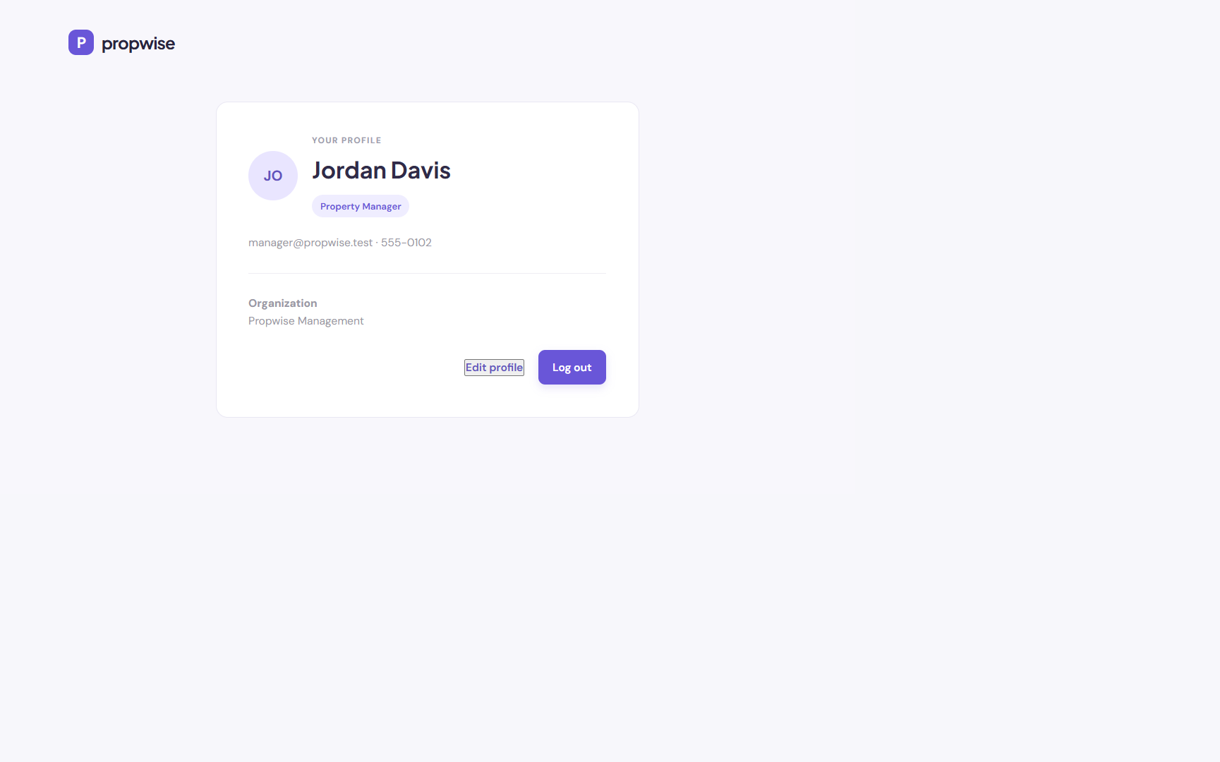
Figure 4. Profile management page.
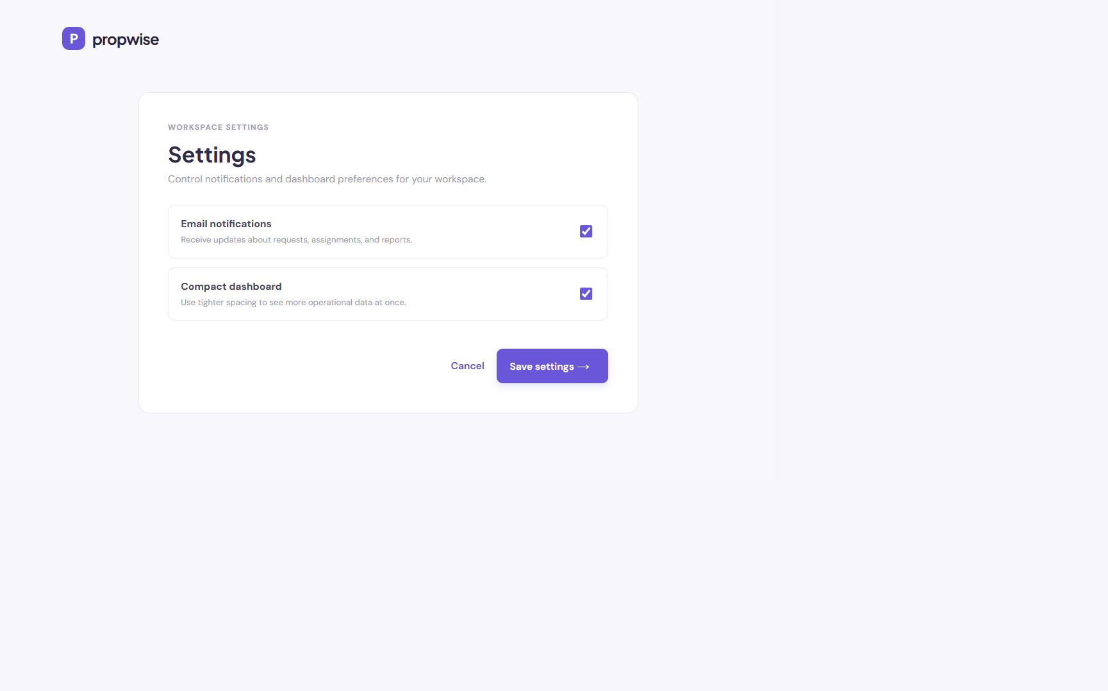
Figure 5. Workspace settings page.

6. UI and Responsive Behavior
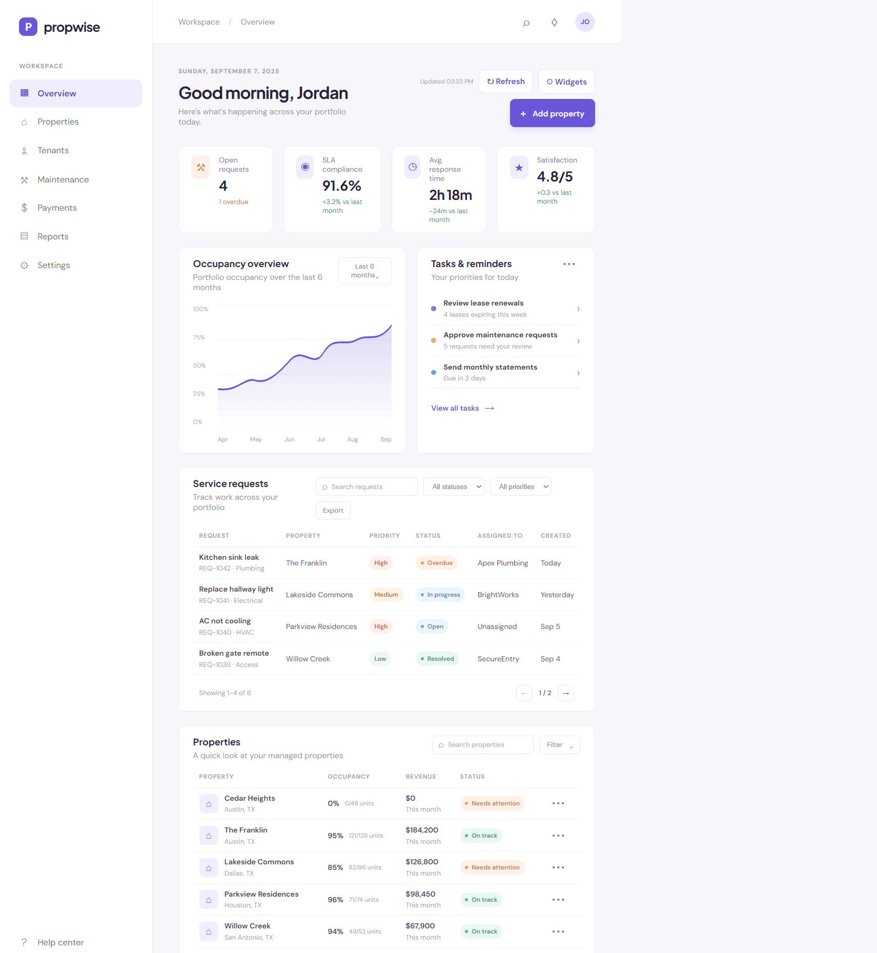
Figure 6. Manager dashboard desktop view with KPI cards, requests, properties, and activity center.
The desktop shell uses a persistent sidebar and operational content area. At mobile widths, the sidebar becomes a drawer with a backdrop. Selecting a route closes the drawer, and Escape closes menus and modal overlays. Focus-visible outlines, reduced-motion support, labeled controls, and aria-expanded state improve keyboard and assistive-technology behavior.

7. Data and Persistence Model
Storage key | Purpose | Production replacement
propwise_session | Current demo user and authentication session. | Server session or short-lived token with secure refresh strategy.
propwise_properties | Created property records used by dashboard cards and search. | Tenant-scoped properties API backed by PostgreSQL/Prisma or equivalent.
propwise_dashboard_widgets | Widget visibility and order. | User preference endpoint or profile settings table.
propwise_notifications | Notification read/unread state. | Notification service with server-side read state.
propwise_email_updates | Profile email-update preference. | User preference field with server validation.
propwise_compact_mode | Dashboard density preference. | User or workspace preference endpoint.

8. Validation and Quality Results
Check | Result | Notes
Oxlint | Passed | Final run completed with zero warnings.
TypeScript/Vite build | Passed | npm run build completed and generated the production bundle.
Production preview | Passed | Preview server responded with HTTP 200 for /manager/dashboard.
Browser workflow validation | Passed | Dashboard, Add Property, filtering, notifications, profile, settings, and mobile drawer were exercised.
Responsive check | Passed | 390px viewport checked; content remained within the viewport and navigation drawer operated.

9. Known Limitations and Risks
- The application is a frontend prototype with static mock service-request records and no backend API.
- localStorage is not suitable for secure authentication, multi-user concurrency, audit history, or server-side authorization.
- The protected routes are client-side guards only; backend authorization and tenant isolation must be implemented before production.
- Several sidebar destinations remain route placeholders and need full feature pages for tenants, maintenance, payments, reports, and help.
- The current single-file App.tsx architecture should be decomposed as the product grows.
- Real analytics, occupancy, revenue, request SLA, and notification data should come from versioned APIs with loading/error states.

10. Recommended Production Roadmap
Priority | Recommendation
P0 | Add a backend API, secure authentication, server-side RBAC, tenant isolation, and database-backed persistence.
P0 | Replace demo credentials and localStorage session handling with secure cookie/token flows and audit logging.
P1 | Complete the placeholder sidebar pages and connect each workflow to real domain services.
P1 | Add automated unit, component, accessibility, and end-to-end tests for Add Property and request operations.
P1 | Introduce feature-folder architecture, shared types, API clients, and query/cache management.
P2 | Add observability, error reporting, analytics, CI checks, environment configuration, and deployment preview environments.

11. Local Run and Deployment Instructions
Requirements: Node.js 20 or newer and npm 10 or newer.
- npm install
- npm run dev
- npm run lint
- npm run build
- npm run preview
Use the demo account manager@propwise.test with password demo123. For static deployment, publish the generated dist/ directory to a static host and configure SPA fallback routing so paths such as /manager/dashboard and /settings serve index.html.

12. Project File Reference
File | Responsibility
src/App.tsx | Application shell, routes, dashboard, overlays, property flow, notifications, settings, and profile.
src/auth.tsx | Authentication context, user model, session persistence, role paths, and permissions.
src/App.css | Application layout, dashboard, modal, panel, mobile, and responsive styling.
src/index.css | Global reset, focus-visible styles, and reduced-motion behavior.
src/main.tsx | React entry point and StrictMode mounting.
README.md | Setup, demo credentials, feature scope, validation, and deployment notes.
package.json | Runtime dependencies and npm scripts.

End of report

