1)Login into SAP

2)va02

And enter the ASO number

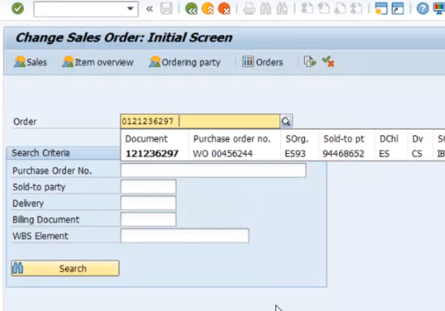

And click on the tick mark

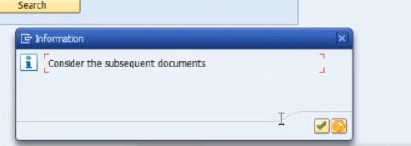

Select the row number and click on the Sales document & click on the deliver .

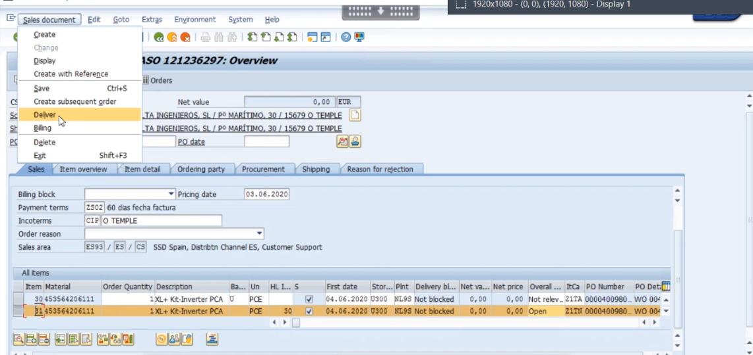

Click on Packing and give the packing Qty as deliver Qty as show below.

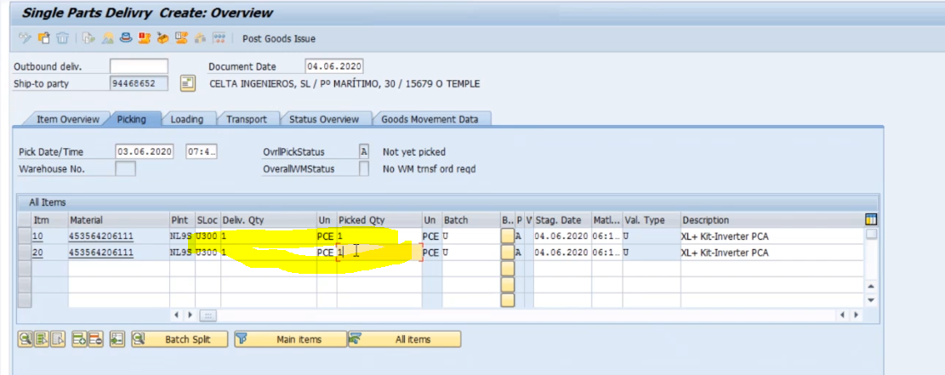

And Select the two rows and click packing button

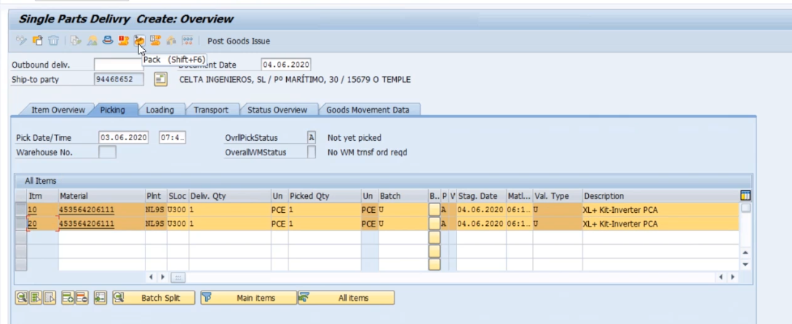

It will navigate to next screen and provide the 38 number and click on the enter button ,

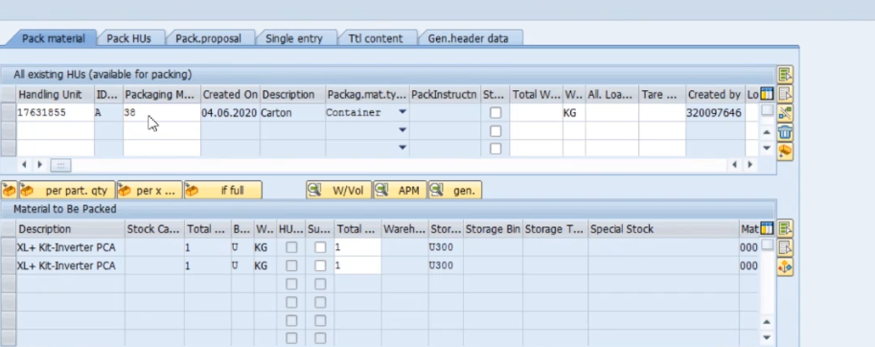

Provide HU Identification number as UPS.

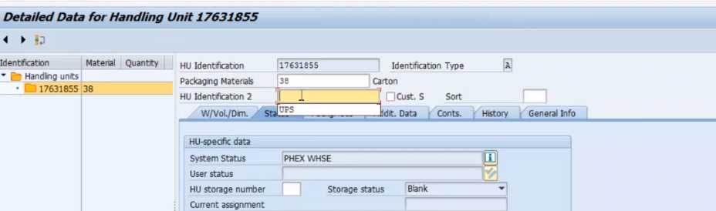

Click on back button

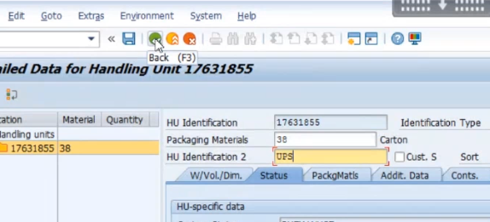

Verify the message

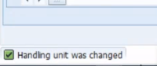

Select all rows and click on pack button

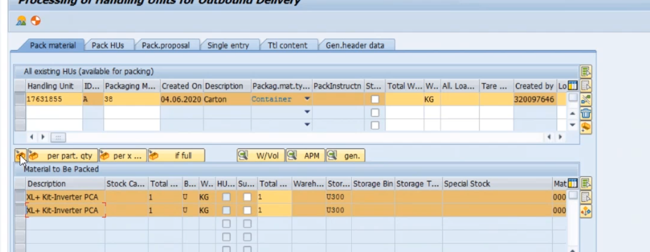

Verify the success message and click on Save button.

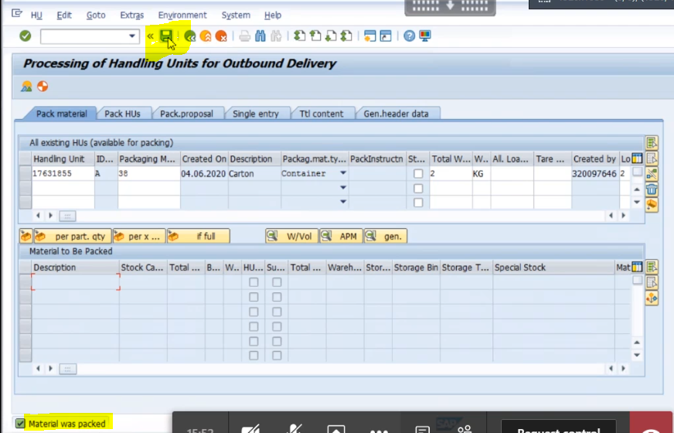

Put the /nvl02n as show below,

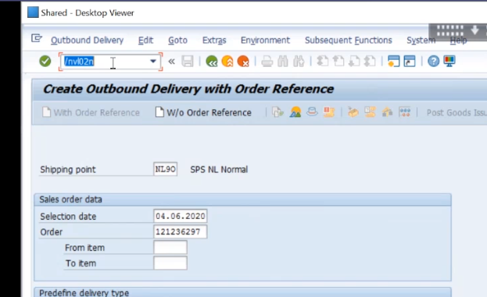

Click on the enter

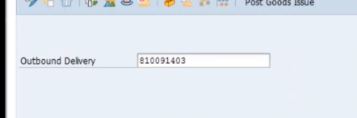

Select two rows and click on goto > header > Parcel tracking

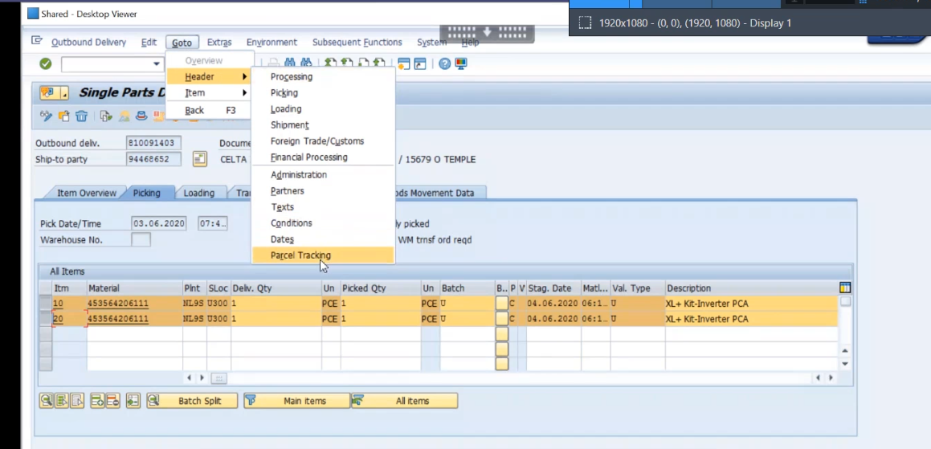

And click save , and wait for some time

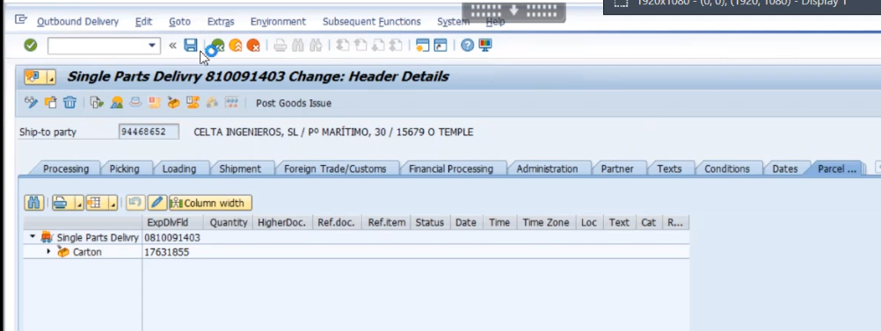

Provide values as show ,

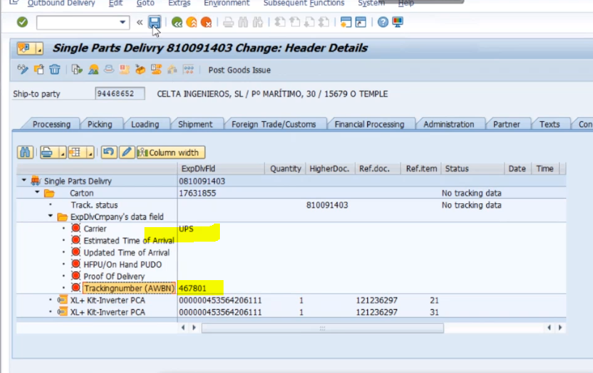

Carrier = UPS and trackingnumber any unique number.

And click on save it.

Key note:

If we tacking any serialized part then serial number should tag to that part.

SNP1 , SNP2 serial number is mandatory , SNP5 bach control number is mandatory

Pick the first row , and

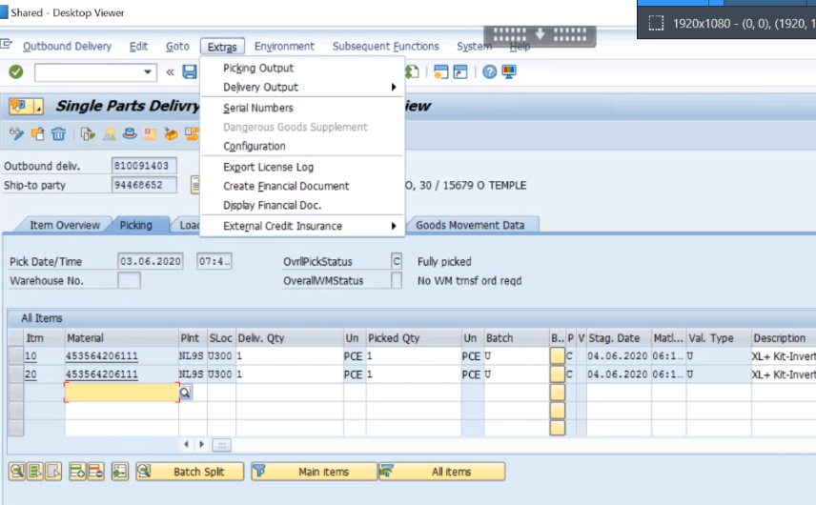

Pick the 1st row and go to extras > Serial Number >

Click on create serial number automatically part .

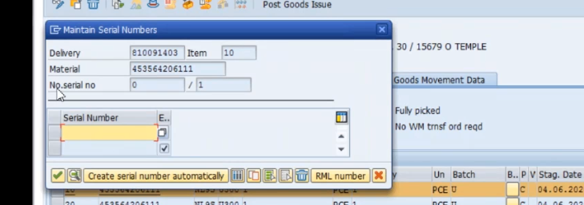

Serial number part will be populated and click on tick mark.

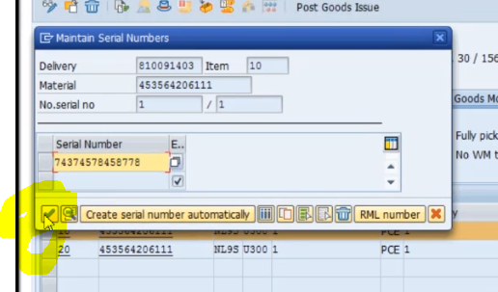

Generate the serial number same for all remaining rows . here for second row also.

Click on Save it

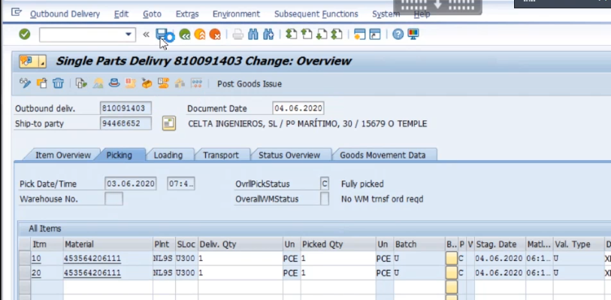

Click on Post goods Issue

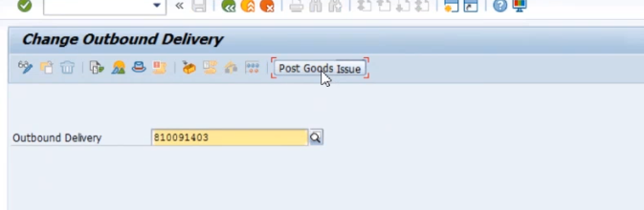

Verify the below message.



Done PGI is complete.