**PROJECT TITLE :** The Website Traffic Analysis

**Project Definition:** The project involves analyzing website traffic data to gain insights into user behavior, popular pages, and traffic sources. The goal is to help website owners enhance the user experience by understanding how visitors interact with the site. This project encompasses defining the analysis objectives, collecting website traffic data, using IBM Cognos for data visualization, and integrating Python code for advanced analysis.

**PREPROCESSING OF DATA**

**Data Cleaning**

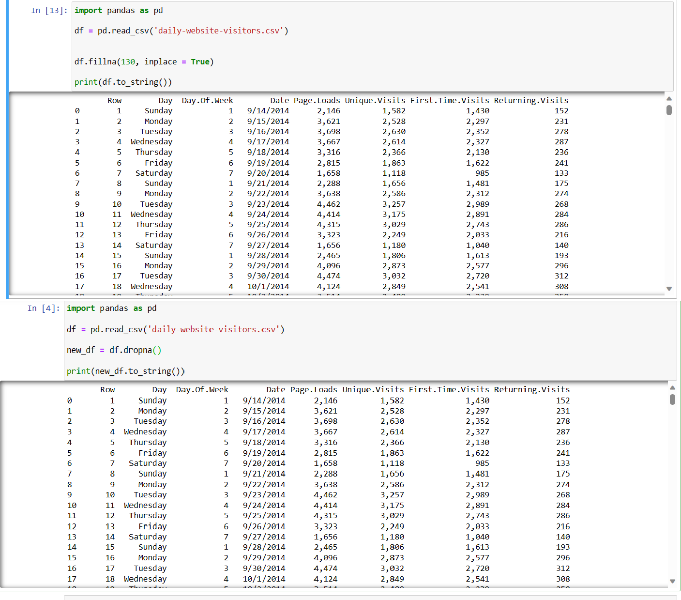

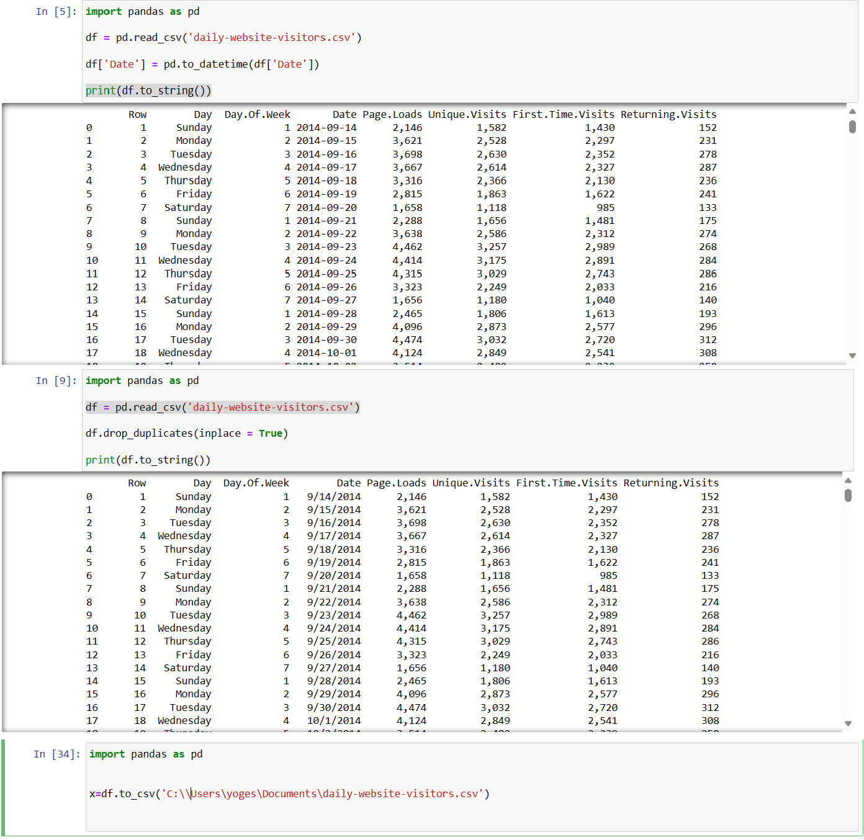

**VISUALATION IS USING IBM COGNOS ANALYTICS**

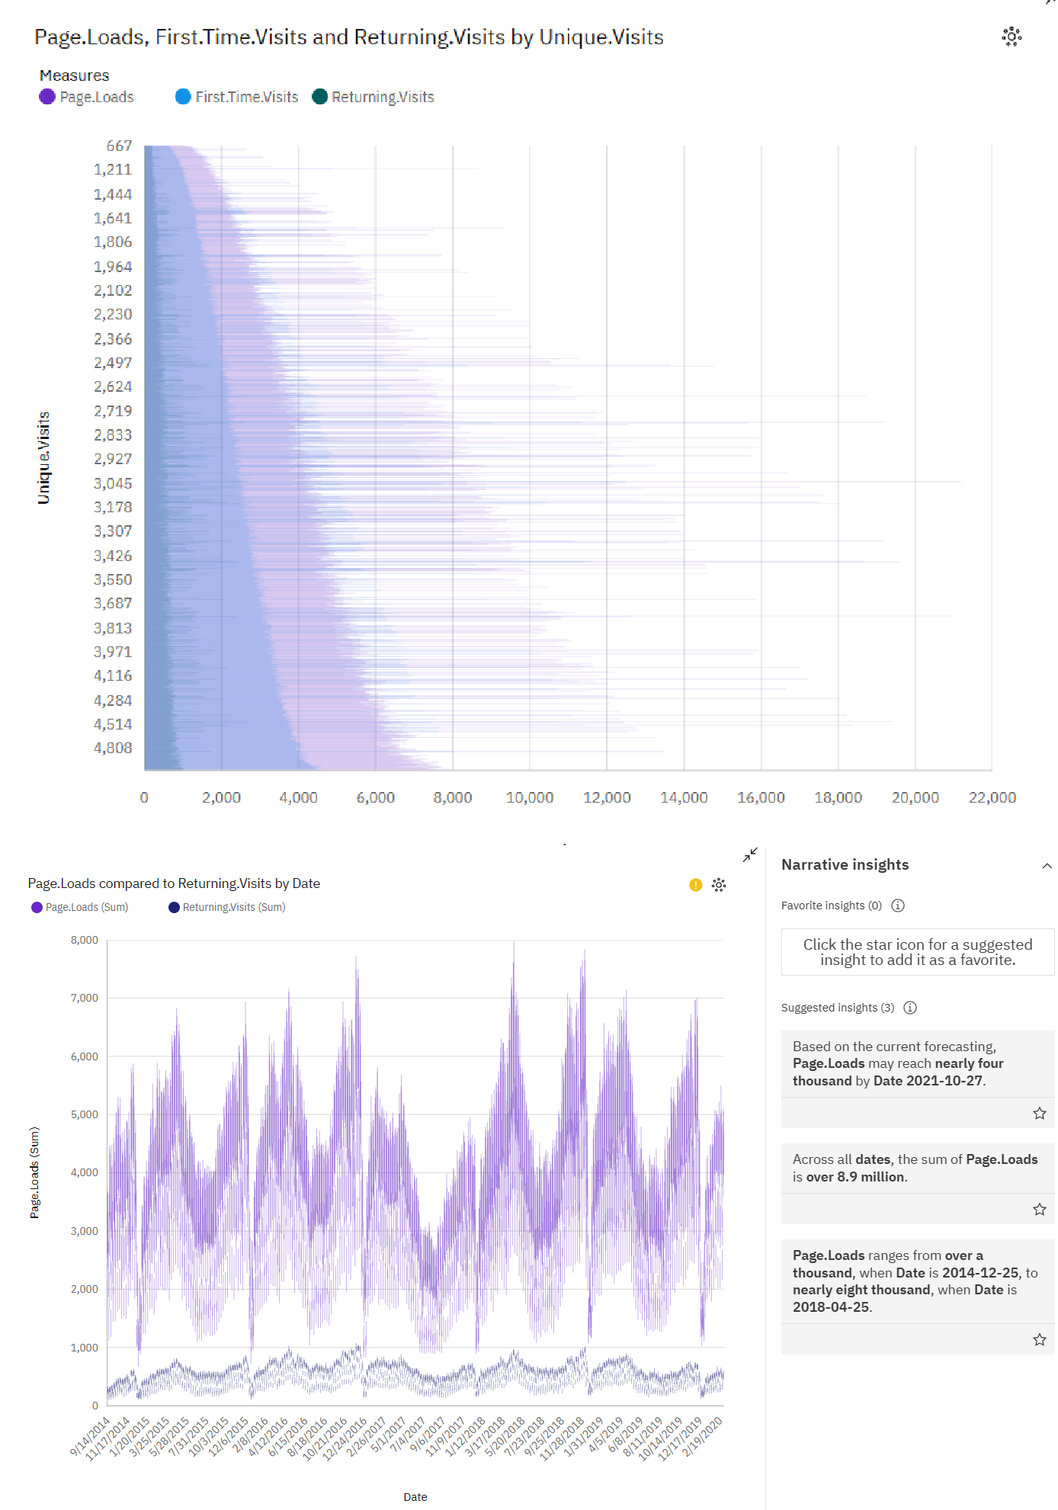

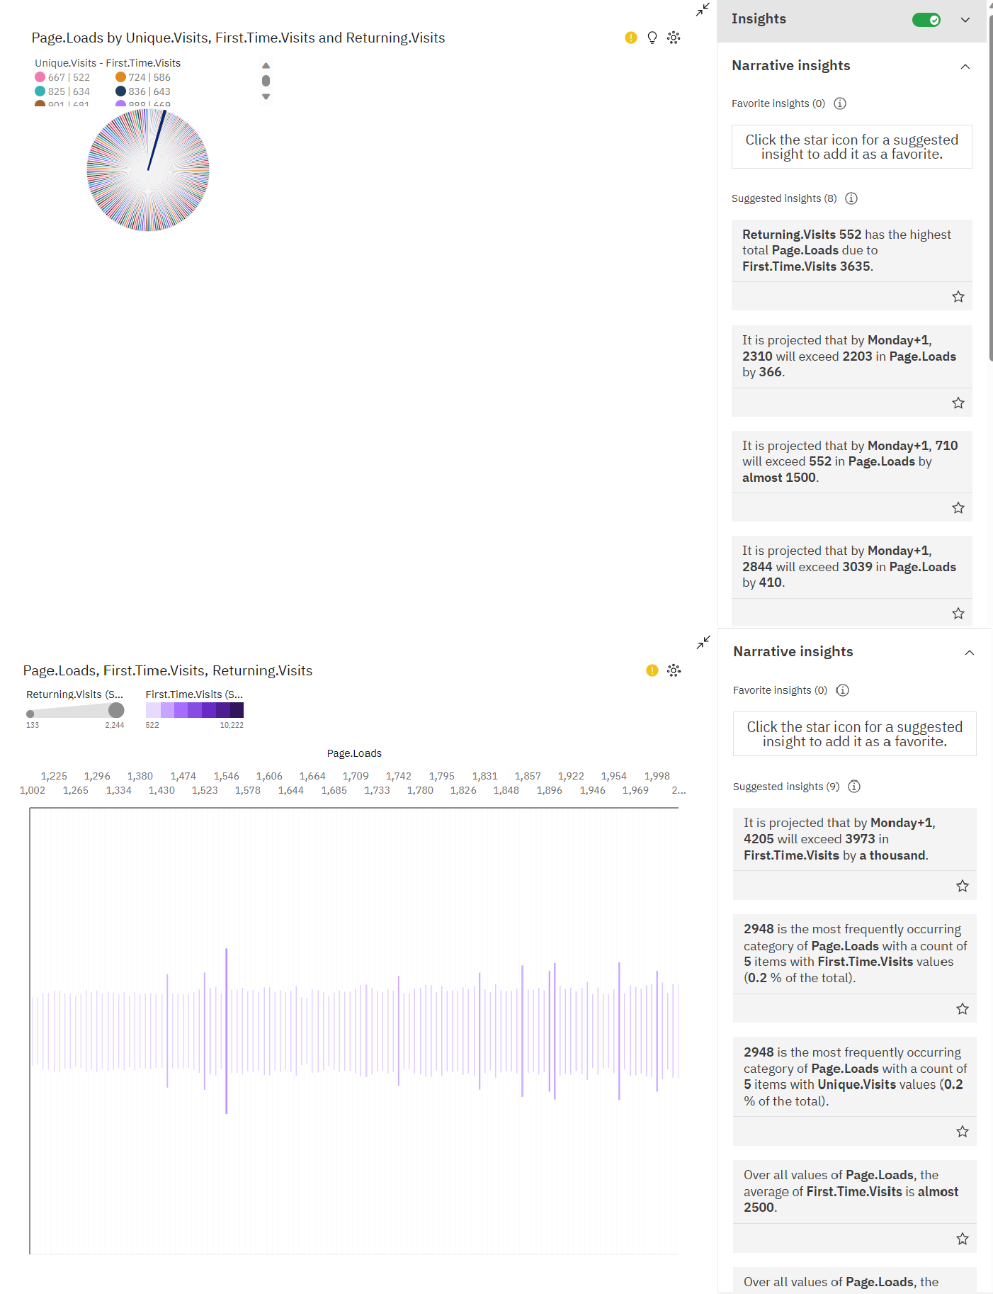

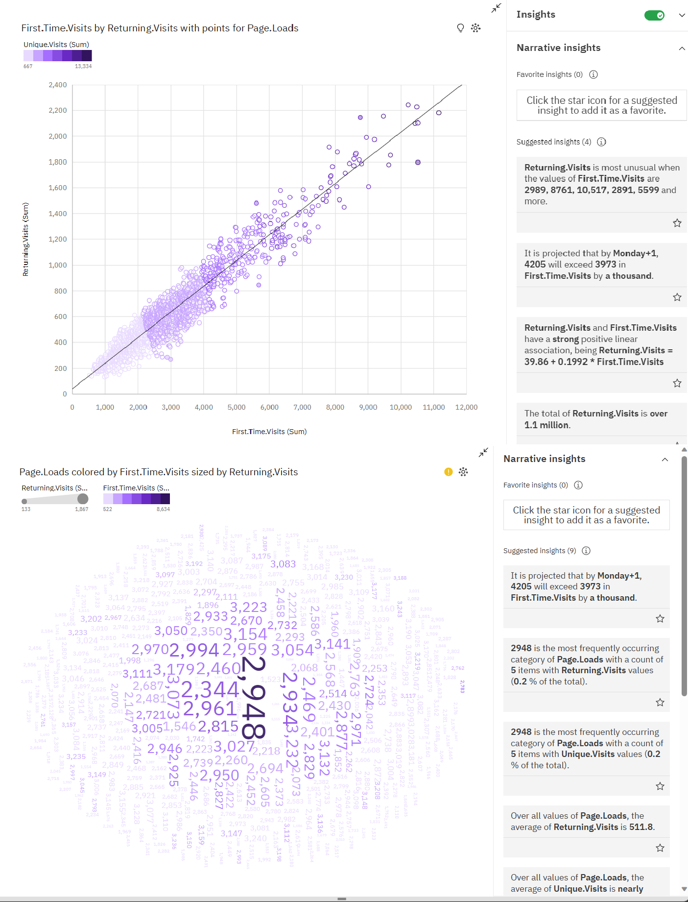

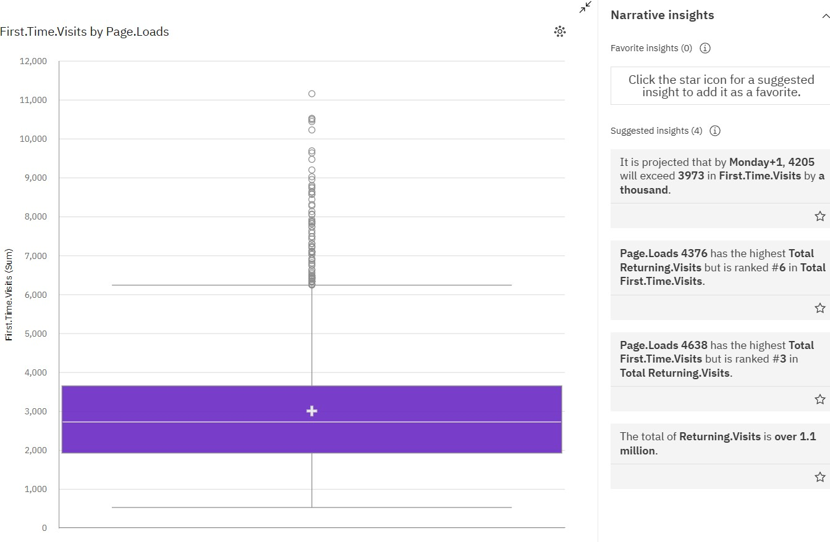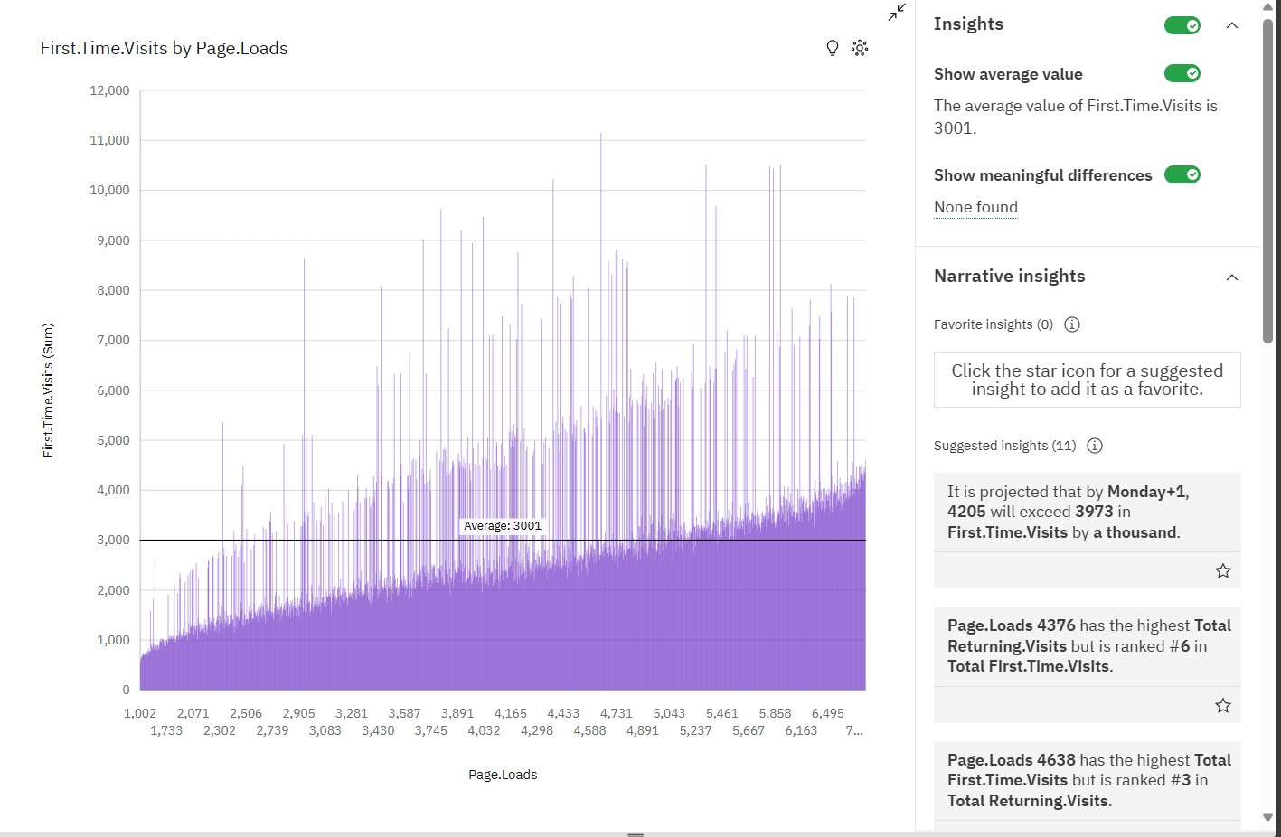

**CONCLUSION**

In conclusion, leveraging IBM Cognos Analytics for website traffic analysis involves meticulous data preprocessing and insightful visualization techniques. By

ensuring data accuracy and employing compelling visualizations, businesses can

extract meaningful insights, enabling informed decision-making and optimizing online performance.