Integration Test Report

Project
IT Asset Management System (ITAMS)

Objective
Verify Login and Forgot Password integration with backend APIs and MySQL.

Modules Tested
- Login
- Forgot Password

Results
Module | Expected | Actual | Status
Login | Login successful | Login successful | Pass
Send OTP | OTP sent | OTP received | Pass
Verify OTP | OTP verified | OTP verified | Pass
Reset Password | Password reset | Password reset | Pass

Conclusion
Integration testing completed successfully. All tested scenarios passed.

ScreenShots:
- Forgot Password – Send OTP
- Screenshot showing the popup:
"If that account exists, an OTP has been sent."

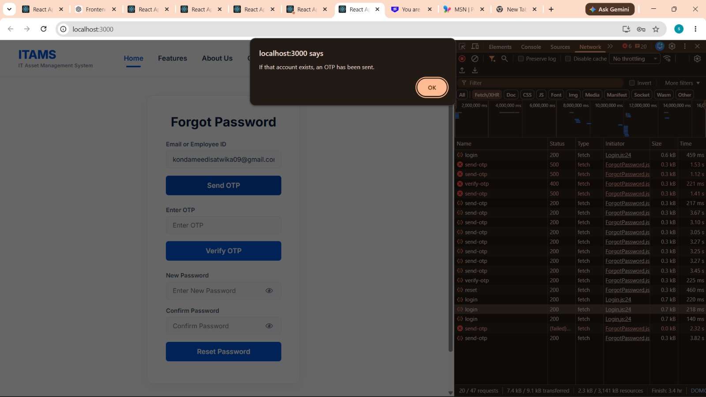

- OTP Received in Gmail
- Screenshot of the email containing the OTP (953894)

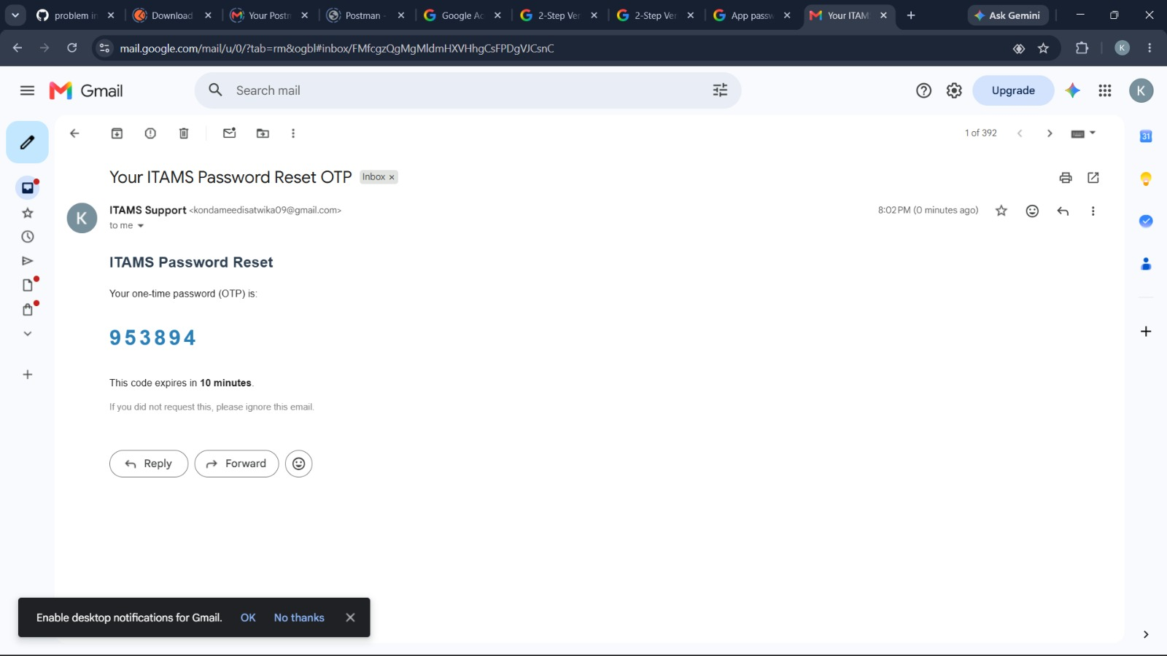
- Verify OTP
- Screenshot after entering the OTP.
- Network tab showing verify-otp → Status 200.
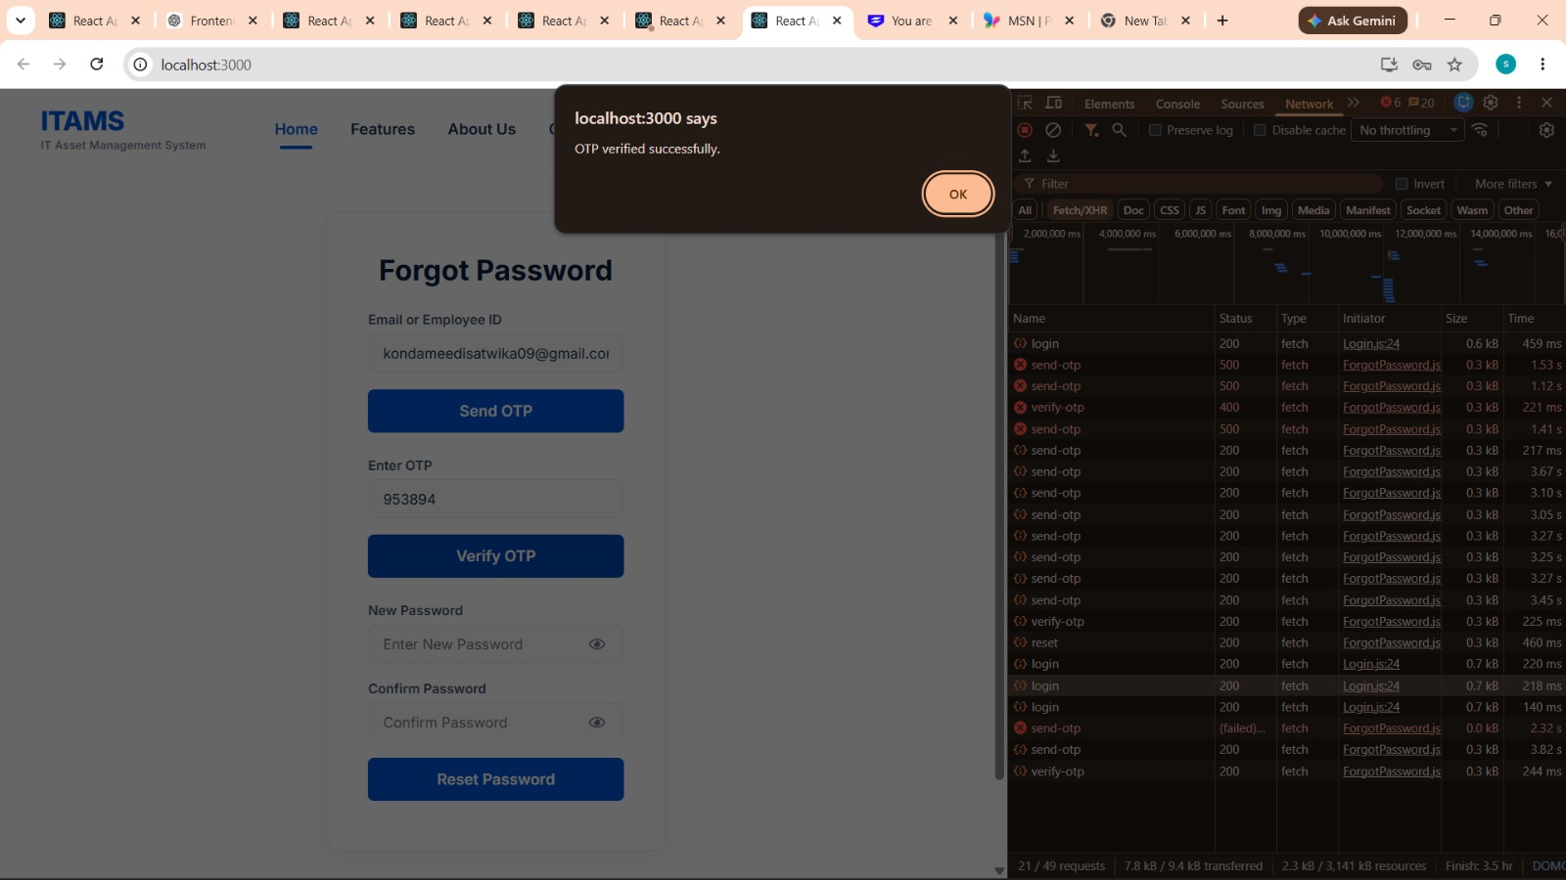

- Reset Password
- Screenshot after entering the new password and clicking Reset Password.
- Network tab showing reset → Status 200.
- 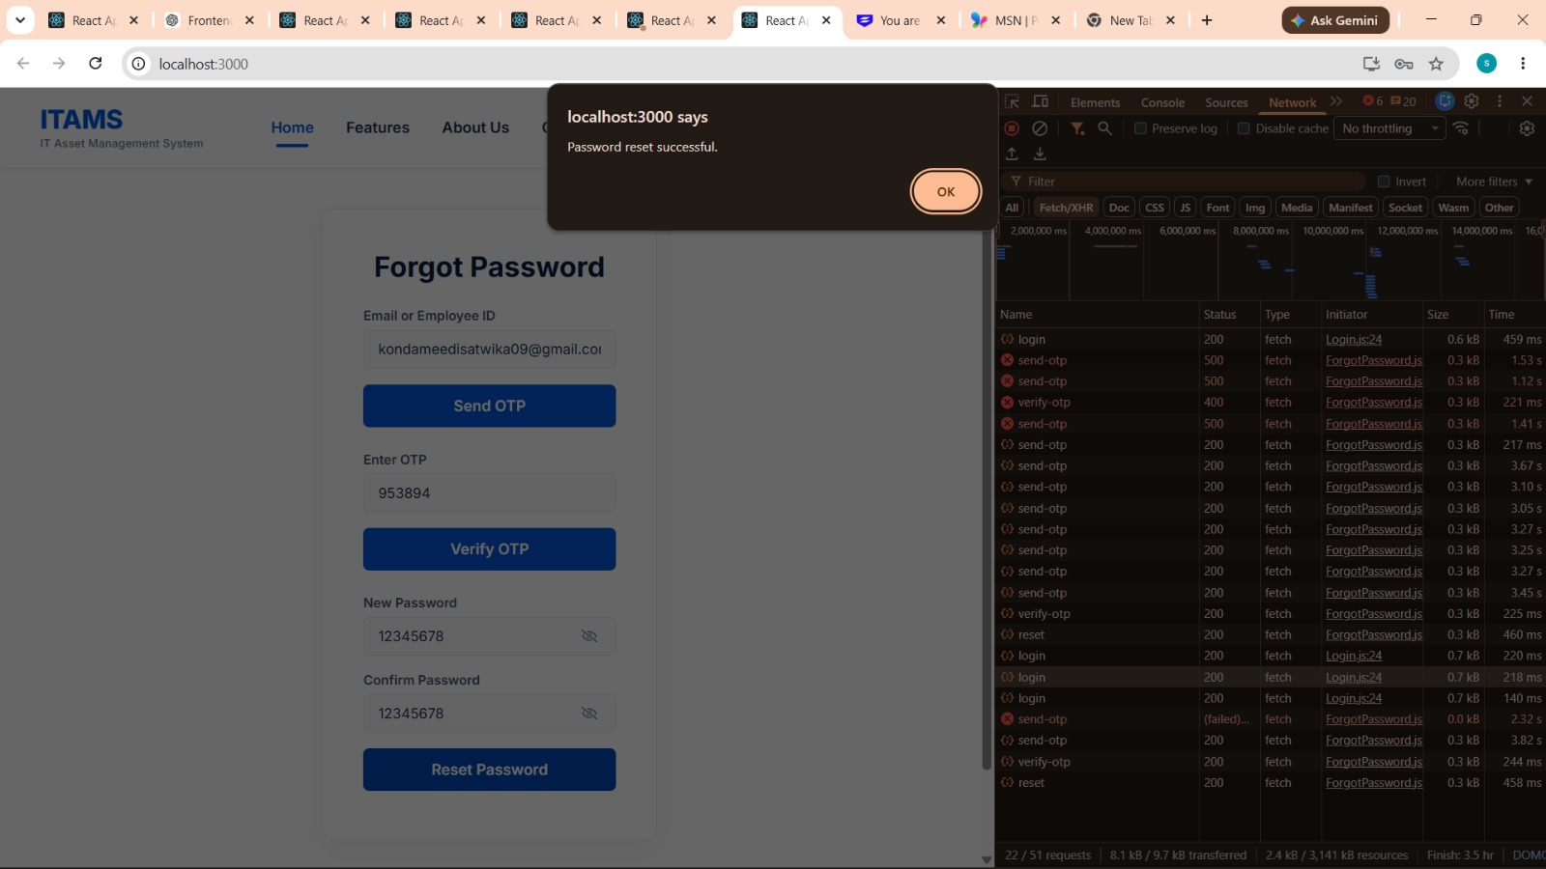

5.Login with New Password
- Screenshot showing "Login Successful" popup.
- Network tab showing login → Status 200
