**Gradient Boosting Machines (GBM)**

**1. Introduction to Gradient Boosting Machines (GBM)**

Gradient Boosting Machines (GBM) is an ensemble learning technique that uses an array of weak models, usually decision trees, and combines them into one strong predictive model. The strategy is to train the trees sequentially such that each tree attempts to learn from the errors of the previous tree. It reduces bias and variance and results in a highly accurate model.

GBM works by adding a new tree on top of the residuals (errors) of the existing ensemble, and optimization is realized through gradient descent for the model. Prediction is realized by summing the outputs of all trees, with each tree contributing in proportion to its accuracy. Being able to minimize both bias and variance, GBM is a robust algorithm, especially for difficult data with intricate patterns.

GBM is very useful in classification and regression tasks. The ability of the algorithm is evident in applications such as customer segmentation, financial forecasting, and ranking problems. Its popularity stems from high accuracy and capacity to handle varied forms of data, even when dealing with missing data or non-linear data.

In this tutorial, we will discuss the inner workings of Gradient Boosting, its implementation, and compare it with other machine learning algorithms in terms of performance and appropriateness for various tasks.

**2. How Does Gradient Boosting Work**

Gradient Boosting follows an iterative method to build a model ensemble (often decision trees) in a way that each of the next models is trained on the residuals or errors of earlier models. This can be done in the following steps:

1.Initial Prediction : The algorithm begins with a base model, often a constant prediction, say the mean of the target variable, which provides a baseline estimate.

2.Calculate Residuals : After the first prediction is done, the residuals (or errors) are calculated. Residuals are the differences between actual values and the predicted values.

3.Fit a New Model : A new model (usually a decision tree) is trained to predict the residuals. This model is on the basis of the mistakes the previous model made.

4.Update the Model : The predictions of the new model are added to the predictions of the existing model to increase the overall accuracy of the ensemble.

5. Repeat : It is repeated over and over again. Each model that comes later attempts to decrease the residuals further, basically undoing the errors of the previous models.

The iterative process of Gradient Boosting allows it to build a robust model by aggregating multiple weak models. This approach reduces both bias and variance, resulting in an accurate and stable predictive model.

**3. Key Concepts and Formulas in Gradient Boosting**

In Gradient Boosting, learning rate, residuals, and loss function are all significant to improve the model's performance.

1. Residuals: The residual is the error at each iteration, indicating how much the model's prediction deviates from the true value. It is calculated as the difference between the predicted value $y^{i}$ and the true value $yi$. The residual informs the model in which direction it must improve:

$$ri​=yi​-y^​i​$$

This helps the new model (tree) focus on correcting errors made by the previous model.

2.Learning Rate : The learning rate $η$ controls the amount of each new model's forecasts to use in the output. The smaller the learning rate, the more conservative updates, reducing the danger of overfitting but potentially requiring more trees to converge on a best solution. The update rule for the forecasted value is:

$$y^​inew​=y^​iold​+η⋅fi​(x)$$

where $fi(x)$ is the prediction of the new tree, and $η$ is the learning rate.

3.Loss Function: Depending on the type of problem, the loss function is selected. For regression problems, Mean Squared Error (MSE) is typically used:

$$MSE=\frac{1}{n​}\sum_{i=1}^{n}{{(yi​-y^​i​)}^{2}}​$$

For problems of classification, use the log-likelihood (cross-entropy) loss. Quantify how well the predictions of the model match up with the actual outcomes using the loss function.

**4. Implementation of Gradient Boosting Machine**

Here, we use the California Housing dataset to predict house prices using a Gradient Boosting Regressor. We first load the dataset from fetch_california_housing() and split it into training and test sets using train_test_split(). We then create a GradientBoostingRegressor model with parameters like 100 estimators, learning rate of 0.1, and max depth of 3 per tree. It is fitted to the training set using the fit() function. We predict target values on the test set with predict() once fitted.

Model performance is verified with Mean Squared Error (MSE) and R-squared (R²), which are printed to see how well the model predicts.

In addition, the importances of the features are retrieved from the trained model using the feature_importances_ attribute. These are plotted using a horizontal bar plot to display the relative contribution of each feature towards the prediction of the housing prices. Finally, a scatter plot of Actual vs. Predicted is created to visually check how well the model performs, with a red dashed line for ideal prediction.

**5. Model Evaluation and Performance**

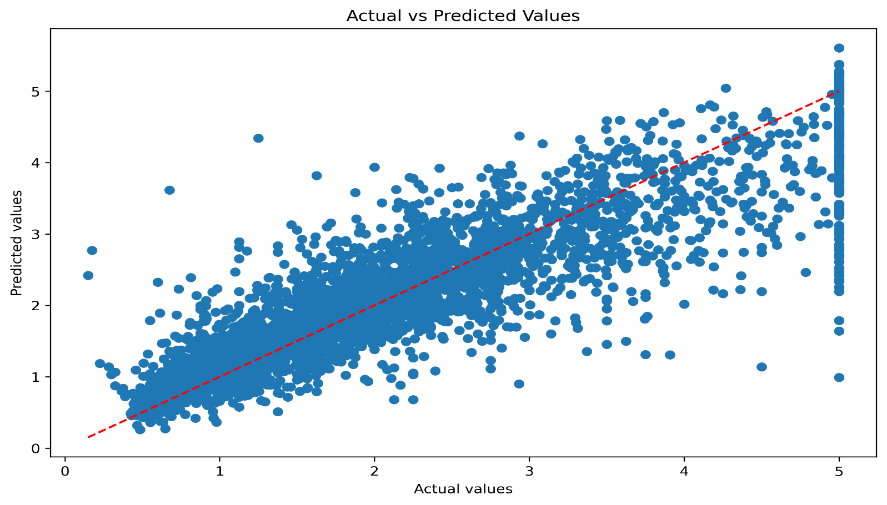The performance of the model is evaluated on Mean Squared Error (MSE) and R-squared (R²). MSE is the average of the squared differences between the target and predicted values, where lower is better. The value of R² between 0 and 1 is the proportion of variance explained by the model. If the R² is nearly 1, then the model accounts for most of the variance in the target variable, which is best for regression tasks.

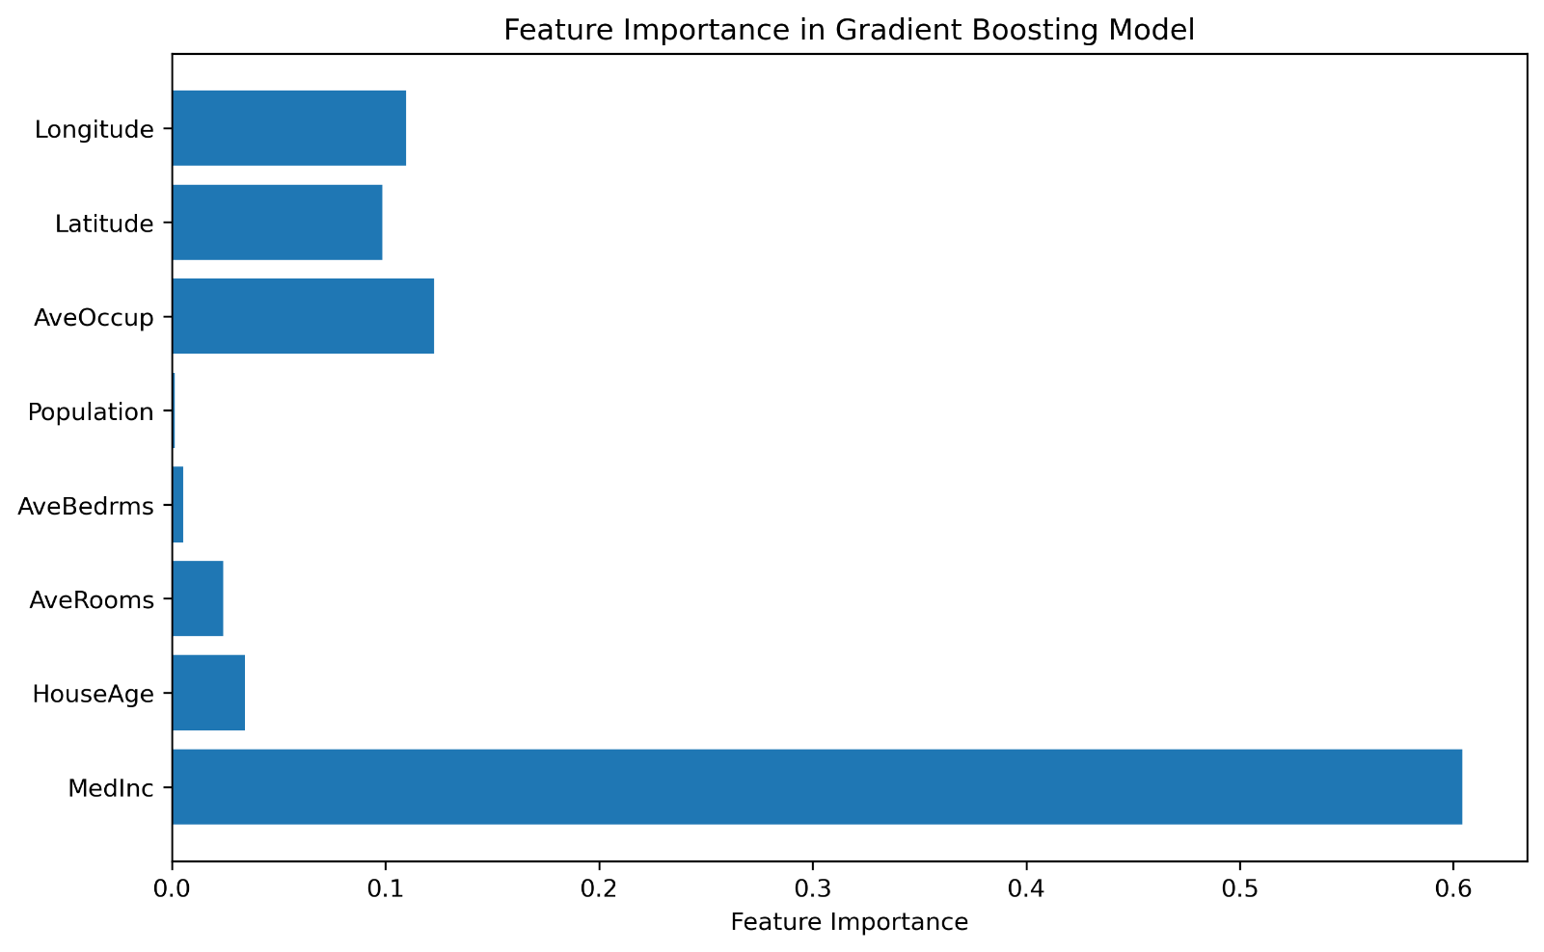In this instance, the R² measure is going to be a good gauge of model fit. High R² implies that the Gradient Boosting model is very accurate in predicting house prices. The MSE gives a different perspective of the model's error in prediction. Lower MSE and higher R² indicate that the model is accurate and generalizes well on the test set.

Feature importance plot indicates that Median Income, Latitude, and Longitude are the most predictive features for house prices. Such features' importance is in accordance with human intuition of what affects house value.

**6. Advantages, Pros & Cons, and Comparison with Other ML Algorithms**

**Advantages:**

- High Accuracy : Gradient Boosting Machines (GBM) tends to be more accurate in predictions than other algorithms, especially with challenging datasets.

- Versatility : GBM can be used both for regression and classification problems, which is a feature making it a universal option for various problems.

- Handles Non-linear Data : Unlike linear models, GBM can model intricate, non-linear relationships in the data, which makes it ideal for challenging problems.

**Disadvantages**

- **Overfitting :** GBM can suffer from overfitting, particularly when many trees are used or if the learning rate is high. Regularization techniques can be employed to slow this down.

- **Computationally Expensive :** Training of the GBM model can be slow and computation-prohibitive, particularly on large data.

- **Hyperparameter Sensitivity :** GBM performance is often best with careful hyperparameter adjustment like the number of trees, learning rate, and tree depth.

**Comparison with Other Algorithms:**

|  |  |  |  |
| --- | --- | --- | --- |
| Feature | GBM | Random Forest | SVM |
| Accuracy | **High** | **High** | **Medium** |
| Overfitting Risk | **Medium** | **Low** | **Low** |
| Interpretability | **Low** | **Medium** | **Low** |
| Training Time | **Slow** | **Faster** | **Medium** |

**7. Applications of Gradient Boosting**

- **Finance:** GBM is widely applied to financial issues like credit scoring, stock price prediction, and detecting fraud. The sophisticated relations that the model can capture enable it to excel in the prediction of financial results as well as detection of fraudulent transactions, where accurate and trustworthy predictions are critical.

- **Healthcare:** In medical care, GBM is utilized in predicting patient outcome, disease growth, and clinical diagnosis. Based on past data analysis, it helps to identify patterns and trends in the health of patients that can guide better decisions by medical practitioners and lead to improved care for patients.

- **Marketing :** GBM is also a powerful tool for marketing and customer segmentation, campaign optimization, and demand planning. By conducting analysis of how consumers behave as well as looking at transaction details, companies are able to direct the right consumers, optimize campaigns, and anticipate future demand for products or services.

- **E-commerce:** For recommendation engines, price optimisation, and customer churn prediction, GBM models are used in e-commerce. The company is able to personalize recommendations, price optimise, and predict customer churn based on customer buying history and browsing behaviour. It helps companies improve retention and sales.

These applications demonstrate the versatility of Gradient Boosting, which has become popular with the majority of industries because of its ability to make very accurate predictions**.**

**8. How to Improve Accuracy of Gradient Boosting?**

To increase the accuracy of a Gradient Boosting model, you can implement a number of strategies:

1. Hyperparameter tuning: Fine-tune significant parameters like the number of estimators, learning rate, and depth to find the optimal settings.

2. Regularization: Implement techniques like early stopping to prevent the model from overfitting and generalizing better.

3. Ensemble methods: Combine Gradient Boosting with another model, e.g., Random Forest or XG Boost, to leverage the strengths of multiple algorithms and improve performance.

4. Feature engineering: Improve your dataset by adding more relevant features or transforming existing ones to represent the underlying patterns more effectively.

5. Cross-validation: Use cross-validation to validate your model's performance and avoid overfitting the training data, allowing better generalization on new data.

Using these methods, you can refine your model to be more accurate and reliable, especially with complex datasets.

**9. Conclusion**

Gradient Boosting Machines (GBM) is an ensemble learning technique that develops a strong predictive model by aggregating many weaker models, typically decision trees. GBM works on training a new model to learn from the errors (residuals) of the previous models in the sequence. By iterative improvement on previous prediction, GBM generates strong predictive models. GBM is excellent at handling complex problems with non-linear interactions, and the ability to learn from different types of data makes it extremely useful for classification and regression tasks.

GBM does have the disadvantage of requiring careful hyperparameter tuning such as the number of trees, learning rate, and tree depth to avoid overfitting and high computational costs. A poorly tuned model can lead to either underfitting or overfitting, impacting performance. Despite this, GBM has proved to be an effective method across a wide range of applications, such as finance for credit risk scoring and forecasting stock prices, healthcare for outcome prediction for patients, and marketing for segmentation of customers and demand forecasting.

When well-tuned, GBM can be better than most other machine learning algorithms and is one of the most powerful predictive modelling tools. Its high computational expense, however, can limit its scalability in certain applications.

**10. References**

1. **Friedman, J. H. (2001). "Greedy Function Approximation: A Gradient Boosting Machine." *The Annals of Statistics*.**
2. **Scikit-learn Documentation:** [**https://scikit-learn.org/**](https://scikit-learn.org/)
3. **Hastie, T., Tibshirani, R., & Friedman, J. (2009). *The Elements of Statistical Learning*. Springer.**