**SERVERLESS IOT DATA PROCESSING**

**ABSRTACT:**

The convergence of the Internet of Things (IoT) and serverless computing has ignited a paradigm shift in data processing strategies. This abstract offers a glimpse into a project designed with a strong foundation in design thinking principles, aiming to revolutionize IoT data processing using serverless technologies.

Our project begins with a user-centric approach, understanding the unique challenges faced by IoT practitioners and stakeholders. Design thinking methodologies, such as empathy mapping and user journey analysis, are employed to identify pain points, opportunities, and user requirements in the context of IoT data processing.

Through iterative ideation and prototyping, we have developed a serverless-based architecture tailored to the specific needs of IoT applications. The architecture is inherently scalable, event-driven, and cost-effective, addressing the core challenges in processing vast and dynamic IoT datasets.

Key design considerations include data ingestion, transformation, and real-time analysis. Serverless functions are leveraged to seamlessly integrate with IoT devices, ensuring efficient data flow and low-latency processing.

Our design thinking approach extends to robust monitoring and optimization strategies, ensuring the system continuously evolves to meet evolving user needs and market demands.

**OBJECTIVE:**

* The idea of the smart house has transformed from a sci-fi fantasy to a practical reality in the age of rapid technological innovation. Homeowners may now take advantage of a level of automation and control that was previously unthinkable because to the growth of Internet of Things (IoT) devices and the introduction of artificial intelligence.
* The incorporation of machine learning (ML) models into smart homes, which endows these environments with improved automation and advanced decision-making skills, is a crucial component of this shift. The diverse potential and ramifications of ML integration in smart homes are examined in this abstract.
* A new age in home automation will begin with the incorporation of ML into smart homes. It enables a variety of applications, all of which aim to improve the comfort, effectiveness, and security of our daily life.
* Making tailored experiences possible through the use of ML in smart homes is one of its most significant advantages. These devices are able to pick up on and adjust to the inhabitants’ preferences and routines.
* To provide an unmatched level of comfort and convenience, ML models, for instance, can modify lighting, temperature, and entertainment options based on personal preferences and the time of day.
* Another important area where ML shines is in energy efficiency. ML algorithms can forecast and optimize energy use if they have access to both historical data and current information. With this capacity, a household can save a lot of money and lessen its environmental impact.
* For instance, ML models can figure out when to reduce the temperature or switch off the lights in unused spaces, which would ultimately result in more sustainable energy usage.

**DIAGRAM FOR SEVERLESS IOT DATA PROCESSING:**

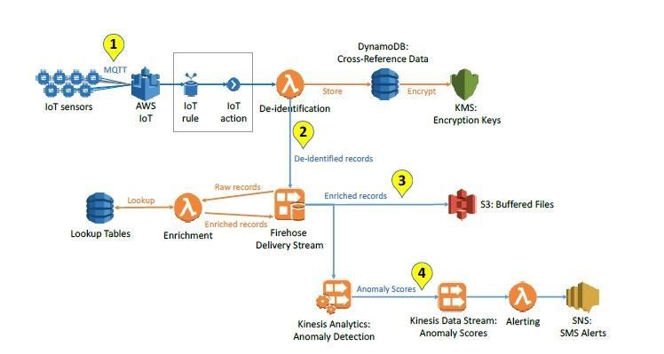

**KEY FEATURES:**

**IOT DEVICE:**

* Sensors, cameras, and other IoT devices are examples of IoT devices that collect data.

**DATA INGESTION:**

* IoT data is absorbed into the system during data ingestion. Cloud-based services like AWS IoT Core and Azure IoT Hub can be used for this.

**SERVERLESS FUNCTION:**

* Use serverless computing services like AWS Lambda, Azure Functions, or Google Cloud Functions to process data using serverless functions. This is where you build the code to handle incoming data and is the primary component of your serverless architecture.

**DATA STORAGE:**

* Processed data may be kept in serverless databases such as Google Cloud Firestore, Azure Cosmos DB, or AWS DynamoDB. It can also be forwarded to data warehouses or lakes for additional analysis.

**EVENT TRIGGERS:**

* Events serve as the triggers for serverless functions. These can be bespoke events created according to the logic of your program, time-based triggers, or data changes.

**SERVERLESS ORCHESTRATOR:**

* Use a serverless orchestrator, such as AWS Step Functions or Azure Logic Apps, to oversee the workflow of various serverless functions and to coordinate multiple serverless activities.

**DATA ANALYSIS AND INSIGHTS:**

* Data Analysis and Insights: Processed data can be evaluated in batch using serverless ETL (Extract, Transform, Load) operations or in real-time using serverless analytics tools.

**Output and Notifications:**

* Use serverless messaging services like AWS SNS, Azure Service Bus, or Google Cloud Pub/Sub to send notifications or alarms based on the studied data to the appropriate stakeholders.

**MONITORING AND LOGGING:**

* Implement serverless monitoring and logging tools to keep tabs on the system’s performance and health. This can be accomplished by using services like AWS CloudWatch, Azure Monitor, or Google Cloud Monitoring.

**Properties**:

* Adaptability
* Efficiency
* Personalization
* Automation
* Scalability
* Real-time Decision-Making
* Predictive Capabilities
* Fault Tolerance
* Learning from Experience
* Interconnectivity
* Security Enhancements

**DEVELOPMENT:**

The Internet of Things (IoT) has revolutionized the way we collect and process data from connected devices. Building a serverless IoT data processing solution using IBM Cloud Functions o ers a scalable and cost-e ective approach to handle the influx of data from various IoT devices. This report outlines the key components and steps to create such a solution.

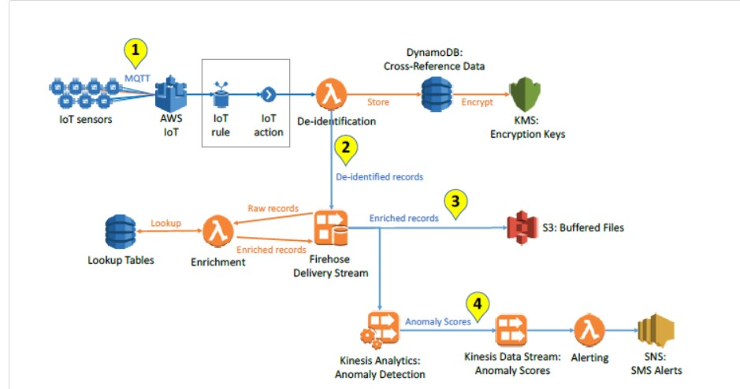

1. **Overview of Server Less Architecture:**

Serverless computing eliminates the need for managing server infrastructure and allows developers to focus on code execution.

IBM Cloud Functions is an event-driven, serverless compute platform that can be used to process IoT data e ciently.

1. **Device Integration:**

IoT devices, such as sensors and actuators, need to be integrated into the solution.

IoT device data can be collected using MQTT, HTTP, or other IoT protocols.

Data should be sent to an IoT platform for ingestion, such as IBM Watson IoT Platform.

1. **Data Ingestion:**

IBM Watson IoT Platform can be used to ingest data from devices.

It provides tools for device management, security, and data routing.

Data can be stored in a cloud-based database or data lake for further processing.

1. **Data Processing with IBM Cloud Functions:**

IBM Cloud Functions can be triggered by events, such as new data arriving in the IoT platform.

Use IBM Cloud Functions to process incoming data in a serverless environment.

Functions can be written in various programming languages, and third-party libraries can be used.

1. **Data Transformation and Analysis:**

IBM Cloud Functions can transform and analyze IoT data in real-time.

Perform data filtering, aggregation, and enrichment.

Utilize serverless functions to trigger alerts or notifications based on predefined rules.

1. **Data Storage and Visualization:**

Processed data can be stored in databases or cloud storage services.

Visualization tools or dashboards can be used to gain insights from the data. IBM Cloud services, like Cloudant or Db2, can be used for data storage.

1. **Scalability and Cost-E ciency:**

Serverless architecture automatically scales based on demand, reducing operational costs.

Pay only for the actual compute resources used during execution.

1. **Security:**

Implement proper security measures for device communication, data storage, and function execution.

Use encryption, access controls, and authentication.

**iX. Dataset:**

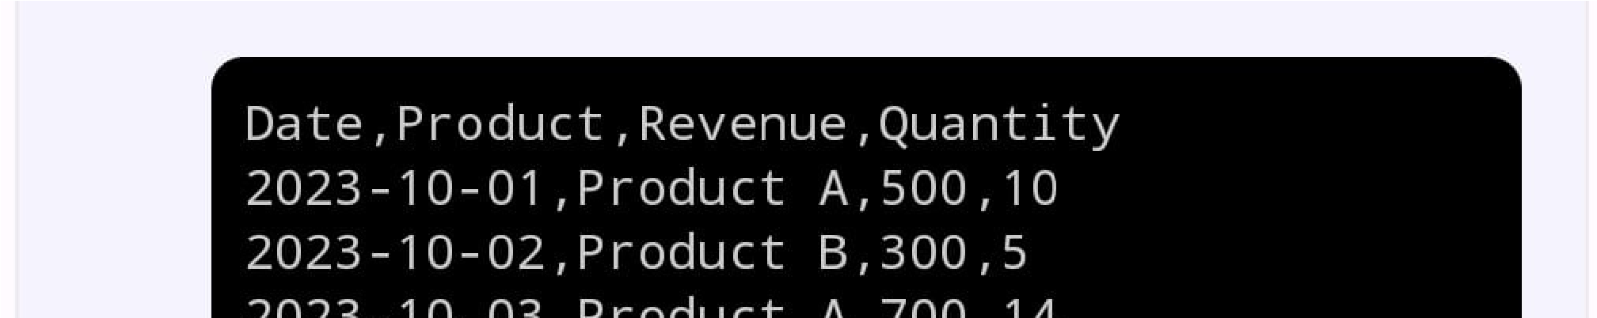

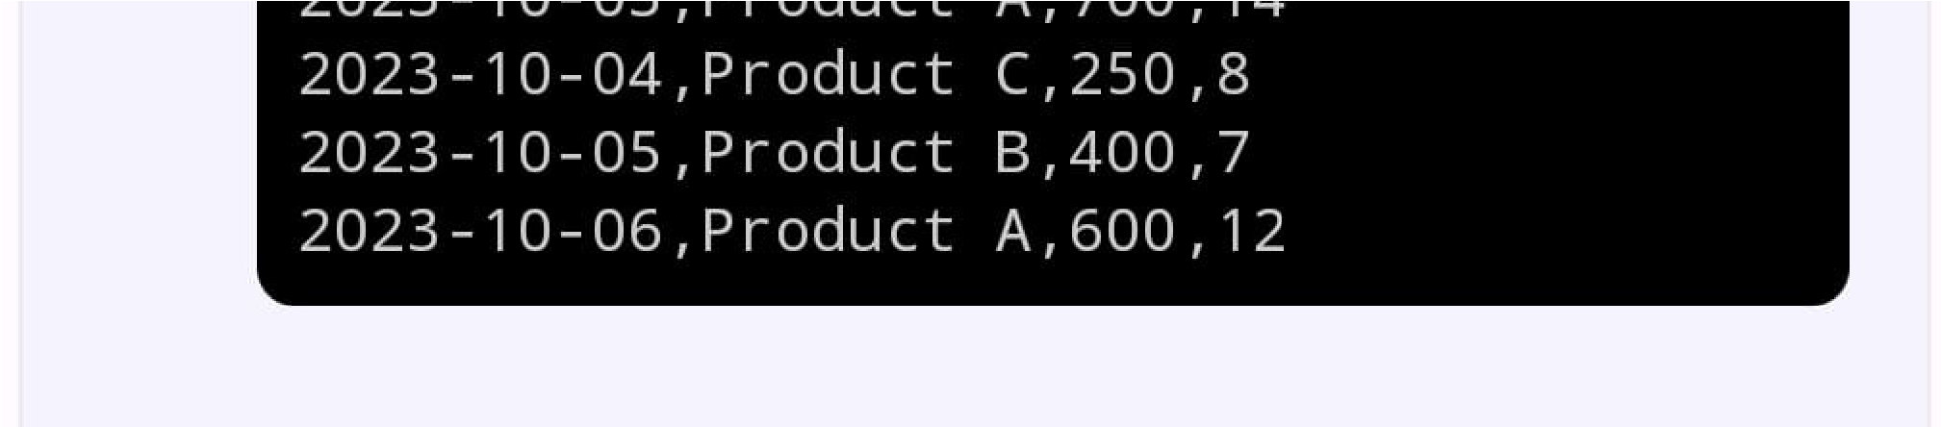

**X. Code:**

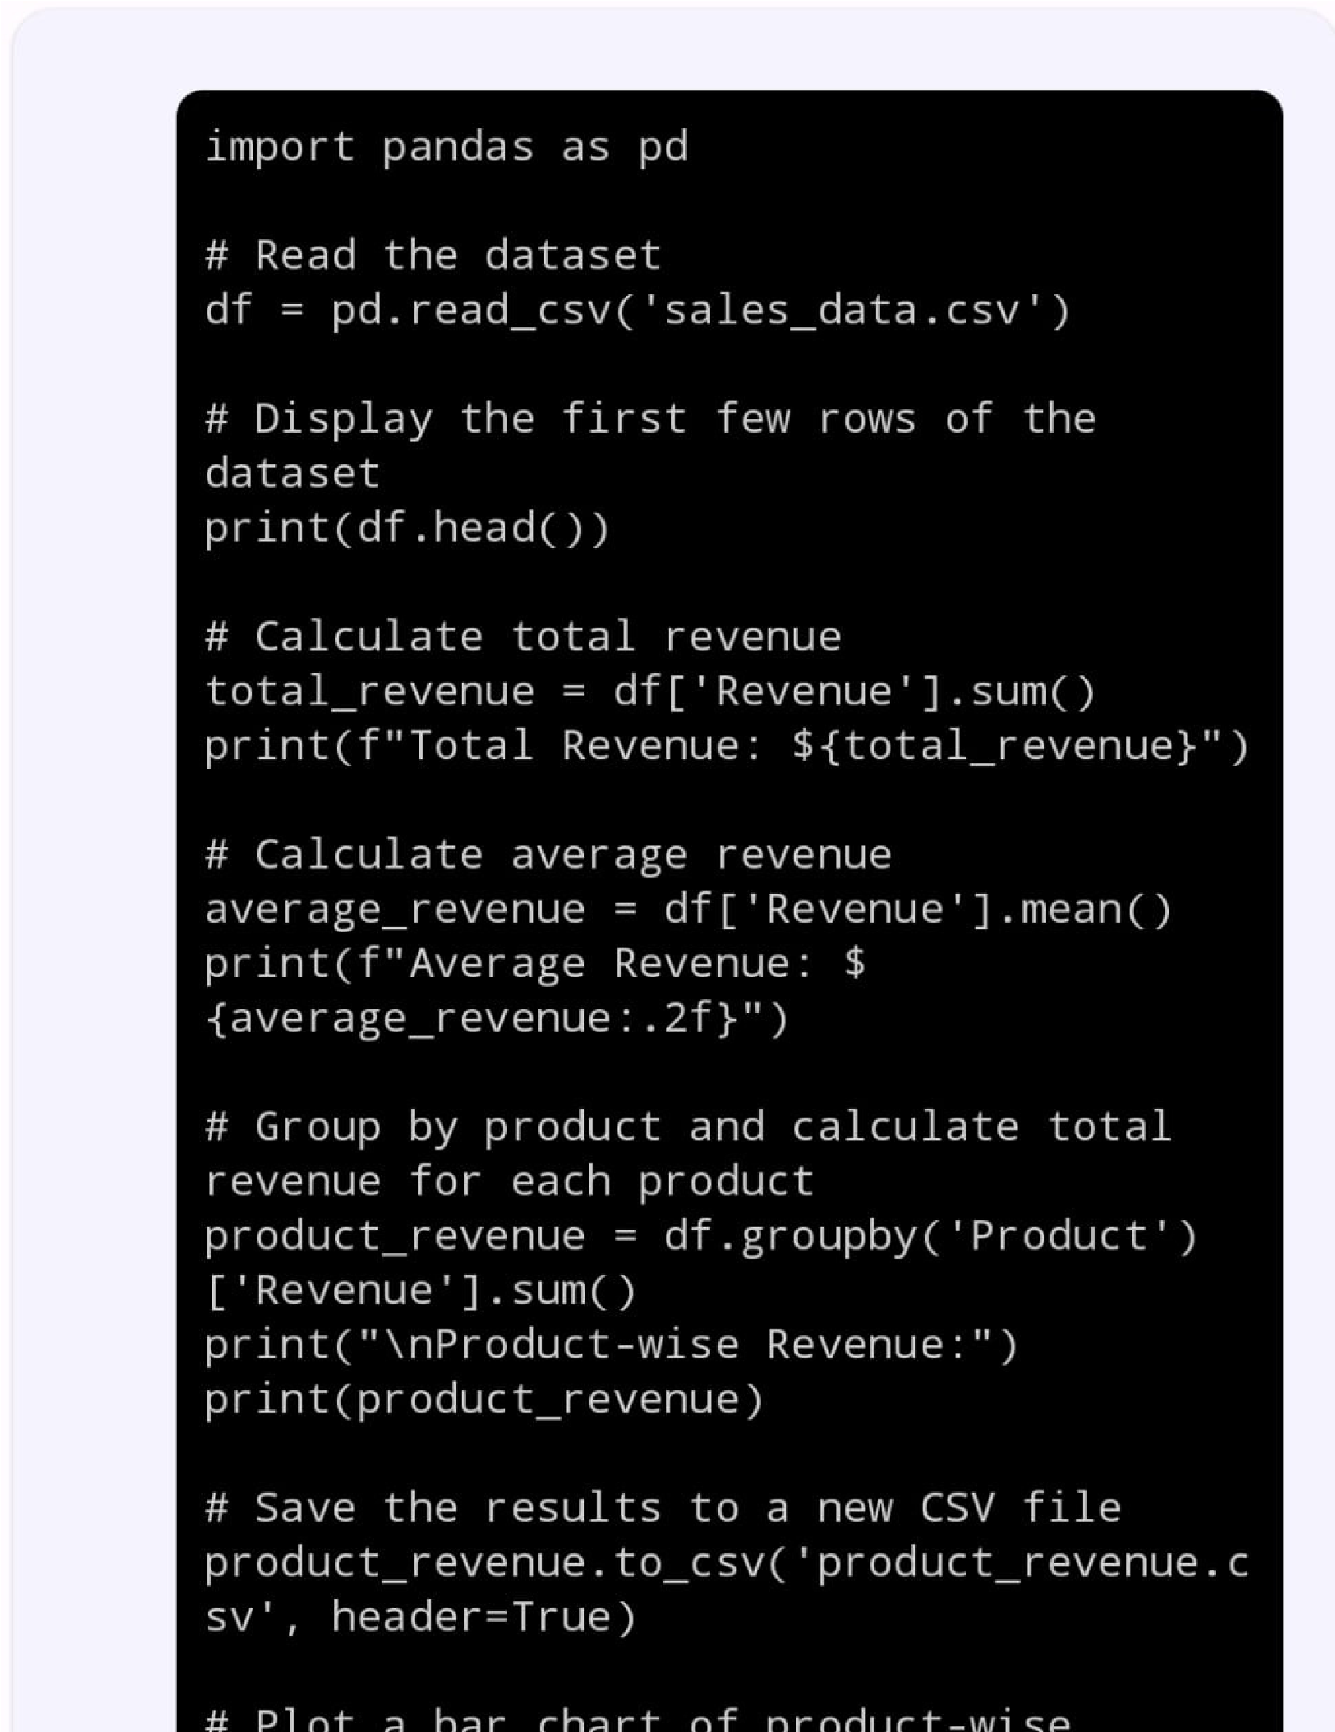

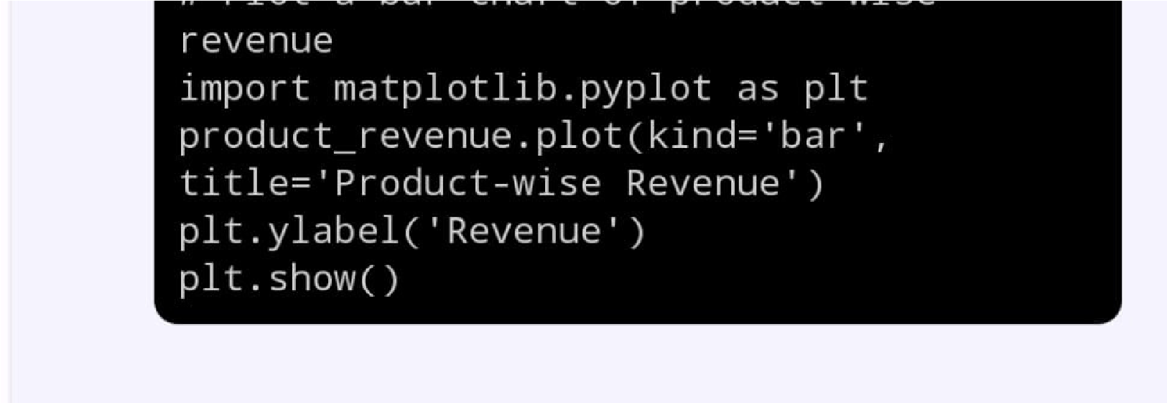

**STEPS FOR DEVELOPMENT**

* **Set Up IBM Cloud Account**: If you haven't already, sign up for an IBM Cloud account and create a project.
* **Create an IBM Cloud Object Storage Instance:** In the IBM Cloud dashboard, create an instance of IBM Cloud Object Storage to store your processed data.
* **Create IBM Cloud Functions**: Create serverless functions in IBM Cloud Functions that will process the incoming data and trigger automated routines. You can write these functions in a variety of programming languages supported by IBM Cloud Functions.
* **Configure Triggers:** Set up triggers for your functions to initiate them when new data arrives. For example, you can use HTTP triggers, message queues, or other event sources to trigger your functions.
* **Data Processing**: In your IBM Cloud Functions, implement the data processing logic. This could involve data transformation, validation, analysis, or any other processing required.
* **Automation:** Define automated routines within your functions. These routines can perform actions like sending notifications, updating databases, or triggering other functions.
* **Data Storage**: Once the data is processed and the automation is complete, store the processed data in your IBM Cloud Object Storage instance. You can use the IBM Cloud Object Storage SDK or APIs to upload the data.
* **Data Analysis:** For data analysis, you can use various tools and services that integrate with IBM Cloud Object Storage. You might choose to use IBM Watson services or any other analytics tools.
* **Monitoring and Scaling:** Implement monitoring and scaling strategies to ensure the system runs smoothly and can handle varying workloads.
* **Security and Compliance**: Make sure to implement appropriate security measures and comply with data protection regulations if applicable.

**IMPLEMENTING REAL TIME DATA PROCESSING,AUTOMATION AND STORAGE**

* **Define Your Requirements:**
  + Identify the specific data sources and types you need to process in real-time.
  + Determine the automation tasks you want to perform.
  + Understand the storage needs for the processed data.
  + **Example**: "We need to process sensor data from IoT devices in real-time, automate anomaly detection, and store the processed data for further analysis."
* **Choose Data Processing Technologies:**
  + Flink Select a real-time data processing framework or platform, such as Apache Kafka, Apache, or Apache Spark Streaming.
  + Set up the necessary data pipelines to ingest, process, and transform data in real-time.
  + **Example**: "We'll use Apache Kafka for data ingestion and Apache Flink for real-time data processing. Our data pipeline will include producers to collect IoT sensor data and Flink jobs for processing."
* **Implement Automation:**
  + Develop automation scripts or use automation tools like Ansible or Puppet to perform tasks such as data quality checks, alerts, and notifications.
  + **Example**: "We'll use Ansible playbooks to automate the deployment of anomaly detection algorithms and send alerts when anomalies are detected."
* **Choose Data Storage Solutions:**
  + Select a storage solution that suits your data storage needs, such as databases (SQL or NoSQL), data lakes, or cloud storage services.
  + Set up the necessary data storage infrastructure to store processed data.
  + **Example**: "For storing the processed data, we'll use a combination of Apache Cassandra for real-time storage and Amazon S3 for long-term storage in a data lake."
* **Develop Data Processing and Automation Logic:**
  + Write code to process incoming data streams.
  + Implement automation logic to trigger actions based on predefined criteria.
  + **Example**: "We will develop Flink jobs in Java to process IoT sensor data and Python scripts for automation. The Flink jobs will calculate real-time statistics, while the Python scripts will automate alert generation."
* **Testing and Validation:**
  + Thoroughly test the entire system to ensure it processes data in real-time, automation works as expected, and data is stored correctly.
  + **Example**: "We will conduct extensive testing using simulated data to verify that the real-time data processing and automation components are functioning properly. We'll validate data storage and retrieval as well."
* **Monitoring and Maintenance:**
  + Implement monitoring and alerting systems to keep track of system performance and anomalies.
  + Set up regular maintenance and updates for the system.
  + **Example**: "We will use monitoring tools like Prometheus and Grafana to keep an eye on system performance. Routine maintenance will include updating data processing logic and ensuring the automation scripts are up-to-date."
* **Scaling and Optimization:**
  + Plan for scaling the system as data volume and processing needs increase.
  + Continuously optimize the system for better performance and cost-efficiency.
  + **Example**: "We'll monitor resource usage and implement auto-scaling for data processing clusters. Additionally, we will conduct regular performance tuning to optimize resource utilization."
* **Documentation and Training:**
  + Create documentation for the system architecture, data flow, and automation procedures.
  + Train the relevant teams on how to use and maintain the system.
  + **Example**: "We will document the system architecture and automation procedures using Confluence and provide training sessions for the operations and data science teams."
* **Security and Compliance:**
  + Ensure data security and compliance with relevant regulations by implementing authentication, authorization, and encryption measures.
  + **Example**: "We will implement role-based access control, encrypt data in transit and at rest, and conduct regular security audits to comply with data privacy regulations like GDPR."

**USE IBM CLOUD FUNCTIONS TO PROCESS DATA AND TRIGGER AUTOMATED ROUTINES**

* **Create Triggers:**
  + Set up triggers to monitor data source events. Triggers can be created in response to various types of events:
  + HTTP request triggers for incoming HTTP requests.
  + Message queue triggers for events from message brokers like IBM Message Hub or Apache Kafka.
  + Time-based triggers for scheduled tasks.
  + External service triggers for integrating with external APIs.
* **Sequence Your Actions:**
  + Define sequences to orchestrate a series of actions.
  + Sequences allow you to specify a chain of actions that should be executed in a specific order, enabling more complex workflows.
* **Automate Routines:**
  + Use rules to associate triggers with specific actions or sequences.
  + Rules specify which actions should be executed when a particular trigger event occurs.
  + This step effectively automates the execution of your routines when the trigger conditions are met.
* **Scaling and Monitoring:**
  + IBM Cloud Functions automatically scales based on the incoming workload, so you don't have to manage server provisioning or scaling.
  + Utilize the built-in monitoring and logging features to track the performance and execution of your serverless functions.
* **Testing and Validation:**
  + Thoroughly test your actions, sequences, and triggers using sample data or actual data sources.
  + Ensure that the automation rules are responding correctly to trigger events.
* **Security and Authentication:**
  + Implement proper security measures, including access controls, authentication, and encryption, to protect your data and functions.
  + Leverage IBM Cloud Identity and Access Management (IAM) for user and resource access control.
* **Documentation and Maintenance:**
  + Create comprehensive documentation that describes your IBM Cloud Functions setup, actions, triggers, sequences, and automation rules.
  + Plan for ongoing maintenance, updates, and optimization of your serverless functions.

**Data Sources**: Data sources include incoming customer support tickets submitted through a web form or API.

**Action Functions:** Develop action functions in Node.js to process support tickets. These functions may categorize tickets, assign them to support agents, and send automated responses.

**Triggers:** Set up triggers that monitor incoming support ticket submissions via HTTP requests.

**Sequences:** Create sequences to handle the ticket processing workflow, which may include categorization, assignment, and response actions.

**Automation Rules**: Define rules to associate the HTTP request triggers with the appropriate sequences. For instance, when a new support ticket is submitted, it triggers the ticket processing sequence.

**Scaling**: IBM Cloud Functions automatically scales to handle an increased number of support ticket submissions during peak hours.

**STORE PROCESSED DATA IN IBM CLOUD OBJECT STORAGE FOR ANALYSIS**

* **Generate Service Credentials:**
  + To access your IBM Cloud Object Storage from your applications or scripts, you need to create service credentials.
  + Go to your Object Storage instance, select "Service credentials," and create a new set of credentials. These credentials will provide the necessary access permissions.
* **Write Code for Data Storage:**
  + Depending on your programming language and environment, you'll need to write code to interact with the IBM Cloud Object Storage service.Use the IBM Cloud SDK or relevant APIs for your language to upload the processed data to the storage buckets.
  + Make sure to use the service credentials you generated to authenticate the API calls.
* **Automate Data Storage:**
  + Integrate data storage as part of your automated data processing workflow. This could be done by adding a step in your automation routines to upload the processed data to the appropriate storage bucket.
* **Data Categorization and Organization:**
  + Organize your data within the storage buckets, considering the structure that makes sense for your analysis. This might involve creating subfolders, using naming conventions, or using metadata.
* **Data Retention Policies:**
  + Consider setting up data retention policies and versioning as needed. This helps manage the lifecycle of your data, especially if you have regulatory or compliance requirements.
* **Access Control and Security:**
  + Configure access control to ensure that only authorized users or applications can access the data stored in IBM Cloud Object Storage.
  + Implement encryption to protect data at rest and in transit.
* **Backup and Disaster Recovery:**
  + Implement backup and disaster recovery plans to ensure data integrity and availability.
* **Documentation and Metadata:**
  + Maintain documentation that describes the structure and content of the data stored in IBM Cloud Object Storage.
  + Use metadata to provide additional information about the stored data, making it easier to search and understand.

**PROGRAM CODE:**

import ibm_boto3

from ibm_botocore.client import Config

cos_credentials = {

"apikey": "your-api-key",

"resource_instance_id": "your-resource-instance-id",

"endpoint_url": "your-endpoint-url",

}

cos = ibm_boto3.client(

"s3",

ibm_api_key_id=cos_credentials["apikey"],

ibm_service_instance_id=cos_credentials["resource_instance_id"],

ibm_auth_endpoint="https://iam.cloud.ibm.com/identity/token",

config=Config(signature_version="oauth"),

endpoint_url=cos_credentials["endpoint_url"],

)

bucket_name = "your-bucket-name"

object_key = "data/processed_data.csv"

with open("processed_data.csv", "rb") as data:

cos.uploa