

**SWEET WORLD GROUP OF COMPANIES**

**IMPORT SUPPLIER INVOICE**

**END USER MANUAL**



**MUKESH INFOSERVE PRIVATE LIMITED, CHENNAI**

**DEC 2021**

**END USER MANUAL**

**Import Supplier Invoices**

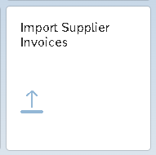

**Note:**

**Purchase-order-based invoices are not supported.**

Without PO Invoice (Multiple Line Items Upload with SAP Format):

**Step 1:**

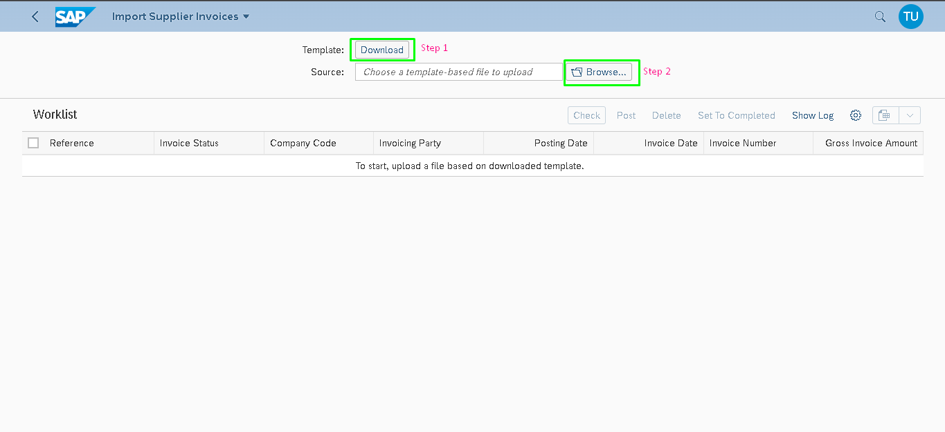

**Step 2:**

Upload Excel Sheet:



**Step 3:**

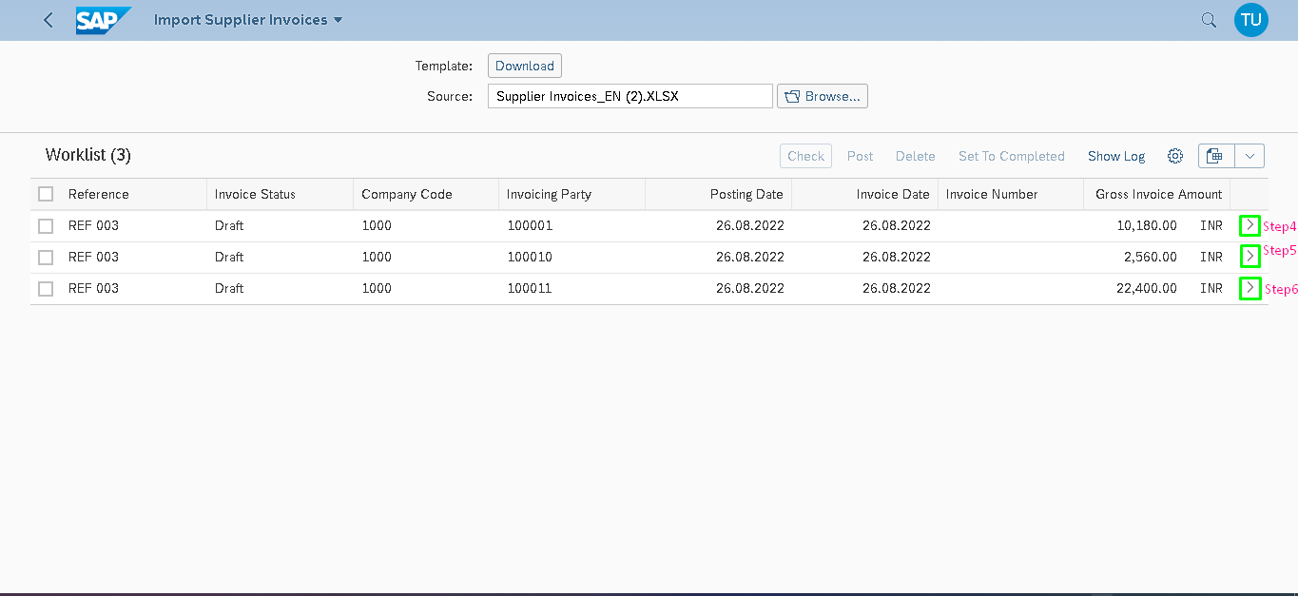

**Step 4:**

Document Posted

Check Doc No: 190012

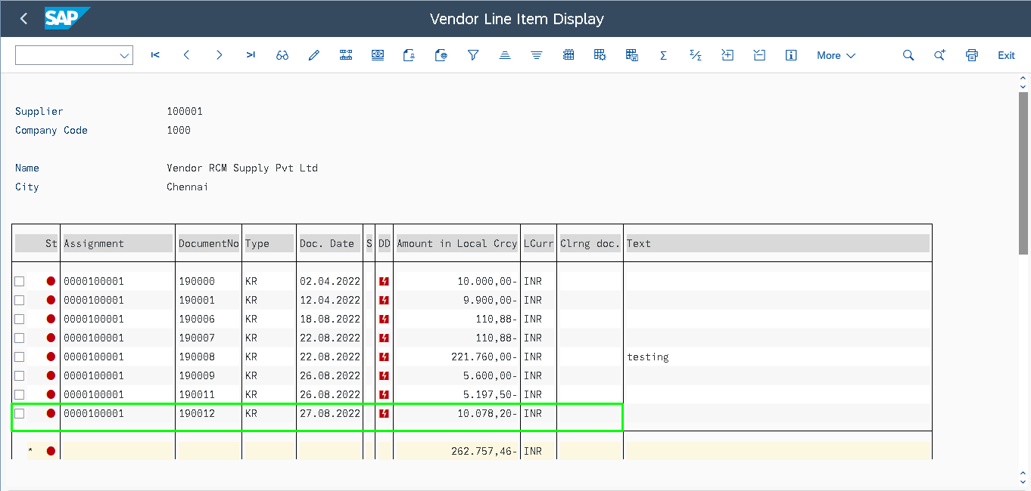

**Step 5:**

Document Posted

Check Doc No:190013

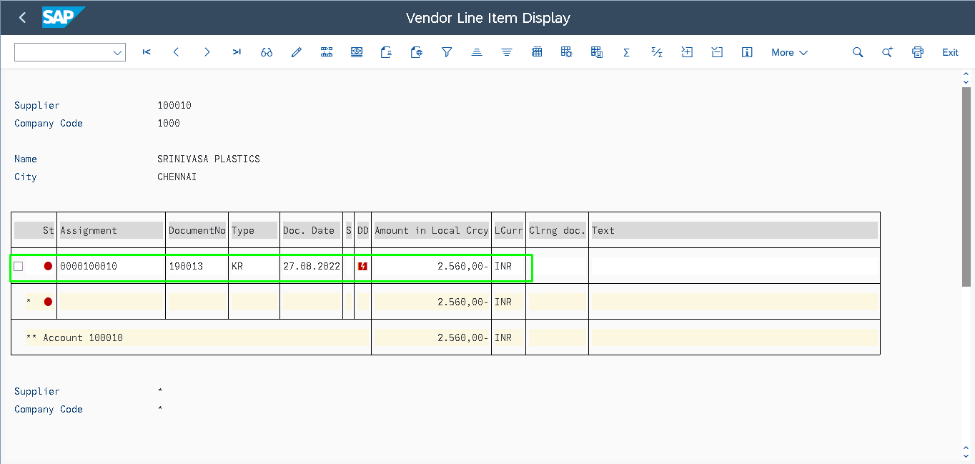

**Step 6:**

Document Posted

Check Doc No:190014

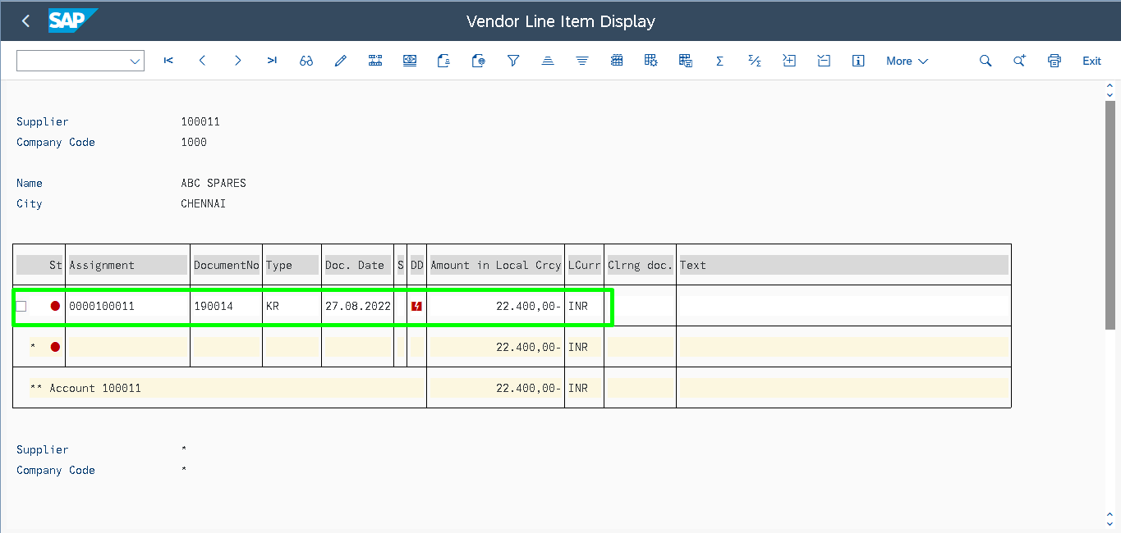

--------------------------------------------------------------END------------------------------------------------------------