**Scheduling Agreement Process with MRP Process**

A Scheduling Agreement is a long term agreement with a vendor for the supply of material with condition valid for predefined period and a predefined total purchase quantity.

Without release documentation(Document type LP)

The delivery schedule lines have official character-that is to say,they are transmitted to the vendor as they are saved in the system.The system does not document in detail releases aganist the scheduling agreement that have been sent to the vendor.Therefore,in the case of the document type without release documentation,the message control facility should be set up in such a way that a message is immediately sent to vendor if any changes are made to the delivey schedule stored in the system.

With release documnetation(Document type LPA)

If you use scheduling agreement with release documentation,the delivery schedule lines are not transmitted directly to the vendor.Intially ,the lines of the delivery schedule stored in the system for an LPA scheduling agreement for an internal information only.A message informing the vendor of your material requirements cannot be transmitted to the vendor until you explicitly create an SA release,that is forecast (FRC) or Just in Time(JIT) delivey schedule.Through this process,you can change the way schedule lines are represented.With release documentation,you can disply the SA releases(delivery schedules) transmitted to a vendor over a certain period of any time.This enables you to trace precisely when you sent which information to vendor

Advantages:

Scheduling agreement for avoid large number of standard po or contract release order.this reduce processing time and amount of paper work.

Company has maintain minimum warehouse stock as most of stock holding with fulfil by vendor with ultimately reduce the inventory stock

It enables negotiations with vendor for more favourable conditions

Purchase Info Record

1. Info record is a master data containing lastest price for a material / vendor combination for a period.

2. Prices in info record will be automatically picked while creating PO. Once it is saved in info record, it is the master data.

3. You dont have to enter manually the price in schedule agreement or PO if there is PIR available.

4. If theer is any change in price , it has to be updated in info record master and this will be latest price and it will be picked in purchasing documents.

5. You can store data on basic price and other conditions in info record

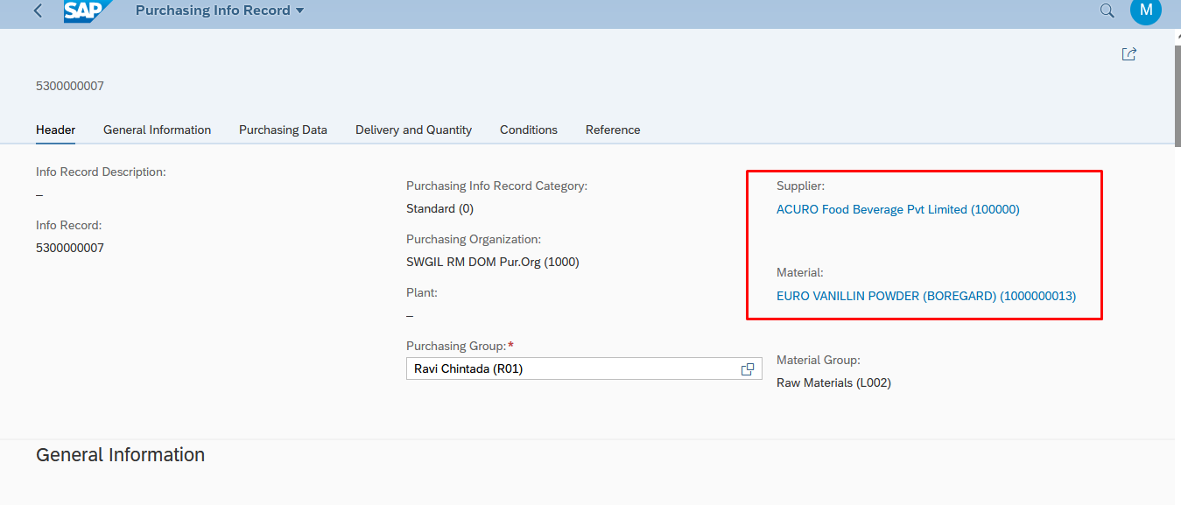

Source List

In the source list, we must ensure that there is a reference to the scheduling agreement and that the field 'Source List Usage in Materials Planning (MRP)' is set to '2 Record relevant to MRP. Sched. lines generated automatically' if we want to have schedule lines created automatically

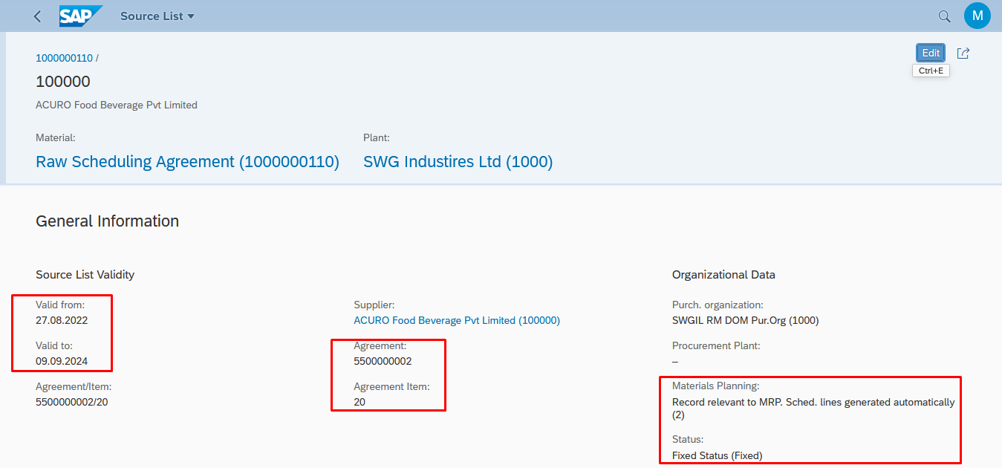

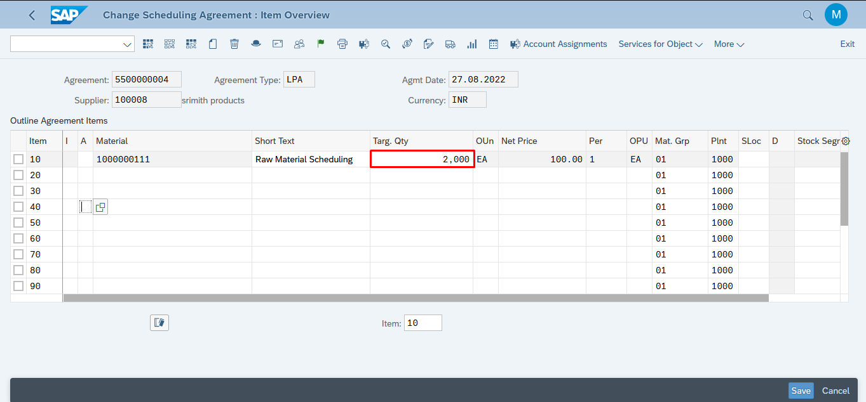

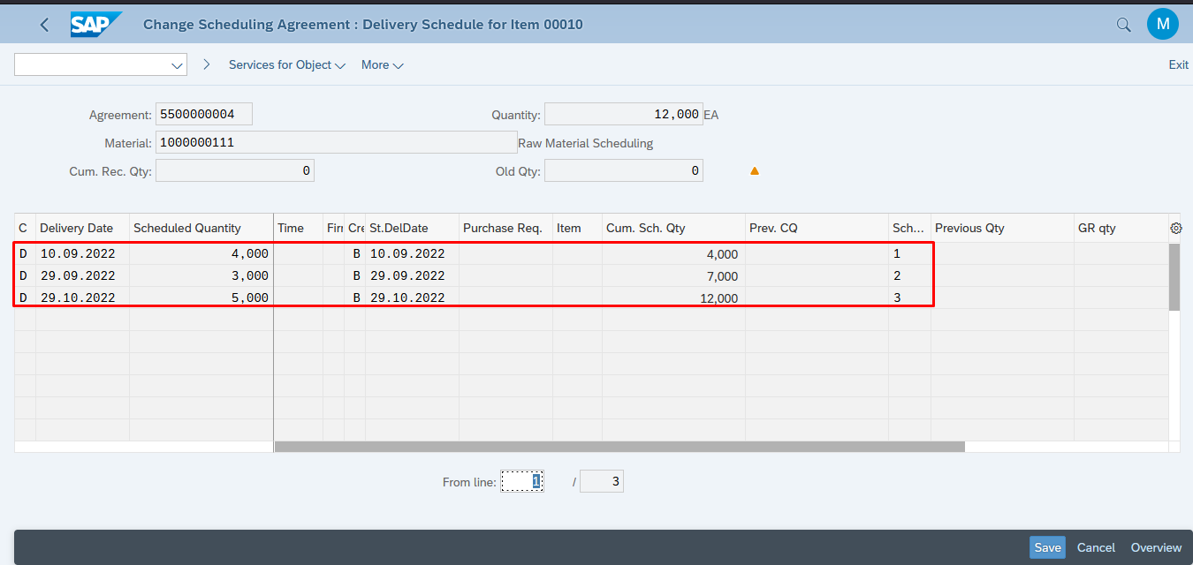

**SAP MRP Profile**

[SAP material master](https://erproof.com/mm/free-training/sap-mm-material-master/) has four MRP views in it, viz., MRP 1, MRP 2, MRP 3 and MRP 4 views.

**MRP 1 view**: This view contains fields that are relevant to general data, MRP procedure, and lot size data.

**MRP 2 view**: In this view, fields pertaining to procurement data, scheduling, and net requirements calculation are maintained.

**MRP 3 view**: Fields pertaining to forecast requirements, planning, availability check, and plant specific configuration are maintained in this MRP 3 view.

**MRP 4 view**: This view has fields that are required for BOM explosion/dependent requirements and repetitive manufacturing.

### **PP-VIEW EXTENSION IN MATERIAL MASTER (FG):**

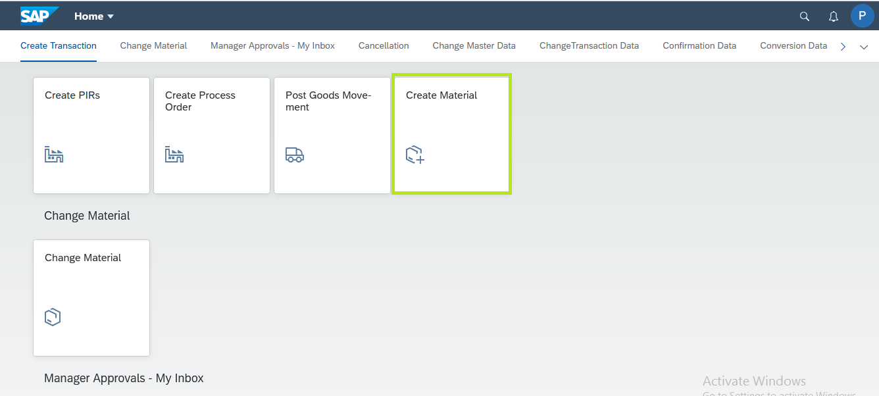

**In SAP Fiori screen**:

**\*Log on** **🡪** **Create material**

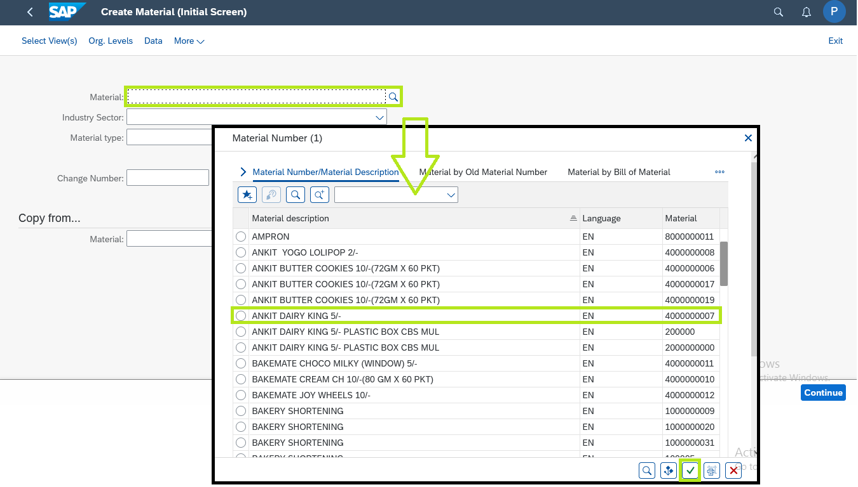

* **Choose the required**

**Material and plant**

### **PP-VIEW EXTENSION IN MATERIAL MASTER (FG):**

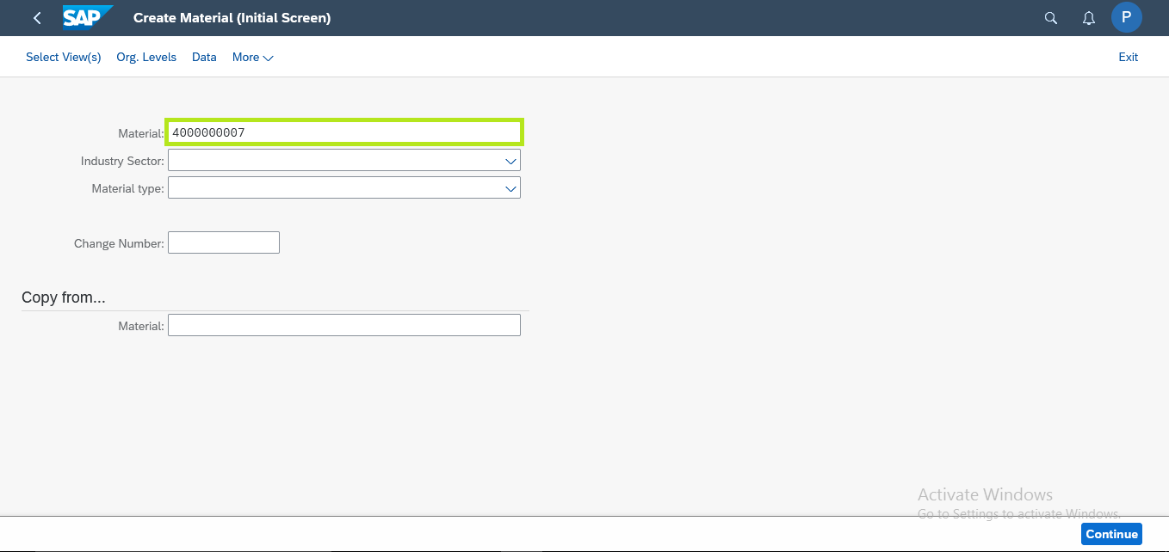

* **After choosing the material code**

**Click enter**

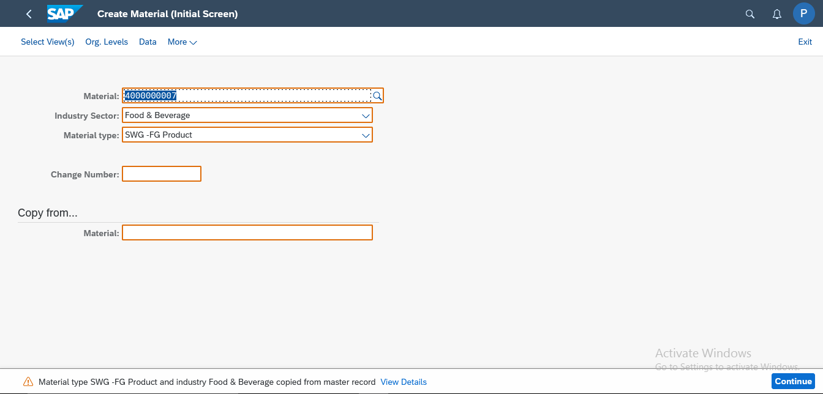

* **After clicking the enter**
* **You can able to see the description of the material as per the master data**
* **Again click enter**

**PP-VIEW EXTENSION IN MATERIAL MASTER (FG):**

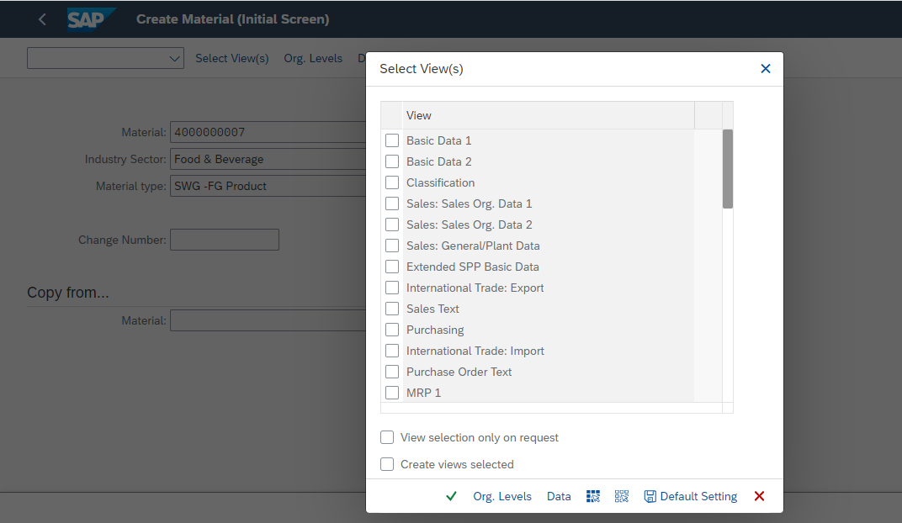

* **Here you can see Select view pop up**

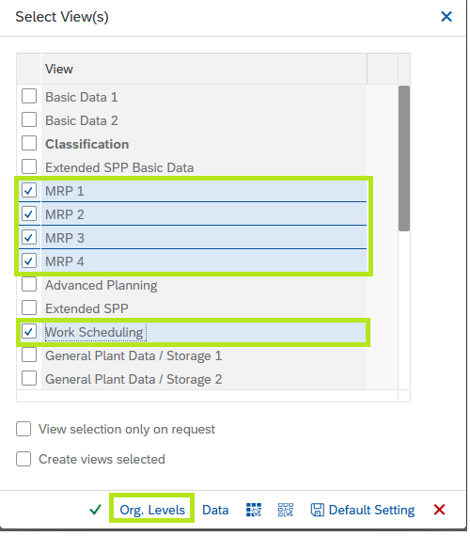

* **For FG material, you should Tick MRP1, MRP2, MRP3, MRP4 and Work Scheduling**
* **And then click Org.Levels icon**

**PP-VIEW EXTENSION IN MATERIAL MASTER (FG):**

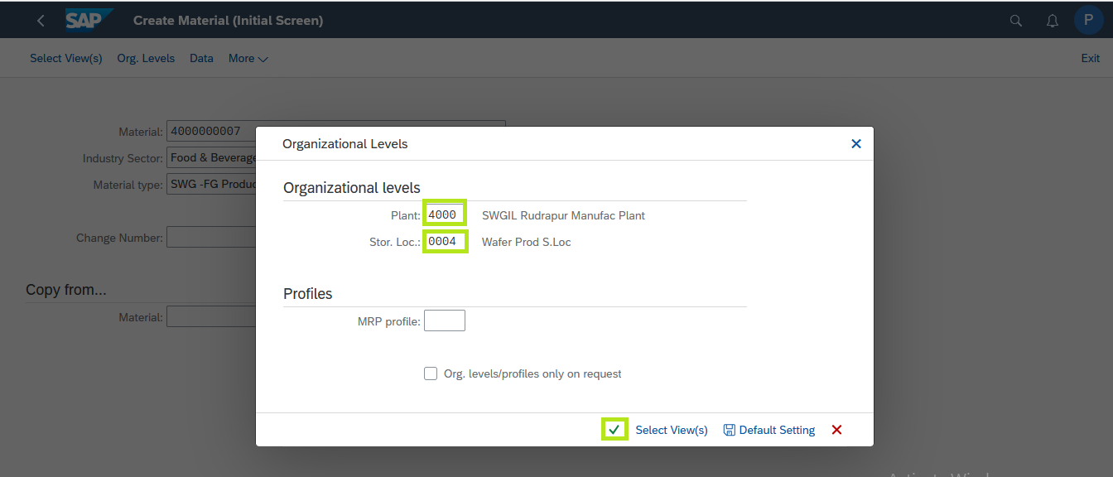

* **In organizational levels, choose the required plant code for example “4000”**
* **Click tick icon.**

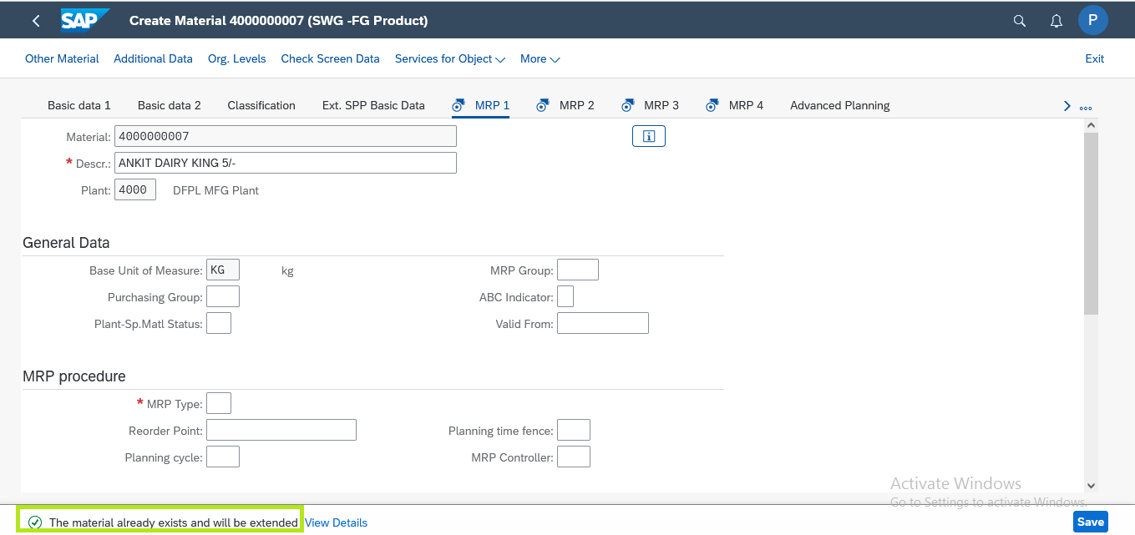

* **In this screen, you can able to extend the 5 views for FG material**

**PP-VIEW EXTENSION IN MATERIAL MASTER (FG):**

**In MRP 1,**

* **Choose the required MRP type for example “PD”**
* **Choose the required MRP Controller For example “RU1”**

**Choose the Lot Sizing Procedure For example “EX**

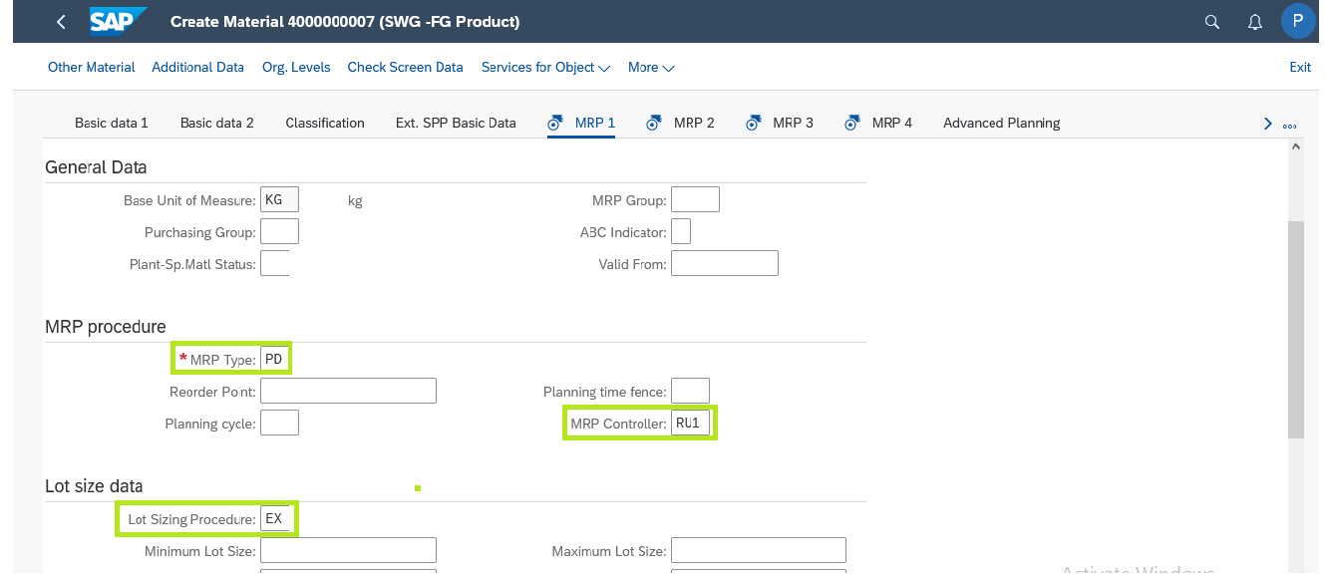

**In MRP 2,**

* **Choose the required procurement type for example “E”**
* **Choose the required production storage location for example “008”**
* **Enter the required In house production value for example : 1 days**

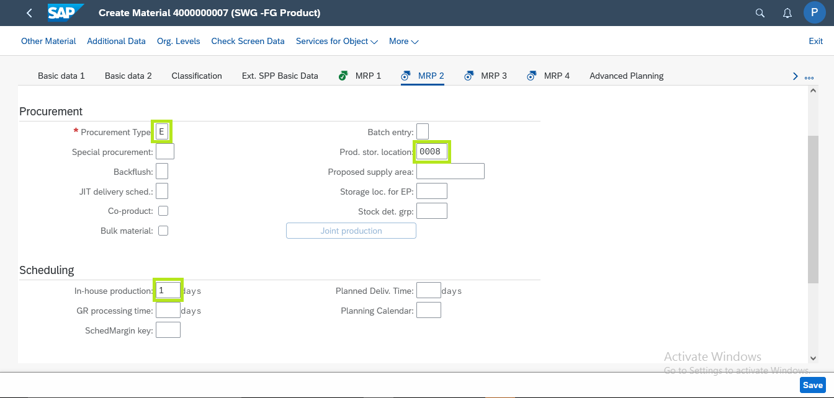

* **PP-VIEW EXTENSION IN MATERIAL MASTER (FG):**

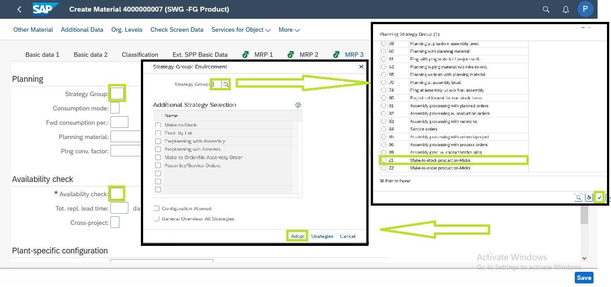

**In MRP 3,**

* **1. Choose the required Strategy group for example “Z1”**

**2. Choose the required availability check**

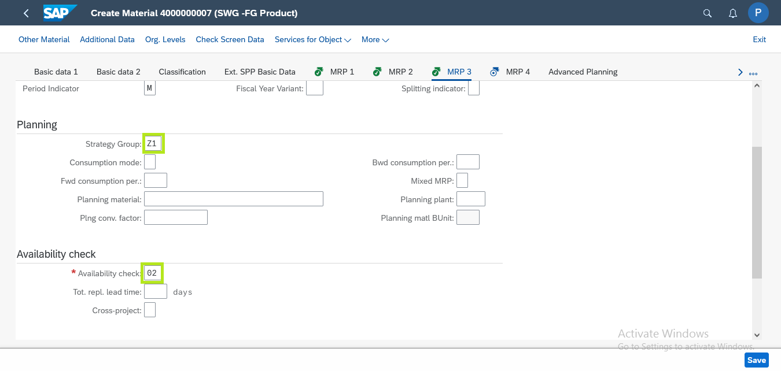

* **After choosing the required strategy group**
* **Choose the availability check for example “02”**
* **PP-VIEW EXTENSION IN MATERIAL MASTER (FG):**
* **In MRP 4,**
* **No changes required Here**
* **Just extend the view**

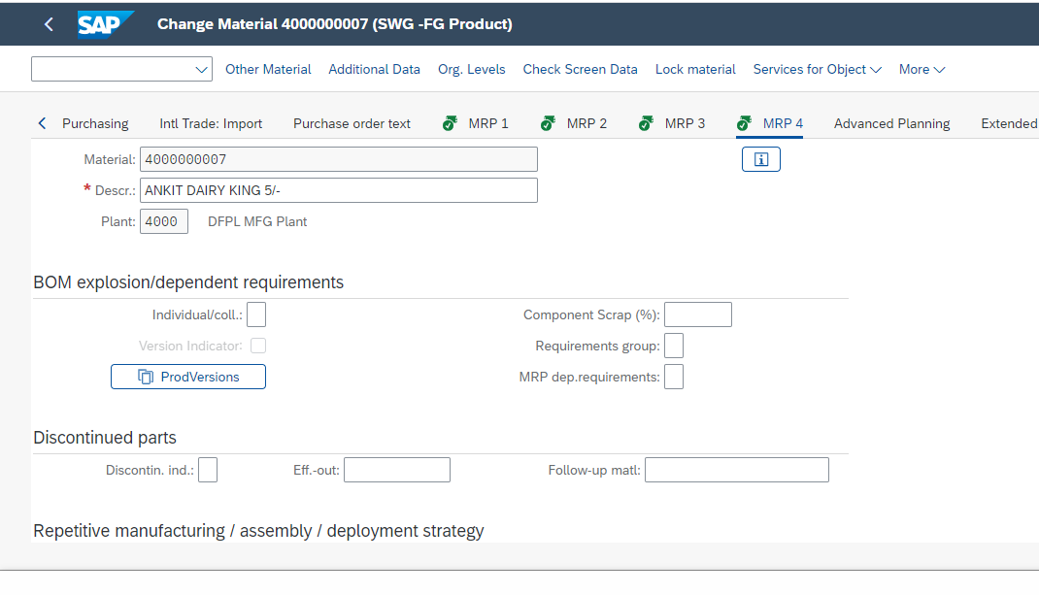

**In Work scheduling View:**

* **Choose the required Production scheduling profile for example “DDOM”**
* **Click tick icon**

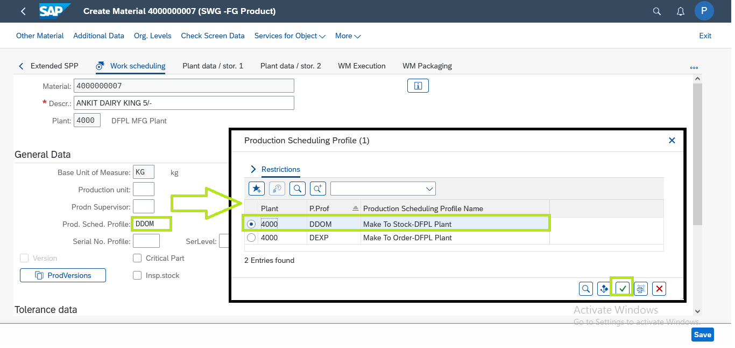

* **PP-VIEW EXTENSION IN MATERIAL MASTER (FG):**
* **After entering all the values**

**Click save**

