

XCMG Testing Screenshot -PP

Test Scenario:1

|  |  |  |  |  |
| --- | --- | --- | --- | --- |
| **Material** | **Material Type** | **MRP Type** | **Procurement Type** | **Strategy Group** |
| 310409429 | FG | PD | E | 10 |
| 960600000085 | SFG-1 | ND | F | NIL |
| 960600000087 | SFG-2 | ND | F |
| 960700000040 | RM-1 | ND | F |
| 960700000051 | RM-2 | ND | F |

Master data Creation:

Bill of Material- Finished Goods: 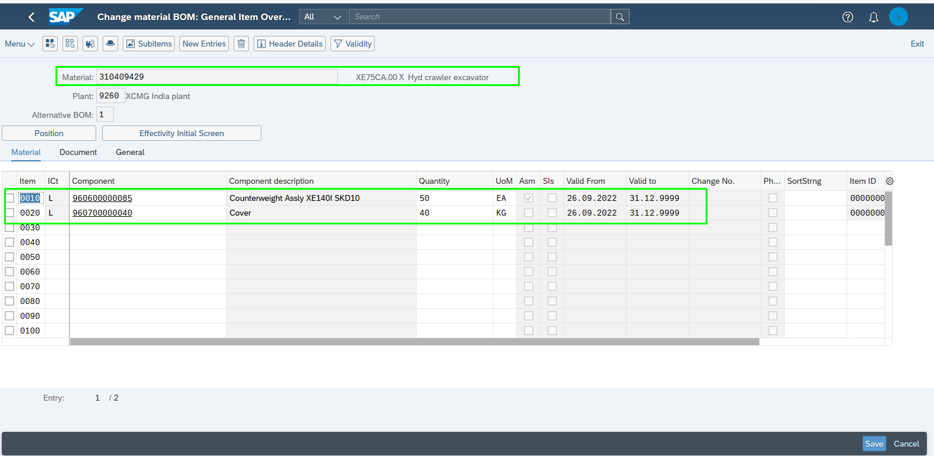

Bill of Material- Semi Finished Goods-1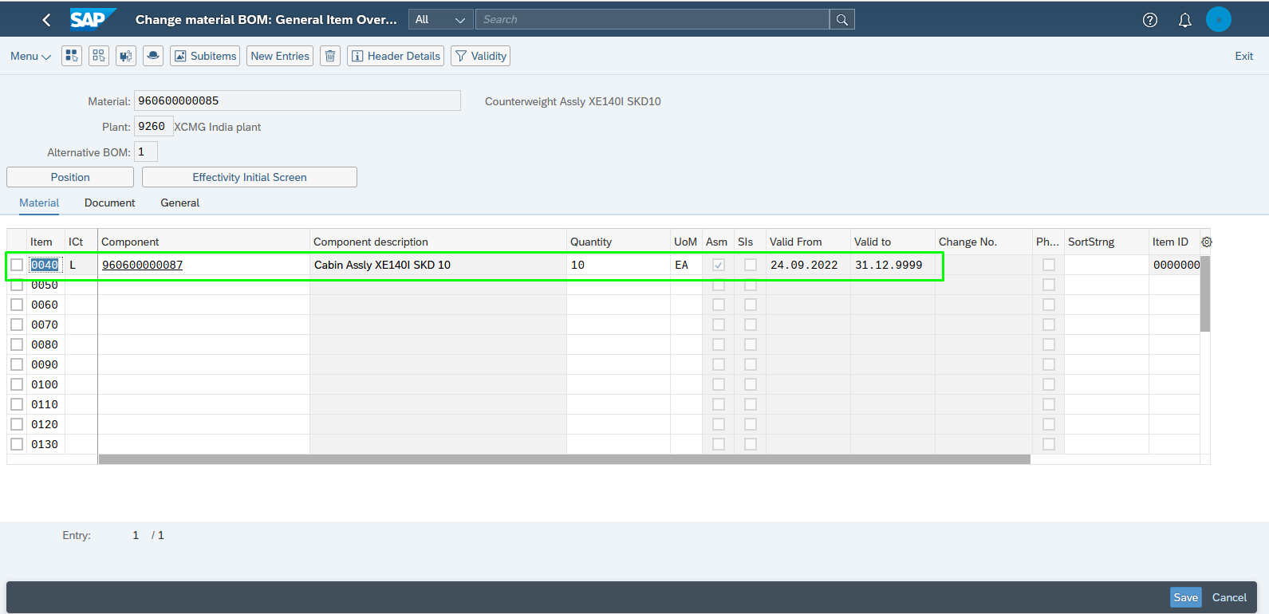

Bill of Material- Semi Finished Goods-2:

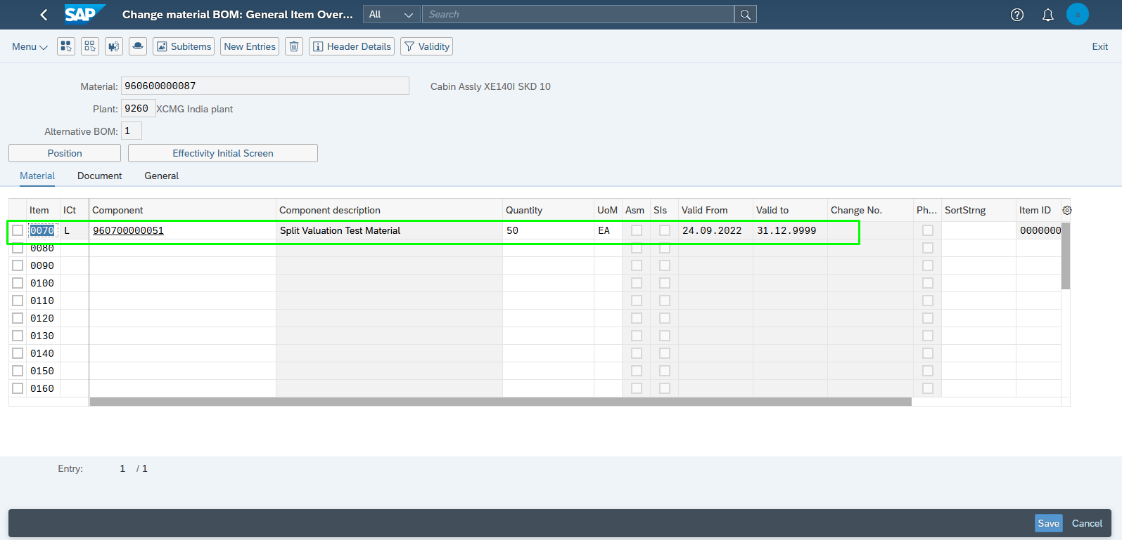Maintained Material Master- Finished Goods:

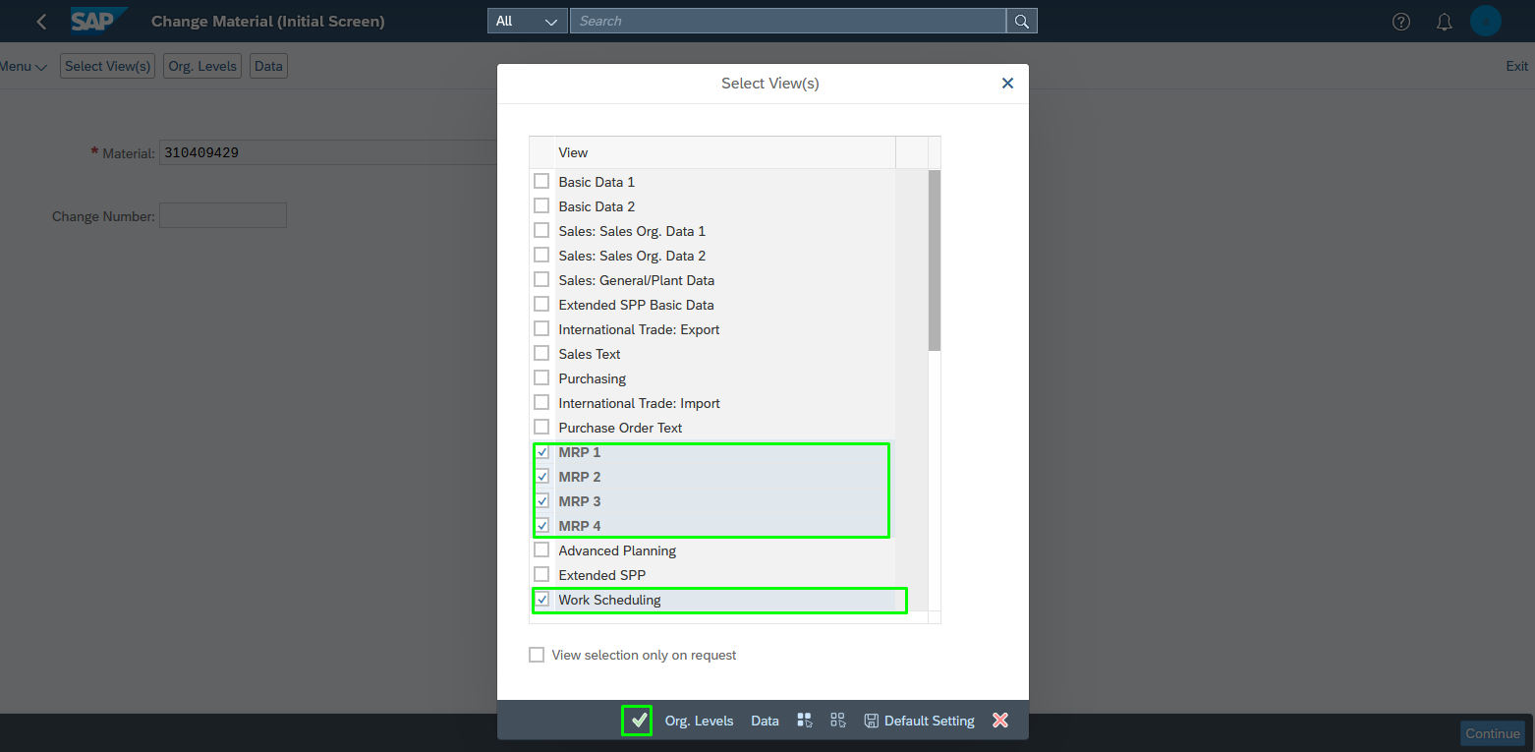

MRP VIEW -1: 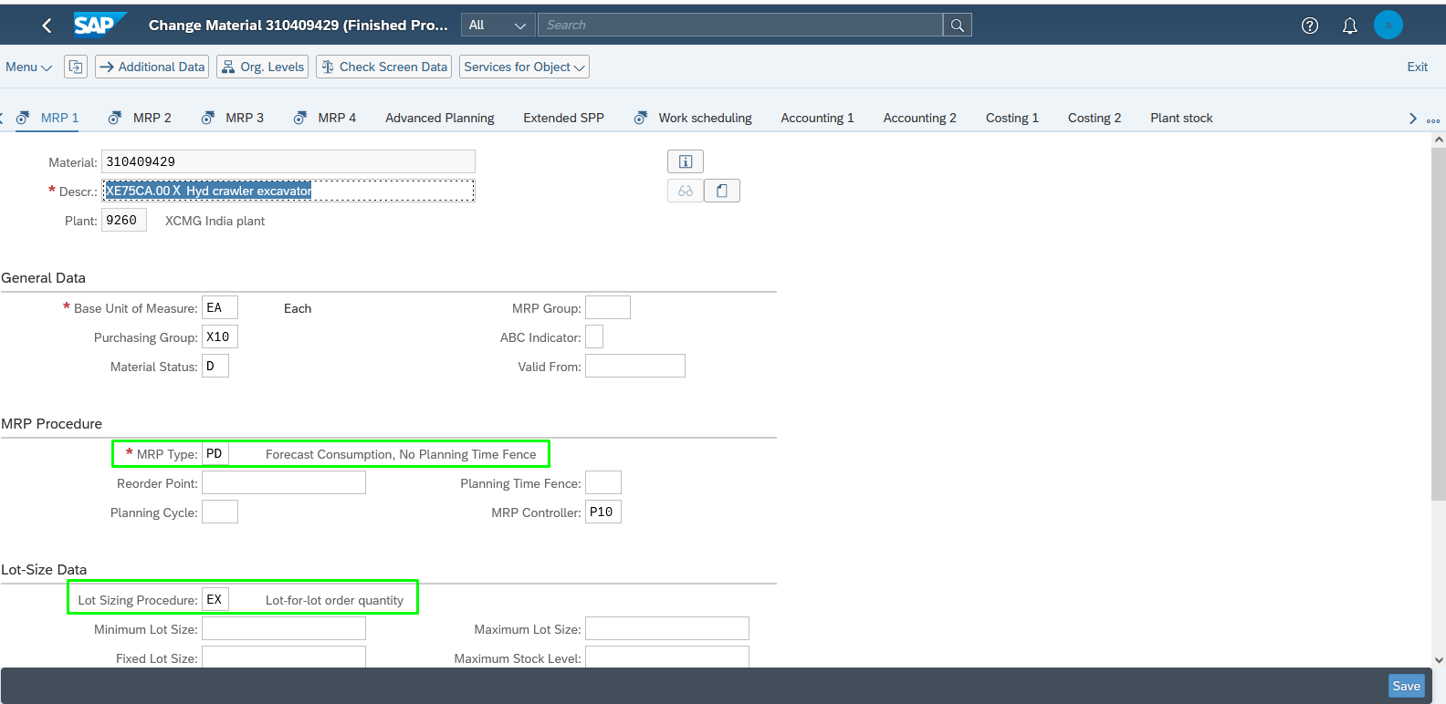

MRP VIEW -2: 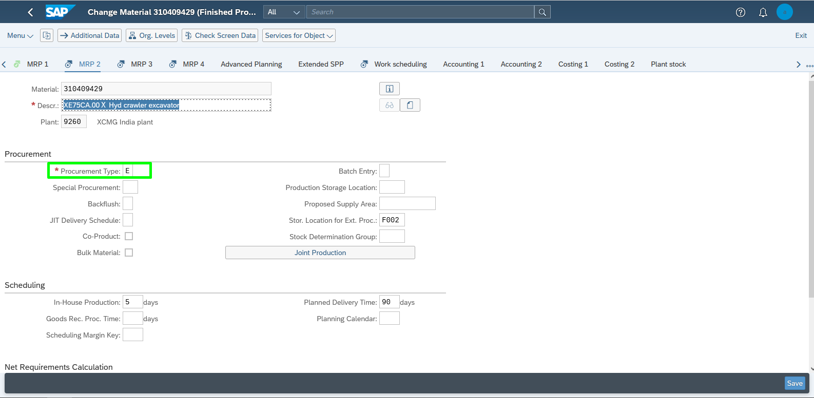

MRP VIEW -3: 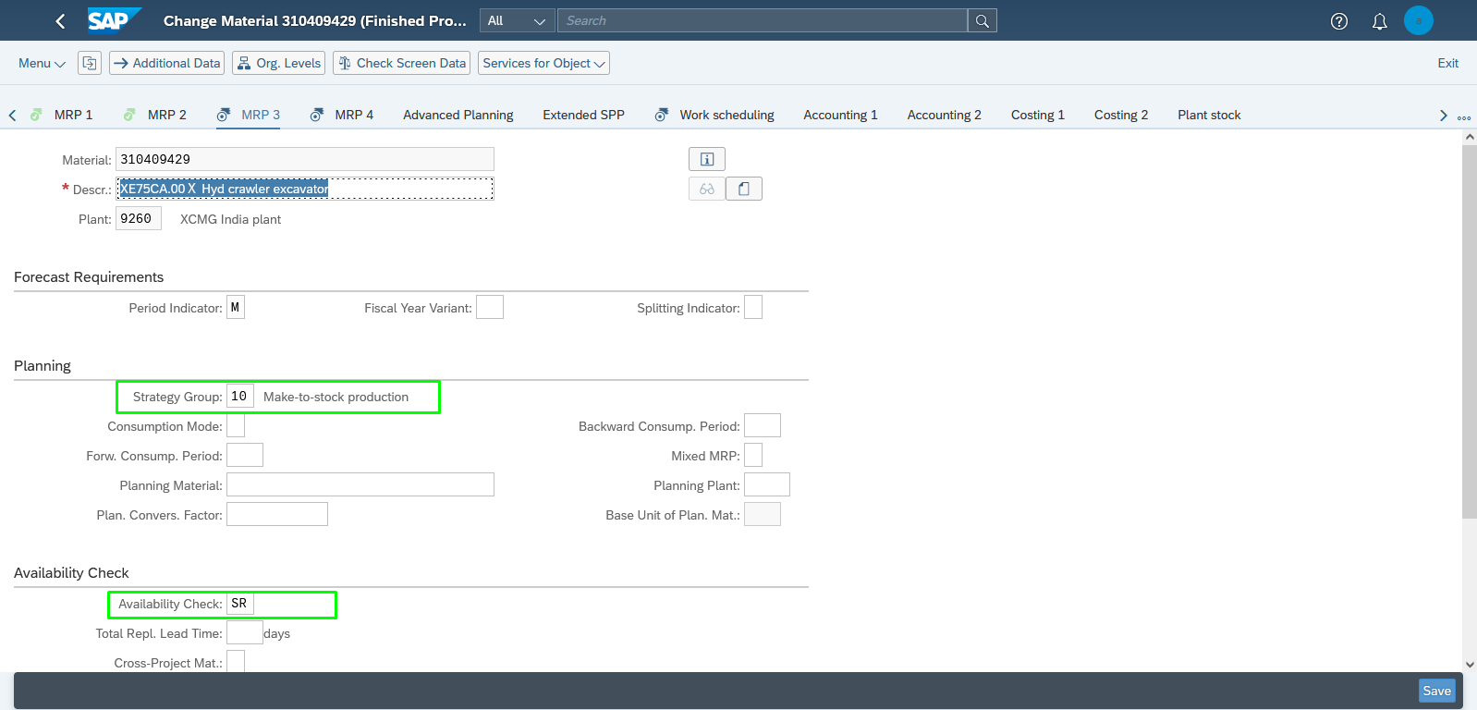

MRP VIEW -4: 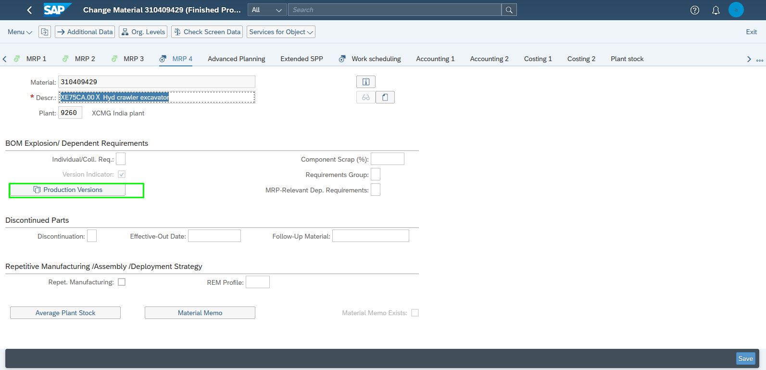Work Scheduling view: 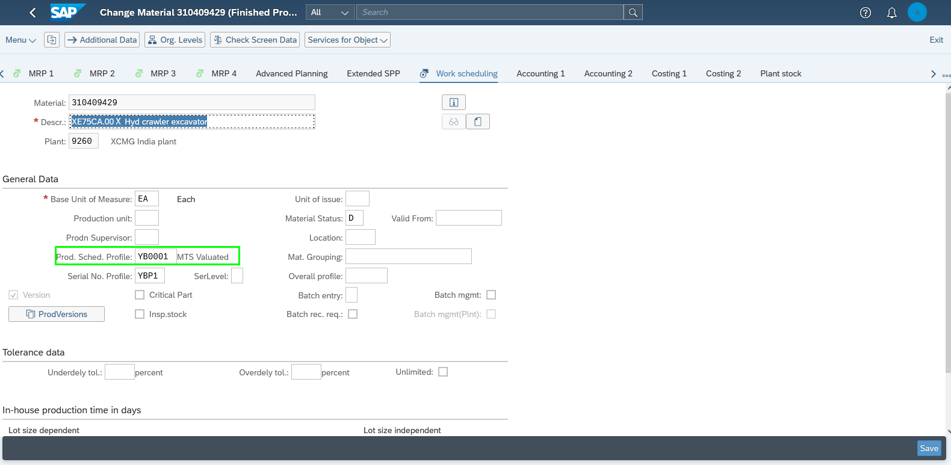

Maintain Material Master- Semi Finished Goods-2:

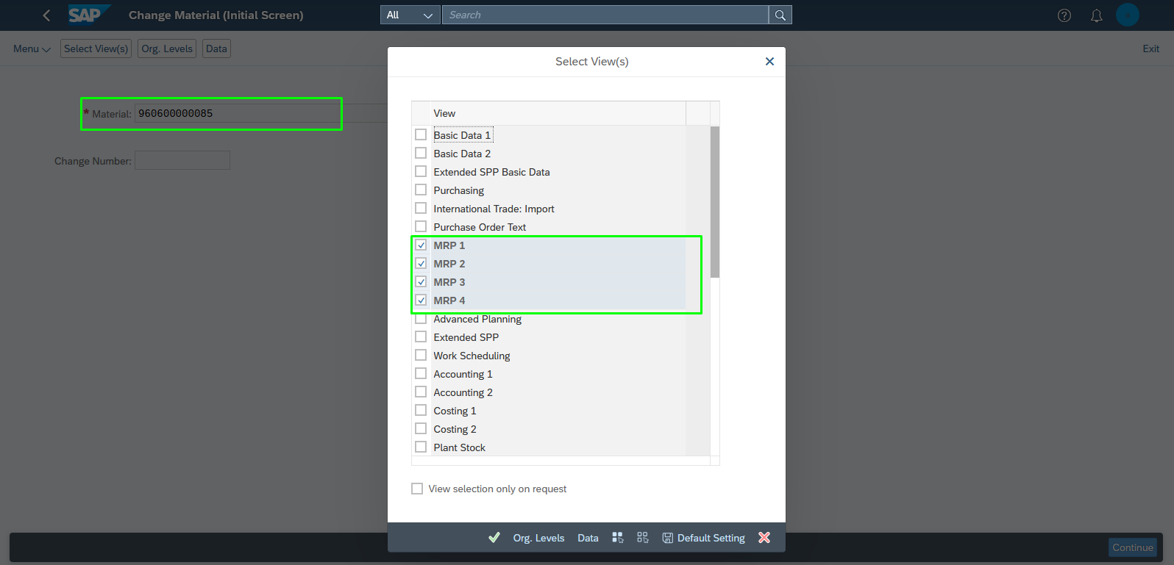

MRP VIEW -1: 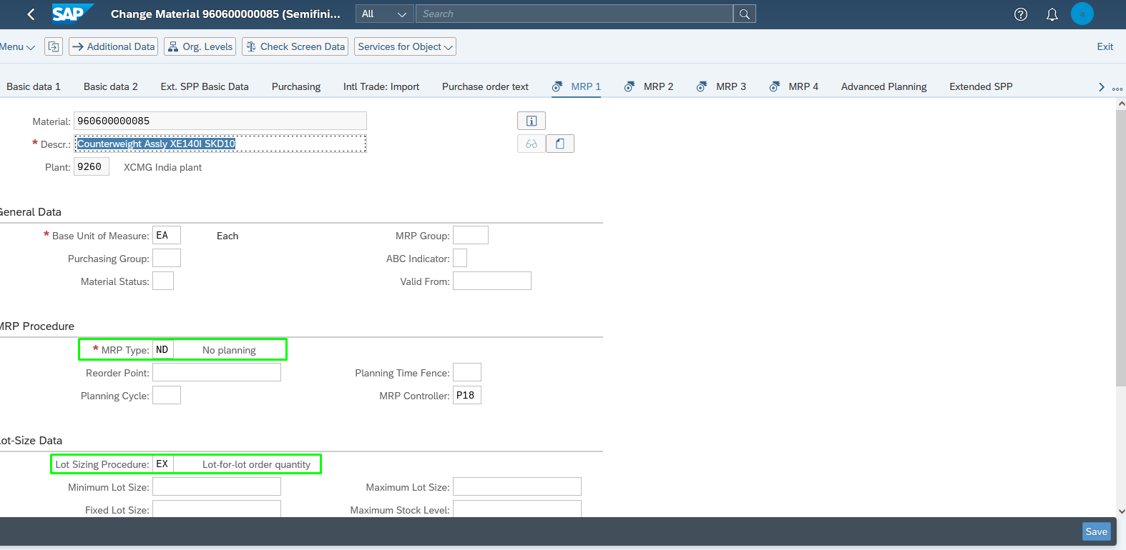

MRP VIEW -2: 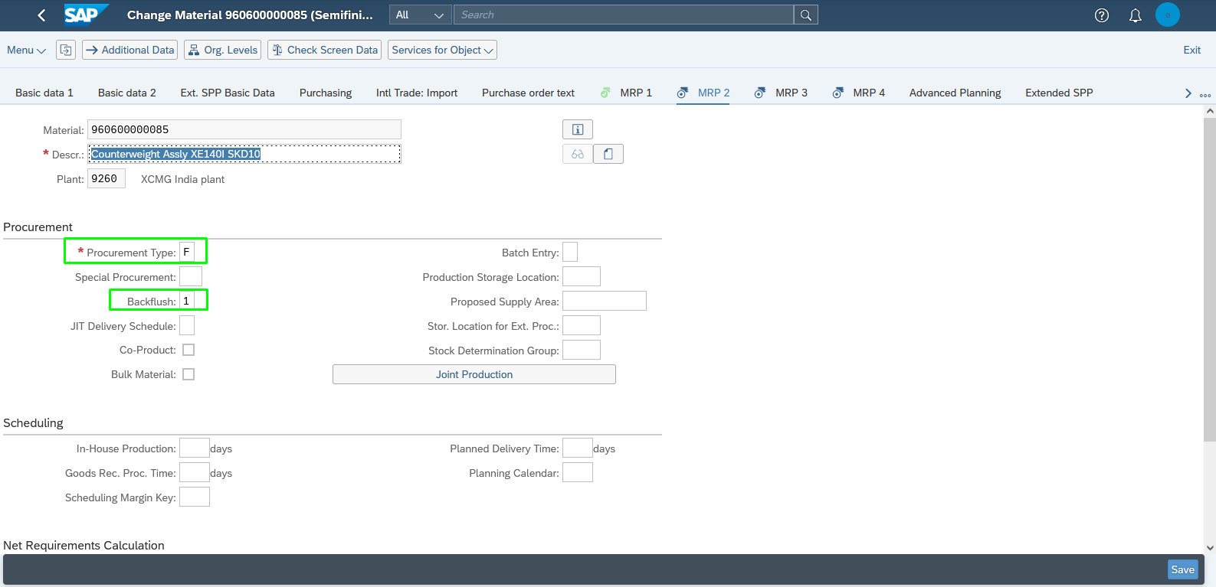

MRP VIEW -3: 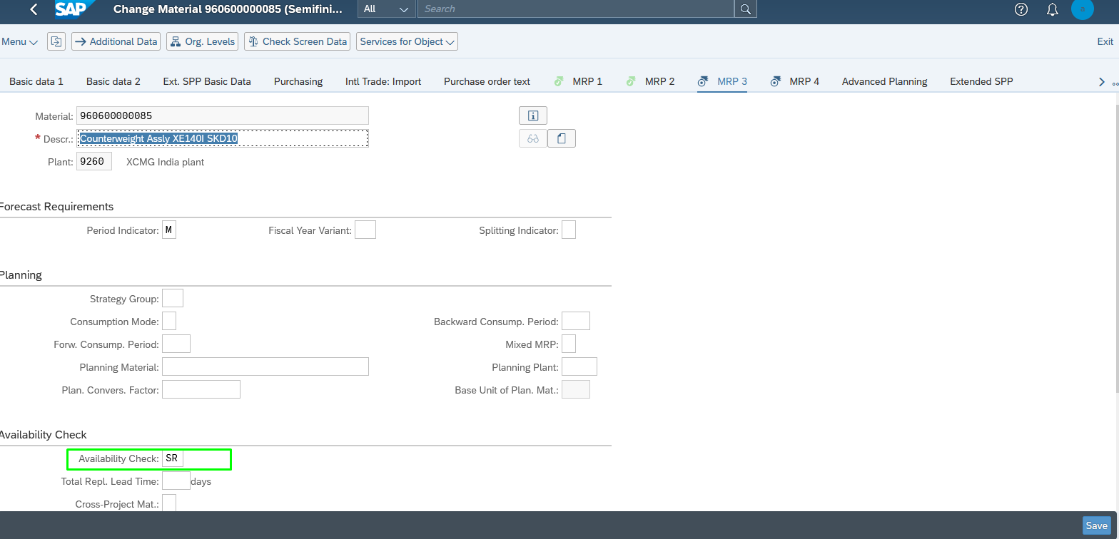

MRP VIEW -4: 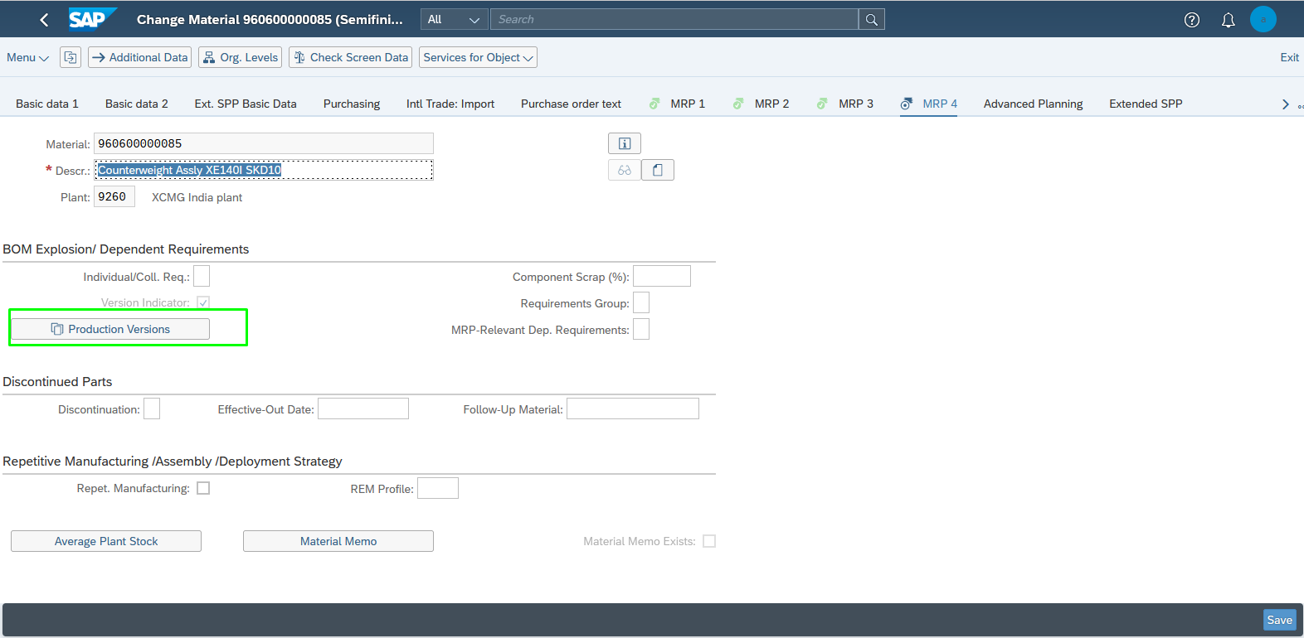Maintain Material Master- SemiFinished Goods-2: 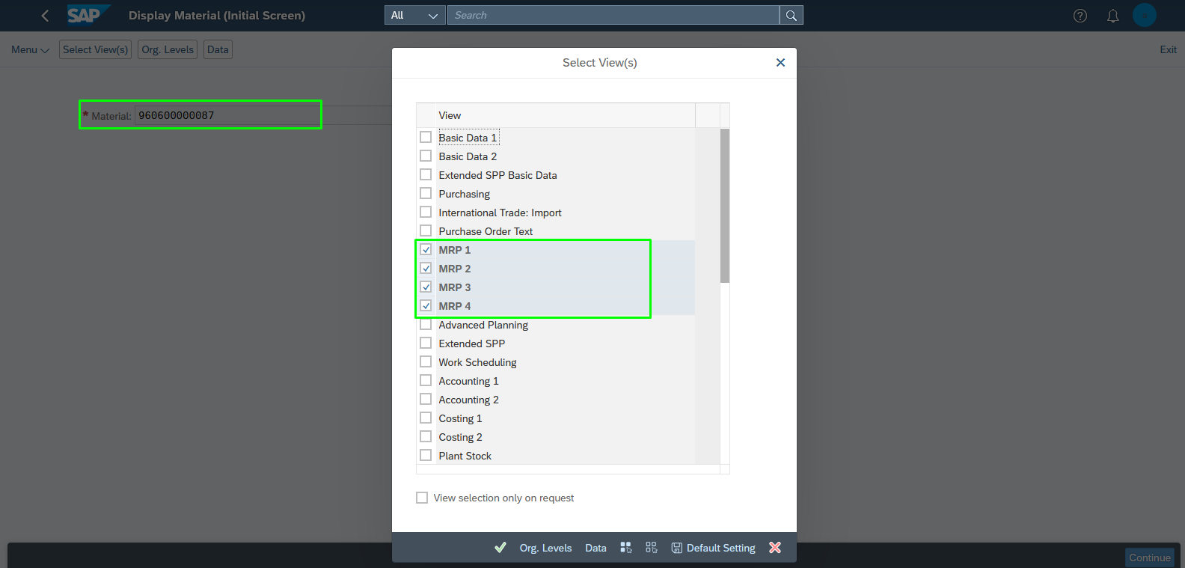

MRP VIEW -1: 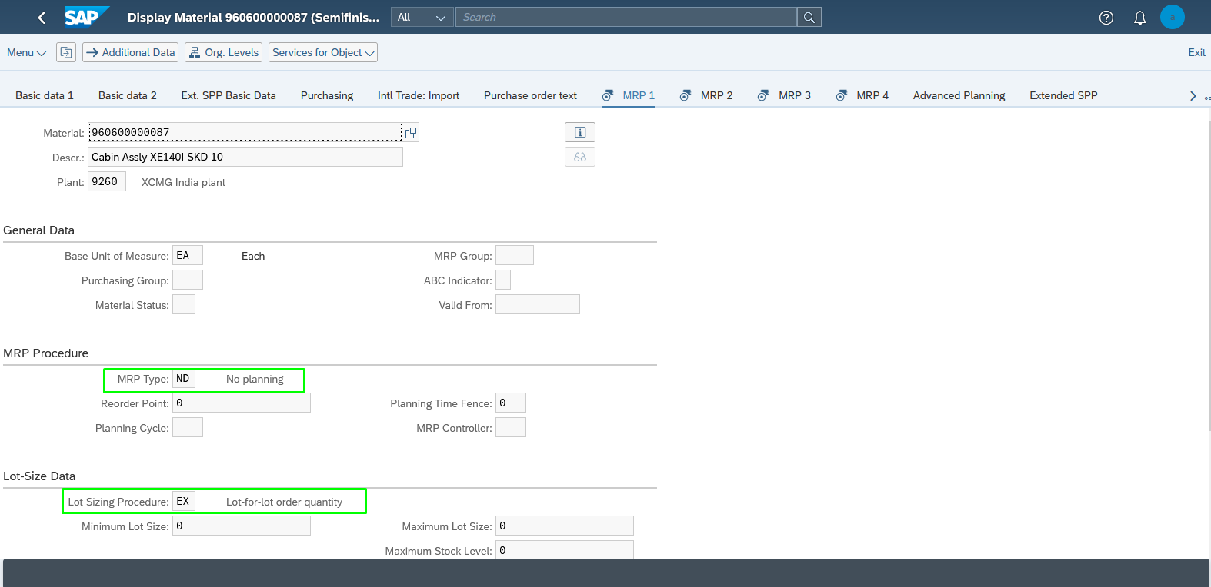

MRP VIEW -2: 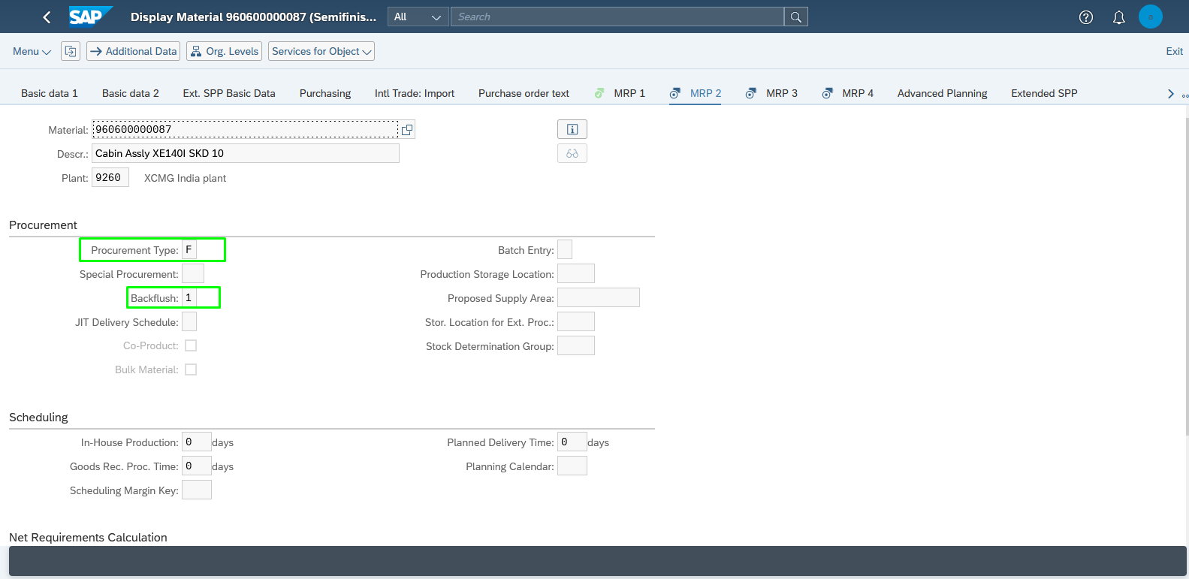

MRP VIEW -3: 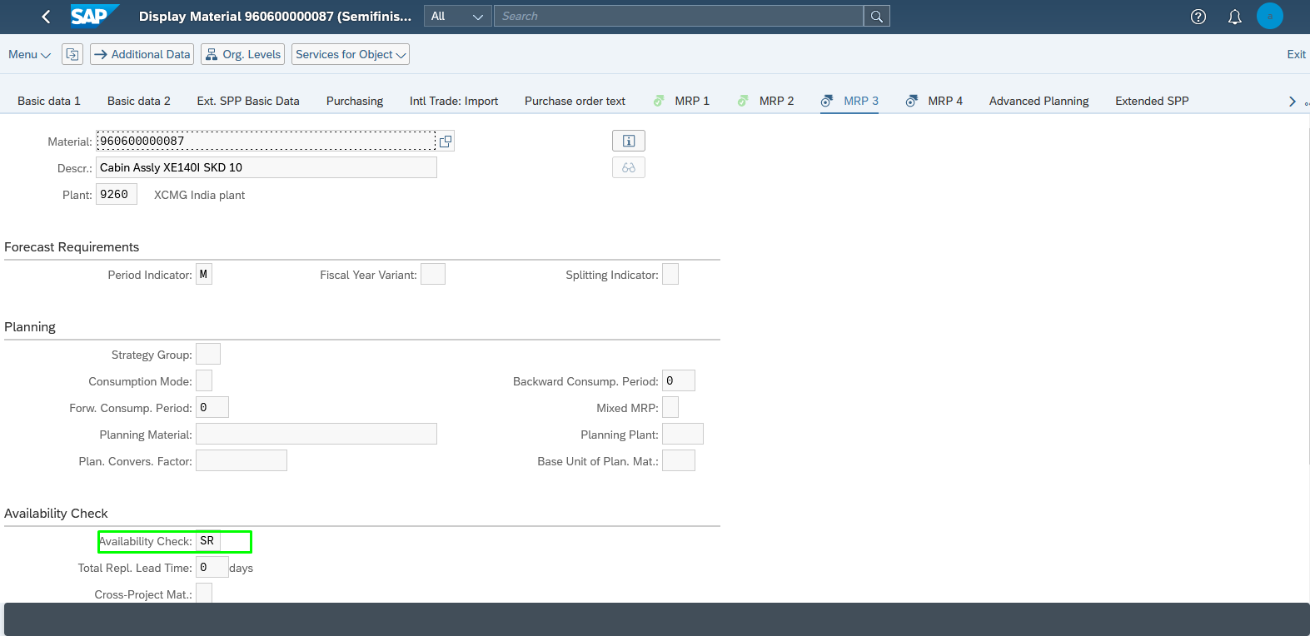

MRP VIEW -4: 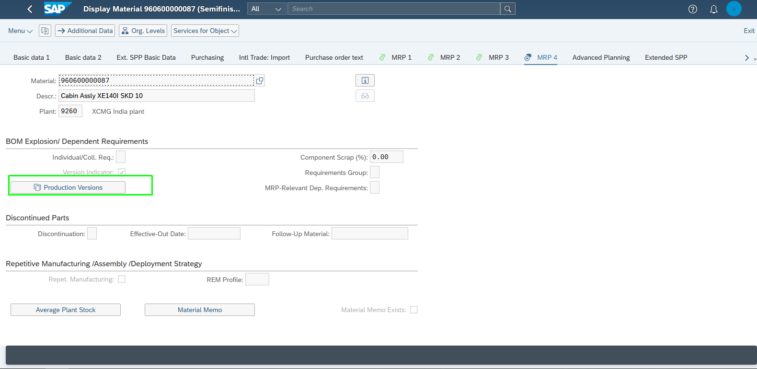

Maintain Material Master- Raw Material-1: 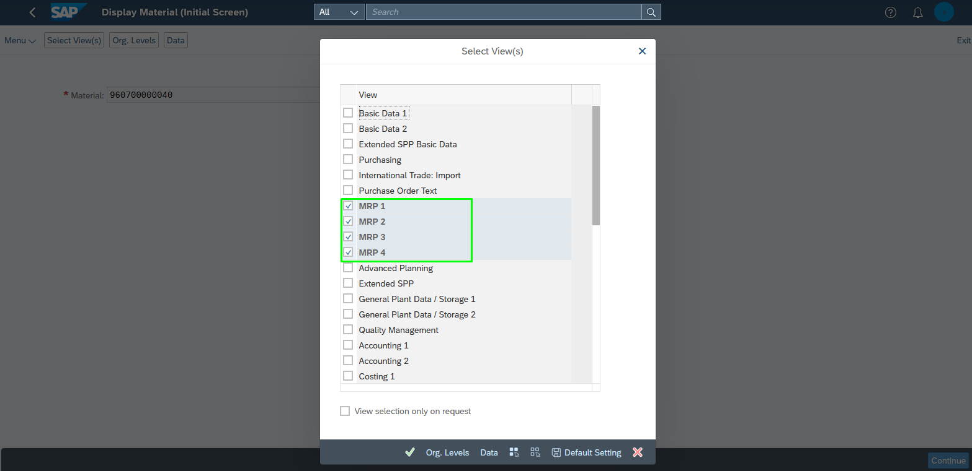

MRP VIEW -1: 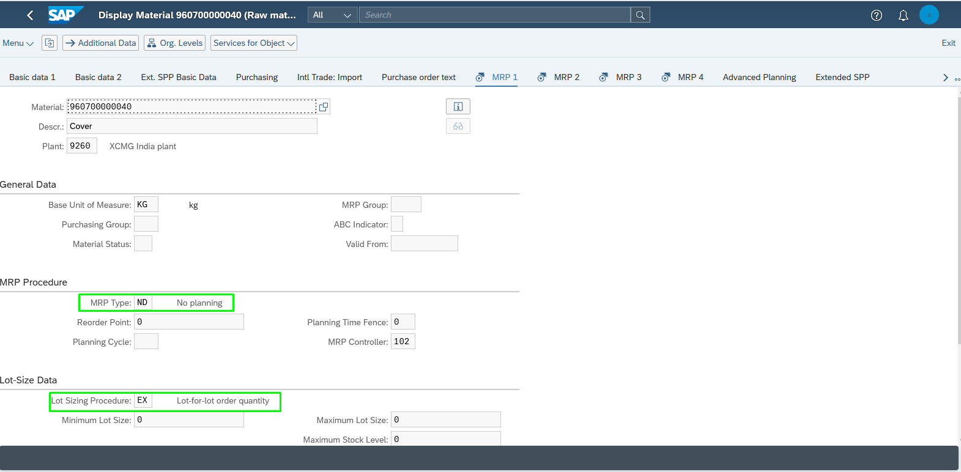

MRP VIEW -2: 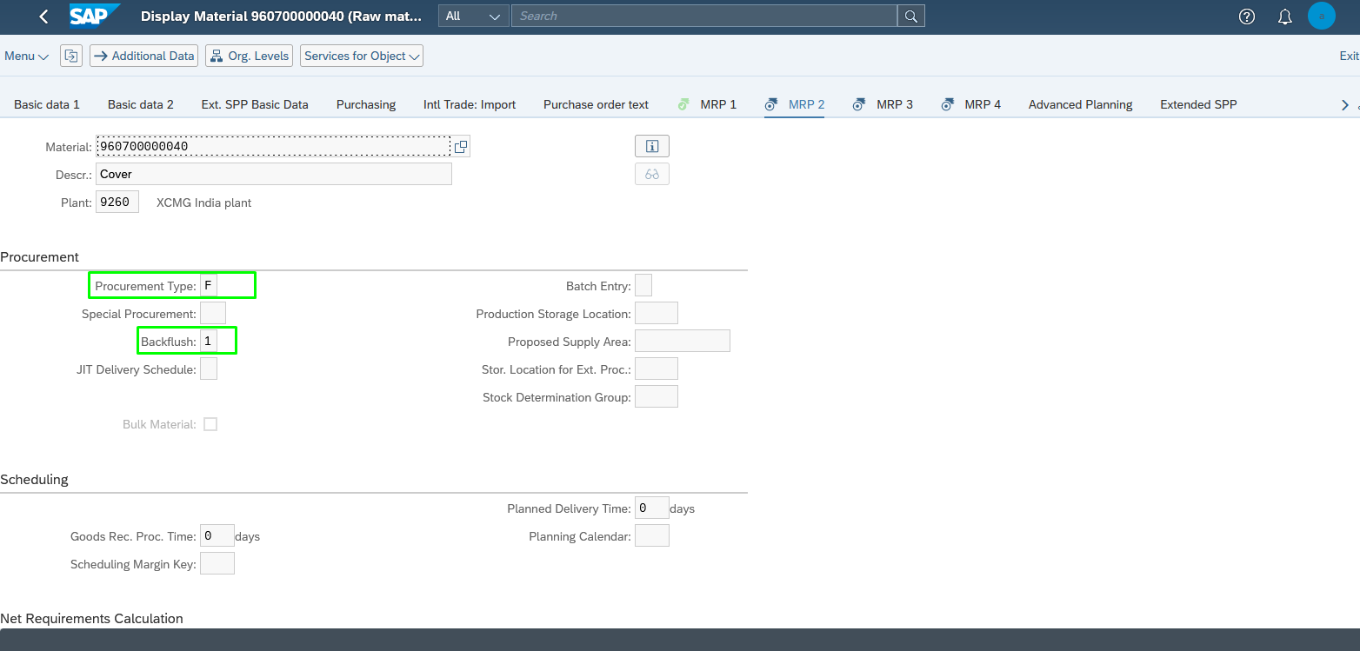

MRP VIEW -3: 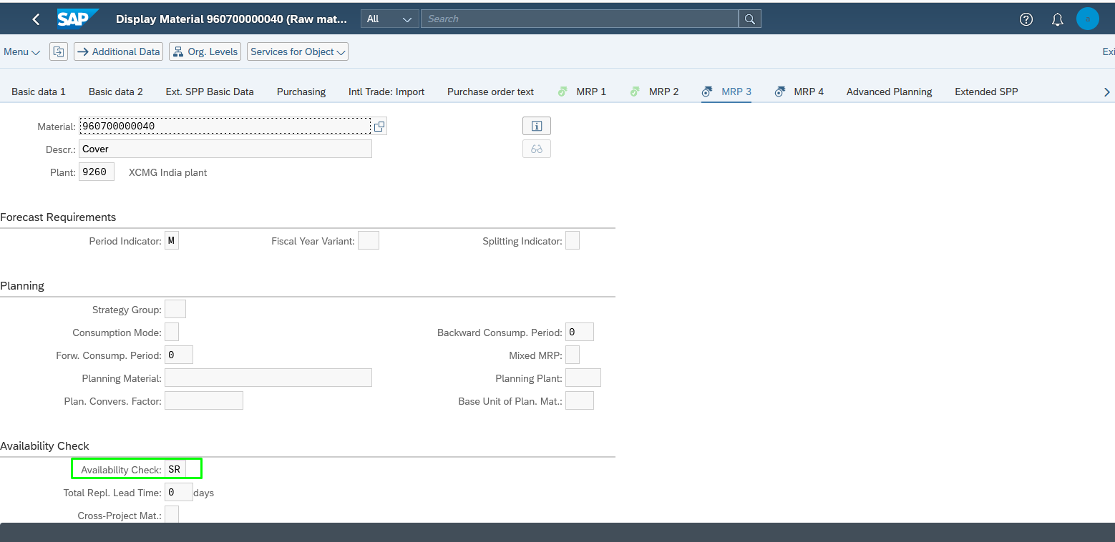

Maintain Material Master- Raw Material-2: 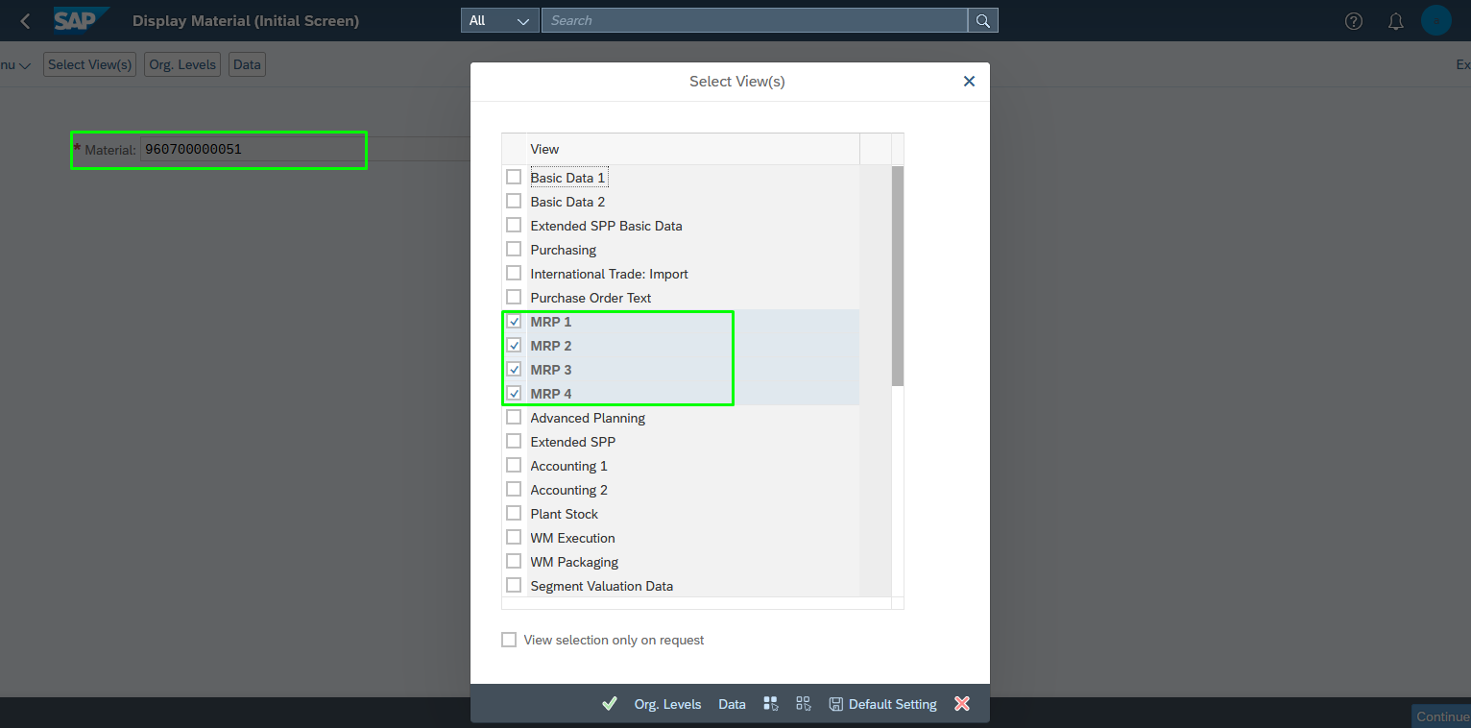

MRP VIEW -1: 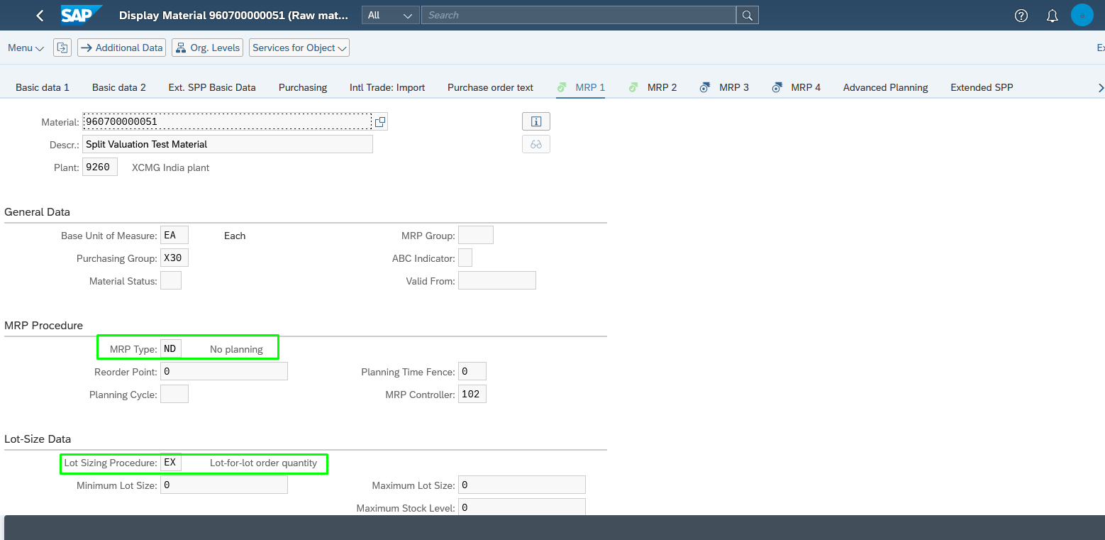

MRP VIEW -2: 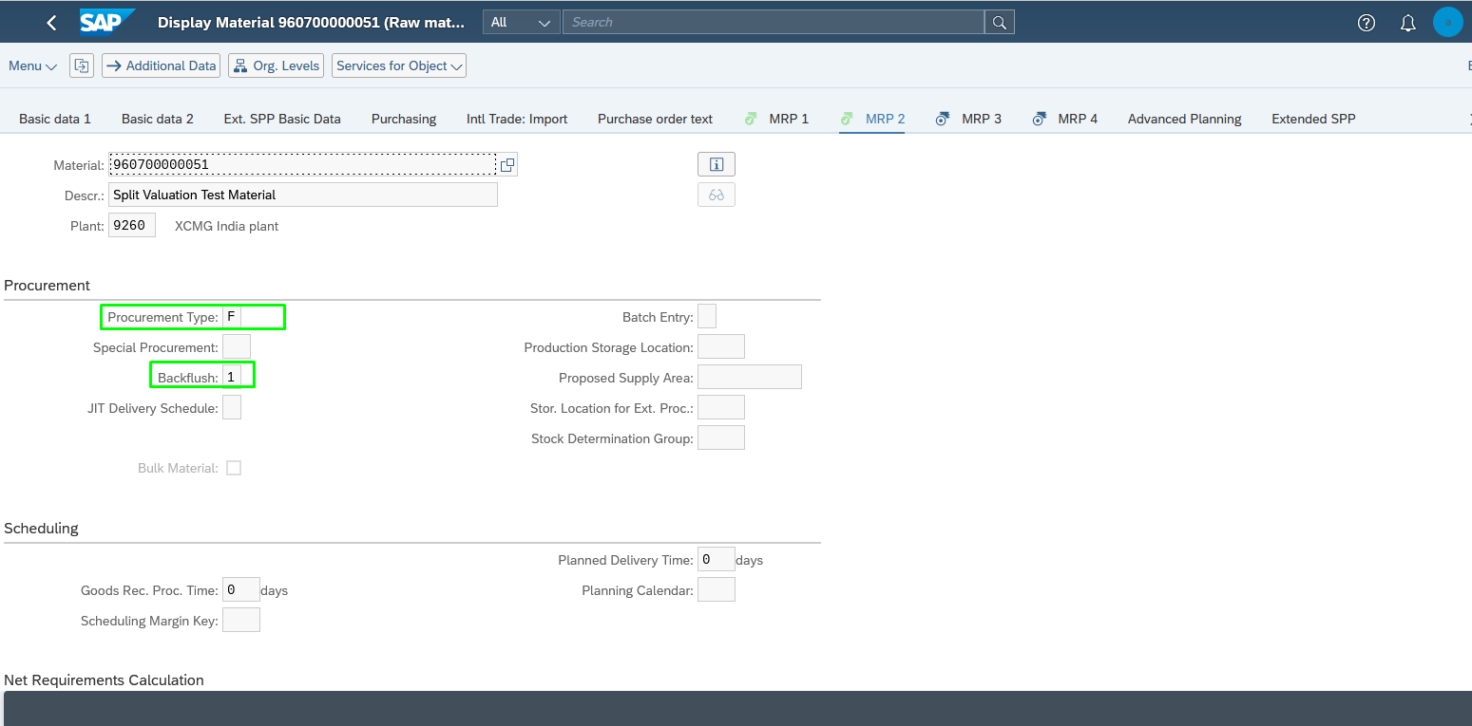

MRP VIEW -3: 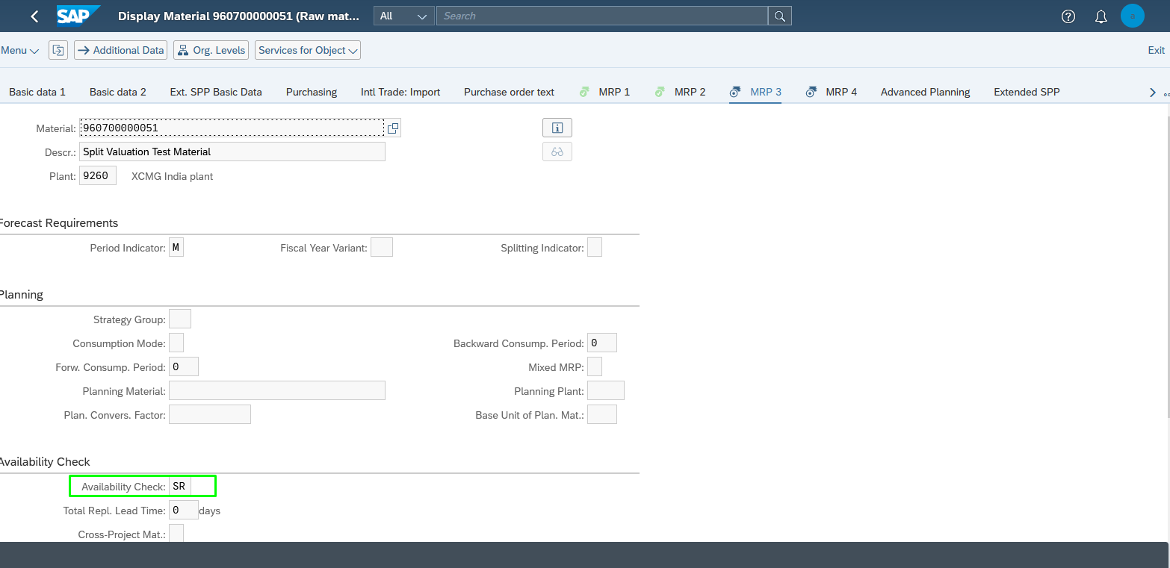

Create PIRs:

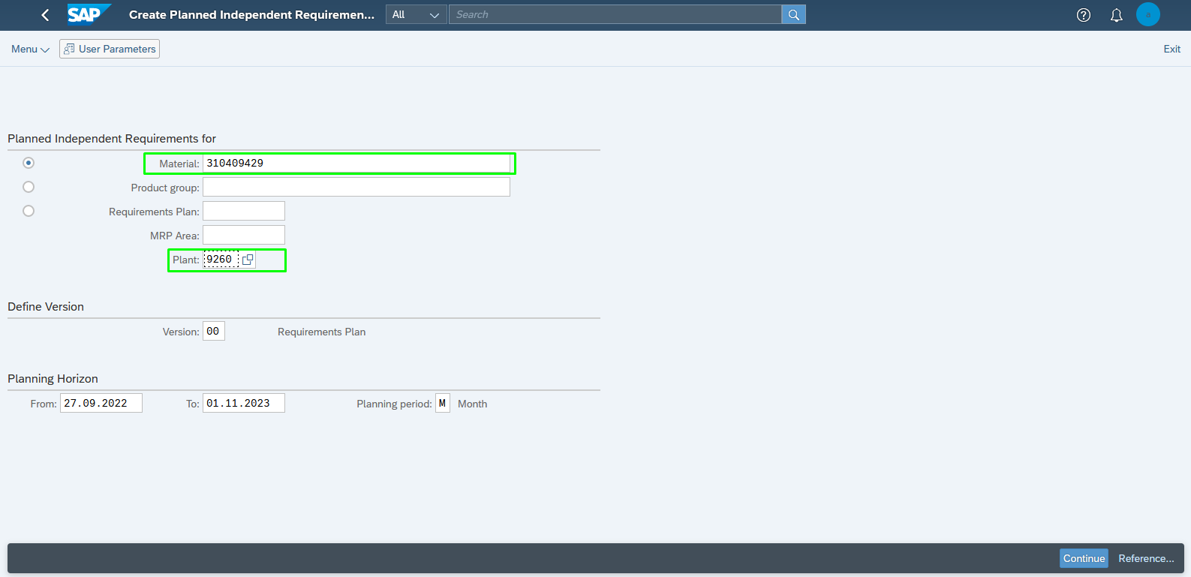

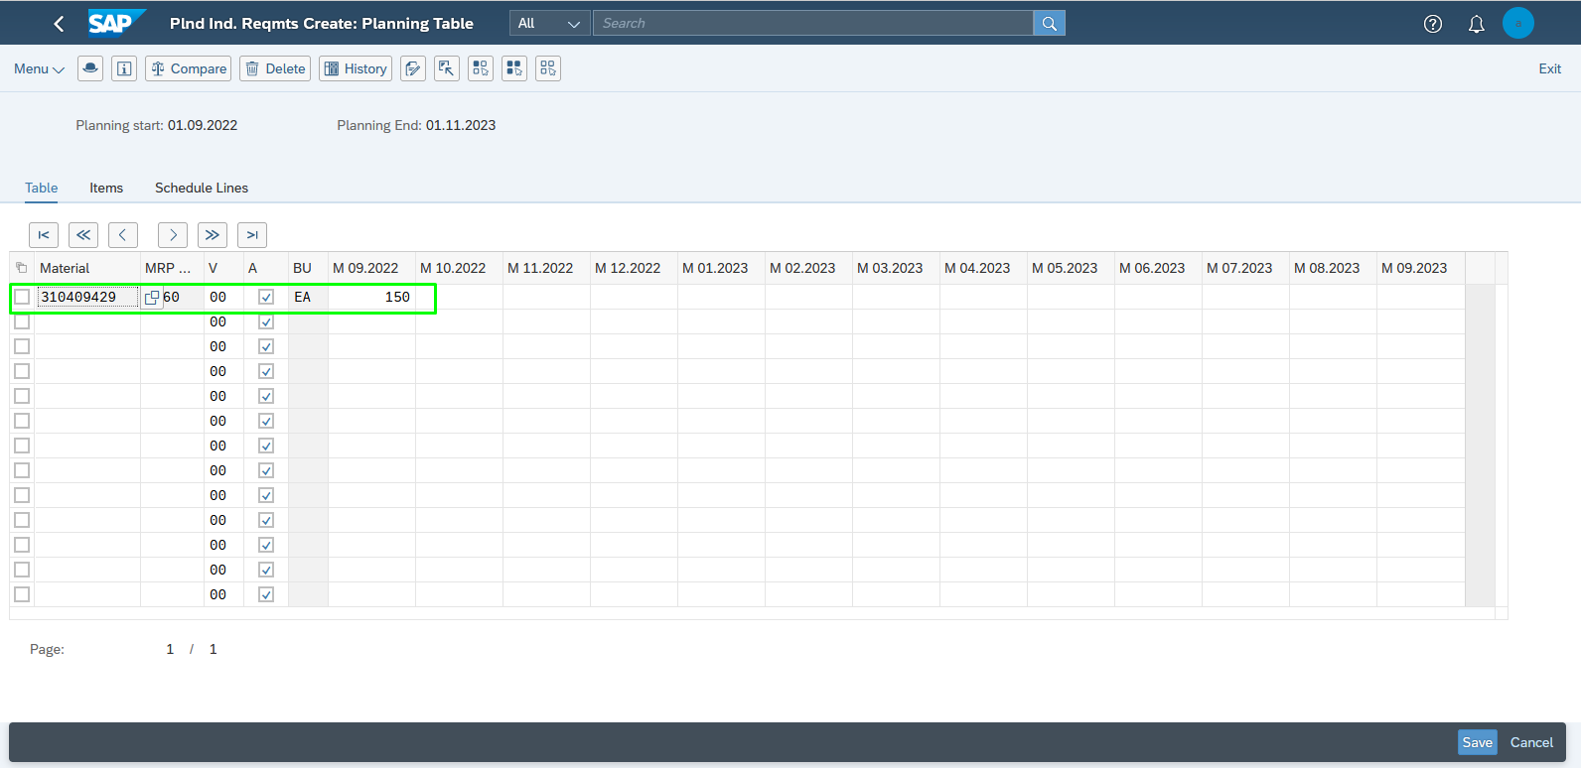

MRP RUN:

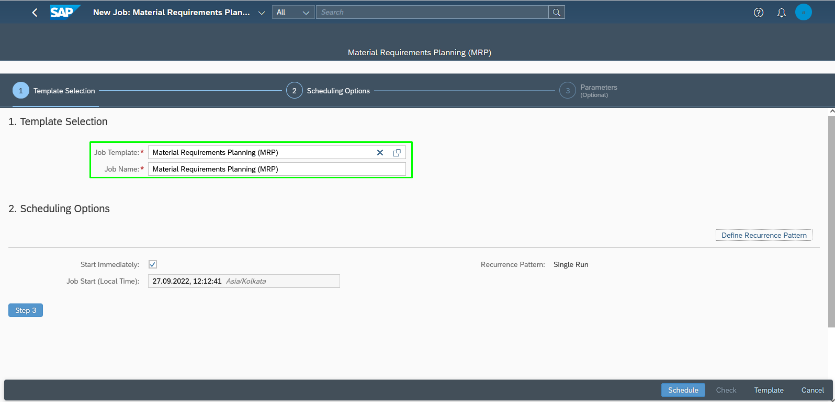

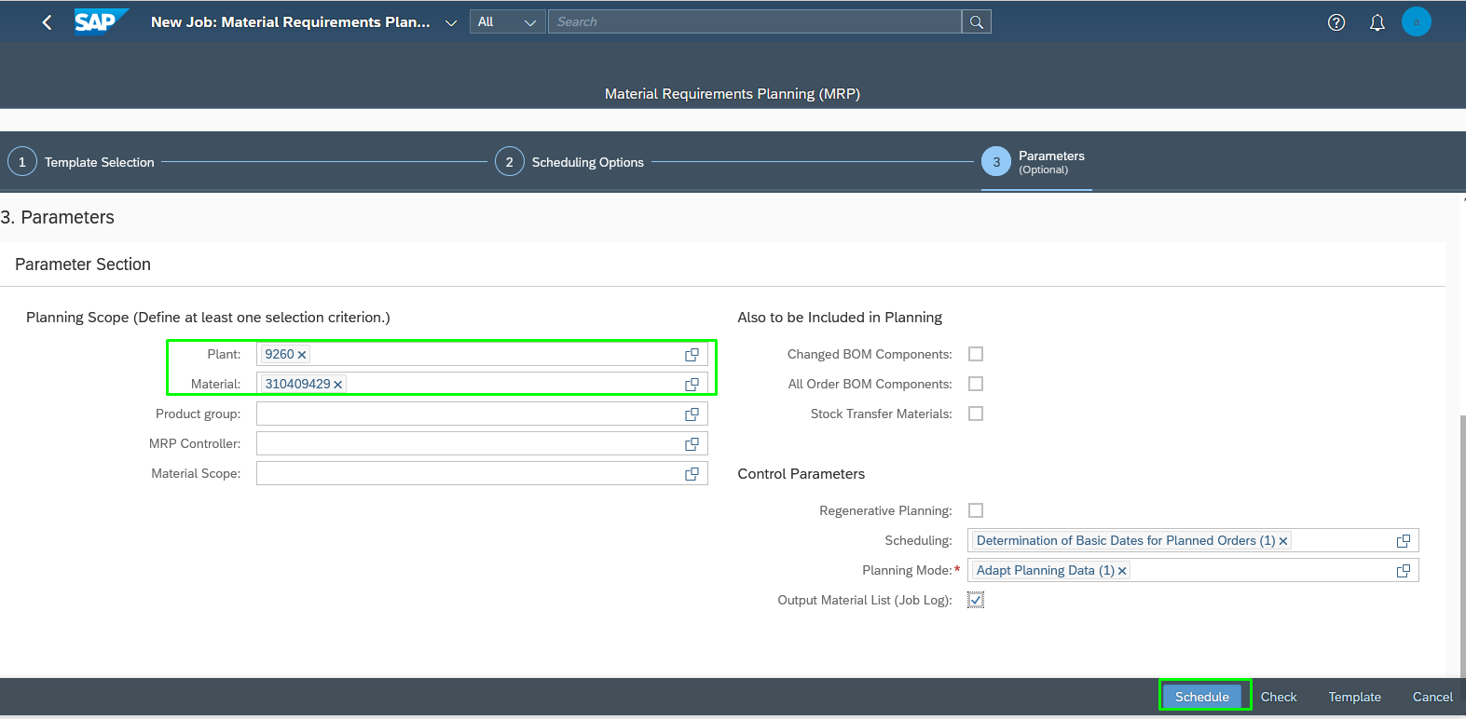

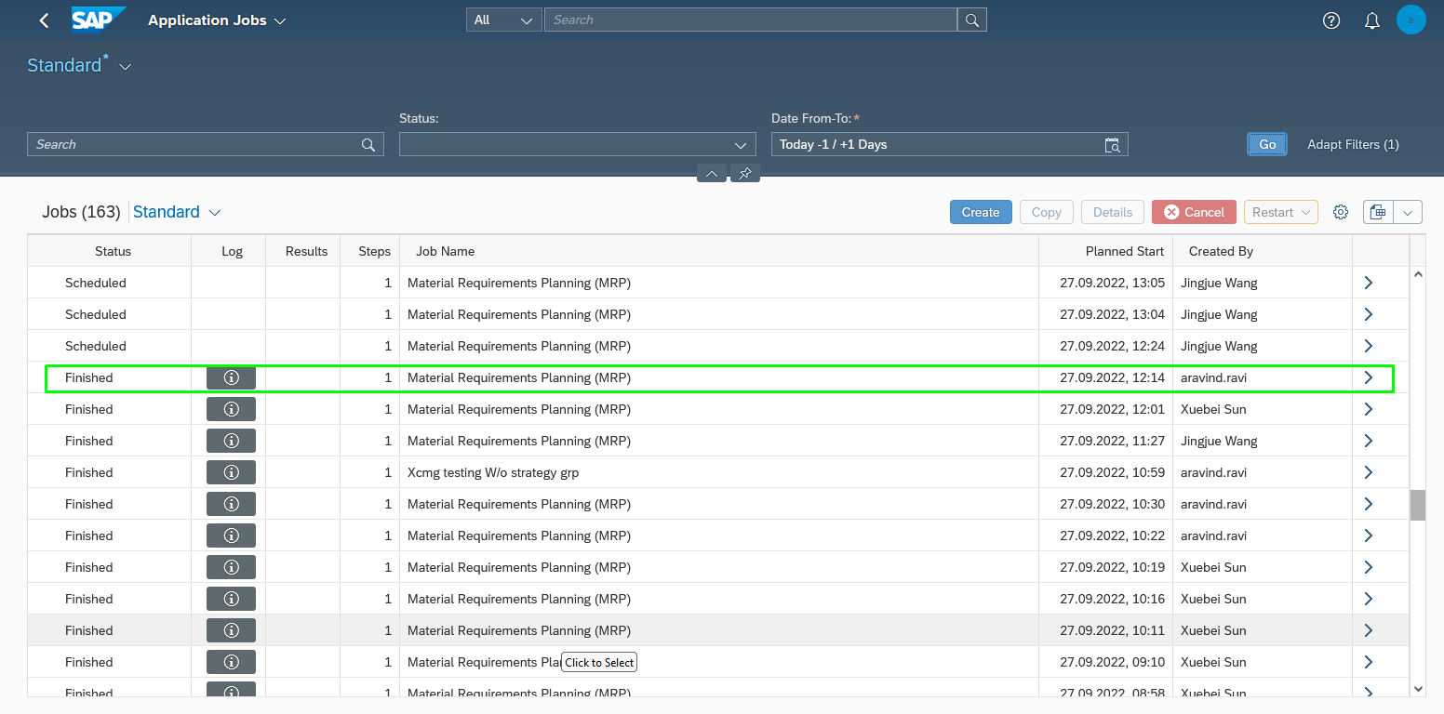

Output Results

Monitor Stock Requirement:(FG)

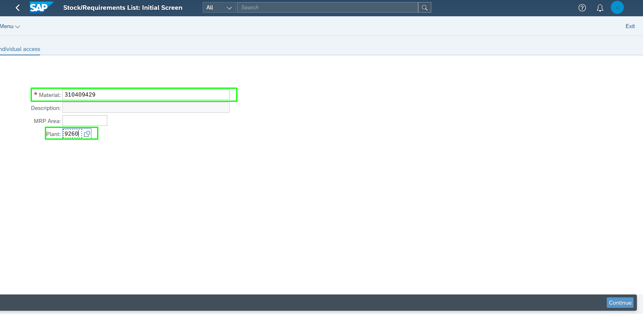

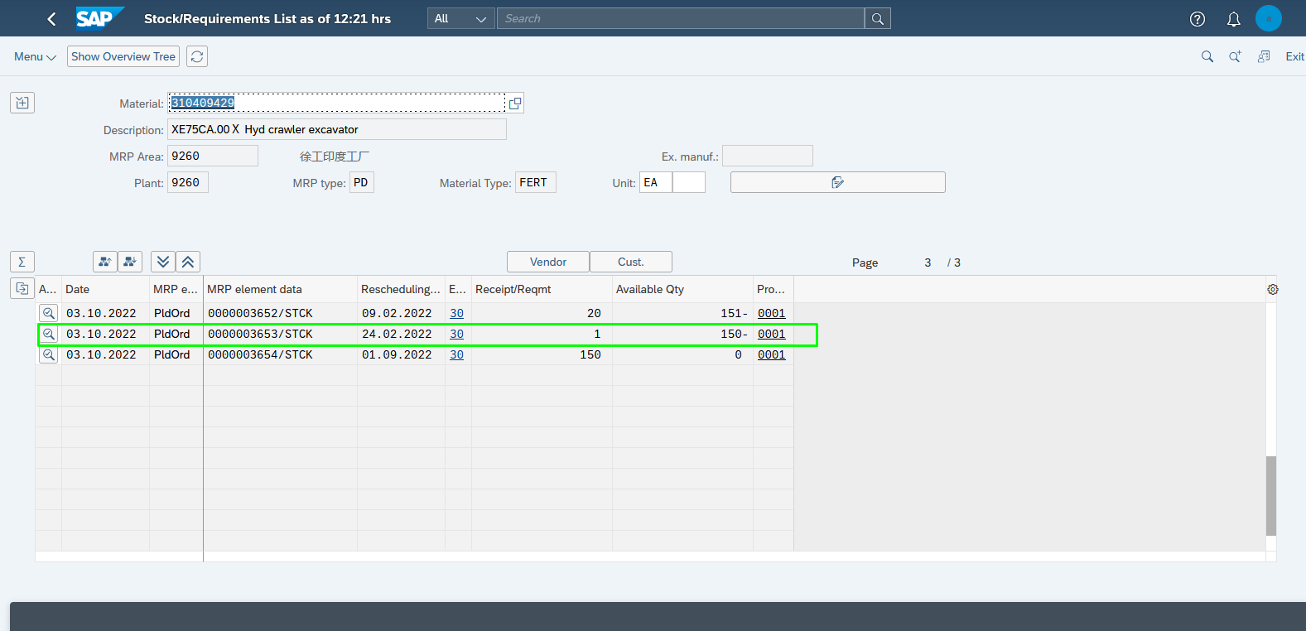

Monitor Stock Requirement:(SFG-1)

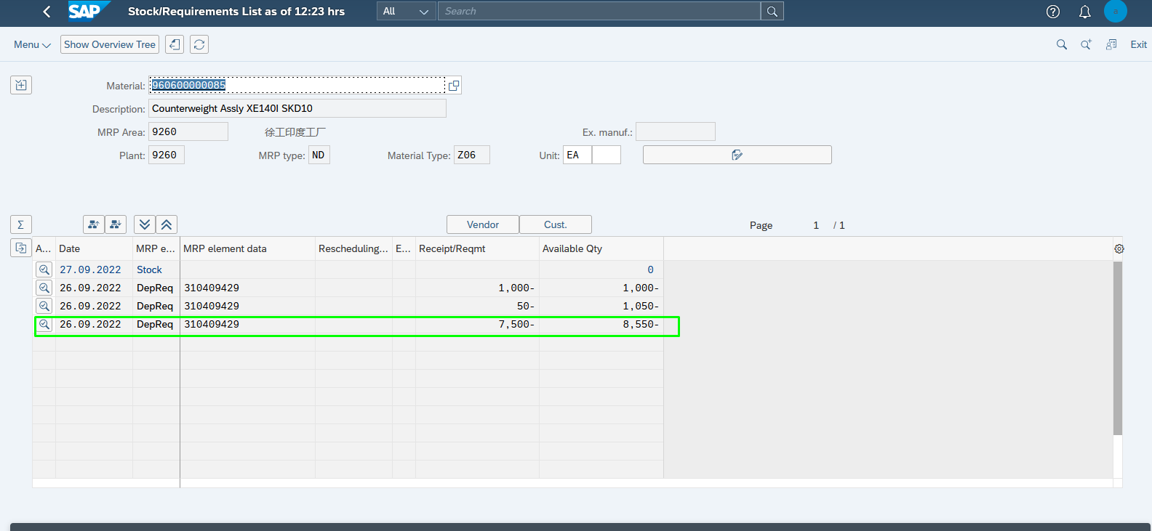

Monitor Stock Requirement:(SFG-2)

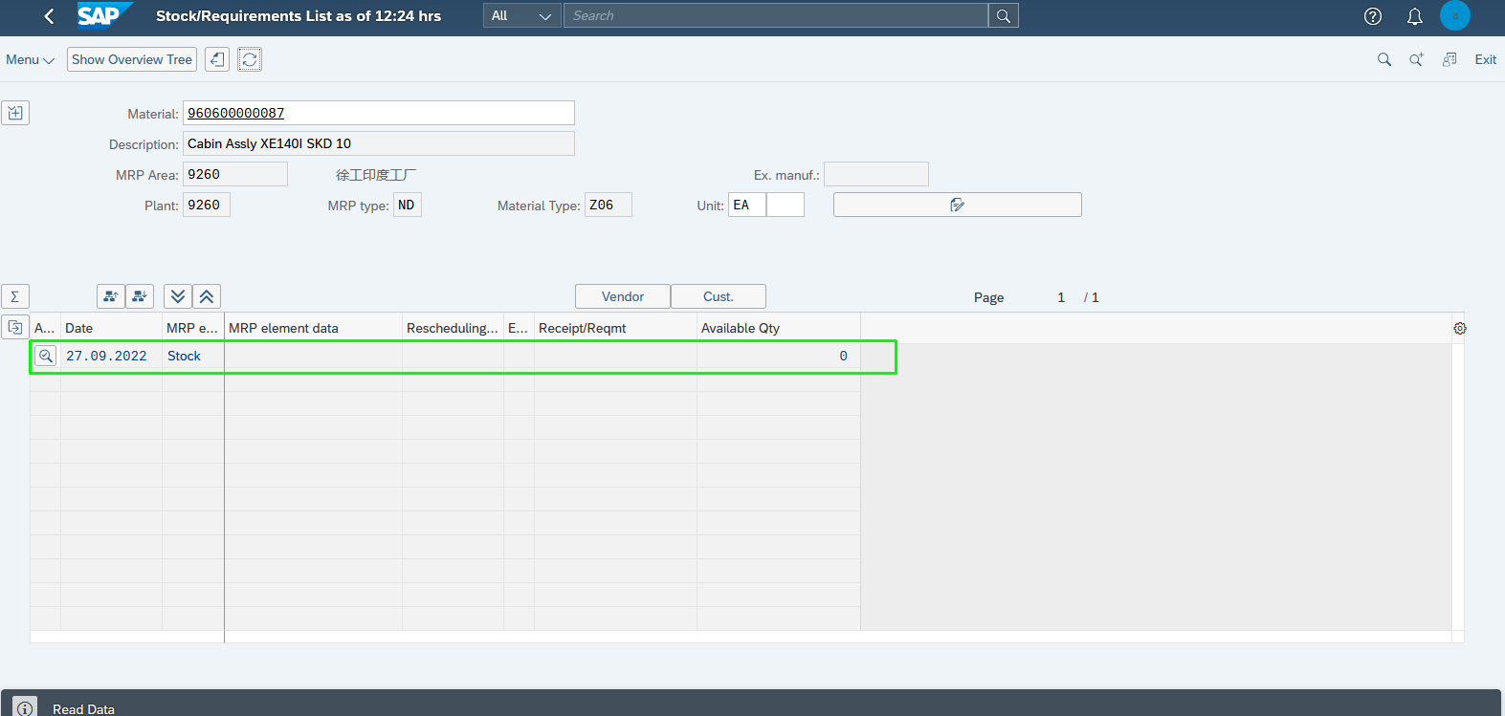

Monitor Stock Requirement:(RM-1 )

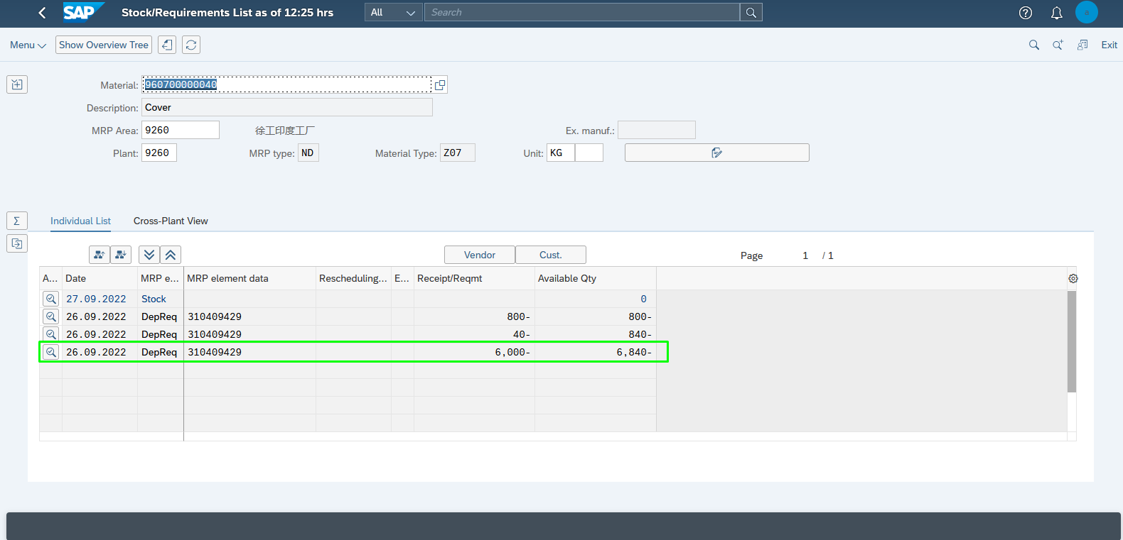

Monitor Stock Requirement:(RM-2)

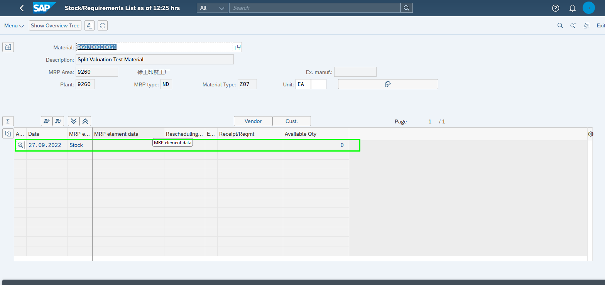

**Thank You..**