**Business Blueprint Document**

XCMM - RISE WITH SAP S/4 HANA- 2022 Private Cloud

Process Optimization

**FINANCE**

**Record to Report (R2R)**

**For**



**Xuzhou Construction Machinery Manufacturing India Private Limited**

**Submitted By**

**ZYNOVIQ SOLUTIONS PRIVATE LIMITED**



**SEPT-2022**

|  |  |  |
| --- | --- | --- |
| PROJECT IDENTIFICATION | | |
| **Project Name** | | **Project Description** |
| XCMM | | SAP- RISE WITH SAP S/4 HANA 2022 Process Optimization |
| **Customer Name** | | **Location** |
| Xuzhou Construction Machinery Manufacturing India Private Limited | | Cheiyyar, Tamil Nadu |
| **SAP Project Manager** | **Customer Project Manager** | |
| Mr. B. Ganesh Kumar | Mr. Rajeshwaran | |

DOCUMENT IDENTIFICATION

|  |  |  |  |  |  |  |
| --- | --- | --- | --- | --- | --- | --- |
|  | | | | | | |
| Author | | | | | Document Location (repository/path/name) | |
| **Chandramohan P R** | | | | |  | |
| Version | | Status | | | Date (YYYY-MM-DD) | |
| 01 | |  | | |  | |
| REVISION HISTORY | | | | | | |
| Version | Date | | Description | | | |
| 01 |  | |  | | | |
| 02 |  | |  | | | |
| 03 |  | |  | | | |
| Review and Approval | | | | | | |
| **Mr. Rajeshwaran**  Business Process Owner/ Division Head | | | |  | | Date (YYYY-MM-DD) |
| Process Advisory Head | | | |  | | Date (YYYY-MM-DD) |
| **Mr. Rajeshwaran**  Customer Project Manager | | | |  | | Date (YYYY-MM-DD) |
| **Mr. B. Ganesh Kumar**  Implementation Project Manager | | | |  | | Date (YYYY-MM-DD) |

**TABLE OF CONTENTS**

1. XCMG - INTRODUCTION 4

2. J77-FINANCIAL ORGANISATION STRUCTURE 7

**2.1. CLIENT:** 7

**2.2. COMPANY CODE:** 7

**2.3. CHART OF ACCOUNTS:** 8

**2.4. CHART OF DEPRECIATION:** 8

**2.5. CONTROLLING AREA:** 8

3. J77- FINANCIAL ACCOUNTING GLOBAL SETTINGS: 10

**3.1. FISCAL YEAR:** 10

**3.2. ACCOUNTING CURRENCIES:** 10

**3.3. ACCOUNTING PRINCIPLES:** 10

4. GENERAL LEDGER ACCOUNTING: 11

**4.1. ACCOUNT GROUP:** 11

**4.2. RETAINED EARNINGS:** 11

**4.3. RECONCILIATION ACCOUNT:** 11

5. J60 – ACCOUNTS PAYABLE 12

**5.1. CREATE SUPPLIER DOWN PAYMENT** 12

**5.2. POST SUPPLIER INVOICE** 13

**5.2.1. POST SUPPLIER INVOICE WITHOUT P.O** 13

**5.2.2 VENDOR INVOICE WITH P.O** 13

6. J59 – ACCOUNTS RECEIVABLES: 14

**6.1. CUSTOMER INVOICE WITH SALES ORDER:** 14

**6.2. CUSTOMER DOWN PAYMENT** 14

7. BFA – HOUSE BANK ACCOUNTING 15

**7.1. MANAGE HOUSE BANK** 15

**7.2. CHEQUE/ BANK TRANSFER PAYMENT:** 16

**7.3. BANK RECONCILIATION STATEMENT** 16

8. TAX ON SALES AND PURCHASE 17

**8.1. GOODS AND SERVICES TAX** 17

**8.2. WITHHOLDING TAX & TCS** 18

9. 2QY – FIXED ASSET ACCOUNTING 18

**9.1. FIXED ASSET** 18

**9.2. CHART OF DEPRECIATION:** 19

**9.3. ASSET CLASS:** 20

**9.4. DEPRECIATION RUN:** 20

**9.5. ASSET TRANSACTIONS:** 20

**9.6. ASSET HISTORY SHEET:** 20

**9.7. PERFORM WRITEUP:** 20

**9.8. DEPRECIATION LIST – YEAR END CLOSING** 21

**9.9. DEPRECIATION LIST – MONTH END CLOSING** 21

10. MASTER DATA 21

**10.1. G/L MASTER** 22

**10.2. BANK MASTER** 22

**10.3. ASSET MASTER** 22

11. 1GA – FINANCE REPORTS 22

**11.1. TRIAL BALANCE** 22

**11.2. BALANCE SHEET / INCOME STATEMENT** 23

**11.3. AGING REPORT - ACCOUNTS PAYABLE** 23

**11.4. AGING REPORT – ACCOUNTS RECEIVABLE** 23

**11.5. INDIA WITHHOLDING TAX (TDS & TCS)** 23

**11.6. ASSET BALANCES** 23

**10.7. DISPLAY PROCESS FLOW – ACCOUNTS PAYABLE** 23

**10.8. DISPLAY PROCESS FLOW – ACCOUNTS RECEIVABLE** 23

**10.9. GST REPORTS** 24

**1. XCMG - INTRODUCTION**

Xuzhou Construction Machinery Group Co., Ltd. (XCMG) was founded in 1943. Since then, XCMG has stood at the forefront of the Chinese construction machinery industry and developed into one of the domestic industry's largest, most influential, and most competitive enterprise groups with the most complete product varieties and series.

XCMG is the 3rd largest construction machinery company in the world. It is ranked 65th in the list of China's Top 500 Companies, 44th in the list of China's Top 100 Manufacturing Enterprises, and 2nd in the list of China's Top 100 Machinery Manufacturers. XCMG is dedicated to its core value of “Taking Great Responsibilities, Acting With Great Morals, and Making Great Achievements” and its corporate spirit of being “Rigorous, Practical, Progressive, and Creative” in order to keep moving towards its ultimate goal of becoming a leading world-class enterprise capable of creating real value.

**The RISE WITH SAP S/4 HANA modules which are being implemented.**

|  |  |
| --- | --- |
| SAP Code | Description |
| FI | Finance |
| CO | Controlling |
| PP | Production Planning |
| QM | Quality Management |
| MM | Material Management |
| SD | Sales and Distribution |
| ABAP | Advance Business Application Programme |

This document summarizes the findings of the Zynoviq Solutions Pvt Ltd team, which conducted the requirement analysis of XCMM Pvt. Ltd, Chennai for the RISE WITH SAP S/4 HANA system. This information was gathered through requirement gathering conducted at the XCMM Pvt. Ltd with Project managers, key users, and personnel from the information system, as well as the reviews of the business processes, business procedures, documentation, and relevant reports.

The immediate purpose of the analysis is to prepare to move rapidly with the implementation of the XCMM Pvt. Ltd S/4 HANA System. At the conclusion of the blueprint, the Zynoviq team will determine the SAP functionality required to run the XCMM Pvt. Ltd business.

The Blueprint and its associated appendices present a summarized perspective of all functional business.

Processes that will be implemented. As such, the Blueprint document will serve - from this point forward the dual role of both official project scope as well as system acceptance criteria.

The body of this document describes the organizational structure, enterprise area, and S/4 HANA functional process flows to be implemented at XCMM Pvt. Ltd, Chennai. Generally, requirements that can be met using standard S/4 HANA system functionality through routine configuration tasks are not explicitly documented. However, certain key requirements are explicitly identified and summarized to highlight their importance to XCMM Pvt. Ltd and to document the approach proposed to meet the requirement.

The Blueprint reiterates the S/4 HANA system organizational structures that have been identified and will serve as the basis for the initial configuration activities. The Zynoviq Team believes that the S/4 HANA system can accurately model XCMM Pvt. Ltd organizational requirements.

The information gathered and documented in the Blueprint is sufficient for the team to go forward into the Realization phase.

# **2. J77-FINANCIAL ORGANISATION STRUCTURE**

CLIENT

COST CENTER

OPERATING CONCERN

CONTROLLING AREA

CHART OF

ACCOUNTS

CHART OF

DEPRECIATION

COMPANY

CODE

PROFIT CENTER

CREDIT CONTROL AREA

## **2.1. CLIENT:**

The client is a legally and organizationally independent unit. This means all business and commercial data are secure from other Clients. Clients are identified by a four-figure Client number.

## **2.2. COMPANY CODE:**

Company Code is smallest organizational unit of external accounting for which a complete, self-contained set of accounts can be created. This includes the entry of all transactions that must be posted and the creation of all items for legal individual financial statements, such as the Balance sheet (BS) and the Profit and loss (P&L) statement.

|  |  |  |
| --- | --- | --- |
| Description | AS-IS | TO-BE |
| Company Code | 9260(Standard) | 9260(Custom) |

## **2.3. CHART OF ACCOUNTS:**

List of General Ledger (G/L) accounts used by one or several Company Codes. For each G/L account, the Chart of Accounts (COA) contains the account number, account name, and the information that controls how an account functions and how a G/L account is created in a Company Code.

|  |  |  |
| --- | --- | --- |
| Description | AS-IS | TO-BE |
| Chart of Accounts | YOCA(Standard) | 1000(Custom) |

## 

## **2.4. CHART OF DEPRECIATION:**

Chart of Depreciation is used to manage various legal requirements for the depreciation and valuation of assets. The Charts of Depreciation are usually country-specific and is defined independently of the other organizational units.

|  |  |  |
| --- | --- | --- |
| Description | AS-IS | TO-BE |
| Chart of Depreciation | SAP Standard | 1000(Custom) |

## **2.5. CONTROLLING AREA:**

Controlling Area represents a system, which is used for cost accounting purposes within an organization. Controlling Area represents a contained cost accounting environment where costs and revenues can be managed.

|  |  |  |
| --- | --- | --- |
| Description | AS-IS | TO-BE |
| Controlling Area | A000 (Standard) | 1000 (Custom) |

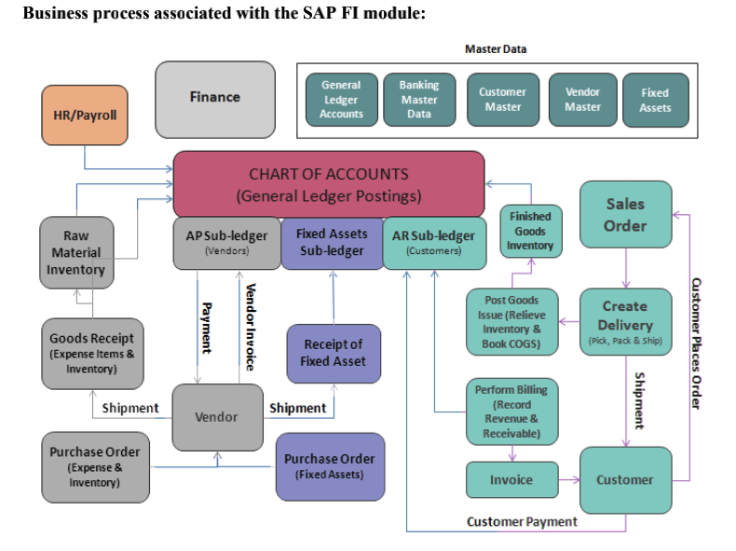

# **3. J77- FINANCIAL ACCOUNTING GLOBAL SETTINGS:**

Set Global Parameters With this app, you can specify the global parameters that will apply to all further configured for consolidating different sets of financial data such as actuals or budget data according Fiscal Year/Period Consolidation Chart of Accounts.

## **3.1. FISCAL YEAR:**

To separate business transactions into different periods, a Fiscal Year with posting periods has to be defined. The Fiscal Year is defined as a variant, which is assigned to the Company Code. A Fiscal Year will consist of maximum of 12 posting periods and 4 special periods.

SAP standard recommends V3 as the Fiscal year variant.

|  |  |  |
| --- | --- | --- |
| Description | AS-IS | TO-BE |
| Fiscal Year | K4 (JAN - DEC) | V3 (APR - MAR) |

## **3.2. ACCOUNTING CURRENCIES:**

A currency is the legally recognized means of payment in a given country. A currency needs to be specified for every financial amount. Currencies are specified using the ISO standard form.

|  |  |  |
| --- | --- | --- |
| Description | AS-IS | TO-BE |
| Currencies | INR | INR, USD, CNY (Additional Currencies) |

## **3.3. ACCOUNTING PRINCIPLES:**

**GAAP-Accounting Rules Standards Important**

In basic terms, GAAP is a collection of widely-followed accounting principles, rules and standards for financial reporting. It is intended to ensure consistency in financial reporting, which makes it easier for investors to analyze the information presented and compare it between companies.

|  |  |  |
| --- | --- | --- |
| Description | AS-IS | TO-BE |
| Accounting Principles | INGAAP | INGAAP |

# **4. J58 - GENERAL LEDGER ACCOUNTING:**

General Ledger Accounting serves as a complete record of all business transactions, providing a centralized, up-to-date reference for the rendering of accounts. Actual individual transactions can be checked at any time in real-time processing by displaying the original documents, line items, and transaction figures at various levels to support parallel accounting.

## **4.1. ACCOUNT GROUP:**

An account group is a named collection of accounts. CSA uses account groups in financial statements to increase their flexibility and to enable you to use a financial statement for multiple clients. Some account group names are pre-defined, but account group definitions are client specific.

|  |  |  |
| --- | --- | --- |
| Description | AS-IS | TO-BE |
| Account Group | 9 G/L Account Group (YOCA) | 1000 (Custom COA) – New GL Group Yet be Received |

## **4.2. RETAINED EARNINGS:**

By definition, retained earnings are the cumulative net earnings or profits of a company after accounting for dividend payments. It is also called earnings surplus and represents the reserve money, which is available to the company management for reinvesting back into the business.

|  |  |  |
| --- | --- | --- |
| Description | AS-IS | TO-BE |
| Retained Earnings | YOCA (Prior year income adjustment) | 1000  (Retained Earnings Under Reserves & Surplus) |

## **4.3. RECONCILIATION ACCOUNT:**

Reconciliation is an accounting process that compares two sets of records to check that figures are correct and in agreement. Account reconciliation is particularly useful for explaining the difference between two financial records or account balances.

|  |  |  |
| --- | --- | --- |
| Description | AS-IS | TO-BE |
| Reconciliation Accounts | Configured | Need to be configured based on new data |

# 

# **5. J60 – ACCOUNTS PAYABLE**

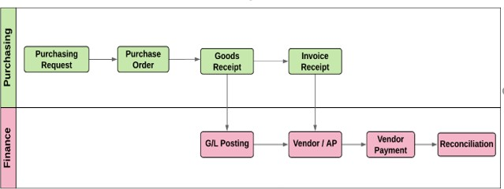

## **5.1. CREATE SUPPLIER DOWN PAYMENT**

A down payment is a payment made or received before the physical exchange of goods and services. Once the receipt or delivery of goods and services occurs, the down payment clears against the final invoice.

**Supplier Down Payment Process**

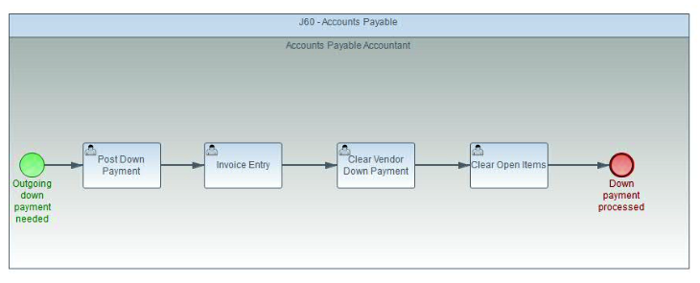

## **5.2. POST SUPPLIER INVOICE**

With this app you can create and display a supplier invoice based on the received document. These items can also have multiple account assignment. You can choose among several assignment options depending on the reference document category. To identify the most relevant service entry sheet items, If you select the *Simulate* or *Post* function, the system compares the quantity and amount data of each supplier invoice item with the data of the related purchase order item. If goods-receipt-based invoice verification has been defined for a purchase order item, the system compares the supplier invoice data with the related goods receipt data.

### **5.2.1. POST SUPPLIER INVOICE WITHOUT P.O**

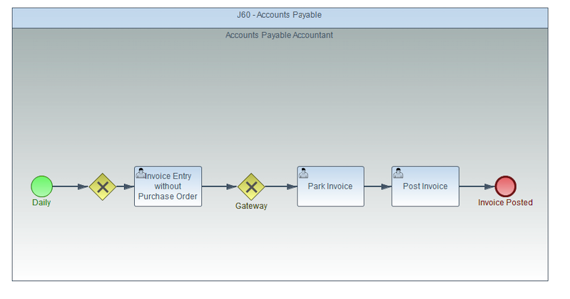

### **5.2.2 VENDOR INVOICE WITH P.O**

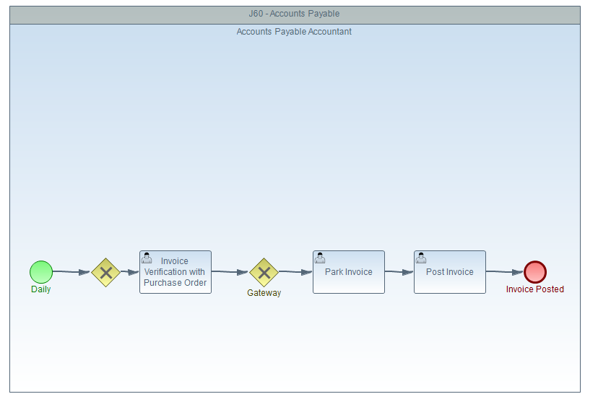

# **6. J59 – ACCOUNTS RECEIVABLES:**

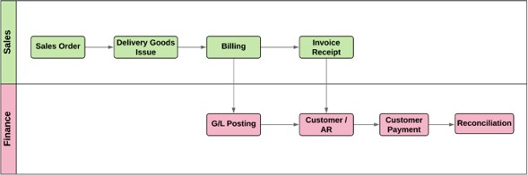

## **6.1. CUSTOMER INVOICE WITH SALES ORDER:**

You can manage open receivables invoices that are automatically created from sales processes. You can manage and control open items with various analytical tools to optimize accounts receivables handling. The primary source of incoming payments is incoming bank statements loaded within the Cash Management process. They are automatically reconciled with open invoices. Easy-to-use views make the post processing of open items convenient and efficient.

Alternatively, manually post incoming payments and easily reconcile the payment with an open item. Several analytical tools are available to monitor the receivables, allowing you to react quickly if you discover a declining payment discipline among your customers.

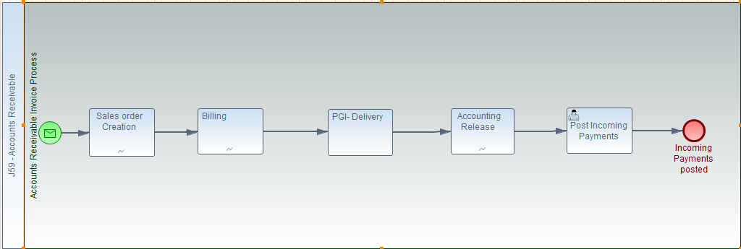

## **6.2. CUSTOMER DOWN PAYMENT**

With this app you can post and clear a single incoming payment in one step. You usually check for incoming payments using online banking. However, if payments are not received using electronic bank statements, you need to enter the payment data manually and trigger a search for the matching open items. Ideally, the system proposes a list of matching items for which you can post and clear the payment in one step. If it is not possible to clear the payment, you can post it on account or to a G/L account.

**Key Features**

* Obtain a list of open items that can be used to clear the open payments.
* Add or change the discount that is to be applied to each invoice.
* Create residual items by entering a residual amount and assigning one or more reason codes and reference information about the business partner to residual items.
* In business configuration, you can define whether a new item is to be posted to the business partner account, or if the difference is to be cleared.
* Post an incoming payment to a G/L account, if required with account assignment
* Post an incoming payment on account, that is, to a customer or supplier account without reference to a specific item if clearing is not possible.

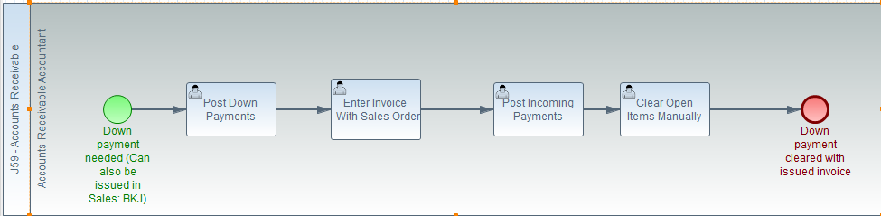

# 

# **7. BFA – HOUSE BANK ACCOUNTING**

**System Configuration Considerations**

01. House Bank Creation

02. Account ID Creation

03. Bank Key Creation

04. Maintain Customized Payment Program.

## **7.1. MANAGE HOUSE BANK**

With this app you can display, create, and change data about the banks your company, your customers, and your suppliers use to transact business.

House Bank is a term used in SAP for Bank Accounts maintained by a company which is an operating bank where all transactions are done. Each Bank Account with any bank will have an SAP ID number, which will be identified as house bank number. For current accounts bank provides cheque numbers which can be recorded in SAP to provide automation of cheque preparation process. Various types of payments like Cheque or RTGS or NEFT payments can be recorded manually and also automatic payment program can be scheduled if required.

|  |  |  |
| --- | --- | --- |
| Description | AS-IS | TO-BE |
| House Bank | HSBC, HDFC, SCB  (Only one G/L Account Maintained) | HSBC, HDFC, SCB  (Three G/L Account need to be maintained for one House Bank) |

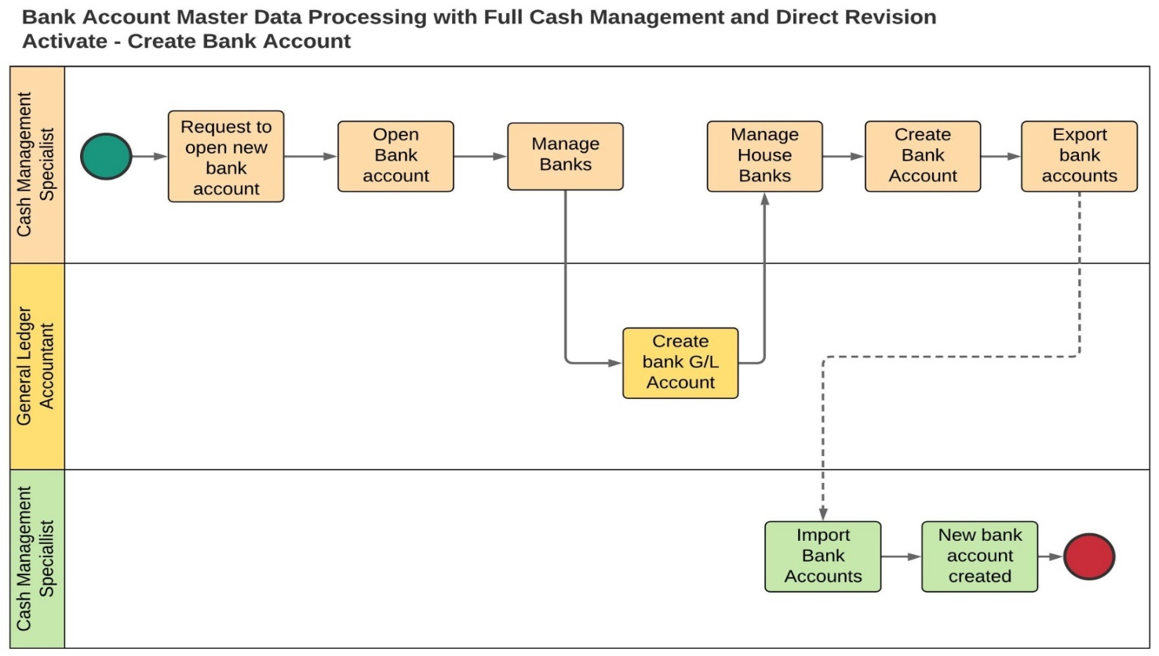

## **7.2. CHEQUE/ BANK TRANSFER PAYMENT:**

You can transfer money from your one account to another account by cheque. You have to simply draw a stating payee as your name along with the account number wherein you want to transfer the amount along with your signature. It's done immediately at a branch if the transfer is within your bank

## **7.3. BANK RECONCILIATION STATEMENT**

Businesses maintain cash book to record both the cash as well as bank transactions. A Cashbook has a cash column which shows cash available with the business and a bank column which shows cash at bank. Bank also keeps an account for every customer in their books. All the deposits are recorded on credit side of customer’s account and withdrawals are on the debit side of their account.

An account statement is sent regularly to the customers by the bank. Sometimes the bank balances as per cash book and bank statement doesn’t match. In case balance available in the passbook doesn’t match the bank column of the cash book, the business should identify the reasons for the same. It is important to reconcile the differences. For reconciling the balances as shown in the Cash Book and passbook a reconciliation statement is prepared known as Bank Reconciliation Statement or BRS. In other words, BRS is a statement which is prepared for reconciling the difference between balances as per cash book’s bank column and passbook on a given date.

|  |  |  |
| --- | --- | --- |
| Description | AS-IS | TO-BE |
| BRS | Not Configured | PHASE I – Manual BRS  PHASE II - EBRS |

# **8. TAX ON SALES AND PURCHASE**

## **8.1. GOODS AND SERVICES TAX**

GST , or Goods and Services Tax , is an indirect tax imposed on the supply of goods and services . It is a multi - stage , destination - oriented tax imposed on every value addition , replacing multiple indirect taxes , including VAT , excise duty , service taxes , etc. Goods and services are included under a single domestic indirect taxation law for the whole of India . In this regime , tax is charged at each point of sale .

**System Configuration Considerations**

1.Define Condition Type

2.Define Procedures

3.Assign Country to Calculation Procedure

4.Define Tax Code

5.Assign Tax Code to GL Account

6.GST RCM Configuration

GST SLAB RATES:

5%, 12%, 18%, 28%

## **8.2. WITHHOLDING TAX & TCS**

Income tax is one of the most important financial planning aspects. Tax Deducted at Source and Tax Collected at Source are both incurred at the source of income.

TDS is the tax which is deducted on a payment made by a company to an individual, in case the amount exceeds a certain limit. TDS deduction is applicable on payments such as salaries, rent, professional fee, brokerage, commission, etc. TDS is applicable only on payments that exceed a certain amount.

TCS is the tax which is collected by sellers while selling something to buyers. TCS is applicable on sales of specific goods which don’t include production or manufacturing material. TCS deduction is applicable on sales of goods like timber, scrap, mineral wood, and so on.

|  |  |  |
| --- | --- | --- |
| **SECTION** | **DECRIPTION** | **PERCENTAGE** |
| 194IB | Rent | 5% |
| 194I | Plant & Machinery rent | 2% |
| Rent of Furniture, Building, or Land | 10% |
|  |  |
| 206AA | In case PAN is not available | 20% of rate in force or double the rate as per the act, whichever is higher |
| 194Q | Goods that are purchased | 0.10% |
| 194C | Contract | 2% Non-Individual |
| 1% Individual |
| 194H | Brokerage & Commission | 5% |
| 194 | Dividend | 10% |

# **9. 2QY – FIXED ASSET ACCOUNTING**

**System Configuration Considerations**

01. Chart of Depreciation

02. Depreciation Area

03. Define Asset Classes

04. Depreciation Key and Method, Asset Master.

## **9.1. FIXED ASSET**

With this app you can easily access key information and KPIs within the Asset Accounting area, and gain insight into current trends. The app provides a central source of information for the asset accountant, and offers a range of filters and built-in navigation to related apps.

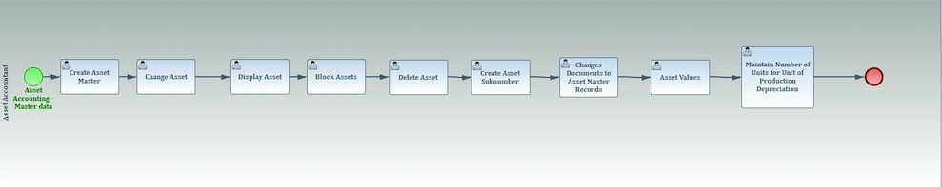

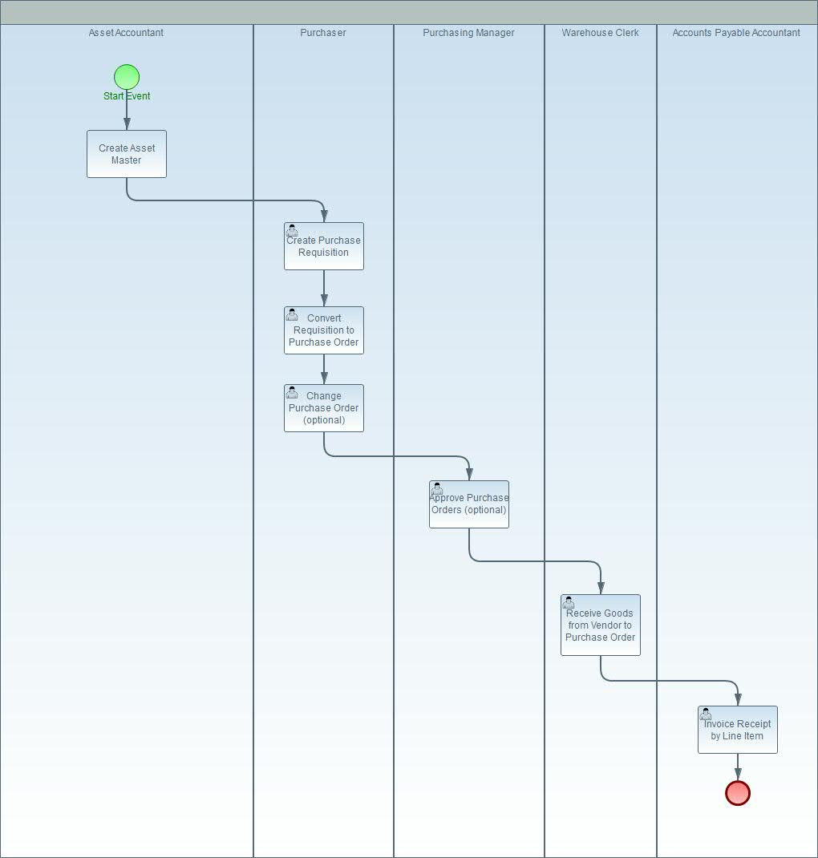

## **9.2. CHART OF DEPRECIATION:**

Charts of depreciation are usually country-specific and are defined independently of the other. You define the characteristics, and thereby the significance, of the individual depreciation areas in. You flexibly define the keys for the automatic depreciation.

There has to be Integration of Company Code with Chart of Depreciation You have to assign each company code defined in Asset.

## **9.3. ASSET CLASS:**

With this app you can display a work list of fixed assets and quickly get an overview of the status of all assets in the list. As well as displaying a list according to specific criteria such as company code or asset class, you can quickly refine the list to show, for example, only incomplete assets, capitalized assets, or retired assets.

## **9.4. DEPRECIATION RUN:**

With this transactional app we can Manage Depreciation Runs. You can schedule and execute depreciation runs for multiple company codes. You can search for and display the details of depreciation runs that have already been scheduled or executed.

## **9.5. ASSET TRANSACTIONS:**

With this app you can check and evaluate daily operations in Asset Accounting. The SAP standard key figure groups enable you to select asset transactions by group, such as acquisitions, retirements, or transfers. The report then displays all transactions of the selected key figure groups and their respective key figures. For example, retirements are listed with retirement revenues or costs, gains, losses, retired APC, and book value.

## **9.6. ASSET HISTORY SHEET:**

With this app, you can call up the asset history sheet that shows value changes to the fixed asset balances in a fiscal year for a depreciation area. The asset history sheet enables you to document and explain the balances on fixed assets for every accounting principle, any local regulation, and for management purposes. SAP provides pre-configured key figure groups that you can use for your reporting. These key figure groups bundle key figure codes, such as acquisitions, retirements, transfers, and depreciation. You can also create your own key figure groups in Customizing to define individual layouts and granularity for your reports.

## **9.7. PERFORM WRITEUP:**

A write-up is generally understood to be a later change to the valuation of an asset. This procedure is described in detail in Post-Capitalization (Write-Up to APC). You must now correct this error using a write-up in the current fiscal year. During a fiscal year change, the write-ups posted up to the year-end are balanced with the depreciation Activities.

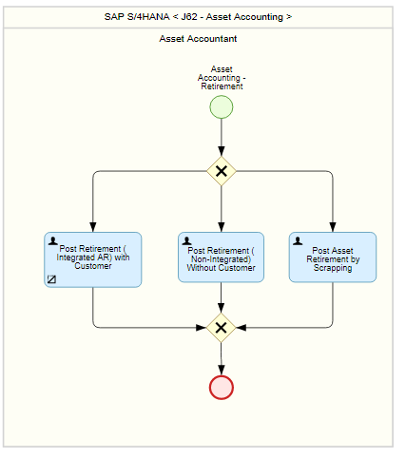

## **9.8. DEPRECIATION LIST – YEAR END CLOSING**

The year-end closing is an annual balance sheet, an annual profit. You use the year-end closing program to close the fiscal year for one or more company codes from an accounting example, by recalculating depreciation).

## **9.9. DEPRECIATION LIST – MONTH END CLOSING**

Perform a complete period end closing in Asset Accounting in your system. Perform a complete period-end closing - if you have not yet done so - for the previous month.

# **10. MASTER DATA**

### **10.1. G/L MASTER**

G/L account master records contain the data that is always needed by the General Ledger to determine the account's function. The G/L account master records control the posting of accounting transactions to G/L accounts and the processing of the posting data.

G/L account master records are divided into two areas so that company codes with the same chart of accounts can use the same G/L accounts.

* **Chart of accounts area:** The chart of accounts area contains the data that is valid for all company codes, such as the account number.
* **Company code specific area:** The company code specific area contains data that may vary from one company code to another, such as the currency in which the account may be posted.

### **10.2. BANK MASTER**

SAP ERP system maintains a list of all the banks that are used by your company or customers and vendors of this company. The list of all banks is called bank directory and for each bank used in SAP system there is a corresponding master data record stored in the bank directory. Before using any bank in the system, you need to create this bank so that it is added to the bank directory

1. House Bank Creation

2. Account ID Creation

3. Bank Key Creation

4. Maintain Customized Payment Program

### **10.3. ASSET MASTER**

Asset master record is the reliable and authoritative data maintained by an organization relating to the various fixed and intangible assets used by it.

Key features of Asset Master Data are:

1. Master data does not change frequently
2. Fixed number of key attributes can be used to capture the relevant details of the asset for analysis and reporting.

# **11. 1GA – FINANCE REPORTS**

## **11.1. TRIAL BALANCE**

With this app you can display debit or credit balances for a specified time range. You can do this for each ledger and all company codes. If you select individual periods only, you can show the balances of the previous and the following periods in the reporting year.

## **11.2. BALANCE SHEET / INCOME STATEMENT**

Use this app to display balance sheets as well as profit and loss statements for your companies using charts of accounts. These reports are generated on the fly by analyzing all relevant line items. From these reports, you can also access the line items of a specific G/L account as well as customer and supplier line items.

## **11.3. AGING REPORT - ACCOUNTS PAYABLE**

Use this app to analyze the payable amounts to suppliers by aging intervals. These intervals allow you to quickly recognize the payments that are due in the current month, the next month, and so on.

## **11.4. AGING REPORT – ACCOUNTS RECEIVABLE**

Use this app to analyze the receivable amounts from customers by aging intervals. These intervals allow you to quickly recognize the receipts that are due in the current month, the next month, and so on.

## **11.5. INDIA WITHHOLDING TAX (TDS & TCS)**

Use this app to display the TDS/TCS Status Reports. Vendor/customer wise reports can be generated with this app.

## **11.6. ASSET BALANCES**

With this app, you can display balances of fixed assets according to various criteria, such as company code, depreciation area, segment, or profit center. The report enables you to understand the netbook value of fixed assets derived from acquisition and production costs (APC) and depreciation.

## **10.7. DISPLAY PROCESS FLOW – ACCOUNTS PAYABLE**

With this app you can display the relationships between Accounts Payable (AP) documents, including purchase orders, goods movements, incoming invoices, journal entries, and clearing entries.

## **10.8. DISPLAY PROCESS FLOW – ACCOUNTS RECEIVABLE**

With this app you can display the relationships between Accounts Receivable (AR) documents, including quotations, sales documents, delivery documents, billing documents, journal entries, and clearing entries.

## **10.9. GST REPORTS**

Use these app to display GSTR1 & GSTR2 Reports.

-----------------------------------------**THE END** --------------------------------------------