**Business Blueprint Document**

**XCMM – RISE WITH SAP -PROJECT OPTIMIZATION**

**PRODUCTION PLANNING**

**Plan to Produce (P2P)**

For



**Xuzhou Construction Machinery Group**

**Submitted**

**By**



**ZYNOVIQ SOLUTIONS PRIVATE LIMITED, CHENNAI**

**September- 2022**

|  |  |
| --- | --- |
| PROJECT IDENTIFICATION: | |
| P Project Name | P Project Description |
| XCMM | S Rise With SAP |
| D Description | L Location |
| Xuzhou Construction Machinery Group | C Kanchipuram |
| S SAP Project Manager | C Customer Project Manager |
| Mr. B. Ganesh Kumar |  |

|  |  |  |  |  |  |  |
| --- | --- | --- | --- | --- | --- | --- |
| Document Identification | | | | | | |
| Author | | | | | Document Location (repository/path/name) | |
| Veera Manikandan | | | | | E-mail Submission | |
| Version | | Status | | | Date (YYYY-MM-DD) | |
| V0 | | Draft | | | 27-08-2022 | |
| Revision history | | | | | | |
| Version | Date | | Description | | | |
|  | 27.08.2022 | | Draft Version | | | |
|  |  | |  | | | |
| Review and Approval | | | | | | |
| BPO or Division Head | | | |  | | Date (DD.MM.YYYY) |
| Client Project Manager | | | |  | | Date (DD.MM.YYYY) |
| Implementation Project Manager | | | |  | | Date (DD.MM.YYYY) |

Table OF CONTENT

1.0 INTRODUCTION 6

**1.0.1 Company Profile** 6

**1.0.2 Overview of the Blueprint phase** 8

**1.0.3 XCMM – Organization Structure** 8

**1.0.4 Production Planning – Introduction** 12

**1.0.5 PP Module integration with other modules** 15

2.0 PROCESS DESCRIPTION – (Define Product Structures) 17

**2.0.1 BPML_01.01.01.01 - Business Process Description** 17

**2.0.2 Process Step Detailed Requirements & Solution** 17

**2.0.3 Operational Decisions or Logic within the Process** 29

**2.0.4 SOX & Legal Considerations and Company-Specific Policies** 29

**2.0.5 Reference Process KPIs** 29

**2.0.6 Business Process Diagram** 29

2.1 Functional Solution Design 29

**2.1.1 Organization Structure Considerations** 29

**2.1.2 Master Data Considerations (including all relevant data relationships)** 29

**2.1.3 System Configuration Considerations** 30

2.2 Technical/Development Related Items 30

**2.2.1 Reporting (operational and analytical)** 30

**2.2.2 Authorization** 30

3.0 PROCESS DESCRIPTION – (Demand Management Integration to Production - ZDM) 31

**3.0.1 BPML_PP_01.02.01.01 - Business Process Description** 31

**3.0.2 Process Step Detailed Requirements & Solution** 31

**3.0.3 Operational Decisions or Logic within the Process** 33

**3.0.4 SOX & Legal Considerations and Company-Specific Policies** 33

**3.0.5 Reference Process KPIs** 33

**3.0.6 Business Process Diagrams** 33

3.1 Functional Solution Design 34

**3.1.1 Organization Structure Considerations** 34

**3.1.2 Master Data Considerations (including all relevant data relationships)** 35

**3.1.3 System Configuration Considerations** 35

3.2 Technical/Development Related Items 35

**3.2.1 Reporting (operational and analytical)** 35

**3.2.2. Data/Conversion** 35

**3.2.3 Authorization** 35

4.0 PROCESS DESCRIPTION – (Material Requirement Planning – J44) 36

**4.0.1 BPML_PP_01.02.01.02 - BUSINESS PROCESS DESCRIPTION** 36

**4.0.2 PROCESS STEP DETAILED REQUIREMENTS & SOLUTION** 36

**4.0.3 OPERATIONAL DECISIONS OR LOGIC WITHIN THE PROCESS** 39

**4.0.4 SOX & Legal Considerations and Company-Specific Policies** 39

**4.0.5 Reference Process KPIs** 39

**4.0.6 Business Process Diagrams** 40

4.1 Functional Solution Design 41

**4.1.1 Organization Structure Considerations** 41

**4.1.2 Master Data Considerations (including all relevant data relationships)** 41

**4.1.3 System Configuration Considerations** 42

4.2 Technical/Development Related Items 42

**4.2.1 Reporting (operational and analytical)** 42

**4.2.2 Authorization** 42

5.0 PROCESS DESCRIPTION – (Plan Discrete Production – ZPP) 43

**5.0.1 BPML_PP_01.02.01.03 - BUSINESS PROCESS DESCRIPTION** 43

**5.0.2 Process Step Detailed Requirements & Solution** 43

**5.0.3 Operational Decisions or Logic within the Process** 45

**5.0.4 SOX & Legal Considerations and Company-Specific Policies** 45

**5.0.5 Reference Process KPIs** 45

**5.0.6 Business Process Diagrams** 45

5.1 Functional Solution Design 47

**5.1.1 Organization Structure Considerations** 47

**5.1.2 Master Data Considerations (including all relevant data relationships)** 47

**5.1.3 System Configuration Considerations** 47

5.2 Technical/Development Related Items 47

**5.2.1 Reporting (operational and analytical)** 47

**5.2.2 Authorization** 48

6.0 PROCESS DESCRIPTION – (Capacity RequiremenT Planning – 31L & 3LQ) 48

**6.0.1 BPML_PP_01.02.01.04 - BUSINESS PROCESS DESCRIPTION** 48

**6.0.2 Process Step Detailed Requirements & Solution** 48

**6.0.3 Operational Decisions or Logic within the Process** 51

**6.0.4 SOX & Legal Considerations and Company-Specific Policies** 51

**6.0.5 Reference Process KPIs** 51

**6.0.6 Business Process Diagrams** 52

6.1 Functional Solution Design 53

**6.1.1 Organization Structure Considerations** 53

**6.1.2 Master Data Considerations (including all relevant data relationships** 53

**6.1.3 System Configuration Considerations** 54

6.2 Technical/Development Related Items 54

**6.2.1 Reporting (operational and analytical)** 54

**6.2.2 Authorization** 54

7.0 PROCESS DESCRIPTION - (Execute Discrete Production – BJ8) 55

**7.0.1 BPML_PP_01.03.01.01 - BUSINESS PROCESS DESCRIPTION** 55

**7.0.2 Process Step Detailed Requirements & Solution** 55

**7.0.3 Operational Decisions or Logic within the Process** 58

**7.0.4 SOX & Legal Considerations and Company-Specific Policies** 58

**7.0.5 Reference Process KPIs** 59

**7.0.6 Business Process Diagrams** 59

7.1 Functional Solution Design 61

**7.1.1 Organization Structure Considerations** 61

**7.1.2 Master Data Considerations (including all relevant data relationships)** 61

**7.1.3 System Configuration Considerations** 61

7.2 Technical/Development Related Items 62

**7.2.1 Reporting (operational and analytical)** 62

**7.2.2. Output (e.g., Forms)** 62

**7.2.3 Authorization** 62

8.0 PROCESS DESCRIPTION - (Engineering ChANGE MANAGEMENT –NA) 63

**8.0.1 BPML_PP_01.04.01.01 - BUSINESS PROCESS DESCRIPTION** 63

**8.0.2 Process Step Detailed Requirements & Solution** 63

**8.0.3 Operational Decisions or Logic within the Process** 64

**8.0.4 SOX & Legal Considerations and Company-Specific Policies** 65

**8.0.5 Reference Process KPIs** 65

**8.0.6 Business Process Diagrams** 65

8.1 Functional Solution Design 66

**8.1.1 Organization Structure Considerations** 66

**8.1.2 Master Data Considerations (including all relevant data relationships)** 66

**8.1.3 System Configuration Considerations** 66

8.2 Technical/Development Related Items 66

**8.2.1 Reporting (operational and analytical)** 66

**8.2.2. Output (e.g., Forms)** 66

**8.2.3 Authorization** 67

9.0 STANDARD PRODUCTION PLANNING REPORTS 67

10.0 ADDITIONAL POINTS Discussed (MOM) 68

# 1. INTRODUCTION

## 1.1 Company Profile

Xuzhou Construction Machinery Group Co., Ltd. (XCMM) was founded in 1943. Since then, XCMM has stood at the forefront of the Chinese construction machinery industry and developed into one of the domestic industry's largest, most influential, and most competitive enterprise groups with the most complete product varieties and series.  
  
XCMM is the 3rd largest construction machinery company in the world. It is ranked 65th in the list of China's Top 500 Companies, 44th in the list of China's Top 100 Manufacturing Enterprises, and 2nd in the list of China's Top 100 Machinery Manufacturers. XCMM is dedicated to its core value of “Taking Great Responsibilities, Acting With Great Morals, and Making Great Achievements” and its corporate spirit of being “Rigorous, Practical, Progressive, and Creative” in order to keep moving towards its ultimate goal of becoming a leading world-class enterprise capable of creating real value.

Rise With SAP modules are being implemented, are

|  |  |
| --- | --- |
| RISE WITH SAP | Module Description |
| FI/CO | Financial Accounting / Controlling (Record to Report) |
| SD | Sales and Distribution (Quote to Cash) |
| MM | Material Management (Procure to Pay) |
| PP | Material Planning (Plan to Produce) |
| SECURITY | Business Application System Integrated Solutions (Technical) |
| ABAP | Advance Business Application Programme (Technical) |

## 1.2 Overview of the Blueprint phase

This document summarizes the findings of the Zynoviq team, which conducted the requirement analysis of XCMM Group of Companies for the Rise With SAP system. This information was gathered through requirement gathering conducted at with XCMM Group of Companies Project managers, key users, and personnel from the information system, as well as the reviews of the business processes, business procedures, documentation, and relevant reports.

The immediate purpose of the analysis is to prepare to move rapidly with the implementation of the XCMM Group of Companies in the Rise With SAP system. At the conclusion of the blueprint, the Zynoviq team will determine the Rise With SAP system functionality required to run the XCMM business.

The Blueprint and its associated appendices present a summarized perspective of all functional business processes that will be implemented. As such, the Blueprint document will serve - from this point forward the dual role of both official project scope as well as system acceptance criteria.

The body of this document describes the organizational structure, enterprise area, and Rise With SAP functional process flows to be implemented at XCMM. Generally, requirements that can be met using standard Rise With SAP Edition system functionality through routine configuration tasks are not explicitly documented. However, certain key requirements are explicitly identified and summarized to highlight their importance to XCMM and to document the approach proposed to meet the requirement.

The Blueprint reiterates the Rise With SAP system organizational structures that have been identified and will serve as the basis for the initial configuration activities. Zynoviq team believes that the Rise With SAP system can accurately model XCMM‘s organizational requirements. The information gathered and documented in the Blueprint is sufficient for the team to go forward into the Realization phase.

## 1.3. XCMM – Organization Structure

## 1.3.1 Client:



A client is a group or combination of legal, organizational, business, and/or administrative

units with a common purpose. Example: a corporate group.

* Client is the highest hierarchical level in the SAP system.
* Client represents a corporate group in **RISE WITH** **SAP** Enterprise structure.
* Client is identified in the system by 3- digit numeric code ( Ex: 100 ).
* Several company codes can be uniquely assigned to a client.
* Data maintained at the Client level is valid across all other organizational levels.

## 1.3.2 Company Code:

The company code is the organizational unit that allows you to structure your enterprise from a financial accounting perspective. This level represents an independent accounting unit within a client

Example: a subsidiary company, member of a corporate group.



* Company code is the smallest organizational unit within the client to the company

Code is a legal entity & independent accounting unit.

* Each company code has its own balance sheet and its own profit and loss statement.
* Company code is defined as a 4-digit Alphanumeric key
* Company Code is an organizational unit prepared by FI Module Consultant.

|  |  |  |
| --- | --- | --- |
| S. No. | Company Code | Description |
| 1 | 1000 | XCMM |

## 1.3.3 Plant:

In SAP, a Plant is defined as an organizational logistics unit that structures the enterprise from the perspective of production, procurement, plant maintenance, and materials planning. A Plant is thus a manufacturing facility or branch within the company.  
The plant is an operating area or branch within a company. The plant is embedded in the organizational structure as follows:

* The plant is assigned to a single company code. A company code can have several plants.

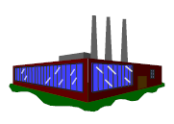

* Several storage locations can be maintained for each plant based on material stock.
* A single business area is assigned to a plant and a division.
* A plant can be assigned to several combinations of purchase organization and distribution channel.
* A plant can have several shipping points. A shipping point can be assigned to several plants.
* A plant can be defined as a planning plant. The plant is recommended to use as a valuation area for Material valuation.

**As Is Process:**

* In XCMM Currently only one Plant is Configured.

|  |  |  |  |
| --- | --- | --- | --- |
| Company Code | Company Code Description | Plant | Plant Description |
| 9260 | XCMM | 9260 | XCMM India plant |

**To Be Process:**

* New Plant Configuration for R&D, Spares, and Oragadam location.

|  |  |  |  |
| --- | --- | --- | --- |
| Company Code | Company Code Description | Plant | Plant Description |
| 1000 | XCMM | 1000 | XCMM Manufac Plant |
| 1000 | XCMM | 2000 | XCMM R&D Plant |
| 1000 | XCMM | 3000 | XCMM Spares Plant |
| 1000 | XCMM | 4000 | XCMM Warehouse Plant |

## 1.3.4 Storage Location:

The Storage Location is an organizational unit that allows the differentiation of material stocks within a Plant. Stocks are managed only on a quantity basis and not on a value basis at the storage location level. Storage Location is the lowest organizational level in MM and it helps to differentiate the stocks.

**A storage location has the following attributes:**

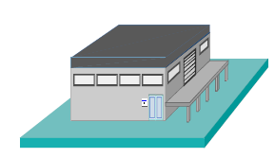

* Defined as 4 digit alphanumeric key in the SAP system

( Ex: SL01).

* There may be one or more storage locations within a

Plant.

* A storage location has a description and at least one

Address.

* There will be always at least one storage location defined for one

Plant.

* It is possible to store material data specific to a storage location.
* Physical inventory is carried out at the storage location level.
* Stocks are managed only on a quantity basis and not on a value basis at storage location level.

|  |  |  |  |
| --- | --- | --- | --- |
| Plant | Plant Description | Storage Location | Storage Location Description |
| 9260 | XCMM India plant | E001 | Equi. Spare Part |
| 9260 | XCMM India plant | F001 | Finish Goods |
| 9260 | XCMM India plant | F002 | CBU Delivery |
| 9260 | XCMM India plant | F003 | CBU Spare Parts |
| 9260 | XCMM India plant | F004 | CBU Return |
| 9260 | XCMM India plant | L001 | Lab. Prot. Appl. |
| 9260 | XCMM India plant | MRPC | MRP AREA |
| 9260 | XCMM India plant | P001 | Line Room |
| 9260 | XCMM India plant | P002 | Comm. Vehicle |
| 9260 | XCMM India plant | P003 | Painting Vehicle |
| 9260 | XCMM India plant | S001 | Ser. Spare Parts |
| 9260 | XCMM India plant | S002 | SpareParDelivery |
| 9260 | XCMM India plant | T001 | Tools |
| 9260 | XCMM India plant | T002 | MeasuringInstru |
| 9260 | XCMM India plant | W001 | Import Parts |
| 9260 | XCMM India plant | W002 | Standard Parts |
| 9260 | XCMM India plant | W003 | Supp. Parts  1 |
| 9260 | XCMM India plant | W004 | Supp. Parts  2 |
| 9260 | XCMM India plant | W005 | Row Material |
| 9260 | XCMM India plant | W006 | Semi-CBU |
| 9260 | XCMM India plant | W007 | Supp. Parts |
| 9260 | XCMM India plant | W008 | Return |
| 9260 | XCMM India plant | W009 | Claim |
| 9260 | XCMM India plant | W901 | W/o Billing Age |
| 9260 | XCMM India plant | W902 | W/o Billing Ind |
| 9260 | XCMM India plant | W903 | W/o Billing SP |
| 9260 | XCMM India plant | X001 | R & D Library |
| 9260 | XCMM India plant | Y001 | Prototype |

### **1.0.4 Production Planning – Introduction**

The logistics and supply chain management is far more volatile, uncertain, complex, and ambiguous due to the globalized supply chain and shorter product lifecycle, production planning in RISE WITH SAPoffers several planning tools to help reduce volatility, uncertainty, complexity, and ambiguity.

* Production Planning is one of the key modules in RISE WITH SAP and deals with planning processes, such as capacity planning, material planning, execution of production orders, bill of material, and goods movement.
* SAP PP module handles the master data required for Bill of Materials (BOMs) activity, work center, routing, and keeps it in a separate component.

Based on the process understanding in workshop requirement gathering sessions, the Zynoviq team will suggest **Production Planning – Discrete Industries** processes for XCMM production process planning and execution in RISE WITH SAP System.

**Diagram**

PP includes the following production planning tools:

**Master data**

Production Planning includes the material Master – PP View, Bill of Material(BOM), Work Center, Routing, and a production version.

**Production planning**

Production Planning Process includes material forecasting, demand management (which flows from the sales team)

**MRP Run**

The MRP run generates a list of dependent requirements based on the explosion of Bill of Material (BOM) components and levels for its corresponding independent material. The system also carry out the scheduling of the above requirements and plans for capacity requirements for producing the above dependent/independent requirements.

**Capacity requirements planning (CRP)**

Capacity Requirement Planning consists of capacity evaluation and capacity leveling. The capacity evaluation reflects the load and overload at Work Center, whereas capacity leveling helps the planner optimize the production processes.

**Production order creation and release**

Production order is the main element used for detailed planning and execution of process manufacturing. In the MRP run the system creates planned orders that in turn can be converted to Production orders (if the goods are produced in-house) before actual production execution. Alternatively, if the requirements are procured externally, these requirements are directly converted into Purchase requisitions. It would also be possible to generate purchase requisitions directly during the MRP run.

After the production order is created, the following activities need to be carried out before releasing,

**Availability check for materials** to verify whether the availability of all materials required for starting the production exists.

**Availability check for capacity** availability at the individual resource which has been defined in the recipe for the particular material.

Based on the availability, the system would create necessary reservations for the material and work center. As the actual production starts on the scheduled dates, the user will carry out production confirmations on the system. The system shall have a provision to capture production quantities, production time i.e. setup, machine, and labor time. As the confirmations against production orders are over, the user shall carry out Production order settlement to formally close the order and allocate all costs to the relevant cost objects.

**Flow Diagram of Order Processing**

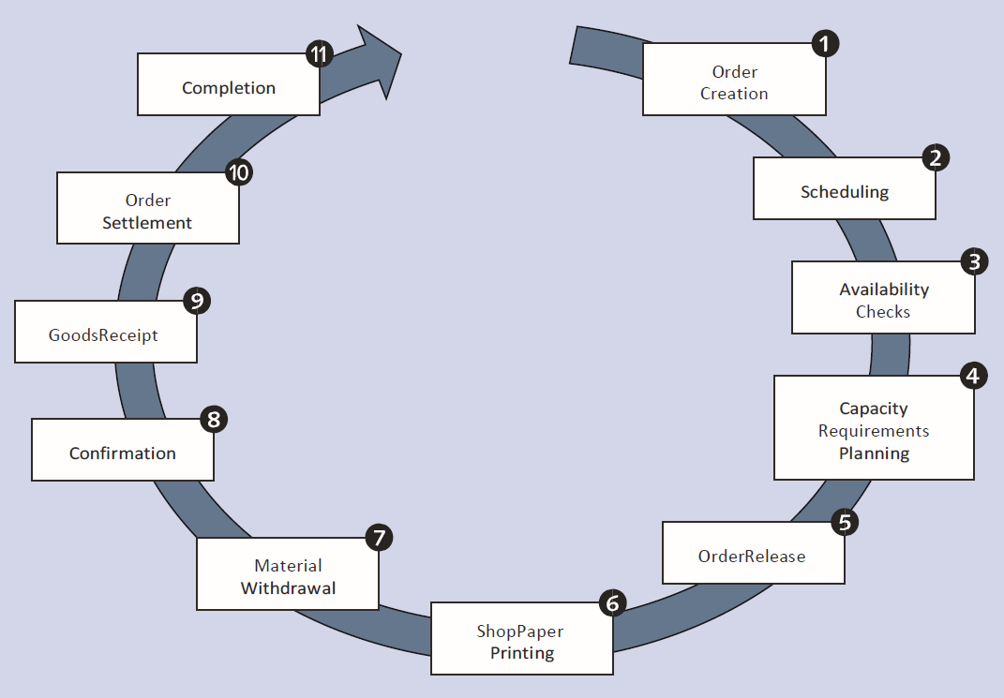

**Product cost controlling (CO-PC)**

Controlling integrates with PP and is responsible for ensuring all production-related costs are accounted for including below objects,

* + - overheads
    - variances
    - work in process (WIP).

**Reporting**

A large number of information systems and standard and flexible analysis reporting options are available in PP.

### **1.0.5 PP Module integration with other modules**

* The Production Planning module is fully integrated with other modules of RISE WITH SAP
* The continuous exchange of information with other application areas in the RISE WITH SAP System ensures a real-time database.
* Considering the specific requirements of the organization, the SAP PP module could be integrated with other modules.

The broad level integration areas with SAP PP module in XCMM are,

**1.Material Management**

PP Module integrated with Material Management in below scenarios,

* This involves the movement of goods issue and goods receipt.
* It includes creating a reservation for Process Order/Planning.
* Raising purchase orders with MRP Run.
* Quotations and Vendor selection

**2.Finance and Controlling**

PP Module integrated with Finance and Controlling in below scenarios,

* Price updation for Manufactured material in material master data.
* Defining activity type in the cost center.
* Assigning activity type to a resource.
* Cost Estimation.
* Production cost controlling
* Posting accounting activities related to goods movement, material request, etc.
* Costing sheets for overheads.

**3.Sales and Distribution**

PP Module integrated with Sales and Distribution in below scenarios,

* Make to Stock Scenario-MRP Run, Requirement Types
* Sales plan to arrive weekly/Daily /monthly production plan

2.0 PROCESS DESCRIPTION – (Define Product Structures)

### **2.0.1 BPML_01.01.01.01 - Business Process Description**

|  |  |
| --- | --- |
| Process Characteristics | |
| Process Trigger | Manual |
| Process Input | Production Planning master data |
| Process Output | Master Data |
| Process Owner | Production department |
| Process Volumes | Approximately 200 |
| Process Frequencies | When a prospective/new material is added to the business. |

### **2.0.2 Process Step Detailed Requirements & Solution**

This section describes the master data in production planning.

**Master Data for Production Planning**

Production Planning master data contains the main detailed objects in the SAP Production Planning module.

In SAP PP, the main objects are,

* + Material master (MRP view and Workscheduling view)
  + Bill of Material
  + Work Centre
  + Routing
  + Production Version

Master data contains the key properties of these objects such as Production order, material type, planning requirements, goods issue, and goods receipt.

1. **BPML_PP_01.01.01.01.01- Manage Material Master – PP view**

 The material master contains information on all the materials that a company procures, produces, stores, and sells. A Material Master is a central master data of an organization that contains information related to the procurement, production, quality, sales, and financial data for the material.

The material master contains information related to different material types like the finished product, raw material. The material master can be used for identifying a product, purchase material, goods issue or good receipt, MRP, and production confirmation.

Different departments in a company work with the same material, but every department uses different information on the material, the data in a material master record is subdivided by the user department.

This is illustrated in the following graphic representation:

Basic Data

Forecasting

Classification

Work Scheduling

Purchasing

Sales Org

MRP

Costing

Quality Mgmt

Accounting

Material

Master

The following views are relevant for production planning:

* MRP 1
* MRP 2
* MRP 3
* MRP 4
* Work Scheduling

The Material types used in Production planning for XCMM business they are,

|  |  |  |
| --- | --- | --- |
| Sl. No | Material types | Required views |
| 1 | COMPLETELY BUILT UNIT | MRP 1 |
| MRP 2 |
| MRP 3 |
| MRP 4 |
| Work scheduling |
| 2 | SEMI KNOCKED DOWN | MRP 1 |
| MRP 2 |
| MRP 3 |
| MRP 4 |
| Work scheduling |
| 3 | LOCAL MATERIALS | MRP 1 |
| MRP 2 |
| MRP 3 |
| MRP 4 |
| 4 | BULK MATERIALS | MRP 1 |
| MRP 2 |
| MRP 3 |
| MRP 4 |

* In the XCMM business, it is necessary to ensure that all manufactured materials (like Semi Knocked Down materials, Completely Built Unit) that all procured production-consumption materials (like raw materials and Bulk Materials) need to meet production standards.
* It is necessary to maintain the MRP view and work scheduling view in the material master, If the material needs to be planned and scheduled for production in the RISE WITH SAP system.
* Work scheduling view and MRP view is defined at the **Plant level** for required material

As per the Requirement gathering discussions, the following are the essential values required to be maintained for the XCMM production process

MRP 1 view

1. MRP Type – It’s the key that determines whether and how the material is planned. The material should be maintained with the following possible values

PD-Material Requirements Planning (Planned Deterministic – For all in-house manufactured products and finished products)

ND- No Planning (For all non-production consumption materials)

1. Lot Size Procedure – It’s the Key that determines which lot-sizing procedure the system uses within materials planning to calculate the quantity to be procured or produced.

Ex- Lot for Lot,

FX- Fixed Lot Size,

MB - Monthly Lot Size (For all in-house manufactured products)

1. MRP Controller will be the person responsible for planning and procuring/producing material.

|  |  |  |
| --- | --- | --- |
| **Plant** | **MRP CONTROLLER** | **Description** |
| 1000 | ZM01 | Import Raw Material for 1000 plant |
| 1000 | ZM02 | IN Raw Material for 1000 plant |
| 1000 | ZM03 | Chinese Raw Material |
| 1000 | ZM04 | Import KIT for 1000 plant |
| 1000 | ZM05 | IN KIT for 1000 plant |
| 1000 | ZM06 | Chinese KIT for 1000 plant |
|  |  |  |
| 2000 | ZR01 | Import Raw Material for 2000 plant |
| 2000 | ZR02 | IN Raw Material for 2000 plant |
| 2000 | ZR03 | Chinese Raw Material |
| 2000 | ZR04 | Import KIT for 2000 plant |
| 2000 | ZR05 | IN KIT for 2000 plant |
| 2000 | ZR06 | Chinese KIT for 2000 plant |
|  |  |  |
| 3000 | ZS01 | Import Raw Material for 3000 plant |
| 3000 | ZS02 | IN Raw Material for 3000 plant |
| 3000 | ZS03 | Chinese Raw Material |
| 3000 | ZS04 | Import KIT for 3000 plant |
| 3000 | ZS05 | IN KIT for 3000 plant |
| 3000 | ZS06 | Chinese KIT for 3000 plant |
|  |  |  |
| 4000 | ZW01 | Import Raw Material for 4000 plant |
| 4000 | ZW02 | IN Raw Material for 4000 plant |
| 4000 | ZW03 | Chinese Raw Material |
| 4000 | ZW04 | Import KIT for 4000 plant |
| 4000 | ZW05 | IN KIT for 4000 plant |
| 4000 | ZW06 | Chinese KIT for 4000 plant |

MRP 2 View

1. Procurement Type - It’s the indicator that defines how the material is procured.

The following values should be maintained,

* E- for all in house manufactured products
* F-For Externally Procured
* X- for Items that are manufactured in-house and procured externally.

1. Special Procurement - special procurement should be maintained only for those materials for which the procurement type in the material master should be overridden or define the procurement type more precisely.
2. Production Storage Location (This is the storage location from which components have to be consumed/backflushed)
3. In-house Production Time-This is the time in workdays needed to produce the material in-house. In-house production time is independent of the order quantity.
4. Planned Delivered Time - Number of calendar days needed to obtain the material or service if it is procured externally.
5. GR processing time - Number of workdays required after receiving the material for inspection and placement into storage.
6. Scheduling Margin Key – It’s the key that the system uses to determine the floats required for scheduling an order. Floats are maintained on workdays.
7. Safety Stock – Specifies the quantity whose purpose is to satisfy the unexpectedly high demand in the coverage period. The risk of shortfalls is reduced by having a [safety stock](SAPEVENT:DOCU_LINK\DS:GLOS.3526C4C6AFAB52B9E10000009B38F974).

MRP 3 view

* **Planning Strategy – Make to Stock** In a Make To Stock environment, production begins Before a sales order is received, and any receipt from the production line is placed in inventory, from which customer orders are fulfilled.

1. **Planning strategy - (Make to Stock/Net requirements planning) assigned in the MRP3 view of the material master. The system carries out Net requirements planning for finished products to achieve the requirements for the Forecasting plan, this case is applicable only to plan at CBU Level so as to keep the CBU as readily available stock if required**

**(Note: Zynoviq will enable Make to Order process in RISE WITH SAP system for future requirement)**

1. Availability Check - Specifies whether and how the system checks availability and generates requirements for [materials planning](SAPEVENT:DOCU_LINK\GL:materials_planning). (“02- Individual Requirements” should be maintained for all materials)

MRP 4 view

1. Individual/ Collective requirements – It’s the indicator determining whether the Requirement quantities of the dependent material are stated individually / grouped. Value - “2- Collective requirements” should be maintained for all the materials.
2. In RISE WITH SAP, production version is mandatory and it should be maintained.
3. In XCMM scenario, Numerous Production versions will be maintained. So that the planner will have to select the relevant production version, before running the MRP.

Work Scheduling View:

This view should be maintained only for the In-house manufactured products (Finished/Semi Knocked Down material).

1. Production Scheduling Profile - Profile that can be used to specify that certain business transactions are carried out in parallel in a Production order (for example, create and release order at the same time, or release order and print the shop papers, trigger an automatic goods receipt for the order, etc). The production scheduling profile is copied into the order during the order creation.
2. Production Supervisor - The production supervisor processes production orders, checks available stocks in production, and confirms completed production orders in the system. He or she evaluates data from production

The list of Production Supervisor going to configure in RISE WITH SAP System are,

|  |  |  |
| --- | --- | --- |
| **Plant** | **MRP CONTROLLER** | **Description** |
| 1000 | ZM01 | Import Raw Material for 1000 plant |
| 1000 | ZM02 | IN Raw Material for 1000 plant |
| 1000 | ZM03 | Chinese Raw Material |
| 1000 | ZM04 | Import KIT for 1000 plant |
| 1000 | ZM05 | IN KIT for 1000 plant |
| 1000 | ZM06 | Chinese KIT for 1000 plant |
|  |  |  |
| 2000 | ZR01 | Import Raw Material for 2000 plant |
| 2000 | ZR02 | IN Raw Material for 2000 plant |
| 2000 | ZR03 | Chinese Raw Material |
| 2000 | ZR04 | Import KIT for 2000 plant |
| 2000 | ZR05 | IN KIT for 2000 plant |
| 2000 | ZR06 | Chinese KIT for 2000 plant |
|  |  |  |
| 3000 | ZS01 | Import Raw Material for 3000 plant |
| 3000 | ZS02 | IN Raw Material for 3000 plant |
| 3000 | ZS03 | Chinese Raw Material |
| 3000 | ZS04 | Import KIT for 3000 plant |
| 3000 | ZS05 | IN KIT for 3000 plant |
| 3000 | ZS06 | Chinese KIT for 3000 plant |
|  |  |  |
| 4000 | ZW01 | Import Raw Material for 4000 plant |
| 4000 | ZW02 | IN Raw Material for 4000 plant |
| 4000 | ZW03 | Chinese Raw Material |
| 4000 | ZW04 | Import KIT for 4000 plant |
| 4000 | ZW05 | IN KIT for 4000 plant |
| 4000 | ZW06 | Chinese KIT for 4000 plant |

1. **BPML_PP_01.01.01.01.02-Maintain Bill of Material**

* Bill of Materials or commonly called BOM is a formally structured list of components that make up a product or assembly.
* The list contains the material number of the component together with the quantity and unit of measure.

BOM is used for the following activities in RISE WITH SAP production planning:

1. Material requirement planning based on the BOM components.
2. Product costing.
3. Material provisions for the production order.

* Material BOM will be created with usage “1” – Production for all the Bill of material, with the current date as the valid from date.
* Item Category “L – stock item” will be used for all the BOM items.
* Planned component scrap/operation scrap will be maintained for the relevant items in the BOM of Semi Knocked Down and finished products (packed SKD).
* If the same product can be produced by using a different set of components, then multiple BOM (more than one alternative BOM) should be created for such products.

**Based on Requirement gathering discussion, It required multiple alternative BOM for production planning .**

* BOM items quantity can be maintained either in the base unit of measurement or alternative unit of measurement (provided a relationship exists in the additional data of that particular material master for the base unit of measurement and alternative unit of measurement).
* All the material BOM should be created for a base quantity for the respective base unit of measurement.
* All the BOM will be created/changed using the system date as the valid from date.
* In XCMM, the Bill Of Material Structure is Multi-Level

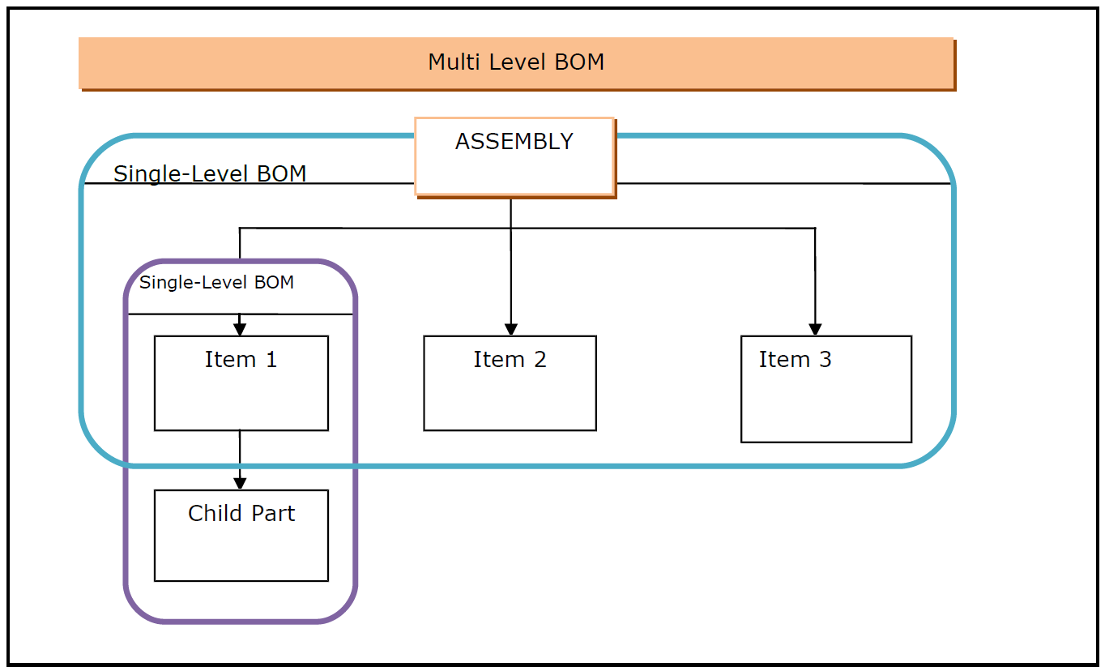

1. **BPML_PP_01.01.01.01.03- Define Work Centre**

* A work center is an organizational unit where manufacturing activities are performed.
* In other words, Work Centers are the master data that represent real machines, Production Lines, Assembly Work Center, etc. Manufacturing activity or Operations are carried out at Work Center.
* Work Centers are used in task list (routing) operations and are copied to Production orders for the shop floor planning and execution.

Work Center data is used for

1. **Scheduling**

When a production order is created, the duration of an operation can be calculated based on operating times in routing and formulas which are entered in the Work Center.

1. **Costing**

The costs of an operation can be calculated in the production Order based on the formulas which are entered in the Work Center. Work Center is also linked to a cost center.

1. **Capacity Planning**

The available capacity and formulas for calculating capacity requirements are stored in the Work Center.

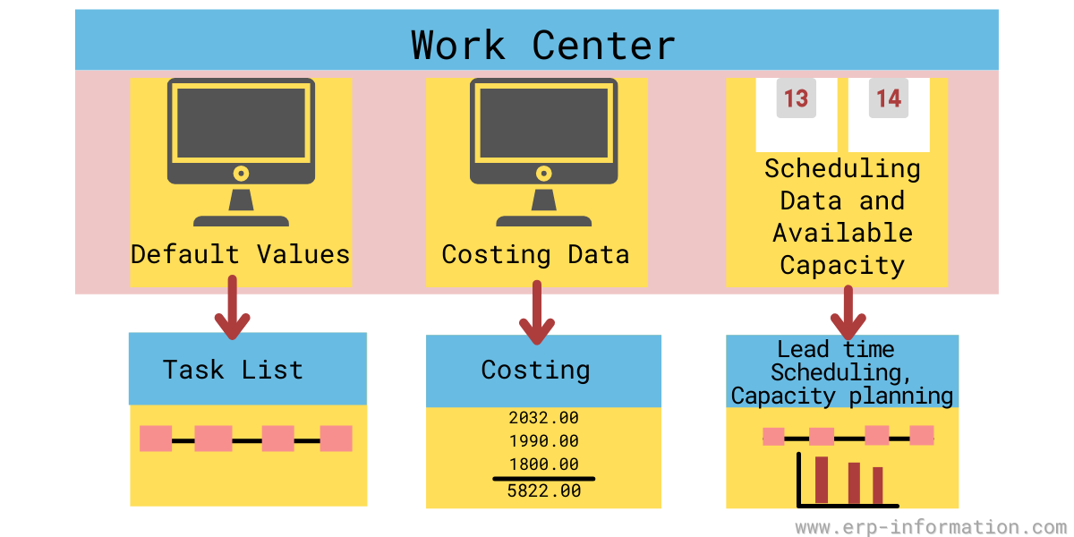

1. **BPML_PP_01.01.01.01.03-Manage Routing**

Routing is a description of which operations or a list of activities has to be carried out during the production and planning process.

* It also tells what order or sequence the activities/operations needs to be carried out at work centers or machines.
* There may be several alternative routings for a product. For example, the product can be manufactured on 2 manually operated machines (drilling and grinding) and simultaneously manufactured on 1 automatic machine (which has both drilling and grinding functions).In this case, Material has 2 alternative routings viz, automatic machine and manual operated machine.
* Multiple materials can follow the same routing group which means a group of materials can have a single routing.
* Routing is used in Production for scheduling and cost of operations for finished and Semi Knocked Down materials.
* Routing is also used in standard cost calculation for finished Products by calculating the operational cost of the finished product.
* Before creating the routing, Work Centre must be available in the system.
* **The Routing Master data changes will be automatically updated in next Production Order or able to update in existing Production order through “Read PP Master Data“ functions in Change Production Order Fiori App.**

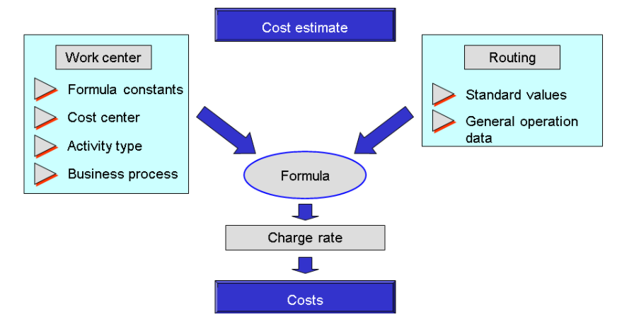

1. **BPML_PP_01.01.01.01.03-Manage Production version**

* Production versions will be maintained for all the in-Completely Built Units with a suitable lot size, validity date, respective material’s Routing number & group counter, and Bill of material combinations.
* If there is more than one valid production version for material, then the system will automatically take the first production version for production planning and execution purpose.
* The production version selection will be manual during Production order creation as this helps in transferring the suitable BOM and Routing for actual production execution.
* Multiple production versions can exist for any in-house manufactured product that has multiple BOM or more than one Routing Operation is available.

**Based on Requirement gathering discussion, the XCMM production process requires multiple production versions (combination of Routing Operation and BOM) for CBU product.**

### **2.0.3 Operational Decisions or Logic within the Process**

The Production planning master data will be creating/changing/set deleting flag in RISE WITH SAP system based on the new requirement in XCMM.

### **2.0.4 SOX & Legal Considerations and Company-Specific Policies**

The Master data management team will be authorized for material master management in the XCMM business

### **2.0.5 Reference Process KPIs**

Fit-to-Standard workshop gathering document.

### **2.0.6 Business Process Diagram**

Not Applicable

# 2.1 Functional Solution Design

### **2.1.1 Organization Structure Considerations**

|  |  |  |  |  |  |
| --- | --- | --- | --- | --- | --- |
| Organizational Structure | | | | | |
| Object | ID | Description | Plant | Description | Remarks |
| Company | 1000 | XCMM Pvt Ltd | 1000 | Plant XCMM |  |
| Company | 1100 | XCMM Systems Pvt Ltd | 1100 | Plant XCMM |  |

### **2.1.2 Master Data Considerations (including all relevant data relationships)**

* Material Data - From Material master
* Plant - From Org. structure

### **2.1.3 System Configuration Considerations**

|  |  |  |  |
| --- | --- | --- | --- |
| Core Configuration | | | |
| ID | Description | IMG Activity | Owner |
| SG-PP-CC001 | MRP Controller |  | Functional |
| SG-PP-CC002 | Scheduling Margin Key |  | Functional |
| SG-PP-CC003 | Define Work Centre Category |  | Functional |
| SG-PP-CC004 | Production scheduling profile |  | Functional |

# 2.2 Technical/Development Related Items

### **2.2.1 Reporting (operational and analytical)**

Not Applicable

### **2.2.2 Authorization**

|  |  |  |  |  |
| --- | --- | --- | --- | --- |
| Authorizations | | | | |
| ID | Authorization | Data Objects | Reason | No of employees |
| SG-PP-A001 | MDM Team | Master Data | Master data control by a specific team in XCMM | 1 |

# 

# 3.0 PROCESS DESCRIPTION – (Demand Management Integration to Production - ZDM)

### **3.0.1 BPML_PP_01.02.01.01 - Business Process Description**

|  |  |
| --- | --- |
| Process Characteristics | |
| Process Trigger | Manual |
| Process Input | Monthly Plan |
| Process Output | Production requirements |
| Process Owner | Production Planner |
| Process Volumes | Approximately 20 |
| Process Frequencies | Weekly once or daily once |

### **3.0.2 Process Step Detailed Requirements & Solution**

**Overview**:

Demand Management is a sub-process in the Production Planning module. This process is initiated on how demand flows in the manufacturing facilities. Standard Planned independent requirement manages and maintains the demand.

**AS-IS PROCESS**

* In the current process, the Purchase Order provided by Customers and will be considered as Firmed Plan by XCMM Production Team in advance.
* The production execution process planned for confirmed customer orders will be based on Make to Stock scenario.

**TO-BE PROCESS**.

ZYNOVIQ team suggest the XCMM business team to follow RISE WITH SAP and Make to Stock concept to meets XCMM business requirements

**1. BPML_PP_01.02.01.01.01 Manage planning strategies**

* Based on the planning strategy **(20 – Make to Stock with Individual/Collective requirement indicator)** assigned in the MRP3 and MRP4 view of the material master then the system carries sales order planning for both Semi Knocked Down and finished products to achieve the requirements.

**2.BPML_PP_01.02.01.01.02 Maintain planned independent requirements**

* In RISE WITH SAP the monthly production plan (proposed based on the past history, present market situation) for each finished material will be maintained as Planned independent requirements in Fiori App“ Maintain PIRs“ at each plant level.
* The monthly demand will be maintained as planned independent requirements for the period indicator – M for the active version 00 and the active check box included.

If weekly means the period indicator is ’W‘.

* Production schedules will be created by the system based on the base of Planned Independent Requirement(P.I.R) input in the demand management.

**3.BPML_PP_01.02.01.01.03 Consume planned independent requirements**

* In RISE WITH SAP, the system considers the requirements entered in the Planned independent requirement (P.I.R) as the required quantities and consumes while running material requirement planning (M.R.P)
* There is no concept of Planned Independent Requirement consumption through customer requirements since customer requirement is not relevant for make-to-stock production.

**4.BPML_PP_01.02.01.01.04 Reduce planned independent requirements**

* IN RISE WITH SAP The system reduces the P.I.R quantities at the time of goods receipt for respective material

**5.BPML_PP_01.02.01.01.05 Reorganise planned independent requirements.**

* It is recommended to use Reorganisation of Planned independent requirement(P.I.R)
* In this scenario, the unused planned independent requirement quantities in past forecast plans can reorganize with the current forecast plan.

### **3.0.3 Operational Decisions or Logic within the Process**

For Make To Stock (MTS), planning strategy Planned independent requirement is mandatory for running Material Requirement Planning

### **3.0.4 SOX & Legal Considerations and Company-Specific Policies**

In XCMM business production planners can create and change planned independent requirements and the necessary roles and authorization will be provided in the system.

### **3.0.5 Reference Process KPIs.**

Fit-To Standard Workshop Requirement Gathering Document

### **3.0.6 Business Process Diagrams**

# 

# 3.1 Functional Solution Design

Sap standard planned independent requirement is good to use at XCMM

### **3.1.1 Organization Structure Considerations**

|  |  |  |  |  |  |
| --- | --- | --- | --- | --- | --- |
| Organizational Structure | | | | | |
| Object | ID | Description | Plant | Description | Remarks |
| Company | 1000 | XCMM | 1000 | XCMM Manufac Plant |  |
| Company | 1000 | XCMM | 2000 | XCMM R&D Plant |  |
| Company | 1000 | XCMM | 3000 | XCMM Spares Plant |  |
| Company | 1000 | XCMM | 4000 | XCMM Warehouse Plant |  |

### **3.1.2 Master Data Considerations (including all relevant data relationships)**

1.Material Master – PP Views

### **3.1.3 System Configuration Considerations**

|  |  |  |  |
| --- | --- | --- | --- |
| Core Configuration | | | |
| ID | Description | IMG Activity | Owner |
| SG-PP-CC005 | Plant Parameter for carrying out MRP |  | Functional |

# 3.2 Technical/Development Related Items

### **3.2.1 Reporting (operational and analytical)**

Standard FIORI analytical Application is enough to cover all Demand Management Requirements

### **3.2.2. Data/Conversion**

|  |  |  |  |  |  |  |
| --- | --- | --- | --- | --- | --- | --- |
| Conversion | | | | |  |  |
| WRICEF ID | Conversion object | Source | Conversion Activities  (e.g., cleansing) | Conversion Method (manual / automated) | # Of Objects to be converted | Owner |
| NA | NA | NA | NA | NA | NA | NA |

### **3.2.3 Authorization**

|  |  |  |  |  |
| --- | --- | --- | --- | --- |
| Authorizations | | | | |
| ID | Authorization | Data Objects | Reason | No. of employees |
| SG-PP-A002 | Production Planner | Planned Independent Requirement | Only for XCMM Authorized person | 2 |

# 4.0 PROCESS DESCRIPTION – (Material Requirement Planning – J44)

### **4.0.1 BPML_PP_01.02.01.02 - BUSINESS PROCESS DESCRIPTION**

|  |  |
| --- | --- |
| Process Characteristics | |
| Process Trigger | Manual |
| Process Input | Planned Independent Requirement (P.I.R) |
| Process Output | Production Requirements |
| Process Owner | Production Planner |
| Process Volumes | Approximately 20 |
| Process Frequencies | Weekly once or monthly once |

### **4.0.2 PROCESS STEP DETAILED REQUIREMENTS & SOLUTION**

**Overview**:

This section describes the process of material requirement planning. This process is initiated for the planning of material based on the net requirement and customer order.

**AS-IS PROCESS**

* In the XCMM business, the material requirement planning process is managed in excel.
* The Planner manages the planning process manually based on customer orders.
* Material requirements are converted to picklist and shared with the store's department.
* The purchase order quantity and material required dates are confirmed by the Production department.
* After the E-mail confirmation, the purchase requisition is converted to a purchase order.
* Based on planner input, the production requirements are shared to the shop floor through excel.
* The work order for all customer orders is managed by the planner through the picklist form.

**TO-BE PROCESS**

* ZYNOVIQ recommends the XCMM production team to run Material Requirement Planning (MRP) standard features available in RISE WITH SAPbased on the customer order that they receive from the sales team for the finished product.
* MI recommends managing the Planned Independent Requirement for common assembly level and Run MRP to maintain the Assembly stock on the shop floor to reduce the lead time of Finished goods after customer order received.
* The main function of Material Requirements Planning is to guarantee material availability to the shop floor.
* The output of MRP may either be procured or produced.
* **Internal Order report for both MTO & MTS scenarios is in standard.**
* The aim of material requirements planning is to tailor available capacities and receipts on time to suit requirement quantities. This can be achieved by MRP.

1. **BPML_PP_01.02.01.02.01 Set Up MRP Parameters**

* In RISE WITH SAP MRP parameters are required to run material requirement planning to meet PIR and to use Routing information
* Setup of MRP parameters such as Processing Key, Scheduling, Material, Plant, etc.

1. **BPML_PP_01.02.01.02.02 Run MRP**

* In the XCMM, MRP can be planned either at the plant-level or Material-level.
* The Planner will run the MRP for listed scenarios to achieve the XCMM Bussiness requirements,
  + Strategy for Planning Components -70 (Planning at Assembly level)
  + Make-to-Order 20 with Individual/Collective requirement indicator
* Make-to-Order 20 with Individual/Collective requirement indicator- The system explodes the Bill of Material for material and generates the dependent requirement against the sales order for RM/PM Material and Finished Goods.
* In RISE WITH SAP MRP will automatically generate order proposals to purchasing(purchase requisition) and production(planned order).
* Zynoviq recommends to use planning strategy 70 for XCMM Sub Assembly with multiple variants of the finished product that are manufactured using common assemblies to forecast these assemblies well in advance that has long Lead time
* **Through MRP, we able to get collective requirement of single material in one Purchase Requistion.Each material from Bill of material will appear in individual PR only**

1. **BPML_PP_01.02.01.02.03 Evaluate and Process MRP Results**

* The output of the MRP run is the planned order
* In case of materials, which are not produced in-house, the MRP run shall create Purchase Requisitions. Purchase requisitions can also be created from a planned order.
* If Minimum and Maximum lot sizes are specified for material in the material master, the system will create planned order quantities within the above range.
* The purchase requisitions created by MRP will always be of document type NB - Purchase requisition. For details on purchase document type refer to MM Blueprint on purchasing.
* The unconverted planned orders will be deleted in the next MRP run if no requirements exist for the said materials. However, firmed planned orders shall not be deleted automatically by the system.

**Consumption Based Planning (CBP)**

Consumption based planning functionality is part of standard SAP and will need to be activated. Reorder point planning procedure will also be activated.

* The materials which are identified as those items to be planned/procured based on their consumption (CBP items) reorder point needs to be defined in their material master data.
* Based on the requirement, the concerned department raises a Reservation document mentioning the relevant cost center against which the consumption has to be booked.
* Then store person issues the materials against the reservation and consumption entries are posted.
* As and when the stock level falls below the Reorder point, the system will identify the material for planning.
* Procurement item-PR is generated as an output of the MRP run.
* Purchasing department further processes the PR for procurement.



### **4.0.3 OPERATIONAL DECISIONS OR LOGIC WITHIN THE PROCESS**

Material Requirement Planning is mandatory for planning the production

### **4.0.4 SOX & Legal Considerations and Company-Specific Policies**

Only the Nominated production planner can run and change Material requirement planning(MRP) and the necessary roles and authorization will be provided in the system.

### **4.0.5 Reference Process KPIs**

Fit-To Standard Workshop Requirement Gathering Docume

### **4.0.6 Business Process Diagrams**

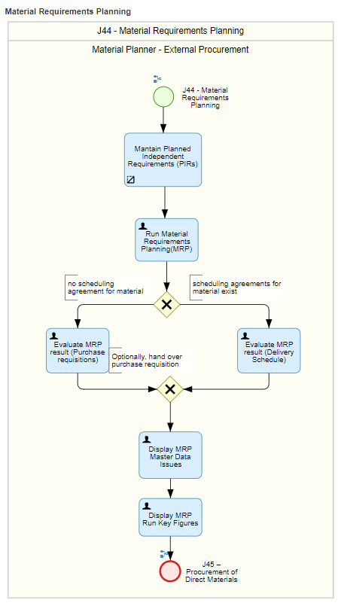

# 4.1 Functional Solution Design

Sap standard material requirement planning is good to use at XCMM.

### **4.1.1 Organization Structure Considerations**

|  |  |  |  |  |  |
| --- | --- | --- | --- | --- | --- |
| Organizational Structure | | | | | |
| Object | ID | Description | Plant | Description | Remarks |
| Company | 1000 | XCMM Pvt Ltd | 1000 | Plant XCMM |  |
| Company | 1100 | XCMM Systems Pvt Ltd | 1100 | Plant XCMM |  |

### **4.1.2 Master Data Considerations (including all relevant data relationships)**

1. Material Master

Schedule margin key

|  |  |
| --- | --- |
| **S.no** | **Description** |
| 01 | float before production |
| 02 | float after production |
| 03 | No floatation |

Here in this case there will be no float before and after production.

1. Bill of Material(B.O.M)

In the Bill of Material for each product component quantity will be considered while running material requirement planning.

1. Routing

Routing is considered in material requirement planning based on the calculation of operation time and the resource allocated to the material.

1. Production Version

The production version is considered in material requirement planning to assign the combination of BOM and Routing

### **4.1.3 System Configuration Considerations**

|  |  |  |  |
| --- | --- | --- | --- |
| Core Configuration | | | |
| ID | Description | IMG Activity | Owner |
| SG-PP-CC006 | Plant Parameters | SPRO 🡪IMG🡪Production 🡪Material Requirements Planning 🡪Plant Parameters 🡪Carry Out Overall Maintenance of Plant Parameters | Functional |
| SG-PP-CC007 | MRP Group for Each Material Type | SPRO🡪IMG🡪Production🡪Material Requirements Planning🡪MRP Groups🡪Define MRP Group for Each Material Type | Functional |
| SG-PP-CC008 | Number Range for Planning Run | SPRO 🡪IMG 🡪Production 🡪Material Requirements Planning 🡪number range | Functional |

# 4.2 Technical/Development Related Items

### **4.2.1 Reporting (operational and analytical)**

Standard FIORI analytical Application is enough to cover all scenarios in Material Request Planning.

### **4.2.2 Authorization**

|  |  |  |  |  |
| --- | --- | --- | --- | --- |
| Authorizations | | | | |
| ID | Authorization | Data Objects | Reason | No of employees |
| SG-PP-A002 | Production planner | Run MRP | Only for XCMM Authorized person | 2 |

# PROCESS DESCRIPTION – (Plan Discrete Production – ZPP)

### **5.0.1 BPML_PP_01.02.01.03 - BUSINESS PROCESS DESCRIPTION**

|  |  |
| --- | --- |
| Process Characteristics | |
| Process Trigger | Manual |
| Process Input | MRP Result |
| Process Output | Production order |
| Process Owner | Production Planner |
| Process Volumes | Approximately 20 |
| Process Frequencies | Daily basis |

### **5.0.2 Process Step Detailed Requirements & Solution**

**Overview**:

This section describes the process of the planned order and firmed the production requirement as per the time framed by the XCMM business.

**AS-IS PROCESS**

* Currently, XCMM handles the production requirement manually using Excel so there is no planned order concept
* The production requirement list was received from a planner and the execution process take care of by the shop floor in charge.
* The Production requirements are based on dependent material availability in stores.
* The firm order concept is not followed because XCMM business does not use any software for planning.
* The Production requirements are manually check and confirmed by stores representative to initiate the procurement for respective work order.

**TO-BE PROCESS**

**1.BPML_PP_01.02.01.03.01 Firm Planned Order**

* In RISE WITH SAPthe Firmed planned order means no automatic changes take place in order while running the MRP. It can be done by planning time fence in master data.
* Firm planned order is that which will not be considered in the next planning run.

**2. BPML_PP_01.02.01.03.02 Convert Planned Orders to Production order**

* In RISE WITH SAPProduction order can be created with reference to a planned order.
* While creating the Production orders through planned order, the system will allow listed possibilities are,
  + - Individual conversions of planned orders.
    - Partial conversions of planned orders.
    - collective conversions of planned orders.

The listed Production order type will be assigned once the planned order is converted to a Production order for the respective plant.

|  |  |  |  |  |  |
| --- | --- | --- | --- | --- | --- |
| **Plant** | **Description** | **Order Type** | **Name** | **Number Range** | **Ext / Int** |
| **1000** | **Plant XCMM** | **AMP1** | **Production Order-AMPL** | **100000000-199999999** | **Internal Number** |
| **1020** | **Plant XCMM** | **AMS1** | **Production Order-AMS** | **200000000-299999999** | **Internal Number** |
| **1000** | **Plant XCMM** | **AMPR** | **Rework Order-AMPL** | **300000000-399999999** | **Internal Number** |
| **1020** | **Plant XCMM** | **AMSR** | **Rework Order-AMS** | **400000000-499999999** | **Internal Number** |

### **5.0.3 Operational Decisions or Logic within the Process**

The planned order is converted to Production order by production planned based on capacity and requirements of individual Plant.

### **5.0.4 SOX & Legal Considerations and Company-Specific Policies**

In the XCMM business, only the Production Planner will allow converting planned order to Production order as per requirements.

### **5.0.5 Reference Process KPIs**

Fit-To Standard Workshop Requirement Gathering Document

### **5.0.6 Business Process Diagrams**

Planning at Discrete Industry at assembly level

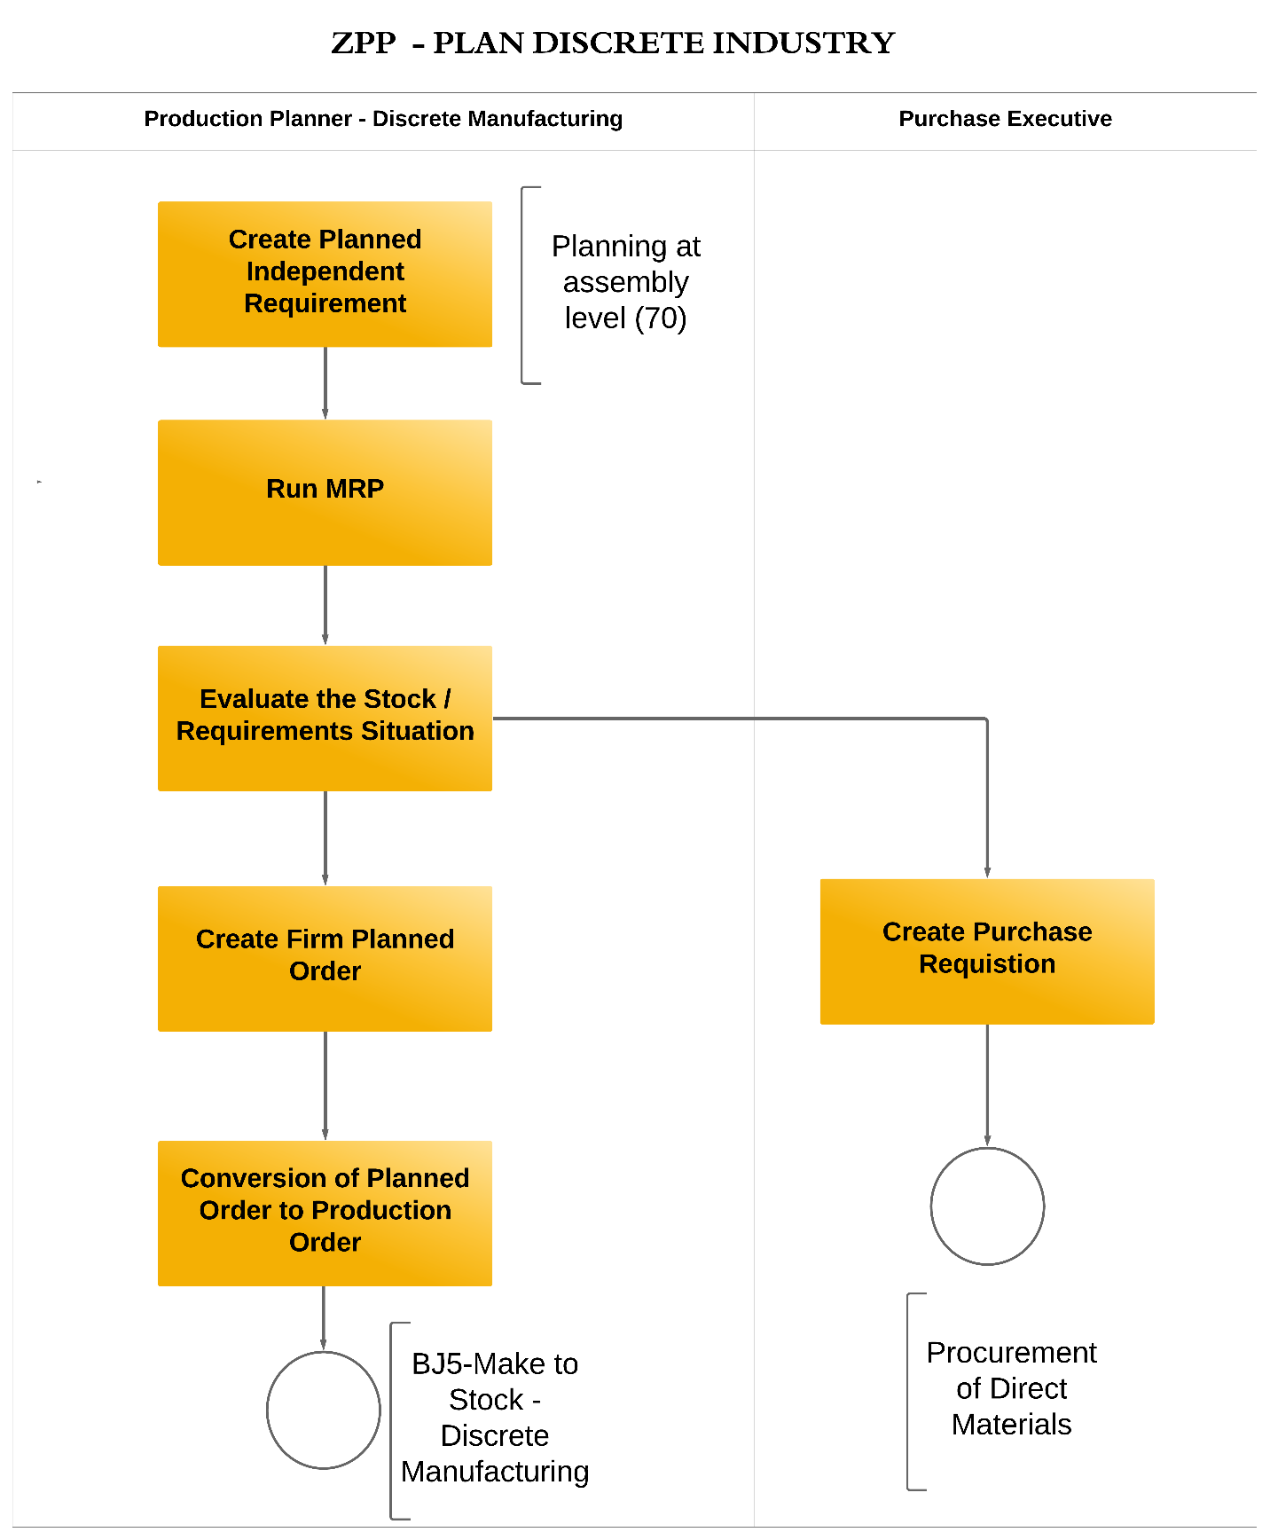

Planning at Discrete Industry for Sales Order

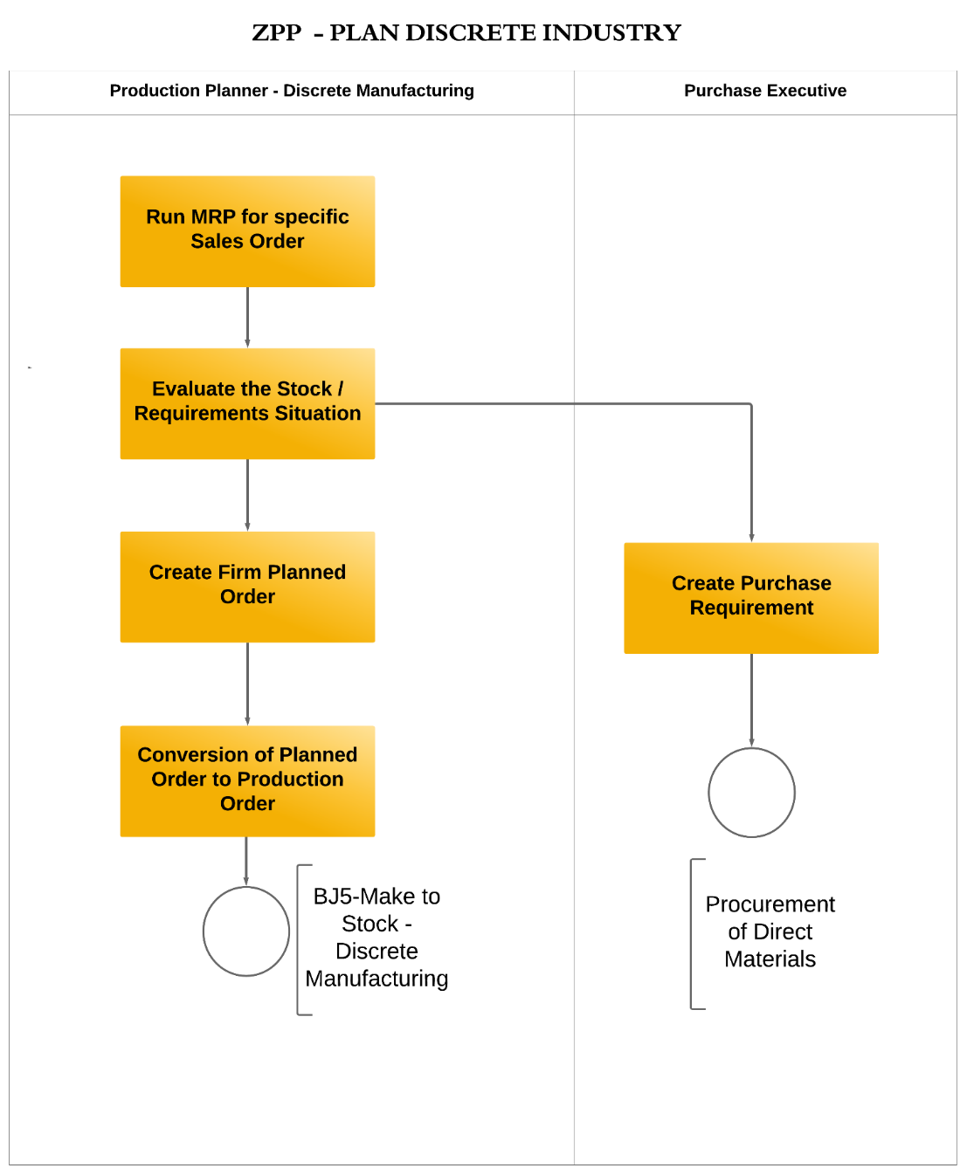

# 5.1 Functional Solution Design

Sap standard conversion of planned order to Production order is good to use at XCMM

### **5.1.1** **Organization Structure Considerations**

|  |  |  |  |  |  |
| --- | --- | --- | --- | --- | --- |
| Organizational Structure | | | | | |
| Object | ID | Description | Plant | Description | Remarks |
| Company | 1000 | XCMM Pvt Ltd | 1000 | Plant XCMM |  |
| Company | 1100 | XCMM Systems Pvt Ltd | 1100 | Plant XCMM |  |

### **5.1.2 Master Data Considerations (including all relevant data relationships)**

1. Material master
2. Bill of material
3. Routing
4. Production version

### **5.1.3 System Configuration Considerations**

|  |  |  |  |
| --- | --- | --- | --- |
| Core Configuration | | | |
| ID | Description | IMG Activity | Owner |
| SG-PP-CC009 | Order type define for conversion | SPRO 🡪IMG🡪Production 🡪Material Requirements Planning 🡪Plant Parameters 🡪Carry Out Overall Maintenance of Plant Parameters | Functional |

# 5.2 Technical/Development Related Items

### **5.2.1 Reporting (operational and analytical)**

Standard FIORI analytical Application is enough to cover all planning processes.

### **5.2.2 Authorization**

|  |  |  |  |  |
| --- | --- | --- | --- | --- |
| Authorizations | | | | |
| ID | Authorization | Data Objects | Reason | No of employees |
| SG-PP-A002 | Production Planner | Firm planned order | Planning is controlled by an authorized person only | 2 |

# 6.0 PROCESS DESCRIPTION – (Capacity RequiremenT Planning – 31L & 3LQ)

### **6.0.1 BPML_PP_01.02.01.04 - BUSINESS PROCESS DESCRIPTION**

|  |  |
| --- | --- |
| Process Characteristics | |
| Process Trigger | Manual |
| Process Input | Production Order |
| Process Output | Sequence the Production order based on Capacity |
| Process Owner | Production Manager or Plant Manager |
| Process Volumes | Approximately 20 |
| Process Frequencies | Daily basis |

### **6.0.2 Process Step Detailed Requirements & Solution**

**Overview**:

This section describes the capacity requirement planning is initiated to balance the load at the resource and can calculate the production capacity based on the requirement of the product as per the available capacity.

**AS-IS PROCESS**

* In the XCMM, Capacity planning is carried out manually at the plant level through production scheduling in an Excel spreadsheet.
* During monthly production planning, products are taken for processing based on the Work Center available at a particular time.

**TO-BE PROCESS**

In RISE WITH SAPthe purpose of capacity planning is to assess the economic use of the Work Centre in the shop floor areas.

**1.BPML_PP_01.02.01.04.01 Set Up Capacity Requirements Planning**

* MI Team recommended using standard RISE WITH SAPcapacity requirement planning
* The purpose of capacity planning is to assess the economic use of the Work Center in the shop floor areas.
* Capacity planning is used for evaluating the capacity to analyze capacity loads in shop floor.
* Capacity planning is done to evaluate the capacity situation or capacity load at the Work Center.
* Rescheduling of the overloaded Work Center is done manually to distribute the load equally at any point in time.

The capacity planning involves the following basic functionalities:

* + Capacity evaluation - To analyze capacity loads
  + Capacity leveling - Detailed scheduling
  + Capacity requirements
* Available capacities are maintained at a work center using different capacity categories like a machine capacity or a labor capacity.
* Every work center can be maintained with standard available capacity and to use more detailed available capacities, shift definitions and sequences can be used.
* Capacity requirements are generated by planned orders and Production orders.
* Calculating the capacity requirements for an operation on a resource for manufacturing a material takes place in capacity by the formulae provided in the resource.
* With capacity leveling, the optimal commitment for the Work Center can be found.
* The planning tables (graphical and tabular versions) can be used to display the capacity situation and to carry out capacity leveling. Based on capacity planning work center planning can be done.
* Capacity availability should be checked when an order is released.
* Capacity planning should include the planned stoppages of the work centers and holidays planned for the specific plant.
* Process time and efficiency of the work center, Recipe master data, and Bill of materials should be available.
* Updating of the above should be done in case of process improvements/capacity enhancements.
* Load situation will be indicated resource-wise.
* Capacity requirements and available capacity will be compared and displayed in a graphical model and tabular model.

Routing

Work center

Capacity Load

Capacity Leveling

Capacity Availability

Capacity Requirement

**2.BPML_PP_01.02.01.04.02 Capacity Evaluation**

* In SAP S/4HANA, the capacity evaluation is done manually based on the evaluation of Work Centre load.
* The production schedule is balanced by adjusting the availability capacity.

**3.BPML_PP_01.02.01.04.03 Capacity Levelling**

* Capacity leveling is an important tool for creating realistic plans. It helps to ensure that the targets are within capacity constraints



### **6.0.3 Operational Decisions or Logic within the Process**

The capacity planning will manage manually by the production supervisor whenever the capacity is imbalanced in production.

### **6.0.4 SOX & Legal Considerations and Company-Specific Policies**

The production supervisor is allowed to manage the capacity requirements for the production process in the XCMM business.

### **6.0.5 Reference Process KPIs**

Fit-to-Standard Workshop Requirement Gathering Document.

### **6.0.6 Business Process Diagrams**

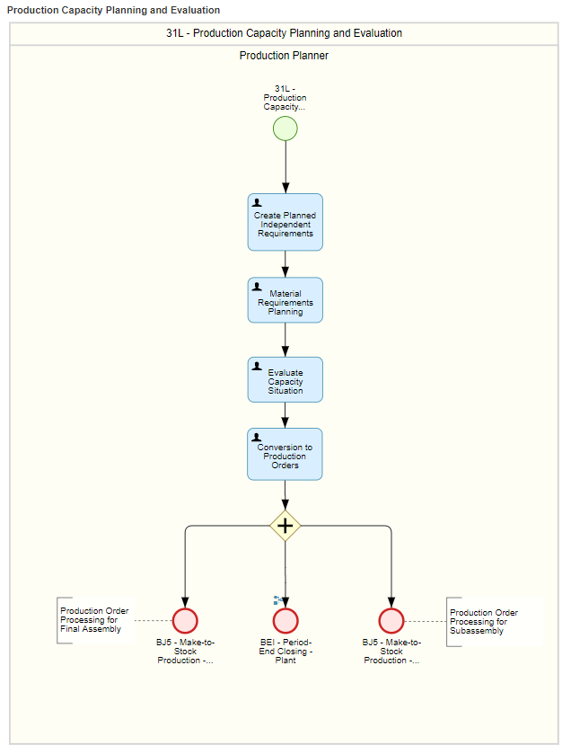

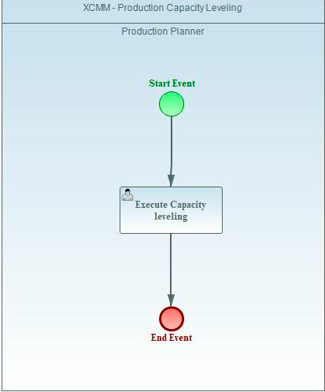

# 6.1 Functional Solution Design

### **6.1.1** **Organization Structure Considerations**

|  |  |  |  |  |  |
| --- | --- | --- | --- | --- | --- |
| Organizational Structure | | | | | |
| Object | ID | Description | Plant | Description | Remarks |
| Company | 1000 | XCMM Pvt Ltd | 1000 | Plant XCMM |  |
| Company | 1100 | XCMM Systems Pvt Ltd | 1100 | Plant XCMM |  |

### **6.1.2 Master Data Considerations (including all relevant data relationships**

1. Material master
2. Bill of material
3. Routing
4. Production version

### **6.1.3** **System Configuration Considerations**

|  |  |  |  |
| --- | --- | --- | --- |
| Core Configuration | | | |
| ID | Description | IMG Activity | Owner |
| SG-PP-CC010 | Scheduling parameter | SPRO🡪IMG🡪Production-🡪Capacity Requirements Planning 🡪Operations 🡪 Scheduling 🡪 Define Scheduling Parameters | Production Planner |

# 6.2 Technical/Development Related Items

### **6.2.1 Reporting (operational and analytical)**

Standard FIORI analytical Application is enough to cover all capacity requirement planning process

### **6.2.2 Authorization**

|  |  |  |  |  |
| --- | --- | --- | --- | --- |
| Authorizations | | | | |
| ID | Authorization | Data Objects | Reason | No of employees |
| SG-PP-A003 | Production Manager | Capacity planning | Only for XCMM Authorized person | 2 |

# 7.0 PROCESS DESCRIPTION - (Execute Discrete Production – BJ8)

### **7.0.1 BPML_PP_01.03.01.01 - BUSINESS PROCESS DESCRIPTION**

|  |  |
| --- | --- |
| Process Characteristics | |
| Process Trigger | Manual |
| Process Input | Production Order |
| Process Output | Release the Production Order |
| Process Owner | Production Supervisor |
| Process Volumes | Approximately 20 |
| Process Frequencies | Daily basis |

### **7.0.2 Process Step Detailed Requirements & Solution**

**Overview**

This section describes the process about the process execution. process execution is initiated based on the process flow in shop floor

**AS-IS PROCESS**

* In the XCMM business, the work order creates manually and execute the process based on the operation sequence maintain in Excel.
* The goods required for a work order is requested in general stores using the “Picklist provided by the Planning team“
* After complete the final operation then the finished goods are moved to the store.
* The serial number is punched in Finished Goods manually and updated in the serial number traceability card for future use.
* All the dependent materials for a work order are issued through “Picklist“, there is no possibility of an excess material requirement for the particular work order.
* In some cases, the finished goods for one sale order will be mapped to another sale order based on business requirements.

**TO-BE PROCESS**

* This process describes the daily production process happening on the shop floor for finished material.
* Finished products are represented based on customer stock.
* Production order is a manufacturing order used in Discrete industries that define which material is to be processed, at which location, at what time, and how much work is required.
* It also defines which Work Center is to be used and how the order costs are to be settled.

The listed Production Order type concerning manufacturing plants are

|  |  |  |  |  |  |
| --- | --- | --- | --- | --- | --- |
| **Plant** | **Description** | **Order Type** | **Name** | **Number Range** | **Ext / Int** |
| **1000** | **Plant XCMM** | **AMP1** | **Production Order-AMPL** | **100000000-199999999** | **Internal Number** |
| **1020** | **Plant XCMM** | **AMS1** | **Production Order-AMS** | **200000000-299999999** | **Internal Number** |
| **1000** | **Plant XCMM** | **AMPR** | **Rework Order-AMPL** | **300000000-399999999** | **Internal Number** |
| **1020** | **Plant XCMM** | **AMSR** | **Rework Order-AMS** | **400000000-499999999** | **Internal Number** |

* Production order is used in Discrete Manufacturing Industries.
* Production orders are the main element used for the detailed planning and execution of process manufacturing.

A Production order contains the following information.

* + - Product to be manufactured
    - Qty to be produced
    - Start and end date of production
    - Materials with quantities and batches to be used for producing the product.

**Changes in Production Order**

* Changes in Production order can be made individually only.
* Authorization for changing the production order shall rest with the designated people only.

**The finished stock changed to another customer based on value addition**

* **Move the Finished goods from sales stock to unrestricted stock**
* **Create “the production order without reference“ to incorporate the changes in finished goods and moved to the required sale order stock.**

**The Cost capturing in Production order:**

**1.Goods issue (all materials)**

**2.Confirmation activities (all operation cost)**

**3.Additional material apart from Bill of Material (through 261)**

**4.Rework material cost is not directly adding in Production Order (It mentioned in MM and CO BBP)**

**1.BPML_PP_01.03.01.01.01 Release Production Order**

* In SAP S/4HANA, the Production order is released to execute the production process.
* The changes in the Production order are not possible after the release of the Production order.
* The goods issue is performed only after released the Production order.

**3.BPML_PP_01.03.01.01.02 Perform Goods Issue**

* In SAP S/4HANA, the goods issue will be done based on the material request form for each Production Order.
* The Production supervisor will raise the Material Request Note based on the Production Order and hand-over to the stores in charge.
* The Goods issue is managed for each Production order in the RISE WITH SAPsystem for XCMM Business Process.

**4.BPML_PP_01.03.01.01.03 Perform Confirmations**

* Production order confirmation documents the processing status of operations or sub-operations. The SAP System distinguishes between partial and final confirmations. A final confirmation is used to determine:
  + At which work center the operation was carried out
  + Who performed the operation
  + Quantities of yield and scrap produced
  + Actual values (time) taken for the operation
* The operation activities covered for confirmation is listed below,
  + Machine Hours
  + Labour Hours
* After the creation and release of the Production order, the user confirmation process has to be performed. the confirmation will be done at the operation level.
* While confirming, the production supervisor will key actual Production data

**Reason for Variance:**

* **Machine malfunction**
* **Operating error**
* **Defective material**

**5.BPML_PP_01.03.01.01.04 Receive Finished Goods into Inventory**

* In SAP S/4HANA, the receipt of the goods is performed by the store's executive based on the production order.
* Goods Receipt against production order to be done to mark the transfer of material from shop floor to Stores.

**6.BPML_PP_01.03.01.01.05 Manage Serial Number for Semi Finished and Final Product**

* **In SAP S/4HANA, the serial number for finished material and Semi Knocked Down material will be manually entered whenever the receipt of the goods is done for production order.**
* Manually assign the serial number to trace the sequence in RISE WITH SAPSystem.
* Serial Numbers will be maintained with the external number range

### **7.0.3 Operational Decisions or Logic within the Process**

* Whenever the production requirement raised or planner provide the Production order then the production supervisor release and execute the process in XCMM business.
* The stores executive will be issued the goods/components for production orders based on the material request form
* The store's executive will receipt the finished goods based on a production order and serial number key manually.

### **7.0.4 SOX & Legal Considerations and Company-Specific Policies**

* Only Nominated production supervisors can have access to release and confirm the Production order and the necessary roles and authorization will be provided in the system.
* Only Nominated stores executive can have the access to assign batch for finished goods while receipt against production order and the necessary roles and authorization will be provided in the system.

### **7.0.5 Reference Process KPIs**

Fit-To Standard Workshop Requirement Gathering Document

### **7.0.6 Business Process Diagrams**

Production Orders

Production Order Confirmation

Finished Goods

Finished Goods Stores

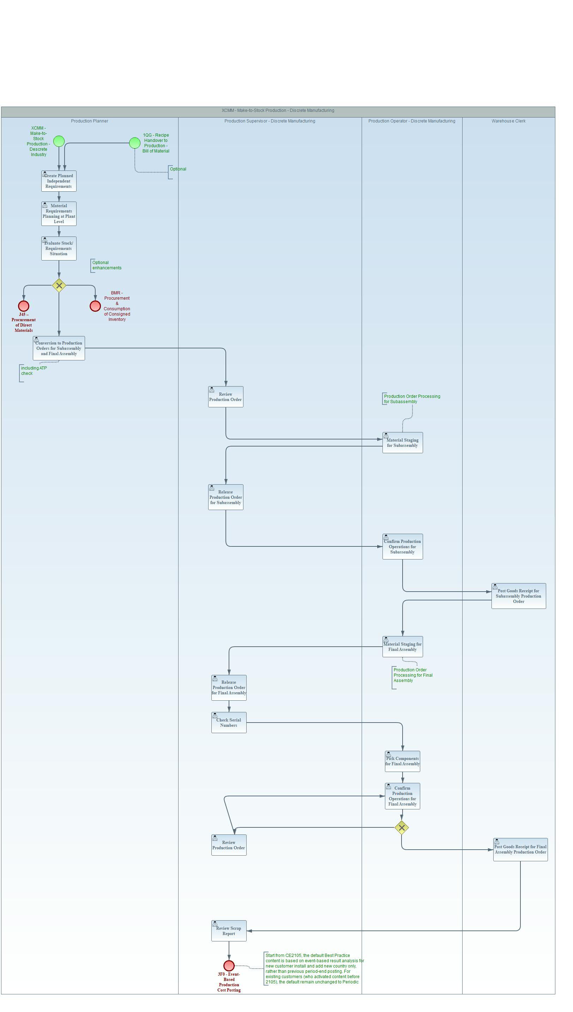

# 7.1 Functional Solution Design

### **7.1.1 Organization Structure Considerations**

|  |  |  |  |  |  |
| --- | --- | --- | --- | --- | --- |
| Organizational Structure | | | | | |
| Object | ID | Description | Plant | Description | Remarks |
| Company | 1000 | XCMM Pvt Ltd | 1000 | Plant XCMM |  |
| Company | 1100 | XCMM Systems Pvt Ltd | 1100 | Plant XCMM |  |

### **7.1.2 Master Data Considerations (including all relevant data relationships)**

The listed master data are required for the Production execution process in the RISE WITH SAPsystem.

* + - Material master
    - Bill of material
    - Routing
    - Production version

### **7.1.3 System Configuration Considerations**

|  |  |  |  |
| --- | --- | --- | --- |
| Core Configuration | | | |
| ID | Description | IMG Activity | Owner |
| SG-PP-CC011 | Order type | SPRO🡪IMG🡪Production-🡪Shop Floor Control 🡪Master Data 🡪 Order 🡪 Define Order Type | Functional |
| SG-PP-CC012 | Order type dependent parameter | SPRO🡪IMG🡪Production-🡪Shop Floor Control 🡪Master Data 🡪 Order 🡪 Define Order Type Dependent Parameter | Functional |
| SG-PP-CC013 | Confirmation parameter | SPRO🡪IMG🡪Production-🡪Shop Floor Control 🡪Operations 🡪 Confirmation🡪 Define Confirmation Parameter | Functional |
| SG-PP-CC014 | Print Control | SPRO🡪IMG🡪Production-🡪Shop Floor Control 🡪Operations 🡪 Define Print Control | Functional |

**7.2 Technical/Development Related Items**

### **7.2.1 Reporting (operational and analytical)**

Standard FIORI analytical Application is enough to cover all Execute production processes.

### **7.2.2. Output (e.g., Forms)**

|  |  |  |  |  |  |  |
| --- | --- | --- | --- | --- | --- | --- |
| Output/Forms | | | | |  |  |
| WRICEF ID | Description | Data object | Output Type | Frequency | Volumes | Owner |
| SG-PP-O001 | Material Request form | Request to store | Form | For each Production Order | Medium | Production Supervisor |

### **7.2.3 Authorization**

|  |  |  |  |  |
| --- | --- | --- | --- | --- |
| **Authorizations** | | | | |
| **ID** | **Authorization** | **Data Objects** | **Reason** | **No of employees** |
| SG-PP-A004 | Production Supervisor | Change Production order | Only for XCMM Authorized person | 2 |
| SG-PP-A005 | Stores executive | Goods Issue | Only for XCMM Authorized person | 2 |
| SG-PP-A005 | Stores executive | Goods Receipt | Only for XCMM Authorized person | 2 |

# 8.0 PROCESS DESCRIPTION - (Engineering ChANGE MANAGEMENT –NA)

### **8.0.1 BPML_PP_01.04.01.01 - BUSINESS PROCESS DESCRIPTION**

|  |  |
| --- | --- |
| Process Characteristics | |
| Process Trigger | Manual |
| Process Input | Change Request |
| Process Output | Engineering Change Order |
| Process Owner | Design Head |
| Process Volumes | Not able to describe |
| Process Frequencies | Needy Basis |

### **8.0.2 Process Step Detailed Requirements & Solution**

**Overview**

This section describes the engineering change management and it was initiated to revise the change number whenever the design is changed for the respective material number.

**AS-IS PROCESS**

* In the current process changes to any document are monitored through the Request for change control.
* This is issued by the design department to all other departments to follow the changes in the future.
* These changes are initiated by the Design team whenever the changes in Design.
* After approval the old version is archived

**TO-BE PROCESS**

* Engineering Change Request is a function that can be used to change various aspects of master data or revision of master data or any documents.
* The engineering Change request is a cross-application component that helps in controlling changes to operations-related data. It operates through a change number. The change number specifies the reason for the change and the date of effect. A standard status profile is attached to the number, which is used to monitor the progress of the change and approval process. Objects like Bill of material, material master the stage of request.
* These objects can be changed only concerning this Change number.

The following information is stored for each change:

1. The old and new status of the changed data
2. Change date and a person affected the change
3. Date from which the change is valid
4. Type of change, such as new item or item deleted

**Procedure to change**

* Engineering Change Request (ECR) is created by the application dept. based on the type of change proposed. Internal numbering will be followed for ECR numbering and this contains objects, which need to be changed through this ECR like BOM or any document as per requirement.

The steps involved when the business change the Bill of Material through **ECR** are,

1. **Check Engineering Change Request (ECR) and convert to Engineering Change Order (ECO)**
2. **Approve Request**
3. **Convert Request, and then make a necessary change in the document.**
4. **Close the Order**
5. **Release the Order, changed document will be released.**

### **8.0.3 Operational Decisions or Logic within the Process**

* Whenever the Design change is initiated by the design team, it's through Engineering Change Request in the RISE WITH SAPsystem.
* **The engineering change request is created in the system and changes incorporate with revision numbers and release to the departments through the ECR form.**
* **Able to assign the Revision for all levels (CBU,SCBU,RM),Traceability at all level is possible.**
* BOM tracking is also possible with revision level
* **Approvel stages able to define through customized Program.**
* If revision level for part level only need,then other levels of revision will not be display

### **8.0.4 SOX & Legal Considerations and Company-Specific Policies**

* Only Nominated Design team members can have access to create and release Engineering Change Request & order and the necessary roles and authorization will be provided in the system.

### **8.0.5 Reference Process KPIs**

Fit-To Standard Workshop Requirement Gathering Document

### **8.0.6 Business Process Diagrams**

Generate Change request

Check feasibility

Approve

ECR

Apply changes to change objects

Set change object status to completed

Close change order

Release Change order

# 8.1 Functional Solution Design

### **8.1.1 Organization Structure Considerations**

|  |  |  |  |  |  |
| --- | --- | --- | --- | --- | --- |
| Organizational Structure | | | | | |
| Object | ID | Description | Plant | Description | Remarks |
| Company | 1000 | XCMM Pvt Ltd | 1000 | Plant XCMM |  |
| Company | 1100 | XCMM Systems Pvt Ltd | 1100 | Plant XCMM |  |

### **8.1.2 Master Data Considerations (including all relevant data relationships)**

The listed master data are required for the Engineering Change Order in the RISE WITH SAPsystem.

* + - Bill of material
    - Document Info Record

### **8.1.3 System Configuration Considerations**

* + - Standard RISE WITH SAPConfiguration

**8.2 Technical/Development Related Items**

### **8.2.1 Reporting (operational and analytical)**

Not Applicable

### **8.2.2. Output (e.g., Forms)**

|  |  |  |  |  |  |  |
| --- | --- | --- | --- | --- | --- | --- |
| Output/Forms | | | | |  |  |
| WRICEF ID | Description | Data object | Output Type | Frequency | Volumes | Owner |
| SG-PP-O002 | Engineering Change Order | Request for design change | Form | For each change request | Medium | Design Team |

### **8.2.3 Authorization**

|  |  |  |  |  |
| --- | --- | --- | --- | --- |
| **Authorizations** | | | | |
| **ID** | **Authorization** | **Data Objects** | **Reason** | **No of employees** |
| SG-PP-A006 | Design Head | Engineering Change Order release | Only for XCMM Authorized person | 1 |

# 9.0 STANDARD PRODUCTION PLANNING REPORTS

|  |  |
| --- | --- |
| **S. No.** | **Standard Production Planning Reports** |
| **1** | **Production Order Information System** |
| **2** | **Display BOM Level by Level** |
| **3** | **Multilevel BOM** |
| **4** | **Single-Level Where-Used List** |
| **5** | **Routing usage and Work center** |
| **6** | **Summarized BOM** |
| **7** | **Current Material Overview** |
| **8** | **Display Stock/Requirements Situation** |
| **9** | **Individual Display Of MRP List** |
| **10** | **Collective Display Of MRP List** |
| **11** | **Collective Display of Planned Orders** |
| **12** | **Multilevel Order Report** |
| **13** | **Purchase Requisitions: List Display** |
| **14** | **Display Planned Independent Requirements** |
| **15** | **Display Total Independent Requirements** |
| **16** | **Display Plant Stock Availability** |
| **17** | **Materials List** |
| **18** | **Mass Processing: Production Orders** |
| **19** | **Print MRP List** |
| **20** | **Monitor Internal Requirements** |
| **21** | **Monitor Material Coverage / Material Shortage** |
| **22** | **Schedule MRP Run** |
| **23** | **Planner Overview** |
| **24** | **Internal Order for MTO & MTS report** |

# 10.0 ADDITIONAL POINTS Discussed (MOM)

* Production work order – entry need dropdown menu to select for operator / supervisor to key in time – **Out of Scope.**
* How to trace the CBU/SCBU from End to End - **Serial number for each SCBU/CBU will be built manually in Standard SAP and then it can be tracked.**
* Design team need access to view material quantity, open PO to know the status of material as per roles and authorisation - **It will provide through Roles and Authorization process.**
* Part number revision should reflect for previous and new part available in stock – **Its Possible if we maintain different Material Master for all revisions but its not possible for XCMM Business.**
* In work order, adding material (SAP team should show) routing operation (work order change) When the standard cost will get change - **Planned order cost will not change; only Actual cost will be varied and hence cost variance will be captured**
* OA swapping (change in production order) - **Sale order stock available will be transferred to Another sale order (OA) in SAP**
* Design should confirm regarding revision number (R01-01-01) - **Design Team to check and confirm**
* Ideal time analysis - **Ideal time cannot be tracked in SAP**
* Rework order time – **it will be captured during order confirmation**
* 262 material reversal for manufacturing and production - **It is included in Material Management BBP**
* BOM revision tracking - **Design team to confirm if they want to have new part code with suffix 01,-02 after the part code**
* Adding new sub assembly to original BOQ - **Yes, it should be done before production release, otherwise it can be directly added in production order**
* Reorder level – single PR - **Single PR will be created based on the weekly or Monthly lot size based on the requirement date provided falls within the week /Month during MRP run**
* MTS scenario available in system default - **Based on Sale forecast**
* Sub assembly planning for MTS - **Once forecast is confirmed, the Business can take the print out of the forecast maintained in Planned Independent requirement which they can see in Standard SAP if it is fine**
* Internal order for sub assembly - **Sale order stock available will be transferred to Another sale order(OA) in SAP**
* How to assign MTS sub assembly to MTO - **MTS stock is produced separately and it can be moved to the Sale order stock for the respective CBU MTO**
* To add one more assembly after production confirmation - **Yes, Subassembly can be added by creating production order without material and can be consumed**

-------------------------------END-------------------------------