Problem Statement
To Simulate a DVD Inventory System which will allow to Add, Delete, Modify and List records
Details:
- A DVD store needs to maintain an inventory and keep track of records.
- Users can search for DVDs, based on certain criterion.
- User may add new DVD records or delete existing ones
- User can also modify existing information of records
- Intention is to facilitate querying from database, with basic UI at command

Python Module:

Design Approach
- Simulate a Menu driven Main screen with following options
Title
- Add a DVD
- Search
- Modify a DVD
- Delete a DVD
- Exit
- Script to have the following fields for a DVD record
(Title, Star name, Year of Release and Genre as Drama, Horror, Comedy, Romance, Action etc)
- The ADD and Modify operations should be based on the above mentioned fields
- The Delete operation should be based on Movie Title only
- The Search operation should have a sub menu for Genre, besides conducting a search on other fields of the DVD record
- Provide necessary exception handling mechanism wherever required
- The project to use MySql as Database. This assignment will require user to install MySQLdb package for python.
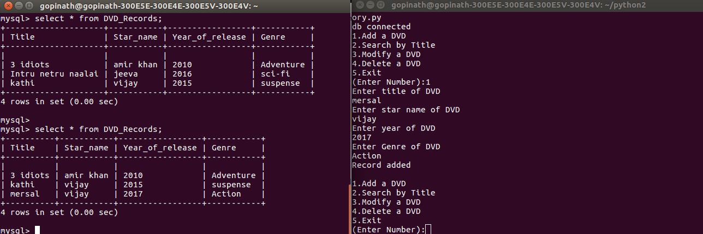
1. Adding a DVD

2. Searching a DVD

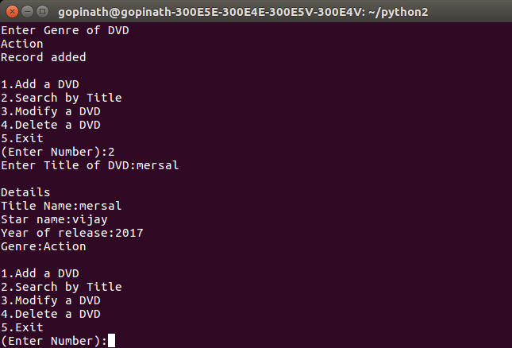

3. Modifying a DVD

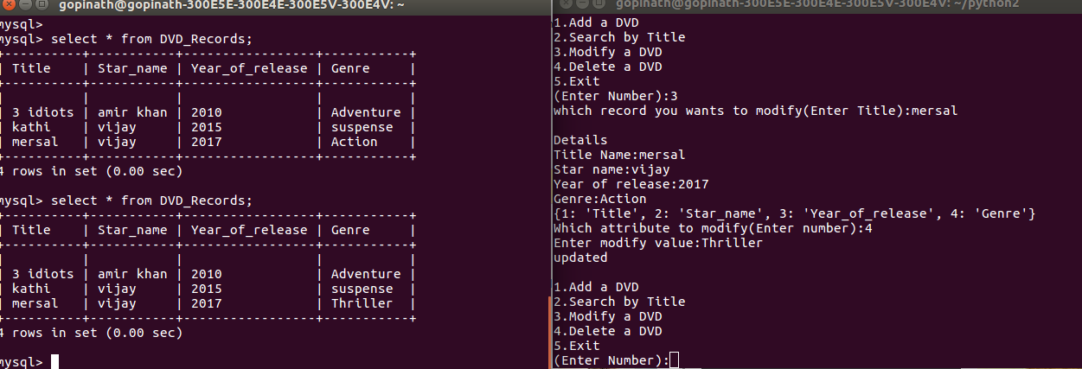

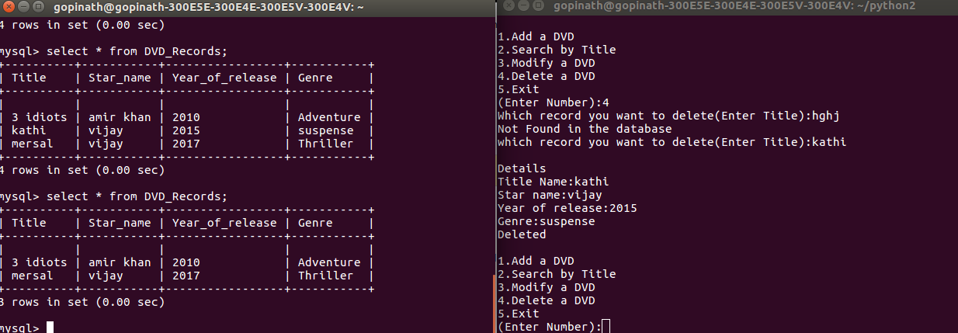
4. Deleting a DVD

