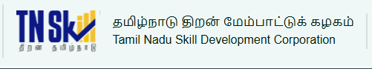

PROJECT REPORT

AI FAQ ASSISTANT

YEAR : 2026 – 2027
COLLEGE NAME : K.C.S KASI NADAR COLLEGE OF ARTS & SCIENCE
CODE : UNM203
DEPARTMENT : COMPUTER APPLICATION
PROGRAM : B.C.A
SEMESTER : V
PROJECT SUBMITTED TO: UNIVERSITY OF MADRAS /
VETRI THIRAN PAYIRCHI THITTAM
Course Name : AI Augmented Backend Development with
Node JS and MongoDB
TEAM LEADER: GOPINATH.S
MEMBERS:
- GANESH RANA.N
- KISHORE.M
- VISHAL.R
GUIDED BY: Dr.S.KALAISELVI
SPOC NAME: Dr.K. LALITHAKAMESWARI

CHAPTER 1: INTRODUCTION

1.1 Project Overview
AI FAQ Assistant is a secure REST API that helps support teams build, organise and search a knowledge base without writing every answer by hand. Authors sign in, create FAQ entries under categories, and can ask Google Gemini AI to draft a question and answer pair from a single topic. Readers can browse and search the published FAQs instantly.
Security is central to the design. Passwords are hashed with bcrypt, sessions use stateless JWT tokens, and only the original author may change a record. Mongoose schemas validate every document, and a centralised error handler returns consistent responses without exposing database details.

1.2 Problem Statement
Consider Priya, who runs customer support operations. Her team answers the same questions again and again, while the knowledge base grows messy and out of date. She faces the following problems:
- Documentation is hard to keep up to date.
- Drafting detailed support answers by hand takes too long.
- There is little visibility into which searches match and how quickly they resolve.
- There is no permission layer protecting private documentation from public changes.

1.3 Objectives
- Let Google Gemini draft a question, answer and category from a topic.
- Provide real-time keyword search over FAQs.
- Allow only the author to edit or delete a record.
- Organise all FAQs into categories.
- Provide a clean, modular and scalable backend that a web or mobile client can consume.

1.4 Technology Summary
Area | Choice | Purpose
Runtime | Node.js | Runs the server and business logic
Framework | Express.js | Routing, middleware and JSON handling
Database | MongoDB + Mongoose | Stores users and FAQs with schema validation
Security | JWT + bcrypt | Stateless sessions and hashed passwords
AI | Google Gemini AI | Generates FAQ pairs and answers from a topic
Search | Keyword search | Finds matching FAQs quickly by query
Testing | Postman / ThunderClient | Manual verification of every endpoint

1.5 Key Features
- Secure access: JWT authentication and authorisation protect private endpoints.
- AI FAQ generation: Google Gemini AI suggests questions, answers and topics.
- Search: Keyword-based search finds relevant FAQs quickly.
- Full CRUD: Create, read, update and delete FAQ records.
- Categories: Structured grouping keeps the knowledge base easy to browse.
- Password encryption: bcrypt hashes every password before storage.
- Validation and error handling: Mongoose validation plus one central error handler.
- Modular REST design: Separate route files keep the API scalable.

1.6 Scope of the Project
In scope for this version:
- User registration, login and profile access using JWT.
- Creating, listing, viewing, updating and deleting FAQs.
- Public keyword search over the stored FAQs.
- AI-assisted generation of a FAQ pair and AI-assisted answers through Google Gemini.
Not covered yet (see Future Scope): a graphical front end, an admin dashboard, semantic search and user feedback on answers.

1.7 Existing System versus Proposed System
Aspect | Existing (manual) system | Proposed AI FAQ Assistant
Writing answers | Written by hand, one by one | Gemini drafts question, answer and category from a topic
Finding answers | Scrolling through documents or files | Instant keyword search through a REST endpoint
Access control | Anyone with file access can edit | Only the author can edit or delete a record
Data quality | Inconsistent, no validation | Mongoose schemas validate every document
Passwords / sessions | Often shared or unprotected | bcrypt-hashed passwords and stateless JWT sessions
Organisation | Unstructured | Every FAQ belongs to a category

1.8 Advantages of the System
- Saves time: support staff no longer draft every answer from scratch.
- Secure by design: hashed passwords, token-based access and ownership checks.
- Consistent data: schema validation rejects incomplete or invalid entries.
- Reusable backend: any web, mobile or Postman client can use the same API.
- Easy to extend: controllers, routes, models and services are separate modules.

CHAPTER 2: SYSTEM REQUIREMENTS

2.1 Software Requirements
Tool | Version | Why it is needed
Operating system | Windows 10/11, macOS or Linux | Cross-platform development
Node.js | v18 or above | Runs the server
npm | v9 or above | Installs and manages dependencies
Express.js | v4 / v5 | Builds the REST entry points
MongoDB / Mongoose | Local or Atlas | Stores users and FAQs
Postman / ThunderClient | Latest | Tests the API endpoints
VS Code | Or any IDE | Writing and running the code

2.2 Hardware Requirements
Component | Minimum | Recommended
Processor | Intel Core i5 (8th Gen) / Ryzen 5 | Same or better
RAM | 8 GB | 16 GB, for MongoDB and the server running together
Storage | 1 GB free | 1 GB free

2.3 Users and Roles
Role | Responsibilities
Admin | Manage all users; view, update and delete any FAQ; monitor AI-generated content; manage categories; full system access.
Content creator | Create FAQs; edit and delete own records; generate FAQs with AI; organise FAQs into categories.
Authenticated user | View public FAQs; search by keyword; get AI-assisted answers; access own profile.
Public user | View published FAQs and search. Cannot create, edit or delete, and has no access to protected endpoints.

2.4 Functional Requirements
- The system shall allow a new user to register with a name, email and password.
- The system shall authenticate a user and return a JWT token on login.
- The system shall let an authenticated user view their own profile.
- The system shall let an authenticated user create a FAQ with a question, answer and category.
- The system shall let anyone list all FAQs, view one FAQ by id and search FAQs by keyword.
- The system shall let only the author update or delete a FAQ.
- The system shall generate a FAQ pair and an answer from a topic using Google Gemini AI for authenticated users.

2.5 Non-Functional Requirements
Attribute | Requirement
Security | Passwords are stored hashed; protected routes require a valid Bearer token; secrets are kept in the .env file.
Reliability | A centralised error handler returns a consistent JSON error for every failure.
Maintainability | Code is split into config, controllers, middleware, models, routes, services and utils.
Scalability | Stateless JWT sessions let the API run on more than one server instance.
Performance | Ordinary database calls respond in well under a second; AI calls depend on the Gemini service.
Portability | Runs on Windows, macOS and Linux with Node.js v18 or above.

2.6 Feasibility Study
- Technical: Every tool (Node.js, Express, MongoDB, Mongoose) is open source and well documented, and the team already had the required skills from the course.
- Economic: The software stack is free to use; Gemini offers API access that can be used within a free quota for development.
- Operational: The API is simple to run with one command and easy for a client application to consume.

CHAPTER 3: SYSTEM DESIGN

3.1 System Architecture
Requests reach the API through a layered server. Each request is filtered by middleware (token check, validation, error handling) before a controller calls a service or a Mongoose model. Gemini is reached only through a dedicated AI service so the rest of the code never depends on it directly.
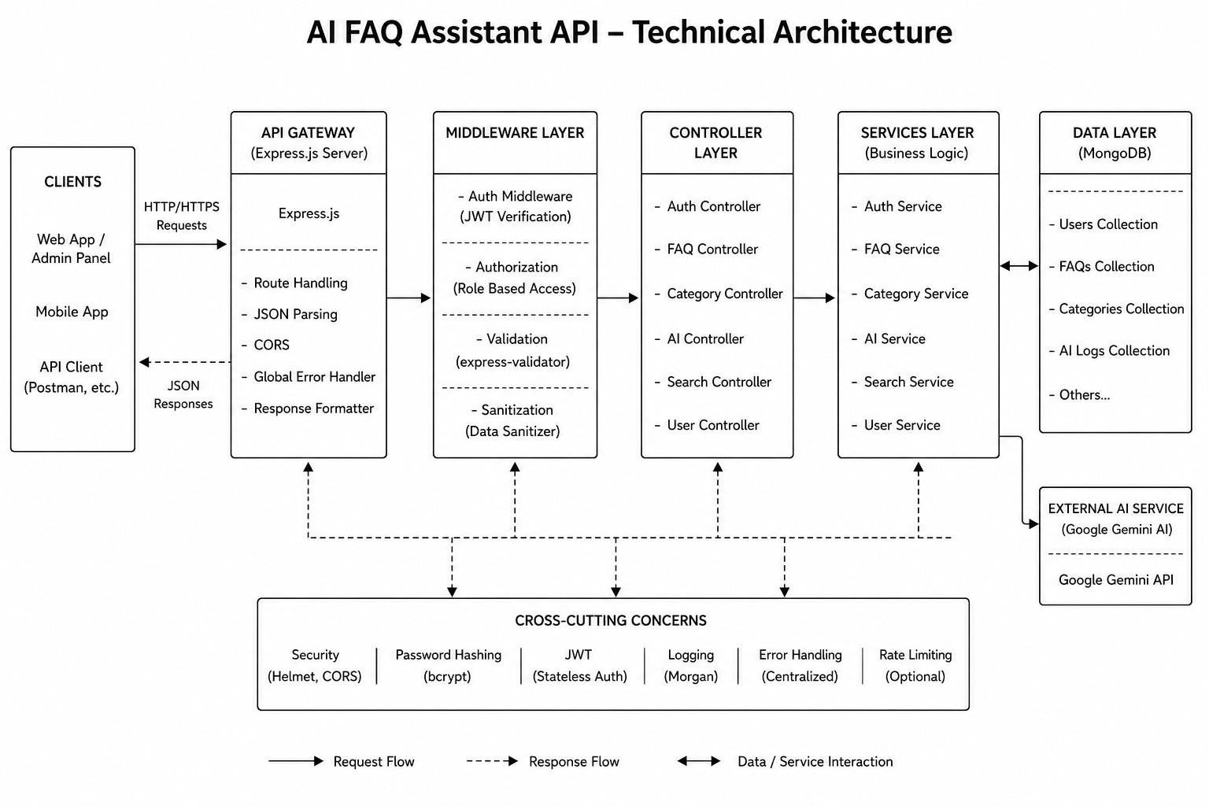
Figure 3.1: Technical architecture of the API
Layer | What lives here | Job
Clients | Web app, mobile app, Postman | Send JSON requests and read responses
Gateway | Express app, CORS, JSON parser | Maps HTTP methods and mounts the route groups
Middleware | auth, validation, error handler | Checks JWT, validates input, formats errors
Controllers | auth, faq, ai | Coordinate each request and shape the response
Services | Gemini service | Talks to Google Gemini AI
Data | User and FAQ models | Mongoose schemas backed by MongoDB

3.2 MVC Pattern
- Model: Mongoose schemas define fields, rules and defaults before anything is saved.
- View (routes): A headless API has no templates, so the routing layer maps each path to a controller.
- Controller: Checks the request, calls models or services, and returns standard JSON.
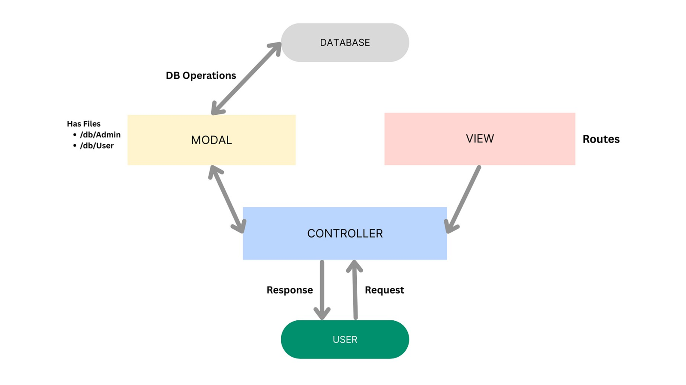
Figure 3.2: MVC pattern

3.3 Data Model
User and FAQ are stored collections; AI Generation and Category are logical entities.
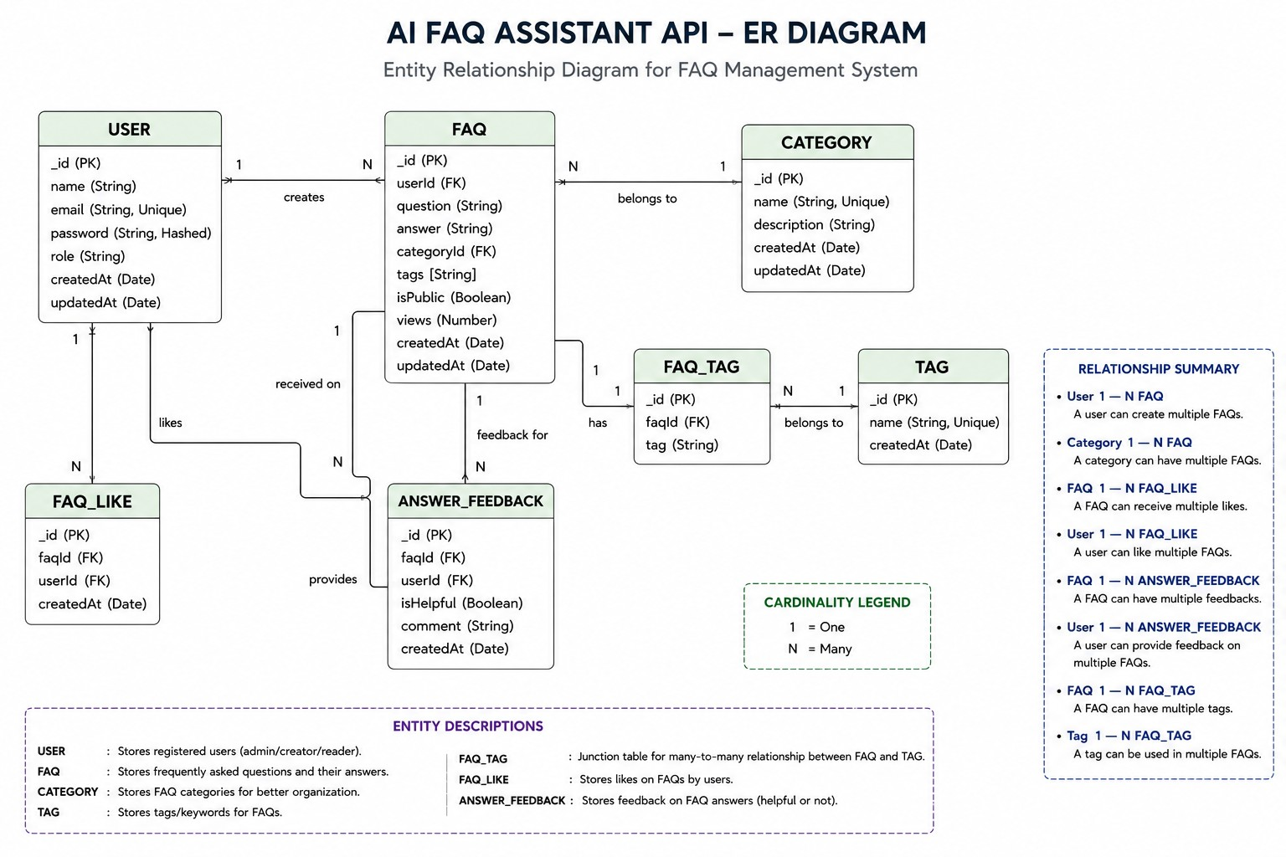
Figure 3.3: Entity-relationship diagram
Table 3.1: User collection
Field | Type | Rules
_id | ObjectId | Primary key
name | String | Required
email | String | Required, unique
password | String | Required, stored hashed (minimum 6 characters)
role | String | Defaults to "user"
createdAt / updatedAt | Date | Added automatically

Table 3.2: FAQ collection
Field | Type | Rules
_id | ObjectId | Primary key
question | String | Required
answer | String | Required
category | String | One of Technology, Education, Health, Banking, General (default General)
createdBy | ObjectId | Reference to the author (User), required
createdAt / updatedAt | Date | Added automatically

Table 3.3: Logical entities
Entity | Fields | Notes
AI Generation | topic, generatedQuestion, generatedAnswer, generatedCategory, generatedAt | Created on the fly by Gemini before anything is saved
Category | categoryName, description, totalFAQs | Groups FAQs for easier navigation

Table 3.4: Relationships
From | To | Type | Meaning
User | FAQ | One-to-many | One user can create and manage many FAQs
Category | FAQ | One-to-many | One category holds many FAQs
User | AI-generated FAQ | One-to-many | A user can generate many drafts and save them later
FAQ | Search results | Logical | Queries return FAQs that match the keywords

3.4 User Flow
- Register or log in and receive a JWT.
- Browse or search public FAQs (no token needed).
- Create, edit or delete your own FAQs with the token.
- Ask the AI service to generate a FAQ pair from a topic.
- The API checks the token on every protected call and returns the result.
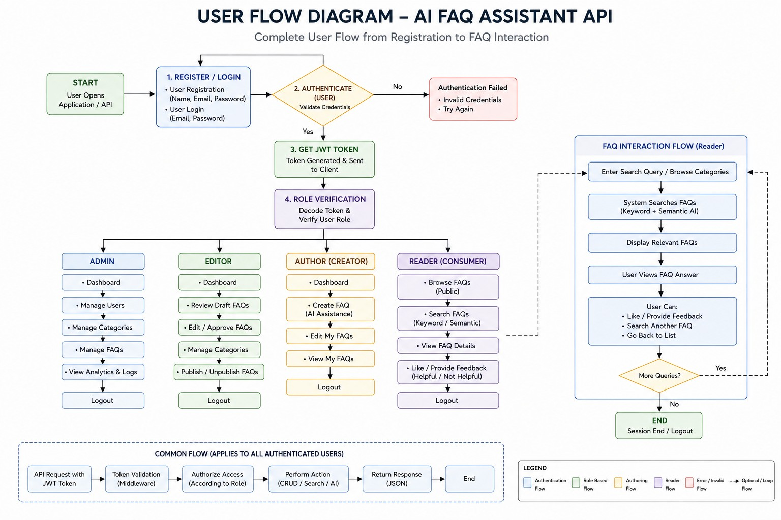
Figure 3.4: Complete user flow diagram

3.5 Request Lifecycle
Every request passes through the same sequence of steps:
- The client sends an HTTP request with a JSON body and, for protected routes, an Authorization: Bearer <token> header.
- Express parses the JSON body and CORS headers, then matches the URL to a route group (/api/auth, /api/faqs or /api/ai).
- For protected routes, the protect middleware verifies the JWT and loads the user from the database without the password.
- The validation middleware checks the request body.
- The controller performs the work, using a Mongoose model or the Gemini service.
- A JSON response is returned; if anything fails, the error handler formats the error and sends the right status code.

3.6 Security Design
Concern | How it is handled
Password storage | A pre-save hook in the User schema hashes the password with bcrypt (10 salt rounds) whenever it is new or modified.
Authentication | On register and login the server signs a JWT with JWT_SECRET; the client sends it back as a Bearer token.
Authorisation | Only the user stored in FAQ.createdBy may change or delete that FAQ.
Data leakage | The auth middleware selects the user with “-password”, so the hash never reaches the request object or the response.
Secrets | JWT_SECRET, MONGO_URI and GEMINI_API_KEY are read from environment variables and kept out of Git.
AI abuse | The AI endpoints are protected routes, which prevents anonymous overuse of the Gemini quota.

3.7 AI Integration Design
All communication with Google Gemini goes through one file, services/geminiService.js. The controllers call this service and never talk to the Gemini SDK directly, so the AI provider can be replaced without touching the routes or models. The service exposes two behaviours:
- POST /api/ai/generate-faq: takes a topic and returns a suggested question, answer and category.
- POST /api/ai/answer: takes a question and returns an AI-drafted answer.
The generated content is only a draft. Nothing is saved until the author reviews it and submits it through POST /api/faqs, which keeps a human in control of the knowledge base.

3.8 Error Handling Matrix
Situation | Status | Message returned
Missing or invalid / expired token | 401 | Not authorized, token failed
Token valid but user no longer exists | 401 | Not authorized, user not found
Duplicate unique value (e.g. email) | 400 | Duplicate field value entered: <field>. Please use another value.
Schema validation failure | 400 | All validation messages joined together
Malformed ObjectId in the URL | 404 | Resource not found with id of <value>
Error carrying its own status (e.g. 429 from Gemini) | As set | Error message from the service
Any other unexpected error | 500 | Generic message; stack trace is logged on the server only

CHAPTER 4: IMPLEMENTATION

4.1 Project Setup
- Create a new project folder and a subfolder named src, then open it in VS Code.
- Open the terminal in the root folder and create the package file:
npm init -y

- Install the dependencies:
npm install express mongoose dotenv cors jsonwebtoken bcrypt @google/genai

Package | Role
express | Web framework and routing
mongoose | MongoDB object modelling
dotenv | Loads values from the .env file
cors | Cross-origin request handling
jsonwebtoken | Creates and verifies JWT tokens
bcrypt | Password hashing
@google/genai | Google Gemini AI client

4.2 Folder Structure
Everything lives inside src, split by responsibility: config (db.js), controllers (aiController, authController, faqController), middleware (authMiddleware, errorMiddleware, validationMiddleware), models (FAQ, User), routes (aiRoutes, authRoutes, faqRoutes), services (geminiService) and utils (helpers). The root also holds app.js, server.js, .env, package.json, a README, a Postman collection and a small test_api.js script.
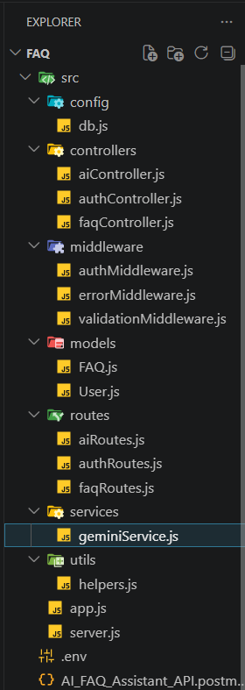
Figure 4.1: Project file and folder structure

4.3 Environment Variables
Variable | Example value | Meaning
PORT | 5000 | Port the server listens on
MONGO_URI | your_mongodb_connection_string | Database connection string
JWT_SECRET | your_jwt_secret | Secret used to sign tokens
GEMINI_API_KEY | your_gemini_api_key | Key for Google Gemini AI
Note: add .env to .gitignore so that keys are never pushed to GitHub.

4.4 Core Backend Modules
- server.js: Loads environment variables, connects to the database and only then starts listening on the configured port. It also shuts the server down cleanly on unhandled promise rejections.
- app.js: Creates the Express app, enables CORS and JSON parsing, exposes a health-check route and mounts the auth, FAQ and AI routes under /api, followed by the error handler.
- authMiddleware.js: Reads the Bearer token from the Authorization header, verifies it, loads the matching user without the password, and rejects the request if the token is missing, invalid or expired.
- errorMiddleware.js: Turns duplicate-key, validation, bad-ObjectId and JWT errors into clear status codes and messages, and hides internal details from the client.
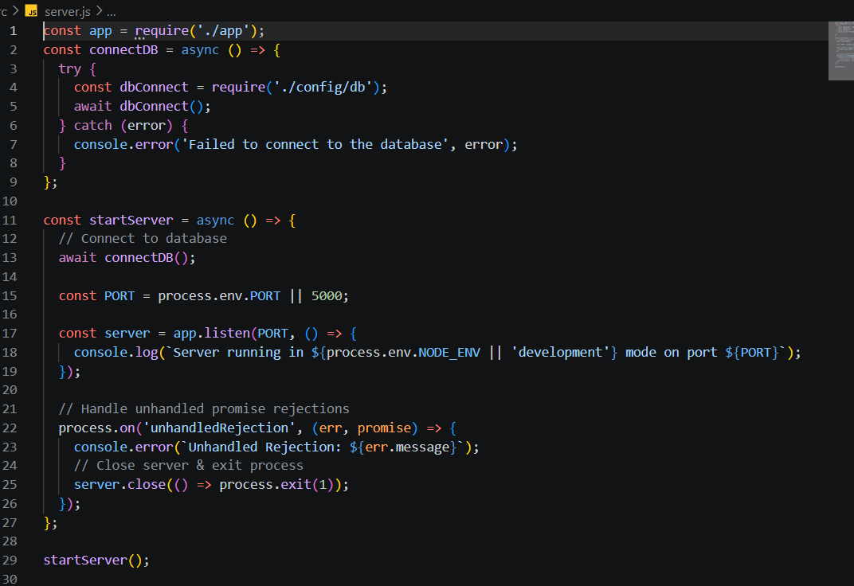
Figure 4.2: server.js
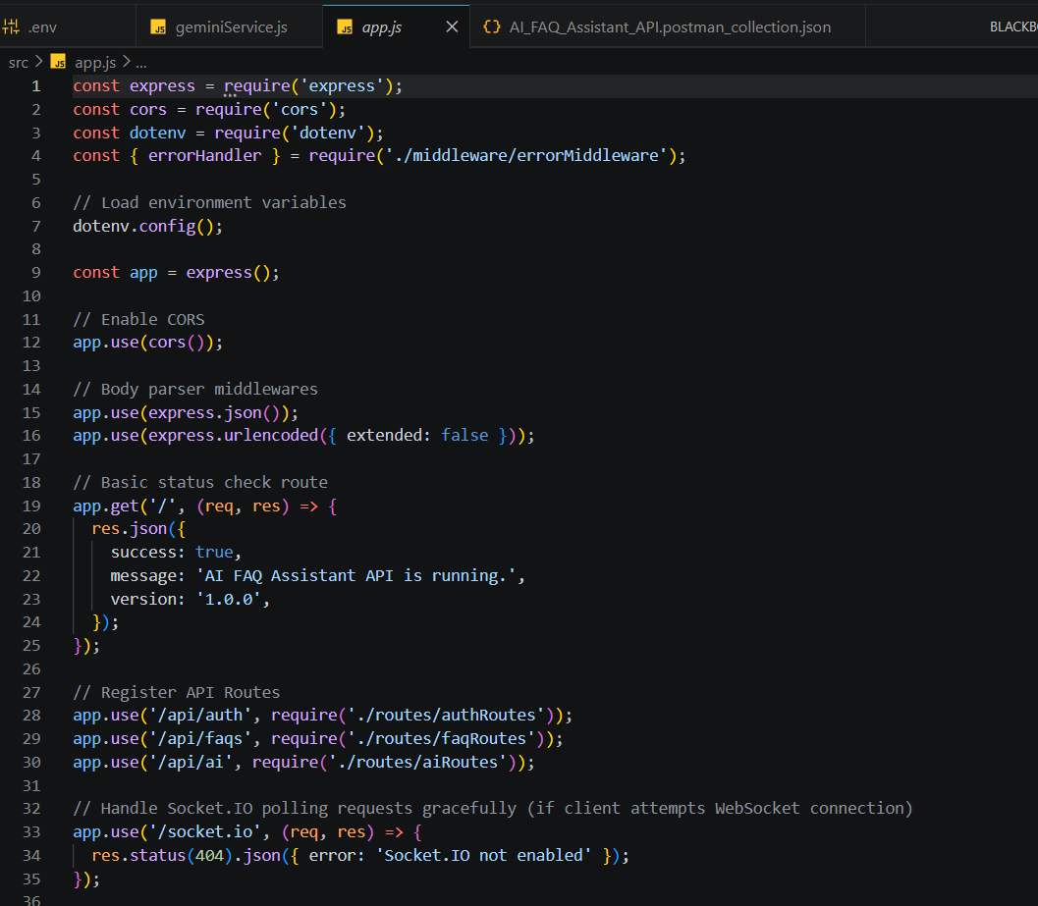
Figure 4.3: app.js
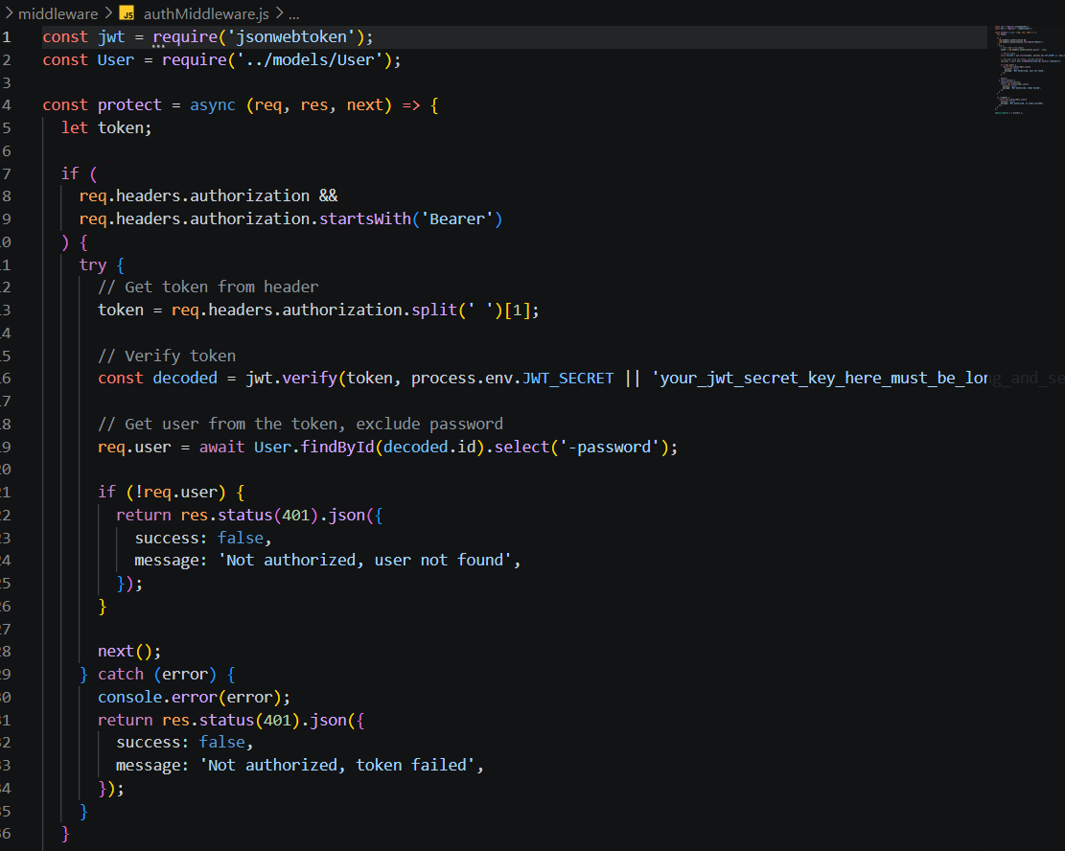
Figure 4.4: authMiddleware.js
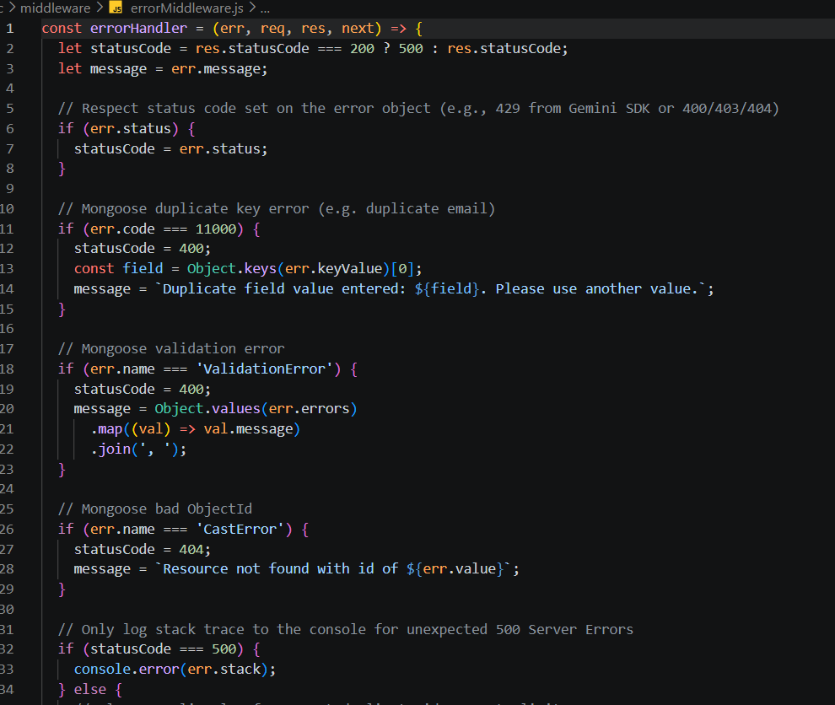
Figure 4.5: errorMiddleware.js

4.5 Database Schemas
The User schema sets rules for name, email and password and hashes the password automatically with bcrypt in a pre-save hook. The FAQ schema stores the question, answer and category and links every FAQ back to its author through the createdBy reference.
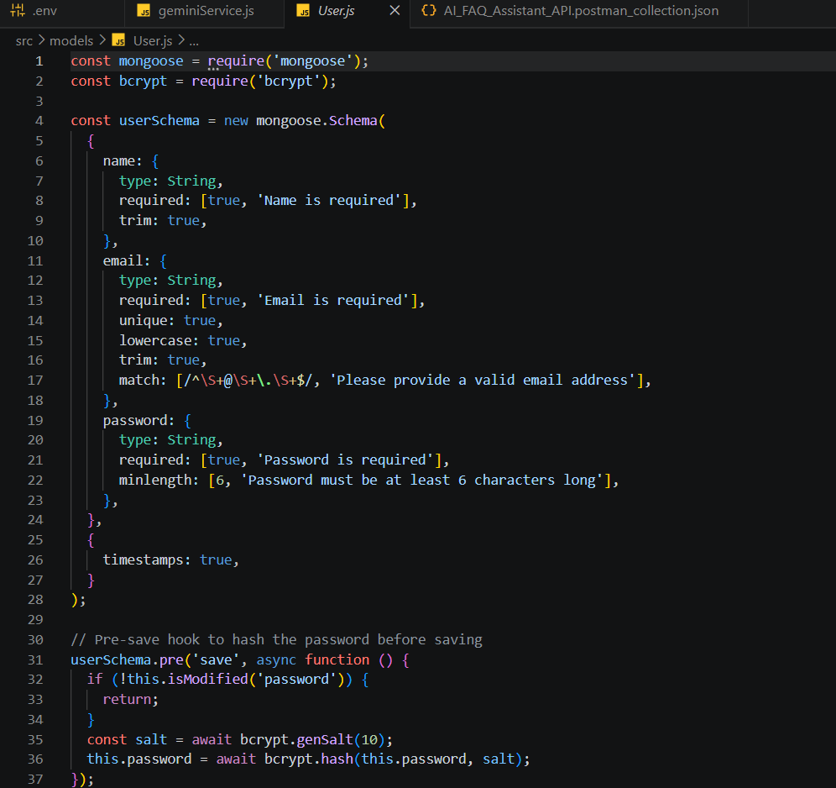
Figure 4.6: User schema (src/models/User.js)
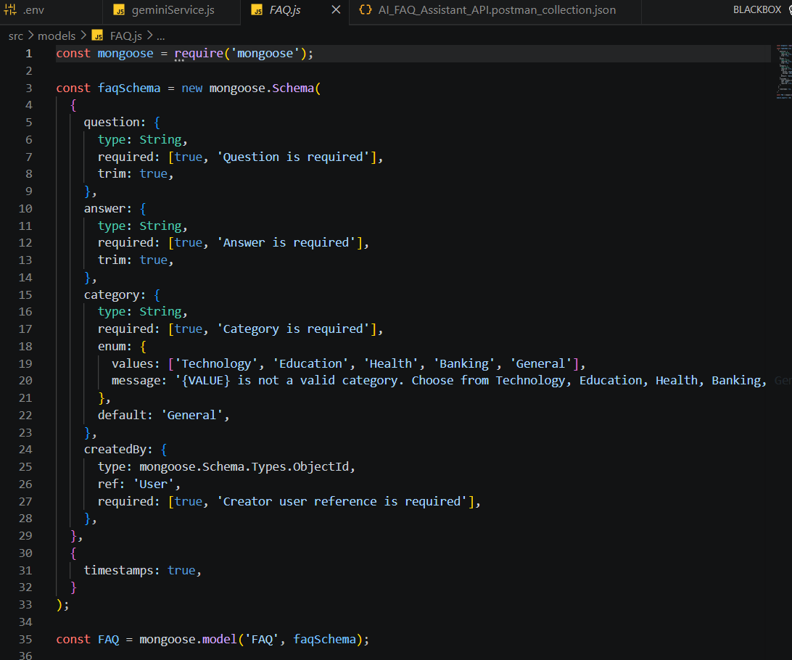
Figure 4.7: FAQ schema (src/models/FAQ.js)

4.6 API Routes
Route file | Public | Protected (JWT)
authRoutes | POST /register, POST /login | GET /profile
faqRoutes | GET /search, GET /, GET /:id | POST /, PUT /:id, DELETE /:id
aiRoutes | None | POST /answer, POST /generate-faq
The search route is declared before /:id so that “search” is never mistaken for an id.
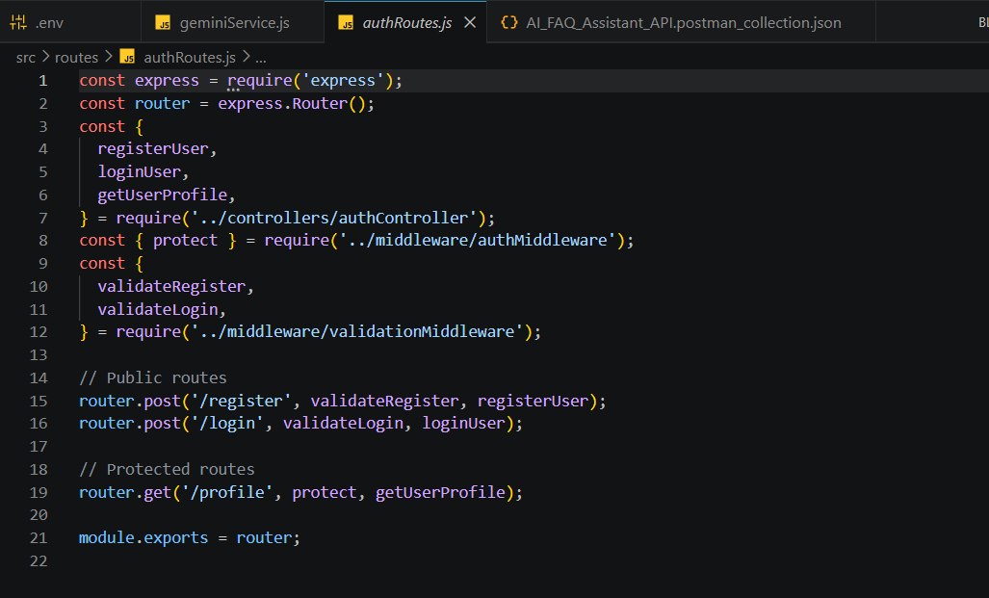
Figure 4.8: Authentication routes (src/routes/authRoutes.js)
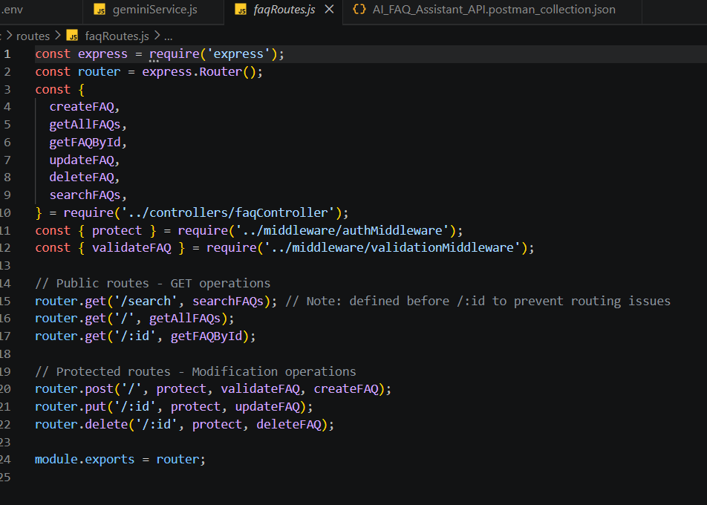
Figure 4.9: FAQ routes (src/routes/faqRoutes.js)
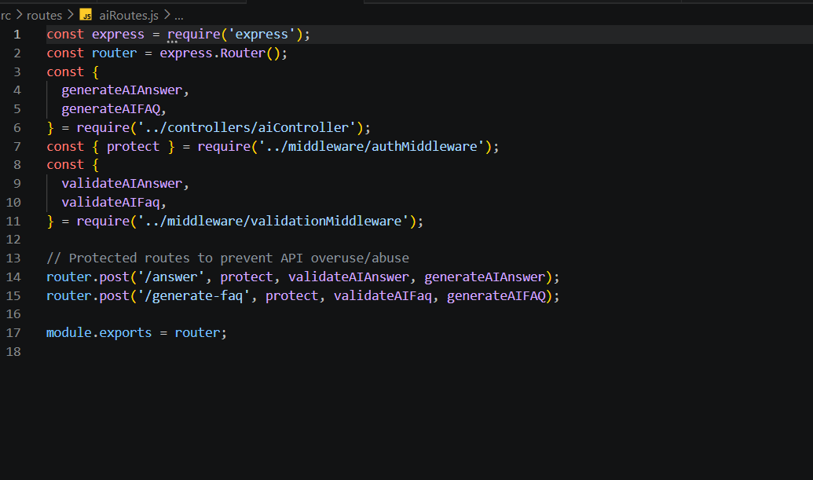
Figure 4.10: AI routes (src/routes/aiRoutes.js)

4.7 Authentication Implementation
- The client posts name, email and password to /api/auth/register; validateRegister checks the body.
- registerUser creates the User document. The pre-save hook generates a salt and replaces the plain password with a bcrypt hash.
- The controller signs a JWT containing the user id and returns it with the user details.
- On /api/auth/login the stored hash is compared with the submitted password; a correct match returns a fresh token.
- For protected routes the protect middleware decodes the token, finds the user and attaches it to req.user.

4.8 Authorisation of FAQ Changes
Creating a FAQ stores req.user._id in the createdBy field. Update and delete requests are allowed only when the FAQ’s createdBy matches the logged-in user, so one author can never modify another author’s entries. Public readers never reach these routes because they lack a token.

4.9 Search Implementation
GET /api/faqs/search?q=<keyword> is a public route. The controller builds a query from the keyword and returns only FAQs whose content matches it. Because the route is registered before /:id, Express does not mistake the word “search” for a FAQ id. GET /api/faqs returns every FAQ together with the name and email of its author, populated from the User collection.

4.10 Running the Project
- Make sure MongoDB is running and the .env file has PORT, MONGO_URI, JWT_SECRET and GEMINI_API_KEY.
- Start the server from the root folder with npm start (or node src/server.js).
- The terminal shows “MongoDB Connected: 127.0.0.1” and “Server running in development mode on port 5000”.
- Open http://localhost:5000 – the health-check route replies with success: true, the message “AI FAQ Assistant API is running.” and the version 1.0.0.
- Send requests to /api/auth, /api/faqs and /api/ai from Postman or ThunderClient.

CHAPTER 5: TESTING AND RESULTS
MongoDB was started locally and the server was run with npm start. Every endpoint was tested with Postman / ThunderClient against the base URL http://localhost:5000.

5.1 Endpoints Tested
Endpoint | Method | Access | Purpose
/api/auth/register | POST | Public | Create an account
/api/auth/login | POST | Public | Log in and get a token
/api/faqs | POST | Private | Create a FAQ
/api/faqs | GET | Public | List all FAQs
/api/faqs/search?q=configure | GET | Public | Search FAQs by keyword
/api/ai/generate-faq | POST | Private | Generate a FAQ pair with AI

5.2 Test Cases
Test 1: Register (public). Request body:
{ "name": "user_1", "email": "user@gmail.com", "password": "password123" }
Result: 201 Created, returns the user details and a JWT token.
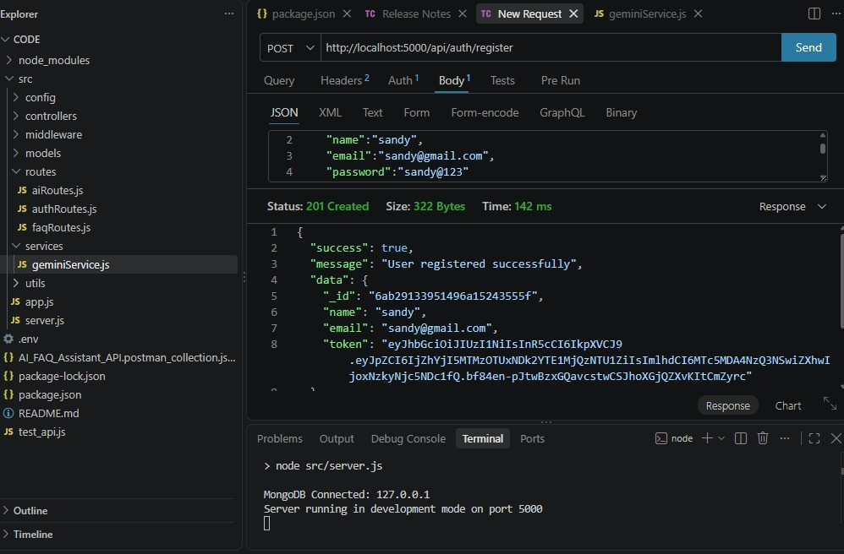
Figure 5.1: Register request and response
Test 2: Login (public). Request body:
{ "email": "user@gmail.com", "password": "password123" }
Result: 200 OK, “Login successful” with a token.
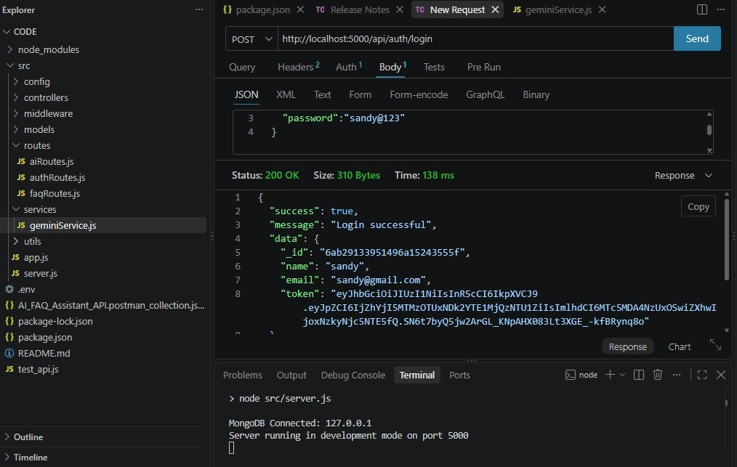
Figure 5.2: Login request and response
Test 3: Create a FAQ (private, header Authorization: Bearer <JWT token>). Request body:
{ "question": "what is node.js?",
"answer": "Node.js is a run time environment build on chrome's v8 engine.",
"category": "Technology" }
Result: 201 Created, “FAQ created successfully”.
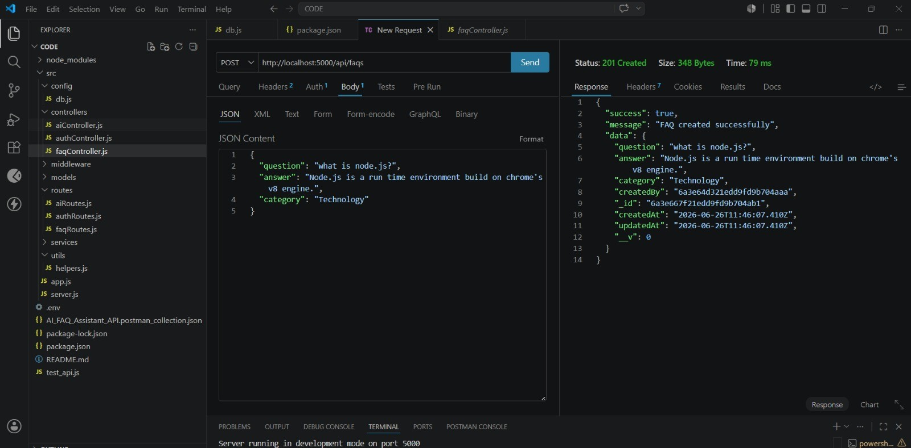
Figure 5.3: Create FAQ request and response
Test 4: Fetch and search FAQs (public). GET /api/faqs returns every FAQ with its author, and GET /api/faqs/search?q=configure returns only the matching ones.
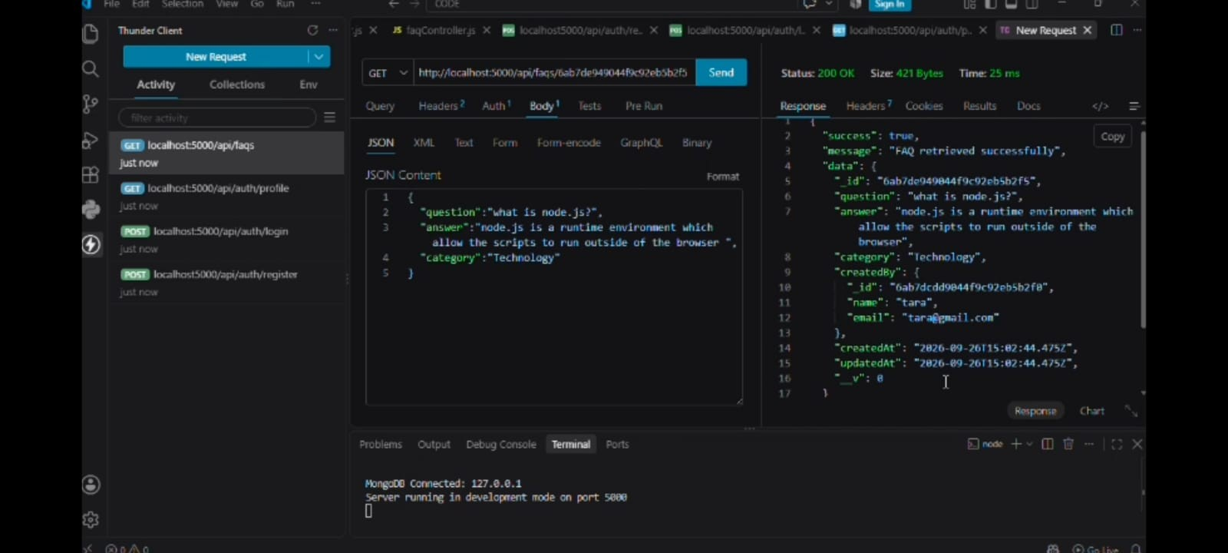
Figure 5.4: Fetch and search FAQs
Test 5: Generate a FAQ with AI (private). Request body:
{ "topic": "gen ai" }
Result: 200 OK, Gemini returns a suggested question (“What is Generative AI?”), answer and category.
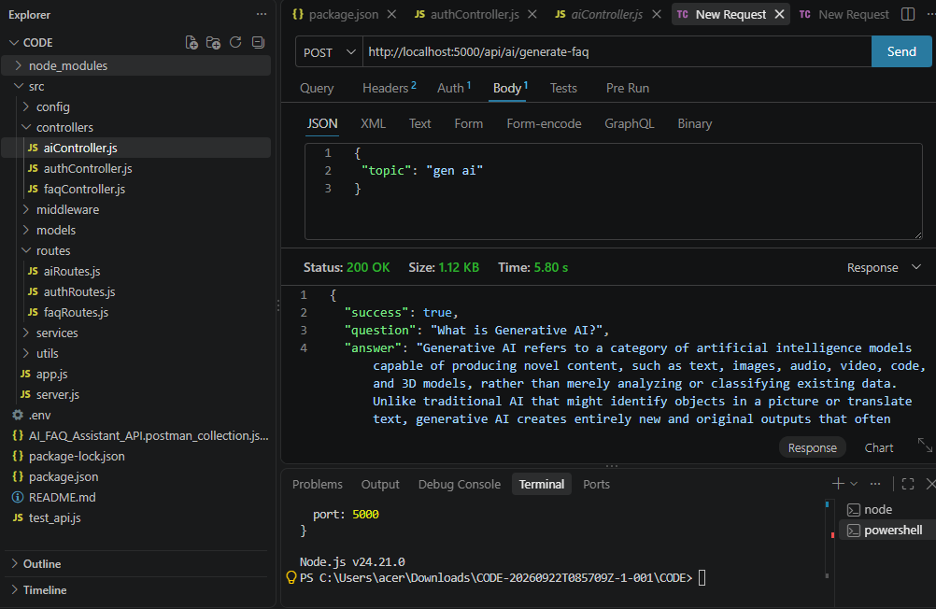
Figure 5.5: Generate FAQ with AI

5.3 Test Summary
The results below were observed in the ThunderClient screenshots above.
Test | Expected | Observed status | Observed time
Register | User created and token returned | 201 Created | 142 ms
Login | Token returned for valid credentials | 200 OK | 138 ms
Create FAQ | FAQ saved with createdBy set | 201 Created | 79 ms
Fetch FAQ | FAQ returned with author details | 200 OK | 25 ms
Generate FAQ (AI) | Question, answer and category from Gemini | 200 OK | 5.80 s

5.4 Sample Responses
Successful registration (token shortened):
{
"success": true,
"message": "User registered successfully",
"data": { "_id": "...", "name": "sandy", "email": "sandy@gmail.com", "token": "eyJhbGci..." }
}

Successful FAQ creation:
{
"success": true,
"message": "FAQ created successfully",
"data": { "question": "what is node.js?", "category": "Technology",
"createdBy": "...", "_id": "...", "createdAt": "...", "updatedAt": "..." }
}

Error response format (for example, a request without a valid token):
{ "success": false, "message": "Not authorized, token failed" }

5.5 Error Scenarios by Design
The following behaviours are defined by the middleware and error handler and can be reproduced in Postman:
Scenario | How to reproduce | Expected result
No token on a private route | POST /api/faqs without the Authorization header | 401 – Not authorized, token failed
Duplicate email | Register twice with the same email | 400 – Duplicate field value entered: email
Invalid category | POST /api/faqs with a category outside the allowed list | 400 – “<value> is not a valid category…”
Malformed id | GET /api/faqs/123 | 404 – Resource not found with id of 123

5.6 Observations
- Database-backed endpoints respond in well under 150 ms on a local machine.
- The AI endpoint is the slowest (about 5.8 seconds) because it waits for the external Gemini service.
- Protected routes consistently reject requests without a valid token.
- Responses always follow the same success / message / data structure, which makes client code simple.

CHAPTER 6: CONCLUSION AND FUTURE SCOPE

6.1 Conclusion
AI FAQ Assistant shows how a small, well-structured Node.js backend can remove much of the manual work of maintaining a knowledge base. Schema validation keeps data clean, JWT tokens ensure only authors change their own documents, and keyword search makes answers easy to find. Google Gemini AI cuts the time needed to draft new entries, while the layered MVC design keeps the code modular and easy to extend.

6.2 Limitations
- Search is keyword based, so it cannot match a question phrased with completely different words.
- Role-based features (admin, editor) are part of the design, but the current routes enforce author-only ownership.
- The AI endpoints need internet access, a valid Gemini API key and available quota, and they respond more slowly than database calls.
- There is no rate limiting or front-end interface in this version.

6.3 Future Scope
- Implement the Admin and Editor roles shown in the user-flow diagram, with a review and publish workflow.
- Add full Category management endpoints and tag support.
- Add semantic (AI-based) search alongside keyword search.
- Add likes and helpful / not-helpful feedback on FAQ answers.
- Build a web front end and add rate limiting for the AI endpoints.

6.4 Project Links
Resource | Link
API testing video | https://drive.google.com/file/d/1y0vp8eE9ydbYVBwoHNpdIm6tMXrmxGNm/view?usp=drivesdk
Demo video | https://drive.google.com/file/d/1y0vp8eE9ydbYVBwoHNpdIm6tMXrmxGNm/view?usp=drivesdk

