Functional roles of plants in pollinator interactions are systematically under-detected by conventional network methods
Abstract
1. Plant–pollinator interaction networks are shaped as much by the methods used to construct them as by the ecology they describe. Most networks rely on a single methodology — typically field observation of floral visitation — capturing only one functional outcome of plant–pollinator contact and systematically excluding interactions involving consumption of dietary resources or transport of pollen to nests. This methodological approach distorts which plant taxa appear most important and how specialized pollinators seem.
2. We build a plant interaction network with multiple functional links for the bumblebee Bombus pascuorum by integrating three complementary methodologies, each revealing a distinct functional outcome: field observation of floral visitation, gut-content metabarcoding of consumed plant taxa, and corbicular pollen metabarcoding of transported plant taxa. We compare network topology, plant importance, and apparent pollinator specialization across and between methods.
3. Combining approaches increases detected plant interactions more than sixfold relative to field observation alone, revealing dietary links to plants — including anemophilous taxa — that conventional surveys exclude. Gut-content metabarcoding additionally exposes seasonal shifts in foraging breadth consistent with active hunger-gap foraging before and after the floral peak, when B. pascuorum consumes a more diverse assemblage than the local entomophilous community provides. Field observations overstate specialization and produce less consistent community characterizations across sites and time than either molecular approach.
Synthesis. Integrating visitation, transport, and consumption data fundamentally changes plant–pollinator network topology and the apparent roles of plant nodes. We advocate for defining interactions by their functional outcome and combining methods accordingly — an approach that reveals previously undetected structure in ecological networks and identifies which plant taxa warrant greater attention in pollinator habitat management.
Introduction
Pollination is a critical ecosystem service that is currently threatened by global anthropogenic change, including habitat loss, intensifying agriculture, pathogens, and invasive species (Klein et al. 2006). Despite the clear importance of understanding plant-pollinator interactions, our knowledge of interaction diversity remains incomplete, as the methodological approach to studying plant-pollinator interactions has historically been biased towards the plant side of interactions (Bosch et al. 2009; Evans & Kitson 2020). As a consequence, the well-established relationship between pollinator diversity and the productivity of plant communities (Artamendi et al. 2025) lacks an equally developed mirrored perspective, describing the floral diversity that supports pollinator populations.
If the plant taxa that support pollinator populations are systematically misrepresented, the capacity to make effective management and conservation decisions is correspondingly limited. Ecological network approaches provide a framework for describing the diversity and organization of plant–pollinator interactions and identifying the resources that support pollinator communities (Burkle & Alarcón 2011), however, existing methodologies for reconstructing interaction networks tend to emphasize structural patterns, while overlooking the functional outcomes of interactions that are critical for understanding how plant communities support pollinators (Quintero et al. 2022). In Apidae, for example, plant interactions may have several outcomes. Bees consume plant material, including pollen, nectar, or even plant tissue (Vaudo 2015; Pashalidou et al. 2020). They also collect pollen on their corbicula, which is transported to the nest for brood provisioning (Vaudo 2015; Leach & Drummond 2018). Finally, visitation of the reproductive parts of flowers can have various outcomes for both the plant and pollinator, including pollen transfer (Emer & Memmott 2023) and pathogen transfer (Lignon et al. 2024). Interaction networks generally represent only one of these outcomes, although each is important to understanding how plant taxa support pollinators, particularly across different life stages.
Because the resources needed for foraging adult pollinators are different from those needed by larvae or other colony members (Vaudo 2015; Leach & Drummond 2018), transported pollen may not completely represent the interactions necessary to sustain adult pollinators. This is especially true for bumblebees (Bombus spp.), which are able to evaluate pollen resource quality to discern foraging choices (Leonhardt & Blüthgen 2012; Timberlake et al. 2024a). Bumblebees make trial-and-error floral visits in order to find adequate forage (Selva et al. 2024), sometimes resulting in pollen transport without consumption. Conversely, consumption, or simply visitation, may occur without resulting in transport (Popic et al. 2012).
Metagenomics, including metabarcoding, has emerged as a powerful tool for detecting plant-pollinator interactions that may be unobserved in pollen microscopy and field surveys (Bell et al. 2016; Pornon et al. 2017; Lowe et al. 2022), in some cases increasing interaction species detection by 9 - 144% (Smart et al. 2017; Milla et al. 2022; Baksay et al. 2022) and network sampling completeness up to 30%, while reducing exaggeration of specialization (Arstingstall et al. 2021), as well as revealing interactions beyond the traditionally surveyed anemophilous floral community (de Vere et al. 2017; Milla et al. 2022). Advances in the reliability and accessibility of sequencing technologies have made molecular approaches more feasible for studying plant-pollinator interactions.
Most pollination studies applying metabarcoding focus on the external pollen loads of bees or pollen stored in nest reserves of honey or beebread (Leontidou et al. 2021; Baksay et al. 2022; Leponiemi et al. 2023; Devriese et al. 2024; Selva et al. 2024), despite the limitations of these sampling targets owed to environmental contamination (Negri et al. 2015). Beyond potential contamination, externally transported pollen has an inherently restricted capacity for representing interaction types. For example, corbicular loads are made from pollen collected for transport to the nest for brood feeding (Vaudo 2015; Leach & Drummond 2018), only directly representing pollen transport interactions (Arstingstall et al. 2021). This pollen is often the central sample type used to represent foraging networks, where it is considered synonymous with diet and successful pollination interactions (Shi et al. 2025), likely overstating the functional role of certain plant taxa within plant-pollinator networks.
Pollinator intestinal tracts contain pollen and other plant material that can reveal interactions (Mayr et al. 2021; Haag et al. 2023; Li et al. 2025) with consumption as the exclusive outcome. There is an accumulating body of evidence demonstrating that pollinators regularly forage across the entirety of the anemophilous-entomophilous spectrum of plant taxa to meet their nutritional needs (de Vere et al. 2017; Tanaka et al. 2020; Milla et al. 2022; Wood et al. 2022; Timberlake et al. 2024a; Selva et al. 2024; Ibiyemi et al. 2025), although little attention has been given to observations of interactions with anemophilous taxa as a potentially important part of plant-pollinator interaction networks (Saunders 2018). The understudied nature of the roles played by differently pollinated plant taxa in pollinator interaction networks, together with the surprising lack of genetic analyses of pollinator gut contents, represent a clear opportunity for deepening our knowledge of pollination ecology.
We assess whether metabarcoding of pollinator gut contents can complement the characterization of plant-pollinator interaction networks described by more common methodologies, including field observations, and external pollen load metabarcoding. To this end, we compare interaction diversity and frequencies recorded by each of these methodologies for the wild bumblebee, Bombus pascuorum. Because gut contents directly reflect ingested resources, this approach may reveal interactions that are undetected by observational or external pollen-based methods. We therefore expect that gut metabarcoding will identify a unique group of plant taxa compared to those detected by other methodologies, while also showing partial overlap across approaches in the plant species interacting with bumblebees.
Methods
Our sample collection was conducted in Gorbeia Natural Park (coord: 43.068, -2.796), a protected area in the Basque Country of Northern Spain. We selected 16 sampling sites located within the mixed zones of meadows and shrublands around or above 800 m a.sl.. We conducted fieldwork from early April to the end of July, 2023, covering the main flowering season and peak annual pollinator activity. Each site was visited six times throughout the flowering season, separated by approximately two-week periods. During each visit, we conducted three types of surveys: (1) floral diversity surveys (“flower counts”), (2) interaction transect surveys, and (3) Bombus pascuorum specimen collection for metabarcoding analyses.
For both interaction transect and flower count surveys we used one 250 m transect at each site, recording observations within a ~2 m wide transect line. Interaction surveys were conducted three times per day (~11:00, ~13:00, ~15:00), each lasting 1 h. We recorded all observations of Bombus pascuorum individuals contacting the reproductive parts of herbaceous flowers. For each site and sampling period, one flower count was conducted by recording all of the flowering herbaceous species within the transect.
For every period visit at each site, we collected up to five B. pascuorum specimens for molecular analyses (N = 126). We brought specimens back from the field and froze them at -20°C until processed. In the lab, we extracted the entire gut and honey stomach and, if present, collected pollen from the corbicula of specimens into sterile 1.5 mL centrifuge tubes. Pollen samples were stored individually by specimen sample at -20°C.
Genomic DNA was extracted from guts using the NucleoSpin® 96 Soil kit (Macherey-Nagel, Düren, Germany). To avoid site and period bias, all samples were randomized before the DNA extraction. We followed the kit manufacturer protocol, only adjusting centrifuge spin duration to account for differing maximum velocity available within our centrifuge (Appendix S1: Section 1). Nanodrop spectrophotometry was used to quantify DNA concentration and purity of a random subset of extracts by measuring reflectance at 260/230 nm wavelengths.
DNA was extracted from pollen pellets (N = 25) using the Machery-Nagel NucleoSpin® 8 Food kit, including additional initial steps recommended by the kit’s supplementary protocol for pollen DNA extraction (Appendix S1: Section 2). A Qubit high sensitivity dsDNA kit (Thermo Fisher Scientific) was used to quantify DNA extract concentrations for randomly selected samples.
Gut-content DNA extracts were amplified in duplicate using a dual-indexed, two-step PCR method described by Donald et al. (2022). Briefly, the ITS2 region was amplified using the primers, ITS-S2F (ATGCGATACTTGGTGTGAAT) (Chen et al. 2010) and ITS4R (TCCTCCGCTTATTGATATGC) (White et al. 1990). The resulting amplicons were pooled in equal volumes, purified using SPRI-beads, and used as templates in the second-step PCR to attach unique dual indices and Illumina p5/p7 sequencing primers. Amplicons were purified and size-selected using SPRI-beads and pooled in a final library (see Appendix S1 for full library preparation), which was sequenced on an Illumina MiSeq instrument for 300 cycles in paired-end mode at the Ecological Genetics laboratory, Bioeconomy Science Institute, Auckland, New Zealand. Pollen DNA samples were sequenced and processed by NOVOGENE (Planegg, Germany) using the same primer pair on an Illumina Novaseq platform configured for PE250 sequencing for 518 cycles.
For all samples, raw reads were processed using the DADA2 bioinformatics pipeline (Callahan et al. 2016), producing two key datasets: a sample x ASV counts matrix and reference ASV fasta file (Appendix S1: Section 4). Reference ASVs were used to call taxonomic identities using DADA2 in conjunction with the published ITS2 reference database of Bell (2021). Taxonomy data were combined with the sample x ASV matrix and sample metadata using phyloseq (McMurdie & Holmes 2013) and downstream quality control and statistical analyses were performed in the R analysis environment. For contaminant and misidentified ASV removal, we tested our ASVs for contaminants using the R package, decontam (Davis et al. 2018). Then, the remaining list of taxa was screened against a locally specific herbarium (Hermosilla & Agut 2025).
Statistical analysis
We used iNEXT to quantify sampling completeness for our data using sample coverage (Hsieh et al. 2025). Coverage summaries were calculated at the observed sample size only, excluding extrapolated values.
As an initial broad test of whether the methodologies detected interactions with different plant communities, we used binary presence-absence matrices to compare the communities detected by each methodology for each sampling day. Data were aggregated by sampling day for all sets of observations. Community composition was contrasted using the Raup-Crick dissimilarity index in a PERMANOVA test within the R package, vegan (Oksanen et al. 2024), with methodology as the independent variable. Further pairwise comparisons of these data were made by subsetting the dissimilarity matrix used in the first test by each unique methodology pair and using multiple pairwise PERMANOVAs and beta dispersal for comparison.
From the 126 B. pascuorum specimens, we obtained both gut-content and pollen sequence data for 23 individuals. Using this subset of paired samples, we compared the plant communities detected by the two metabarcoding methodologies at the individual sample level without aggregation. PERMANOVA compared both methodologies’ detected communities in strata defined by specimen of sample origin.
We used interaction frequencies from the three methodologies to build individual B. pascuorum–plant interaction networks and calculate species-level metrics for plant importance and specialization. Plant importance was defined as the proportion of all B. pascuorum interactions involving a given plant genus. For metabarcoding and pollen-load data, interactions were counted as the number of individual bee samples in which a plant genus was detected; for observational data, interactions corresponded to recorded visits. Species-level specialization (d’) was calculated following Blüthgen et al. (2006), as implemented in the R package bipartite (Dormann et al. 2009).
Results
Assessment of floral resource use relative to availability
Within our flower count surveys we registered a total of 117 flowering herbaceous plant genera across the sampling season, representing the pool of floral resources available to B. pascuorum, which interacted with only a subset of this diversity (Fig. 1A). In fact, 39 genera recorded in flower counts were absent from the interaction networks generated by any of the methodologies. Interaction transects revealed interactions with 27 genera (23% of total floral diversity), while gut-content and corbicular pollen metabarcoding revealed interactions with 58% and 53% of available taxa, respectively.
Comparison of interaction detection by methodology
Both metabarcoding methodologies detected multiple unique taxa (33 taxa for gut contents and 30 for corbicular pollen), while interaction transects did not detect any unique interactions (Fig. 1A). The two metabarcoding methodologies shared 83 common plant genera, representing 68% of the total corbicular pollen diversity and 63% of the gut content diversity.
Taxonomic diversity varied across sampling periods, revealing distinct temporal patterns in flowering taxa and interactions (Fig. 1B). Although floral and interaction diversity increased overall from the first to the last period, flowering taxa peaked in period four, whereas interactions peaked in period six. Metabarcoding consistently detected more taxa than interaction transects, with gut-content metabarcoding detecting more diversity than all other methods. In periods one, two, and six—before and after peak flowering—gut-content metabarcoding detected 59% more taxa than were recorded in flower counts, while in periods three to five floral diversity exceeded gut-content diversity.
Gut-content compositional diversity
The design of interaction transects only included taxa from the entomophilous community, while both metabarcoding methodologies detected taxa from the anemophilous community as well, representing 28% (N = 41) of the total identified plant genera between the two methodologies. Among these were 20 genera from Poaceae, nine tree or woody plant genera, and 12 other herbaceous genera (Appendix S2: Figure S3). During periods one, two, and six—when gut-content metabarcoding detected more taxa than the entomophilous community recorded in transects—an average of 13% of those taxa were anemophilous or partially anemophilous (Appendix S2: Figure S4).
Plant community composition across methodologies
PERMANOVA indicated a significant effect of methodology on the observed community (P < 0.001, R² = 0.28). In this analysis, interaction transects showed high beta-dispersal (distance to centroid = 0.62) compared to the more centered metabarcoding and flower count results (distance to centroid ≤ 0.10), and an ANOVA test of mean dispersal by methodology indicated different levels of dispersal (P < 0.001) for each methodology. The communities detected by each of the methodologies were also visualized using non-metric Multidimensional Scaling (nMDS, stress = 0.17, Fig. 1C). Pairwise comparisons (Appendix S2: Table S1) showed that the plant communities detected by flower counts were different from those of all other methodologies (P < 0.001, Holm-Bonferroni), although between pairs of interaction methodologies, no differences were observed. Removing flower count data from the analysis to observe finer differences between the interaction methodologies did not change these results (Appendix S2: Figure S5, Table S2).
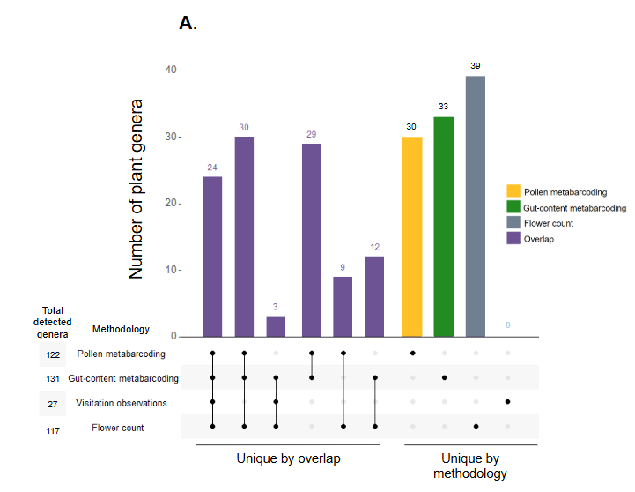
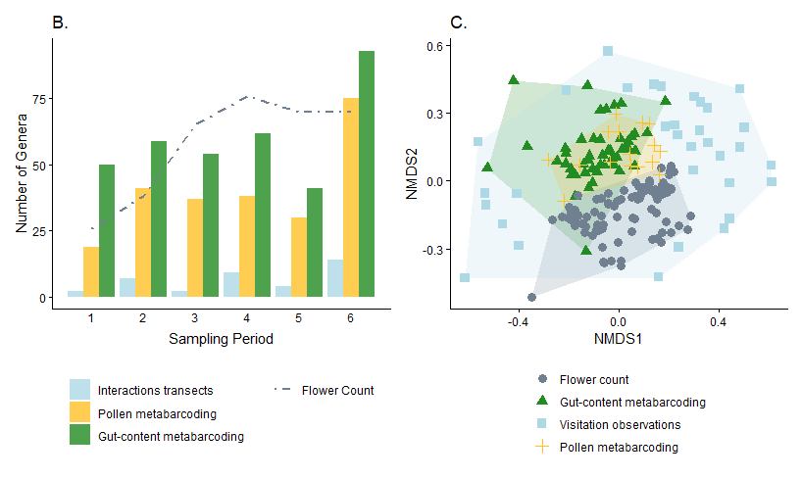
Figure 1. Complementarity of methodologies for characterizing plant–pollinator interactions of Bombus pascuorum. (A) Total plant genus diversity and overlap detected by floral surveys, visitation observations, and metabarcoding of corbicular pollen and gut contents. (B) Temporal patterns in cumulative plant genus diversity across six sampling periods (April–August 2023) detected by visitation surveys and metabarcoding of gut contents and corbicular pollen. Values represent cumulative raw richness per methodology and period. (C) Differences in plant communities detected by each methodology and floral surveys, visualized using non-metric Multidimensional Scaling based on presence–absence data and Raup–Crick dissimilarity (stress = 0.17).
Gut-content vs. pollen-derived plant communities from paired samples
Comparing metabarcoding results from the same specimens, gut contents yielded fewer taxa (mean = 13 genera, sd = 9) than pollen samples (mean = 19 genera, sd = 7). On average, only 21% of taxa (mean = 7 genera, sd = 3) were shared between the two sample types. A PERMANOVA with specimen as a blocking factor indicated a difference in the plant community observed by both sample types (Appendix S2: Table S3) explaining 16% of the variation between gut- and pollen-based detections. Data used in this comparison were similarly dispersed (distance to centroid = 0.08), with no difference between the two groups observed by a permutest.
Species level interaction network
We calculated interaction specialization of B. pascuorum and an importance metric for the plant taxa within interaction networks. Specialization (d’) declined over the season for transect and pollen-metabarcoding data but remained relatively stable for gut-content metabarcoding (Fig. 2), with transects indicating complete specialization in the first period. Across all methods, Lotus emerged as the most important plant genus, though the structure of importance differed. The transect network was dominated by a few top taxa (Fig. 3a), whereas the two metabarcoding networks showed more evenly distributed importance values (Fig. 3b-c).
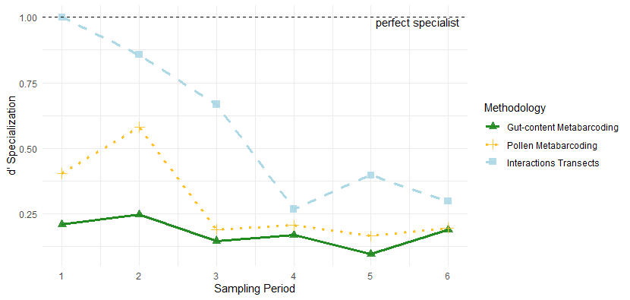
Figure 2. Specialization of Bombus pascuorum across sampling periods estimated from visitation surveys, gut-content and corbicular pollen metabarcoding. Specialization was calculated as d’ (Blüthgen et al. 2006), where d’ = 1 indicates complete specialization.
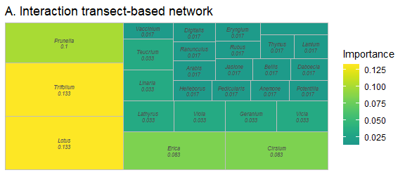
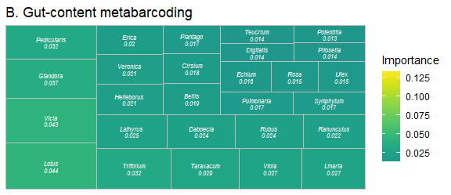
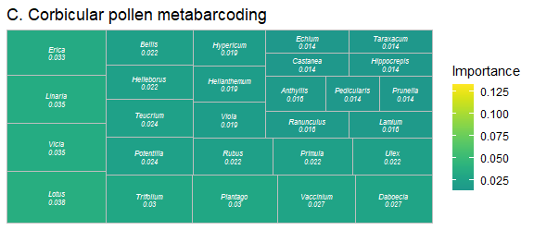
Figure 3. Plant importance within Bombus pascuorum interaction networks based on (A) visitation surveys, (B) gut-content metabarcoding, and (C) corbicular pollen metabarcoding. Importance represents the proportion of interactions involving each plant genus. Block size and color indicate relative importance within each methodology.
Combined interaction network
We combined the results from each interaction methodology to create an interaction network for B. pascuorum with links defined by interaction outcomes, including consumption, transport, and visitation (Fig. 4). This single species network included 171 nodes, increasing the number of taxa included in the network compared to individual methodology constructed networks. Additionally, each plant taxa received up to three links, including link metadata for interaction outcomes in the network. In total, the network contained 281 descriptive links.
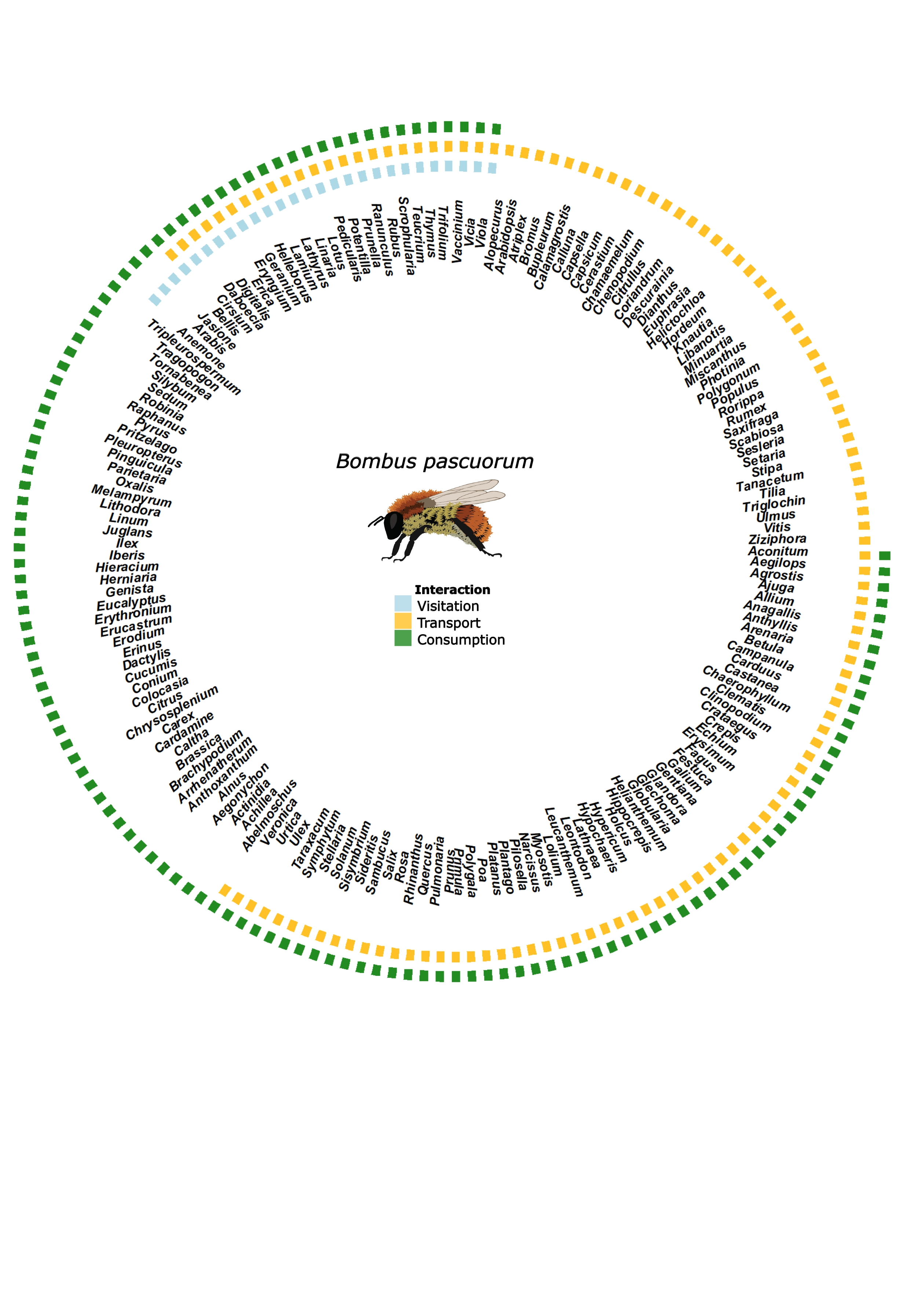
Figure 4. Combined interaction network for Bombus pascuorum integrating visitation (visitation), corbicular pollen metabarcoding (transport), and gut-content metabarcoding (consumption). The network includes 170 plant genera, with links indicating the presence of each interaction type.
Discussion
The functional role a plant serves for a pollinator - whether as a source of consumed nutrients, transported pollen, or a visited flower - is observable in specific contexts. Our results show that applying multiple interaction observation methods captures greater interaction diversity, highlights which plant taxa provide the most resources to pollinators, and reveals a clearer image of pollinator specialization. Most strikingly, we show that B. pascuorum forages well beyond the entomophilous community, consuming taxa from the anemophilous plant group — particularly during periods of low floral availability — in a pattern consistent with active hunger-gap foraging (Becher et al. 2024; Timberlake et al. 2024b). That this goes undetected by field surveys with restrictive designs alone has direct implications for which plant taxa we prioritize in pollinator conservation.
We compared each methodology in terms of the diversity of detected interactions, assignment of relative importance of plant taxa and specialization of B. pascuorum within the resulting network, and observed plant community composition. Consistent with previous comparisons between field and metabarcoding observation of plant-pollinator interactions, metabarcoding increased observed interaction diversity (Smart et al. 2017; Milla et al. 2022; Baksay et al. 2022), in our case by more than six-fold compared to interaction transect results. Considering this, and the time dedicated to data collection for both types of methodologies, metabarcoding was a more efficient approach. Interaction transects did provide the advantage of greater taxonomic resolution, as we were able to detect interactions at the species-species level, whereas metabarcoding provided species-genus level interactions. Beyond taxonomic detection capabilities, the results from each methodology allowed for network-level cross-validation.
Network topology and specialization patterns differed markedly across methodologies. Interaction transects tended to overstate both the degree of specialization and the dominance of the most frequently visited plant taxa. Although B. pascuorum is known to form strong early-season associations with certain plant species (Artamendi et al., in prep), the metabarcoding approaches indicated much lower specialization and produced more evenly distributed network structures. These results mirrored previous interaction networks constructed for individual pollinator species, which also have shown a tendency towards representing pollinators as specialists when using field observation data, in contrast to the generalist behavior indicated by metabarcoding data (Arstingstall et al. 2021). Overall, the combined datasets across methodologies suggested a more diverse foraging niche than visitation interactions alone would have implied.
The three methodologies showed complementary patterns in community composition, with each revealing a distinct slice of the full interaction space. Notably, interaction transects showed substantially higher beta-dispersal (distance to centroid = 0.62) than either metabarcoding approach (≤0.10), indicating that field observations produce highly variable community characterizations across sites and time. This variability likely reflected local habitat heterogeneity and observer effects rather than ecological signal, implying that single-site field surveys are particularly prone to misrepresenting network structure at the landscape scale. Metabarcoding, by integrating foraging across broader spatiotemporal extents, produced less variable community estimates. No statistical differences in overall community composition were detected among the three interaction-focused methods at the aggregate level, though this masked the substantial individual-level variation in gut and pollen content that molecular approaches could access. The minimal overlap between metabarcoding results and flower count data further confirmed that interaction networks routinely incorporate plant taxa absent from local entomophilous floral surveys.
Between the two molecular approaches, gut-content metabarcoding captured greater overall taxonomic diversity and was the more efficient sampling strategy, as every specimen yielded a gut sample but not necessarily a pollen sample. The smaller corbicular pollen dataset (N = 25 vs. N = 126 gut samples) limited the confidence with which direct comparisons between these two molecular approaches could be generalized; future studies should prioritize balanced sampling across methodologies. Pollen samples nonetheless detected more taxa per individual, and demonstrated a promising non-lethal alternative where lethal sampling is not feasible. The combination of both methodologies’ results broadened the interaction network greatly, and incorporated contextualized interaction links. These links showed which plant genera were consumed for adult bee nutrition, and which provided pollen for transport to the nest. In our case, gut-content metabarcoding was particularly informative for revealing seasonal foraging patterns, detecting more consumed taxa than were observed by flower counts in the early and late parts of the season, and showing relatively stable low specialization over time. This stability contradicted previous field observations, indicating higher specialization of the species, especially in the early flowering season (Artamendi et al., unpublished data). Together, these results indicated that the plant community represented in consumption-based interactions differs from the floral community captured by visitation- and transport-focused surveys.
Together, the temporal and diversity patterns in our metabarcoding data demonstrated that B. pascuorum actively forages across plant taxa with multiple pollination strategies, including taxa well outside the traditionally surveyed entomophilous community — trees and shrubs, grasses, and other herbaceous plants. These findings are consistent with the hypothesis that bumblebees expand their foraging niche to bridge seasonal hunger gaps (Becher et al. 2024; Timberlake et al. 2024b), and suggest that conservation assessments based solely on entomophilous floral resources may substantially underestimate the plant diversity required to sustain colonies. Our observations of anemophilous plant interactions are supported by previously documented records for Bombus species (de Vere et al. 2017; Tanaka et al. 2020; Milla et al. 2022; Wood et al. 2022; Timberlake et al. 2024a; Selva et al. 2024; Ibiyemi et al. 2025), and have especially intriguing implications for bumblebee forage behavior. Previous studies using external pollen metabarcoding have excluded wind-pollinated taxa on the assumption that wind-borne pollen represents false positive interactions (Negri et al. 2015; Pornon et al. 2017; Tanaka et al. 2020). However, our gut-content results caution against automatically treating these taxa as contaminants, particularly when external pollen loads are used as standalone proxies for foraging networks.
The presence of DNA from anemophilous taxa within gut samples suggests that interactions with these taxa may be more than coincidental interactions with pollen in the environment. Indeed, beyond consumption for adult nutrition, there are previous indications that pollen from flowering trees supports colony establishment success and low larval mortality (Wood et al. 2022). Our results support the hypothesis that most bumblebees forage selectively for consumption and transport of high-quality pollen (Ruedenauer et al. 2016; Timberlake et al. 2024a), adapting their forage to take advantage of the best available resources as they change with environmental variability (Selva et al. 2024). While it is possible that some plant material may be transported or consumed incidentally (Arstingstall et al. 2021), the taxa detected within B. pascuorum gut contents and corbicular pollen form part of the web of biodiversity that supports the species and possibly other pollinators. Our detection of anemophilous plant DNA in both metabarcoding methodologies indicates that B. pascuorum, and perhaps other bumblebee species, may intentionally forage on these taxa to meet nutritional needs at various life stages.
Our results directly confirm that bumblebees expand their foraging niche during periods of resource scarcity (Morozumi et al. 2022; Wood et al. 2022). Gut-content metabarcoding detected a more diverse plant assemblage before and after the floral peak than were recorded in flower counts, including anemophilous taxa rarely considered part of the foraging network — a pattern that field surveys alone cannot reveal. Whether driven by landscape-level floral resources beyond our transects, intentional foraging beyond entomophilous plant taxa, or both, these findings show that the breadth of plant diversity sustaining a bumblebee population is substantially wider than the entomophilous community that conventional methods capture. The taxonomic and temporal resolution of metabarcoding is essential for detecting this structure, and its value increases further at the individual sample level, where gut and pollen data together reveal which plants matter for adult nutrition versus brood provisioning.
Our comparative analyses understate the resolution of the metabarcoding derived data. We aggregated detections by sampling day to balance effort across methods, overlooking the individual-level detail that metabarcoding can provide. When we compared taxa detected from paired pollen and gut samples at the individual level, overlap was low, revealing a difference between sample sources that was not apparent in comparisons of aggregated data. This difference likely reflects the different roles of corbicular pollen and immediately consumed pollen in the nutrition needed for different life-cycle stages (Vaudo 2015). Taxa repeatedly detected by both methods increased confidence in their importance. For instance, the consistent appearance of Vicia in both sample types early in the season supports field observations of a strong association between B. pascuorum and Vicia species (Artamendi et al., unpublished data), again underscoring the value of integrating field surveys with laboratory-based methods.
Metabarcoding also has limitations that are relevant to the interpretation of our results. We used the ITS region as a target region for amplicon sequencing because it has previously been shown to provide higher taxonomic resolution than other commonly used marker genes (e.g., trnL and rbcL) (Bell et al. 2017; Milla et al. 2022), which is important for fine-scale comparison of floral resource use. However, differences in primer affinity and number of PCR cycles can bias amplification, making some plant taxa more or less likely to appear in final results (Bell et al. 2018; Shneyer & Rodionov 2019; Baksay et al. 2020). This limits the quantitative use of metabarcoding data, and we treated our data as binary, accordingly. While this qualitative presence/absence approach may have both exaggerated and understated the extent of roles of certain plant taxa as food resources, it provides an important first comparison of floral resource importance for diet, pollen transfer, and visitation.
Conclusions
Plant–pollinator interaction networks are shaped as much by the methods used to construct them as by the webs of biodiversity they describe. Our results show that defining interactions by their functional outcome — consumption, transport, or visitation — and combining methodologies accordingly, substantially changes which plant taxa appear important, how specialized pollinators appear to be, and which plant communities are identified as conservation priorities. Most critically, gut-content metabarcoding reveals a foraging niche that extends well beyond the entomophilous plant community, encompassing anemophilous taxa that provide essential resources during periods of low floral availability. These interactions go unseen under most field survey designs and so are systematically excluded from conventional network analyses, despite that they may be central to pollinator survival across seasons.
We advocate for a functional approach to pollinator network research: one that explicitly distinguishes interaction outcomes, integrates gut-content metabarcoding with established field and molecular methods, and extends the scope of floral resource assessment beyond the entomophilous community. Continuing the implementation of this approach will produce a more accurate and ecologically meaningful picture of the plant diversity that sustains pollinator populations — and a more reliable foundation for the habitat management decisions that depend on it.

References
Arstingstall, K.A., DeBano, S.J., Li, X., Wooster, D.E., Rowland, M.M., Burrows, S. & Frost, K. (2021). Capabilities and limitations of using DNA metabarcoding to study plantpollinator interactions. Molecular Ecology, 30, 5266–5297.
Artamendi, M., Martin, P.A., Bartomeus, I. & Magrach, A. (2025). Loss of pollinator diversity consistently reduces reproductive success for wild and cultivated plants. Nature Ecology & Evolution, 9, 296–313.
Baksay, S., Andalo, C., Galop, D., Burrus, M., Escaravage, N. & Pornon, A. (2022). Using metabarcoding to investigate the strength of plant-pollinator interactions from surveys of visits to DNA sequences. Frontiers in Ecology and Evolution, 10.
Baksay, S., Pornon, A., Burrus, M., Mariette, J., Andalo, C. & Escaravage, N. (2020). Experimental quantification of pollen with DNA metabarcoding using ITS1 and trnL. Scientific Reports, 10, 4202.
Barrat, A., Barthélemy, M., Pastor-Satorras, R. & Vespignani, A. (2004). The architecture of complex weighted networks. Proceedings of the National Academy of Sciences, 101, 3747–3752.
Bascompte, J., Jordano, P. & Olesen, J.M. (2006). Asymmetric coevolutionary networks facilitate biodiversity maintenance. Science, 312, 431–433.
Becher, M.A., Twiston-Davies, G., Osborne, J.L. & Lander, T.A. (2024). Resource gaps pose the greatest threat for bumblebees during the colony establishment phase. Insect Conservation and Diversity, 17, 676–689.
Bell, K. (2021). ITS2 july 2021.
Bell, K., Burgess, K.S., Botsch, J.C., Dobbs, E.K., Read, T.D. & Brosi, B.J. (2018). Quantitative and qualitative assessment of pollen DNA metabarcoding using constructed species mixtures. Molecular Ecology, 28, 431–455.
Bell, K., de Vere, N., Keller, A., Richardson, R.T., Gous, A., Burgess, K.S. & Brosi, B.J. (2016). Pollen DNA barcoding: Current applications and future prospects. Genome, 59, 629–640.
Bell, K., Fowler, J., Burgess, K.S., Dobbs, E.K., Gruenewald, D., Lawley, B., Morozumi, C. & Brosi, B.J. (2017). Applying pollen DNA metabarcoding to the study of plant-pollinator interactions. Applications in Plant Sciences, 5, 1600124.
Blüthgen, N., Menzel, F. & Blüthgen, N. (2006). Measuring specialization in species interaction networks. BMC Ecology, 6, 9.
Bosch, J., Martín González, A.M., Rodrigo, A. & Navarro, D. (2009). Plant-pollinator networks: Adding the pollinator’s perspective. Ecology Letters, 12, 409–419.
Burkle, L.A. & Alarcón, R. (2011). The future of plant-pollinator diversity: Understanding interaction networks across time, space, and global change. American Journal of Botany, 98, 528–538.
Callahan, B.J., McMurdie, P.J., Rosen, M.J., Han, A.W., Johnson, A.J.A. & Holmes, S.P. (2016). DADA2: High resolution sample inference from illumina amplicon data. Nature methods, 13, 581–583.
Chen, S., Yao, H., Han, J., Liu, C., Song, J., Shi, L. & Zhu et al., Y. (2010). Validation of the ITS2 region as a novel DNA barcode for identifying medicinal plant species. PLOS ONE, 5, e8613.
Davis, N.M., Proctor, D.M., Holmes, S.P., Relman, D.A. & Callahan, B.J. (2018). Simple statistical identification and removal of contaminant sequences in marker-gene and metagenomics data. Microbiome, 6, 226.
de Vere, N., Jones, L.E., Gilmore, T., Moscrop, J., Lowe, A., Smith, D., Hegarty, M.J., Creer, S. & Ford, C.R. (2017). Using DNA metabarcoding to investigate honey bee foraging reveals limited flower use despite high floral availability. Scientific Reports, 7, 42838.
Devriese, A., Peeters, G., Brys, R. & Jacquemyn, H. (2024). The impact of extraction method and pollen concentration on community composition for pollen metabarcoding. Applications in Plant Sciences, 12, e11601.
Donald, M.L., Galbraith, J.A., Erastova, D.A., Podolyan, A., Miller, T.E.X. & Dhami, M.K. (2022). Nectar resources affect bird-dispersed microbial metacommunities in suburban and rural gardens. Environmental Microbiology, 24, 5654–5665.
Dormann, C.F., Fruend, J., Bluethgen, N. & Gruber, B. (2009). Indices, graphs and null models: Analyzing bipartite ecological networks. 2, 7–24.
Emer, C. & Memmott, J. (2023). Intraspecific variation of invaded pollination networks the role of pollen-transport, pollen-transfer and different levels of biological organization. Perspectives in Ecology and Conservation, 21, 151–163.
Evans, D. & Kitson, J. (2020). Molecular ecology as a tool for understanding pollination and other plant-insect interactions. Current Opinion in Insect Science, 38, 26–33.
Haag, K.L., Caesar, L., Silveira Regueira-Neto, M. da, Sousa, D.R. de, Montenegro Marcelino, V., Queiroz Balbino, V. de & Torres Carvalho, A. (2023). Temporal changes in gut microbiota composition and pollen diet associated with colony weakness of a stingless bee. Microbial Ecology, 85, 1514–1526.
Hermosilla, B. & Agut, A. (2025). Herbario del Jardín Botánico de Olarizu (Vitoria-Gasteiz)/Olarizuko Lorategi Botanikoaren Herbarioa (Vitoria-Gasteiz).
Ibiyemi, D., Harris-Shultz, K., Jespersen, D. & Joseph, S.V. (2025). Understanding the foraging behavior of sweat bees, bumble bees, and honey bees on centipedegrass for conservation strategies. Journal of Insect Behavior, 38, 29.
Klein, A.-M., Vaissière, B.E., Cane, J.H., Steffan-Dewenter, I., Cunningham, S.A., Kremen, C. & Tscharntke, T. (2006). Importance of pollinators in changing landscapes for world crops. Proceedings of the Royal Society B: Biological Sciences, 274, 303–313.
Leach, M.E. & Drummond, F. (2018). A review of native wild bee nutritional health. International Journal of Ecology, 2018, 9607246.
Leonhardt, S.D. & Blüthgen, N. (2012). The same, but different: Pollen foraging in honeybee and bumblebee colonies. Apidologie, 43, 449–464.
Leontidou, K., Vokou, D., Sandionigi, A., Bruno, A., Lazarina, M., De Groeve, J., Li, M. & Varotto et al., C. (2021). Plant biodiversity assessment through pollen DNA metabarcoding in natura 2000 habitats (italian alps). Scientific Reports, 11, 18226.
Leponiemi, M., Freitak, D., Moreno-Torres, M., Pferschy-Wenzig, E.-M., Becker-Scarpitta, A., Tiusanen, M., Vesterinen, E.J. & Wirta, H. (2023). Honeybees’ foraging choices for nectar and pollen revealed by DNA metabarcoding. Scientific Reports, 13, 14753.
Lignon, V.A., Mas, F., Jones, E.E., Kaiser, C. & Dhami, M.K. (2024). The floral interface: A playground for interactions between insect pollinators, microbes, and plants. New Zealand Journal of Zoology, 1–20.
Li, Y., Liu, C., Wang, Y., Li, M., Zou, S., Hu, X. & Chen et al., Z. (2025). Urban wild bee well-being revealed by gut metagenome data: A mason bee model. Insect Science, 32.
Lowe, A., Jones, L., Witter, L., Creer, S. & de Vere, N. (2022). Using DNA metabarcoding to identify floral visitation by pollinators. Diversity, 14, 236.
Mayr, A.V., Keller, A., Peters, M.K., Grimmer, G., Krischke, B., Geyer, M., Schmitt, T. & Steffan-Dewenter, I. (2021). Cryptic species and hidden ecological interactions of halictine bees along an elevational gradient. Ecology and Evolution, 11, 7700–7712.
McMurdie, P.J. & Holmes, S. (2013). Phyloseq: An r package for reproducible interactive analysis and graphics of microbiome census data. 8, e61217.
Milla, L., Schmidt-Lebuhn, A., Bovill, J. & Encinas-Viso, F. (2022). Monitoring of honey bee floral resources with pollen DNA metabarcoding as a complementary tool to vegetation surveys. Ecological Solutions and Evidence, 3, e12120.
Morozumi, C., Loy, X., Reynolds, V., Schiffer, A., Morrison, B., Savage, J. & Brosi, B. (2022). Simultaneous niche expansion and contraction in plantpollinator networks under drought. Oikos, 2022, e09265.
Negri, I., Mavris, C., Prisco, G.D., Caprio, E. & Pellecchia, M. (2015). Honey bees (apis mellifera, l.) as active samplers of airborne particulate matter. PLOS ONE, 10, e0132491.
Oksanen, J., Simpson, G.L., Blanchet, F.G., Kindt, R., Legendre, P., Minchin, P.R. & O’Hara et al., R.B. (2024). Vegan: Community ecology package.
Pashalidou, F.G., Lambert, H., Peybernes, T., Mescher, M.C. & De Moraes, C.M. (2020). Bumble bees damage plant leaves and accelerate flower production when pollen is scarce. Science, 368, 881–884.
Popic, T.J., Wardle, G.M. & Davila, Y.C. (2012). Flower-visitor networks only partially predict the function of pollen transport by bees. Austral Ecology, 38, 76–86.
Pornon, A., Andalo, C., Burrus, M. & Escaravage, N. (2017). DNA metabarcoding data unveils invisible pollination networks. Scientific Reports, 7, 16828.
Quintero, E., Isla, J. & Jordano, P. (2022). Methodological overview and data-merging approaches in the study of plantfrugivore interactions. Oikos, 2022.
Ruedenauer, F.A., Spaethe, J. & Leonhardt, S.D. (2016). Hungry for quality-individual bumblebees forage flexibly to collect high-quality pollen. Behavioral Ecology and Sociobiology, 70, 1209–1217.
Saunders, M.E. (2018). Insect pollinators collect pollen from wind-pollinated plants: Implications for pollination ecology and sustainable agriculture. Insect Conservation and Diversity, 11, 13–31.
Selva, S., Moretti, M., Ruedenauer, F., Keller, A., Fournier, B., Leonhardt, S.D., Eggenberger, H.A. & Abella, J.C. (2024). Urban bumblebees diversify their foraging strategy to maintain nutrient intake.
Shi, H., Ratering, S., Schneider, B. & Schnell, S. (2025). Microbiome of honey bee corbicular pollen: Factors influencing its structure and potential for studying pathogen transmission. Science of The Total Environment, 958, 178107.
Shneyer, V. & Rodionov, A. (2019). Plant DNA barcodes. Biology Bulletin Reviews, 9, 295–300.
Smart, M.D., Cornman, R.S., Iwanowicz, D.D., McDermott-Kubeczko, M., Pettis, J.S., Spivak, M.S. & Otto, C.R.V. (2017). A comparison of honey bee-collected pollen from working agricultural lands using light microscopy and ITS metabarcoding. Environmental Entomology, 46, 38–49.
Tanaka, K., Nozaki, A., Nakadai, H., Shiwa, Y. & Shimizu-Kadota, M. (2020). Using pollen DNA metabarcoding to profile nectar sources of urban beekeeping in kōtō-ku, tokyo. BMC Research Notes, 13, 515.
Timberlake, T.P., de Vere, N., Jones, L.E., Vaughan, I.P., Baude, M. & Memmott, J. (2024a). Ten-a-day: Bumblebee pollen loads reveal high consistency in foraging breadth among species, sites and seasons. Ecological Solutions and Evidence, 5, e12360.
Timberlake, T.P., Tew, N.E. & Memmott, J. (2024b). Gardens reduce seasonal hunger gaps for farmland pollinators. Proceedings of the Royal Society B: Biological Sciences, 291.
Vaudo, A.D. (2015). Bee nutrition and floral resource restoration. Current Opinion in Insect Science, 10, 133–141.
White, T.J., Bruns, T.D., Lee, S.B. & Taylor, J.W. (1990). Amplification and direct sequencing of fungal ribosomal RNA genes for phylogenetics. pp. 315–322. Academic Press.
Wood, T.J., Vanderplanck, M., Vastrade, M., Vaudo, A.D. & Michez, D. (2022). Trees for bees: Could woody plant pollen be used as a consistent resource in bee-focused agri-environment schemes? Entomologia Generalis, 42, 361.
Barrat et al. (2004) Bascompte et al. (2006)

