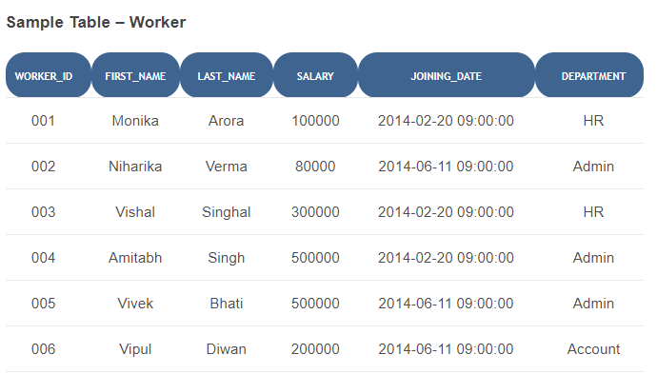

1. Write an SQL query to fetch unique values of DEPARTMENT from Worker table.
2. Write an SQL query to print the FIRST_NAME and LAST_NAME from Worker table into a single column COMPLETE_NAME. A space char should separate them.
3. Write an SQL query to print all Worker details from the Worker table order by FIRST_NAME Ascending.
4. Write an SQL query to print details of workers excluding first names, “Vipul” and “Satish” from Worker table.
5. Write an SQL query to fetch the list of employees with the same salary.
6. Write an SQL query to fetch departments along with the total salaries paid for each of them. Write an SQL query to fetch the names of workers who earn the highest salary.
7. Write an SQL query to fetch worker names with salaries >= 50000 and <= 100000.