**Business Case**

(TINF19C, SWE I Practise project 2020/2021)

***Author:*** Goran Erdeljan

***Project***: Service-Registry

***Clients***: Christian Holder & Markus Rentschler   
Rotebühplatz 41  
70178 Stuttgart

***Supplier:*** Team 3 (Daniel Baumann, Tim Diehl, Goran Erdeljan, Serdar Ilhan, Benedict Wetzel,)  
Rotebühlplatz 41  
70178 Stuttgart

Table of Contents

1. Propose and Scope 3

2. What is the usage of the Business Case? 3

3. Expected working hours 3

4. Cost Calculation 4

5. Offer price 6

# **Propose and Scope**

The goal of the project is to develop an application for an already existing Service-Registry that allows to use the DNS-SD mechanism to discover Services that aren’t already known to the Service Registry. The application should also make it possible to announce the already known Services via DNS-SD in the Network. Additionally, the new interface must be implemented and integrated into an Example project on Linux. The developed applications shall be made publicly available in form of an open-source project.

Since the already existing service registry is to be made with further functionality-related decisions, the effort required for these must be estimated.

# **What is the usage of the Business Case?**

The functionality of a business case is to get an overview of the cost amount and to analyze possible risks and their impact on the upcoming project. The results of this analysis will show if the upcoming project is profitable and consequently whether the project-conditions should be implemented.

# **Expected working hours**

Each member of the Service-Registry-Project has 180 hours available to reach the goal. Since each team member has a different work area, the time invested to the respective category may differ.

In the following you can see the rough time distribution:

|  |  |  |  |  |  |
| --- | --- | --- | --- | --- | --- |
|  | ***Goran Erdeljan (Project Manager)*** | ***Tim Diehl (Product Manager)*** | ***Benedict Wetzel (System Architect)*** | ***Serdar Ilhan (Test Manager)*** | ***Daniel Baumann (Technical Editor)*** |
| ***Analysis*** | *15* | *15* | *15* | *15* | *15* |
| ***Draft*** | *25* | *25* | *25* | *25* | *25* |
| ***Documentation*** | *30* | *35* | *25* | *25* | *35* |
| ***Programming*** | *30* | *30* | *35* | *30* | *25* |
| ***Testing*** | *25* | *30* | *30* | *35* | *30* |
| ***Meetings*** | *25* | *25* | *25* | *25* | *25* |
| ***GitHub management*** | *5* | *10* | *15* | *15* | *15* |
| ***Project management*** | *15* | *0* | *0* | *0* | *0* |
| ***Presentation*** | *10* | *10* | *10* | *10* | *10* |
| ***Total*** | ***180*** | ***180*** | ***180*** | ***180*** | ***180*** |

*Table 1: Expected working hours for each team member*

# **Gantt-Chart for working periods**

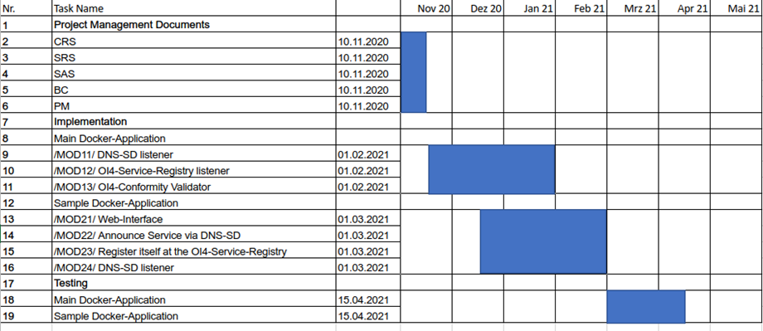

# **Cost Calculation**

Due to the Corona pandemic, each team member will be working in home office which means there is no rent for an office to pay. However, it is important that all team members are accessible via the Internet for meetings and communication in general. This means that the additional costs are about 150 euros for Internet access. The costs for the server of the service registry are about 150 Euros monthly. In special cases, it could be higher. The costs of the team members and other work packages are shown below. In addition, all team members must be technically equipped, which means that they have computers in their home in addition to Internet access. For good technical equipment you must calculate around 700 Euros per team member, so a total of 3500 Euros.

|  |  |
| --- | --- |
|  | ***Costs (in €)*** |
| ***Analysis*** | *3.495,00* |
| ***Draft*** | *5.825,00* |
| ***Programming*** | *7.170,00* |
| ***Testing*** | *7.160,00* |
| ***Documentation*** | *7.155,00* |
| ***Project management*** | *11.675,00* |
| ***Total*** | ***42.480,00*** |

*Table 2: Costs for Project*

|  |  |
| --- | --- |
|  | **Costs (€ / hour)** |
| **Project Manager** | 50,00 |
| **Product Manager** | 45,00 |
| **System Archictect** | 48,00 |
| **Test Manager** | 48,00 |
| **Technical Editor** | 42,00 |

*Table 3: Costs for Salary*

|  |  |  |  |
| --- | --- | --- | --- |
|  | ***Cost (€ / member)*** | ***Duration (in months)*** | ***Total Cost (in €)*** |
| ***Server Costs*** | *150,00* | *6* | *4.500,00* |
| ***Additional Costs*** | *150,00* | *6* | *4.500,00* |
| ***Technical Equipment*** | *700,00* |  | *3.500,00* |
| ***Total*** |  |  | ***12.500,00*** |

*Table 4: Fixed Costs*

The total cost for the project is sum for the fixed costs (**12.500,00€**) and the costs for the project itself (**42.480,00 €**). The sum is therefore **54.980,00 €**.

# **Offer price**

The following offer results from the sum of the total costs and the expected profit after completion of the project. The expected profit is 30%.

|  |  |
| --- | --- |
|  | ***Amount (in €)*** |
| ***Total cost*** | *54.980,00* |
| ***Expected win (30%)*** | *16.494,00* |
| ***Offer price*** | ***71.474,00*** |

*Table 5: Offer price*