**Software Requirements Specification**

(TINF19C, SWE I Praxisprojekt 2020/2021)

*Project: Service Registry*

*Customer: Rentschler & Holder*

*Rotebühlplatz 41*

*70178 Stuttgart*

*Supplier:* Team x (Name1, Name2, Name3, Name4, Name5)

*Rotebühlplatz 41*

*70178 Stuttgart*

|  |  |  |  |
| --- | --- | --- | --- |
| **Version** | **Date** | **Author** | **Comment** |
| 0.1 | 07.09.2020 |  | created |
|  |  |  |  |
|  |  |  |  |
|  |  |  |  |
|  |  |  |  |
|  |  |  |  |
|  |  |  |  |
|  |  |  |  |

# **1. Introduction**

The goal of the project is to add service discovery functionalities to the existing Oi4-Service-Registry, developed by the OI4-Alliance. To be added features are the registration of devices, which are announced via DNS-SD but also to take the services, which are already registered at the OI4-Service-Registry and announce them to the network using the DNS-SD mechanism. These features shall be implemented in an application running in a Docker-Container. The project shall also contain a Docker-Application for testing the functionalities of the system.

# **2. System Overview**

## **2.1 System Environment**

The Project shall be run on any server or computer in a Industry 4.0 environment. In this environment there may be any number of devices, which offer services over a network. These services shall either announce themselves using the DNS-SD mechanism or be directly connected to the OI4-MessageBus running on the MQTT-Broker.

## **2.2 Software Environment**

All parts of the project shall run in Docker-Containers. The software will be implemented using NodeJS. Therefore the Docker-Containers will be based on the 'node'-Docker-Image. It is also required that the OI4-Service-Registry is running on the same Network. To communicate with the registry the network shall also contain a MQTT-Broker like 'Mosquitto'.

## **2.3 Hardware Environment**

The Project shall be run on any server or computer running docker. Preferably the system shall run a distribution of Linux.

## **2.4 Quality Goals**

### **2.4.1 Maintainability**

As the system is split into multiple Docker-Container each one of them can be easily replaced. The application shall be highly configurable and be documented in an extensive user guide, making it easy to adapt and maintain.

### **2.4.2 Efficiency**

The system will work in real-time. Therefore it doesn't require persisting data between sessions. This opens up the possibility of a very lightweight approach and allows the system to work without any dedicated storage, except for the program itself.

### **2.4.3 Portability**

Utilising the Containering provided by Docker shall make the system easily portable to any computer capable of running Docker-Containers.

# **3. Architectural Concept**

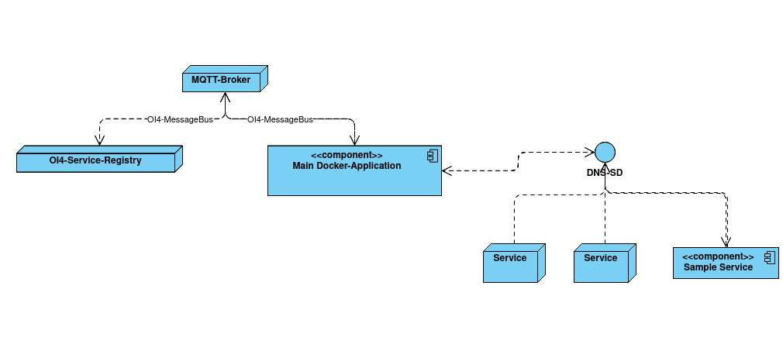 The project consists of two main parts: the Docker-Container connecting the DNS-SD mechanism with the OI4-Service-Registry and the Docker-Container, which tests and showcases the functionalities of the system. To realize a working system, there need to be other applications running in the environment. These are the OI4-Service-Registry developed by the OI4-Alliance and a MQTT-Broker on which the communication with the OI4-Service-Registry takes place. The communication using the MQTT-Protocoll is specified by the OI4-Alliance.

Conceptually the main Docker-Container is just another MQTT-Client. The OI4-Service-Registry also acts as a MQTT-Client. Both communicate with each other over the MQTT-Broker. In most cases the MQTT-Broker of choice will be Eclipse-Mosquitto, as it is available as a Docker-Image and therefore easy to deploy. All Communication over MQTT must be conform with the specifications published by the OI4-Alliance. In the context of the systems specified by the OI4-Alliance this way of communicating is called the OI4-MessageBus. Services can use the MessageBus to be registered at the OI4-Service-Registry. The Test Application shall also be able to connect to the MessageBus, if it is configured to register itself at the OI4-Service-Registry.

The DNS-SD mechanism on the other hand is used to announce important information about a service in the network. It is not limited to services, which are part of the OI4-ecosystem. In this use-case it is not only used to announce the services registered at the Service-Registry, but if configured to, also collect information about not yet registered services, which may announce themselves to the network and register them at the OI4-Service-Registry.

## **3.1 Architectural Model**

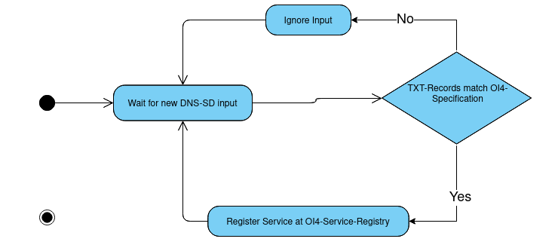 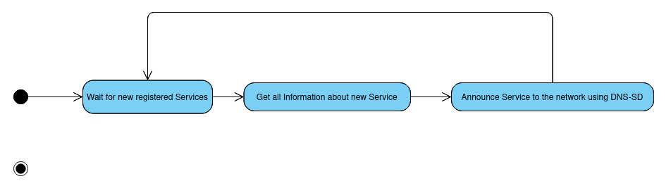 The diagrams above show the two main activities the main Docker-Application performs.

The main Docker-Application consists of multiple functions, which can be categorized, depending on the feature they are part of. The features they implement are: Receiving DNS-SD entries and forwarding them to the OI4-Registry, Checking conformity of data before sending it to the OI4-Registry, Announcing Services registered at the OI4-Service-Registry via DNS-SD. As the Application is written in NodeJS it will mostly be a event-based software-architecture reacting to new DNS-SD entries or new services registered at the OI4-Service-Registry.

The Test-Application will also be implemented in NodeJS. It will have somewhat of a data layer consisting of information about the current configuration but also contain a list of current DNS-SD entries being announced over the network. There will also be a layer announcing the Test-Application either using DNS-SD or registering it directly via the OI4-MessageBus, depending on configuration. This and other options can be configured using the environment-variables of the Docker-Container. The information about current DNS-SD entries is updated based on events thrown by the node module 'mdns'. The web-interface then periodically reads these entries from the data-layer and displays them.

# **4. Subsystem Specifications**

## **4.2 /MOD10/ DNS-SD to OI4-Service-Registry Interface**

### **4.2.1 /MOD11/ DNS-SD listener**

|  |  |
| --- | --- |
| **/MOD11/** | **DNS-SD listener** |
| System requirements covered | LF10 |
| Service | Listens to DNS-SD entries on the network and registers them at the OI4-Service-Registry |
| Interfaces | DNS-SD, OI4-MessageBus |
| External Data | - |
| Storage Location | - |
| Open points | - |

### **4.2.2 /MOD12/ OI4-Service-Registry listener**

|  |  |
| --- | --- |
| **/MOD12/** | **OI4-Service-Registry listener** |
| System requirements covered | LF20 |
| Service | Listens to changes in services registered at the OI4-Service-Registry and announces them to the network using DNS-SD |
| Interfaces | DNS-SD, OI4-MessageBus |
| External Data | - |
| Storage Location | - |
| Open points | - |

### **4.2.3 /MOD13/ OI4-Conformity Validator**

|  |  |
| --- | --- |
| **/MOD13/** | **OI4-Conformity Validator** |
| System requirements covered | LF60 |
| Service | This module shall be used, when registering services at the OI4-Service-Registry to ensure that the OI4-Specifications are met |
| Interfaces | DNS-SD, OI4-MessageBus |
| External Data | - |
| Storage Location | - |
| Open points | - |

## **4.3 /MOD20/ Test Application**

### **4.3.1 /MOD21/ Web-Interface**

|  |  |
| --- | --- |
| **/MOD21/** | **Web-Interface** |
| System requirements covered | LF50 |
| Service | Show all services discovered using DNS-SD |
| Interfaces | Data-Layer, Web-Interface |
| External Data | - |
| Storage Location | - |
| Open points | - |

### **4.3.2 /MOD22/ Announce Service via DNS-SD**

|  |  |
| --- | --- |
| **/MOD22/** | **Announce Service via DNS-SD** |
| System requirements covered | LF30 |
| Service | Announce itself to the network using DNS-SD |
| Interfaces | DNS-SD |
| External Data | - |
| Storage Location | - |
| Open points | - |

### **4.3.3 /MOD23/ Register itself at the OI4-Service-Registry**

|  |  |
| --- | --- |
| **/MOD23/** | **Register itself at the OI4-Service-Registry** |
| System requirements covered | LF40 |
| Service | Register the Test-Application at the OI4-Service-Registry |
| Interfaces | OI4-MessageBus |
| External Data | - |
| Storage Location | - |
| Open points | - |

### **4.3.4 /MOD24/ DNS-SD listener**

|  |  |
| --- | --- |
| **/MOD24/** | **DNS-SD listener** |
| System requirements covered | LF50 |
| Service | Listen to DNS-SD entries on the network and syve them to the data-layer |
| Interfaces | Data-Layer, DNS-SD |
| External Data | - |
| Storage Location | - |
| Open points | - |

# **5. Technical Concepts**

## **5.1 Communication with other IT-Systems**

The main Docker-Container shall communicate with the OI4-Service-Registry and use DNS-SD to receive information about previously unknown services. It shall also use DNS-SD to announce services, that are registered at the OI4-Service-Registry, to the network. The Docker-Container for testing purposes shall use DNS-SD to announce itself to the system and use DNS-SD to list all available services in the network.

## **5.2 Deployment**

The Docker-Images used to create the Docker-Containers can be built from the source-code or downloaded via the 'docker-hub'.

## **5.3 Data Validation**

The system shall validate whether the data it receives is conform with the specifications published by the OI4-Alliance and only use valid data.

## **5.4 Exception Handling**

Exceptions shall be logged to the console. If the Exceptions are fatal, the system shall restart to maximize availability.

## **5.5 Logging**

All main events shall be logged to the console. The output on the console could be directed to a file.

## **5.6 Configurability**

Both Docker-Containers shall be able to be configured using environment-variables, these are easily set when starting a Docker-Container or when inside a 'docker-compose' file.

## **5.7 Internationalization**

All documentation and commenting in the source-code shall be done in English, ensuring maximum internationalization.

## **5.8 Testability**

The system will be tested in different environments covering a number of scenarios.

## **5.9 Availability**

Running in a Docker-Container ensures that the application can be restarted instantly if it stops running. All other forms of unavailability will probably arise because of problems in other parts of the environment.

# **6. References**