

PROJECT MANUAL

**Project: Service-Registry Team 4**

Course: Software-Engineering

Class: TINF19C

Professor: Markus Rentschler, Christian Holder

Project manager: Goran Erdeljan

Team members: Daniel Baumann

Tim Diehl

Goran Erdeljan

Serdar Ilhan

Benedict Wetzel

Version: PHB 2.0, Mai 2016

**Contents**

1 Table of Revision 4

2 Project assignment 5

3 Project Objectives Plan 6

4 Project Context 7

5 Project Organization 8

6 Work Breakdown Structure 8

7 Milestones 10

8 GANTT-Chart 11

9 Project Risks 12

# Table of Revision

|  |  |  |  |
| --- | --- | --- | --- |
| **Table of Revision** | | | |
| **Version number** | **Date** | **Comment** | **Author** |
| 0v1 | 8.11.2020 | created | Benedict Wetzel |
|  |  |  |  |
|  |  |  |  |

# Project assignment

|  |  |
| --- | --- |
| **Project assignment** | |
| Project Objective (Output):  Development of a Docker-Application, that provides an interface between the DNS-SD mechanism and the OI4-Service-Registry, enabling registration of services discovered using DNS-SD at the OI4-Service-Registry and can announce registered services using DNS-SD. Added to that an exemplary Docker-Application shall be developed, which showcases all implemented functionalities. | Non-Objectives:  The Service-Registry itself shall not be part of the project. |
| Project Benefits (Outcome):  The to be added functionalities shall make it easier to discover and register services, which will improve the effectiveness of the Service-Registry. | |
| Client: Markus Rentschler, Christian Holder | Project Manager: Goran Erdeljan |
| Team Members:   * Daniel Baumann * Tim Diehl * Goran Erdeljan * Serdar Ilhan * Benedict Wetzel | Other involved people: - |
| Main Tasks:   * Project files: CRS, SRS, SAS, … * Architectural Design * Implementation * Testing * User-Documentation | Milestones:   * Project files finished * First Presentation * Architectural Design finished * Implementation done * Testing successful * Project Completion |
| Project-Start-Event: Project assignments in lecture | Project-Start-Date: 11.09.2020 |
| Project-End-Event: Final Presentation | Project-End-Date: |

# Project Objectives Plan

|  |  |
| --- | --- |
| **Type of Objective** | **Project Objectives** |
| **Project Objective (Output):** | Development of a Docker-Application, that provides an interface between the DNS-SD mechanism and the OI4-Service-Registry, enabling registration of services discovered using DNS-SD at the OI4-Service-Registry and can announce registered services using DNS-SD. Added to that an exemplary Docker-Application shall be developed, which showcases all implemented functionalities. |
| **Sub-Objectives:** | Project files and presentation:   * CRS, SRS, SAS, BC and Project manual * First presentation * MODs, STP, STR * Final presentation   Main Docker-Application   * DNS-SD listener * Service-Registry listener * OI4-Conformity-Validator   Exemplary Docker-Application:   * Register itself at the Service-Registry using the OI4-Service-Registry * Announce itself using DNS-SD * Listing discovered Devices   User-Documentation:   * Explain all functionalities * Installation Guide |
| **Project Benefits (Outcome):** | The to be added functionalities shall make it easier to discover and register services, which will improve the effectiveness of the Service-Registry. |

# Project Context

|  |
| --- |
| **Initial Situation** |
| Services can be registered at the OI4-Service-Registry using the OI4-MessageBus. There is no DNS-SD functionality built in. |

|  |  |
| --- | --- |
| **Temporal Project Context** | |
| **Pre-Project-Phase** | **Post-Project-Phase** |
| * OI4-Service-Registry has been developed by the OI4-Alliance | - |

|  |  |
| --- | --- |
| **Factual Context** | |
| **Context** | **Required Measures** |
| Dependence on OI4-Service-Registry | The implementation and documentation of the OI4-Service-Registry must be available to the team members |

|  |  |  |  |
| --- | --- | --- | --- |
| **Social Context** | | | |
| **Social Group** | **Chances** | **Risks** | **Measures** |
| Clients | Satisfied with the result | Changes in the requirements during development | As much communication as needed, for clear definitions of requirements |
| User | Uses the System | Does not understand the provided documentation or needs more documentation | Concentrate on making the Documentation as clear as possible |

# Project Organization

|  |  |  |
| --- | --- | --- |
| **Project Organization** | | |
| **Role** | **Description** | **Names** |
| Project client | * Client | Markus Rentschler, Christian Holder |
| Project manager | * Project Manager | Goran Erdeljan |
| Team members | * Product Manager * System Architect * Test Manager * Technical Editor | Daniel Baumann, Tim Diehl, Serdar Ilhan, Benedict Wetzel |

# Work Breakdown Structure

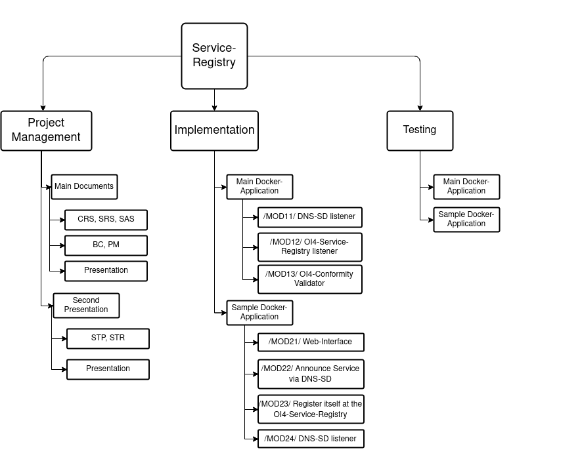

# Milestones

|  |  |  |  |
| --- | --- | --- | --- |
| **Milestone Plan** | | | |
| **PSP-Code** | **Milestone-Name** | **PLAN-Date** | **ACTUAL-Date** |
| **0.0** | **Project Management Documents** |  |  |
| 0.1 | CRS | 10.11.2020 |  |
| 0.2 | SRS | 10.11.2020 |  |
| 0.3 | SAS | 10.11.2020 |  |
| 0.4 | BC | 10.11.2020 |  |
| 0.5 | PM | 10.11.2020 |  |
| **1.0** | **Implementation** |  |  |
| 1.1 | Main Docker-Application |  |  |
| 1.1.1 | /MOD11/ DNS-SD listener | 01.02.2021 |  |
| 1.1.2 | /MOD12/ OI4-Service-Registry listener | 01.02.2021 |  |
| 1.1.3 | /MOD13/ OI4-Conformity Validator | 01.02.2021 |  |
| 1.2 | Sample Docker-Application |  |  |
| 1.2.1 | /MOD21/ Web-Interface | 01.03.2021 |  |
| 1.2.2 | /MOD22/ Announce Service via DNS-SD | 01.03.2021 |  |
| 1.2.3 | /MOD23/ Register itself at the OI4-Service-Registry | 01.03.2021 |  |
| 1.2.4 | /MOD24/ DNS-SD listener | 01.03.2021 |  |
| **2.0** | **Testing** |  |  |
| 2.1 | Main Docker-Application | 01.04.2021 |  |
| 2.2 | Sample Docker-Application | 01.04.2021 |  |

# GANTT-Chart

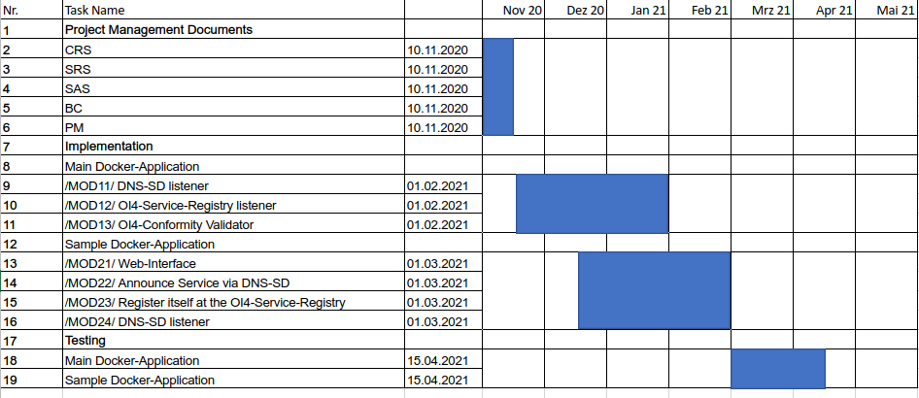

# Project Risks

|  |  |  |  |
| --- | --- | --- | --- |
| **Risk-Analysis** | | | |
| **Risk** | **Probability** | **Effects** | **Measures** |
| A teammember might leave the project | Low | Other teammembers have to do more work, project might not be finished on time or may not be of desired quality | Fair distribution of workloads, not being dependent on just one teammember, all project-data shall be accessible for everyone |
| Miscommunication with client | Medium | Final product might not satisfy client | Constant communication with client and presenting parts of the project during development |
| Financial risks | Low | Project might be more expensive than planned | Good planning and concentrating on main tasks first |
| Time risks | Low | Project might take longer than planned | Good planning and big buffers to manage the risk |