Design an Entity-Relationship diagram :

1. Library Management System
2.Online shopping System
3.College management System
4.Student Registration System
5. Ticket booking System

- Library Management System

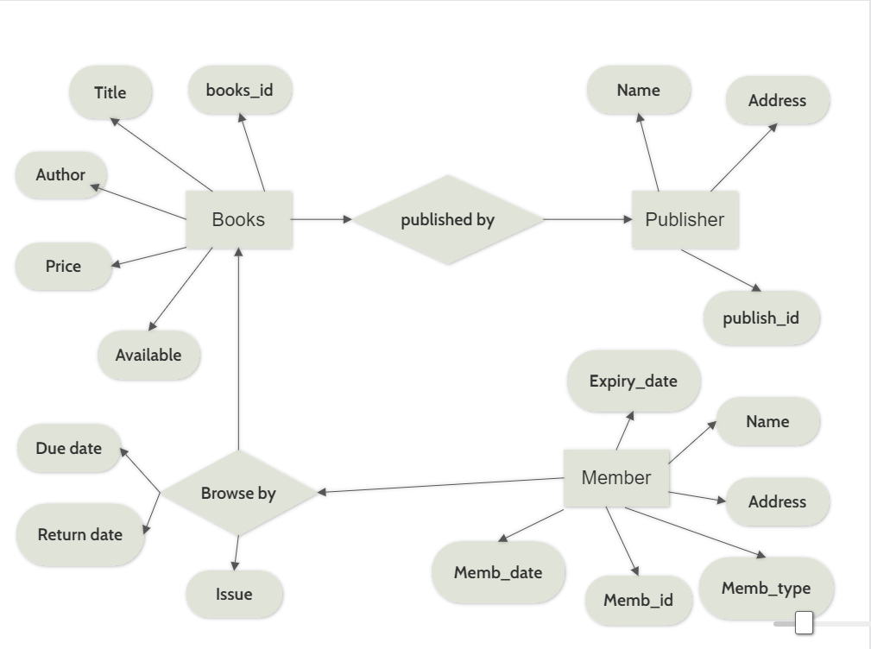

- Online Shopping System

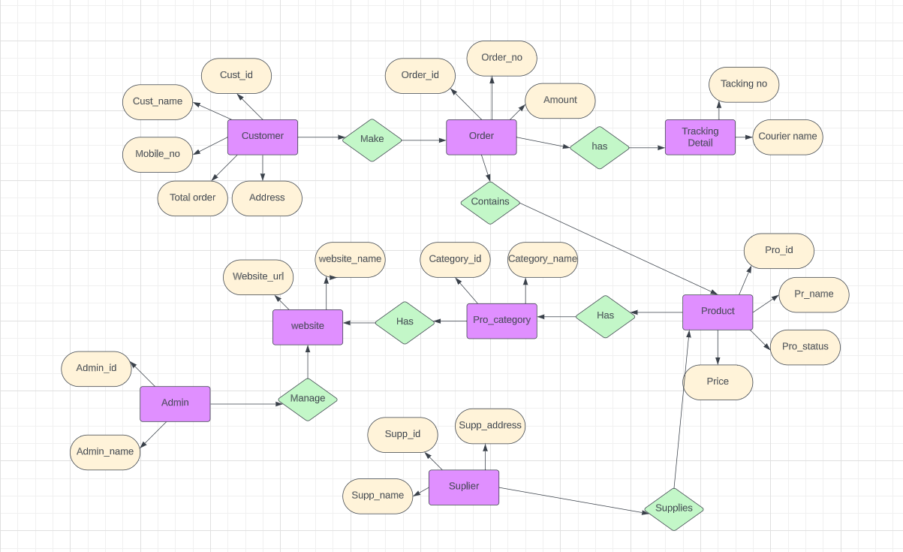

- College Management System

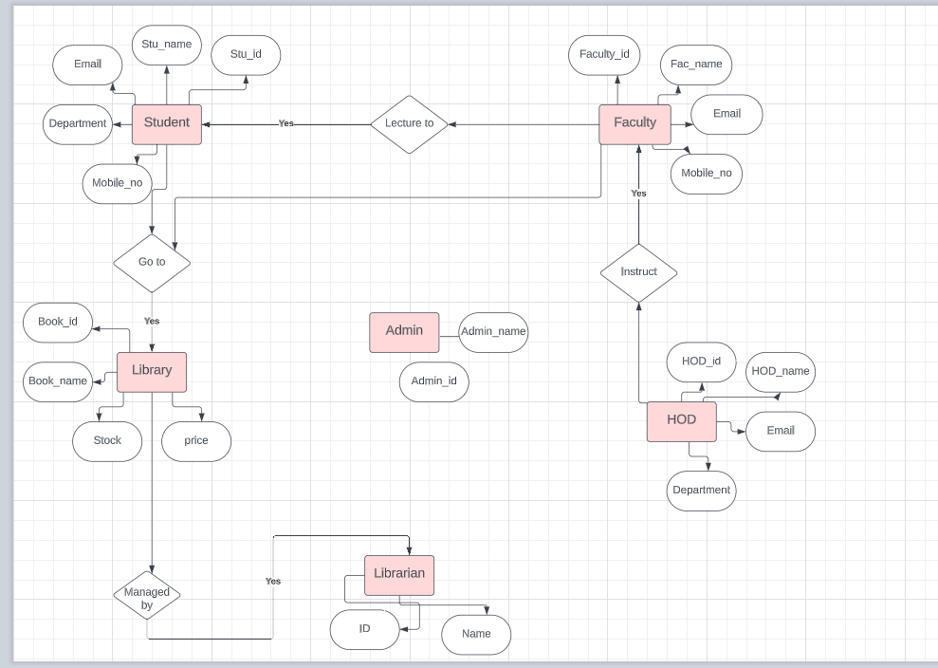

- Student Registration System

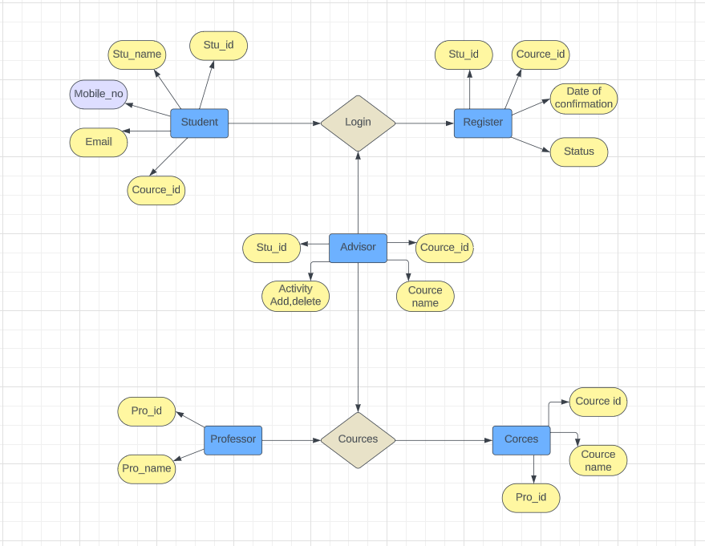

- Ticket Booking System

