1. Describe & perform following UNIX command with example.
(1) login
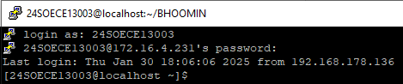
(2) passwd
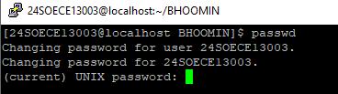
(3) cal
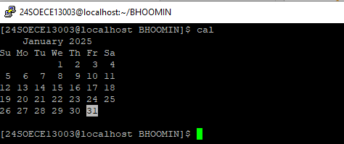
(4) pwd
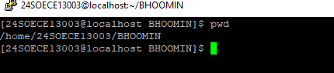
(5) logout
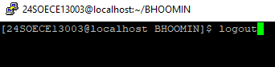
(6) bc
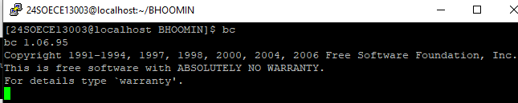
(7) cat
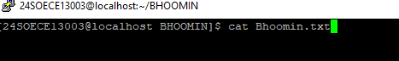

(8) mkdir
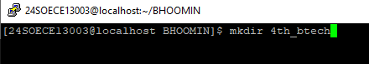
(9) cd
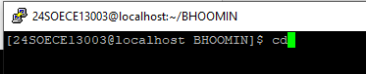
(10) cd ..
(11) rmdir

(12) ls
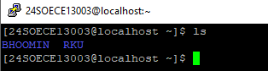
(13) cat >
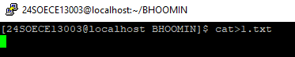
(14) man
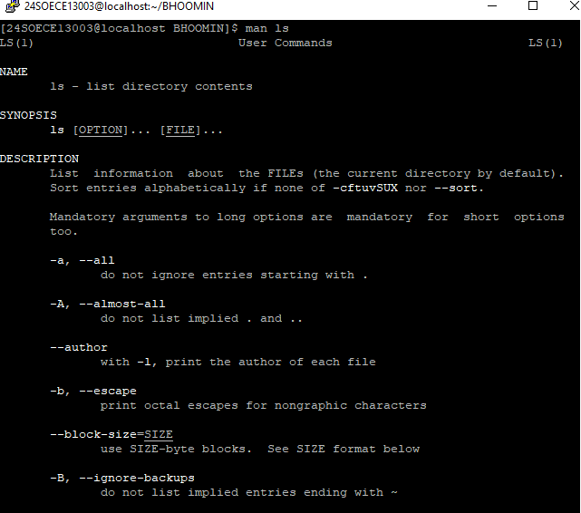

(15) touch
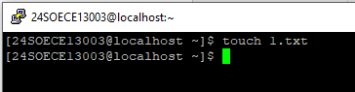
(16) who
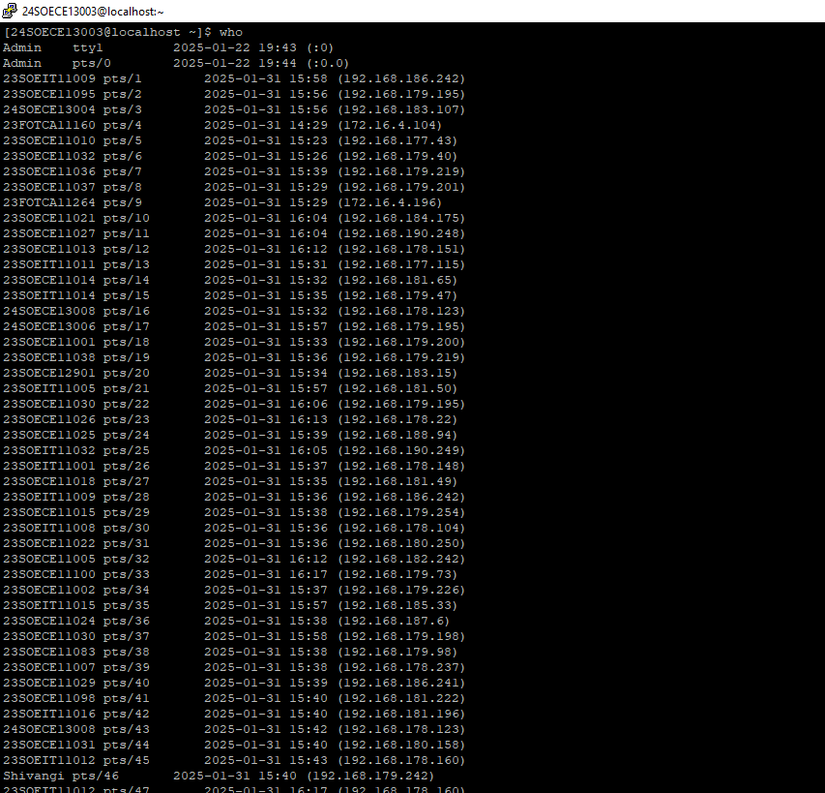

(17) who am I
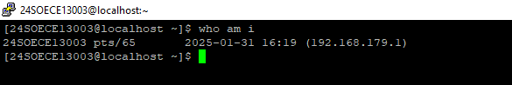
(18) clear
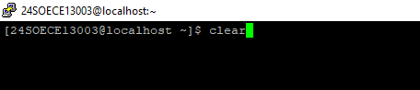
(19) dir
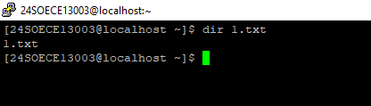

2. Using a Directory related UNIX commands, design appropriate directory tree structure.
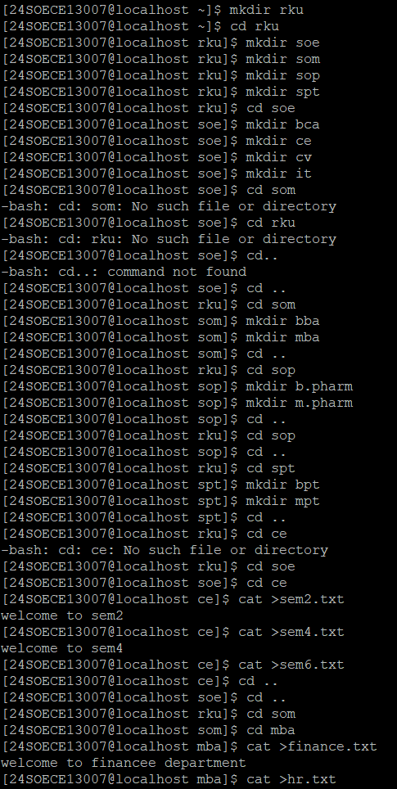
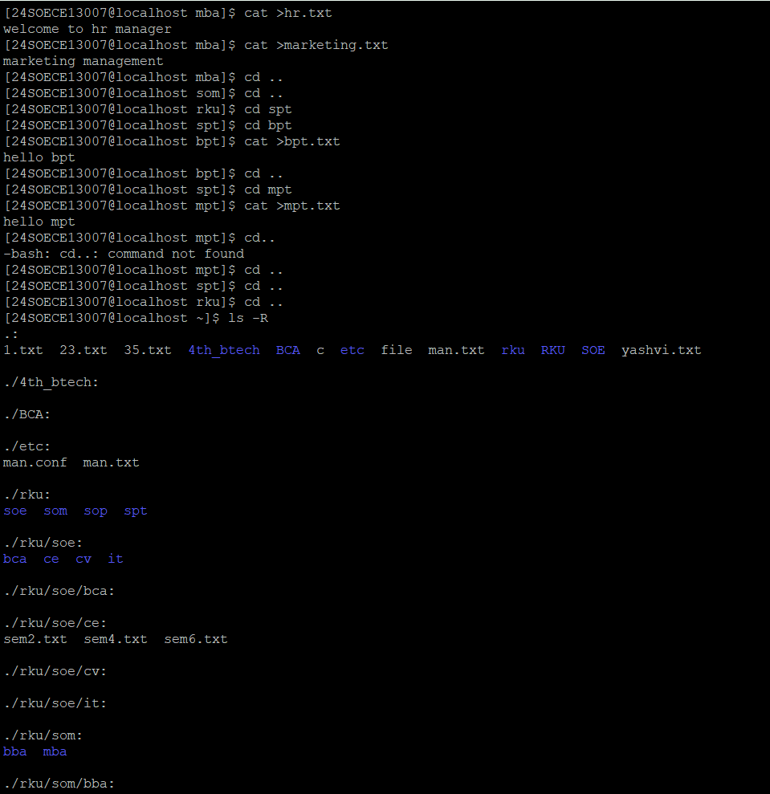
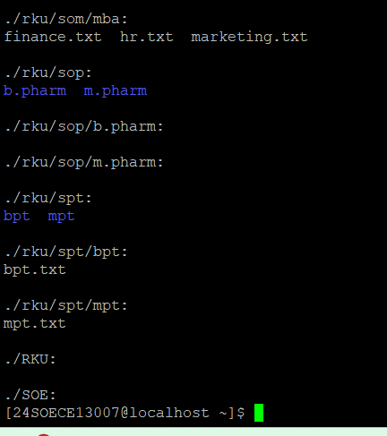

3. Perform following UNIX commands with its parameter.
(1) LS – l
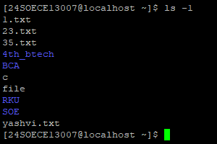
(2) chmod

(3) chown
(4) mv
(5) cp
(6) wc
(7) umask
(8) factor
(9) ln
(10)head
(11)tail
(12) more
(13) less
(14) pg
(15)chgrp
16) LS -a
17) ls -al
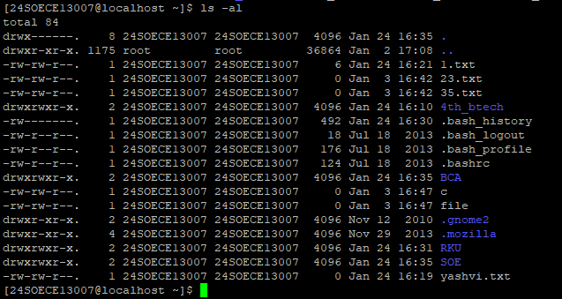
18)ls -lh
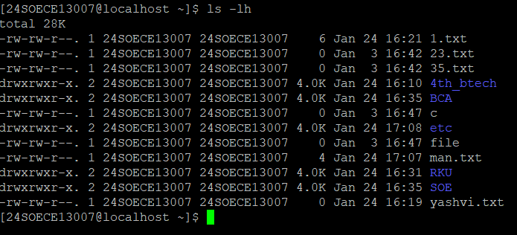
19) ls -r
20)ls -ltr
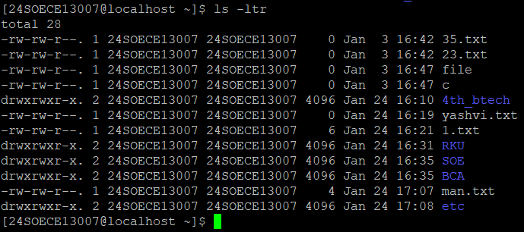
21) ls -ls
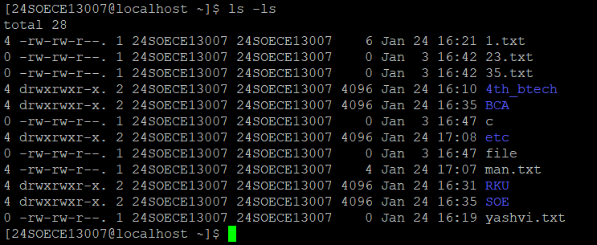
22)version
23)ls -l /tmp
24) cat -n filename
25) cat -e filename
26)cat -T filename
27) Display multiple files at once
28)Use append operator(>>)
29) use (>) redirection operator
30)sort

