# Multi Agent Systems - Question 3

* 1. The query we used to find the grounded set is ‘grounded((free6pm_b, _)).’ with the result being ‘yes’.

In addition we also ran the query ‘grounded(X)’ where X is bound to the result in the form of (claim, [argument]). The resulting grounded set is:

X = (free6pm_a,[free6pm_a]) ? ;

X = (free6pm_b,[free6pm_b]) ? ;

X = (free8am_b,[free8am_b]) ? ;

X = (child_a,[child_a]) ? ;

X = (overweight_b,[overweight_b]) ? ;

X = (not_get8am_a,[not_get8am_a]) ? ;

X = (not_free8am_a,[child_a]) ? ;

X = (not_sports_b,[overweight_b]) ? ;

However we do encounter infinite looping when running this query.

* 1. SXDD confirms that free6pm(b) belongs to the grounded extension.

The table below shows the AB dispute table for free6pm(b). The next page shows the dispute in diagrammatic form.

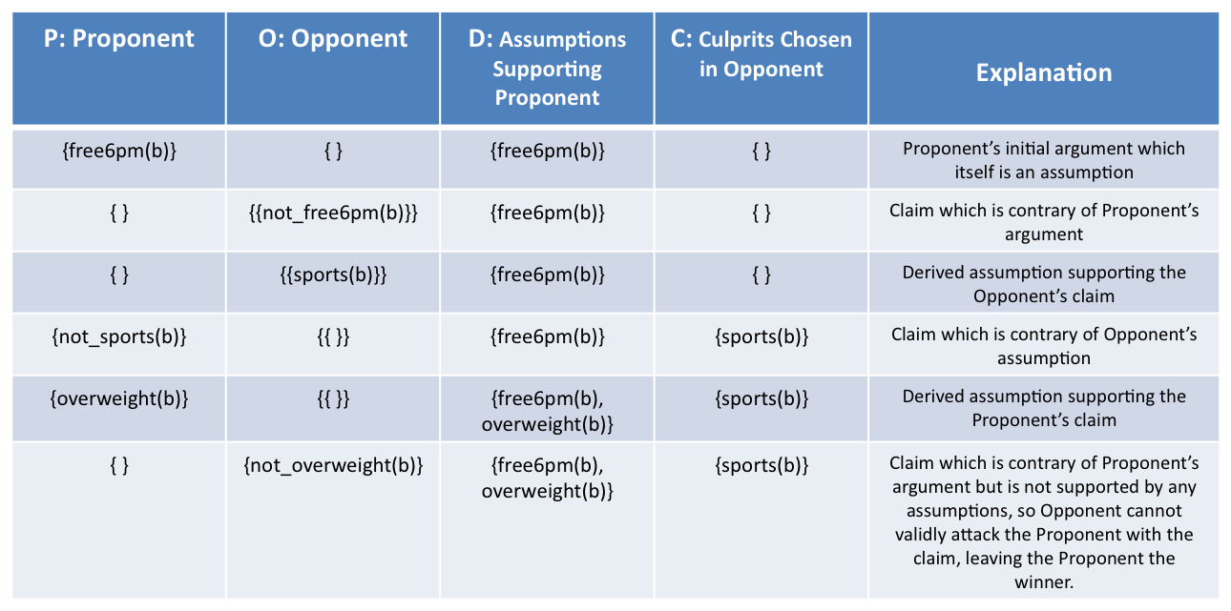

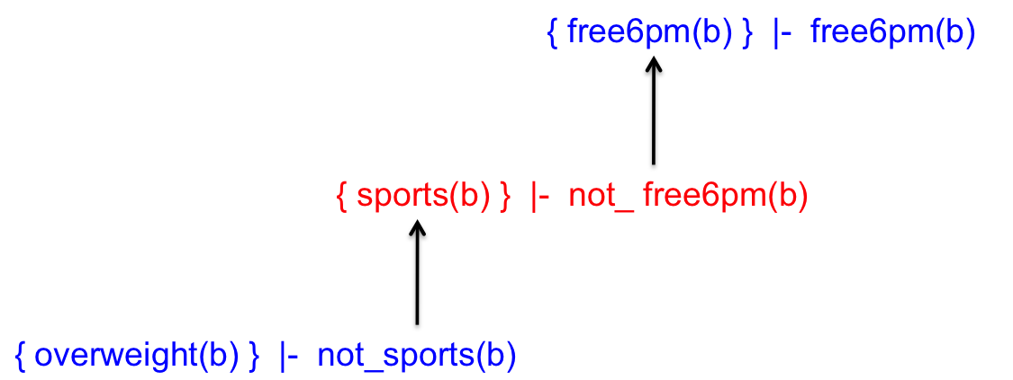

* 1. Looking at our results (and using proxdd) we have confirmed that free8am(b), free6pm(a) and free6pm(b) all belong to the grounded set. This means that free8am(a) does not belong to the grounded set. In addition, the grounded extension says that not_get8am(a) is in the grounded set, meaning Anne (a) cannot get the 8am appointment and therefore she will get the 6pm appointment and Boris (b) will get the 8am appointment.

For stable semantics, a stable set is defined as the set of arguments that does not attack itself and attacks everything not in the set. In our stable set, we can have either get6pm(a) and get8am(b) or get6pm(b) and get8am(a) in the stable set. This is because get6pm(a) is attacked by get8am(a) and get6pm(b) and similarly for the other rules. However get6pm(b) and get8am(a) cannot be in the stable set as get8am(a) is attacked by child(a) which is grounded and not attacked by anything other arguments. Therefore the stable set must contain get6pm(a) and get8am(b) and therefore strongly infers that Anne (a) gets the 6pm appointment and Boris (b) gets the 8am appointment. Using aspartix also confirms that the stable set contains the above two claims.

In addition there is another stable set, which has get6pm(b) but has no other ‘get’ claims/arguments. Get8am(a) is not in the stable set due to child(a). This is possible but leaves Anne with no appointment and Boris with the 6pm appointment.