MOC

Mestna občina Celje  
  
Konfiguracija 2024-02-23

Site: MOC

|  |  |
| --- | --- |
|  |  |
| Number of devices: | 1 |
| Address: | Trg celjskih knezov 9 |
| Post Code: | 3000 |
| City: | Celje |
| Country: | Slovenia |
| Longitude: | 15.26139 |
| Latitude: | 46.22953 |
| AP: | MOC AP-IT |

AP: MOC AP-IT

|  |  |  |  |  |  |  |  |  |  |  |  |  |  |  |  |  |  |  |  |  |  |  |  |  |  |  |  |  |  |  |  |  |  |  |  |  |  |  |  |  |  |  |  |  |  |  |  |  |  |  |  |  |  |
| --- | --- | --- | --- | --- | --- | --- | --- | --- | --- | --- | --- | --- | --- | --- | --- | --- | --- | --- | --- | --- | --- | --- | --- | --- | --- | --- | --- | --- | --- | --- | --- | --- | --- | --- | --- | --- | --- | --- | --- | --- | --- | --- | --- | --- | --- | --- | --- | --- | --- | --- | --- | --- | --- |
| |  |  | | --- | --- | | Parameter | Value | | Site: | MOC | | AP Group: | Tehnopark | | AP Model: | 515 | | Serial No: | CNLGKD5FY4 | | Labels: | ['SMJ MOC mreža', 'Tehnopark'] | | MAC address: | fc:7f:f1:c4:06:5a | | Mesh role: | Unknown | | IP address: | 172.16.57.25 | | Public IP address: | 91.132.73.130 | | Firmware version: | 10.5.0.1_88128 | | SSID count: | 3 | | RF zone: | 0 | | |  |  | | --- | --- | | Radio | Parameter | | Radio 0: | |  |  | | --- | --- | | macaddr: | fc:7f:f1:c0:65:b0 | | radio_name: | Radio 5 GHz | | radio_type: | 802.11ax | | spatial_stream: | 4x4:4 | | tx_power: | 24 | | | Radio 1: | |  |  | | --- | --- | | macaddr: | fc:7f:f1:c0:65:a0 | | radio_name: | Radio 2.4 GHz | | radio_type: | 802.11ax | | spatial_stream: | 2x2:2 | | tx_power: | 12 | | |

Notes:

Location:

Configuration

version 10.5.0.0-10.5.0  
virtual-controller-country us  
virtual-controller-key d1527d9801af0b186e53f203d473043761a57dc67475f7ce40  
name Tehnopark  
terminal-access  
ntp-server 193.77.204.19  
clock timezone Ljubljana 01 00  
clock summer-time CEST recurring last sunday march 00:00 last sunday october 03:00  
rf-band all  
  
  
  
  
rf dot11a-radio-profile  
 max-tx-power 24  
 min-tx-power 18  
  
rf dot11a-secondary-radio-profile  
 max-tx-power 24  
 min-tx-power 18  
  
rf dot11-6ghz-radio-profile  
 allowed-channels 1,5,9,13,17,21,25,29,33,37,41,45,49,53,57,61,65,69,73,77,81,85,89,93  
  
  
syslog-level warn ap-debug   
syslog-level warn network   
syslog-level warn security   
syslog-level warn system   
syslog-level warn user   
syslog-level warn user-debug   
syslog-level warn wireless   
  
  
  
  
iot radio-profile BLE_Console  
 radio-mode ble  
 ble-console dynamic  
  
  
  
vlan-name Tehnopark  
vlan-name TP-WiFi-public  
vlan Tehnopark 58  
vlan TP-WiFi-public 59  
  
  
  
  
  
  
  
  
  
  
  
  
  
  
  
hash-mgmt-password  
hash-mgmt-user admin password hash 39594e9202bb0b9865da41125f5d0aa624e14b0e14b08f7fbbf6e7e4afcabe137342e5f586  
  
  
wlan access-list route "default policy"  
 index 0  
 rule any any any any match any any any redirect cluster  
  
wlan access-rule default_wired_port_profile  
 index 0  
 rule any any match any any any permit  
 airslice-application-list zoom slack skype webex gotomeeting office365 dropbox amazon-aws github ms-teams  
 monitoring-application-list zoom slack skype webex gotomeeting office365 dropbox amazon-aws github ms-teams  
  
wlan access-rule wired-SetMeUp  
 index 1  
 rule masterip 0.0.0.0 match tcp 80 80 permit  
 rule masterip 0.0.0.0 match tcp 4343 4343 permit  
 rule any any match udp 67 68 permit  
 rule any any match udp 53 53 permit  
 airslice-application-list zoom slack skype webex gotomeeting office365 dropbox amazon-aws github ms-teams  
 monitoring-application-list zoom slack skype webex gotomeeting office365 dropbox amazon-aws github ms-teams  
  
wlan access-rule "Celje WiFi"  
 utf8  
 index 2  
 rule any any match any any any permit  
 airslice-application-list zoom slack skype webex gotomeeting office365 dropbox amazon-aws github ms-teams  
 monitoring-application-list zoom slack skype webex gotomeeting office365 dropbox amazon-aws github ms-teams  
  
wlan access-rule Tehnopark  
 utf8  
 index 3  
 rule any any match any any any permit  
 airslice-application-list zoom slack skype webex gotomeeting office365 dropbox amazon-aws github ms-teams  
 monitoring-application-list zoom slack skype webex gotomeeting office365 dropbox amazon-aws github ms-teams  
  
wlan access-rule "Celje Centralka_#guest#_"  
 index 4  
 captive-portal external profile "Celje Centralka_#guest#_"  
 rule alias licdn.com match tcp 443 443 permit  
 rule alias twimg.com match tcp 443 443 permit  
 rule alias bam.nr-data.net match tcp 443 443 permit  
 rule alias js-agent.newrelic.com match tcp 443 443 permit  
 rule alias symcb.com match tcp 80 80 permit  
 rule alias symcd.com match tcp 80 80 permit  
 rule alias digicert.com match tcp 80 80 permit  
 rule alias centralka.si match tcp 443 443 permit  
 rule alias centralka.celje.si match tcp 443 443 permit  
 airslice-application-list zoom slack skype webex gotomeeting office365 dropbox amazon-aws github ms-teams  
 monitoring-application-list zoom slack skype webex gotomeeting office365 dropbox amazon-aws github ms-teams  
  
wlan access-rule "Centralka wifi"  
 utf8  
 index 5  
 rule any any match any any any permit  
 airslice-application-list zoom slack skype webex gotomeeting office365 dropbox amazon-aws github ms-teams  
 monitoring-application-list zoom slack skype webex gotomeeting office365 dropbox amazon-aws github ms-teams  
  
wlan access-rule "Centralka page_#guest#_"  
 index 6  
 captive-portal external profile "Centralka page_#guest#_"  
 rule alias licdn.com match tcp 443 443 permit  
 rule alias twimg.com match tcp 443 443 permit  
 rule alias bam.nr-data.net match tcp 443 443 permit  
 rule alias js-agent.newrelic.com match tcp 443 443 permit  
 rule alias symcb.com match tcp 80 80 permit  
 rule alias symcd.com match tcp 80 80 permit  
 rule alias digicert.com match tcp 80 80 permit  
 rule alias celje.si match tcp 443 443 permit  
 rule alias centralka.si match tcp 443 443 permit  
 airslice-application-list zoom slack skype webex gotomeeting office365 dropbox amazon-aws github ms-teams  
 monitoring-application-list zoom slack skype webex gotomeeting office365 dropbox amazon-aws github ms-teams  
  
wlan ssid-profile "Celje WiFi"  
 enable  
 index 0  
 type guest  
 essid "Celje WiFi"  
 utf8  
 opmode enhanced-open  
 max-authentication-failures 0  
 vlan 59  
 auth-server AS1_#guest#_  
 auth-server AS2_#guest#_  
 set-role-pre-auth "Celje Centralka_#guest#_"  
 rf-band all  
 captive-portal external profile "Celje Centralka_#guest#_"  
 mac-authentication  
 mac-authentication-delimiter :  
 mac-authentication-upper-case  
 dtim-period 1  
 broadcast-filter arp  
 deny-intra-vlan-traffic  
 enforce-dhcp  
 radius-accounting  
 radius-interim-accounting-interval 5  
 g-min-tx-rate 12  
 a-min-tx-rate 12  
 multicast-rate-optimization  
 dynamic-multicast-optimization  
 dmo-channel-utilization-threshold 90  
 local-probe-req-thresh 0  
 max-clients-threshold 64  
 dot11k  
 rrm-quiet-ie  
 mfp-capable  
 ftm-responder-enable  
  
wlan ssid-profile Tehnopark  
 enable  
 index 1  
 type employee  
 essid Tehnopark  
 utf8  
 wpa-passphrase dee00b3fdfd9444173fee46738cd09477bff0302a64c94aa  
 opmode wpa3-sae-aes  
 max-authentication-failures 0  
 vlan 58  
 auth-server InternalServer  
 rf-band all  
 captive-portal disable  
 dtim-period 1  
 broadcast-filter arp  
 g-min-tx-rate 12  
 a-min-tx-rate 12  
 multicast-rate-optimization  
 denylist  
 dynamic-multicast-optimization  
 dmo-channel-utilization-threshold 90  
 local-probe-req-thresh 0  
 max-clients-threshold 64  
 dot11k  
 rrm-quiet-ie  
 ftm-responder-enable  
  
wlan ssid-profile "Centralka wifi"  
 disable  
 index 2  
 type guest  
 essid "Centralka wifi"  
 utf8  
 opmode enhanced-open  
 max-authentication-failures 0  
 vlan TP-WiFi-public  
 auth-server AS1_#guest#_  
 auth-server AS2_#guest#_  
 set-role-pre-auth "Centralka page_#guest#_"  
 rf-band all  
 captive-portal external profile "Centralka page_#guest#_"  
 dtim-period 1  
 broadcast-filter none  
 deny-intra-vlan-traffic  
 radius-accounting  
 radius-interim-accounting-interval 5  
 dmo-channel-utilization-threshold 90  
 local-probe-req-thresh 0  
 max-clients-threshold 1024  
 dot11k  
 rrm-quiet-ie  
  
auth-survivability cache-time-out 24  
  
  
  
  
  
  
dpi  
  
wlan auth-server AS1_#guest#_  
 radsec  
 ip euw1.cloudguest.central.arubanetworks.com  
 port 1812  
 acctport 1813  
 timeout 20  
 nas-id 06788da1-0280-4db4-be05-533bc9c7fa07  
 rfc3576  
  
wlan auth-server AS2_#guest#_  
 radsec port 443  
 ip euw1-elb.cloudguest.central.arubanetworks.com  
 port 1812  
 acctport 1813  
 timeout 20  
 nas-id 06788da1-0280-4db4-be05-533bc9c7fa07  
 rfc3576  
  
wlan external-captive-portal  
 server localhost  
 port 80  
 url "/"  
 auth-text ""  
 auto-allowlist-disable  
 https  
  
wlan external-captive-portal "Celje Centralka_#guest#_"  
 server euw1.cloudguest.central.arubanetworks.com  
 port 443  
 url "/portal/scope.cust-58aeca167c4811ed957ab6cd43cbf282/Celje%20Centralka/capture"  
 auth-text ""  
 server-fail-through  
 https  
  
wlan external-captive-portal "Centralka page_#guest#_"  
 server euw1.cloudguest.central.arubanetworks.com  
 port 443  
 url "/portal/scope.cust-58aeca167c4811ed957ab6cd43cbf282/Centralka%20page/capture"  
 auth-text ""  
 server-fail-through  
 https  
  
  
denylist-time 3600  
auth-failure-denylist-time 3600  
  
  
ids  
 wireless-containment none  
  
  
  
wired-port-profile wired-SetMeUp  
 switchport-mode access  
 allowed-vlan all  
 native-vlan guest  
 no shutdown  
 access-rule-name wired-SetMeUp  
 speed auto  
 duplex auto  
 no poe  
 type guest  
 captive-portal disable  
 no dot1x  
  
wired-port-profile default_wired_port_profile  
 switchport-mode trunk  
 allowed-vlan all  
 native-vlan 1  
 port-bonding  
 no shutdown  
 access-rule-name default_wired_port_profile  
 speed auto  
 duplex full  
 no poe  
 type employee  
 captive-portal disable  
 no dot1x  
  
  
enet0-port-profile default_wired_port_profile  
  
uplink  
 preemption  
 enforce none  
 failover-internet-pkt-lost-cnt 10  
 failover-internet-pkt-send-freq 30  
 failover-vpn-timeout 180  
  
  
  
airgroup  
 disable  
  
  
  
  
  
  
clarity  
 inline-sta-stats  
 inline-auth-stats  
 inline-dhcp-stats  
 inline-dns-stats  
  
cluster-security  
 allow-low-assurance-devices  
  
  
  
  
  
  
  
  
  
server-cert-checksum 1e670d2a418814bcd37f8d0c837fa997  
cp-cert-checksum 1e670d2a418814bcd37f8d0c837fa997  
  
per-ap-settings fc:7f:f1:c4:06:5a  
 hostname "MOC AP-IT"  
 ip-address 0.0.0.0 0.0.0.0 0.0.0.0 0.0.0.0 ""  
 swarm-mode cluster  
 wifi0-mode access  
 wifi1-mode access  
 g-channel 0 -127  
 a-channel 0 -127  
 uplink-vlan 0  
 g-external-antenna 0  
 a-external-antenna 0

**Bill of Materials Report Feb 23, 2024**

|  |  |  |  |  |  |  |  |  |  |  |  |  |  |  |  |  |  |  |  |  |  |  |  |  |  |  |  |  |  |  |  |  |  |  |  |  |  |  |  |  |  |  |  |  |  |  |  |  |  |  |  |  |  |  |  |  |  |  |  |  |  |  |
| --- | --- | --- | --- | --- | --- | --- | --- | --- | --- | --- | --- | --- | --- | --- | --- | --- | --- | --- | --- | --- | --- | --- | --- | --- | --- | --- | --- | --- | --- | --- | --- | --- | --- | --- | --- | --- | --- | --- | --- | --- | --- | --- | --- | --- | --- | --- | --- | --- | --- | --- | --- | --- | --- | --- | --- | --- | --- | --- | --- | --- | --- | --- |
| **Heatmap** | |  |  |  |  |  |  |  |  |  |  |  |  |  |  |  |  |  |  |  |  |  |  |  |  |  |  |  |  |  |  |  |  |  |  |  |  |  |  |  |  |  |  |  |  |  |  |  |  |  |  |  |  | | --- | --- | --- | --- | --- | --- | --- | --- | --- | --- | --- | --- | --- | --- | --- | --- | --- | --- | --- | --- | --- | --- | --- | --- | --- | --- | --- | --- | --- | --- | --- | --- | --- | --- | --- | --- | --- | --- | --- | --- | --- | --- | --- | --- | --- | --- | --- | --- | --- | --- | --- | --- | | **-95** |  |  |  |  |  |  |  |  |  |  |  |  |  |  |  |  |  |  |  |  |  |  |  |  |  |  |  |  |  |  |  |  |  |  |  |  |  |  |  |  |  |  |  |  |  |  |  |  |  |  | **-45** | | | | | | | | | | |
| **Data-Rates** |  | **1.3Gb** |  | **850Mb** |  | **450Mb** |  | **300Mb** |  | **108Mb** |  | **54Mb** |

**Campus: default__58aeca167c4811ed957ab6cd43cbf282**

Data Rate : N/A

Client Xmit : 30

**Building: MOC**

Address : Trg celjskih knezov 9

Data Rate : 36

Client Xmit : 30

Geo Code : Long: 15.26139 Lat: 46.22953

**Floor 1.0: Floor1**

Environment : Offices

Data Rate : 36.0 Mbps

Client Xmit : 30

Floor Height : 10.00 Meters

Image Area : 11,521 Sq Meters

Total Controllers : 0

Total IDFs : 0

Total Racks : 0

Total Switches : 0

Total Ports : 0

Total POE Ports : 0

Total APs : 1

Total AMs : 0

**Floor Plan Only View**

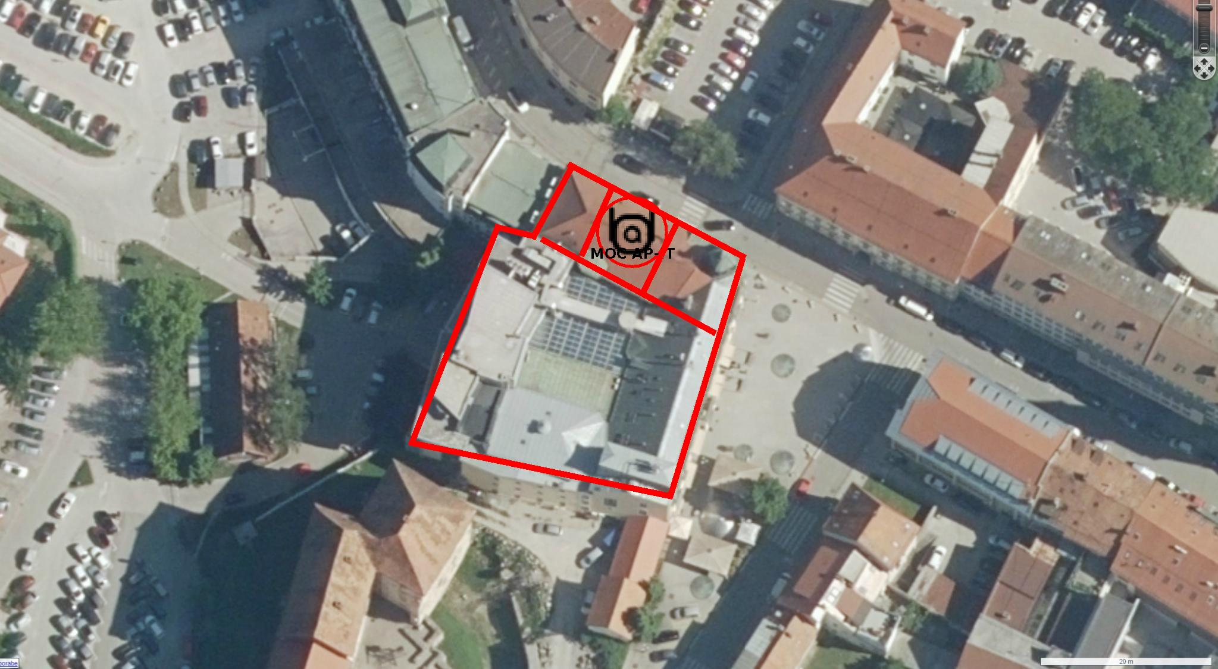

**Data Rate View**

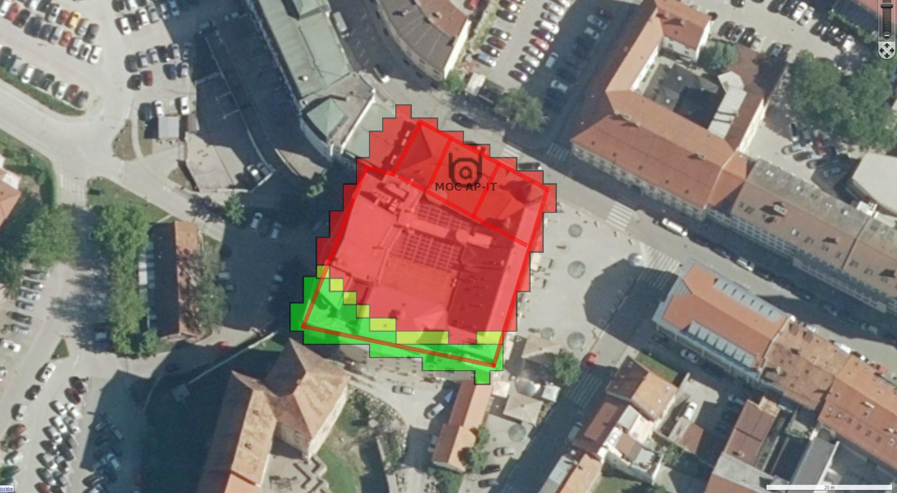

**Heat Map View**

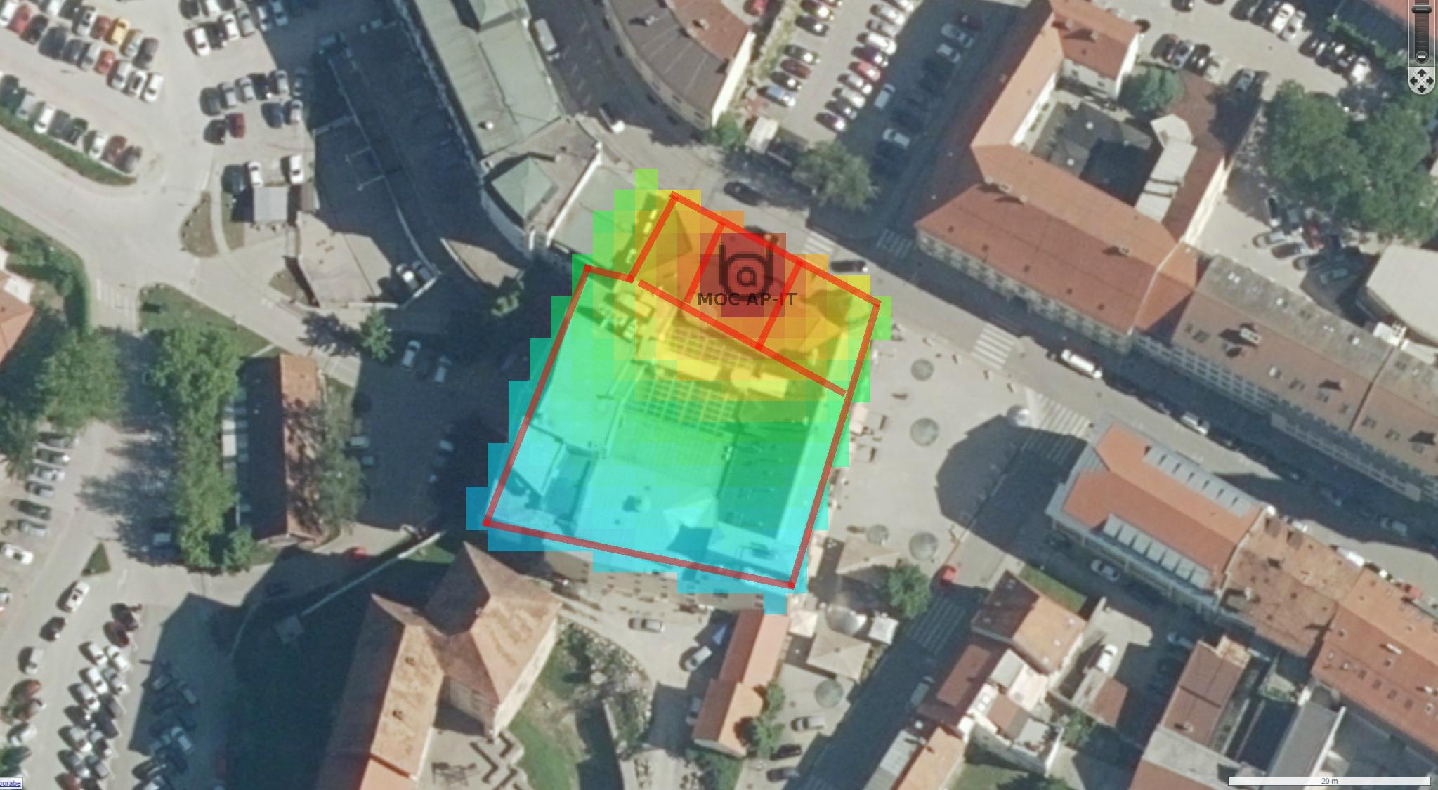

|  |  |  |  |  |  |  |  |  |  |
| --- | --- | --- | --- | --- | --- | --- | --- | --- | --- |
| AP Inventory | | | | | | | | | |
| **Name** | **Model** | **Part #** | **PHY** | **Ch** | **Xmit dBm** | **Ga in dBm** | **LAN MAC** | **Switch** | **Port** |
| MOC AP-IT | Aruba AP 515 | AP-515 | 802.11ax(2.4) | 1 | 12.0 | 2.7 | FC:7F:F1:C4:06:5A |  |  |

|  |  |  |  |  |  |  |  |  |  |
| --- | --- | --- | --- | --- | --- | --- | --- | --- | --- |
| Wired Inventory | | | | | | | | | |
| **Name** | **Model** | **Part #** | **# POE Ports** | **Total Ports** | **IDF** | **Rack** | **Rack Unit #** |

|  |  |  |  |  |  |  |  |  |  |
| --- | --- | --- | --- | --- | --- | --- | --- | --- | --- |
| Floor Total | | | | | | | | | |
| **Part #** | **Type** | **Mode** | **Qty** |
| AP-515 | Aruba AP 515 | AP  AM | 1  0 |

|  |  |  |  |  |  |  |  |  |  |
| --- | --- | --- | --- | --- | --- | --- | --- | --- | --- |
| Summary | | | | | | | | | |
| **Part #** | **Type** | **Mode** | **Qty** |
| AP-515 | Aruba AP 515 | AP  AM | 1  0 |