# UFOnetwork

UFOnetwork – web-application, that allows it`s users to represent them self on their profile page, visit other user`s pages, create and join different groups and communicate inside this groups.

Table of contents

UFOnetwork 1

User 2

Group 2

Visitor (unauthorized user) 2

Entities 2

User Entity 2

Group Entity 2

Message Entity 2

Race Entity 3

Pages 3

Login and registration 3

Registration 4

Search forms 4

a) User search form: 4

a) Group search form: 5

Search results 5

User search results: 6

Group search result: 6

Profile 7

Group 7

Profile settings 8

Group settings 8

Header 8

Server 9

## User

User create his/her/it`s own profile page when register with unique login and password. User`s profile contain name, race, age (in Universal universe date, can be fractional), sex. User can join any group or create his own, live messages there, delete his messages and leave groups or even delete them, if he owns this group. User can search for groups and other users and visit their pages.

## Group

Users can join or create any groups they want. Group has it`s name and link to it`s owner and contain messages that was leaved in it by users and field to leave new messages.

## Visitor (unauthorized user)

Visitor can see only login page.

# Entities

## User Entity

User entity contain:

* Id – unique identificator for user. Hidden from user.
* Login – user`s unique login for authorization.
* Password – user`s password for authorization, stored as SHA-256 hash.
* Name, sex – text fields, contains user`s name and sex, entered by user
* Age – number field, entered by user. (NB: float)
* Race – user`s race. Chosen or created at registration.
* Registration date – contain date of profile creation. Hidden from user. Used to calculate password`s hash.

Connections:

* User-Group (owner) – one to many
* User-Group (participant) – many to many.
* Race-User – one to many
* User-Message (writer) – one to many

## Group Entity

User entity contain:

* Id – unique identificator for group. Hidden from users.
* Owner – user, that create this group
* Name– text fields, entered by owner

Connections:

* User-Group (owner) – one to many
* User-Group (participant) – many to many.
* Group-message(to group) – one to many

## Message Entity

User entity contain:

* Id – unique identificator for message. Hidden from users.
* Date of submition - contain date when user leave this message.
* Text – text field, contain user-written text
* To group – contain group where message posted. Hidden from users.
* Writer – contain user who post this message

Connections:

* User-Message (writer) – one to many
* Group-message(to group) – one to many

## Race Entity

User entity contain:

* Id – unique identificator for race. Hidden from users.
* Race name – text field with name of race

Connections:

* Race-User – one to many

# Pages

## Login and registration

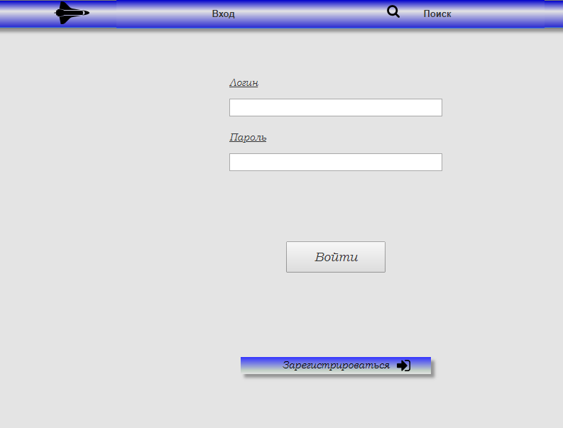

Figure 1 - login and registration

Opens when visitor open the site.

Visitor can login with his unique login-password, register or search users/groups.

Registration

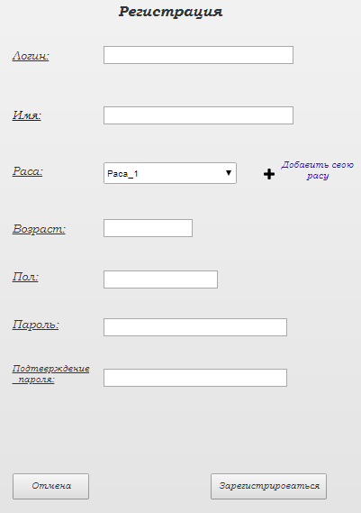

Figure 2 - registration

To register user must fill all fields in registration form. If user trying to submit form without filling some field, he will get alert, unfilled fields will be highlighted.

Login must be unique. If user try to use not unique login, he will get alert about it and choose another

Race can be selected from existing or new one added. If user want to add his own race, choose menu will be replaced with text field. After submition of registration form, race compare with already existed. If user create copy of existed race, his race replace to existed one, if race new – it must be added to race list.

Acceptable symbols(login,password,name,sex): letters, numbers, -, _,.

Acceptable symbols(age): numbers, .

Unacceptable symbols must be highlighted.

## Search forms

### a) User search form:

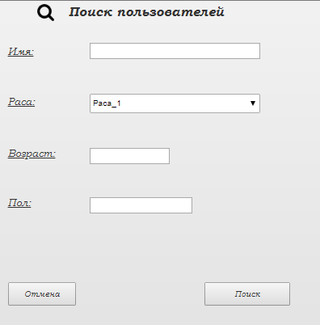

Figure 3 - User search

* For name and sex fields:

Acceptable symbols: letters, numbers, -, _.

Special symbols: *(any number of symbols missed), ?(one symbol missed)

Unacceptable symbols must be highlighted.

If fields not filled - count as *.

Symbols, that used to search, can be in any position in text. (*<search symbols>*).

* Race must be chosen from list of race.
* Age must be numbers, two fields, From and To, any other symbol must be highlighted. Search is inclusive.

If search button pressed, while fields contains unacceptable symbols, same page must be open with fields, filled with correct symbols. Fields with unacceptable symbols must be clear and highlighted.

### a) Group search form:

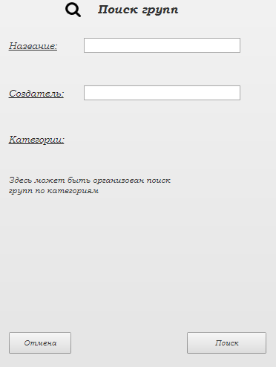

Figure 4 - group search

* For name and onwer fields:

Acceptable symbols: letters, numbers, -, _.

Special symbols: *(any number of symbols missed), ?(one symbol missed)

Unacceptable symbols must be highlighted.

If fields not filled - count as *.

Symbols, that used to search, can be in any position in text. (*<search symbols>*).

(Category (if we use them) - in results show selected, if none selected - count as any category)

If search button pressed, while fields contains unacceptable symbols, same page must be open with fields, filled with correct symbols. Fields with unacceptable symbols must be clear and highlighted.

## Search results

Contain search results.

Opens after search forms.

Button "Return" opens previous page with opened search form, filled with parameters, that was used to open this search result.

### User search results:

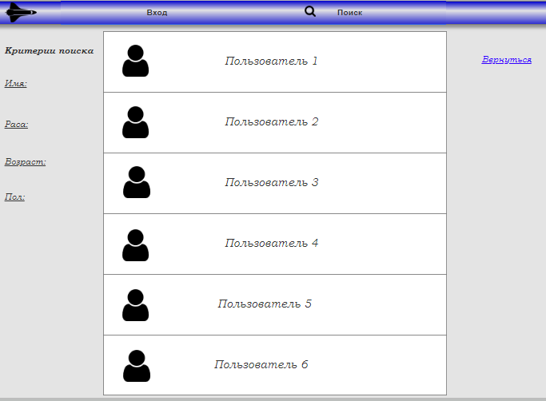

Figure 5 - User search result

List of users. Users shown as they profile photo (if we use them) and name - in any case, highlighted parameters related to search parameters - if this parameters used in search request.

Mouse click open user profile.

### Group search result:

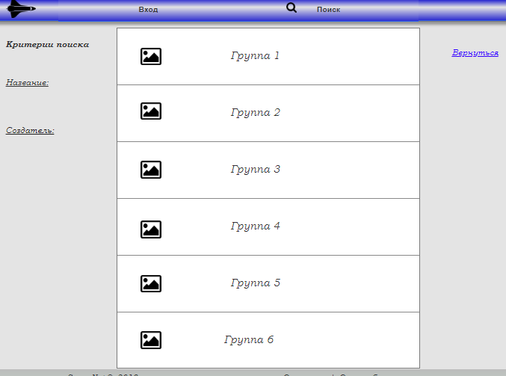

Figure 6 - group search

List of groups. Groups shown as they profile photo (if we use them) and name - in any case, highlighted parameters related to search parameters - if this parameters used in search request.

Mouse click open group.

When user points to a group with mouse, shows additional buttons: join group and search for participants.

## Profile

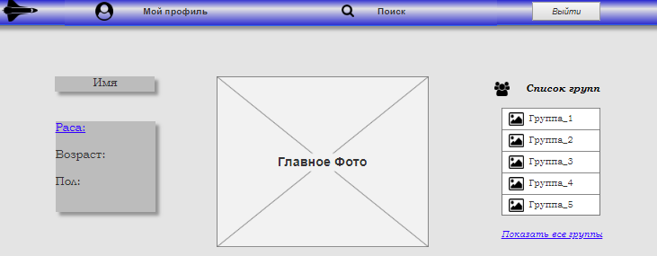

Figure 7 – Profile page

On profile page user can see: name, race, age, sex, profile picture (if we use them), full list of groups.

Group

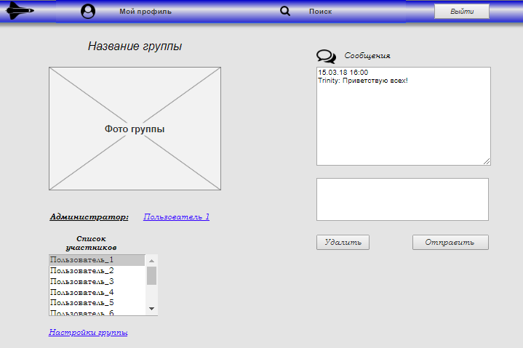

Figure 8 – Group page

User see and use: group picture, owner name (and link), list of participants, posted messages with name of writer and date, field to write message, button to post message, button to delete message on his posted messages.

Group owner additionally can see and use: settings button, button to exclude selected user, button to delete message on any posted message. If Group owner leave group – group deletes.

Profile settings

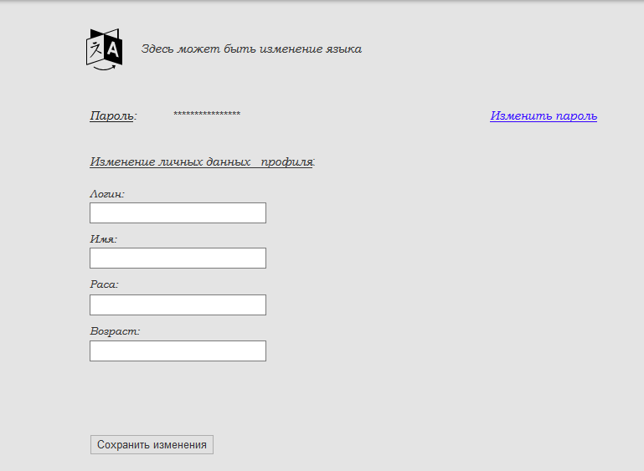

Figure 9 – Profile settings page

Contain editable text fields with login, name, age and button "edit". Fields filled with current information. Modification of this information and click on "edit" button replace current information with new one.

Contain button "Change password", that opens pop-up window, that asks for old password, new one and confirmation of new password.

Contain current profile picture (if we use them) and button to update it.

Acceptable and unacceptable symbols, saving changes: same as at registration page.

Group settings

Contain editable text fields with name filled with current information and button "edit". Modification of this information and click on "edit" button replace current information with new one.

Contain current group picture (if we use them) and button to update it.

(Category field, if we use it, and drop-down menu to select)

Header



Figure 9 – Header for visitor



Figure 10 – Header for user

Contain logo, Profile button for users, search drop-down menu, exit button. All buttons visible only for users.

# Server

* Apache Tomcat
* PostgreSQL