


S.B.V.P.SAMAJ’S

SAHAKAR MAHARSHI BHAUSAHEB SANTUJI THORAT COLLEGE OF ARTS,SCIENCE & COMMERCE SANGAMNER , AHILYANAGAR – 422605
2025-2026

An INDUSTRIAL TRAINING PROJECT REPORT
ON

“Appointment Management System”

Submitted in partial fulfillment of the requirement of the
Department of Msc computer science
Under The Guidance of
Prof . Mande.P.B

Submitted By

Mr. Yash Somnath Gorde & Ms. Priya Shivaji Gunjal

S.B.V.P.SAMAJ’S
SAHAKAR MAHARSHI BHAUSAHEB SANTUJI THORAT COLLEGE
OF ARTS,COMMERCE& SCIENCE
SANGAMNER 422605

Department of Computer Science
Project Report

Academic Year 2024-2025

CERTIFICATE

This certificate is awarded to Mr. Yash Somnath Gorde and Ms. Priya Shivaji Gunjal in appreciation of their meritorious performance in the internship project titled “Appointment Management System.” This project was completed as part of the practical requirements of Savitribai Phule Pune University during the Academic Year 2024-2025.

Mr. Mande.P.B Mr. Thakre M.V
(Project Guide) (HOD)

Internal Examiner External Examiner

ACKNOWLEDGMENT

It is my proud privilege to express gratitude to the entire management of Sahakar Maharshi Bhausaheb Santuji Thorat College of Arts, Science and Commerce (SMBSTC) – M.Sc. Computer Science and teachers of the institute for providing me with the opportunity to avail the excellent facilities and infrastructure of the institute. The knowledge and values inculcated have proved to be of immense help at the very start of my career.
I am grateful to Prof. M.V.Thakare (HOD, M.Sc. Computer Science) for their astute guidance, constant encouragement and sincere support for this project work. I also thank my project mentor Prof P.B.Mande who showed their concerns for my work, encouraged me to keep my best foot forward and gave valuable suggestions which not only helped me in my project work but will be useful in future too.
I would like to thank Maxgen Technologies Pvt. Ltd. for providing me with an opportunity to pursue my industrial training, as it is an important part of the M.Sc. Computer Science course and it is the one that exposes you to the industry standards and makes you adapt yourself to the latest trends and technologies. At the same time, it gives an experience of working on a live project. I feel proud and privileged in expressing my deep sense of gratitude to all those who have helped me in presenting this assignment. I would be failing in my endeavor if I do not place my acknowledgment.
Sincere thanks to all my seniors and colleagues at the company for their support and assistance throughout the project.




INDEX

Sr.No | Topics | Page No
1 | Company Profile | 1-4
 | 1.1 Introduction | 1
 | 1.2 Existing System and Need for the System | 2
 | 1.3 Scope of Work | 3
 | 1.4 Operating Environment | 4
2 | Proposed System | 7-9
 | 2.1 Feasibility Study | 7
 | 2.1 Objective of System | 8
 | 2.2 User Requirement | 9
3 | Analysis & Design | 10-40
 | 3.1 Diagrams | 10-18
 | 1 ER Diagram | 10
 | 2 UML Diagrams | 11-18
 | 2.1 Class Diagram | 11
 | 2.2 Object Diagram | 12
 | 2.3 Use Case Diagram | 13
 | 2.4 Sequence Diagram | 14
 | 2.5 Activity Diagram | 15
 | 2.6 Collaboration Diagram | 16
 | 2.7 Component Diagram | 17
 | 2.8 Deployment Diagram | 18
 | 3.3 Data Dictionaries | 19-23
 | 3.4 User Interface Report Screens | 24-36
 | 3.5 Test Procedures and Implementation | 37-40
4 | User Manual | 41-42
5 | Drawback and Limitations | 43-45
6 | Proposed Enhancement | 46-50
7 | Bibliography | 51
8 | Conclusion | 52-53

1 INTRODUCTION

In the modern healthcare industry, efficient appointment scheduling plays a vital role in ensuring smooth operations for hospitals, clinics, and private practitioners. The Appointment Management System is a microservices-based web application designed to streamline the process of scheduling, managing, and tracking appointments. The system leverages Spring Boot, Django, MongoDB, MySQL, and PostgreSQL to offer a robust and scalable solution. It provides a user-friendly interface where patients can register, book appointments, check doctor availability, and receive real-time notifications, while doctors and administrators can manage schedules, update appointment statuses, and maintain patient records. The platform ensures secure access through role-based authentication and authorization mechanisms, making it an effective solution for handling healthcare appointments with minimal manual intervention.
Developed as part of an internship project, this system follows a distributed microservices architecture, ensuring high availability and better performance under heavy loads. The patient service, doctor service, and appointment service are handled separately to maintain scalability and flexibility. Spring Boot is used for handling high-traffic services, while Django is implemented for managing CRUD operations efficiently. The system integrates MongoDB for unstructured patient data storage, while MySQL and PostgreSQL are used for structured relational data. Additionally, the project incorporates RESTful APIs for smooth communication between different microservices, ensuring seamless data flow and efficient system operation.

One of the key features of this system is its automated notification service, which sends email and SMS alerts for appointment confirmations, cancellations, and reminders. The system also includes a dashboard for doctors and administrators, allowing them to monitor daily schedules and patient records in real time. The Appointment Management System was developed as a practical submission for Savitribai Phule Pune University during the Academic Year 2024-2025. This project showcases expertise in microservices architecture, full-stack development, and healthcare management solutions, making it a highly scalable and industry-relevant application.

1.2 Existing System and Need for the System

Existing System:
In the current healthcare and service-based environments, appointment booking is often managed manually or through semi-automated systems. These systems typically include:
- Phone-based bookings, which require constant staff availability and are prone to human error.
- Paper-based records, which are difficult to manage, retrieve, and prone to damage or loss.
- Limited online systems, which may not support real-time availability checks or multi-user access (e.g., admin, doctors, patients).
- Lack of integration with other services like reminders, doctor availability, or patient history.
- Inadequate scalability, particularly in growing institutions with increasing numbers of patients or clients.
These limitations lead to inefficiencies, missed appointments, overlapping schedules, and poor user experience.

Need For the System
To address the shortcomings of existing systems, a centralized Appointment Management System is essential. The proposed system will:
- Enable patients to book appointments online, reducing wait time and human effort.
- Allow real-time doctor availability tracking and appointment scheduling.
- Automate notifications/reminders via email or SMS.
- Maintain digital patient records, accessible by authorized personnel.
- Provide role-based access control (e.g., Admin, Doctor, Patient) for improved security and workflow.
- Offer scalability and integration with other services or hospital modules in the future.
- Improve data accuracy, reduce operational costs, and enhance overall service quality.
This system aims to bring transparency, convenience, and efficiency to the appointment process, benefiting both service providers and end users.

1.3 Scope of Work

The Appointment Management System is designed to streamline the scheduling, management, and tracking of appointments between patients and healthcare providers. The system enhances operational efficiency, improves communication, and reduces administrative burdens by automating appointment-related tasks.
This system is developed using a microservices architecture with Spring Boot, Django, MongoDB, MySQL, and PostgreSQL to ensure high performance, scalability, and security. It facilitates seamless coordination among hospitals, doctors, and patients while maintaining data integrity and accessibility.

The scope of the system includes:
- Appointment Scheduling: Patients can browse available time slots, book appointments, and receive confirmation notifications. They also have the option to reschedule or cancel appointments.
- Doctor Management: Doctors can manage their schedules, update availability, and access patient appointment details to ensure smooth operations.
- Hospital Administration: Administrators can monitor and oversee hospital-wide appointment activities, manage system users, and generate reports to improve healthcare services.
- Notifications & Reminders: Automated email and SMS alerts help keep patients and doctors informed about upcoming appointments, reducing the likelihood of missed consultations.
- Role-Based Access Control: The system ensures secure authentication and authorization by granting appropriate access levels to patients, doctors, and administrators.
- Data Management: Using MySQL, PostgreSQL, and MongoDB, the system efficiently stores and retrieves structured and unstructured data, ensuring reliability and fast processing.
- Security & Scalability: Built on a microservices-based architecture, the system can handle high volumes of traffic while ensuring secure access through encryption and authentication mechanisms.
- Feedback & Reports: Patients can submit feedback regarding their appointment experiences, and administrators can generate detailed reports to analyze system performance and user satisfaction.

1.4 Operating Environment

Hardware Requirement :
1) Server Configuration
Processor | Intel Xeon / AMD Ryzen 7 or higher
RAM | Minimum 4GB (Recommended: 8GB for high-traffic environments)
Storage | SSD 512GB (Recommended: 1TB for larger databases)
Network | High-speed internet connection with a static IP

2) Client Configuration:
Processor | Intel i5 / AMD Ryzen 5 or higher
RAM | 4GB or more
Storage | Minimum 256GB SSD or HDD

Software Requirement :
1) Server Configuration:
Operating System | Ubuntu 22.04 LTS / Windows Server 2019
Backend Frameworks | Spring Boot (Java),Django (Python)
Database | MongoDB,MySQL,PostgreSQL
Web Server | NGINX
Microservices Communication | Eureka
IDE | Visual Studio Code

2) Client Configuration:
Operating System | Windows 10/11, macOS, Linux
Frontend Technologies | React.js
Browser Compatibility | Google Chrome, Mozilla Firefox, Edge
Mobile Compatibility | Android/iOS (Responsive Design)

2.1 Feasibility Study

The feasibility study assesses whether the proposed Appointment Management System can be successfully developed and implemented. It evaluates multiple aspects such as technical, economic, operational, legal, and schedule feasibility to ensure the system is both practical and beneficial.

1. Technical Feasibility
The proposed system will be developed using modern web technologies such as:
- Frontend: ReactJS
- Backend: Django (or Spring Boot for specific services)
- Database: MongoDB, MySQL, and PostgreSQL (depending on service)
- Architecture: Microservices-based for scalability and maintainability
All required technologies are open-source and widely supported. The development team has sufficient technical knowledge and experience with these tools, making the project technically feasible.

2. Economic Feasibility
The system is cost-effective because:
- It uses free/open-source technologies.
- Deployment can be done on cloud platforms with free or low-cost tiers (e.g., AWS Free Tier).
- It reduces manual work, operational overhead, and time spent on appointment handling.
Thus, the return on investment (ROI) justifies the development cost.

3. Operational Feasibility
The system is designed for:
- Admins to manage doctors, appointments, and users
- Doctors to view appointments and update availability
- Patients to book/view appointments and get reminders
The system’s user-friendly interface and role-based access make it easy for all users to adopt and operate, increasing its chances of success in a real-world environment.

4. Legal Feasibility
The system will handle user and patient data securely by:
- Implementing authentication and authorization
- Following data privacy guidelines
- Not sharing data without consent
As long as local health data privacy laws are followed, there are no legal barriers.

5. Schedule Feasibility
Based on project planning and milestones, the system can be developed and deployed within the given academic/project timeline. Agile development practices allow for flexibility and faster delivery of core features.

2.2 Objective of System

Here is an expanded list of Objectives of the Appointment Management System:
- Enhance Appointment Scheduling Efficiency – Enable patients to book, reschedule, and cancel appointments seamlessly, reducing waiting times and administrative burdens.

- Improve Doctor and Hospital Management – Provide tools for doctors to manage their schedules and for hospitals to oversee patient flow and resource allocation.

- Ensure Secure and Role-Based Access – Implement authentication and authorization mechanisms to safeguard patient data and restrict access based on user roles.

- Optimize Data Management – Utilize MySQL, PostgreSQL, and MongoDB to efficiently store, retrieve, and manage patient and appointment records.

- Increase System Scalability – Leverage microservices architecture with Spring Boot and Django to ensure the system can handle high traffic and future expansions.

- Facilitate Feedback and Reporting – Allow patients to provide feedback and enable administrators to generate reports for performance analysis and decision-making.

- Enhance Patient Experience – Provide an intuitive user interface that allows easy navigation and accessibility for patients of all age groups.

- Reduce Manual Workload for Hospital Staff – Minimize administrative tasks by automating appointment booking, reminders, and reporting.

- Maintain Data Accuracy and Integrity – Ensure all patient and appointment records are stored securely and updated in real time to prevent data inconsistencies.

- Support Multi-Hospital Integration – Enable scalability by allowing multiple hospitals to integrate and manage their appointment schedules efficiently within a single system.

- Ensure Compliance with Healthcare Standards – Implement security and privacy protocols in line with healthcare regulations to protect sensitive patient information.

- Enable Easy System Customization – Provide flexibility for hospitals and clinics to modify system settings based on their specific workflow requirements.

- Track Appointment History and Trends – Maintain detailed logs of past appointments, cancellations, and reschedules to generate insights and improve future scheduling.

2.3 User Requirements

The user requirements define the functionalities and services that the system must provide to its various users. The Appointment Management System will have three types of users: Admin, Doctor, and Patient. Each user will have different access levels and features.

1. Admin Requirements
- Must be able to log in securely.
- Can add, update, or delete doctors.
- Can view and manage patient records.
- Can view and manage appointment schedules.
- Can assign appointments manually if needed.
- Can generate reports related to doctors, patients, and appointments.
- Can manage roles and permissions of users.

2. Doctor Requirements
- Must be able to log in securely.
- Can view assigned appointments.
- Can update availability or working hours.
- Can add medical notes or prescriptions for patients.
- Can view patient history (if allowed by system policy).
- Can accept or reject appointment requests (if allowed by system flow).

3. Patient Requirements
- Must be able to register and log in.
- Can book appointments with available doctors.
- Can view or cancel their appointments.
- Can receive email or SMS notifications/reminders.
- Can view past appointments and prescriptions.
- Can update their profile and health information.

4. System Requirements
- Must support role-based access control.
- Should be responsive and accessible on desktop and mobile devices.
- Should ensure data security and privacy.
- Must store appointment data in a structured database.
- Must be able to scale if the number of users increases.

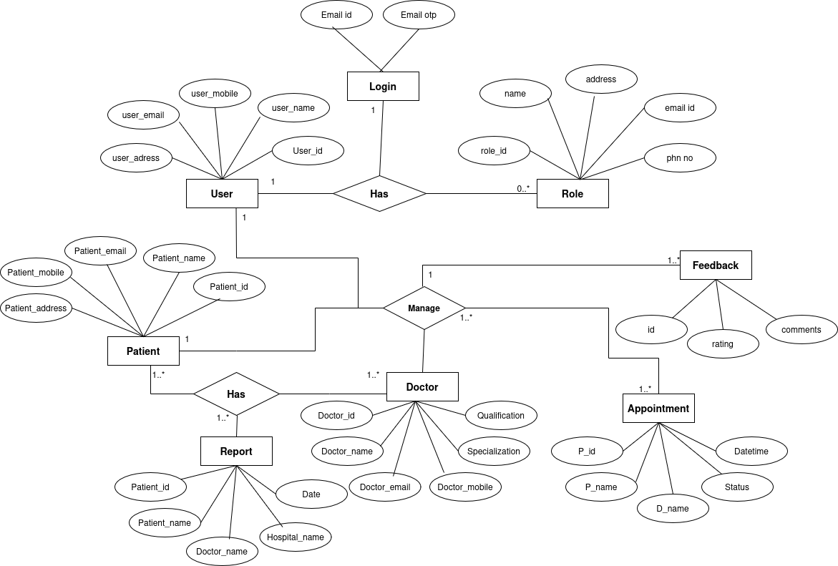
1 ER Digrams

2 . UML Diagrams

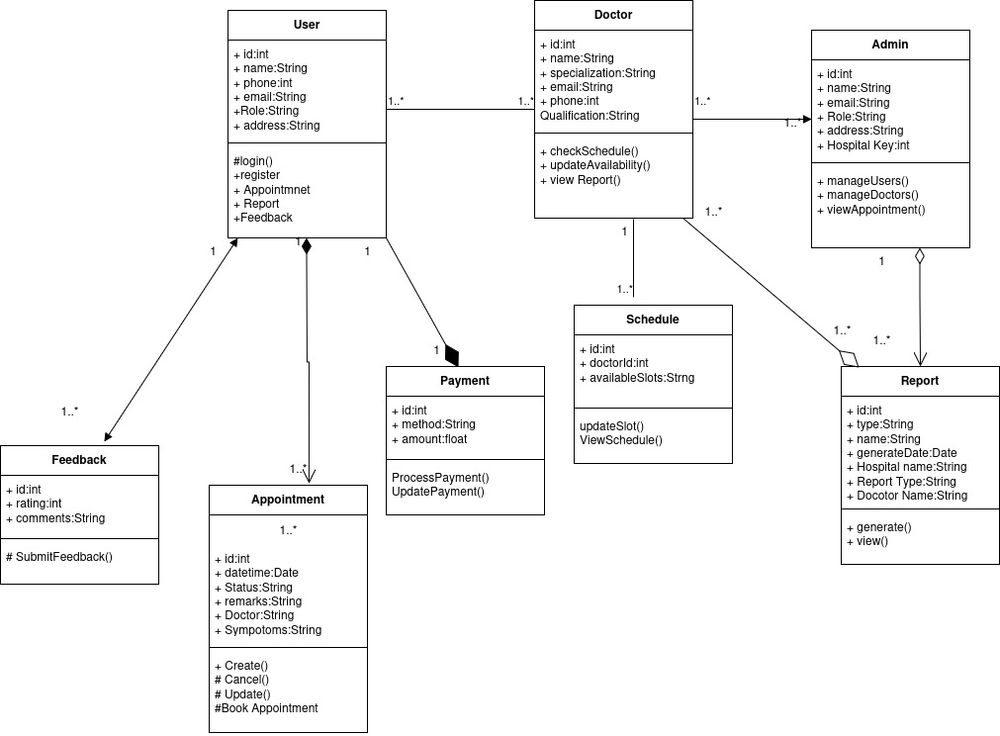
2.1 Class Diagram

2.2 Object Diagram
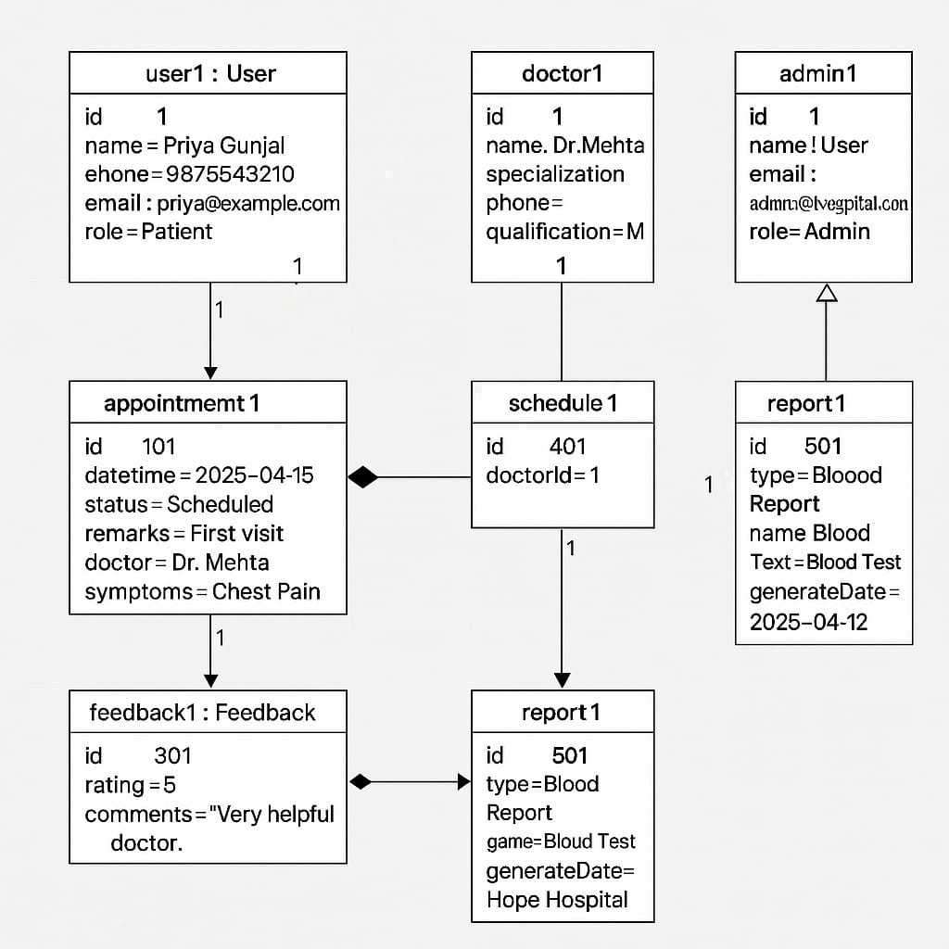
2.3 Use Case Diagram

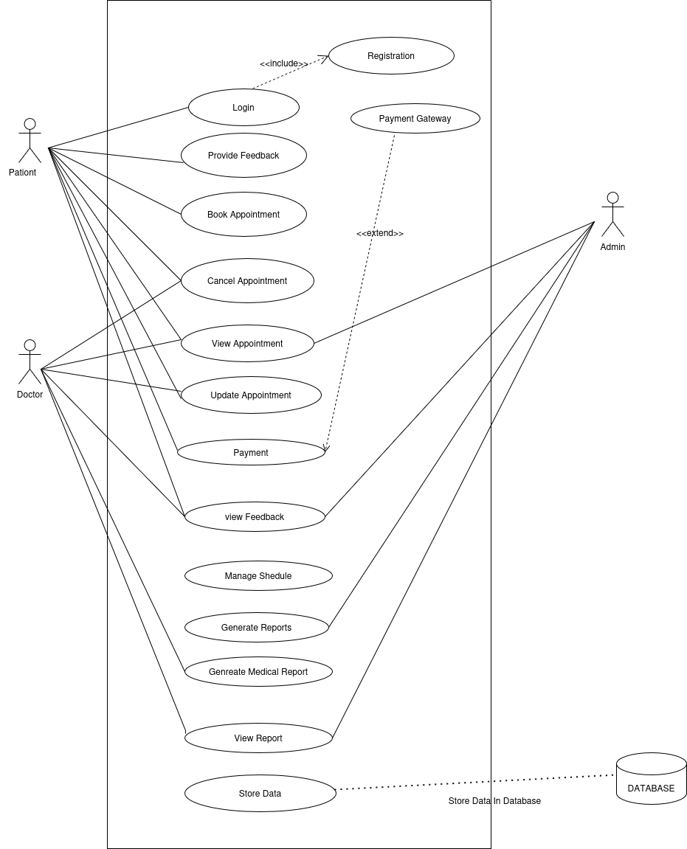

2.4 Sequence Diagram
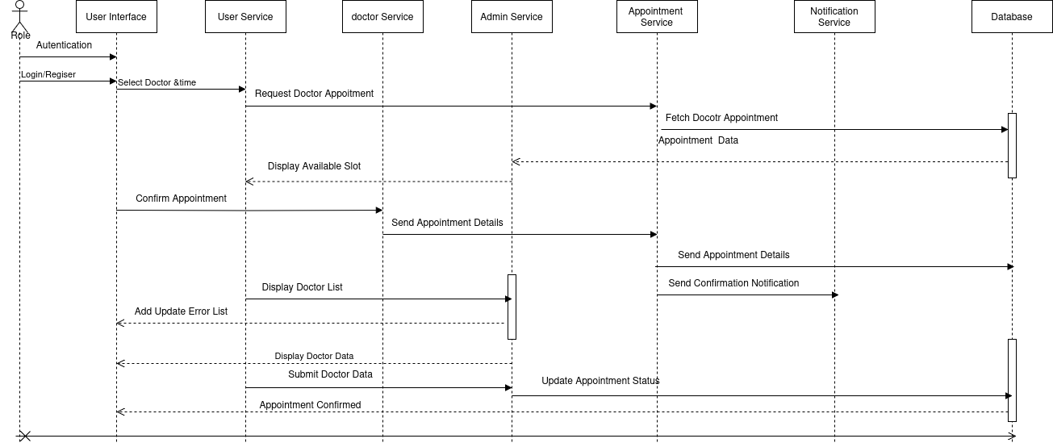
2.5 Activity Diagram

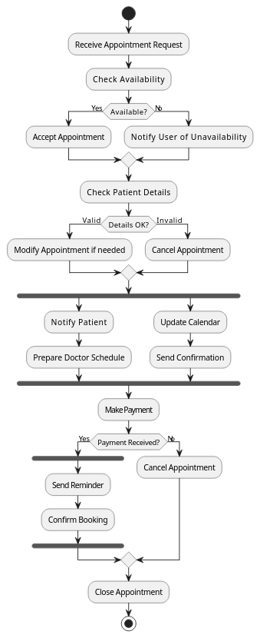

2.6 Collaboration Diagram
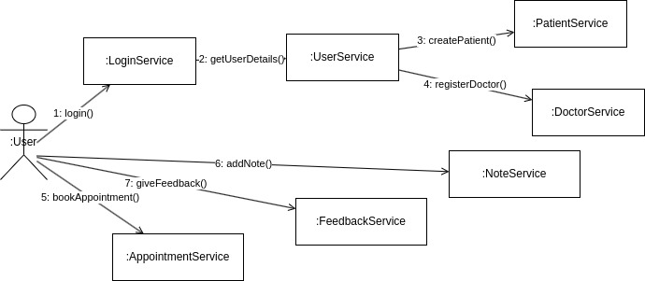

2.7 Component Diagram

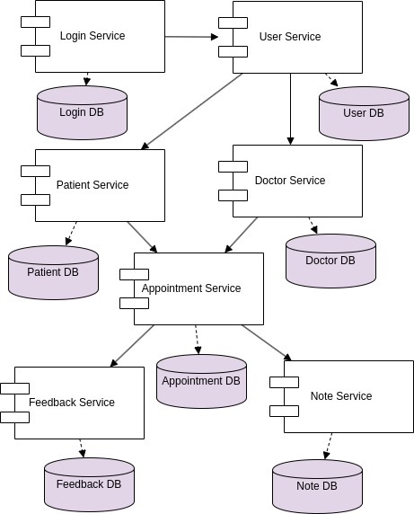

2.8 Deployment Diagram
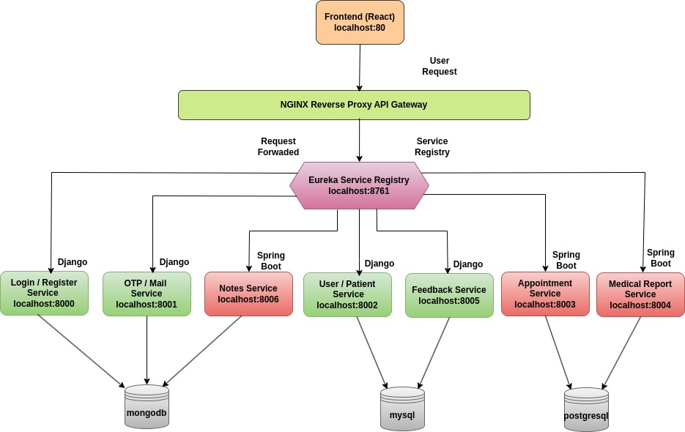

3.2 Data Dictionaries

Doctor_Details

Column | Type | Null | Default | Description
id | bigint | Not Null | - | Primary Key
name | varchar(255) | Not Null | - | Doctors Name
specialization | varchar(255) | Not Null | - | Area of experties
contact | varchar(255) | Not Null | - | Phone number
email | varchar(255) | Not Null | - | Email address
address | longtext | Not Null | - | Residential address
qualifications | longtext | Not Null | - | Education background
experience | int | Not Null | - | Year of experience
doctor_number | varchar(20) | Not Null | - | Registration number
emergency_contact | varchar(15) | Not Null | - | Emergency contact number
aadhar_number | varchar(12) | Not Null | - | Aadhar number
image | longtext | Null | - | Profile Image
aadhar_image | longtext | Null | - | Addhar Image
reg_id | varchar(255) | Not Null | - | Registration Id
hos_id | varchar(255) | Null | - | Hospital Id

Doctor_availability

Column name | Data Type | Null | Default | Description
id | bigint | Not Null | - | Primary Key
day | varchar(20) | Not Null | - | Day of Avalable
time_slot | varchar(50) | Not Null | - | Time of avalable
status | varchar(20) | Not Null | - | Status of Availablity
doctor_id | bigint | Not Null | - | Foreign Key

Patient table

Columne Name | Type | Null | Default | Description
id | bigint | Not Null | - | Uniq Id
patient_id | varchar(24) | Not Null | - | Custom Id
name | varchar(100) | Null | - | Full name
email | varchar(254) | Null |  | Email address
phone | varchar(15) | Null | - | Phone number
dob | date | Null | - | Date of birth
gender | Varchar(10) | Null | - | gender
addredd_line1 | varchar(255) | Null | - | address
city | varchar(100) | Null | - | city
state | varchar(100) | Null | - | state
zip_code | varchar(20) | Null | - | Zip code
created_at | datetime | Not Null | - | Tiime stamp
updated_at | datetime | Not Null | - | Time stamp
profile_image | longtext | Null | - | image

Feedback

Column name | Data Type | Null | Default | Description
id | bigint | Not Null | - | Primary key
feedback_type | varchar(20) | Not Null | - | Type of feedback
rating | int | Not NUll | - | Rating give by user
feedback_text | longtext | Null | - | Option feedback
created_at | datetime | Not Null | - | timestamp
user_id | longtext | Null | - | Foreign key

Appointment

Column Name | Data Type | Null | Default | Description
id | bigint | Not Null | - | Primary Key
appointment_date | date | Not Null | - | Date of appointment
appointment_time | datetime | Not Null | - | Time of appointment
communication_mode | varchar(20) | Not Null | - | Mode of communication
doctor_id | varchar(255) | Not Null | - | Doctor foreign key
is_complete | boolean | Not Null | - | indicator
status | varchar(50) | Null | - | Status of appointment
symptoms | varchar(500) | Null | - | symptoms
user_id | varchar(255) | Not Null | - | User id foregin key
user_name | varchar(100) | Not Null | - | Name of user

Reports

Column Name | Data Type | Null | Default | Description
id | bigint | Not Null | - | Primary key
date_uploaded | varchar(255) | Not Null | - | Date of report uplode
description | varchar(255) | Null | - | descprition
doctor_name | varchar(255) | Null | - | Doctor name
hospital_name | varchar(255) | Null | - | Name of hospital
report_file | text | Not Null | - | image
report_name | varchar(255) | Not Null | - | Report namet
report_type | varchar(255) | Not Null | - | Type of report
uploaded_by | varchar(255) | Not Null | - | Id of uploder
uploader_name | varchar(255) | Not Null | - | Name of the uploder
user_id | varchar(255) | Not Null | - | Id or user

UserData

Field Name | Data Type | Null | Description
_id | ObjectId | Not Null | Unique identifier
email | string | Not Null | Email
name | string | Not Null | Full Name of the user
phone_number | string | Not Null | Contact number
address | string | Not Null | Residential address
role | string | Not Null | Role of user
hospital_key | string | Null | Optional
is_active | string | Not Null | Indicates

UserOtp

Field Name | Data Type | Null | Description
_id | ObjectId | Not Null | Unique identifier
user_email | string | Not Null | User email
user_name | string | Not Null | User name
otp | integer | Not Null | Generated otp
created_at | DateTime | Not Null | Create time
mail_type | String | Not Null | Mail type

Notes

Field Name | Date Type | Null | Description
_id | ObjectId | Not Null | Uniq Id
patientId | string | Not Null | Foregin key
doctorId | string | Not Null | Foregin key
patientName | string | Not Null | Patient Name
date | datetime | Not Null | Created time
noteContent | string | Not Null | Note by the doctor

3.4 Report Screen

Login and Registration
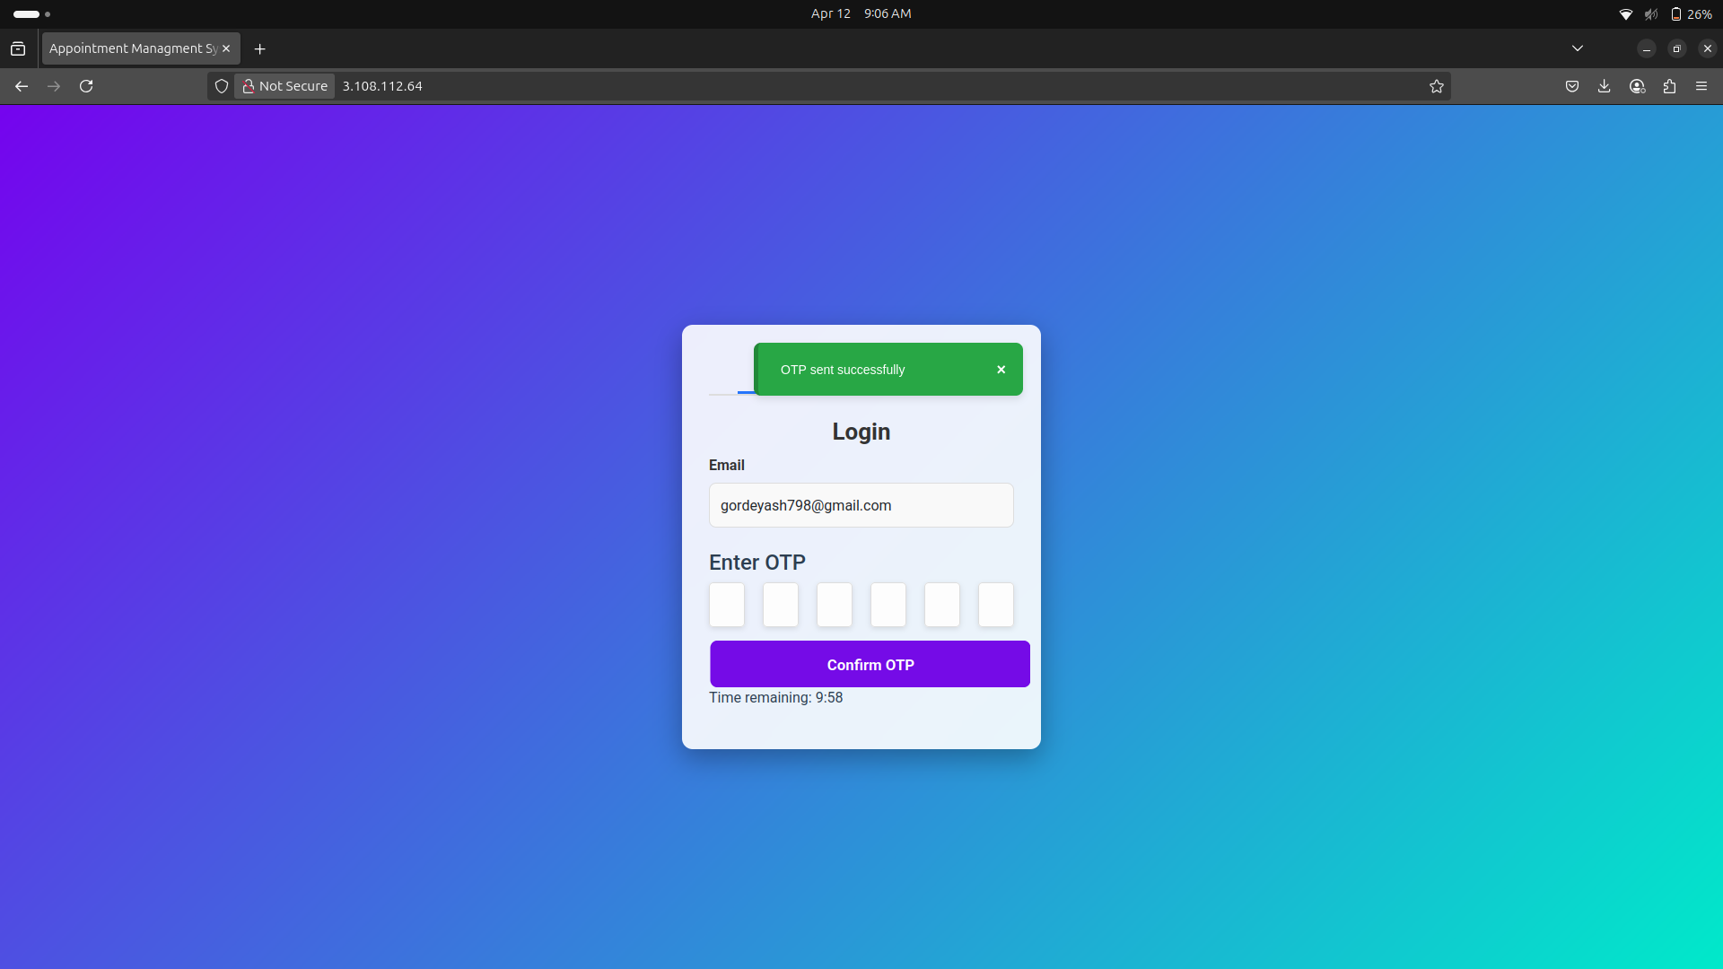
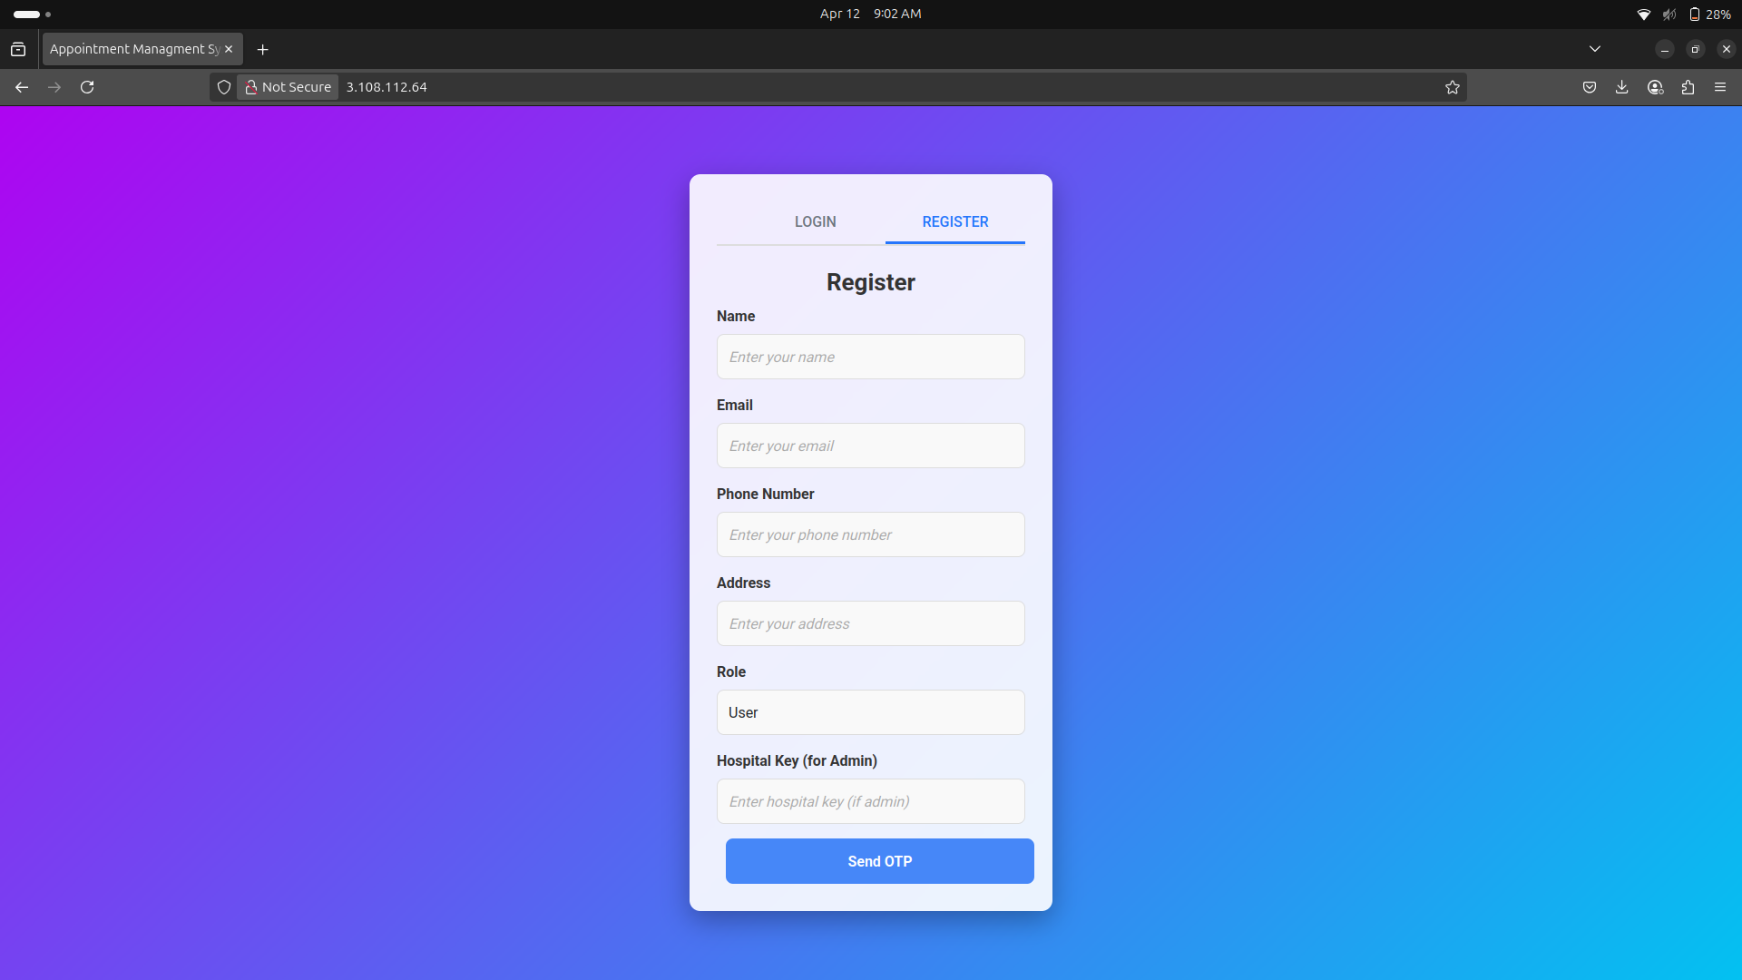

User UI
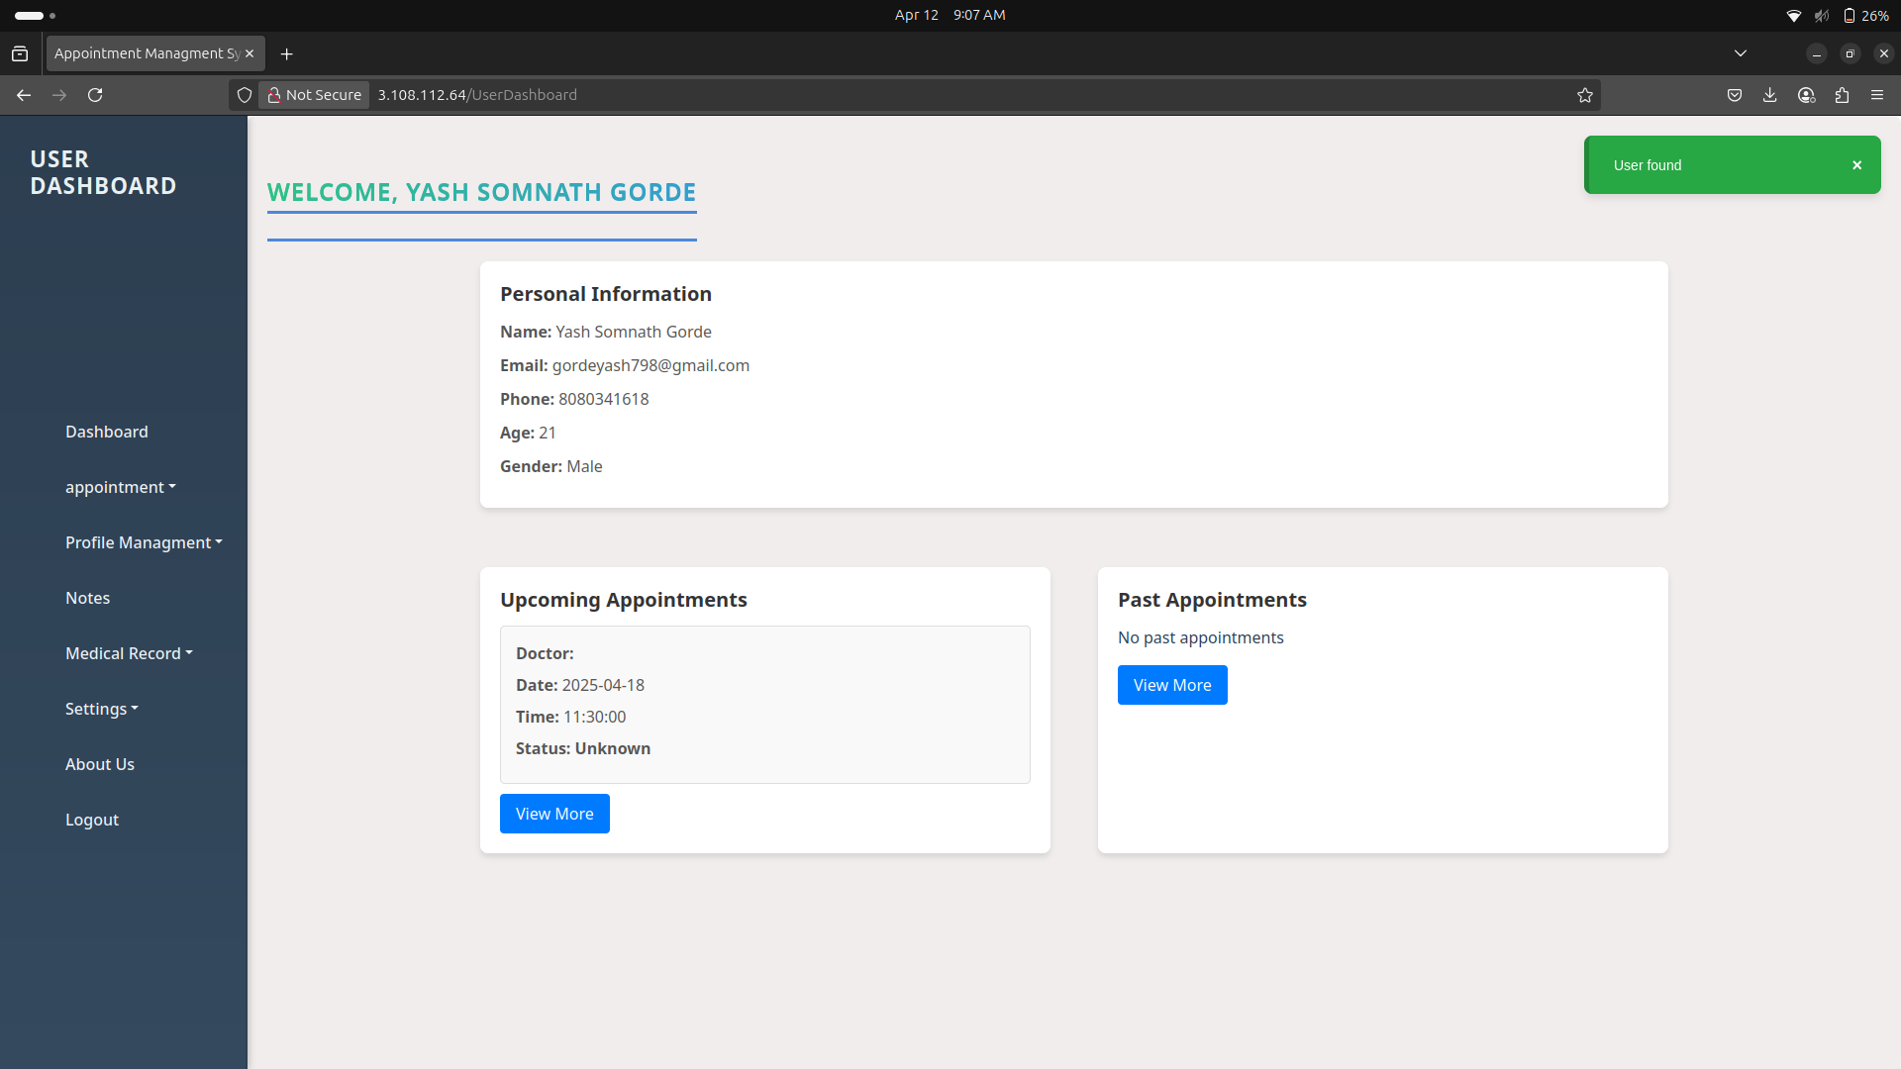

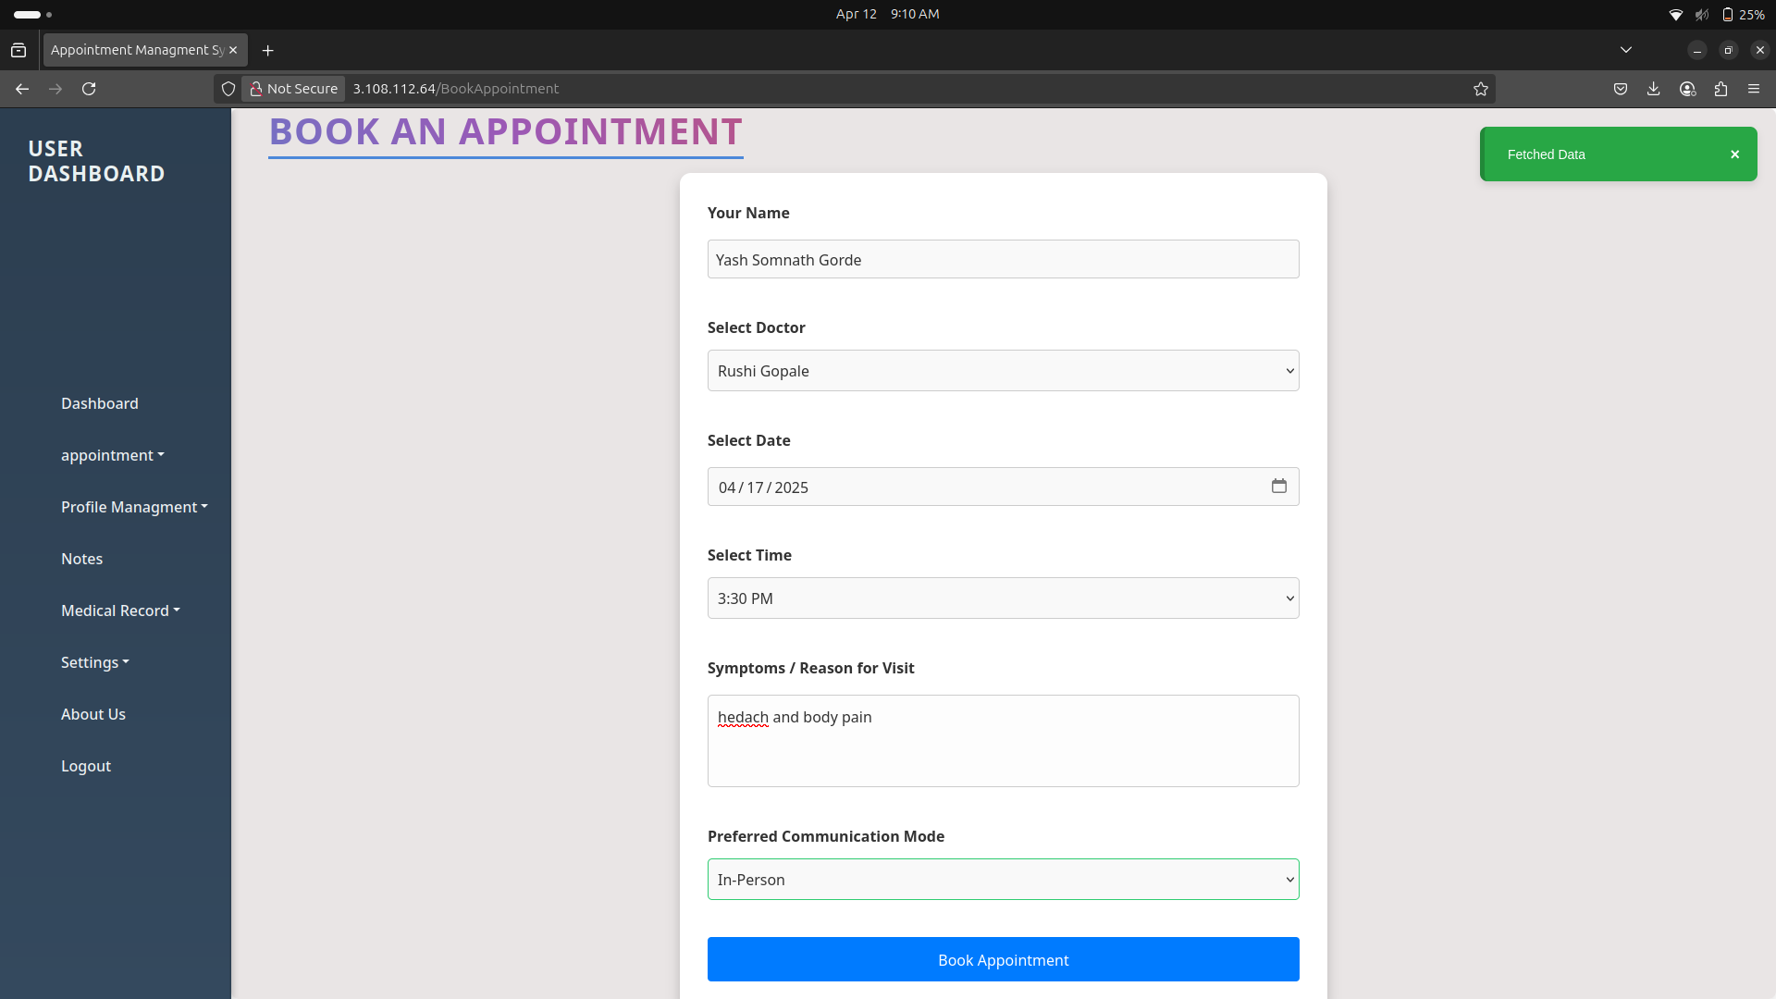

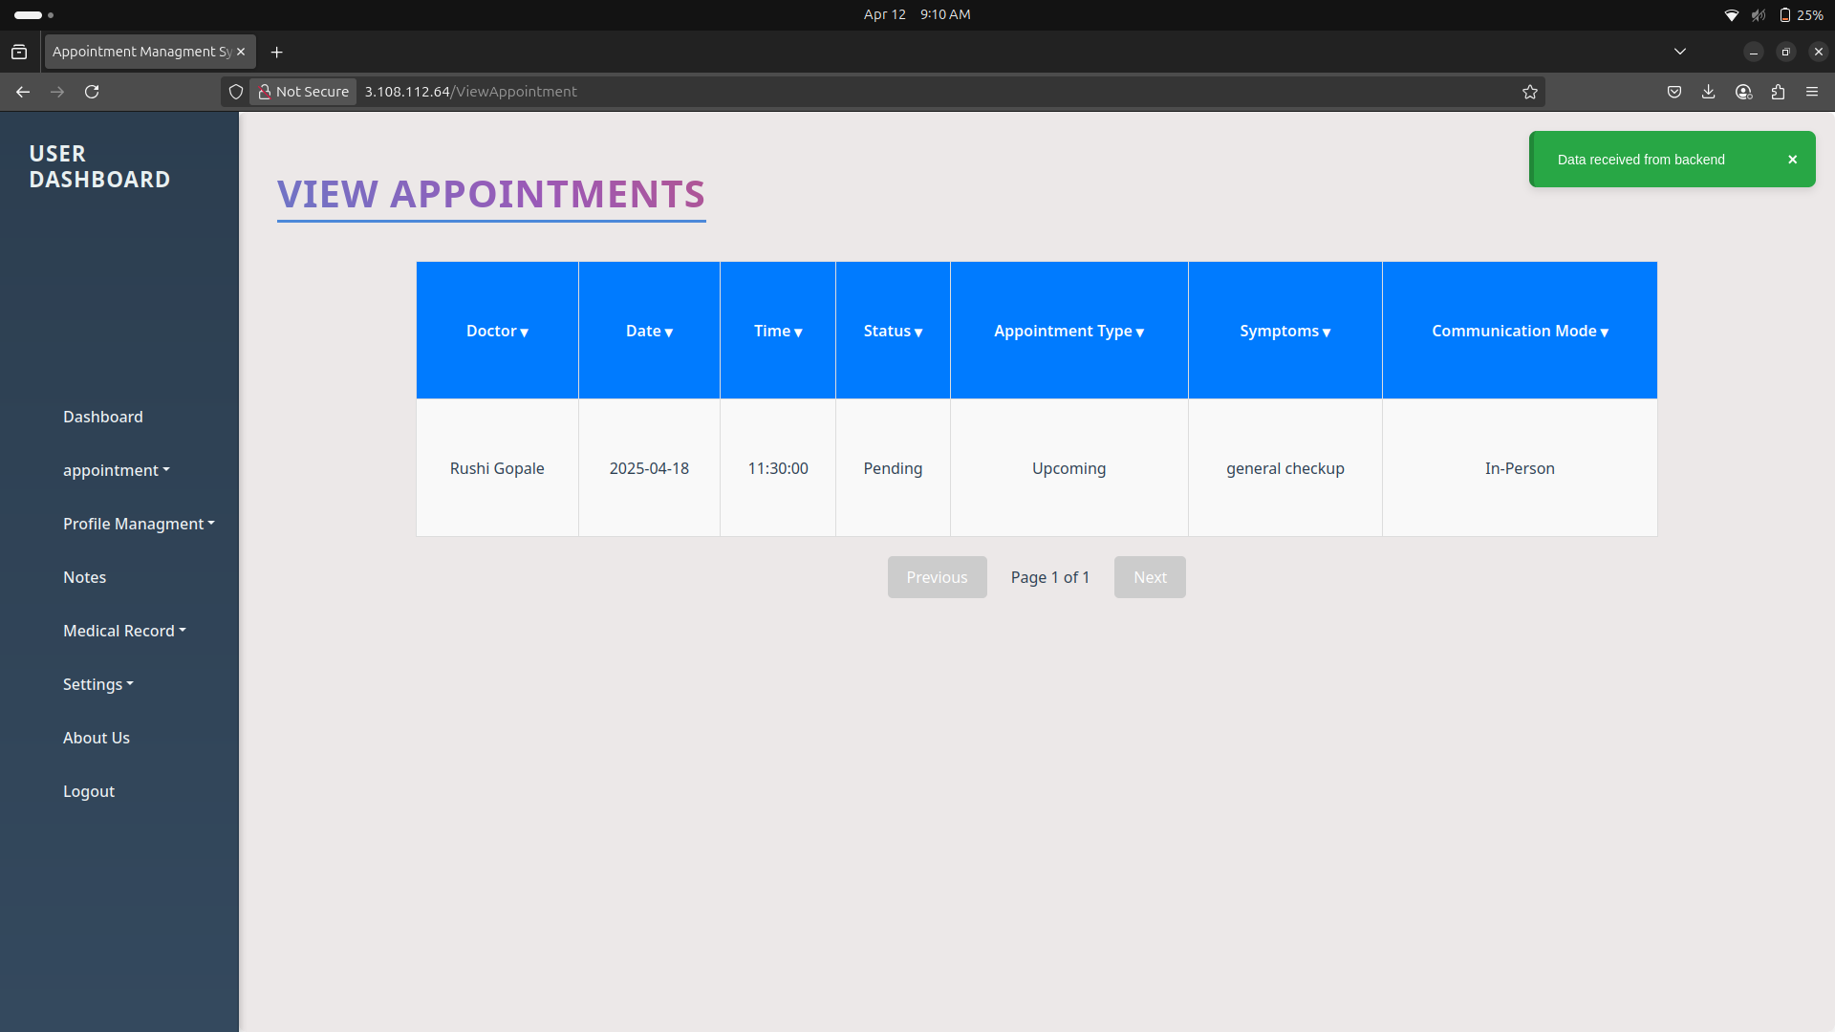

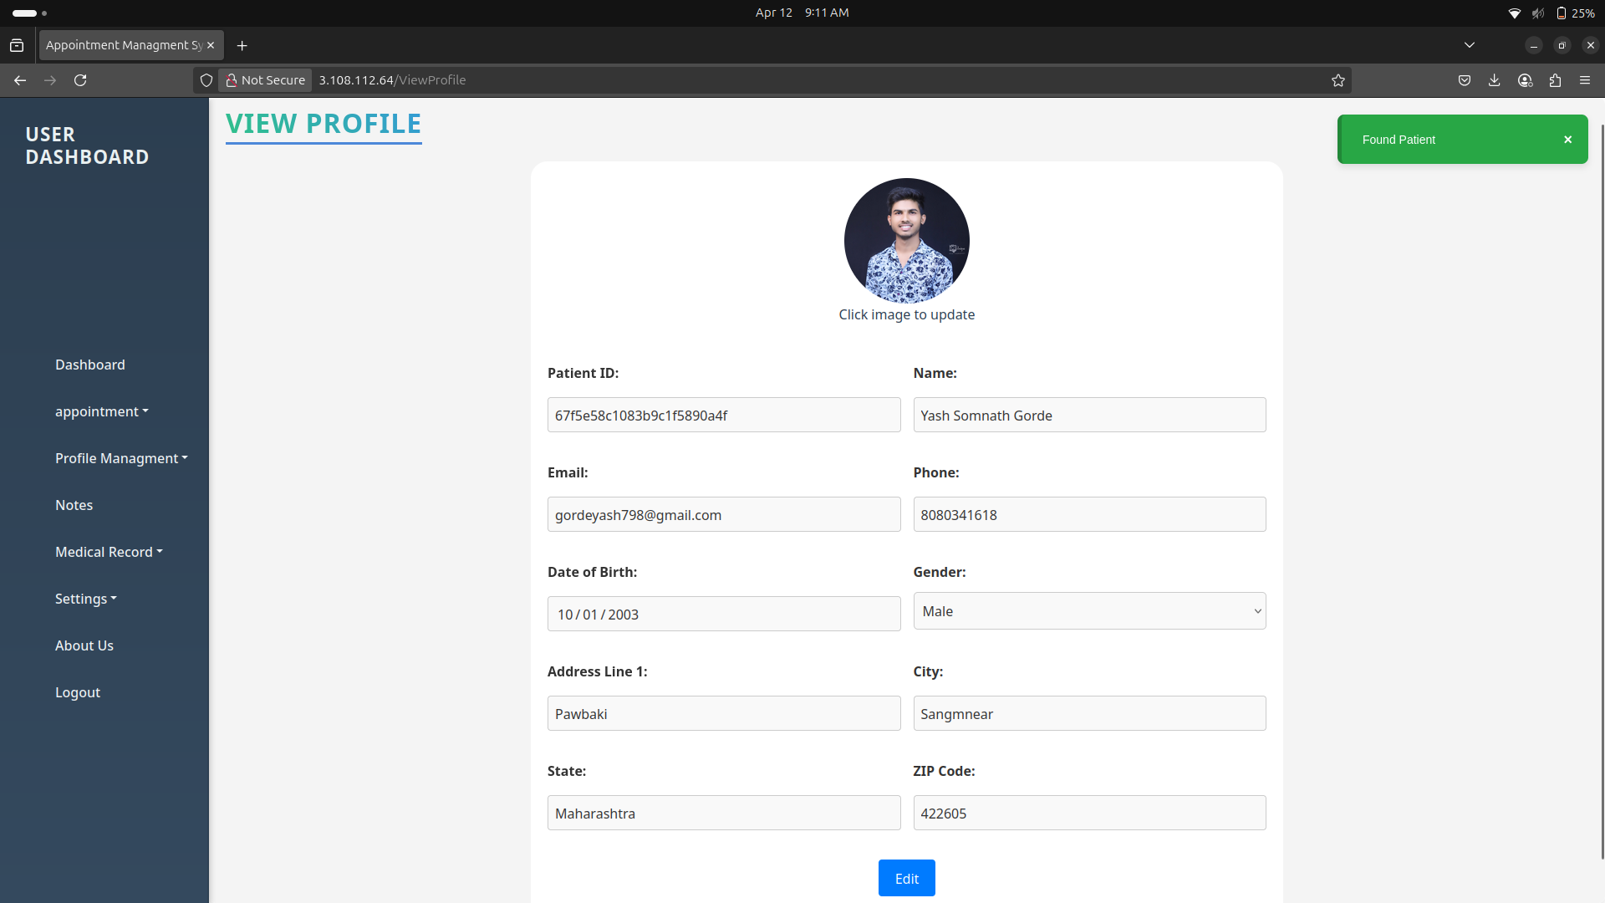

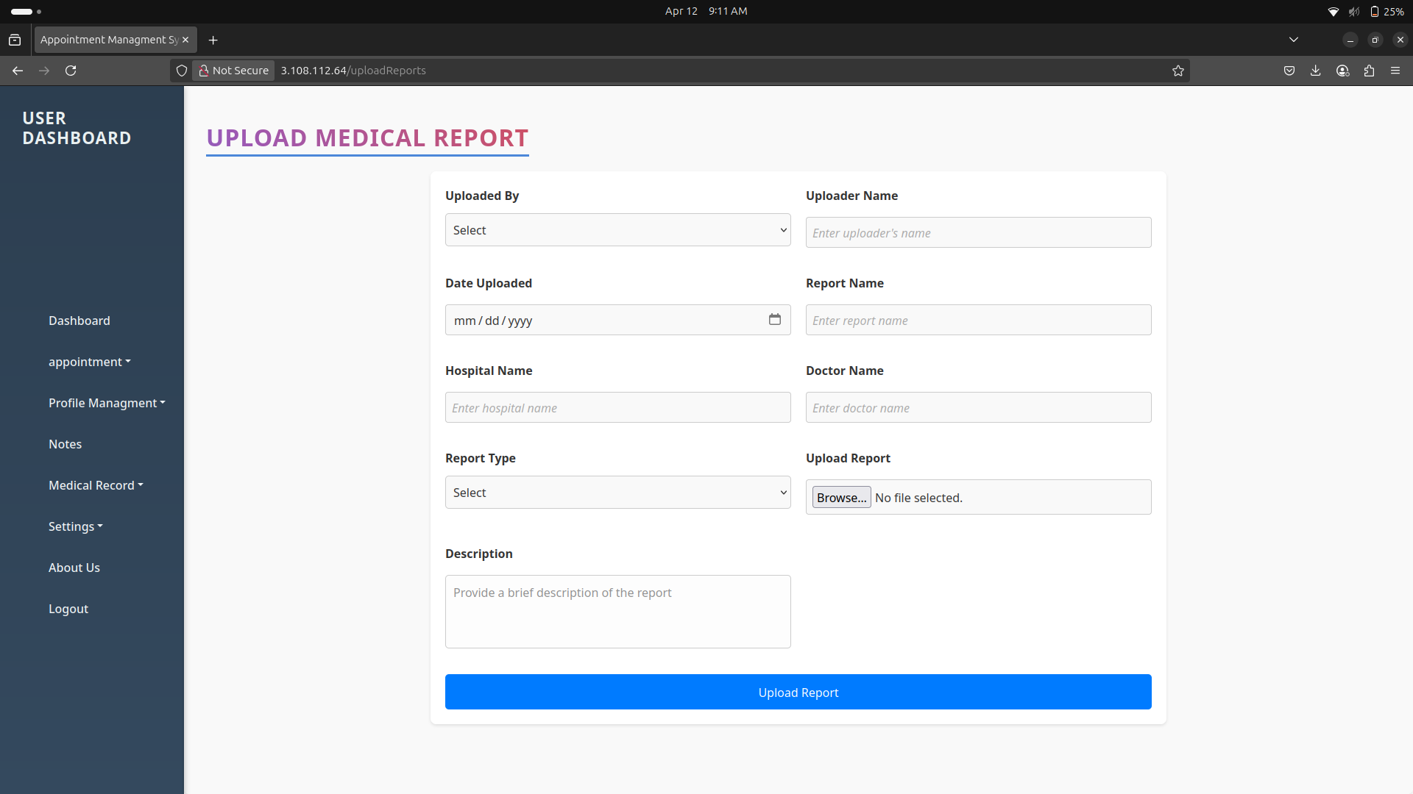

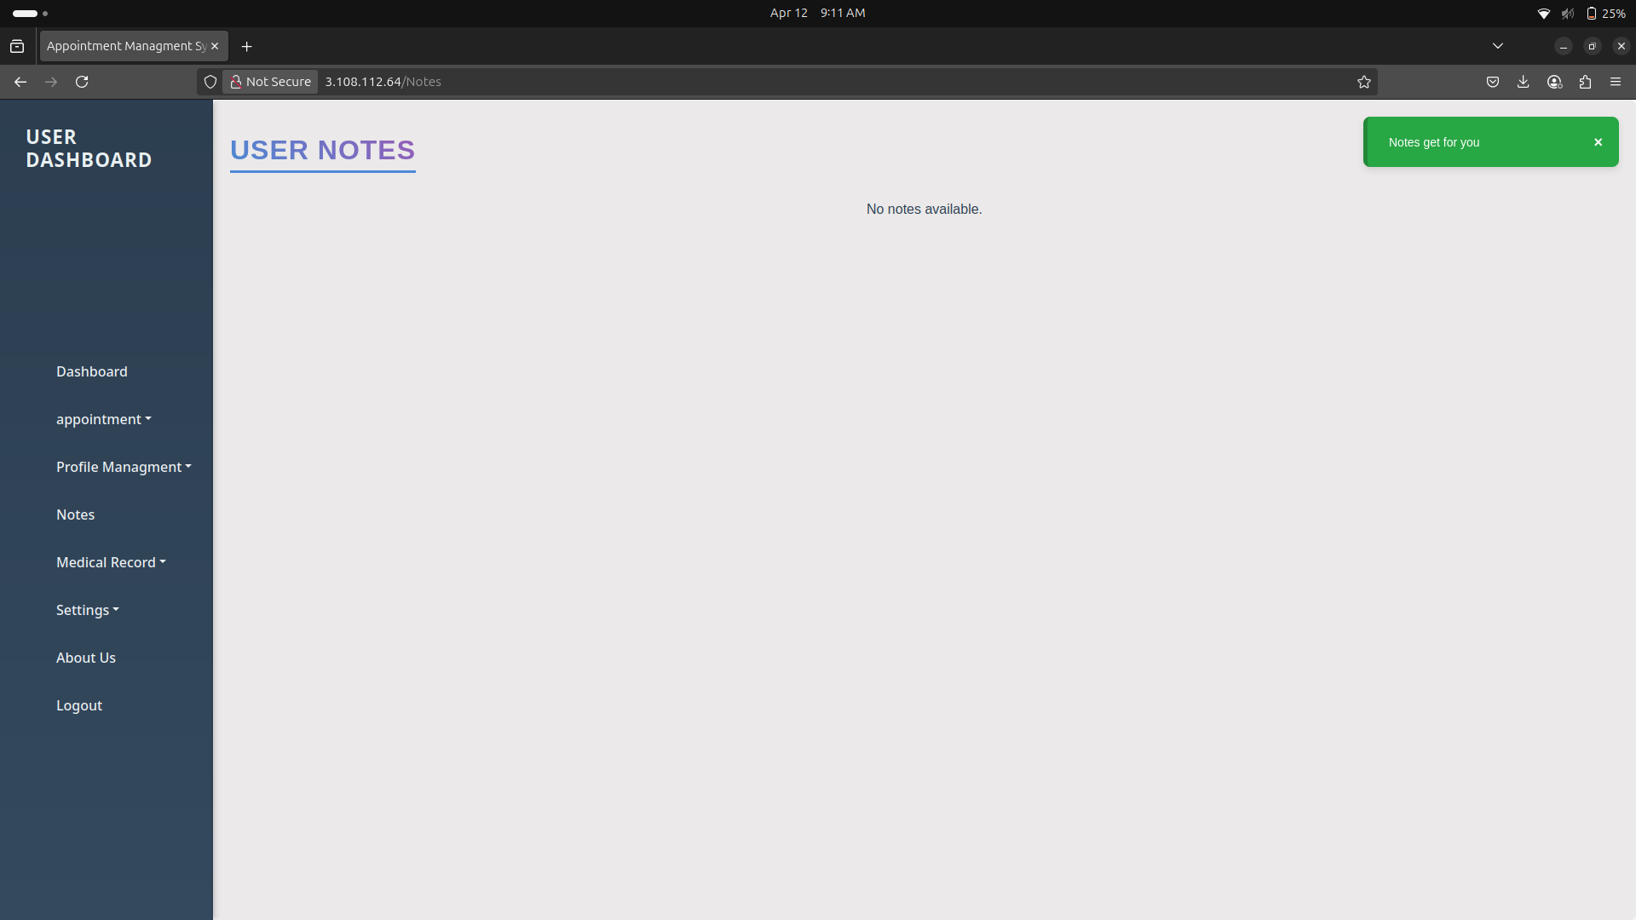

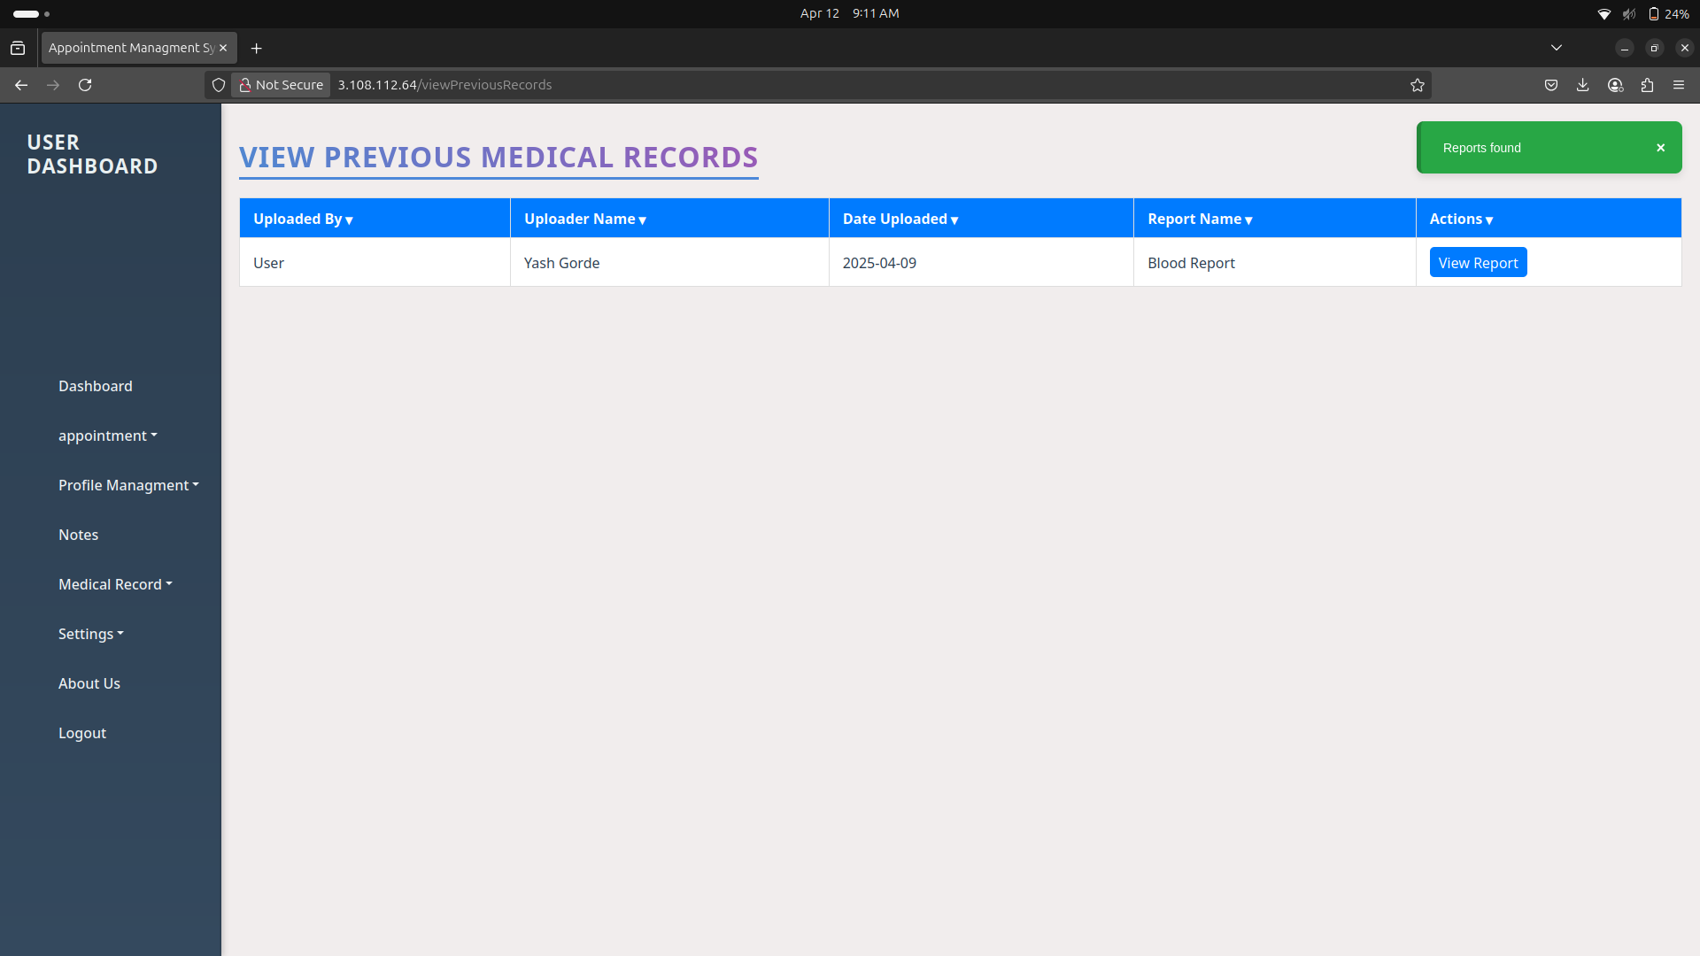
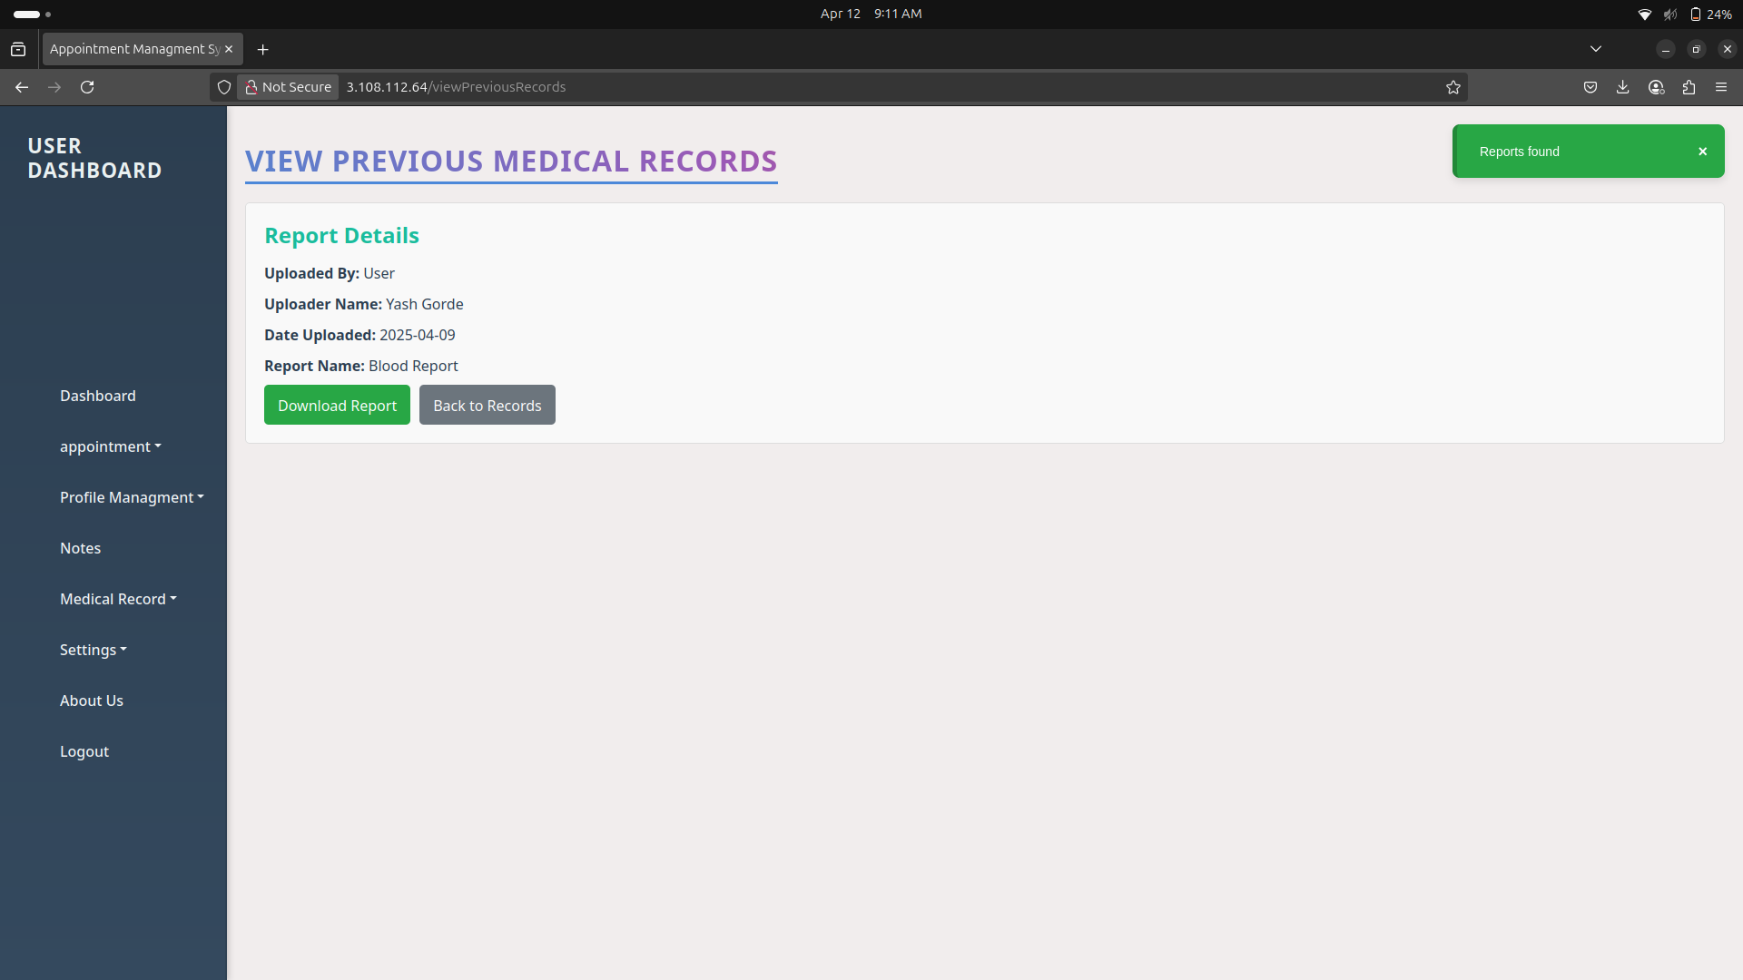

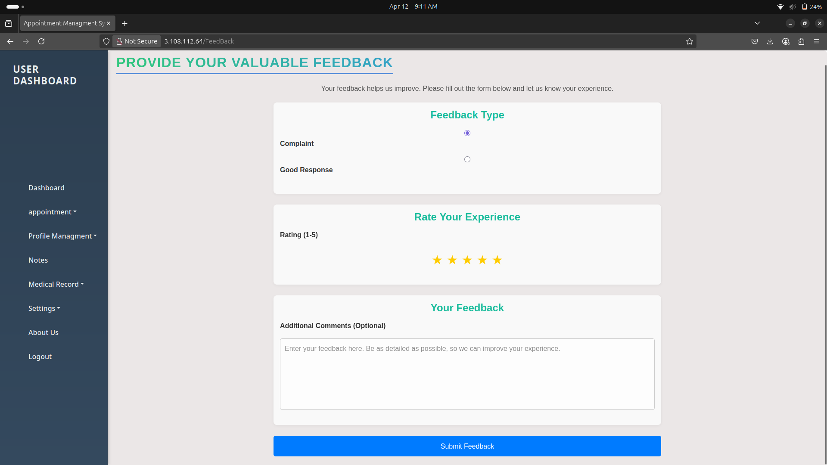
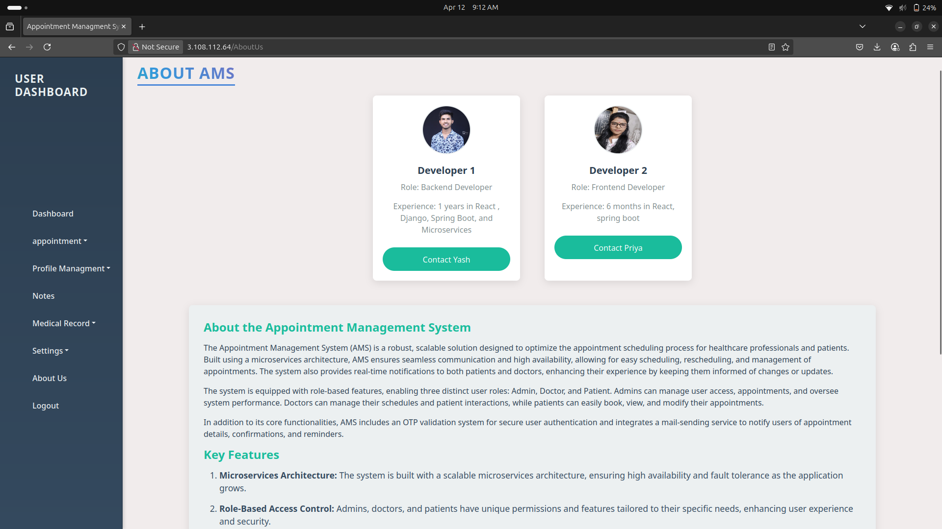

Doctor's UI

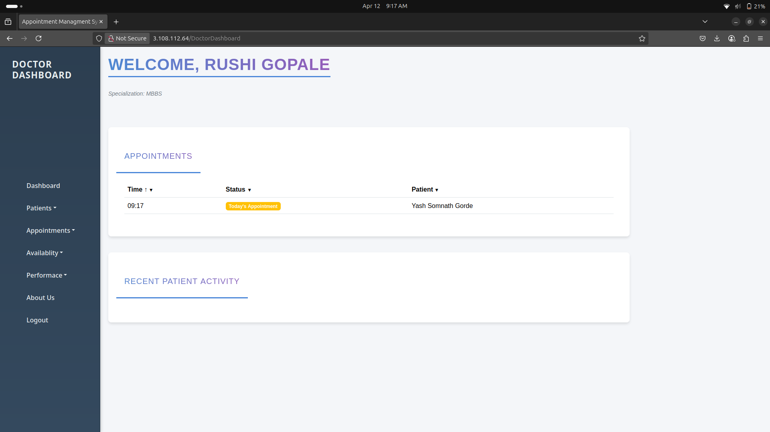
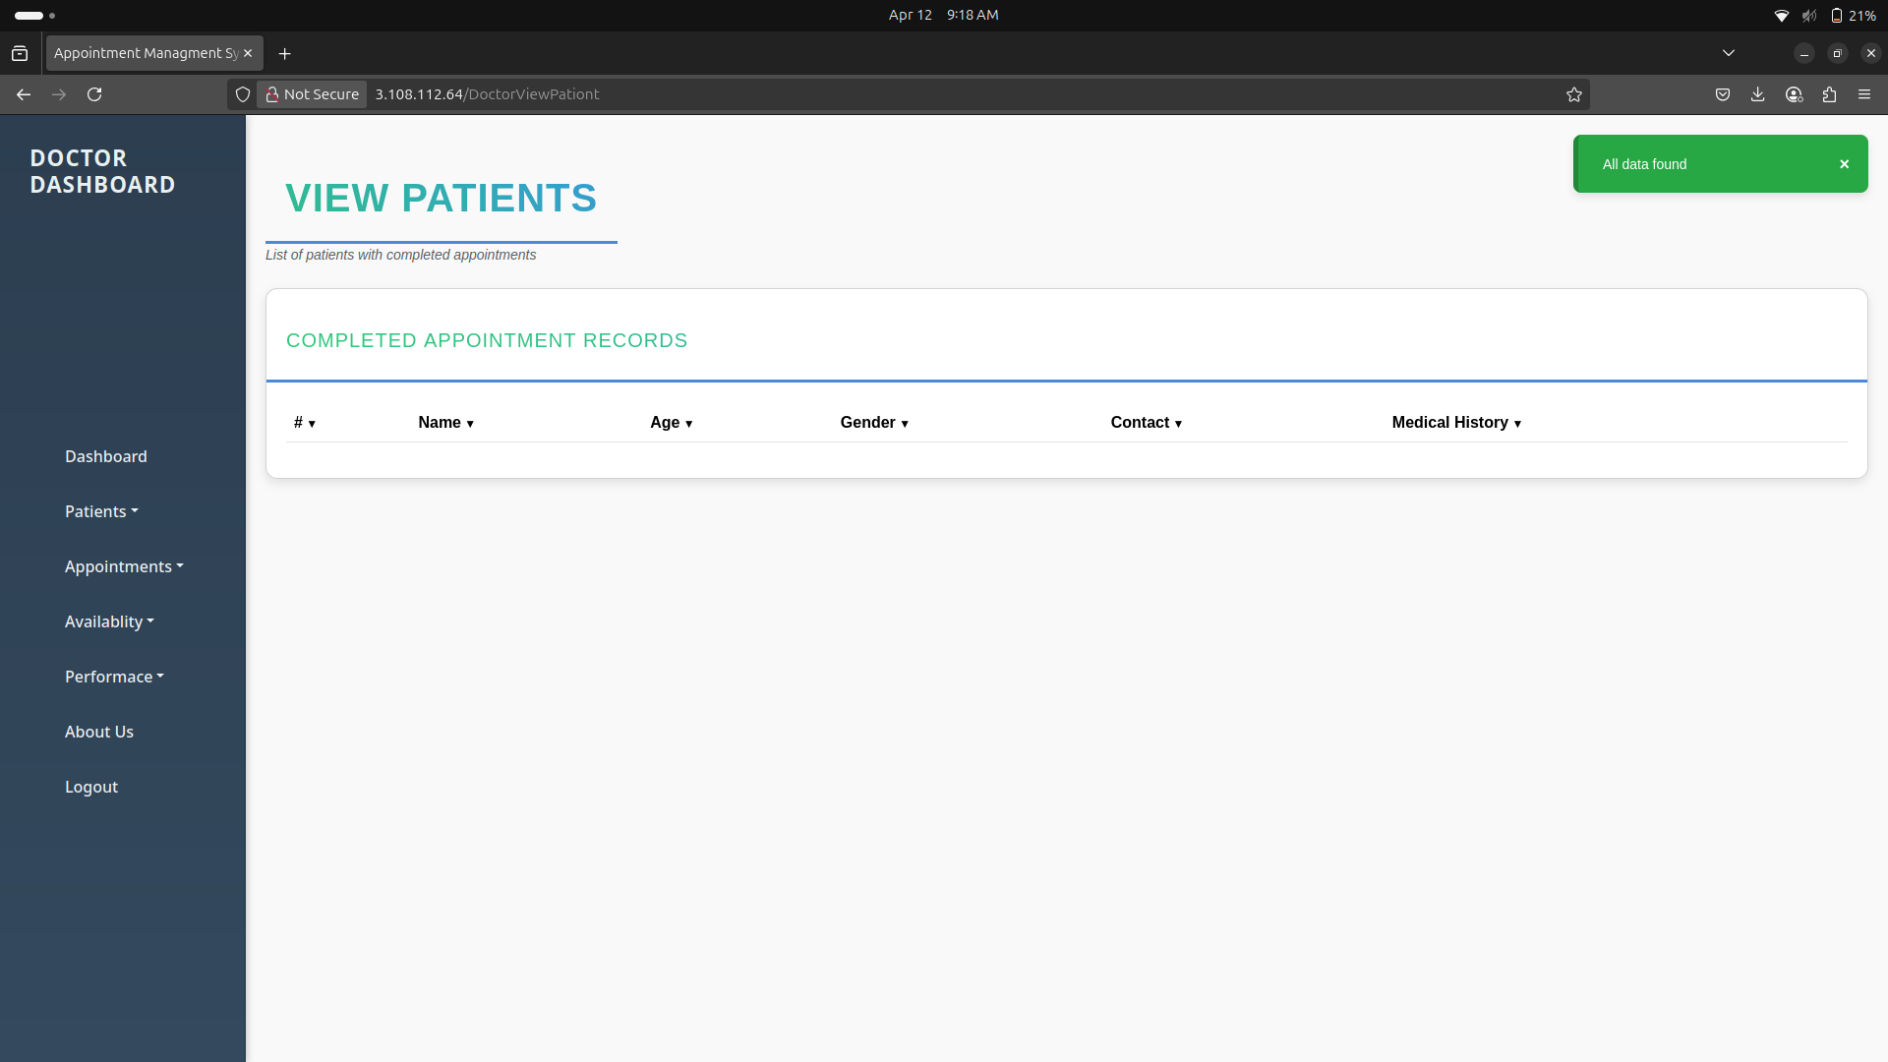

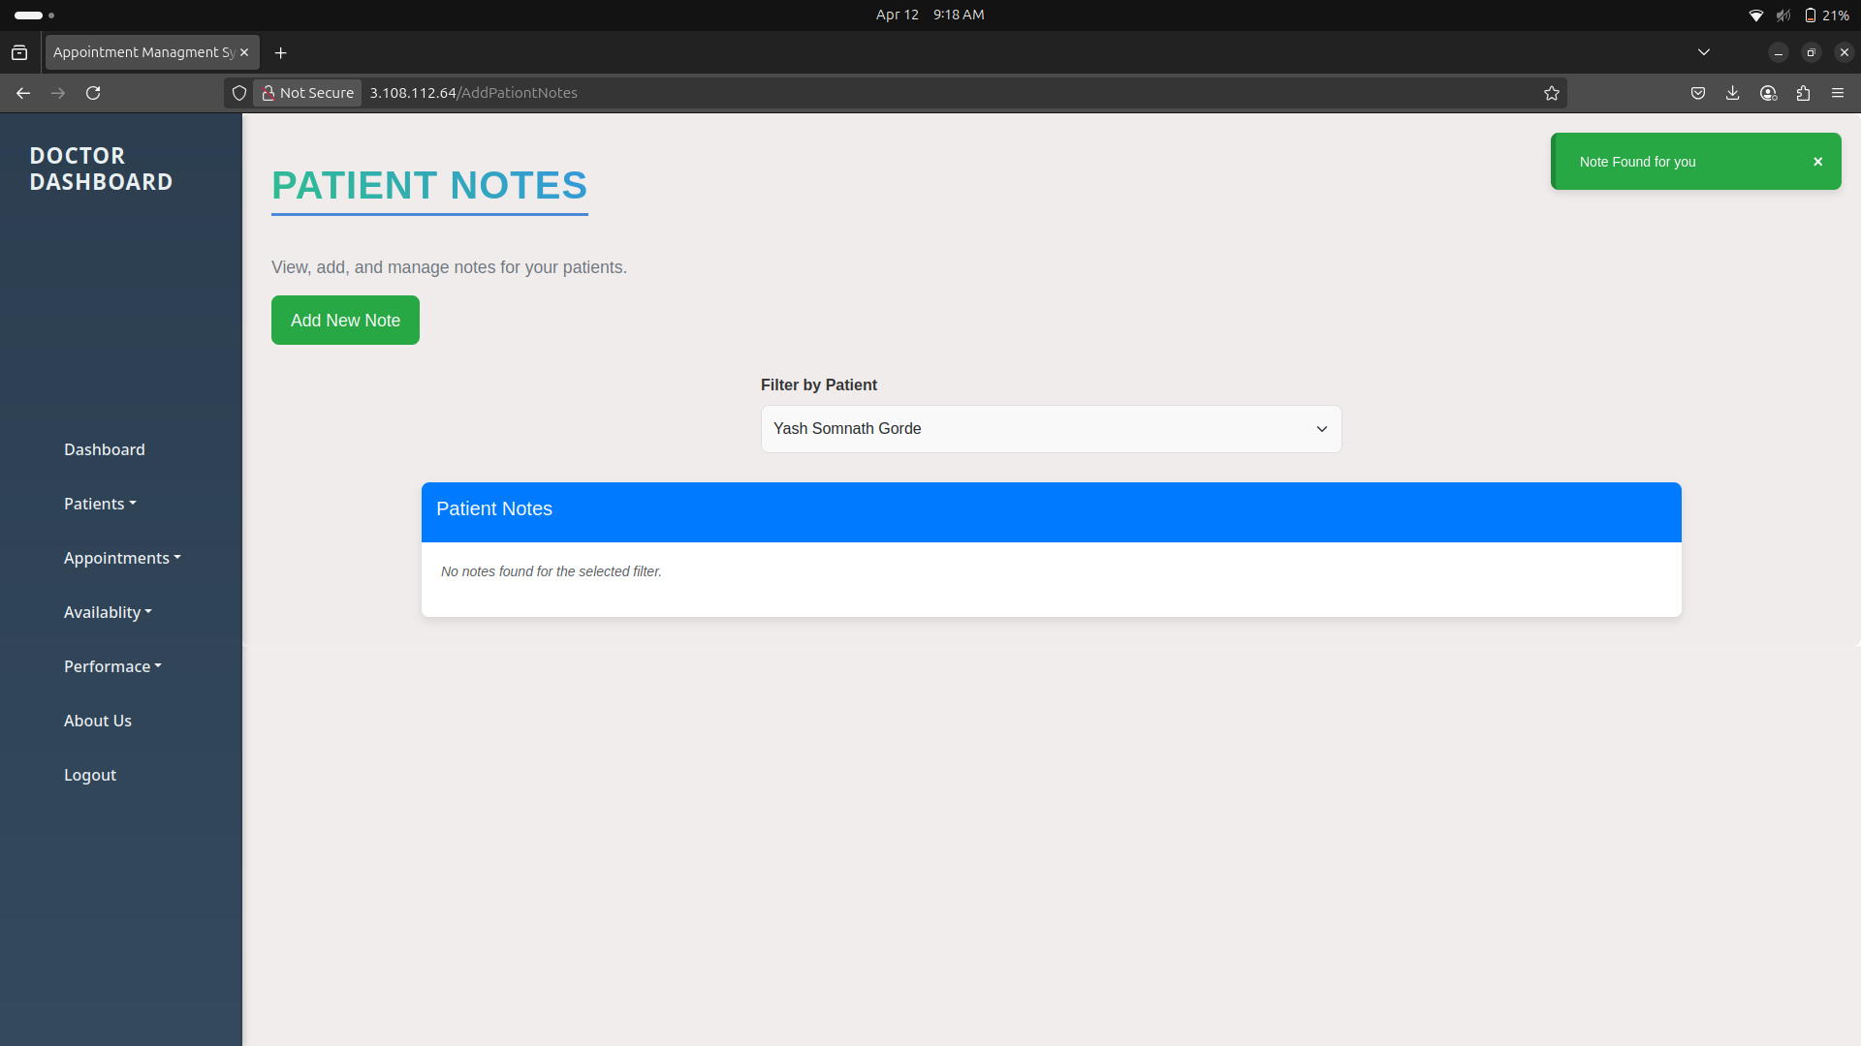

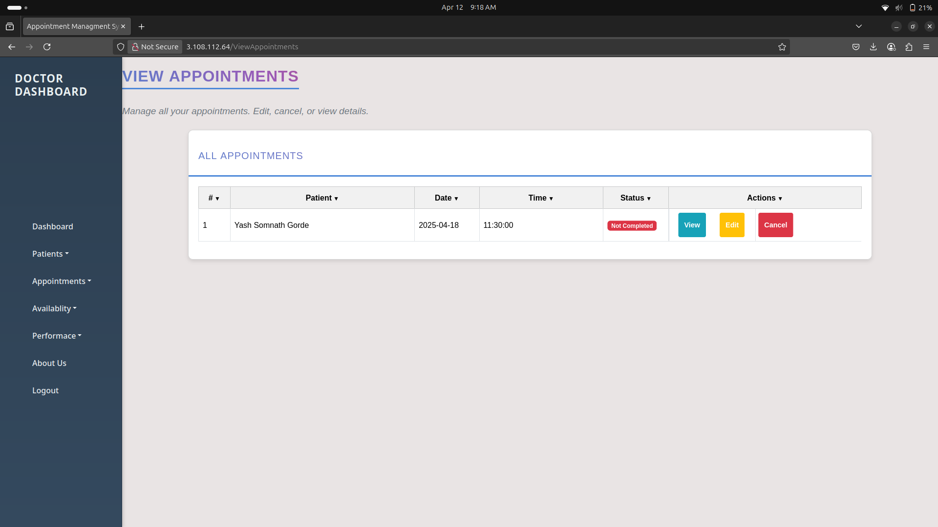

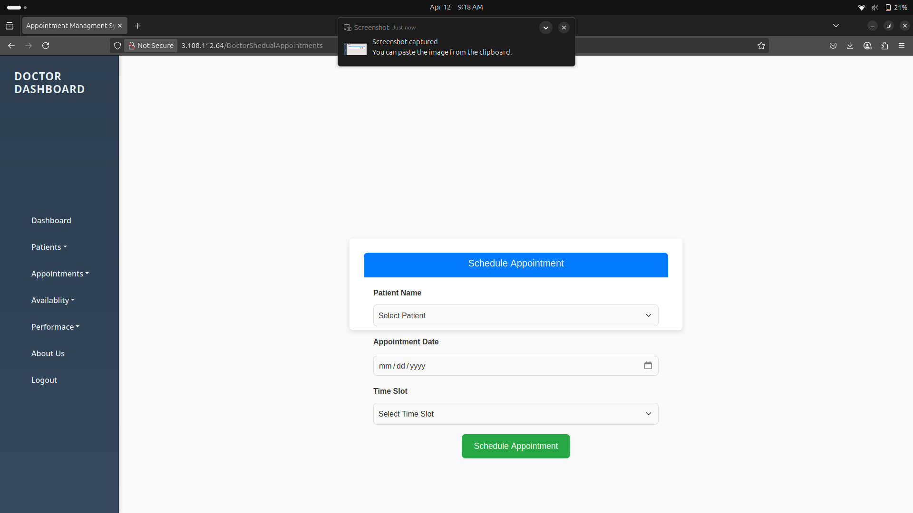

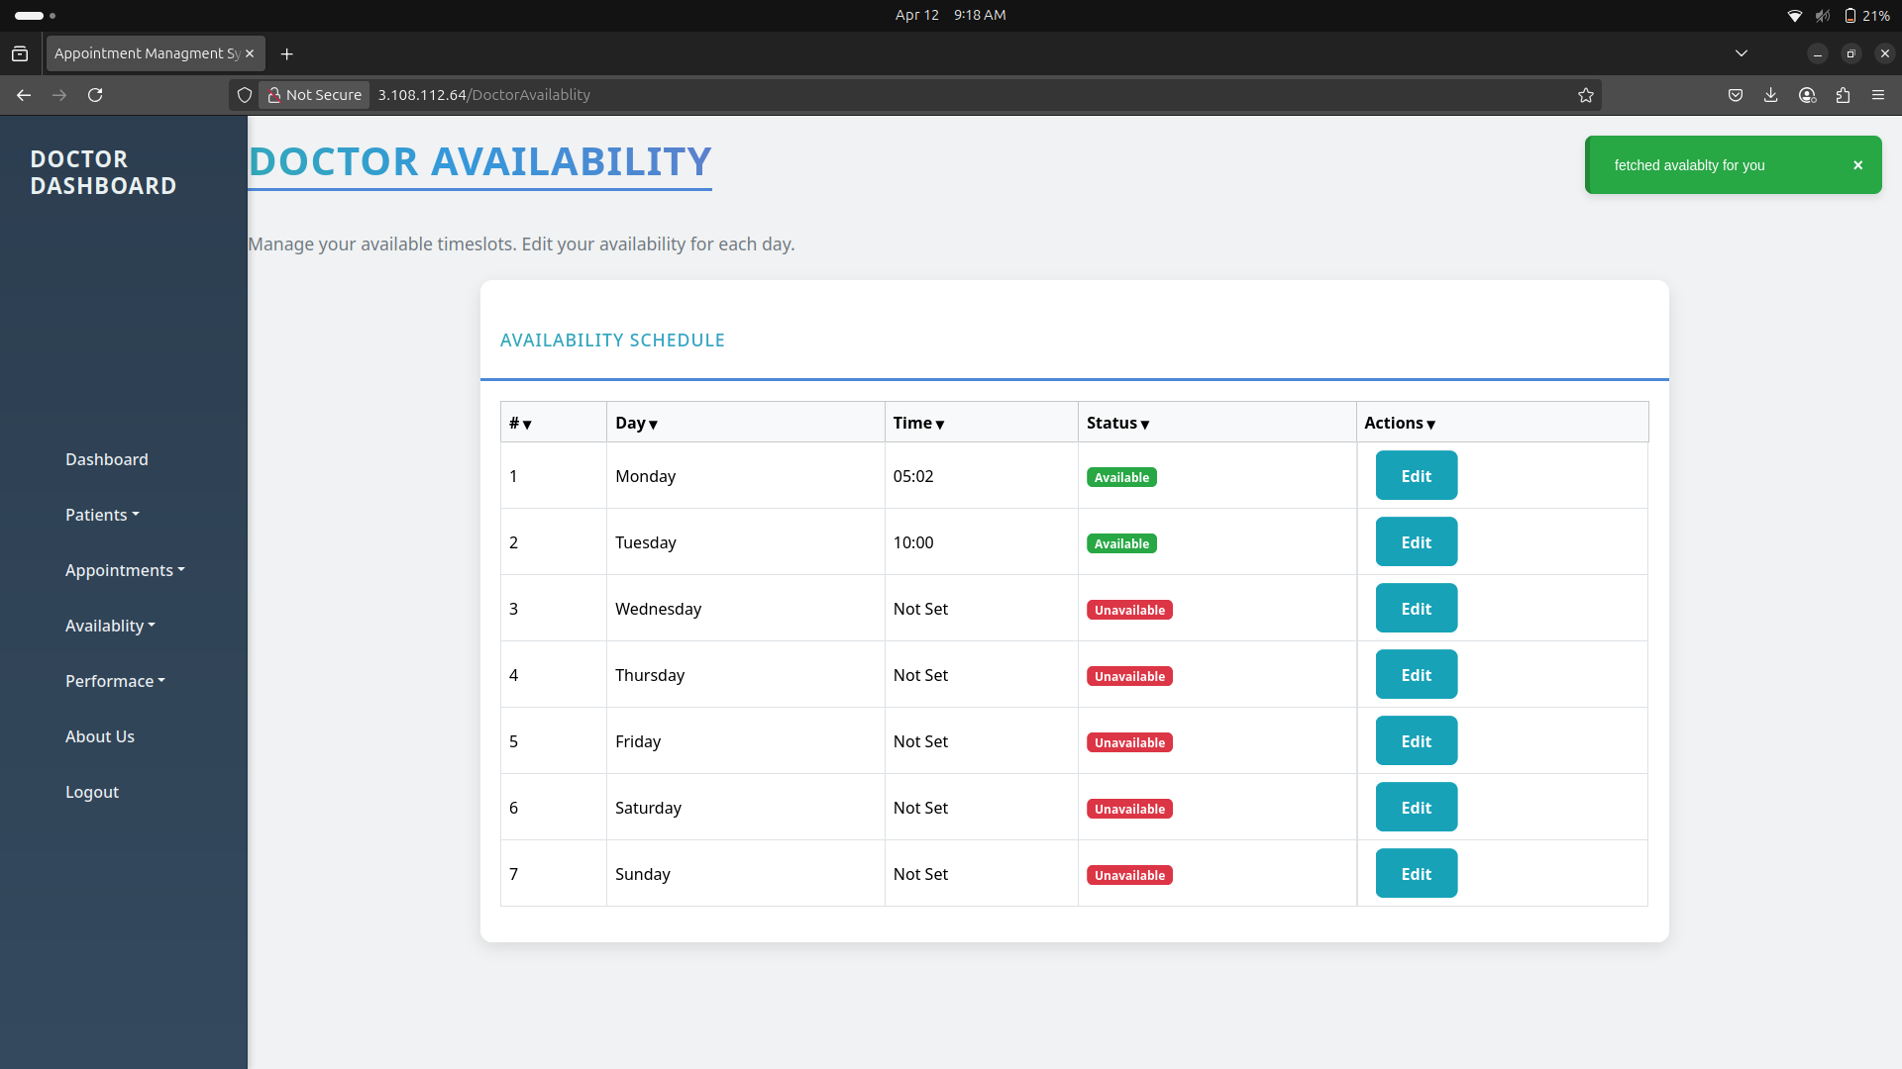

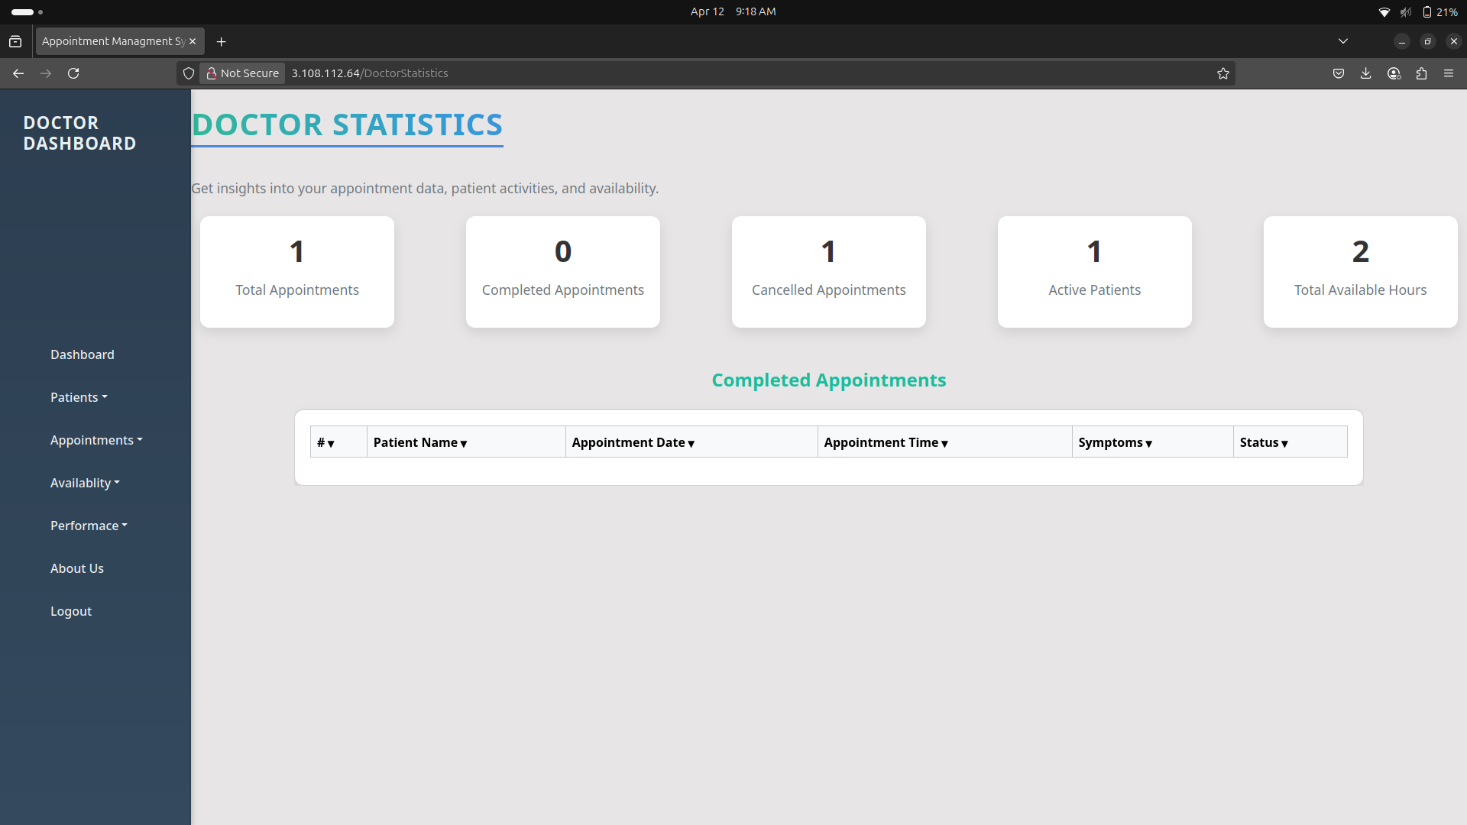

Admin UI

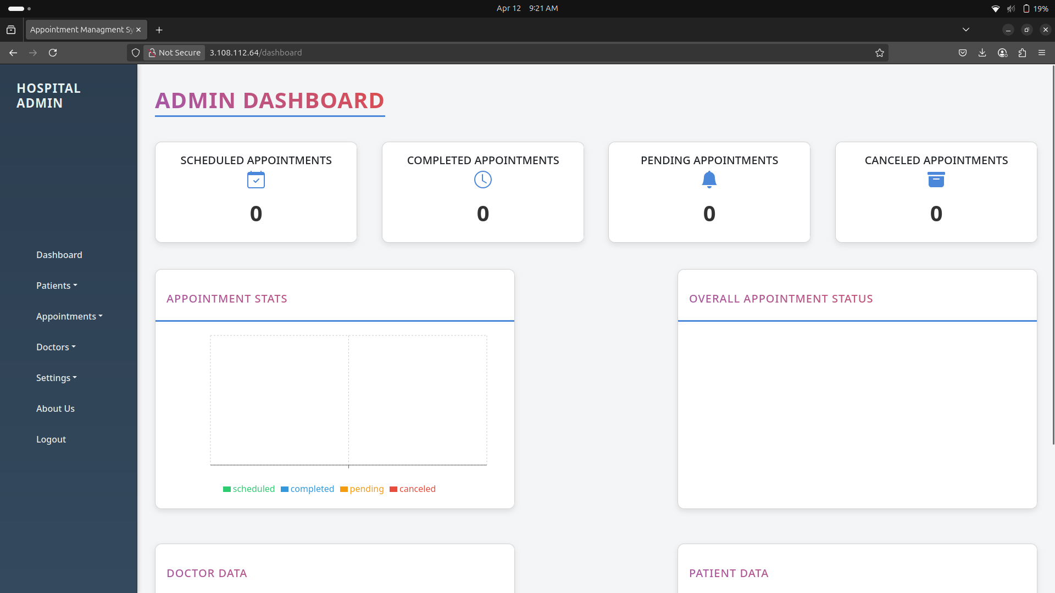

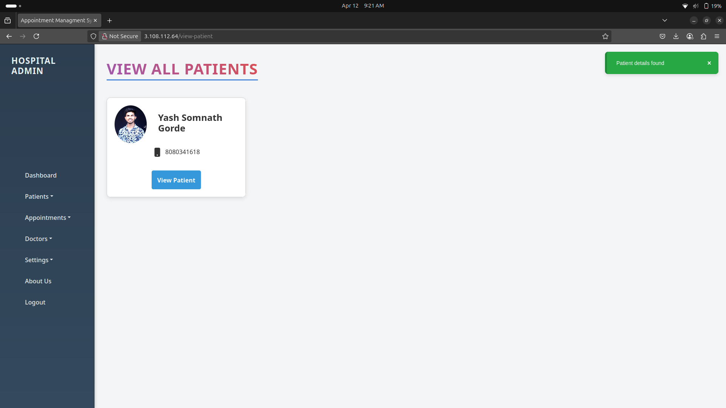

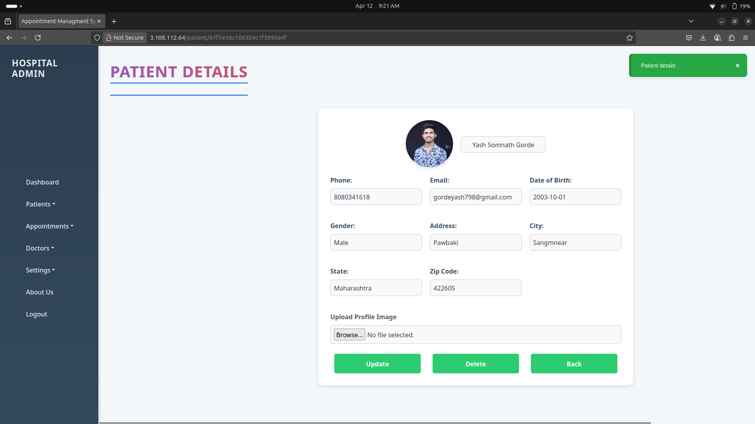
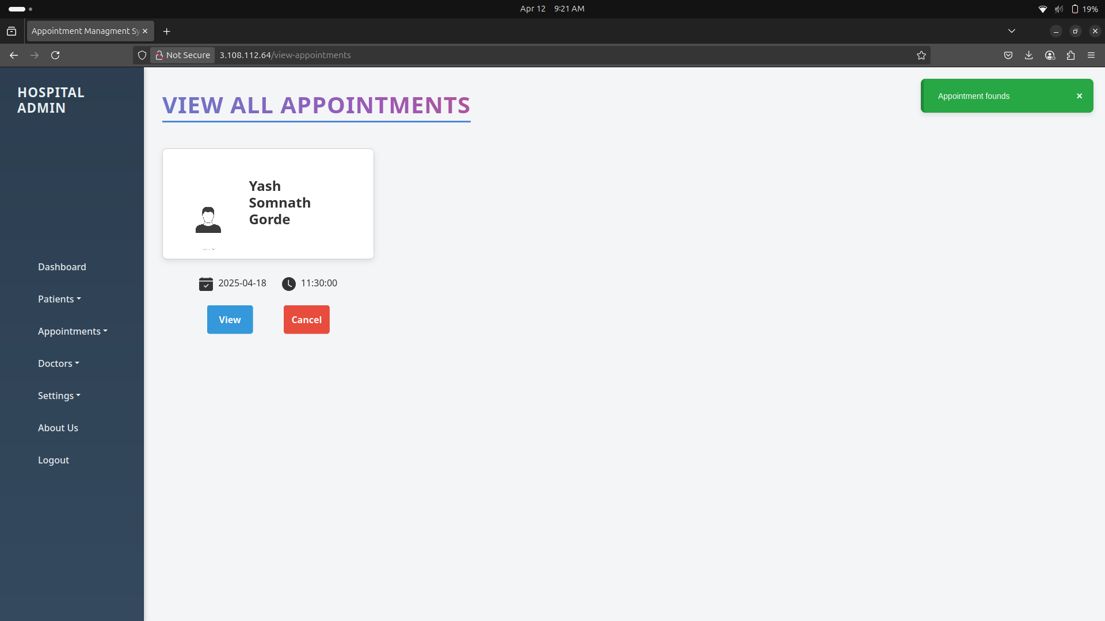

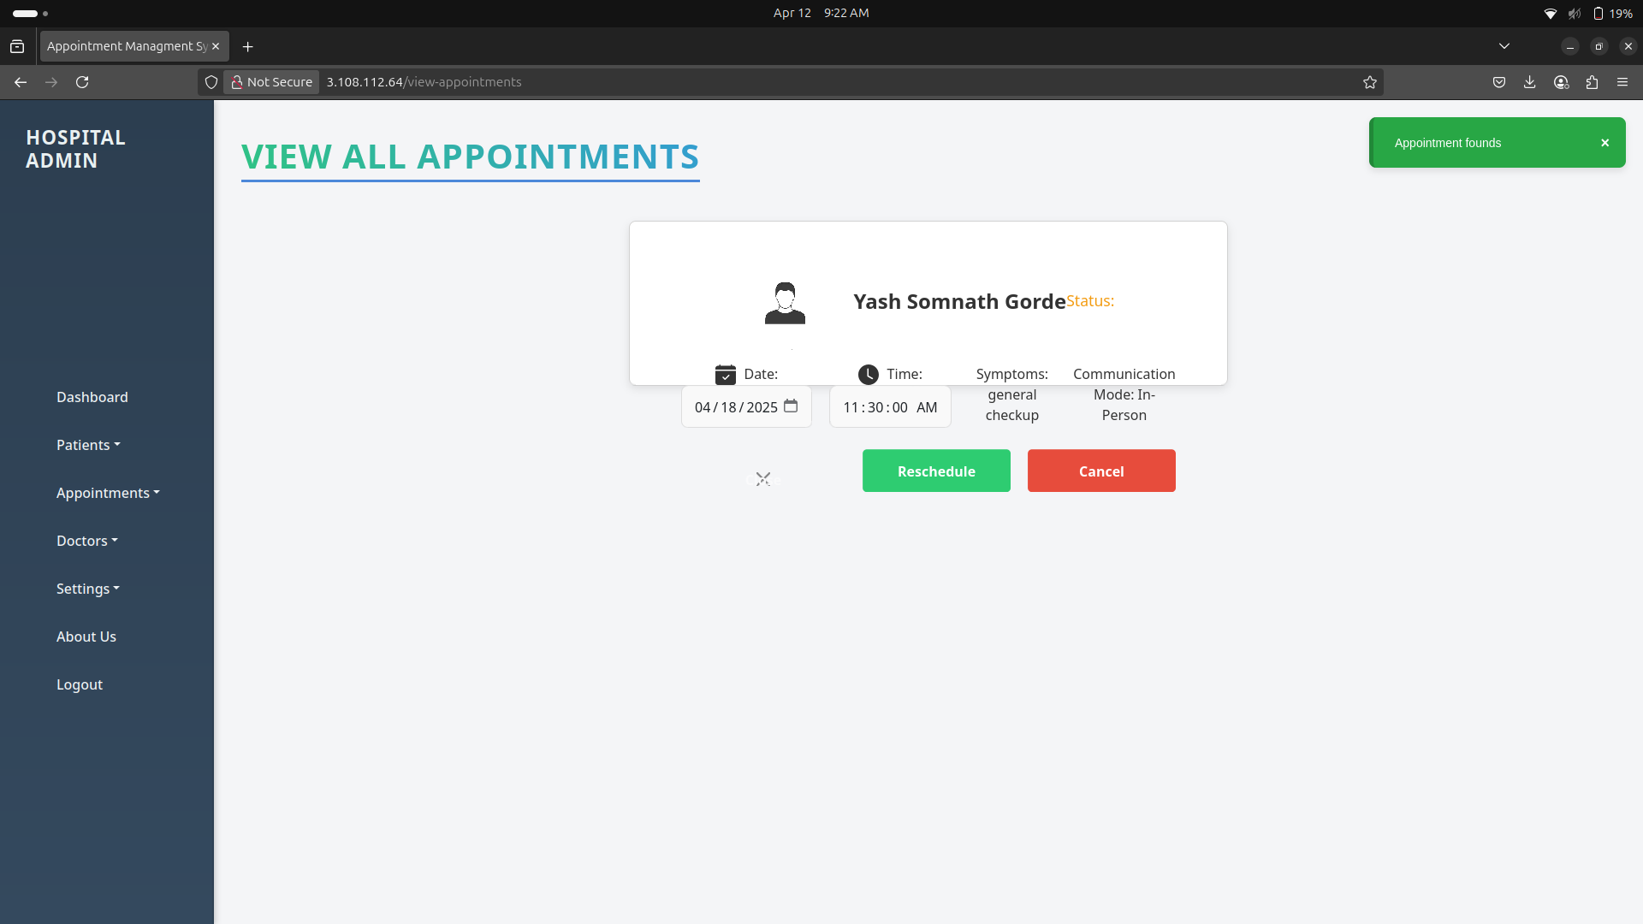

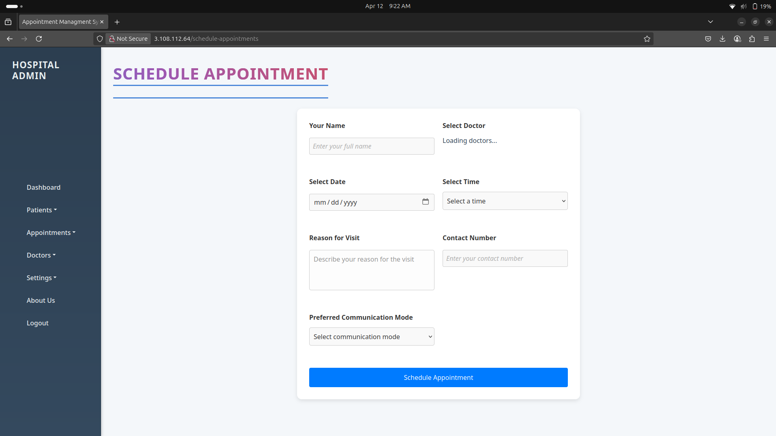

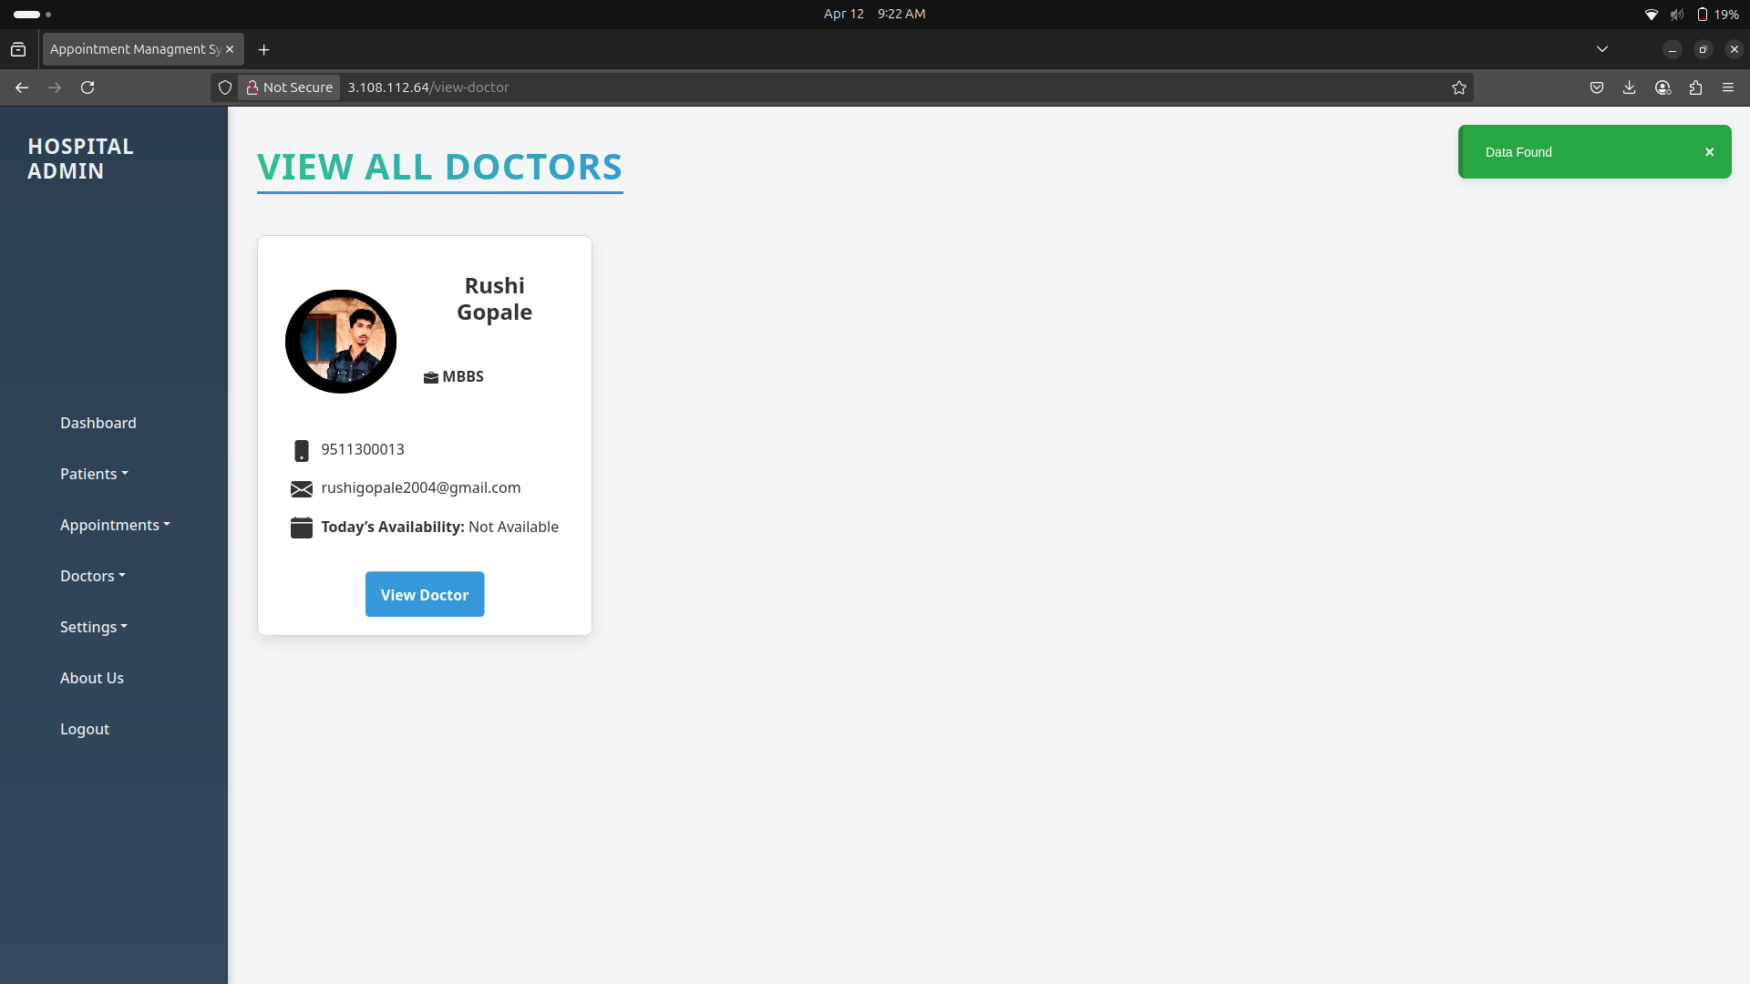

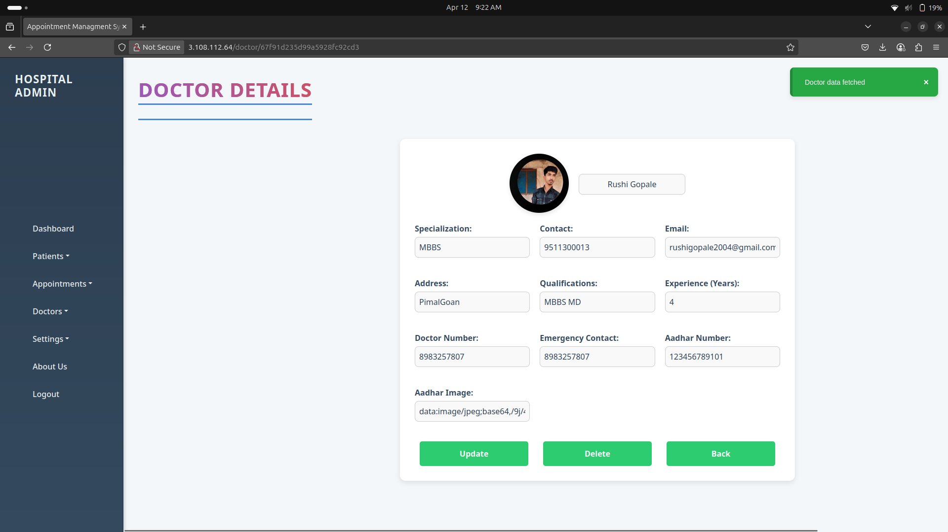

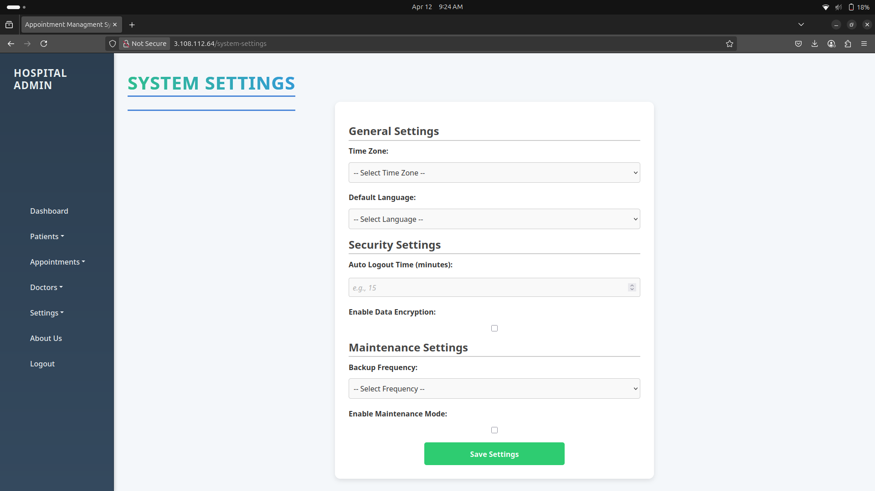

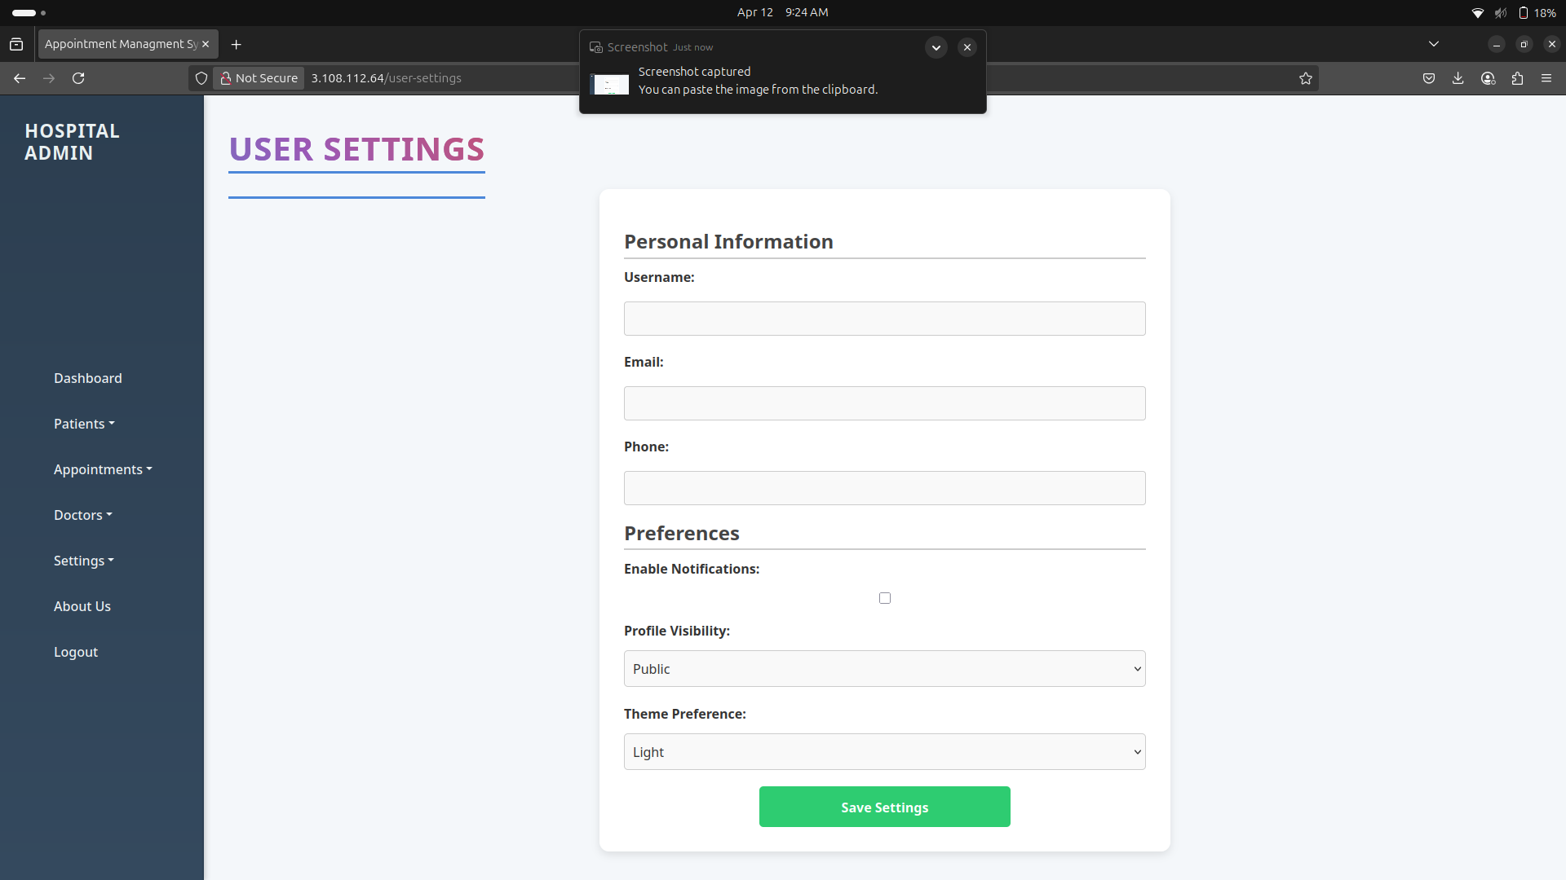

3.4 Test Procedures and Implementation

1. Test Procedures
Testing is a crucial phase to ensure that the Appointment Management System functions as expected. The testing process will cover different levels, including unit testing, integration testing, and user acceptance testing (UAT). Below are the test procedures for the system:

1.1. Unit Testing
- Purpose: Test individual components or modules to ensure they function correctly in isolation.
- Tools:
  - Django: Use Django's built-in testing framework to write test cases for each model, view, and form.
  - React: Use tools like Jest and React Testing Library to test frontend components.
- Procedure:
  - Write Test Cases: Each function or method (e.g., booking an appointment, doctor login, etc.) will have corresponding unit test cases.
  - Execute Tests: Run the tests on individual modules.
  - Validate Output: Ensure that the output matches the expected behavior.

1.2. Integration Testing
- Purpose: Test interactions between different system components, such as frontend and backend, ensuring they work together as expected.
- Tools:
  - Postman for API testing (if using REST APIs between frontend and backend).
  - Selenium or Cypress for end-to-end testing.
- Procedure:
  - Test API Integrations: Test API endpoints to ensure the correct data flow between the frontend and backend.
  - Test User Flows: For example, test the flow of patient appointment booking, admin adding doctors, etc.
  - Test Database Interactions: Ensure data is correctly inserted, updated, and retrieved from the database.

1.3. System Testing
- Purpose: Validate the entire system as a whole, checking for issues such as system stability, user access, and overall functionality.
- Tools:
  - Selenium or Cypress for automated UI testing.
  - Manual testing for user acceptance and navigation.
- Procedure:
  - End-to-End Testing: Test complete processes, from patient registration to appointment booking, ensuring all system features function as expected.
  - Check Edge Cases: Test for scenarios such as overbooked doctors, incorrect user inputs, etc.
  - Stress Testing: Test how the system handles heavy traffic or a large number of users.

1.4. User Acceptance Testing (UAT)
- Purpose: Ensure that the system meets the users' expectations and needs.
- Procedure:
  - Test by Real Users: Have actual users (patients, doctors, and admin) perform common tasks, such as registering, booking an appointment, and managing schedules.
  - Collect Feedback: Gather feedback from the users to ensure the system is intuitive, efficient, and meets requirements.
  - Iterate Based on Feedback: If necessary, implement changes based on user feedback.

1.5. Regression Testing
- Purpose: Ensure that changes made during the development do not break existing functionality.
- Procedure:
  - Re-run Test Cases: After any update or modification, re-run existing tests to ensure no previous functionality has been affected.

2. Implementation

Implementation is the phase where the system is fully developed, deployed, and made operational. It involves system setup, deployment to the server, and user training.

2.1. Pre-Implementation Setup
- Technology Stack: The system will be developed using:
  - Frontend: ReactJS
  - Backend: Django (with Django REST Framework for APIs)
  - Database: MySQL (or PostgreSQL for advanced features), MongoDB (if required for specific data storage)
  - Authentication: JWT or OAuth 2.0
- Environment Setup:
  - Set up development, staging, and production environments.
  - Install necessary dependencies for both frontend and backend.

2.2. System Deployment
- Web Hosting: The system will be deployed on a cloud service like AWS or Heroku to ensure scalability.
- CI/CD: Implement continuous integration and continuous deployment (CI/CD) pipelines for automated testing and deployment.
  - Tools: GitHub Actions, Jenkins, Docker (for containerization), and AWS Elastic Beanstalk.
- Domain Setup: Purchase and configure a domain (e.g., appointment-system.com) and configure DNS settings to point to the server.

2.3. Data Migration
- If the system needs to import data from an existing system, we will create a data migration plan.
  - This could include exporting existing patient and appointment data and transforming it into a format compatible with the new system.

2.4. User Training and Documentation
- User Guides: Provide clear documentation for users (Admin, Doctors, Patients) on how to use the system.
- Admin Training: Train administrators on managing user access, managing appointments, and generating reports.

2.5. Go Live
- Monitoring: Monitor the system’s performance and user activities after going live to address any immediate issues.
- Bug Fixes and Updates: Address any bugs found post-deployment and make necessary updates or patches.

4 . User Manual

1. Introduction
The Appointment Management System provides a secure and efficient platform for managing healthcare appointments. The system supports role-based access for Admins, Doctors, and Patients, and features an OTP-based email verification system for both login and registration to enhance security.

2. System Requirements
- Web Browser: Chrome, Firefox, or Edge (latest versions)
- Internet Access: Required
- Email Account: For receiving OTPs

3. Getting Started

3.1 Registration with Email OTP
  - Go to the Home Page.
  - Click on "Register" and select your role: Admin, Doctor, or Patient.
  - Fill in the registration form with details like name, email, mobile number, etc.
  - Click "Register".
  - An OTP will be sent to your registered email.
  - Enter the OTP in the verification form to complete registration.
  - Upon successful verification, your account will be created.

3.2 Login with Email OTP
  - Click on "Login".
  - Select your role and enter your registered email address.
  - Click "Send OTP".
  - Check your email for the OTP.
  - Enter the OTP in the login form.
  - Upon successful OTP verification, you'll be redirected to your dashboard.

4. Role-Based Functionalities

Admin Dashboard
- View statistics and system overview.
- Add, view, or remove doctors and patients.
- Manage appointments for all users.
- Access logs and user activities.

Doctor Dashboard
- View appointments assigned.
- Update availability and schedule.
- Add medical notes and prescriptions for patients.
- Access patient history.

Patient Dashboard
- Book new appointments with available doctors.
- View appointment history.
- Edit profile and contact details.
- Receive email confirmations and reminders.

5. OTP Troubleshooting
Issue | Solution
OTP not received | Check spam/junk folder or wait a minute
OTP expired | Click on "Resend OTP" to generate a new one
Entered OTP is incorrect | Ensure you typed it exactly as received

6. Security Tips
- Never share your OTP with anyone.
- Each OTP is valid for a limited time (e.g., 5 minutes).
- System uses secure email protocols and encrypted sessions.

7. Support
For help, contact:
gordeyash798@gmail.com
+91-8080341618

5. Drawbacks and Limitations

While the Appointment Management System provides numerous benefits, it also has certain drawbacks and limitations that need to be acknowledged. These limitations should be considered for improvement in future versions or during system maintenance.

1. System Complexity
- Description: The system is built on a microservices architecture, which can make the development, testing, and maintenance more complex.
- Impact: Managing multiple services (Django for appointment management, Spring Boot for handling appointments, etc.) and ensuring seamless communication between them may require additional resources and expertise.
- Limitation: The increased complexity may make it harder to onboard new developers or scale the system efficiently without experienced professionals.

2. Dependency on Internet Connection
- Description: As the system is web-based, it requires a stable internet connection for accessing the application.
- Impact: If users (e.g., doctors, patients) have a poor internet connection, it can lead to delays in loading pages or failed bookings.
- Limitation: Offline functionality for users, such as doctors and patients, is not available in the current version, making it unsuitable for areas with unreliable internet access.

3. Security Concerns
- Description: Handling sensitive data such as patient details, appointment schedules, and medical records presents potential security challenges.
- Impact: While the system will implement strong encryption and secure login (e.g., JWT or OAuth 2.0), there remains a risk of data breaches or cyberattacks if the system is not adequately protected.
- Limitation: Regular updates to security protocols and system patches are necessary to minimize the risk of data theft or unauthorized access.

4. Limited Customization for Different User Types
- Description: The system provides predefined user roles and access controls (e.g., Admin, Doctor, Patient).
- Impact: While this suits standard scenarios, organizations with specific needs might find the default role management limiting.
- Limitation: More granular role management or customization of user access levels might be required for larger hospitals or clinics with complex operations.

5. Scalability Issues
- Description: The system is designed to handle a reasonable number of users (patients, doctors, and administrators), but scalability beyond a certain threshold may pose challenges.
- Impact: The current database structure and architecture may face performance issues if a large number of users or appointments are added simultaneously.
- Limitation: Scaling the system for large hospitals or regions with high patient volumes might require architectural modifications, such as database partitioning or load balancing.

6. Lack of Integration with Other Health Systems
- Description: The system currently operates independently, without integration with external health systems (e.g., Electronic Health Records (EHR) or Hospital Information Systems (HIS)).
- Impact: For hospitals that already use EHR or other management software, this may lead to data silos and additional manual effort for managing patient information.
- Limitation: Future versions may need to implement FHIR (Fast Healthcare Interoperability Resources) or other APIs to integrate seamlessly with other healthcare systems.

7. User Experience (UX) for Elderly or Technologically Challenged Users
- Description: The system’s interface may not be intuitive for all users, especially elderly patients or those who are not familiar with technology.
- Impact: While efforts are made to design a simple and user-friendly interface, some users may find it difficult to navigate or may not trust online appointment booking systems.
- Limitation: More inclusive design features (e.g., text size adjustment, voice commands) might be necessary to ensure accessibility for all types of users.

8. High Initial Setup and Maintenance Costs
- Description: The initial setup, including cloud infrastructure, security measures, and data migration, can be costly.
- Impact: Smaller clinics or healthcare providers may find the upfront costs of setting up the system prohibitive, especially if they are not using cloud services.
- Limitation: The system might need to offer flexible pricing models or discounted solutions for small-scale users or non-profits.

9. Limited Reporting and Analytics
- Description: Although the system provides basic reports, advanced data analytics (such as predictive analysis of patient appointments, doctor availability optimization, etc.) is not included in the initial version.
- Impact: Admins and doctors may miss valuable insights that could help optimize appointment scheduling, staffing, and patient management.
- Limitation: More sophisticated analytics and reporting tools may need to be developed or integrated into the system.

10. Maintenance and Updates
- Description: As the system is web-based, it requires ongoing maintenance, bug fixes, and updates to remain secure and functional.
- Impact: System downtimes or issues after updates could disrupt services for patients or doctors.
- Limitation: Regular maintenance is essential, and unplanned downtime for updates or fixes could affect users’ ability to book or manage appointments.

6. Proposed Enhancements

While the current Appointment Management System provides essential functionalities for managing appointments, patient data, and doctor availability, several enhancements could be implemented to further improve the system’s efficiency, user experience, and scalability. Below are some proposed enhancements:

1. Mobile Application Support
- Enhancement: Develop mobile apps (iOS/Android) for patients, doctors, and administrators to manage appointments and data on the go.
- Benefits:
  - Improved Accessibility: Users can manage appointments, view doctor availability, and receive notifications on their mobile devices.
  - Offline Functionality: Provide offline capabilities, allowing users to view appointments and data when they don’t have internet access, syncing changes when back online.

2. Integration with Electronic Health Records (EHR) Systems
- Enhancement: Integrate with EHR systems or Hospital Information Systems (HIS) to enable seamless data exchange between the appointment system and patient health records.
- Benefits:
  - Unified Data: Doctors can access complete patient histories when managing appointments, eliminating the need for manual data entry.
  - Improved Workflow: Eliminates duplicate data entry and ensures that all healthcare systems are aligned with each other.

3. AI-Based Appointment Scheduling
- Enhancement: Implement an AI-powered appointment scheduling system that can automatically recommend the best available time slots for both patients and doctors based on preferences, previous appointment histories, and doctor availability.
- Benefits:
  - Optimized Scheduling: Minimizes overbooking or underutilization of doctors’ time.
  - Reduced Waiting Time: Patients are more likely to get quicker access to available time slots.
  - Smart Notifications: Patients and doctors can receive intelligent reminders about upcoming appointments based on their behavior and preferences.

4. Telemedicine Integration
- Enhancement: Incorporate telemedicine functionality to enable virtual appointments between patients and doctors, especially for consultations that don’t require in-person visits.
- Benefits:
  - Increased Accessibility: Patients in remote or underserved areas can still access medical consultations.
  - Improved Patient Care: Doctors can provide timely care without the constraints of travel or scheduling conflicts.
  - Reduced Overcrowding: Hospitals and clinics can reduce waiting room overcrowding by offering virtual appointments.

5. Enhanced Reporting and Analytics
- Enhancement: Implement more sophisticated analytics and reporting tools that provide actionable insights, such as:
  - Predicting patient appointment trends.
  - Analyzing doctor performance and patient satisfaction.
  - Monitoring system usage to identify bottlenecks or inefficiencies.
- Benefits:
  - Data-Driven Decisions: Administrators can make informed decisions to optimize staffing, scheduling, and overall patient care.
  - Advanced Analytics: Predictive analytics can help anticipate patient demand, reducing long wait times and optimizing doctor schedules.

6. Advanced Security Features
- Enhancement: Implement multi-factor authentication (MFA), end-to-end encryption, and data tokenization to further strengthen security for sensitive patient data.
- Benefits:
  - Increased Security: Extra layers of security reduce the risk of unauthorized access to medical data.
  - Regulatory Compliance: Ensures that the system complies with healthcare regulations like HIPAA and GDPR for data protection.
  - Patient Trust: Strengthens trust in the system by providing robust data protection mechanisms.

7. Customizable User Roles and Permissions
- Enhancement: Enhance the user roles and permissions system to allow for more flexibility. For example, different levels of access could be provided for senior doctors, junior doctors, medical staff, or administrative personnel.
- Benefits:
  - Role-Specific Functionality: Each user can have access to only the information and tools they need to perform their job effectively, preventing data overload.
  - Improved Workflow: Streamlining user access ensures smoother operations in hospitals or clinics.

8. Integration with Payment Systems
- Enhancement: Integrate with payment gateways (e.g., Stripe, PayPal, Razorpay) to allow patients to pay for appointments directly through the platform.
- Benefits:
  - Convenient Payment Options: Patients can pay online during the booking process, reducing the need for in-person payments.
  - Improved Cash Flow: Hospitals or clinics can improve cash flow management by collecting payments upfront or at the time of booking.
  - Simplified Billing: Automates billing and invoicing for appointments.

9. Multilingual and Multi-Currency Support
- Enhancement: Add multilingual support for the system’s interface to cater to a wider range of users and multi-currency support for international patients.
- Benefits:
  - Global Reach: Support for different languages and currencies makes the system more accessible to patients and doctors in diverse geographic locations.
  - Improved User Experience: Offers a more inclusive experience for non-English speaking users.

10. Performance Optimization and Scalability
- Enhancement: Focus on optimizing the system for high-performance and scalability. This could include database optimization, server load balancing, and implementing cloud-native solutions for seamless scaling.
- Benefits:
  - Faster Load Times: Optimized code and databases ensure that users don’t experience slowdowns, even with high volumes of data.
  - Scalable Infrastructure: The system can handle a growing number of users or appointments without compromising performance.
  - Cost-Efficiency: Scalable cloud infrastructure can reduce operational costs by adjusting resources based on demand.

11. Voice Integration for Appointment Booking
- Enhancement: Introduce voice assistants (e.g., Alexa, Google Assistant) to allow patients to book, cancel, or inquire about appointments using voice commands.
- Benefits:
  - Ease of Use: Users, especially those with disabilities or elderly patients, will find voice commands more convenient for booking appointments.
  - Hands-Free Experience: This allows users to interact with the system without needing to manually navigate the interface.

12. Blockchain for Medical Record Security
- Enhancement: Implement blockchain technology to secure and decentralize patient medical records, ensuring data integrity and preventing unauthorized access.
- Benefits:
  - Immutability: Blockchain ensures that once data is entered into the system, it cannot be altered, ensuring the integrity of medical records.
  - Decentralized Access: Patients control who can access their data, improving privacy and transparency.

7. Conclusion

The Appointment Management System aims to provide an efficient and user-friendly solution for managing patient appointments, doctor schedules, and administrative tasks in healthcare facilities. By leveraging a microservices architecture, the system ensures scalability, flexibility, and a modular approach to healthcare management. It helps reduce administrative overhead, improve appointment scheduling, and streamline communication between doctors, patients, and administrators.

Key Achievements:
- Efficient Appointment Scheduling: The system offers a centralized platform for booking, managing, and tracking appointments. It optimizes doctor schedules and reduces the chances of overbooking or missed appointments.
- Role-based Access Control: With distinct roles for administrators, doctors, and patients, the system ensures secure access and management of sensitive medical data, reducing the chances of errors.
- Enhanced Patient Experience: Patients benefit from a streamlined process, allowing them to book appointments easily, view doctor availability, and receive timely notifications.
- Data Integrity and Security: The system implements robust security features, ensuring that sensitive data, such as patient information and medical records, is protected against unauthorized access.

Challenges and Limitations:
While the current version of the system meets the basic needs of appointment management, there are some challenges, including the complexity of the microservices architecture, the dependency on an internet connection, and the need for further integration with external systems like EHR (Electronic Health Records). These limitations highlight the potential areas for improvement in future versions.

Future Potential:
As outlined in the proposed enhancements, there are several opportunities for future development, such as:
- Integration with telemedicine and EHR systems to provide a more comprehensive healthcare experience.
- The addition of AI-powered scheduling and advanced reporting tools to optimize appointment management and enhance decision-making.
- Expanding the system to include mobile support and offline functionality to cater to a broader user base.

- Improving security measures and data privacy by incorporating technologies like blockchain and multi-factor authentication.

Conclusion:
The Appointment Management System has the potential to significantly enhance the efficiency of appointment scheduling, patient management, and overall healthcare service delivery. With its robust features and scalability, it lays a solid foundation for future enhancements that can address evolving user needs and improve healthcare operations. The ongoing development of new features and optimizations will ensure that the system remains a valuable tool for healthcare providers, administrators, and patients alike.

8 . Bibliography

- Books and Study Materials
  - "Learning Python" by Mark Lutz – O'Reilly Media
  - "Spring Boot in Action" by Craig Walls – Manning Publications
  - "Microservices Patterns" by Chris Richardson – Manning Publications
- Websites and Online Resources
  - https://docs.djangoproject.com/ – Official Django Documentation
  - https://spring.io/projects/spring-boot – Official Spring Boot Documentation
  - https://reactjs.org/ – Official React Documentation
  - https://www.w3schools.com/ – General reference for HTML, CSS, and JavaScript
  - https://developer.mozilla.org/ – MDN Web Docs
- YouTube and Tutorials
  - CodeWithHarry – Python, Django, and React tutorials
  - Telusko – Spring Boot and Microservices explanations
  - Amigoscode – Spring Boot and backend tutorials
  - freeCodeCamp – Full stack development courses
- Tools and Technologies
  - MySQL – Relational Database Management System
  - MongoDB – NoSQL Database
  - Postman – API Testing Tool
  - VS Code – Code Editor
  - GitHub – Source Code Hosting and Version Control
  - Nginx – Reverse Proxy Server
- Research Papers and Articles
  - "Improving Healthcare Services with Appointment Management Systems" – International Journal of Computer Applications
  - "Microservices in Healthcare IT Systems" – IEEE Xplore

