|  |
| --- |
| Heriot Watt University |
| [Type the document title] |
| [Type the document subtitle] |
|  |
| **Sam Haley** |
|  |

date

|  |
| --- |
| [Type the abstract of the document here. The abstract is typically a short summary of the contents of the document. Type the abstract of the document here. The abstract is typically a short summary of the contents of the document.] |

# Test

TEXT

## Sub

### Sub2

# Prototype Development

Simplicity and consistency was a key concept when coming up with a design for how the application was laid out. For this reason the home page was designed to convey as much information about the function of the application with as little text as possible. Large buttons with a “3D” effect have been used throughout the application to make it clear what can be pressed.

All pages of the application use the same basic layout with the time shown in the top right corner, a back button if applicable in the lower left corner, settings / edit in the lower right corner and the main features in the middle of the screen

## Home Page

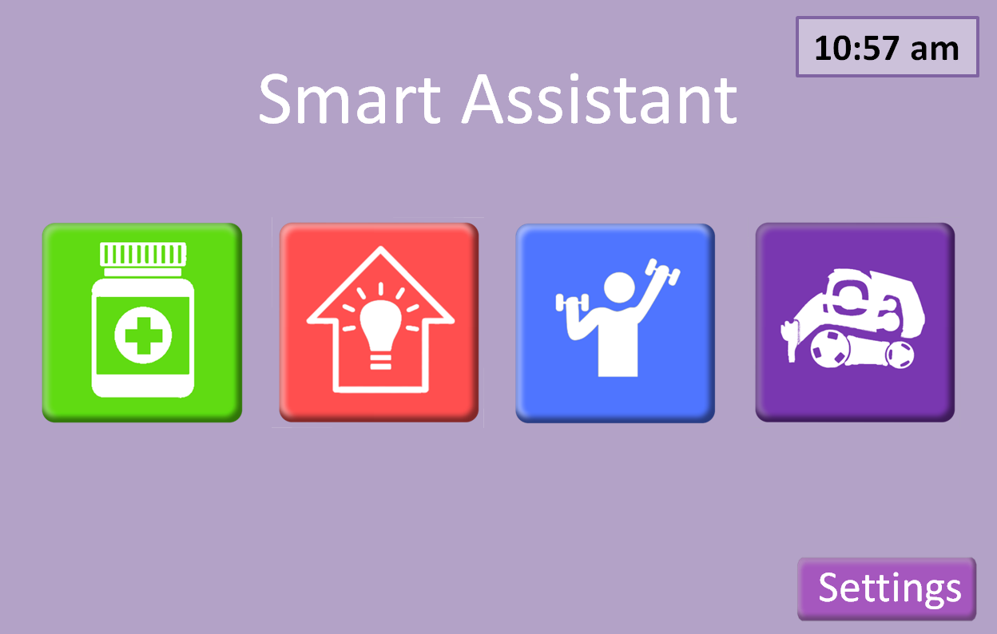

Colour coded buttons with “3d” effect to clearly indicate that they can be pressed

Figure 1 - shows the homepage for the app

The home screen has only five buttons each colour coded to ensure easy identification:

* Green, medication button will take the user to the medication page of the application (see 2.4). This button will also pulse along with a chiming sound when it is time to take a given medication.
* Red, energy/smart home button will take the user to energy page of the application ( see 2.3). This is where users can monitor their energy usage and get tips on how to become more energy efficient.
* Blue, exercise button. Takes the user to a personalised exercise page with exercises tailored to the user’s specific needs. (see 2.2)
* Purple “robot” button to get access to the smart homes assistant robot. (see add section)
* Settings button, this allows the user to tailor the look and feel of the application to fit with their needs, such as colour blindness. (see add section )

## Exercise page

The exercise page shows a list of exercises/activity’s that are tailored the user’s specific requirements.

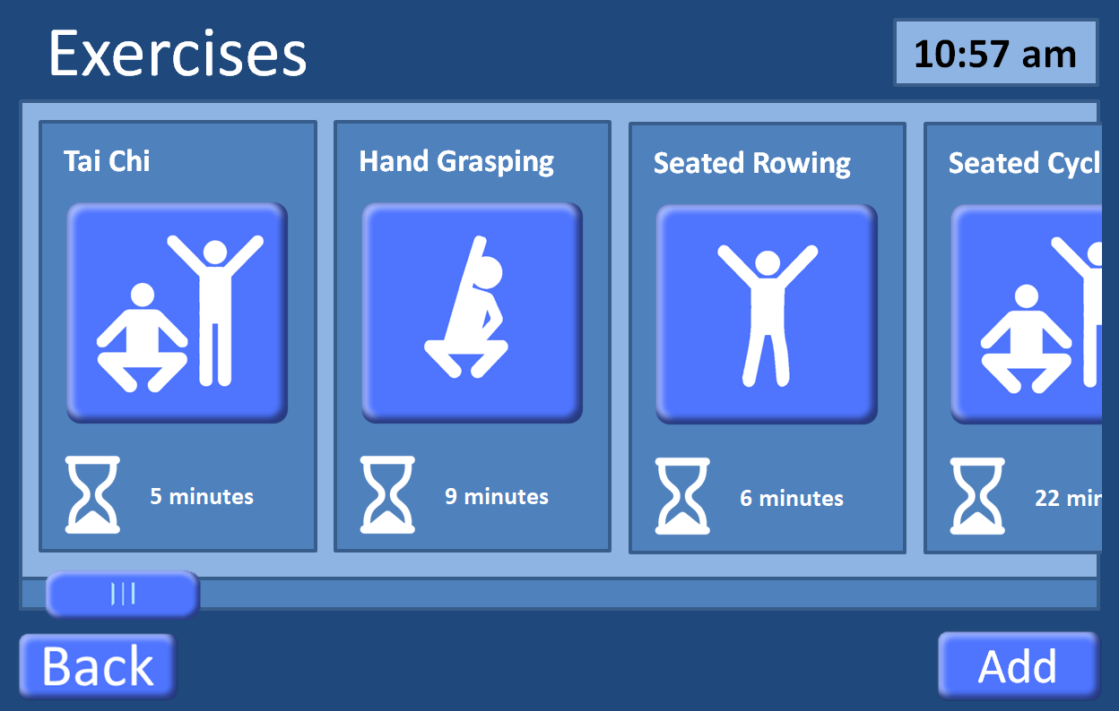

Back button takes user to previous page (home page 2.1)

Press to add/ remove exercisers to the personalised list (see)

Press to start exercise

Indicates expected time needed for exercise

Exercises hang of the end to indicate that the user can scroll. Scrolling can be done two ways: standard touchscreen hold and drag, or by using the scroll bar at the bottom.

### Add exercises

This image will be updated

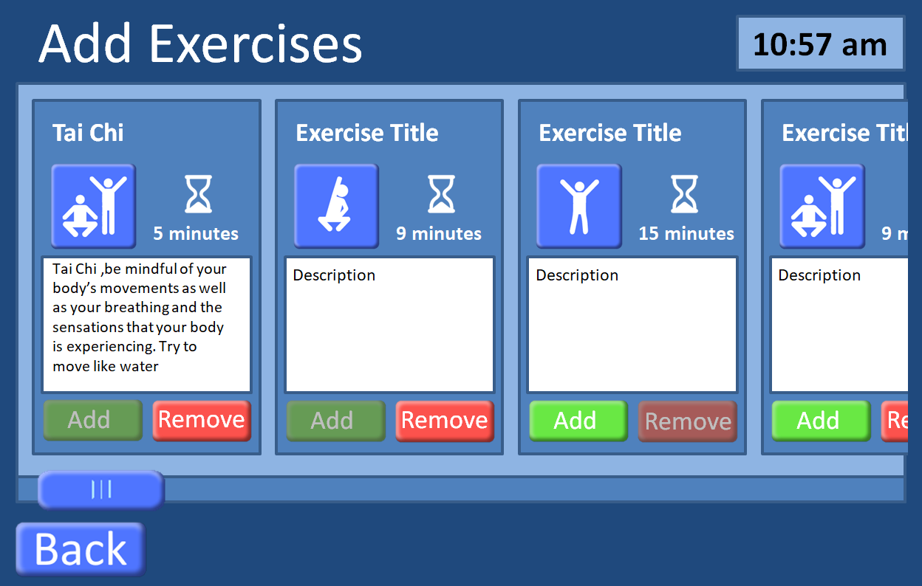

Press exercise button do a run though of the exercise to see if suitable (see 2.2.2).

Exercises can be added or removed based on recommendations from doctors and personal preferences of the user.

### Exercise run-through

Countdown timer showing how long a position must be held.

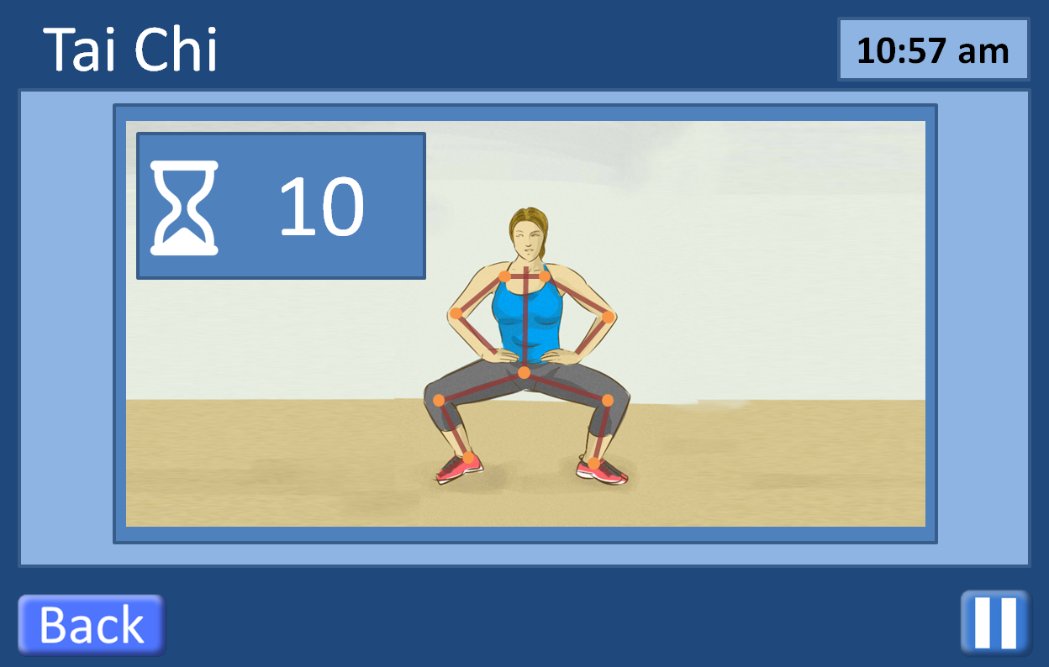

Exercise can be paused at any time

Overlay of user showing how closely they are matching the correct positions

Exercises work by having an animated video of a person doing the activity with an overlay of the user giving immediate feedback on how well the user is doing. Overlays may also appear on screen showing for instance how long the user must hold a certain position. The user can leave the exercise by pressing the back button which will take the user to the previous page (ether Add Exercise 2.2.1 or Exercises 2.2)

## Energy page

This page will be updated

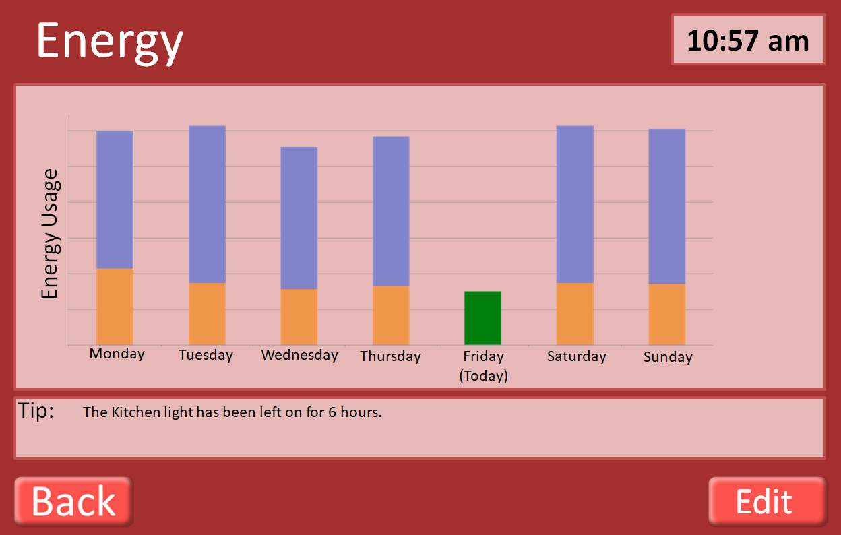

Edit button allows user to add smart devises to be tracked (see 2.3.1)

Total energy usage

Energy usage at 10:57am on given day

This page indicates the energy usage by the user over the past week. It also indicates how much energy had been used by the same time each day of the week. The application also tracks how long devises have been on and tries to prompt users to turn of devices that are not being used.

### Smart appliances

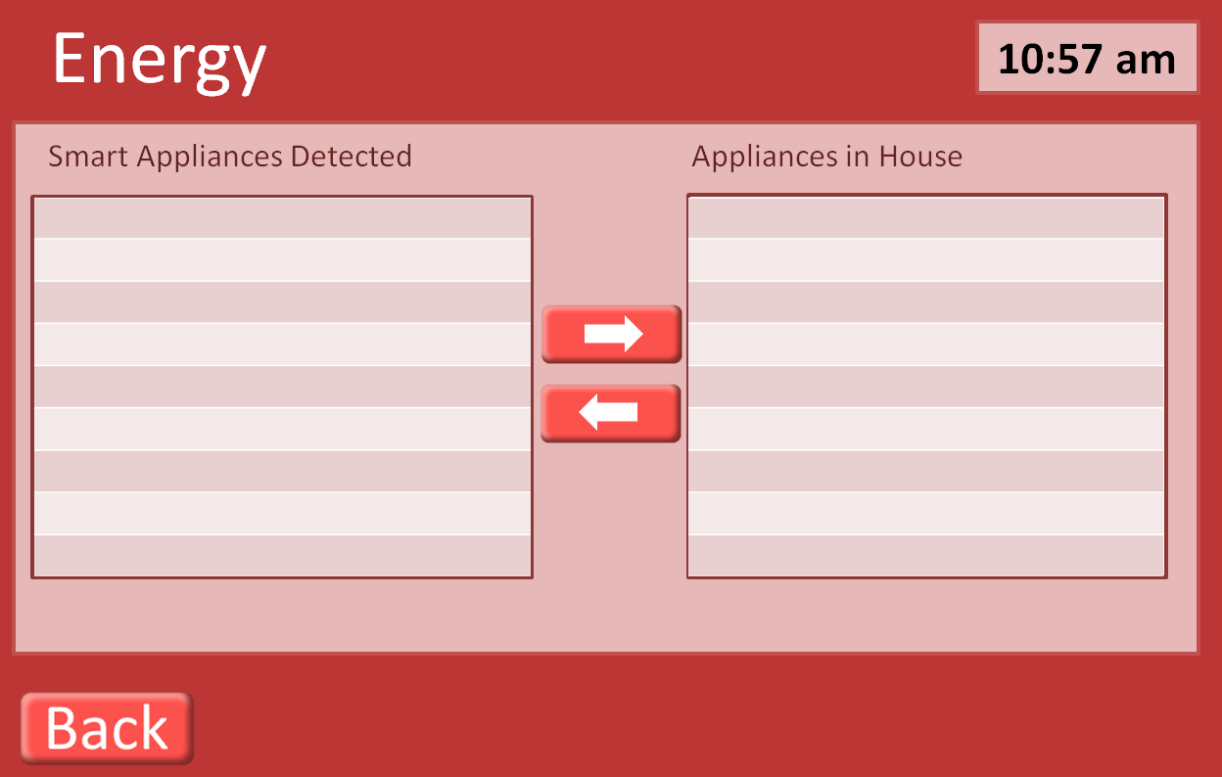

Use arrows to add remove devices from being tracked for energy usage.

This page is used to provide the user with the ability to add devices to be monitored by the application. Smart devices are automatically detected, shown in the Smart Appliances Detected, and can then be added to the home using the arrow buttons.

## Medication

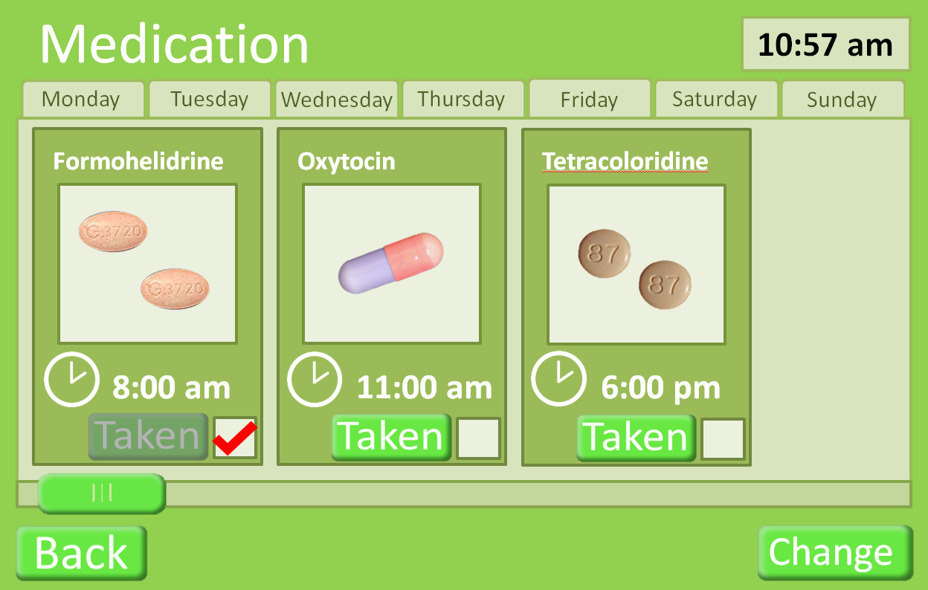

Can press the image of the medication to give more detail of the medication (see 2.4.2)

Press to change medication (see 2.4.1). This would be expected to be done with a doctor.

Press “taken” button when medication has been taken.

The medication page shows the user what medication should be taken on any given day, selected by the tabs at the top, it defaults to the current day. This page was designed to give only as much information as the user needs to take the medication. Hence, it shows: what the drug looks like and how many to take, the time it should be taken (if the user has not taken the medication by the set time the medication button on the home page will pulse and a chiming sound will be heard) and if the user has taken the medication yet that day.

### Add Medication

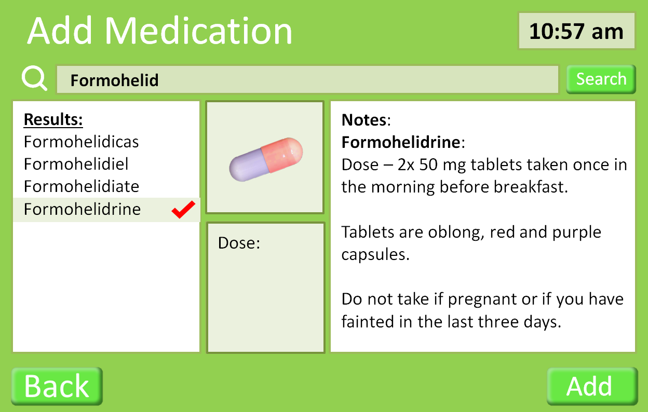

The Add button adds the drug to the user’s medication.

The correct drug can be selected from the results.

Details of the selected drug

Drugs can be searched for in the database.

This page is used in conjunction with a doctor. Drugs can be searched for and added into the users medication.

### Medication Details

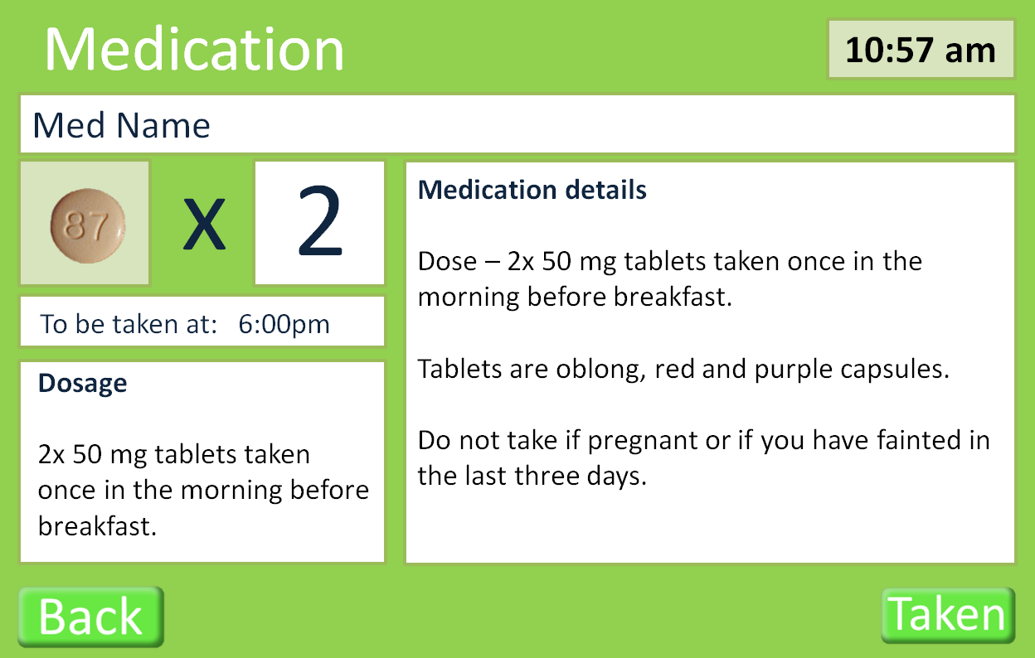

This page shows the full details of a specific medication.

## Smart Robot (Cozmo)

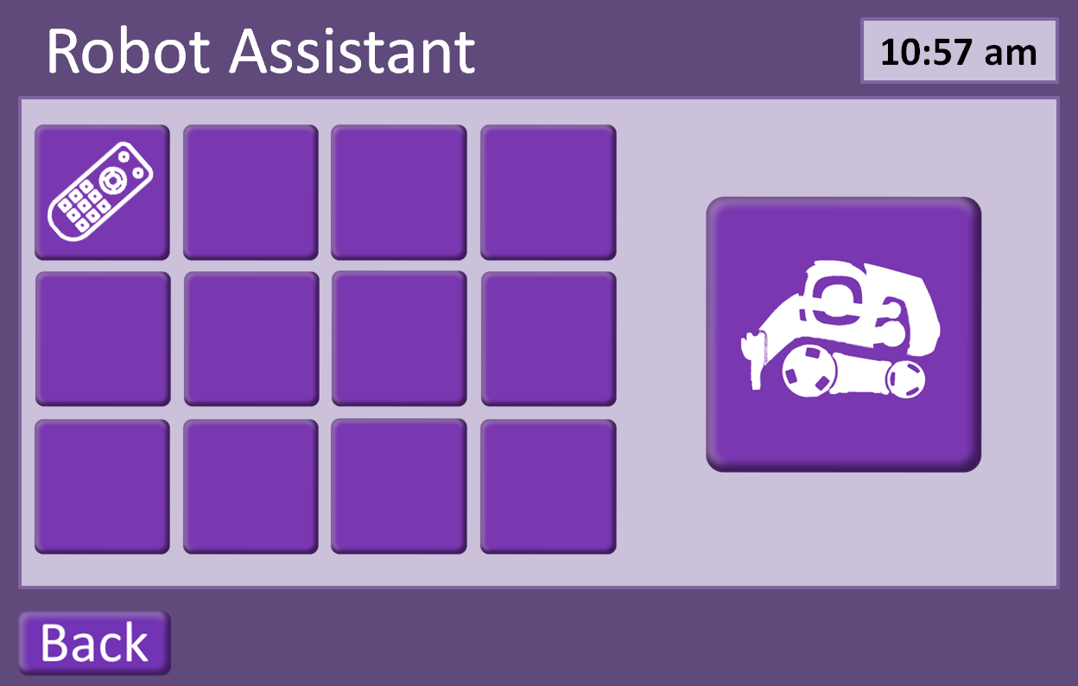

## Settings

