Homework 1 Report

1. Data Preprocessing and Image Handling
I worked in Google Colab and first installed and configured langchaingooglegenai and the Gemini model using VERTEX API key.​
Steps:
- Downloaded and unzipped receipts.zip from Google Drive to obtain 7 JPG receipts.​
- Implemented helper functions mage_to_base64 and get_image_data_url
- Displayed all receipt images in a grid within the notebook for manual inspection of item lines, discounts, subtotals, and payment amounts.​
This ensured that each image could be reliably passed to Gemini as an image URL input.

2. Structured Extraction with Gemini
2.1 System Prompt Design
I created a strict system prompt to force Gemini to output a single JSON object per receipt:​
- The required format:
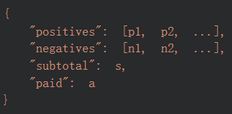
- positives: all product / charge line prices (no discounts), as floats with two decimals.
- negatives: all discounts / coupons / savings as negative floats with two decimals.
- subtotal: printed subtotal on the receipt without roundings.
- paid: final amount paid.​
- Hard constraints in the prompt:
  - Return only raw JSON, no explanation, no markdown.
  - Numbers must be JSON numbers (no quotes).
  - If uncertain, still return valid JSON adhering to the schema.​
2.2 JSON Extraction and Error Handling
Because LLMs sometimes wrap JSON in text, I implemented:
- extract_json_from_text(text):
  - Strips code fences or extra text.
  - Tries json.loads on the full text first.
  - If that fails, searches for the first { ... } block and attempts to parse it.
  - Raises an error if no valid JSON can be extracted.​
- extract_receipt_json(image_path):
  - Builds a ChatPromptTemplate with:
    - SystemMessage: the system prompt above.
    - HumanMessage: containing the image URL and an instruction to “Return ONLY the JSON object as specified.”​
  - Calls llm.invoke(messages) and then extract_json_from_text() on response.content.
  - Returns a Python dict with positives, negatives, subtotal, paid.​
I then iterated over all receipt*.jpg files to build receipt_structs, a list of dicts, one per receipt. For debugging, I printed the extracted fields per image.​

3. Aggregation Logic for Query 1 and Query 2
3.1 Global Totals Function
I implemented compute_totals_from_structs(receipt_structs) to aggregate information across all receipts:​ 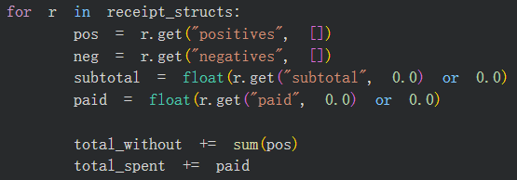
- Inputs (for r in receipt_structs):
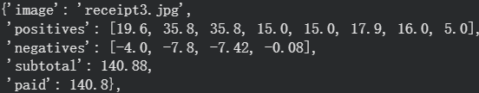
- Outputs (result for each receipt and summary):
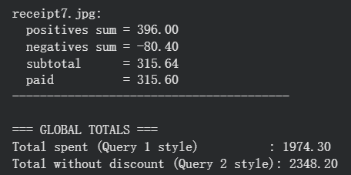
- total_spent: sum of paid values across all receipts (Query 1).
- total_without: sum of all positives across receipts, ignoring discounts (Query 2).
3.2 The usage of these computed Results
After the model computed the results, the results stored in total_spent and total_without.
The suitable answer will be output according to the query (more details in 4.2).

4. Query Classification and Answering
  - Query Type Classification
I wrote classify_query(user_query) to categorize incoming questions into three categories: TOTAL_SPENT, WITHOUT_DISCOUNT and OUT_OF_DOMAIN
It lowercases the query and checks for keyword sets:
- Without discount keywords (checked first):
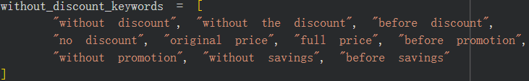
- Total spent keywords:
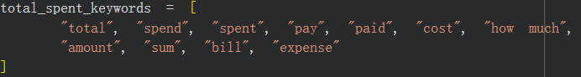
If no keywords match, it returns OUT_OF_DOMAIN.
4.2 Main Answer Function
answer_query(user_query, image_paths) behaves as follows:​
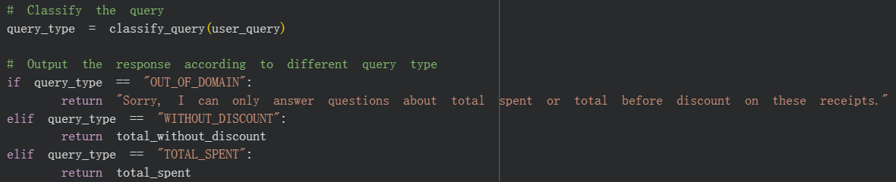
Then the return value can be put into test_query() to see whether it is accurate.

5. Evaluation and Testing
The provided evaluation code defines testquery(generated_answer, actual_answer), which computes expected_total = sum(groundtruth_costs) and asserts abs(answer - expected_total) <= 2.​
Run the code to evaluate query 1:
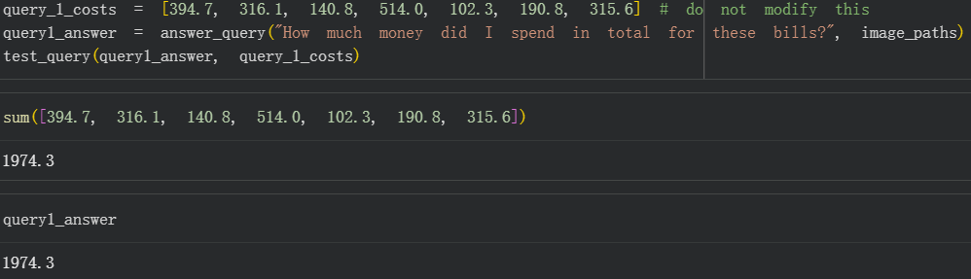
and for Query 2:
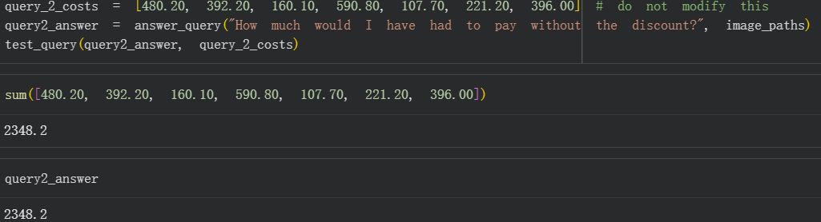
Also handle the out of the domain query:
These test results can confirm that the chain design returns the correct numeric answers within the tolerance and handles the out of domain query.​

