

Botany Downs Secondary College
Internal Assessment
Level 3-2026
91906- Use Complex Techniques to Develop a Computer Program-6 credits
91907- Use complex processes to develop a digital technologies outcome -6 credits
Achieved | Merit | Excellence
• Use complex programming techniques to develop a computer program. | • Use complex programming techniques to develop an informed computer program. | • Use complex programming techniques to develop a refined computer program.

Student Declaration:
I hereby declare that I have completed the assessment for 91906-907, independently and to the best of my abilities. This assessment represents my own work and is based on my own research, practice and understanding of the subject matter.
I confirm that all sources used in this assessment, including but not limited to books, articles, online resources, and any other references, have been appropriately cited and acknowledged according to the prescribed referencing style.
I further affirm that I have not engaged in any form of academic dishonesty, such as plagiarism or unauthorized collaboration, in the completion of this assessment. The ideas, arguments and content presented in this assessment are my own and have not been copied or reproduced from any other source.
I understand that any act of academic misconduct or violation of the academic integrity may result in disciplinary actions, which could include penalties such as grade reduction, course failure or other consequences as determined by the institution.
I take full responsibility for the authenticity and originality of the assessment and acknowledge that my work will be subject to scrutiny and evaluation by my instructors or assessors.
Signed : ……………………………. Date: …………………………………..

Signed:
Date:
Signed: Gordon Date: 20/07/2026

Answer the following questions before you start the assessment:
- Describe the purpose of your digital outcome.
- Who is the intended user?
My intended user is young adults (roughly 18–25) who have some money to invest but little to no financial background e.g first-jobbers, students with part-time income, or anyone who's heard they "should be investing" but doesn't know where to start.
- What problem does it solve?
Most beginner investors don't know their own risk tolerance, don't understand the difference between investment types (e.g. index funds, bonds, stocks, high-interest savings), and find financial advice online either too generic or too overwhelming. This program solves that by asking the user a short series of quiz questions (about their goals, timeframe, comfort with risk, income stability, etc.) and using their answers to recommend a suitable investment category or strategy — tailored, simple, and fast.
- Why is this problem worth solving?
This problem is worth solving because financial literacy among young people is generally low, and poor early financial decisions, or simply doing nothing at all, compound over time; the earlier someone begins investing sensibly, the more they stand to benefit from compound growth later in life. On top of this, professional financial advice is often expensive and inaccessible to someone with only a small amount of money to invest, so a lightweight, judgment-free quiz tool lowers the barrier to entry and encourages young people to start thinking seriously about their finances sooner rather than later.
2 . Explain why you selected this programming language, software and development tools.
Instead of simply naming them, explain why they were appropriate.
Example prompts:
- Why Python? :
Python was chosen because it's readable and quick to develop in, which matters for a project with a limited timeframe. It has strong built-in support for conditional logic and data structures (dictionaries, lists) that are ideal for storing quiz questions, scoring rules, and investment recommendations. It also has a gentle learning curve compared to lower-level languages, meaning more development time could go into refining the logic and user experience rather than fighting the syntax.

- Why Tkinter? :
Tkinter was selected because it's Python's standard GUI library — it comes bundled with Python, so no extra installation or dependency management was needed. It's lightweight and sufficient for a form-based, question-and-answer style interface (radio buttons, labels, buttons), which is exactly what a quiz app needs. Since the project's focus is the logic behind the recommendations rather than advanced visual design, Tkinter's simplicity was an advantage over something heavier like PyQt or a web framework, which would add unnecessary complexity for this scope.

- Why VS Code? :
VS Code was chosen as the development environment because it offers a good balance of lightweight performance and powerful features: built-in Git integration, an integrated terminal, Python-specific extensions (linting, debugging, IntelliSense/autocomplete), and easy project/file navigation. This sped up development and reduced context-switching between tools, and made it easier to catch errors early through real-time feedback.

- Why GitHub?:
GitHub was used for version control and backup, which is important for a solo or small-group project where work needs to be tracked over time. It allows safe experimentation (using branches/commits) without risking loss of a working version, provides a clear history of development progress (useful for documentation/reflection in a school project), and makes it easy to showcase or share the finished project if needed.

Introduction to chosen task: (your task should explain the following items. Background Information:
- Objectives
The main objective is to create an interactive and easy-to-use program that guides users towards investment options appropriate for their risk tolerance. The program should accurately process quiz responses, categorize users into risk profiles, and present clear, easy-to-understand advice while providing an engaging user experience.
- Significance
Many people are interested in investing but are unsure where to begin or which investments suit them. This program provides a simple introduction to investing by helping users understand their own risk tolerance before making financial decisions. It encourages informed decision-making and increases financial awareness in a safe and accessible way.)

Methodology: (Describe the methodology or approach used to tackle the problem. Explain briefly the algorithms, techniques or tools you will employ in the project. This section should provide a clear understanding of how the project will be implemented.)
The project will be developed using Python and will use conditional statements, functions, lists, and dictionaries to process the user's quiz responses and determine their investment profile. Each answer in the quiz will contribute to a score that reflects the user's risk tolerance, allowing the program to classify them as a conservative, balanced, or aggressive investor. Based on this classification, the program will display investment suggestions and a brief explanation of why those options match the user's preferences. The program will also include input validation to ensure users enter valid responses and to improve the overall reliability of the application. Before development begins, the user interface and program layout will be designed in Figma to plan the appearance and navigation of the application. GitHub will be used for version control, allowing changes to be tracked, previous versions to be restored if needed, and the project to be backed up throughout development. Trello will be used to organize tasks, set development milestones, and monitor progress, ensuring the project is completed efficiently and according to the planned timeline.

Software Requirements(List down the system requirements and dependencies necessary to run the project, include the version of python used and any external libraries or specific hardware requirements.)
The project will be developed using Python 3.13. The development environment will require Python to be installed along with any standard libraries used in the program. Figma will be used to design the user interface, GitHub will be used for version control and project backup, and Trello will be used for project planning and task management. The program can run on any standard Windows, macOS, or Linux computer with Python installed and does not require any special hardware.

List of Complex Techniques being used:
- Tkinter
- Libraries
- Classes
- Polymorphism
- Inheritance

List of Complex Processes being used:
- Trello
- Github
- Lucidchart
- Text files

Planning Requirements: (How will you plan your application design. This should include a pseudocode, flowchart, project management tools, saving tools and drawing tools.)
The development of this application will be carefully planned before coding begins to ensure the program is well-structured and easy to maintain. A flowchart will be created to map the overall navigation of the program, including the quiz process, decision-making, and how investment recommendations are displayed. Pseudocode will also be written to outline the logic of each feature, making it easier to translate the design into Python code while reducing errors during development. To manage the project, Trello will be used to organise tasks into different stages such as planning, development, testing, and completion. This will help track progress and ensure deadlines are met. GitHub will be used as the version control and saving tool, allowing changes to be backed up, previous versions to be restored if necessary, and progress to be recorded throughout development. The user interface and application layout will be designed in Figma, which will be used to create wireframes and plan the appearance and user experience of the program before implementation. These planning tools will help ensure the final application is organised, functional, and user-friendly.

Relevant Implications: (list the implications that are only relevant to your program development. Note: How these has been applied in developing your outcome should be written at the end.)
Relevant Implication | Describe | Explain
Social | Social implications refer to the impact a digital outcome has on its users and the wider community. Developers must consider whether the application is appropriate for its intended audience, promotes positive behaviour, and provides accurate, unbiased information. A socially responsible product should be inclusive, accessible, and designed to educate or assist users without causing harm or encouraging unsafe decisions. | The social implication involves creating content that is appropriate and understandable for the intended audience. For my investment quiz, this means designing questions and investment suggestions that align with the knowledge and experience level of 16–18-year-olds. I need to avoid overly complex financial instruments like derivatives, options, or high-leverage products that could be risky or confusing for beginners. The quiz should encourage responsible financial thinking, teaching users how risk tolerance affects investment decisions in a safe and approachable way. By tailoring the content to teenagers, I ensure the quiz is socially responsible and useful, promoting financial literacy without overwhelming them.
Aesthetics | Aesthetics refers to the visual design and overall appearance of a digital outcome. This includes the choice of colours, fonts, images, icons, layout, spacing, and other design elements that influence the user's first impression and overall experience. A well-designed interface makes the application more engaging, easier to navigate, and more enjoyable to use while maintaining consistency throughout the program. | Aesthetics refers to how visually appealing and engaging the quiz is. For my investment quiz, the interface must be modern, inviting, and suitable for teenagers. I plan to use a clean layout, pastel or vibrant colours, relatable icons, and consistent typography to make the experience enjoyable and not intimidating. Visual appeal is crucial because teenagers are more likely to engage with a tool that feels approachable and interactive. Graphs, charts, and progress indicators should be easy to interpret and visually motivating, helping users understand their investment results at a glance.
Intellectual Property | Intellectual property (IP) refers to the legal rights that protect original creations, including software, text, images, logos, graphics, and other digital content. Developers must respect copyright laws by creating their own resources or using content that is copyright-free, licensed, or used with permission. Properly acknowledging sources where required demonstrates professionalism and helps avoid legal and ethical issues. | Intellectual property ensures that all content, images, logos, and educational resources used in the quiz are either created by me, copyright-free, or properly licensed. For the quiz, this includes investment-related icons, infographics, stock images, or example companies. I also need to be careful when referencing real investment products or brands, ensuring that I have permission or use only publicly available information. Respecting IP not only avoids legal issues but also sets a professional standard for the quiz, showing users that the platform is trustworthy and credible.
Functionality | Functionality refers to how effectively a digital outcome performs its intended purpose and meets the needs of its users. It includes the reliability, accuracy, efficiency, and ease of use of the application's features. A functional program should operate without errors, provide clear feedback to users, handle invalid inputs appropriately, and ensure all features work together smoothly to create a positive user experience. | Functionality ensures that the quiz operates correctly and provides accurate, meaningful results. For my outcome, this means that the risk tolerance questions must be clear and logically structured, and the answers must lead to investment suggestions that align with the user’s indicated comfort with risk. The quiz should allow easy navigation, instant feedback, and clear explanations of why certain investments are recommended. Technical aspects, like saving user progress or adapting results based on previous answers, are also critical to prevent confusion. A well-functioning quiz builds trust, encourages repeated use, and provides real educational value.
Privacy | Privacy refers to the protection and responsible handling of users' personal information. Developers should carefully consider what data is collected, why it is needed, how it is stored, and who can access it. Digital outcomes should only collect information that is necessary for the application to function, securely protect user data, and clearly communicate how that information will be used to build trust and ensure users feel safe while using the program. | Privacy involves protecting personal information and ensuring users feel safe while using the quiz. For my outcome, I will only collect essential data: the user’s age, optional name, and their quiz responses used to determine risk tolerance. This data will be securely stored and never shared with third parties. For teenagers, privacy is especially important because they may be under parental oversight, and any data breach could have serious consequences. By clearly communicating how data is used and stored, the quiz fosters trust, making users more comfortable engaging with financial education tools.

Links to Project Management:
Project Management Tool | Link
Trello | https://trello.com/invite/b/684d28fbcf2e584d9338fd36/ATTIc5e5cf6af41be3d21703c16a48d503a55432E026/financial-quiz
Github | https://github.com/Gordon123456789/FinancialQuiz
Draw.IO | https://drive.google.com/file/d/1lTeOr8E1wQGXjUYqEpA7mMALiOmkSNHC/view?usp=sharing

(Screenshot of Task Decomposition from Trello)
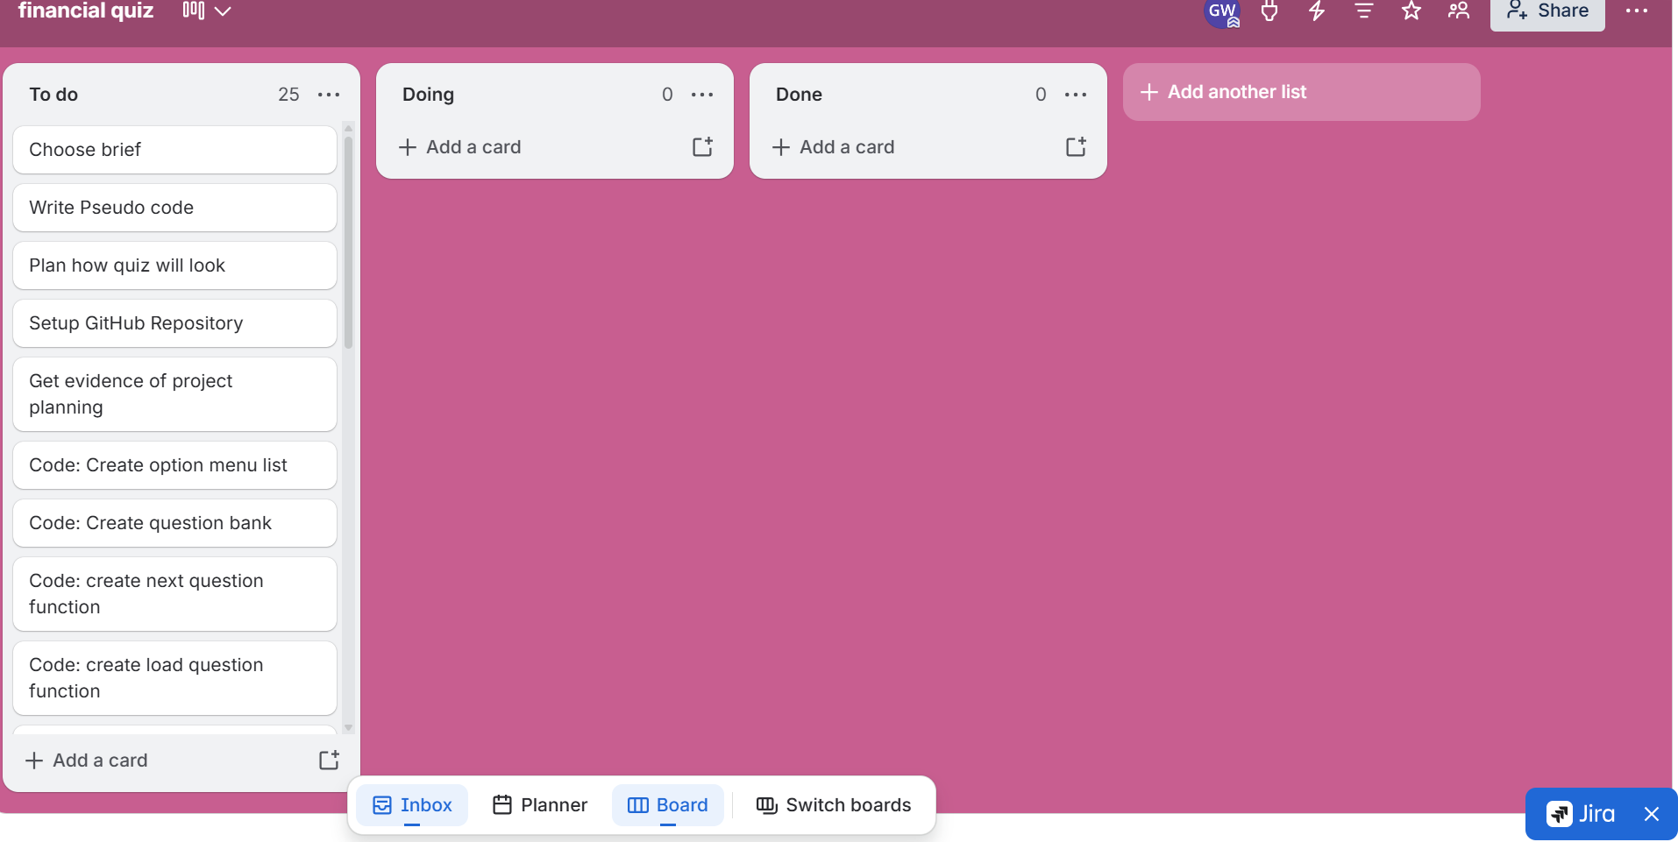

Iteration1: Explain what actions will happen in your first iteration.
(This should include the UML diagram with classes and inheritance if any, wireframe of your GUI, code structure, classes used, functions used. Highlight the key sections of the code that are of significance.)
In Iteration 1, I will create a basic Investment Recommendation Quiz using Python and Tkinter. The user will answer five questions about their investment preferences, with each answer giving a score. The program will calculate the total score and classify the user as Conservative, Moderate, or Growth. It will then display suitable investment recommendations. The GUI will use labels, radio buttons, and a Next button. The main functions will be load_question(), next_question(), and show_results(). The questions will be stored in a list of dictionaries. No custom classes or inheritance will be used in this iteration.

Table of objects required in the program (Add more rows if required.)
Objects/Variables/Storage structures such as lists/dictionaries/CSV/JSON | Datatype | Purpose and its relevance to the outcome development
Questions | List of dictionaries | Stores all the quiz questions, options and scores so they can be easily accessed and displayed.
Score | Integer | Stores the user's total score and determines their final risk profile.
Current_question | Integer | Keeps track of which question the user is currently answering.
Choice | Tkinter | Stores the answer selected by the user through the radio buttons.
Question_label | Tkinter Label | Displays the current question to the user.
Ratio_buttons | List | Stores the radio buttons used to display the possible answers.
Next_button | Tkinter Button | Allows the user to submit their answer and move to the next question.
Root | Tkinter Window | Creates the main GUI window for the investment quiz.
Show_results() | Function | Uses the final score to determine and display the user's investment recommendation.
Screenshot of Version 1 Flowchart:
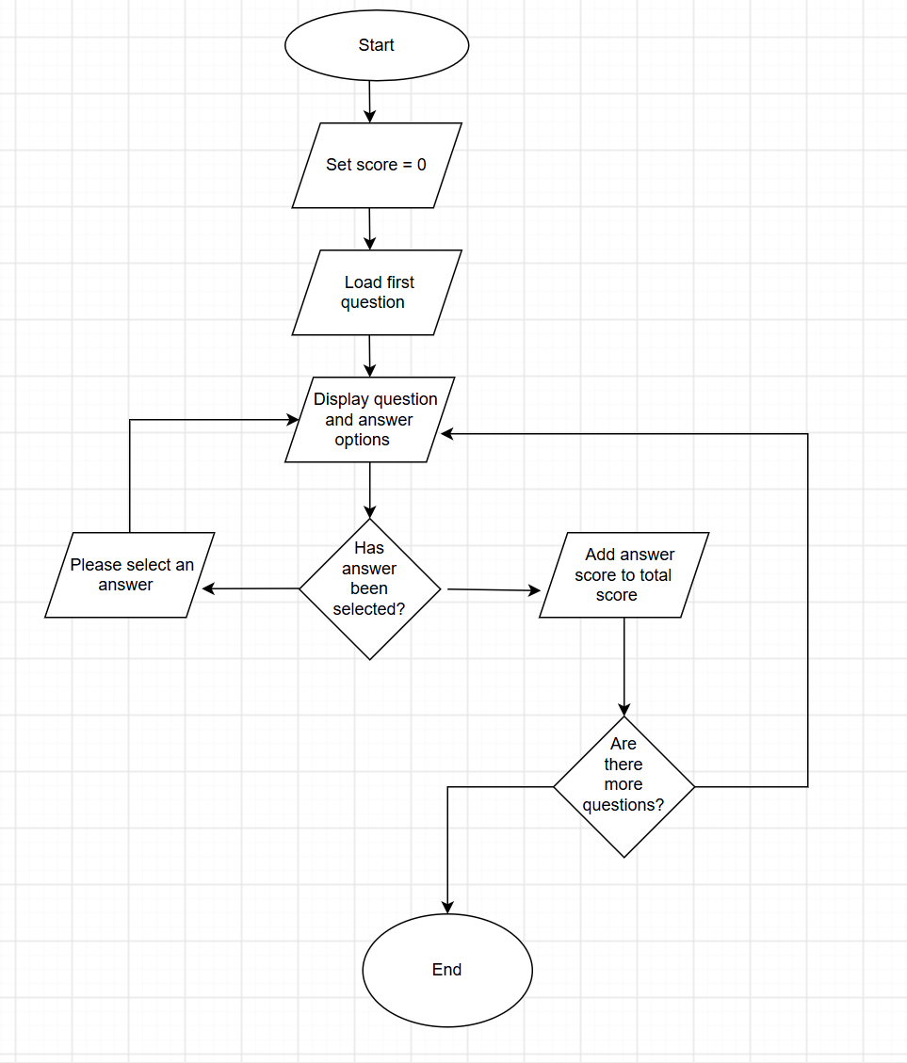

Iteration 1: Component Testing Table: Include Screenshots and give reason which component is selected and why?
Valid Boundary Testing: (This is an example) Copy this table as you require below. Also create a table in this style with Invalid Boundary Testing.
Test Case Information | I will be testing the password input
Test Type | Invalid
Component Being Tested | Password Input
Test Data Entered | abc
Why This Data Was Used | It’s too short (only 3 characters)
Expected Result | Show error message with screenshot
Actual Result | Accepted the password
Pass/Fail | ❌ Fail
How the Error Was Fixed | Added a minimum length check (>=8 characters)
Screenshot | (Paste here)

Feedback on Version 1: include a testing video here.
Stakeholder | Feedback
SH1
SH2
Teacher’s Feedback
Updated Trello Screenshot after Version1

Summary of Feedback and intended changes to make in Version 2:

Iteration2: Explain what actions will happen in your second iteration.
(This should include the GUI Wireframe,code structure, classes used, functions used. Highlight the key sections of the code that are of significance. Include the Task screenshot from Trello)

Screenshot of V2 Flowchart:

Iteration 2: Component Testing Table: Include Screenshots: Include Screenshots and give reason which component is selected and why? Add more tables for other cases such as invalid cases.

Test Case Information
Test Type
Component Being Tested
Test Data Entered
Why This Data Was Used
Expected Result
Actual Result
Pass/Fail
How the Error Was Fixed
Screenshot

Feedback on Version 2: include a testing video here.
Stakeholder | Feedback
SH1
SH2
Teacher’s Feedback

Update the Trello and place a screenshot showing completion of above task.

Summary of Feedback and intended changes to make in Version 3:

Iteration3: Explain what actions will happen in your 3rd iteration.
(This should include the GUI Wireframe, code structure, classes used, functions used. Highlight the key sections of the code that are of significance.)

Screenshot of V3 Flowchart:

Iteration 3: Component Testing Table: Include Screenshots : Include Screenshots and give reason which component is selected and why? Add more tables for other cases such as invalid cases.

Test Case Information
Test Type
Component Being Tested
Test Data Entered
Why This Data Was Used
Expected Result
Actual Result
Pass/Fail
How the Error Was Fixed
Screenshot

Feedback on Version 3: include a testing video here.
Stakeholder | Feedback
SH1
SH2
Teacher’s Feedback

Summary of Feedback and intended changes to make in Version 4:

Iteration4: Explain what actions will happen in your fourth iteration.
(This should include the code structure, classes used, functions used. Highlight the key sections of the code that are of significance.)

Screenshot of V4 Flowchart:

Iteration 4: Component Testing Table: Include Screenshots : Include Screenshots and give reason which component is selected and why? Add more tables for other cases such as invalid cases.
Test Case Information
Test Type
Component Being Tested
Test Data Entered
Why This Data Was Used
Expected Result
Actual Result
Pass/Fail
How the Error Was Fixed
Screenshot

Feedback on Version4: include a testing video here.
Stakeholder | Feedback
SH1
SH2
Teacher’s Feedback
Summary of Feedback and intended changes to make in Version 5:

Iteration5: Explain what actions will happen in your fifth iteration.
(This should include the GUI wire frame, code structure, classes used, functions used. Highlight the key sections of the code that are of significance.)

Screenshot of V5 Flowchart:

Iteration 5: Component Testing Table: Include Screenshots: Include Screenshots and give reason which component is selected and why?
Test Case | Expected

Feedback on Version 5: include a testing video here.
Stakeholder | Feedback
SH1
SH2
Teacher’s Feedback

A comparative chart of Version GUI showing iterative improvement
Version1 Description | GUI Design
Version2 Description and Feedback | Gui Design
Version 3 Description and Feedback | GUI Design
Version4 Description and Feedback | GUI Design
Version 5 Description and Feedback | GUI Design

Discuss how you addressed the Relevant Implications you described and explained earlier. Please provide screenshots where you applied the implication.
Relevant Implication | How I applied this in the development of my outcome.

Final Trello Board showing all the Tasks Done :

Fitness for Purpose:
(Discusses how the information from planning, testing and trialling of components assisted in the development of a high-quality outcome. Include how this can be further developed and implemented in the future.)

Describe two alternative approaches you considered.
Explain why you rejected them.

Describe one major programming challenge you encountered.
Explain
- what caused it
- how you investigated it
- how you solved it
- what you learnt

Choose one important function or algorithm from your program.
Explain
- why it was designed this way
- why this solution is efficient
- what would happen if it were written differently

Explain how decomposition helped you during development.
Possible discussion
- functions
- modules
- classes
- reusable code
- readability

Identify one programming convention you followed.
Examples
- naming conventions
- comments
- indentation
- modular programming
- constants
- validation
Explain why following the convention improved the program.

Describe your testing process.
Include
- unit testing
- integration testing
- user testing
- boundary testing
- invalid data
Choose one bug that was difficult to fix.
Explain
- symptoms
- possible causes
- investigation
- final solution
Describe a situation where testing changed your original design.

What evidence convinced you to make the change?

Describe one piece of stakeholder feedback.
Explain
- why the stakeholder suggested it
- whether you agreed
- what changes you made
- how those changes improved the outcome
Describe one stakeholder suggestion that you did NOT implement.
- Explain why.

- This demonstrates critical judgement rather than blindly accepting all feedback.

Evaluate the strengths of your completed program.
Don't simply list features.
Explain
- how each feature benefits the user
- why it improves fitness for purpose

What evidence shows that your program is fit for purpose?
Support your answer using
- testing
- stakeholder feedback
- final functionality

Make sure you tick all the boxes here.
Requirement | Status  √
Introduction to the project
End users
Project Management Tools such as Trello, Github, Draw.IO used and updated from version to version.
Relevant implications- Described and Explained
Software requirements listed
Program design requirements such as selection, sequence and iteration control structures
Flowcharts
Defined Classes and created obje
GUI wireframes for all versions including annotations
Coding conventions followed
Reads from or writes to files or other persistent storage used
Defined classes and created objects
Defined and used custom data types
Used complex data structures such as Queues
Trello updated frequently.
Links for Trello, Github and Draw.IO given
Comments written to describe the code
Annotated screenshots or screencast videos showing the testing procedures
Annotated screenshots or screencast videos demonstrating the program is functioning
Documented all the testing procedures using tables provided for each version.
Feedback from end users/stakeholders documented correctly.
Addressed relevant Implications with screenshots
Summary of fitness for purpose
Final Update of Trello board with all tasks done.

