

# **Game Design 1 (GAMES-GT 150-002)**

Tisch School of the Arts, Fall 2016 / 4 Credits

**Tue. & Thu. 2:00—4:45 pm (Room 802, 2 MetroTech)**

**Instructor:** Naomi Clark, naomi@halfrobot.com  
**Teaching Assistant:** Hannah Monck, hnm247@nyu.edu

**Overview**

Game Design 1 is a one-semester course that explores the fundamentals of game design via readings, discussion, in-class game-like exercises, and group projects. No programming knowledge is expected or required, because the focus of this class is on the creation of non-digital games, and on the elements common to all games that are fundamental for a game designer working in any format. Digital games will be discussed, however, and one assignment involves pitching a concept for a digital game.

# **Goals of the course**

* Explore the basic methodologies and conceptual skills of game design, such as systems thinking, iterative design process, playtesting, creative collaboration, critical analysis, etc.
* Gain the experience of creating several playable games using an iterative design process.
* Foster an understanding of what games and play consist of, on and off the computer, and how they can function to create meaningful experiences for players.
* Explore fundamental concepts relating to games and design, such as rules and play, emergent complexity, long and short-term goals, etc. This includes understanding games as formal systems, experienced human systems, and cultural systems.
* Become familiar with some foundational concepts and theories in the field of game design, and understand game design as a field that encompasses all kinds of games.
* Link the principles of the course to computer and video games on a variety of platforms.

# **Required Readings**

Readings for the course are taken from varied sources, but multiple readings are taken from two books:

***Rules of Play*, Katie Salen & Eric Zimmerman** – owning a copy highly recommended

***The Game Design Reader*, Katie Salen & Eric Zimmerman, eds.** – owning a copy optional

# **Assignments**

Below is a description of class assignments. Written components of class assignments, such as game rules, design process statements, etc, should be **printed out and brought to class** on the day that the assignment is due, **and *also* emailed** to nmc5@nyu.edu and hnm247@nyu.edu.

**Readings:** Most weeks during the semester, readings will be assigned. Students are responsible for completing these readings, on which there will be **a quiz and discussion** on the day the readings are due.

**Game Design Assignments:** There are seven game design assignments over the course of the semester. These assignments involve the collaborative creation of a playable game and will constitute the bulk of the work during the semester. One week after a game design is assigned, a playable prototype version of the game is due, along with (currently) complete rules for playing the game. Completing a playable prototype on schedule forms part of each group’s grade for an assignment.

These design assignments are completed in groups of three or four students**. It is essential that you attend group meetings and fully participate in the design of your games.** For each assignment, each group must turn in:

* **Overview:** The name of the game, of its creators, and a 100-200 word overview.
* **Elevator Pitch:** A very short description that conveys the most important information you’d want a potential player to know about the game, meant to sound good when spoken aloud in under ten seconds.
* **Rules:** A complete set of game rules, including a list of components and illustrated examples of play.
* **Process Statement:** Describe your process. What challenges did you encounter, how were they solved?
* **Public Group Evaluation:** Each student must email Naomi, Angela, and the rest of their group members one positive thing and one thing that could be improved about each other member of the group.
* **Private Peer Grades:** Each student should *also* email Naomi and Angela private peer grades for each member of the group, including themselves. An explanation must be provided for any grade of C or below.

Below are the projects for this class, in chronological order—additional details will be given in class when assigned:

* **Game Modification:** Groups will take an existing simple game using dice and chips, and modify it.
* **Abstract Game:** Groups will create an abstract game in a traditional non-digital game format, using some combination of dice, cards, and chips.
* **Social Game:** Groups will create a board/card game emphasizing social interaction and player experience.
* **Narrative Game:** Groups will be given a narrative that will be the basis of a game project that expresses some aspect of that story.
* **Intervention/Big Game:** Groups will create a game that is in some way an intervention in the lives of its players on the level of space and ritual.
* **Digital Game Pitch:** Students will work in pairs to make a 5-7 minute presentation to the class about an original digital game concept.
* **Digital Game Concept Document:** Students will build upon their pitch to create a document that presents the concept in written and visual form.
* **Final Project:** Students will work alone or in groups to create a game that builds on one of the projects they worked on earlier in the semester (such as the Abstract, Social, or Narrative Game).

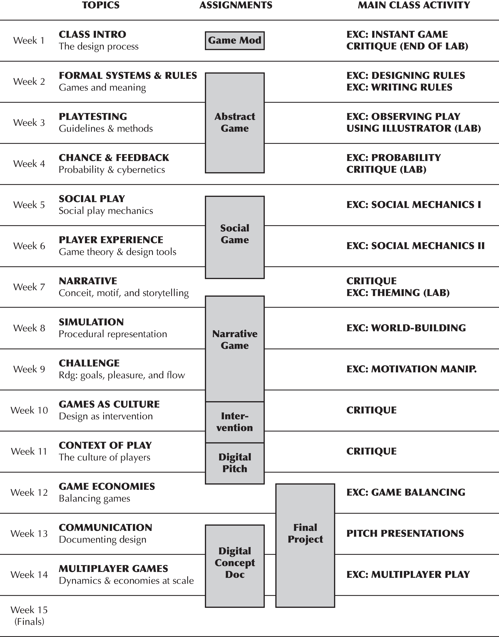

# **Week-by-week Schedule**

**UNIT ONE: Games as Formal Systems**

**Week 1**

9 / 6 TOPICS: introduction to class; what is game design; what makes games meaningful; rules, play, and culture

**PROJECT ASSIGNED: *Game Modification.*** Each group will get a simple but “broken” game as a starting point. Groups will identify what is broken about their game, and make modifications to create a more meaningful experience for players. (1 week)

9 / 8 LAB: working on *Game Modification*

**PROJECT DUE: *Game Modification*.** Playthrough and brief critique in last hour of lab.

**Week 2**

9 / 13 TOPICS: games as formal systems; games and rules; the elements of games

READINGS DUE: *Rules of Play,* Chapter 3: Meaningful Play (9 pages)

*Rules of Play,* Chapter 6: Interactivity (9 pages)

*Rise of the Videogame Zinesters,* Anna Anthropy(12 pages)

**PROJECT ASSIGNED: *Abstract Game.***Groups will be given blank materials (chips, cards, dice) to create a playable, balanced game with minimal narrative or theme. (2 weeks)

9 / 15 LAB: working on *Abstract Game*

**Week 3**

9 / 20 TOPICS: the iterative process; techniques and approaches to playtesting

READINGS DUE: *Game Design Workshop*, Chapter 9: Playtesting (20 pages)

*Problem-Driven Game Design* by Kory Heath (2 pages)

“The Design Evolution of Magic: The Gathering,”Richard Garfield (18 pages)  
“A Primer for Playtesting,”by Nathalie Pozzi & Eric Zimmerman (7 pages)

9 / 22 WORKSHOP: Using Adobe Illustrator  
**LAB: prototype due for *Abstract Game***

**Week 4**

9 / 27 TOPICS: probability; chance and randomness; perception vs. reality in estimations; feedback loops

READINGS DUE: *Rules of Play,* Chapter 15: Games as Systems of Uncertainty (17 pages)

*Rules of Play*, Chapter 18: Games as Cybernetic Systems (15 pages)  
“MDA,” Robin Hunicke, Marc LeBlanc, Robert Zubeck (5 pages)

9 / 29 **PROJECT DUE: *Abstract Game***

**UNIT TWO: Games as Experiential Systems**

**Week 5**

10 / 4 TOPICS: games as social play; patterns of multiplayer interaction

READINGS DUE: *Characteristics of Games,* Richard Garfield et al., Chapter 2 (24 pages)

**PROJECT ASSIGNED: *Social Game***. Groups will be given social/experiential criteria and create a game that produces the desired experience through emergent means. (2 weeks)

10 / 6 LAB: Working on *Social Game*

**Week 6**

10 / 11 TOPICS: game theory; psychology of player interaction

READINGS DUE: *The Bowerbird’s Dilemma,* Larry Gonick (2 pages)

*Rules of Play,* Chapter 19: Games as Game Theory Systems (16 pages)

10 / 13 **LAB: Prototype due for *Social Game***

**Week 7**

10 / 18 TOPICS: games and narrative; conceit and motif

READINGS DUE: “Dramatic Game Dynamics,” in *Game Design Reader,*  Marc LeBlanc (22 pages)  
 *Rules of Play*, Chapter 26: Games as Narrative Play (28 pages)

**PROJECT DUE: *Social Game***

10 / 20 EXERCISE: Theming games

**PROJECT ASSIGNED: Narrative Game.**Starting with a provided narrative, groups will create a game that procedurally represents that narrative through gameplay. (3 weeks)

LAB: Working on *Narrative Game*

**Week 8**

10 / 19 TOPICS: games and simulation; procedural representation; games and drama

READINGS DUE: *Rules of Play*, Chapter 27: Games as the Play of Simulation (15 pages)

*On Game Design,* Chris Crawford, Chapter 19: Gossip (9 pages)

10 / 27 **LAB: prototype due for *Narrative Game***

**Week 9**

11 / 1 TOPICS: short-term and long-term goals; games and fairness; cheating, exploits, and degenerate play; positive and negative rewards; flow and gameplay

READINGS DUE: *Rules of Play,* Chapter 20: Games as Systems of Conflict (9 pages)

*Rules of Play,* Chapter 21: Breaking the Rules (17 pages)

*A Game Design Vocabulary,* Anna Anthropy and Naomi Clark, Ch 5-6 (44 pages)

11 / 3 LAB: refining and finishing *Narrative Game*

BONUS EXERCISE OR LECTURE: *TA Special*

**UNIT THREE: Games as Cultural Systems + Final Project**

**Week 10**

11 / 8 TOPICS: games and culture; games and art; game design as cultural intervention

READINGS DUE: *Critical Play*, Mary Flanagan, Chapter 1: Introduction to Critical Play  
 *Critical Play*, Mary Flanagan, Chapter 6: Artists’ Locative Games

**PROJECT DUE: *Narrative Game***

**PROJECT ASSIGNED: *Intervention / Big Game*.** Groups will create a physical game that is in some way an intervention in the lives of its players, on the level of space and ritual, ideological content, or player lifestyle. (2 weeks)

11 / 10 LAB: Find and work on *Intervention / Big Game* at intervention locations

**Week 11**

11 / 15 TOPICS: digital game design; online multiplayer games; player types and play styles

READINGS DUE: Farmer & Morningstar, *“*The Lessons of Habitat”in *Game Design Reader* (25 pages)  
 “The In-Game Economics of Ultima Online,” Zachary Booth Simpson (10 pages)

**PROJECT ASSIGNED: *Digital Game Pitch.***Students will work in pairs to create a 5-7 minute long slideshow which pitches a digital game. (1 week)

11 / 17 **PROJECT DUE: *Intervention / Big Game***

LAB: Research and create presentations for digital pitches

**Week 11.5 (Thanksgiving Week)**

11 / 22 **PROJECT DUE: *Digital Game Pitch*** (presentations in class)

**Week 12**

11 / 29 TOPICS: game economies; balancing games; using spreadsheets in game design

READINGS DUE: *Game Mechanics: Advanced Game Design*, Chapter 1 & 4 excerpts (32 pages)

**PROJECT ASSIGNED: *Final Project****.* Groups of students will work on one of the projects that came out of the final project concepts. Students will be expected to apply concepts and lessons from the rest of the semester as they plan and execute their final projects. (5 weeks)

12 / 1 LAB: Work on *Final Project*

**Week 13**

12 / 6 TOPICS: communicating ideas, the role of the game designer, documenting design

READINGS DUE: Excerpts from *Kobold Book of Game Design*, Rob Daviau & Mike Selinker (24 pages)

**PROJECT ASSIGNED: *Digital Concept Document.*** Working individually or in pairs, students will turn the game concept that was pitched to class into a short concept document, based on a provided template.

12 / 8 **LAB: Refined Prototype due for Final Project**

**Week 14 – No class on Tuesday due to Legislative Day transmogrifying Tuesday into Monday**

12 / 15 TOPICS: cultural contexts of play; implicit rules; cultural politics in games

READINGS DUE: “Unwritten Rules”, Stephen Sniderman (*Game Design Reader,* 27 pages)

“Hoyle on Troubled Waters”, David Parlett (14 pages)

**Week 15 (Finals Week)**

12 / 21 **PROJECT DUE: *Final Project***  
**PROJECT DUE: *Digital Concept Document***

# **Grading**

**Evaluation of work**

Each project will be evaluated with the following criteria:

* **Functionality.** Has the student made a playable, enjoyable game that can be completed and does not have any obvious structural problems?
* **Balance.** Beyond basic playability, are the systems of the game well-balanced and does the game provide multiple, meaningful choices for players?
* **Creativity.** Does the project evince innovation and uniqueness? Does it show a creative imagination that does not solve the given design problem in an ordinary way?
* **Appropriate for the assignment.** Each project is a response to constraints given by the instructor. Has the project properly addressed these constraints?
* **Presentation.** Each game is presented in material form, along with its rules and a written process statement. Are these materials well-written, well-organized, and easy to use?

Students will be given grades based on a 100 -point scale. Each assignment will be graded on a point scale, and these points will be added up to determine the final grade, according to the following:

|  |  |
| --- | --- |
| 93-100 | A |
| 90-92 | A- |
| 87-89 | B+ |
| 83-86 | B |
| 80-82  etc. | B- |

The following are the components of the grade:

**Attendance & Participation 20**

**Modification Game 5**

**Abstract Game 10**

**Social Game 10**

**Narrative Game 15**

**Intervention / Big Game 5**

**Digital Game Pitch 5**

**Digital Game Concept Doc 5**

**Final Project 25**

**TOTAL 100**

**Late penalties**

It is your responsibility to turn in assignments on time. If an assignment is not turned in by the class for which it is due, its grade will drop 5% + 5% for each day it is overdue.

**Attendance & Participation**

The attendance and participation portion of your grade is based on the following:

* Your attendance in class and tardiness
* Participation in and contributions to group discussions and critiques
* Facilitation of participation by classmates in discussions and by team members in group projects
* Private peer grades from group projects, especially if consistently positive or negative

**Attendance Policy**Attending and arriving on time to all class sessions is required and expected. This includes all labs, recitations, and critiques. If you will be missing a class due to illness, or unavoidable personal circumstances, you must notify the professor in advance via email for the absence to be excused.

Note that department policy also requires the following additional penalties for absence/lateness, with 3 “lates” counting as 1 absence:

* You are allowed *two* unexcused absences without any penalty.
* Your *third* unexcused absence will lower your final grade by a full letter.
* Each subsequent unexcused absence will lower your final grade by a full letter.
* Being more than 15 minutes late will count as two lates.

Absences *may* be excused for religious holidays, illness (with doctor’s note), serious emergencies, and other unavoidable circumstances beyond a student’s control. In order to be considered, any request to be excused must be made as far in advance as feasible based on the nature of the absence.

**Private peer grades**

Peer grades must be emailed to the instructor and TA (and nobody else) for each group assignment. You must give a numeric score to each member of your group. You can add a short explanation if you like, but you *must* provide an explanation when giving a score of 3 or below.

1 = Outstanding, excellent teammate

2 = Good, no complaints

3 = Satisfactory, but there were some problems or inconsistencies (please explain)

4 = Difficult, hindered the group process and/or progress of the project (please explain)

**Group evaluations**

In addition to the private peer grades, students will also write a public evaluation of each team member for each group project. These evaluations should be emailed to all group members, the instructor, and the TA.  
Group evaluations consist of the following:

* **At least one positive observation.** Briefly mention particular skills, behaviors, particular decisions, or other ways in which the team member made a positive contribution to the group.
* **At least one area for improvement.** Briefly provide one or two pieces of thoughtful criticism. Be fair, direct, and honest. Do not focus on circumstances outside of their control or on making general statements about their personality. Instead, focus on how they can be a better collaborator.

**NYU STATEMENT OF ACADEMIC INTEGRITY:**

Plagiarism is presenting someone else’s work as though it were your own. More specifically, plagiarism is to present as your own: A sequence of words quoted without quotation marks from another writer or a paraphrased passage from another writer’s work or facts, ideas or images composed by someone else.

**ACCESSIBILITY AT NYU**

Academic accommodations are available for students with documented disabilities. Please contact the Moses Center for Students with Disabilities at 212-998-4980 for further information.

**Tips for Working Successfully in a Group**

*Adapted from the Building Virtual Worlds class at Carnegie Melon’s ETC Program*

**Meet people properly.** It all starts with the introduction. Exchange contact information, and find out the best methods and times to reach each person. Make sure you know how to pronounce everyone’s names and what pronouns (he, she, they, etc) each person prefers.

**Determine common principles.** Before you get into the specifics of what sort of game you want to make, talk in more general terms about the assignment. What sort of related games do you like? What sorts of things do they have in common? Make a list of the sorts of things that get you excited about a game, and when you start getting into specifics, refer back to it. Many of those things won’t make it into the final game (or else it’s probably an incoherent mishmash), but it’s good to keep them all in mind… and often, trying to reconcile two seemingly contradictory desires is the source of innovative game mechanics!

**Make meeting conditions good and take care of your needs.** Have a large surface to write on, and make sure the room is quiet enough, without lots of distractions. Do what you can to ensure no one is hungry, thirsty, cold/hot, or tired, and do your best to arrive at a meeting having taken care of your basic needs.

**Make sure someone takes lots of notes.** And make sure it’s not the same person every time, unless someone really, really like that role. These notes will be *immensely* valuable for many reasons: in terms of completing the assignment (a little cleaning up and editing, and bam, you’ve got your design doc), in terms of having a trove of alternate ideas to draw on when you get stuck, and out of simple autobiographical interest.

**Let everyone say their piece.** Even if you think it’s dumb. Cutting someone off is rude, and not worth the time saved. Don’t finish someone’s sentences; they can do it themselves. Remember: talking louder or faster doesn’t make your idea any better. Check your egos at the door. When you discuss ideas, immediately label and record them. The labels should be *descriptive of the idea, not the originator*: “the troll bridge story,” not “Jane’s story.”

**Be careful about going off on tangents.** The flipside of this is you should be cognizant of other people’s time and attention. Feel free to volunteer outlandish suggestions for a game, as these can spark more workable ideas. And every group needs to take breaks, both to catch their breath and get to know each other. But if you find yourself talking about something totally unrelated to the game, especially if only one or two of you are interested it’s probably time to get back to the matter at hand.

**Praise each other.** Find something nice to say, even if it’s a stretch. Even the worst idea has something interesting lurking inside it, if you look hard enough. Focus on the good, praise it, and then raise any objections or concerns you have about the rest of it. You might discover something you didn’t realize about the idea in the process!

**Put it in writing.** Always write down who is responsible for what, by when. Be concrete: assign tasks to people. Arrange meetings by email, and establish accountability. Don’t try to guess what your group might want to hear about—*always* CC email to all members of the group, and optionally to your professor as well.

**Be open and honest.** Talk with your group members if there’s a problem, and talk with me if you think you need help. Be forgiving when people make mistakes, but don’t be afraid to raise the issues when they come up.

**Mitigate conflict whenever you can.** When stress occurs and tempers flare, take a short break. Clear your heads, apologize, and take another stab at it. Apologize for upsetting your peers, even if you think someone else was primarily at fault; the goal is to work together, not start a legal battle over whose transgressions were worse. It takes two to have an argument: be the peacemaker whenever possible so that conflicts can resolve.

**Phrase alternatives as questions.** Instead of “I think we should do A, not B,” try “What if we did A, instead of B?” That allows people to offer comments, rather than defend one choice.

**Always remember that this isn’t your last game.** It’s often frustrating when you’re captivated by a great idea but nobody else in the group gets it. If you can’t sell them on it, remember: you’re going to make plenty of games in the future. Write the idea down in your own notebook, and voila, you’ve got your summer project.

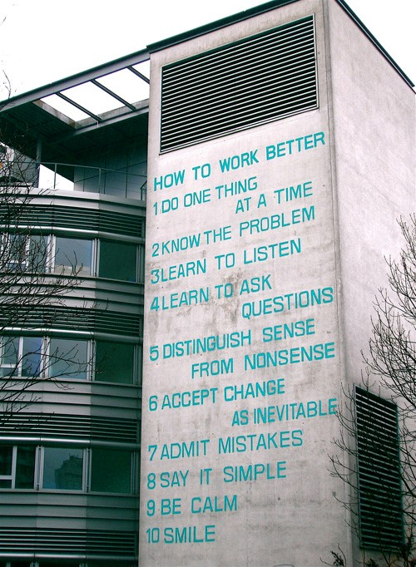

*Peter Fischli and Davis Weiss*