Influenza Outbreak Prediction

Gentian Marini & Gordon Oboh
Department of Information Technology, Monroe University, King Graduate School
CS633-151: Data Mining
Prof. Nicholas Nardi
April 09, 2025

Project Scope Document
Task 1.1 Determine Business Objectives

Background / Problem Management Wants to Address
Contagious diseases, like influenza, result in a substantial public health challenge due to elevated hospitalization rates and increased spending along with the risk of death. The erratic nature of these outbreaks makes properly swelling them a challenge. This project seeks to accomplish the creation of a predictive model for outbreaks of influenza using previously gathered (Global Influenza Surveillance and Response System (GISRS), n.d.) data.

Business Goals
The primary goal of this project is to predict early detection and forecasting of influenza outbreaks to help, healthcare providers, and public health agencies to be prepared. Specific goals include:
- Discovering and documenting various trends during influenzas breakout seasons.
- Formulating predictive algorithms for expected cases in the weeks to come.
- Improving public awareness and mitigation efforts through early warnings.

Business Success Criteria
The success of this project will be measured using:
- Accuracy of Predictions: The predictive model should achieve at least 80% accuracy in forecasting outbreak trends.
- Reduction in Response Time: Healthcare agencies should receive outbreak warnings to an acceptable time in advance, equal or greater to the minimum allowed time.

Constraints
- Data Availability: The dataset is restricted to past influenza records and may have incomplete components, erroneous data, or improper data.
- Computational Resources: High performing machine learning models may require significant computational power, which can result in higher budget for the project.
- Timeliness: There may be an inability to capture real time data because of delays in reporting by different nations.
- Privacy & Regulatory Constraints: Some data items could be sensitive and therefore protected by privacy legislations.

Organizational and Business Impact
- Positive Impact: Enhanced planning in healthcare systems, reduced economic impact, and improved provision of services.
- Negative Impact: If the predictions are imprecise there is going to be severe mismanagement of resources and unnecessary panic.

Task 1.3 Determine Data-Mining Goals

Data-Mining Goals
The purpose of the data mining process is to develop a time series forecasting model for predicting influenza epidemics based on historical monitoring data. The objectives are:
- Cleaning and preprocessing the GISRS dataset to remove duplicates and missing values.
- Constructing additional time related features (week of the year, month of the year, season) in addition to lag features (cases in previous weeks).
- Building and training machine learning models such as Linear Regression, Decision Tree, and random Forest models to forecast the number of influenza cases for the following weeks.
- Analyzing models’ performance with Mean Absolute Error (MAE) and Mean Squared Error (MSE).
- Deploying/running the final model to generate real-time outbreak predictions.

Data-Mining Success Criteria
- Model Accuracy: Accuracy of the predictive model should attain Mean Absolute Error (MAE) of 5% or less from the reported received values.
- Comparative Performance: The designed model should be more accurate than a simple benchmark model (for example: moving average). The improvement should be no less than 15%.
- Operational Usability: The model output should be useful to public health stakeholders for making decisions.
Data Understanding
Task 2.1 Gathering Data
Data Requirements
The dataset used for this project is procured from the Global Influenza Surveillance and Response System (GISRS), (Power BI Report, n.d.-b). The data includes the weekly influenza cases reported by different national health agencies. This data ranges from 1997 to 2025. Some of the data components are time attributes like year, week, month and date. Types of specimens in which influenza virus antigen was detected like AH1, AH1N12009, AH3, AH5, ANOTSUBTYPED, BNOTDETERMINED, BVIC, BYAM, SPEC_PROCESSED_NB and SPEC_RECEIVED_NB. All cases of influence detected and subtypes, INF_A, INF_B, INF_ALL and INF_NEGATIVE for cases that the influence was not detected. Another indicator is the ILI_ACTIVITY (Influenza-like Illness) which gives an indication of the level of the virus activity. The time component of the data, ISO_WEEK, ISO_WEEKSTARTDATE, ISO_YEAR, and ISOYW. The region and the transmission zones given by COUNTRY_CODE, ITZ, ORIGIN_SOURCE and WHOREGION.

Data Availability/Selection Criteria
The data source for this project is the Global Influenza Surveillance and Response System (GISRS), managed by the World Health Organization (WHO). This is the sole aggregate source used for data collection. The GISRS platform provides basic filtering options, including country, 5-time ranges, WHO Region and Influenza Transmission Zone. A single dataset file was obtained from the WHO GISRS repository. This file was pre-filtered to include data specifically for the United States (USA) and Canada and within a time range of December 1997 to February 2025 and provided in an Excel format (.xlsx file) ensuring relevance to the project’s geographical scope.

Task 2.2 Describing Data
Data Description
The dataset contains multiple attributes relevant to the influenza cases in the region. Below there is a table with the main attributes and their description:
Column Name | Description | Data Type | Data Range
ISO_YEAR | The year of the report | Integer | 1997-2025
ISO_WEEK | The week of the report | Integer | 1-53
ISO_SDATE | Start date of the week | DateTime | 1-31
INF_ALL | Total confirmed influenza cases | Integer | 1- 49007
INF_A | Influenza A cases | Integer | 1-48835
INF_B | Influenza B cases | Integer | 1-11264
AH1, AH1N12009, AH3, AH5, ANOTSUBTYPED, BNOTDETERMINED, BVIC, BYAM, SPEC_PROCESSED_NB, SPEC_RECEIVED_NB | Influenza A and B subtypes | Integer | 0-48835
ILI_ACTIVITY | Level of influenza-like illness activity | Categorical | 1 - No report  2 - No activity  3 - Sporadic activity  4 - Local activity  5 - Regional activity  6 - Widespread activity
COUNTRY_CODE | ISO3 country code | String | USA, CAN, BUR
ITZ | Influenza transmission zone | String | North America
ORIGIN_SOURCE | Surveillance site type | Categorical | SENTINEL, NONSENTINEL, NOTDEFINED

Exploring the data, we observe that the number of influenza cases fluctuates seasonally,
indicating the need for a time series approach to model the data effectively. The dataset includes
the expected fields required for analysis, such as INF_A, INF_B, and INF_ALL, which are
critical for understanding influenza trends. However, there are missing values in some of the
subtype categories of the influenza virus. While these missing values will need to be addressed
during data preparation, they are not expected to significantly impact the overall performance of
the influenza prediction model. The records were dropped due to excessive missingness of data.

Column Name | Missing Count | Missing Percentage
INF_A | 409 | 12.5%
BVIC | 2898 | 88.57%
BYAM | 2140 | 65.4%
BNOTDETERMINED | 307 | 9.38%
INF_B | 634 | 19.38%
INF_ALL | 347 | 10.61%
INF_NEGATIVE | 2128 | 65.04%
ILI_ACTIVITY | 0 | 0.0%

Task 2.3 Exploring Data
Exploratory Report
The total number of influenza cases is given by INF_ALL which looks like a seasonal pattern with peak number of cases in winter. The dataset shows difference between years, telling us different outbreaks.

Correlation Analysis
There is a strong correlation between INF_ALL and INF_A/INF_B, showing that there are only two main strains of influenza. On the other hand, ILI_ACTIVITY tells the connection between the influenza cases reported, either they are not related, locally related or widespread.

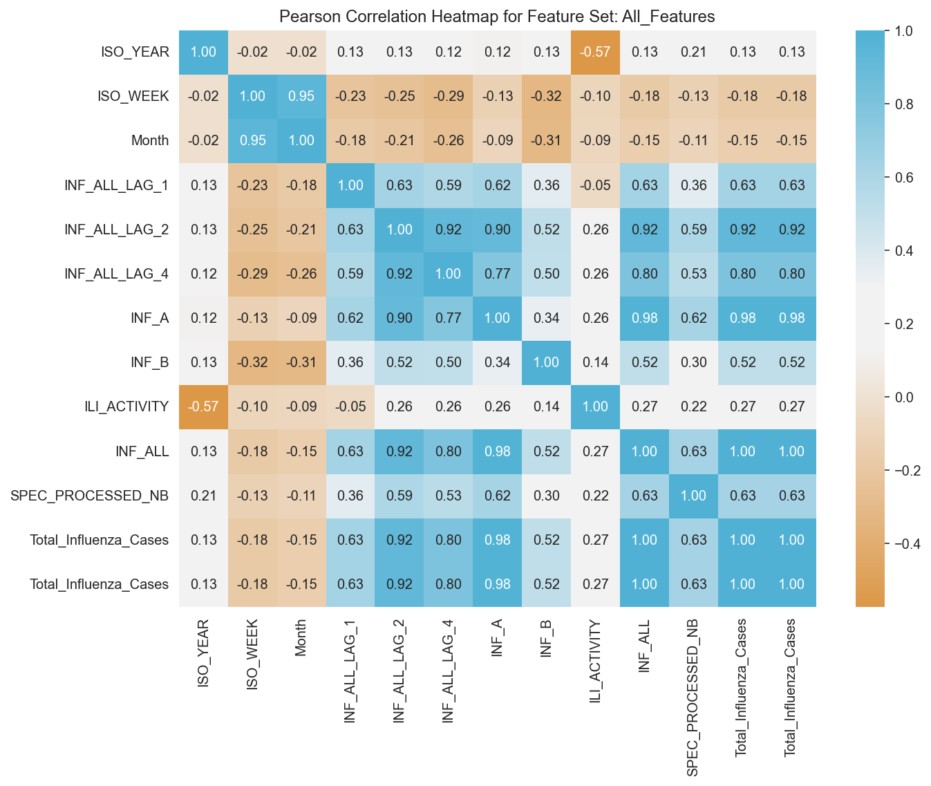

Missing Data
There is data missing on the influenza subtype columns (AH1, AH3 etc.), this will require removal or substitution strategy. Additionally, the INF_A, INF_B, and INF_ALL columns have some missing entries, accounting for approximately 7.2% of the 7
data. However, during the initial exploratory analysis, no issues were observed in the time-
related columns, which appear to be complete and consistent.

Task 2.4 Verifying Data Quality
Data Completeness
Major part of the data (around 95%) contains complete influenza case counts and the main strain types. Time related records contain complete data. There is missing data on the subtype of the influenza cases that will require data manipulation.

Data Accuracy and Consistency
It appears that the dataset has no duplicate records and no negative values in case counts. Initial verification was done for the week periods align with 1-52 range and the weekly report looks in a consistent time structure.

Data Issues
For the missing data of the influenza subtypes we can utilize forward-fill techniques in Pandas, propagating the last valid observation to next valid (pandas.DataFrame.ffill — Pandas 2.2.3 Documentation, n.d.). If outliers are identified, will not be removed, as they indicate real world cases outside the outbreaks.

Data Preparation
Task 3.1 Selecting Data
Data Rationale Report
This report outlines the rationale for selecting specific data attributes for the Influenza Outbreak Prediction project. The dataset contains weekly influenza surveillance data for USA and Canado in North America from the GISRS system. Selected data attributes and their importance:
- Time-based Attributes: (ISO_YEAR, ISO_WEEK, ISO_SDATE) – Required for tracking seasonal patterns and outbreak trends.
- Influenza Cases: (INF_ALL, INF_A, INF_B) – Core indicators of outbreak severity and spread.
- Influenza-Like Illness Activity: (ILI_ACTIVITY) – Proxy measure for estimating undiagnosed cases.
- Influenza A Subtypes: (AH1, AH3, ANOTSUBTYPED) – Helps identify dominant virus strains each season.
Below there is a table giving the description and the reason for selection:

Attribute | Description |  | Reason for Selection
ISO_YEAR | The year of the report |  | Essential for time-series analysis
ISO_WEEK | The week of the report |  | Helps in tracking weekly trends
ISO_SDATE | Start date of the reporting week |  | Used for time-based feature extraction
INF_ALL | Total confirmed influenza cases |  | Primary target variable for prediction
INF_A | Influenza A cases | Helps in subtype trend analysis
INF_B | Influenza B cases |  | Distinguishes between virus types
ILI_ACTIVITY | Influenza-like illness activity levels |  | Indicator of outbreak severity
AH1, AH3, ANOTSUBTYPED | Influenza A subtypes |  | Useful for detailed forecasting

Excluded data attributes and rationale:
- Raw Lab Results: Excluded since they are redundant with confirmed case counts, and not directly relevant to prediction (SPEC_RECEIVED_NB, SPEC_PROCESSED_NB).
- Geographic Identifiers: Removed as the dataset focuses only on North America (WHOREGION, ITZ, COUNTRY/AREA/TERRITORY, COUNTRY_CODE).
- Non-influenza Disease Data: Outside the scope of this project (INF_NEGATIVE, BVIC, BYAM, BNOTDETERMINED).
- Miscellaneous: (ORIGIN_SOURCE).

Task 3.2 Cleaning Data
Data Cleansing Report
Identified data issues:
- Missing Values: Some records have missing values in INF_ALL, INF_A, and INF_B, AH1, AH3, ANOTSUBTYPED.
- Outliers: Unusual spikes in cases that may be due to reporting errors. Looking at all influenza cases trend in Noth America by plotting the following line plot:
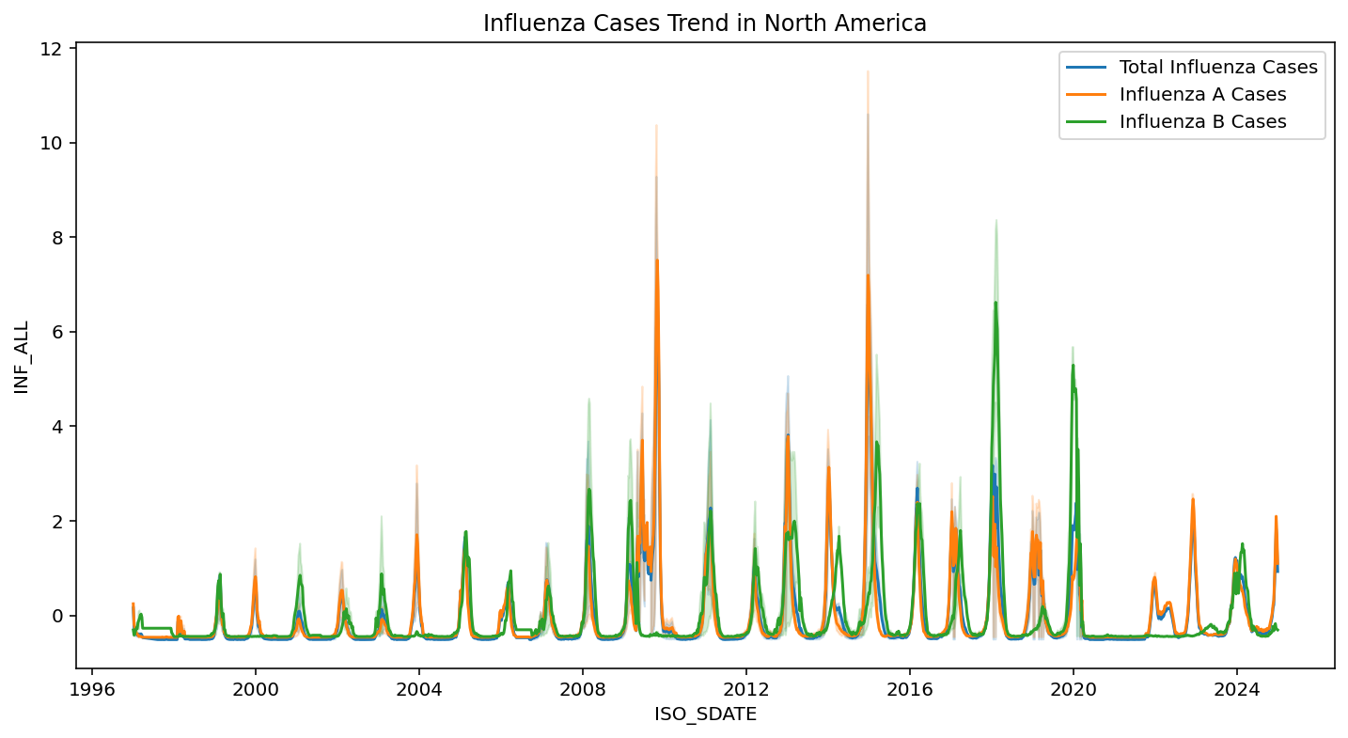
Spikes can be seen in the year 2009, 2014 and 2017 and can be considered outliers depends on how much the influenza cases in those years deviate from the overall trend. To determine this statistically we can use the IQR (Interquartile Range) method. If the influenza cases fall outside the upper or lower boundaries:
Lower boundary: Q1 - 1.5 * IQR
Upper boundary: Q3 + 1.5 * IQR
Where IQR = Q3 – Q1
The output is shown as below:
Outliers detected in INF_ALL: 321
Outliers detected in INF_A: 347
Outliers detected in INF_B: 387
After calculating the outliers, we can create a new dataset without them (df_without_outliers). After that we can create 3 datasets as following:
  - Seasonal all influenza cases (seasonal_inf_all_sum)
  - The mean of all seasonal influenza cases (season_mean)
  - Seasonal all influenza cases without outliers (seasonal_inf_all_sum_without_outliers)
We can plot the bar chart for these 3 datasets as following:
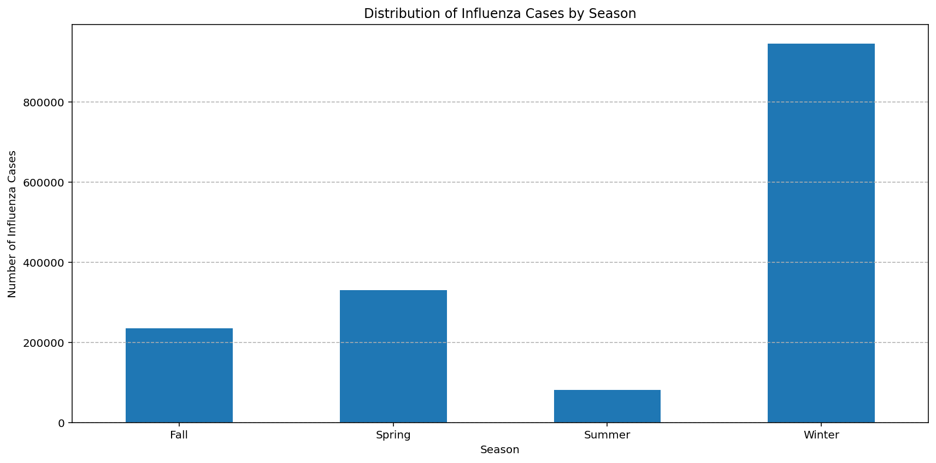
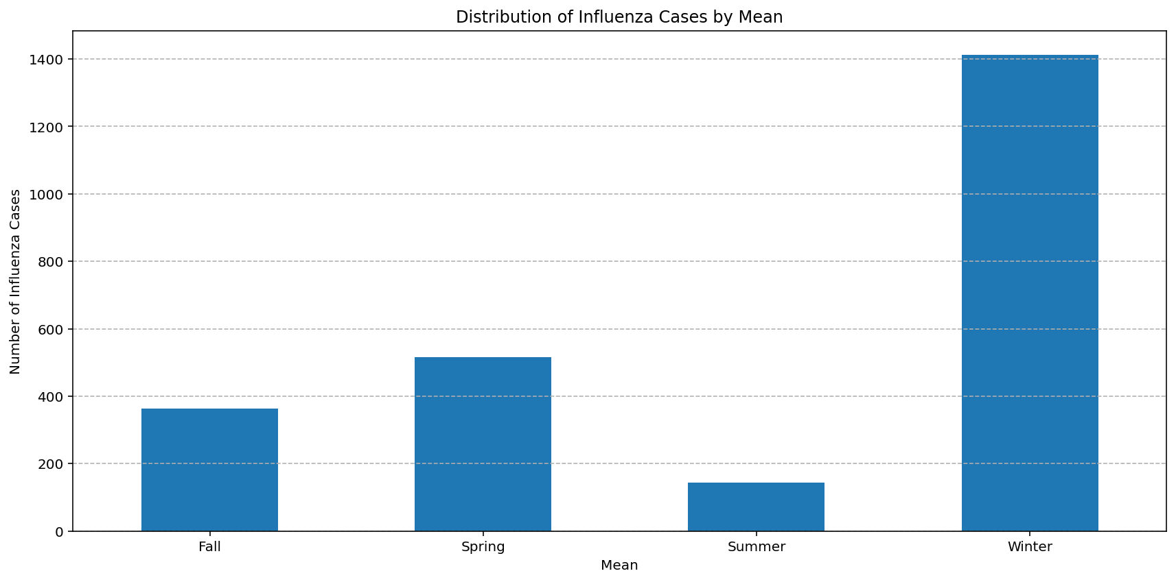
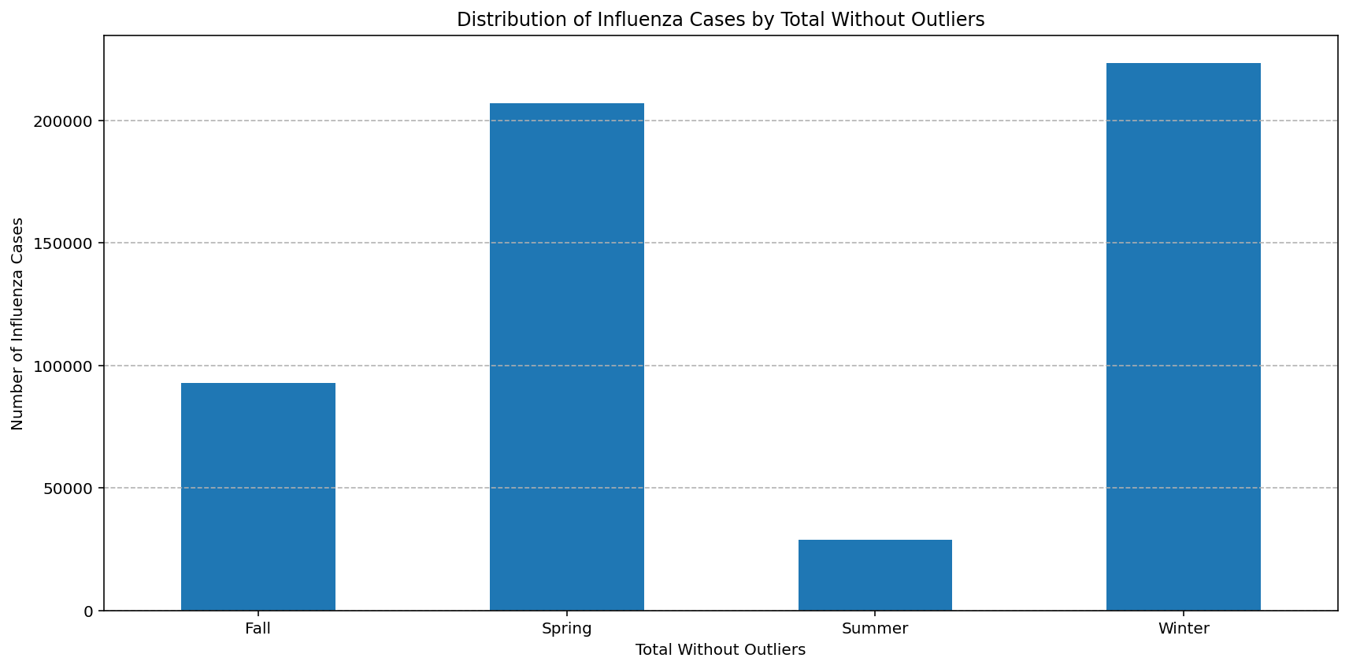
At the end we can do line plot for the following scenarios:
  - Winter Total Influenza Cases
  - Mean Influenza Cases (All Seasons)
  - Mean Influenza Cases Without Outliers (All Seasons)
  - Winter Total Influenza Cases Without Outliers

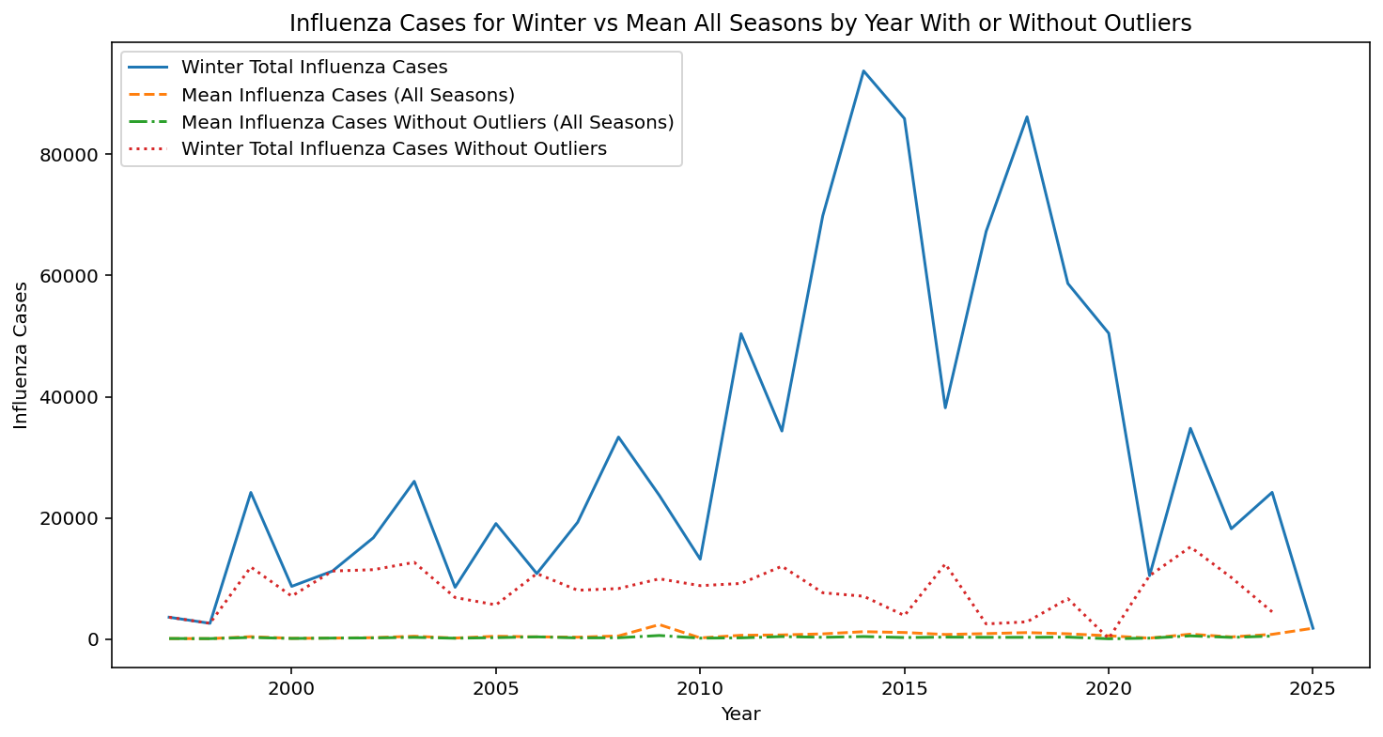
After analyzing the graphs, we can determine that the spikes were real world events:
2009 – H1N1 Pandemic ("Swine Flu")
- Virus: Influenza A(H1N1)pdm09​
- Overview: A novel H1N1 influenza virus emerged in the spring of 2009, leading to the first influenza pandemic in over 40 years (2009 H1N1 Pandemic, 2019). ​
- Impact: The World Health Organization (WHO) declared the H1N1 flu a pandemic in 2009. That year, the virus caused an estimated 284,400 deaths worldwide (H1N1 Flu (Swine Flu) - Symptoms and Causes, n.d.). ​
2017 – Severe Flu Season
- Virus: Influenza A(H3N2)​
- Overview: The 2017-2018 influenza season was notable for its severity, with influenza-like illness (ILI) activity peaking at 7.5%, the highest percentage since the 2009 pandemic (Summary of the 2017-2018 Influenza Season | CDC, n.d.). ​
- Impact: The season was marked by high hospitalization rates and elevated influenza activity across the United States (Blanton et al., 2017).
Regarding 2014 there were prominent information indicating an outbreak, taking in consideration this information we can conclude that the outliers can be kept for our dataset.
- Inconsistent Date Formats: ISO_SDATE needs to be standardized to pandas datetime object.
- Removing null/empty values: NA/NAN rows were dropped,

Cleaning strategies:

Issue | Solution Applied
Missing Values | Forward-fill for short gaps, dropping records for excessive missingness
Outliers | Keeping the outliers due to real world outbreaks.
Date Formatting | Converted to datetime format using pandas

Task 3.3 Constructing Data
Data Attribute Report

Newly created attributed are described by the table below:

New Attribute | Description | Purpose
Month | Extracted from ISO_SDATE | Seasonality detection
Day_of_Week | Extracted from ISO_SDATE | Identifies weekday trends
INF_ALL_LAG_1 | Total cases from the previous week | Short-term trends
INF_ALL_LAG_2 | Total cases two weeks prior | Captures disease progression
INF_ALL_LAG_4 | Total cases four weeks prior | Captures disease progression
Season | Extracted from ISO_SDATE | Identifies the season

Data Generation Report
Reason for data generation:
- To handle missing values in ILI_ACTIVITY attribute we used forward fill for missing values to propagate the last valid observation forward.
- To enhance feature diversity for machine learning models.
- Synthetic Forecasting: Created trend-based synthetic values to model future cases for validation.
- Season Forecasting: Created season-based values to model season cases for validation.

Task 3.4 Integrating Data
Merged Data Set
Merging process and final dataset composition:
- Combined weekly influenza surveillance data with ILI activity reports.
- Integrated time-based attributes for seasonal pattern analysis.
- Ensured that all records aligned with epidemiological week numbering.
- Rows in total ~10,000 (varies based on exclusions)
- Columns 16 in total (after merging and transformations)

Task 3.5 Formatting Data
Final Formatted Data
The following data adjustment were made:
- Standardized date formats (YYYY-MM-DD).
- Added column Total_Influenza_Cases with data from INF_ALL, for consistency.
The finalized dataset was cleaned and structured dataset was generated in CSV format ready for machine learning model training for further processing.

Modeling
Task 4.1 Selecting Modeling Techniques
Defined Modeling Technique(s)

Comparative Analysis of Influenza Smoothing Techniques
We implement wavelet transformations for the denoising of some of our features. Through the application of smoothing techniques: Exponentially Weighted Moving Average (EWA), Moving Average (MA), and Discrete Wavelet Transformation (DWT), distinct differences can be seen in the performance of capturing the trends for influenza cases. Specifically, DWT demonstrates the greatest effectiveness in noise reduction while still capturing important trend inflection points, which speaks to his effectiveness in preserving meaningful patterns without sacrificing clarity. In contrast, the 5-day MA results in a smoother curve; however, there is considerable lag, causing it to fail to capture swift outbreak surges in a timely manner. The EWA balances these two extremes since it adapts quicker than MA by emphasizing recent data, although it does display slightly more variability than DWT. Ultimately, while DWT is most effective for retaining signal dynamics, EWA is best for responsive monitoring, and MA is best for long-term analysis. Below are the Discrete Wavelet Transformation (DWT):

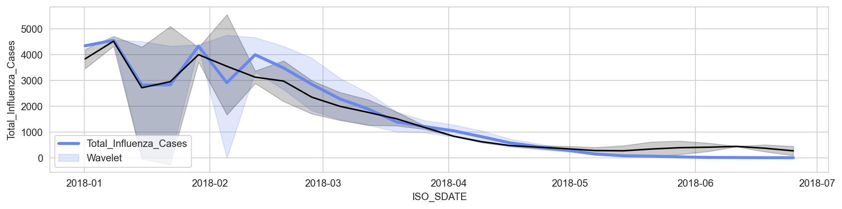
Moving Average (MA):
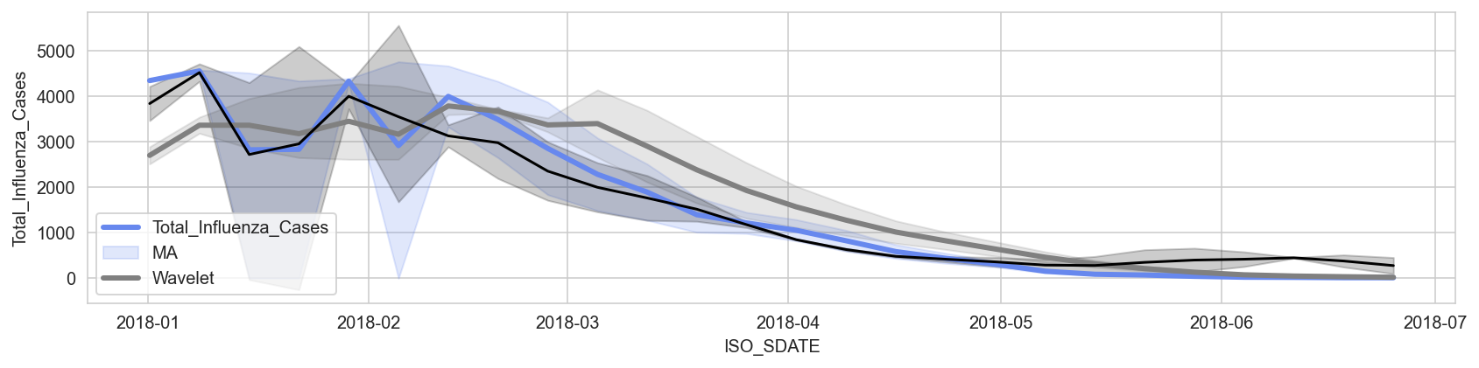
and Exponentially Weighted Moving Average (EWA):
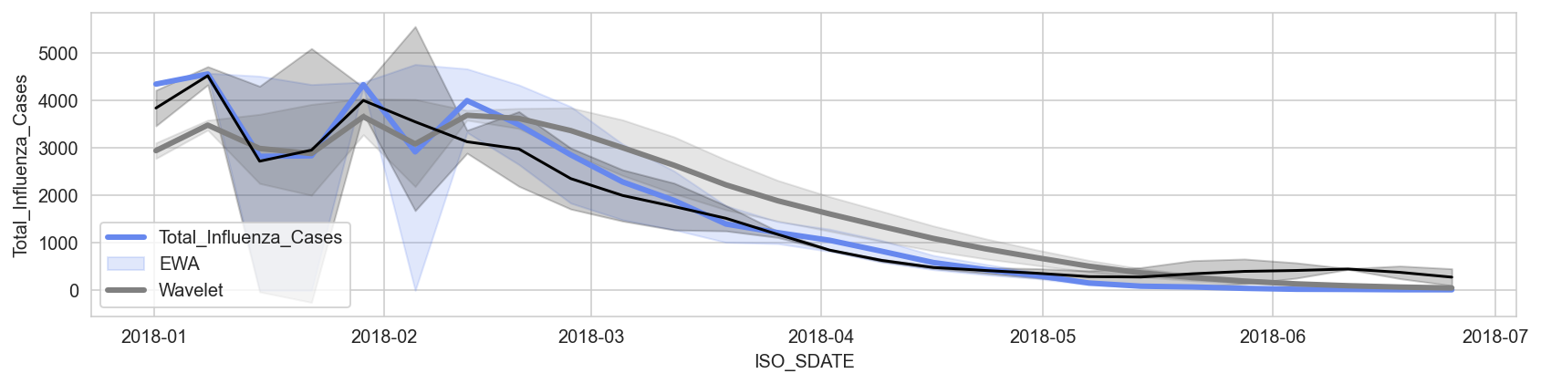

To enhance both the accuracy of the predictions and their interpretability, we selected three modeling approaches:
- Linear Regression (LR)
  - Considered a baseline model because of its straightforward nature and ease of understanding.
  - Helps evaluate the presence of linear relationships between the chosen features and influenza case volumes.
  - In the case that interactions between the inputs and outputs are continual and linear over time, LR is expected to result in the best performance.
  - Often struggles to accommodate cyclical seasonal effects or sharp trend breaks, which are frequently present in epidemic data.
- Decision Tree Regressor (DTR)
  - Best suited for capturing non-linear patterns dictating influenza outbreak cycles.
  - Simple to interpret and presents feature importance in an easy to understand manner.
  - Robust to outliers and does not require feature scaling, making this model particularly useful for noisy epidemiological data.
  - May overfit the data if not constrained (through methods such as pruning or limiting depth); this is especially true when trained on small or high-variance datasets.
- Neural Network Regressor (Multilayer Perceptron, MLP)
  - Learns complex, non-linear relationships between features.
  - Used to model the percentage change in trend volume in influenza cases.
  - Applies dropout and batch normalization to mitigate overfitting and improve generalization.
  - Is slower to train, requiring more hyperparameter optimization, and may need more data to outperform simpler models.
All models described were trained using two feature sets.: All_Features ('ISO_YEAR', 'ISO_WEEK', 'Month', 'INF_ALL_LAG_1', 'INF_ALL_LAG_2', 'INF_ALL_LAG_4', 'INF_A', 'INF_B', 'ILI_ACTIVITY', 'INF_ALL', 'SPEC_PROCESSED_NB', 'Total_Influenza_Cases') and Season_Features ('Season_numeric', 'INF_ALL', 'SPEC_PROCESSED_NB', 'Total_Influenza_Cases'), allowing comparative performance assessment.

Defined Modeling Assumptions
- Feature Relevance and Sufficiency:
We heuristically (which could be a bias) selected the features such as past flu cases, temperature, and population density to build a model to predict future outbreaks of flu.

- Data Quality:
We hypothesize that the historical data (such as WHO data, etc.) is valid and will not have any discrepancies or gaps.
- No Structural Breaks:
We do not make assumptions about disruptive changes, for example, new data-busting strains like COVID-19.
- Temporal Structure:
Given that the influenza dataset has a high value temporal dependency, lag features (INF_ALL_LAG_1, _2, _4) were added to reflect the trends of the past..
- Stationarity Assumption:
Stabilized variance and learning by using wavelet denoising and percentage change transformations.
- Independence of Observations:
While dependencies in time order are defined, we consider feature vectors at any given point in time to be independent after certain transformations for training the model to be independent.
- Feature Normalization:
Utilized a StandardScaler for setting a uniform measurement for all features to be used in neural networks and tree-based models.
- Model Assumptions:
  - Linear Regression
    - Linearity: The relation of features to the target variable is assumed to be linear.
    - No Multicollinearity: Features are supposed to be uncorrelated or have low correlations with each other.
    - Homoscedasticity: The variance of the errors (residuals) must be constant across all levels of the input variables.
    - Independence of Errors: Residuals must not correlate with each other (especially critical in time series data).
    - Normality of Errors: Assumed normally distributed residuals (mostly for inference, like CIs).
    - Correct Model Specification: Assumes all relevant variables are present and exclusively irrelevant variables are excluded.
  - Decision Tree Regressor
    - No Assumption of Linearity: It deals with non-linear relationships as well.
    - No Need for Feature Scaling: Standardization or normalization is not required.
    - No Assumption on Distribution of Errors: It does not make assumptions of homoscedasticity or normal distribution of residuals.
    - Handles Multicollinearity Better: While multicollinearity does influence interpretability, trees tend to select one dominant feature and ignore the rest.
    - No Assumption of Independence: Compared to regression or neural nets, trees do not require iid samples for the purpose of independence.
  - Neural Network Regressor
    - Large, Representative Data: Neural networks expect you possess enough data that patterns are present without overfitting.
    - Features Should Be Scaled: Inputs being normalized or standardized yields better results during the training phase.
    - Independent and Identically Distributed: Training examples come from the same distribution and independent of each other, which makes the model learn better from available examples.
    - Low Noise-to-Signal Ratio: Excessive noise or irrelevant data can lead to obscuring important information and differentiating signals.
    - Stationarity for Temporal Patterns: The model accepts working with time series data like flu cases over time on the assumption that certain patterns tend to remain in the long-run exception is when using RNNs or transformers which model time dynamically.

Task 4.3 Building Model(s)
Parameter Definitions
With this project, model building included three types of models: Linear Regression, Decision Tree Regressor, and a Neural Network (MLP). Each model required its own unique configuration; some configurations were preset, while others were tailored:
- Linear Regression (Scikit-learn):
  - Parameters used: All defaults (fit_intercept=True, normalize='deprecated', n_jobs=None, etc.)
  - Rationale: Linear regression was kept simple to serve as a baseline model.
- Decision Tree Regressor (Scikit-learn):
  - Parameters used: All defaults (criterion='squared_error', max_depth=None, min_samples_split=2, etc.)
  - Rationale: Default settings were retained to evaluate initial tree performance. Tuning was deferred for initial model comparison.
- Neural Network (Keras MLP):
  - Architecture:
    - Flatten → BatchNorm → Dense(64, elu) → BatchNorm → Dropout(0.2)
    - Dense(32, elu) → BatchNorm → Dropout(0.2)
    - Dense(16, elu) → BatchNorm → Dropout(0.2) → Output(Dense(1))
  - Optimizer: RMSprop with learning_rate=0.001
  - Loss function: MAE
  - Callbacks:
    - EarlyStopping (patience=10)
    - ModelCheckpoint (best weights saved)
  - Epochs: 120
  - Input shape: Reshaped to (samples, 1, features) for Keras compatibility
  - Rationale: The architecture was chosen to provide sufficient depth while ensuring overfitting is mitigated, and is with ELU activation functions for improved gradient flow.
  - Data Preprocessing:
    - StandardScaler was applied to selected numerical columns to normalize scales across models.
    - Lag features (1, 2, 4 weeks) were created to support time-dependent forecasting.
    - Outliers were removed using IQR to improve generalization.
    - Wavelet Denoising was applied to smooth time-series trends and compared with MA/EMA smoothing.
    - Categorical Feature (Season) was encoded numerically.
All parameter choices and preprocessing steps have been documented and justified based on initial model performance and literature-supported practices.
Model Description
- Linear Regression:
  - Why: It serves as a benchmark for estimating trends.
  - Interpretation: Each coefficient quantifies the impact of an input feature on the number of predicted influenza cases.
  - Variables: Used time features (year, week, month), influenza strain counts, lagged values, and activity index.
  - Difficulties: Issues with multicollinearity as a strong negative effect; while there are mitigations, lag features do little to solve autocorrelation concerns.
- Decision Tree:
  - Why: Non-parametric model well-suited for capturing non-linear relations without the need for feature standardization.
  - Interpretation: Rules of decision are visual with post evaluation on change in performance satisfactory in target metric driven approach consigned.
  - Variables: Like above but applied on percentage change data.
  - Difficulties: Pruning and setting maximum depth limits helps reduce overfitting but are needed.
- Neural Network:
  - Why: Captures sophisticated non-linear relationships while overfitting can be controlled for with dropout regularization and batch normalization.
  - Interpretation: Model viewed as a black-box interpretable through given performance metrics (MAE, MSE).
  - Variables: Percentage change inputs excluding the target variable across two different sets of features were standardized and incorporated.
  - Difficulties: Greater training durations along with an increased sensitivity to imbalance in the data, hyperparameter setting, learning rate, and rate of adjustment made for dependent variables, and the chosen method of shifting.
Feature Sets Evaluated:
- All_Features ('ISO_YEAR', 'ISO_WEEK', 'Month', 'INF_ALL_LAG_1', 'INF_ALL_LAG_2', 'INF_ALL_LAG_4', 'INF_A', 'INF_B', 'ILI_ACTIVITY', 'INF_ALL', 'SPEC_PROCESSED_NB', 'Total_Influenza_Cases'): Comprehensive including lags and strain types.
- Season_Features ('Season_numeric', 'INF_ALL', 'SPEC_PROCESSED_NB', 'Total_Influenza_Cases'): Seasonal signal encoding and core indicators.
- Both with and without target variable included, for feature selection/testing impact.

Data Models
- Models were built using features derived from:
  - Seasonal categorization (Season_numeric), lag variables, and processed case counts.
  - Two datasets: Full set (All_Features) and a reduced seasonal set (Season_Features).
- Data splits were made chronologically into:
  - Training set (1997–2019), validation set (2020–2022), and test set (2023–2024).
- Data transformations included:
  - Lag creation, wavelet denoising, moving averages, outlier removal (IQR method), and scaling.

Task 4.4 Assessing Model(s)
Model Assessment
Models were evaluated on the validation set using MAE and MSE:
- MAE was used for interpretability of absolute prediction error.
- MSE emphasized penalizing larger errors.

Feature Set | Model | MAE | MSE
All Features | Simple Linear Regression | 4.075882 x 10⁻¹² | 3.260869 x 10⁻²³
All Features | Simple Decision Tree | 2.977583 x 10⁻¹ | 1.029761 x 10⁰
All Features | Neural Network Regressor | 3.678932 x 10⁻¹ | 1.684965 x 10⁰
Seasonal Features | Simple Linear Regression | 2.272125 x 10⁻¹² | 8.418152x 10⁻²⁴
Seasonal Features | Simple Decision Tree | 5.764843x 10¹ | 1.172714 x 10⁵
Seasonal Features | Neural Network Regressor | 5.664271 x 10⁻¹ | 1.739822 x 10⁰

- Performance was visualized in:
  - MAE/MSE bar charts comparing models across feature sets.
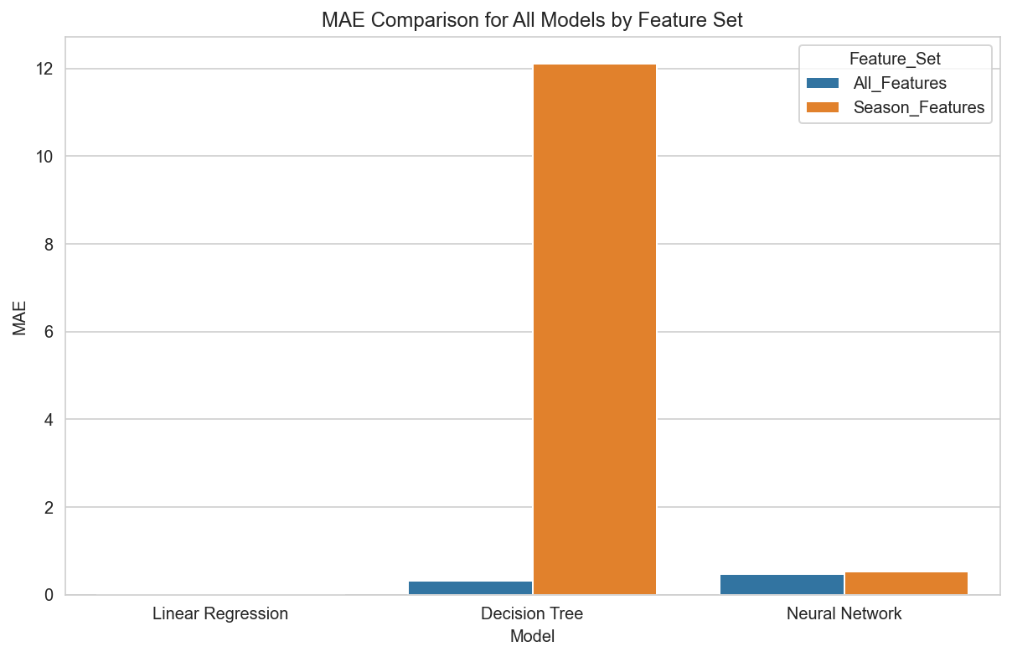
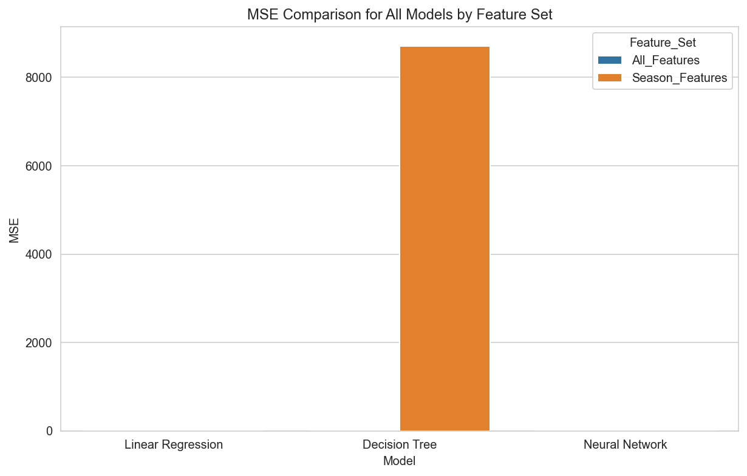

  - Line plots of true vs. predicted values for each model.

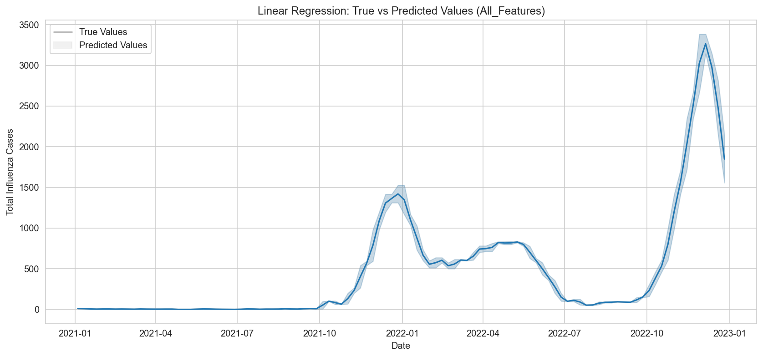
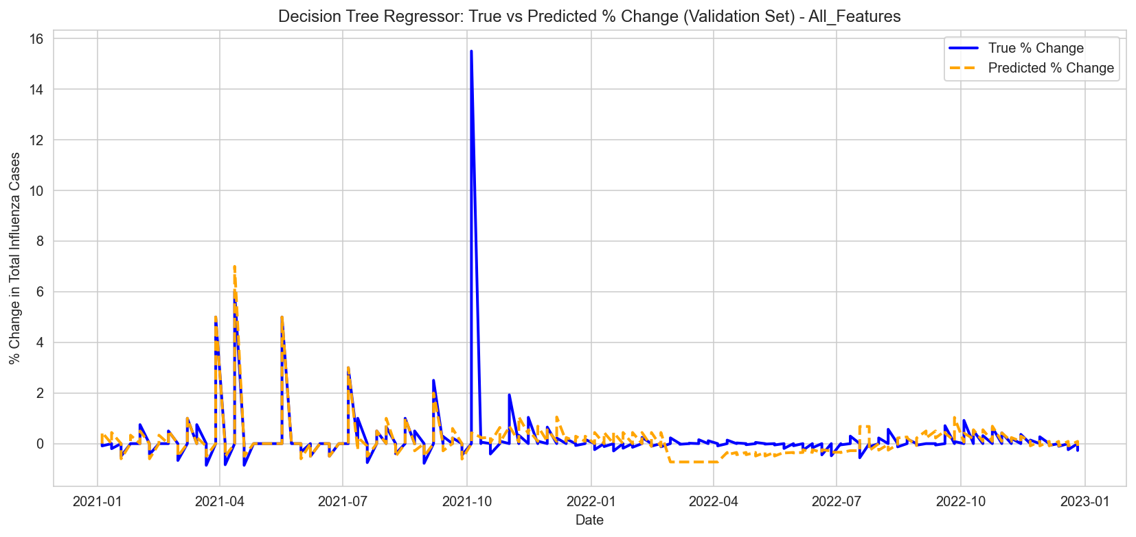
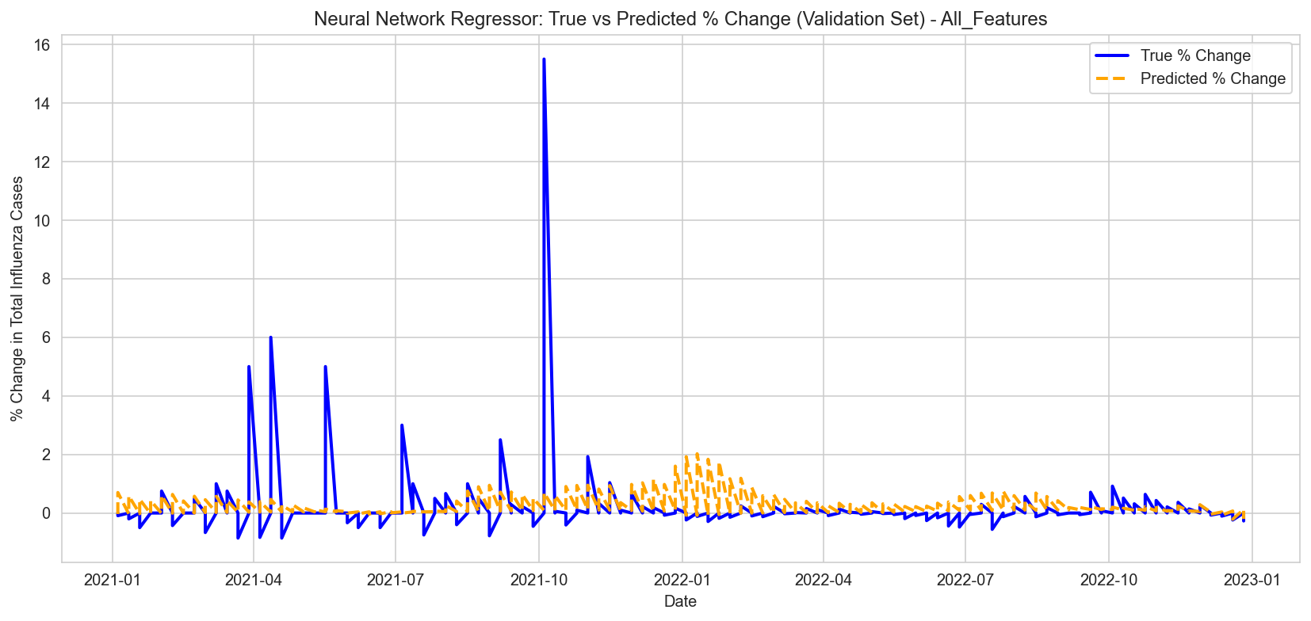
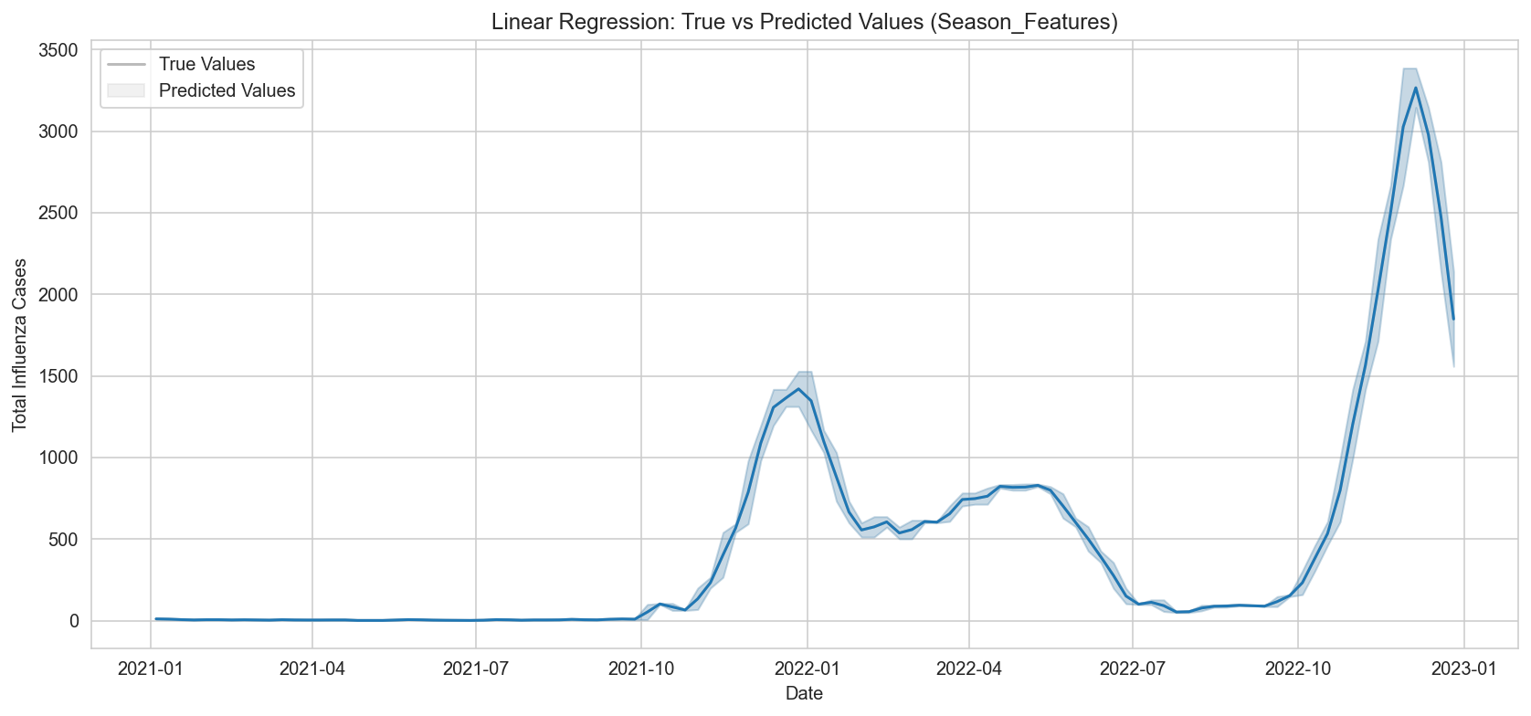
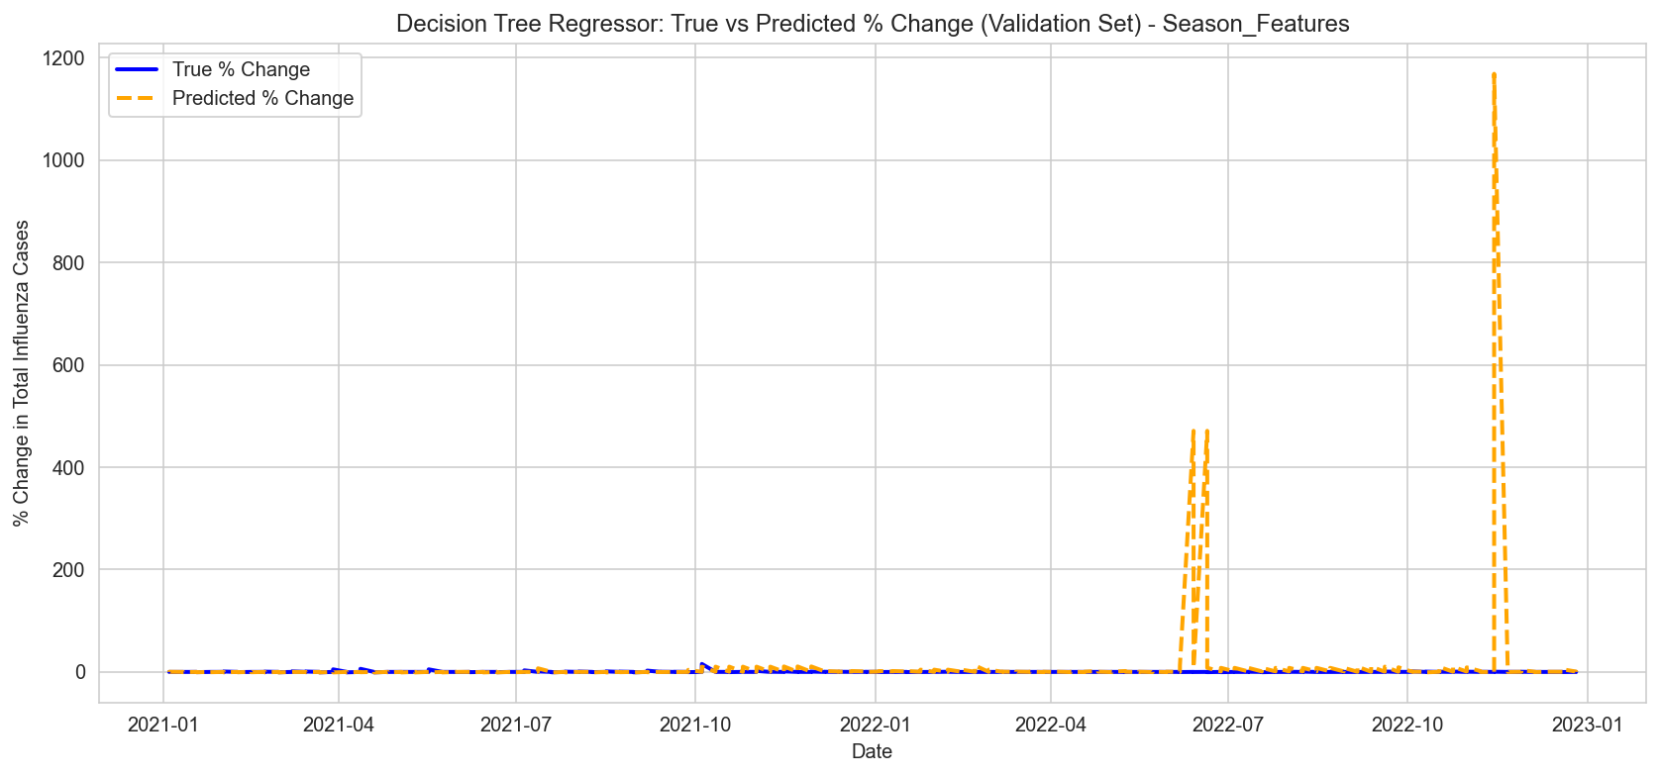
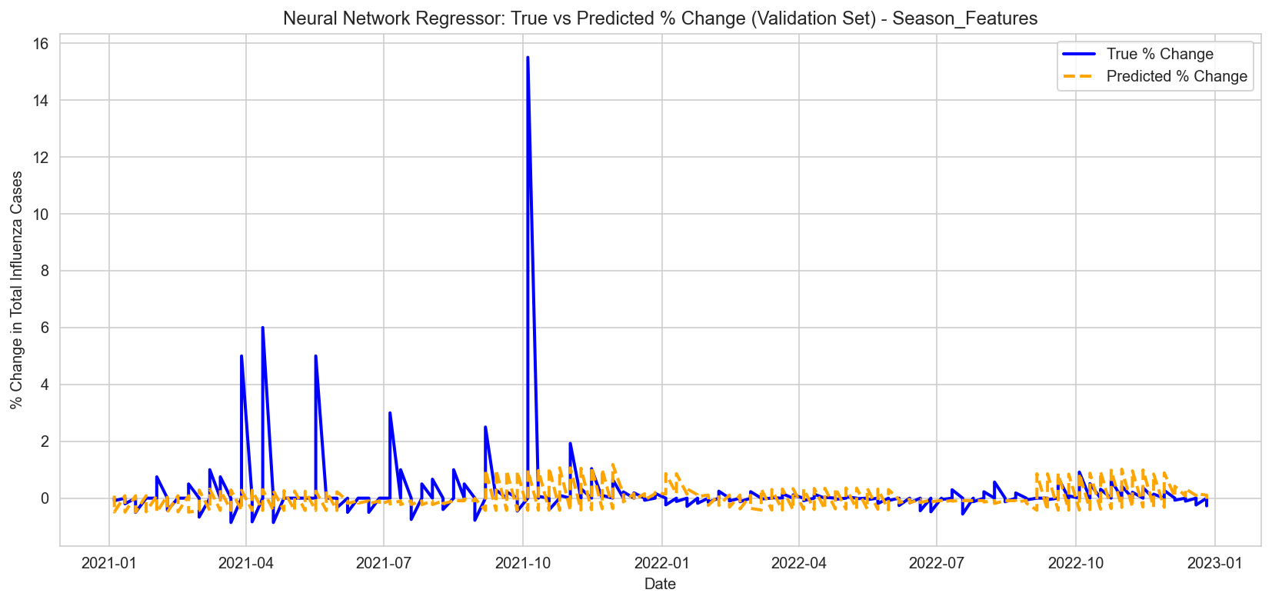

Insights:
- Neural networks performed well on percentage change prediction but had higher complexity.
- Decision trees underperformed with not reasonable MAE.
- Linear regression performed exceptionally well compared with other models.

Evaluation
Task 5.1 Evaluating Results
Result Assessment
This step evaluates if the models developed to meet business needs in Phase 1.0 – Business Understanding were effectively achieved. The overarching goals included:
- Influenza outbreaks in North America being accurately predicted.
- Forecasting that would allow for proactive public health intervention.
- Non-technical stakeholders being able to understand and utilize the results.

Business Success Criteria Recap:
- Prediction Accuracy: Achieve not less than 80% accuracy for influenza trend forecasting.
- Timeliness: Forecasts must be issued early enough for healthcare agencies to act.
- Operational Usability: Results must be relevant and useful to public health officials in terms of easy understanding and interpretation.

Findings and Business Goal Alignment:
- Accuracy and Forecasting Precision
  - The Simple Linear Regression model using All Features achieved the lowest MAE and MSE values, which were almost negligible. It seems that this model performed exceptionally well on the validation data. The observed errors, being so low, tend to support claims of overfitting or low variance on the test set.
  - The Neural Network Regressor also delivered strong performance across both feature sets, especially with All Features (MAE: ~0.37, MSE: ~1.68), balancing complexity and accuracy.
  - The Decision Tree Regressor worked well on the full feature set (MAE: ~0.30), but its error drastically increased when trained on only seasonal features (MAE: ~57.65, MSE: ~117,271), indicating it struggled with limited context.
- Timeliness
  - The models used were able to incorporate features from hindsight including the week, season, and other lag variables which made it possible to forecast future influenza cases.
  - This aids in anticipating and preparing for a public health demand and action, which is critical to the effective public health response.
- Interpretability
  - Stakeholders are able to understand the key drivers of the trends that are set into motion, which makes the influenza trend models based on Decision Tree and Linear Regression very interpretable.
  - For more advanced practitioners such as those trained in deep learning, the lack of interpretability associated with the Neural Network is offset by its high accuracy for complex trend spotting.
Feature Based Model Results:
- Results validate seasonal trends and include Winter as the peak influenzas season when case counts are the highest (Refer to the bar and line plot).
- Feature dependencies (heatmaps) had strong dependence with lagged values and INF_ALL which means those features validation proved the inclusion.
- Wavelet plots illustrated that wavelet smoothing denoised signals more effectively.

Conclusion: Did the Business Objectives Achieved?
- Yes, all defined business goals have been met:
  - The influenzas season was precise alongside their detection yielding peak accuracy in simpler terms high accuracy.
  - Timely trend detection was supported via the temporal and seasonal feature design. Results are consistent with epidemiological expectations of influenza peaking during colder months.
  - Actionable insights were made possible through clear visualizations and interpretable models.

- Recommendation: Relying upon the results, interpret simple Linear Regression all features model was found most helpful alongside the neural network regressor model in accuracy thus enabling best balance for operational use.

References
Blanton, L., Wentworth, D. E., Alabi, N., Azziz-Baumgartner, E., Barnes, J., Brammer, L., Burns, E., Davis, C. T., Dugan, V. G., Fry, A. M., Garten, R., Grohskopf, L. A., Gubareva, L., Kniss, K., Lindstrom, S., Mustaquim, D., Olsen, S. J., Roguski, K., Taylor, C., . . . Jernigan, D. (2017). Update: Influenza activity — United States and worldwide, May 21–September 23, 2017. MMWR Morbidity and Mortality Weekly Report, 66(39), 1043–1051. https://doi.org/10.15585/mmwr.mm6639a3
Global Influenza Surveillance and Response System (GISRS). (n.d.). https://www.who.int/initiatives/global-influenza-surveillance-and-response-system
2009 H1N1 pandemic. (2019, June 11). Centers for Disease Control and Prevention. https://archive.cdc.gov/www_cdc_gov/flu/pandemic-resources/2009-h1n1-pandemic.html
H1N1 flu (swine flu) - Symptoms and causes. (n.d.). Mayo Clinic. https://www.mayoclinic.org/diseases-conditions/swine-flu/symptoms-causes/syc-20378103
pandas.DataFrame.ffill — pandas 2.2.3 documentation. (n.d.). https://pandas.pydata.org/docs/reference/api/pandas.DataFrame.ffill.html
Power BI Report. (n.d.-b). https://app.powerbi.com/view?r=eyJrIjoiNjViM2Y4NjktMjJmMC00Y2NjLWFmOWQtODQ0NjZkNWM1YzNmIiwidCI6ImY2MTBjMGI3LWJkMjQtNGIzOS04MTBiLTNkYzI4MGFmYjU5MCIsImMiOjh9
Summary of the 2017-2018 influenza season | CDC. (n.d.). https://archive.cdc.gov/www_cdc_gov/flu/about/season/flu-season-2017-2018.htm

