McDonnell Douglas MD-11 Autoflight System

Josh Davidson (Octal450)

Updated: 11/28/2023

Note: This guide is not an FCOM and does not describe every single behavior of the system.

Contents

Introduction 2

Flight Mode Annunciator 2

Status Boxes 2

Autoflight Modes 3

Speed Modes 3

Lateral Modes 3

Vertical Modes 3

Land Modes 4

Armed Modes 5

Controls 5

Flight Control Panel 5

Other Controls 7

Procedures 8

Takeoff and Climb 8

Engaging the AP or ATS 8

Disengaging the AP or ATS 9

Setting a New Speed or Heading 9

Climbing or Descending to a New Altitude 9

Performing an ILS Approach or Autoland 9

# Introduction

The MD-11 has a 3-axis Autoflight system, consisting of 2 independent Autopilots (APs). Each system has a coupled Auto Thrust System (ATS). The system is capable of automatically flying the aircraft from shortly after liftoff, to touchdown and rollout.

The controls for the system are located on the Flight Control Panel (FCP) on the glareshield. Outputs from the system are shown on both Primary Flight Displays (PFDs) in the form of the Flight Mode Annunciator, Flight Director and target bowtie indicators.

The system controls roll through the ailerons and spoilers, pitch through the elevators and horizontal stabilizer trim, and yaw through the rudders. Yaw control is only active during Takeoff and Autoland modes.

# Flight Mode Annunciator

The Flight Mode Annunciator (FMA) shows the engaged and armed modes of the system. It is located at the top of each PFD.

Status Boxes



Vertical Modes

Lateral Modes

Speed Modes

## Status Boxes

These boxes show the engagement status of the system. When visible and white, the system is off, but available. When the boxes are visible and amber, the system is off and not available.

When turning off a system, the associated box will flash red until silenced (for the AP, the autopilot aural will also play).

When not visible, the systems are engaged. “AP1” or “AP2” is displayed to indicate the active system. During a DUAL LAND, both APs are engaged, and simply “AP” is displayed.



When the speed mode is in PITCH, the boxes switch places. This is because the AP is now controlling the speed and lateral modes, while ATS is controlling the vertical mode.



# Autoflight Modes

## Speed Modes

The speed mode is coupled to the vertical mode. When the AP is controlling the vertical mode, such as altitude hold or vertical speed, ATS is controlling the speed. When the AP is tracking the speed, ATS is controlling the vertical mode. During landing, RETARD mode engages at 50ft radio altitude.

When FMS SPD is engaged, the mode is displayed in magenta.

Available modes are:

* THRUST: ATS is adjusting the throttles to track airspeed or mach number
* PITCH: AP is adjusting the pitch angle to track airspeed or mach number
* RETARD: ATS is retarding the throttles for touchdown

## Lateral Modes

The lateral modes are controlled by the AP.

When the DUAL LAND is active, active mode is displayed in green.

Available modes are:

* HEADING (white): FCP selected heading is being captured and held
* TRACK (white): FCP selected ground track is being captured and held
* NAV (magenta): FMS lateral path is being captured and tracked
* VOR1/VOR2 (white): VOR localizer is being captured and tracked
* LOC/LOC ONLY (white or green): ILS localizer is being captured and tracked
* ALIGN (white or green): Runway alignment is occurring
* ROLLOUT (white or green): Runway centerline is being tracked
* TAKEOFF (white): Takeoff guidance is being tracked

## Vertical Modes

Vertical path modes are controlled by the AP, and level change modes are controlled by ATS.

The system will automatically engage HOLD mode and capture the altitude selected on the Flight Control Panel, except when the system is in G/S or Autoland modes.

When the DUAL LAND is active, active mode is displayed in green. When the FMS is controlling the vertical mode, the active mode is displayed in magenta.

Available path modes are:

* HOLD (white or magenta): FCP selected altitude is being captured and held
* V/S (white or magenta): FCP selected vertical speed is being tracked
* FPA (white or magenta): FCP selected flight path angle is being tracked
* G/S (white or green): ILS glideslope is being captured and tracked
* FLARE (white or green): The flare maneuver is occurring
* ROLLOUT (white or green): The nose is being lowered to the ground

When in Level Change mode, the AP controls the airspeed by adjusting pitch angle, and ATS controls the vertical mode by setting power. This provides the best climb/descent rates and is automatically engaged based on the aircraft’s position in reference to the FCP selected altitude. When ATS is in any CLAMP mode, the throttle servos are unpowered and the levers can be moved by the pilot.

Available level change modes are: (white or magenta)

* T/O THRUST (Climb): Takeoff Thrust limit is being set
* T/O CLAMP (Climb): Takeoff Thrust limit was set and the servers are now unpowered.
* GO AROUND (Climb): Go Around limit is being set
* MCT THRUST (Climb): Max Continuous Thrust limit is being set
* CLB THRUST (Climb): Climb Thrust limit is being set
* IDLE THRUST (Descent): Throttles are being driven to idle and held
* IDLE CLAMP (Descent): Throttles are being driven to idle and then the servos will be unpowered

## Land Modes

When engaged, the land mode capability is displayed to the right of the vertical mode section in place of the target altitude. The indications will appear roughly 10 seconds after passing 1500ft radio altitude.



* DUAL LAND (green): Both APs are available for Autoland
* SINGLE LAND (white): Only one AP is available for Autoland
* APPR ONLY (white): Autoland is not available, disconnect system above 100ft

## Armed Modes

Armed modes appear above the active modes on the FMA. They disappear when the mode activates.

Lateral armed modes are:

* NAV ARMED (Magenta): NAV mode is armed
* LAND ARMED (White): LOC mode is armed
* LOC ARMED (White): LOC ONLY mode is armed
* VOR ARMED (White): VOR1 or VOR2 mode is armed

Vertical armed modes are:

* LAND ARMED (WHITE): G/S mode is armed
* PROF ARMED (Magenta): PROF mode is armed

# Controls

## Flight Control Panel

The Flight Control Panel (FCP) is the location of most of the controls for the Autoflight system. It is located on the glareshield.

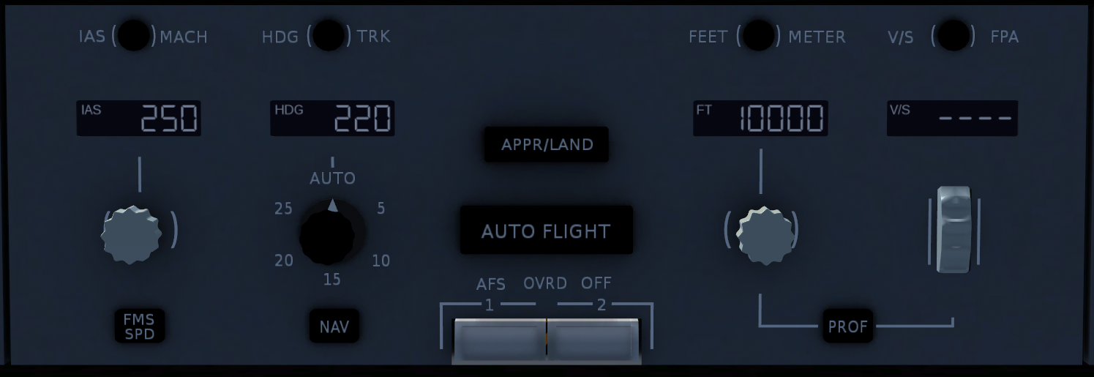

12

3

15

17

6

18

14

5

13

2

1

19

16

11

10

7

8

9

4

Knobs 3, 8, and 15 are multi-function knobs. A mouse or trackpad with a scroll wheel is required to use them. This applies to the 2D Panel version as well.

* Turn knobs by using the scroll wheel, hold Shift to accelerate adjustment
* Push knobs by left clicking
* Pull knobs by middle-clicking or holding Shift and left-clicking

1. IAS Mach Selector  
   Switches the speed pre-select and target between indicated airspeed (knots), and mach.
2. Speed Window  
   Displays the speed pre-select. Dashed when FMS SPD mode is active.
3. Speed Knob  
   Turn: Adjusts the speed pre-select.  
   Push: Sets the speed target to the current speed. Cancels FMS SPD.  
   Pull: Sets the speed target to the pre-selected value. Cancels FMS SPD and RETARD mode.
4. FMS SPD Button (Currently INOP)  
   Push to engage FMS SPD mode. Does not work on the ground.
5. Heading Track Selector  
   Switches between heading and ground track modes.
6. Heading Window  
   Displays the heading pre-select. Dashed unless HEADING, TRACK, or TAKEOFF lateral modes are active.
7. Bank Limit Selector  
   Selects the maximum bank angle in HEADING or TRACK modes. No effect in other modes.
8. Heading Knob  
   Turn: Adjusts the heading/track pre-select.  
   Push: Engages HEADING or TRACK and holds the current value. Cancels armed lateral modes.  
   Pull: Engage HEADING or TRACK and sets the target to the pre-selected value.
9. NAV Button  
   Arms or engages NAV mode (if available).
10. APPR/LAND Button  
    Arms LAND modes for ILS approaches if the frequency is in range.
11. AUTOFLIGHT Button  
    When airborne, engages both ATS and either AP1 and AP2. The engaged AP is alternated every engagement, and pushing the button while engaged will swap to the other AP.
12. AFS Override Off Switches  
    Emergency disconnect switches. Immediately disconnects ATS and both APs. Also cancels envelope protection features and Roll Control Wheel Steering (if equipped). Do not use during normal operation.
13. Feet/Meter Selector (Currently INOP)  
    Switches the altitude pre-select and target between feet and meters.
14. Altitude Window  
    Displays the altitude pre-select.
15. Altitude Knob  
    Turn: Adjusts the altitude pre-select.  
    Push: Engages HOLD mode and holds the current altitude. Cancel armed vertical modes.  
    Pull: Engages Level Change mode and sets the altitude target to the pre-selected value.
16. PROF Button (Currently INOP)  
    Arms or engages PROF mode (if available).
17. Vertical Speed/Flight Path Angle Selector  
    Switches between vertical speed and flight path angle modes.
18. Vertical Speed/Flight Path Angle Window  
    Displays the target vertical speed in feet-per-minute or flight path angle in degrees.
19. Vertical Speed/Flight Path Angle Knob  
    Engages V/S or FPA modes and adjusts the target value.

## Other Controls

Yoke

Throttles

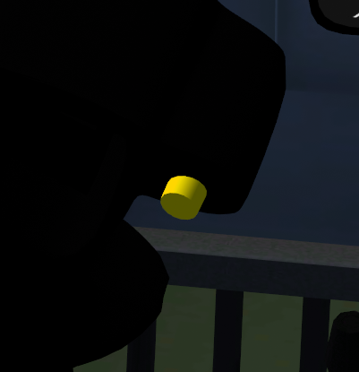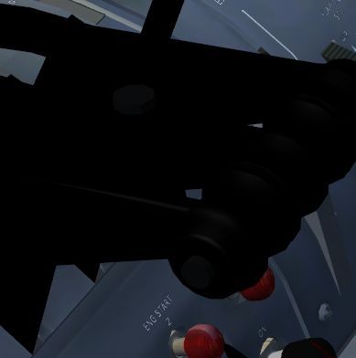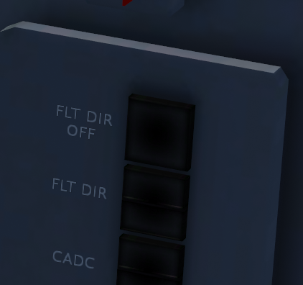

Sides of Main Panel

5

4

3

2

1

1. AP Disconnect Button (Both Yokes)  
   Disconnects both APs. Aural warning will sound and the AP OFF box on the FMA will flash red. Second press silences the warning. Holding the button temporarily overrides LSAS and RCWS.
2. Go Around Button  
   Engages HEADING and GO AROUND modes. ATS sets throttles to the Go Around Thrust limit. If the gear is on the ground and the AP is on, it will disconnect. Autobrakes are also disarmed. Button has no effect above 2500ft radio altitude.
3. ATS Disconnect Button (Throttle 1 and 3)  
   Disconnects ATS. ATS OFF box on the FMA will flash red. Second press silences the warning.
4. Flight Director Off Button  
   Toggles the Flight Director on the associated PFD.
5. Flight Director Selector (Currently INOP)  
   Switches the associated FD to the other system. For example, the captain’s side switch will set FD1 to be driven by the Flight Control Computer 2.

# Procedures

## Takeoff and Climb

1. Ensure T/O CLAMP is indicated on the FMA, climb speed and initial altitude are set on the FCP. Optionally arm NAV and PROF (once implemented) modes.
2. Spool the engines up to approximately 60% N1 (GE) or 1.10 EPR (PW) and wait for them to stabilize.  
   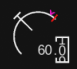 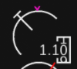
3. Push AUTOFLIGHT button.
4. Push throttles up and check that “T/O THRUST” appears on the FMA and ATS drives throttles to the Takeoff Limit.
5. At 80kts, observe and crosscheck “T/O CLAMP” re-appearing on the FMA and power is set.
6. At rotation speed, smoothly rotate the aircraft up and center the Flight Director bars. Do not chase the bars.
7. AP can be engaged at 100ft radio altitude unless NAV mode is armed or active, where 400ft radio altitude is the minimum. Center FD bars before engaging AP.
8. At thrust reduction altitude, observe “CLB THRUST” appearing on the FMA and the engines rolling back to the climb limit.
9. At acceleration altitude, if FMS SPD is not active, pull the Speed Knob to accelerate to the climb speed set in the FCP.

## Engaging the AP or ATS

1. Ensure the desired modes are active, and the Flight Director bars are centered.
2. Push AUTOFLIGHT button.

## Disengaging the AP or ATS

1. Push the AP Disconnect Button on the Yoke or the ATS Disconnect Button on the Throttles.
2. Silence the disconnect warning and flashing red box by pressing the AP or ATS Disconnect Button again.

## Setting a New Speed or Heading

1. Set desired speed or heading into the FCP.
2. Pull Speed Knob or Heading Knob.

## Climbing or Descending to a New Altitude

1. Set desired altitude into the FCP.
2. Pull Altitude Knob to engage Level Change.
3. Observe ATS setting power for climb or descent and the AP pitching for speed.

## Performing an ILS Approach or Autoland

1. Set frequency and course into ILS radio using MCDU.
2. When on an intercept course (30 degrees or less recommended), push APPR/LAND button.
3. When LOC engages, ensure LAND ARMED is displayed in the vertical mode of the FMA.
4. When G/S engages, ensure the missed approach altitude is set in FCP.
5. If performing an Autoland, ensure DUAL LAND is annunciated roughly 10 seconds after passing 1500ft radio altitude.
6. Monitor AP performance and be prepared to take over if system disconnects due to loss of ILS signal or malfunction.