McDonnell Douglas MD-80

Thrust Limits and TRI

Josh Davidson (Octal450)

Updated: 12/26/2023

Note: This guide is not an FCOM and does not describe every single behavior of the system.

Contents

Introduction 3

Controls and Indicators 3

Thrust Limits 4

Automatic Reserve Thrust 5

Automatic Thrust Restoration 6

EPR Limit Override 6

# Introduction

The MD-80’s two engines are conventionally controlled by cables running from the throttles to each engine. In order to maintain safe operation, thrust limits are controlled and displayed in the cockpit by the Thrust Rating Indicator (TRI), Engine Pressure Ratio (EPR) gauges, and Automatic Reserve Thrust (ART) switch.

# Controls and Indicators

These controls are used for controlling and displaying the thrust limits.

Thrust Rating Indicator

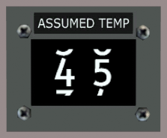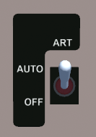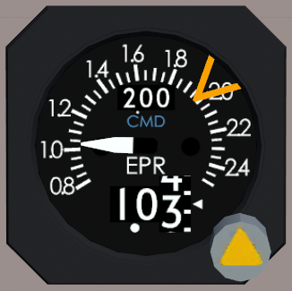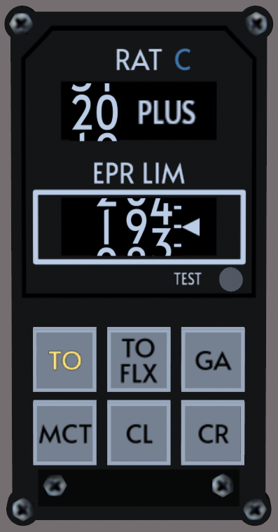

12

Assumed Temp Selector

10

11

ART Switch and Lamps

First Officer Panel

7

3

6

8

4

5

9

1

2

EPR Gauges (2)

1. Ram Air Temperature Window  
   Displays the Ram Air Temperature (RAT) used for EPR limit calculations. Also known as Total Air Temperature (TAT).
2. EPR Limit Window  
   Displays the active EPR limit computed by the TRI.
3. TRI Test Button  
   Tests the TRI when depressed. RAT window will display 12 PLUS. EPR limit window will display one of the following values based on engine type: -217: 1.94, -217A: 2.04, -219: 2.08. Upon releasing, TRI will be in NO MODE.
4. EPR Limit Selection Buttons  
   Selects the EPR limit mode on the TRI.
   * TO: Takeoff Limit
   * TO FLX: Takeoff Flex Limit, requires Automatic Reserve Thrust (ART) switch set to OFF
   * GA: Go Around Limit
   * MCT: Maximum Continuous Thrust Limit
   * CL: Climb Limit
   * CR: Cruise Limit
5. NO MODE Light  
   Illuminates when the TRI is not in a valid mode. The EPR limit will not be computed. Do not allow the engines to be operated with the NO MODE light illuminated, as this risks engine overspeed.
6. EPR Limit Override Window  
   Displays the EPR limit override. Window is hidden when the override is not enabled.
7. EPR Limit Bug  
   Displays the active EPR limit from the TRI, or the EPR limit override value.
8. EPR Limit Override Knob  
   Pull/Push: Enable/Disable EPR limit override. When pushed in, override is disabled.  
   Turn: Adjust EPR limit override value.
9. ART Switch  
   When set to OFF, disables the Automatic Reserve Thrust system. Required to be off to use the TO FLEX mode on the TRI.
10. ART Ready Light  
    Illuminates when the Automatic Reserve Thrust system is armed and ready to activate if needed.
11. ART Light  
    Illuminates when the Automatic Reserve Thrust system activates and increases power.
12. Assumed Temp Selector  
    Used to select the temperature used for flexible (flex) takeoff operations.

# Thrust Limits

The Pratt & Whitney JT8D engine is controlled via Engine Pressure Ratio (EPR). EPR is an indicator of the thrust produced by the engine. As a result, it can be used to ensure the engine is operating within safe parameters, which is called the thrust limit. There are many different thrust limits that the engines can be controlled to. The Auto Thrust System (ATS) will respect the set thrust limit when engaged.

Normal Takeoff Thrust  
Available with the TRI set to TO and the Automatic Reserve Thrust switch set to AUTO. Normal thrust used for takeoff.

Maximum Takeoff Thrust  
Available with the TRI set to TO and the Automatic Reserve Thrust (ART) switch set to OFF. Also available when ART activates due to an engine failure. Maximum possible thrust used for takeoff. Use of this mode is abnormal.

Takeoff Flex Thrust  
Available with the TRI set to TO FLEX and the Automatic Reserve Thrust (ART) switch set to OFF. Allows flexible takeoff thrust using a derate based on an assumed temperature to reduce engine wear. Assumed temperature for flex computation can be set on the assumed temp selector. ART must be disabled as a derate from normal thrust is not allowed.

Go Around Thrust  
Available with the TRI set to GA. Maximum thrust available for a go around. This mode should be pre-selected when beginning final approach.

Maximum Continuous Thrust  
Available with the TRI set to MCT. Maximum thrust available for continuous operation without limitations. Only to be used during engine-out operations.

Climb Thrust  
Available with the TRI set to CL. Maximum climb thrust for normal operations. This mode should be entered at the thrust reduction altitude (if unsure, use 1000ft radio altitude).

Cruise Thrust  
Available with the TRI set to CR. Maximum cruise thrust for normal operations. This mode should be entered when reaching cruise altitude.

# Automatic Reserve Thrust

The Automatic Reserve Thrust (ART) system is provided by the Digital Flight Guidance System (DFGS) and increases thrust from normal takeoff thrust to maximum takeoff thrust if an engine fails during the takeoff roll.

The ART system is ready when the airplane is on the ground, the ART switch is in AUTO, the slats are extended, and both engines are running. The READY light will illuminate. The ART system becomes armed when both engines reach at least 64% N1.

If one engine drops by at least 30.2% N1, the DFGS fails, or power is lost, the ART system will engage and increase power on the remaining engine to the maximum takeoff thrust limit. The ART light will illuminate and the TRI will display the maximum takeoff thrust limit.

The thrust increase is accomplished via a solenoid in the fuel control unit, so the throttles do not move. Once the ART switch is set to OFF, the system will reset and the thrust increase will be removed.

# Automatic Thrust Restoration

The Automatic Thrust Restoration (ATR) system is provided by the Digital Flight Guidance System (DFGS) and is separate from the Automatic Reserve Thrust system. The system provides restoration of thrust after takeoff.

ATR is armed if the pitch axis of the DFGS is in the TAK OFF mode, the Auto Thrust System (ATS) is engaged, the airplane is above 350ft radio altitude, and the EPRs on both engines are below the go around limit.

If one engine drops by at least 0.25 EPR or 7% N1, or the vertical speed is less than zero for 5 seconds, ATR will activate. The TRI will automatically switch to GA and the ATS will switch to EPR G/A and control to the go around limit.

# EPR Limit Override

Normally, the EPR limit is set automatically by the TRI. However, the EPR limits can be overridden by the pilot manually if the TRI malfunctions or an unusual thrust setting is required.

The thrust limit for each engine can be overridden individually. To enable, the EPR limit override knob is pulled on the EPR gauge(s). The EPR limit override window will be uncovered displaying the current override limit. The knob can then be turned to set the desired thrust limit.

The Auto Thrust System may be used with the override set and will respect the overridden limit, but will not exceed the EPR limit commanded by the TRI.