Chad Rush

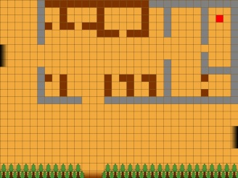The game has four areas: a castle area, a plains area, a forest area, and a cave area. The player can move between these four areas by entering a shaded area at the edge of the current screen. The areas are arranged as such:



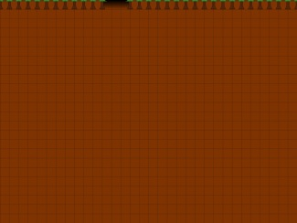

Each area currently has its own ground color:

Castle: tan

Plains: yellowish

Forest: brown

Cave: grey

Each area also has its own background music:

Castle: Chill

Plains: As long as a word remains unspoken

Forest: Elegy

Cave: Arpology 2

All of the music was composed by Longzijun, and acquired from Longzijun.wordpress.com on 3/31/13.