GoreeCloud Search
PR #18 Rendered Machine Evidence
Evidence type: rendered machine / browser presentation
Lifecycle: Development • Glaze UI target: 1.5.1 • Acceptance: partial / non-conforming until remaining gates pass

1. Evidence Status and Scope
Disposition: Rendered machine evidence collected successfully for the exact GoreeCloud Search PR #18 source revision. This evidence validates representative presentation behavior only. It does not establish Glaze UI consumer acceptance, assistive-technology acceptance, owner/human approval, supported-laptop-browser acceptance, live-provider behavior, Caddy/private-DNS behavior, VPS target-runtime acceptance, deployment, production acceptance, or Stable qualification.

2. Exact Source Binding
Field | Verified value
Repository | GoreeCloud/goreecloud-search
Pull request | #18 — private VPS Search web UI
Exact source revision | 7930107d7a572478d852641e74d48e09d0129995
Search version | 0.1.0.dev12
Glaze UI target | 1.5.1 (current Stable target; adoption not accepted)
web_ui.py Git blob | 271f26013e21c8170ab8ead3c78b6c49695c3db9
search.css Git blob | a48523f198beea2dd4e22183945b9ee6ce8c4359
version.py Git blob | 86b304a424ab370e529ecd89099540d04f44aad9
Materialization check: the locally rendered web_ui.py, search.css, and version.py were verified with Git blob hashing and matched the GitHub blob SHAs above before rendering.

3. Render Harness Boundary
Chromium was used as the rendering engine. Direct localhost navigation is blocked by this sandbox, so the harness loaded the exact server-rendered HTML bytes generated by PR #18's render_search_page() and then injected the exact PR #18 CSS file as a browser stylesheet. The representative result data is a synthetic fixture created only to exercise presentation states; it is not live provider or VPS evidence.
Representative states rendered: desktop light results, desktop keyboard focus, mobile dark with Reduced Motion, Reduced Transparency + Increased Contrast, and explicit error/unavailable state.

4. Machine Checks
State | No horizontal overflow | Form | Scripts | Remote resources
Desktop light | Pass | post /search | 0 | 0
Mobile dark + Reduced Motion | Pass | post /search | 0 | 0
Reduced Transparency + Increased Contrast | Pass | post /search | 0 | 0
Error state | Pass | post /search | 0 | 0
Accessibility-tree evidence exposed a main landmark, a search landmark, the Search heading, Search button, result headings, and result links. Keyboard focus evidence: first Tab reached the skip link with a 3 px visible outline; second Tab reached the query input with a 3 px visible outline.
Constrained-material computed state: backdrop-filter = none; box-shadow = none; border-top-width = 2px; background = rgb(255, 255, 255).
Error-state evidence exposed a role=alert with the visible text: “Search unavailable — — The Search service could not complete this request.”

5. Screenshot Artifact Hashes
Screenshot | SHA-256 | Bytes
desktop-keyboard-focus.png | 6064234a304168e329174cd713b2df72a15c8ab0560ea45ef6fde89495048eb7 | 357175
desktop-light-results.png | e88cda8b0d7e3c31cd5ce777ba62b8247f2a276e1f03a84681b73da96241aa73 | 357393
error-state.png | cb25de9a6645e49810d8f5ef9df632a619f6f0272a0bce32297671e7b0f52b01 | 206248
mobile-dark-results.png | 5f8c7ef7c46588a79d17ec5176abf90e69561f3593dfdf2bd4641e8ee996b219 | 176898
reduced-transparency-high-contrast.png | a1bc816b28bb45711b0275531b6ed1d44796e19879b766f1fbf6de7d9965979e | 228722

6. Rendered States
Figure 1. Desktop light results
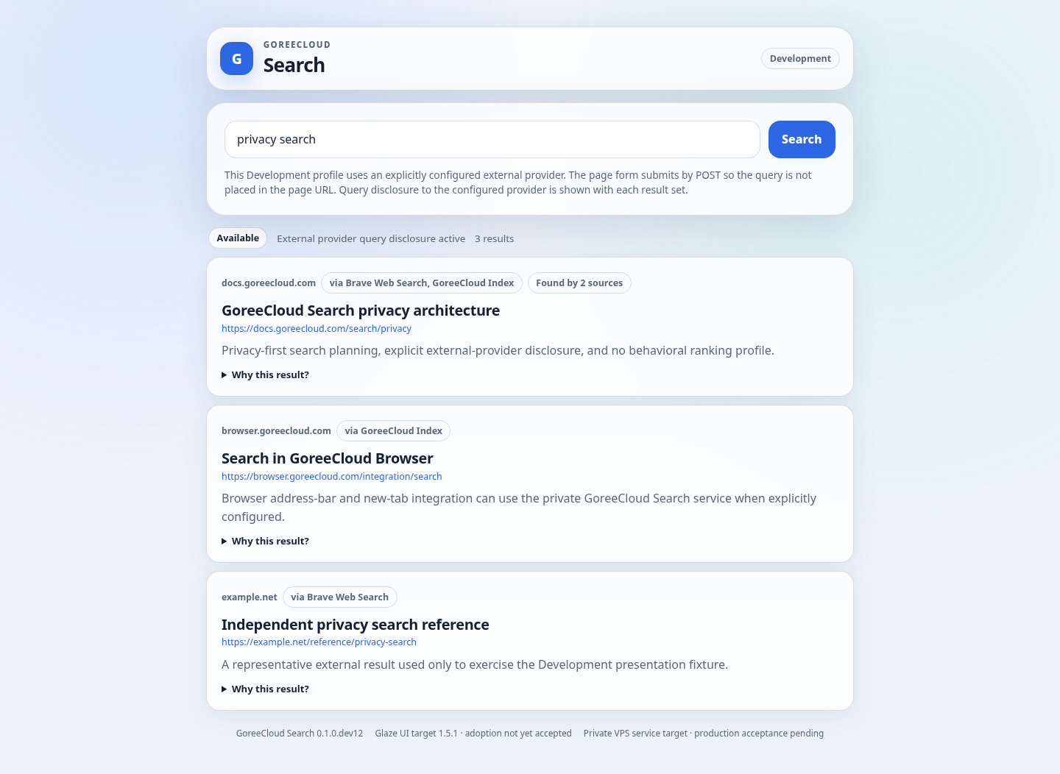
Representative desktop results state. Source disclosure, availability, result provenance, multi-source discovery count, and ranking explanation controls are visible.

Figure 2. Desktop keyboard focus
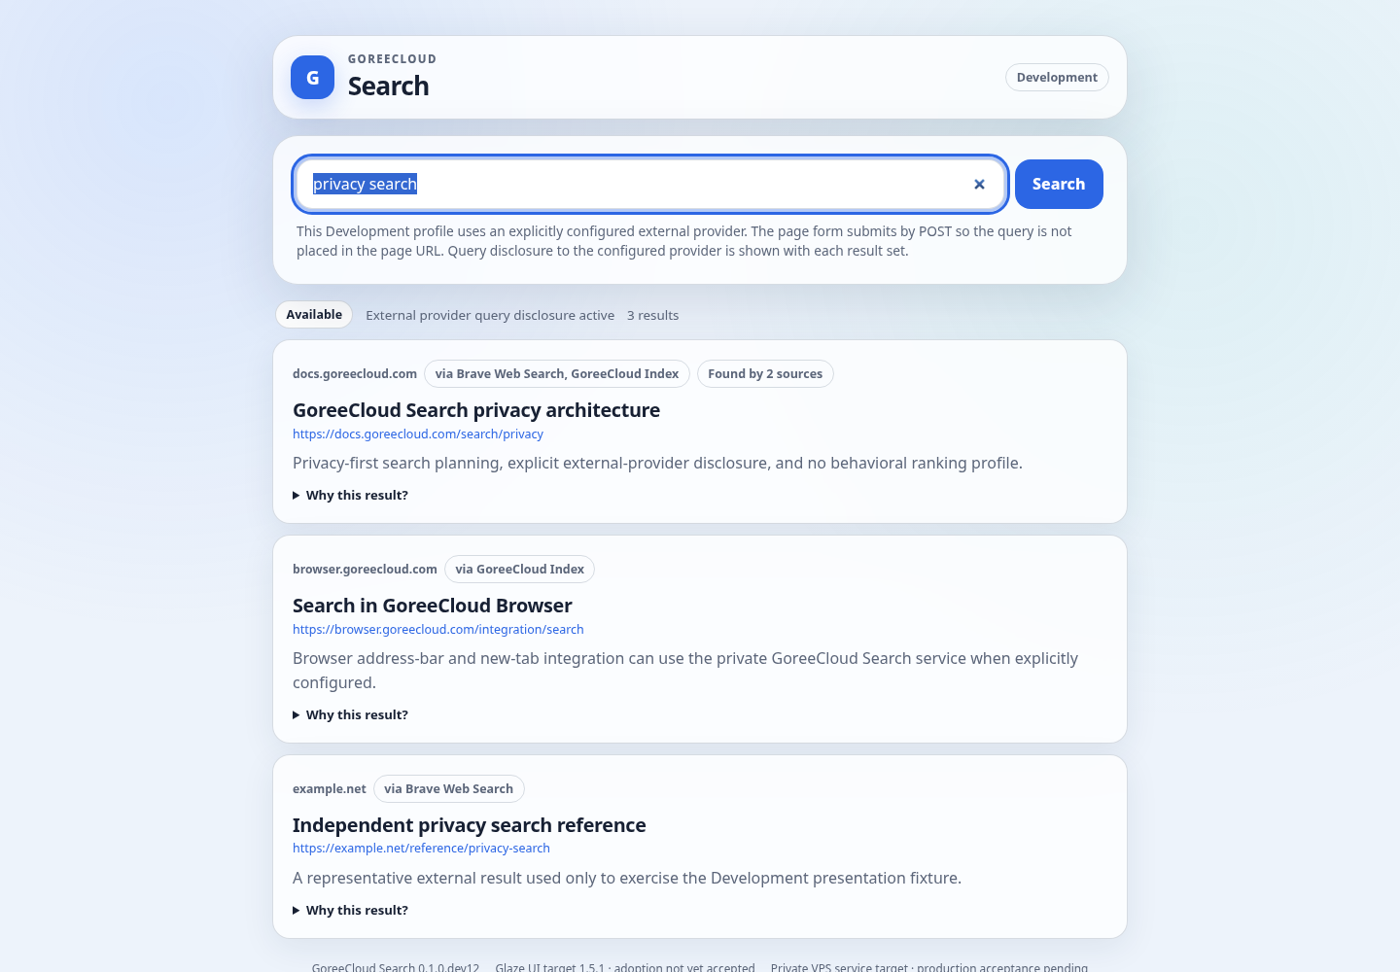
Keyboard focus after Tab navigation reaches the query input with a visible focus outline; the prior Tab target is the skip link.

Figure 3. Mobile dark + Reduced Motion
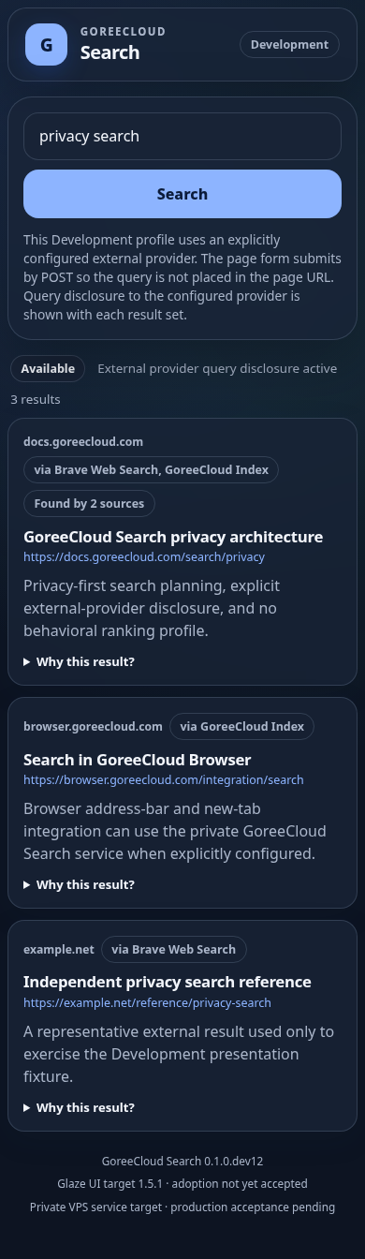
390 px mobile viewport using dark color scheme and Reduced Motion. Layout remains single-column with no horizontal overflow.

Figure 4. Reduced Transparency + Increased Contrast
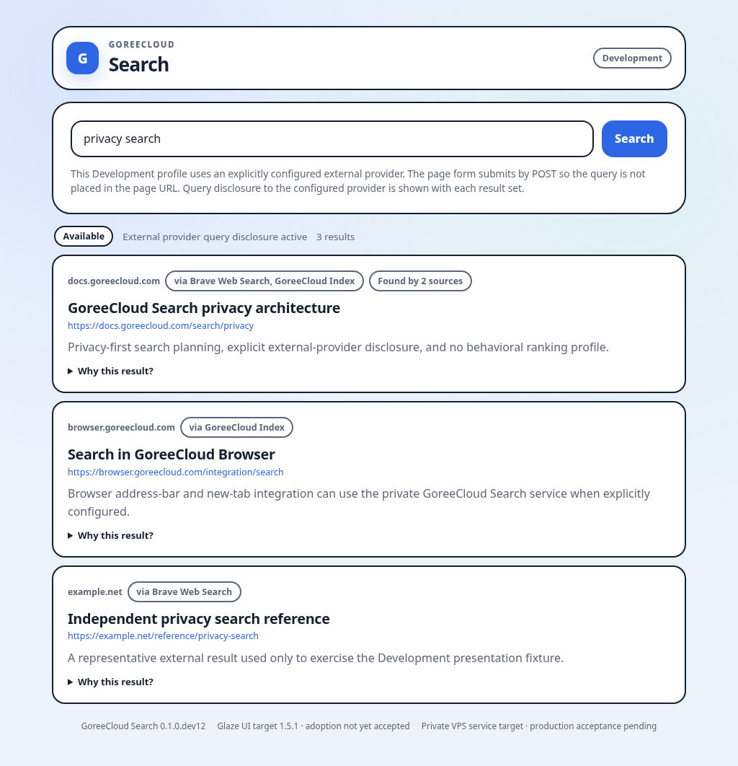
Chromium media emulation confirms opaque surfaces, no backdrop blur/shadow, and stronger 2 px borders.

Figure 5. Unavailable / error state
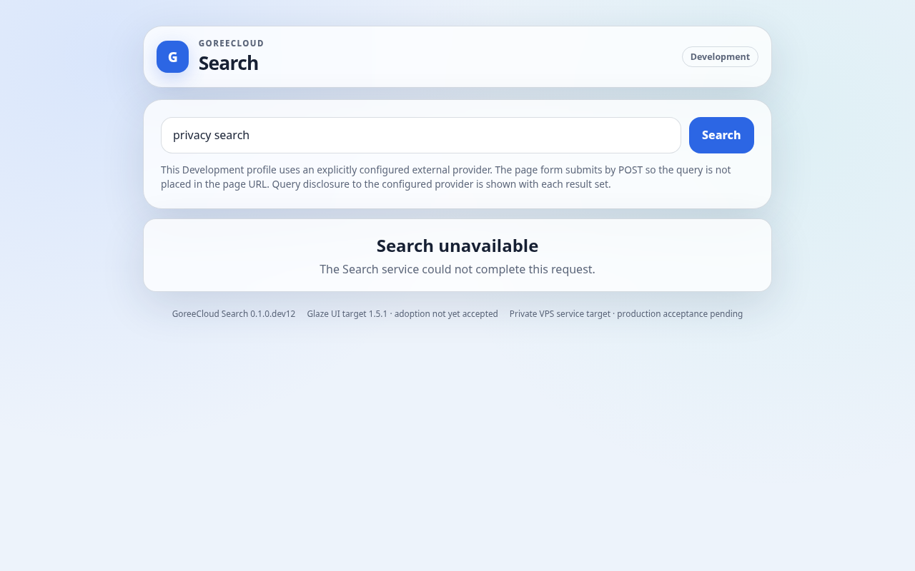
Explicit unavailable state rendered as an alert rather than silently redirecting or substituting another provider.

7. Remaining Acceptance Gates
- Owner/human visual review of the exact revision.
- Assistive-technology validation on a supported browser/platform.
- Supported laptop/browser and real-device acceptance, including zoom/text scaling and browser-specific behavior.
- Live Caddy/private-DNS response behavior for the new UI surface.
- Live external-provider target-runtime behavior with the approved credential path.
- Exact deployed artifact/digest verification on goreecloud-vps-01.
- GoreeCloud Browser address-bar/new-tab integration acceptance.
- Shared Glaze consumer evidence tuple and production eligibility only after all required consumer gates pass.

8. Evidence Rule
This record must not be used to claim production deployment, Stable qualification, broad Glaze UI conformance, or SearXNG replacement completion. It is one bounded evidence layer for PR #18 at the exact source revision identified above.

